
KWAME NKRUMAH UNIVERSITY OF SCIENCE AND TECHNOLOGY
COLLEGE OF SCIENCE
FACULTY OF PHYSICAL AND COMPUTATIONAL SCIENCES
DEPARTMENT OF COMPUTER SCIENCE
PROJECT DOCUMENTATION
FOR CONSIDERATION UNDER
BACHELOR OF COMPUTER SCIENCE (BSc) PROGRAMME
PROJECT TITLE:
DriveSense — A Real-Time Driver Drowsiness and Distraction Detection System

SUBMITTED BY
Davis Opoku - 3406422
Nartey Osborn Ojerh Tettey - 3401622
SUPERVISOR
DR. BENJAMIN TEI-PARTEY
April 2026

TABLE OF CONTENTS
CHAPTER 1: INTRODUCTION 4
1.1 Background 4
1.2 Problem Statement 4
1.3 Project Aim 4
1.4 Specific Objectives 4
1.5 Scope 5
1.6 Significance 5
1.7 Methodology 5
1.8 Plan of Activities 5
CHAPTER 2: REVIEW OF RELATED SYSTEMS 6
2.1 Commercial Driver Monitoring Systems 6
2.2 Academic Rule-Based EAR Systems 6
2.3 Machine Learning-Based Approaches 6
2.4 Multi-Modal Distraction Detection 7
2.5 Web-Based Monitoring Dashboards 7
2.6 Gaps and Justification for DriveSense 7
CHAPTER 3: REQUIREMENTS SPECIFICATION 7
3.1 User Requirements 7
3.1.1 Functional User Requirements 8
3.2 System Requirements 8
3.2.1 Functional System Requirements 8
3.2.2 Non-Functional System Requirements 9
CHAPTER 4: UML DIAGRAMS 9
4.1 Use Case Diagram 9
4.2 Activity Diagram 10
4.3 Sequence Diagram — Detection Cycle 10
4.4 Sequence Diagram — Eye Calibration 11
CHAPTER 5: PROJECT DESIGN 11
5.1 Architectural Design 11
5.1.1 Layer Descriptions 12
5.1.2 Web Dashboard Architecture 12
5.2 Component Design — Class Diagram 12
5.2.1 Key Classes / Modules 13
5.3 Database / Data Schema 13
5.4 UI Design — Web Dashboard 14
5.4.1 Screen Inventory 14
5.4.2 Dashboard Wireframe 15
CHAPTER 6: ALGORITHMS 15
6.1 Eye Aspect Ratio (EAR) Computation 15
6.2 Mouth Open Ratio Computation 15
6.3 Temporal Split Training Strategy 16
6.4 Micro-Sleep Detection Algorithm 16
6.5 Head-Pose Distraction Detection 17
6.6 Gaze Deviation Detection 17
6.7 Eye Calibration Algorithm 17
6.8 Fatigue Score Algorithm 18
CHAPTER 7: FLOWCHARTS 19
7.1 Main Detection Loop Flowchart 19
7.2 Training Pipeline Flowchart 19
CHAPTER 8: FINDINGS, CONCLUSIONS AND RECOMMENDATIONS 20
8.1 Findings 20
8.2 Conclusions 21
8.3 Challenges Encountered 21
8.4 Novelty of the System 21
8.5 Known Limitations 22
8.6 Future Additions 22
REFERENCES 23

CHAPTER 1: INTRODUCTION

1.1 Background
Road traffic accidents caused by driver fatigue and inattention remain one of the leading causes of injury and death globally. According to the World Health Organisation, approximately 1.35 million people die annually in road traffic crashes, with driver fatigue implicated in an estimated 20–30% of all accidents. In Ghana and across sub-Saharan Africa, long-distance commercial driving, irregular working hours, and limited enforcement of rest regulations compound this risk significantly.
Advances in computer vision and machine learning now make it possible to monitor driver alertness non-intrusively using a standard webcam. By analysing facial landmarks in real time, a system can compute physiological indicators of drowsiness — such as progressive eye closure, yawning frequency, and head-pose deviation — and alert the driver before fatigue becomes dangerous.
DriveSense is a real-time driver drowsiness and distraction detection system that leverages MediaPipe facial landmark estimation and a scikit-learn Random Forest classifier to continuously monitor driver alertness. The system classifies three primary states — AWAKE, DROWSY, and YAWNING — and additionally detects head-pose distraction, gaze deviation, abnormal blink rates, and micro-sleep events. A cross-platform web dashboard provides a live camera feed, real-time biometric charts, adjustable detection thresholds, and a per-driver eye calibration facility.

1.2 Problem Statement
Despite widespread awareness of the dangers of drowsy driving, no affordable, non-invasive, real-time solution has achieved widespread adoption among individual drivers or fleet operators in low-to-middle-income countries. Specifically, the following problems motivate this work:
- Rule-based threshold systems fail to generalise across drivers with different facial geometries; a fixed EAR threshold that triggers for one driver misses drowsiness in another.
- No affordable open-source system combines ML-based drowsiness classification with multi-modal distraction detection (head pose, gaze deviation, blink rate, micro-sleep) in a single pipeline.
- Existing systems lack a web dashboard that allows per-driver calibration, live biometric charting, and remotely adjustable sensitivity controls.
- Train/serve skew arises when feature computation logic is duplicated across training and inference scripts, producing inconsistent threshold behaviour.

1.3 Project Aim
The aim of this project is to design, develop, and evaluate DriveSense — a real-time, ML-powered driver drowsiness and distraction detection system that uses a standard webcam, MediaPipe facial landmark estimation, and a Random Forest classifier to monitor driver alertness and deliver timely audible alerts, accessible via both a terminal OpenCV interface and a browser-based dashboard.

1.4 Specific Objectives
- To design and implement a shared feature extraction module (src/features.py) computing Eye Aspect Ratio (EAR), Mouth Open Ratio, iris horizontal and vertical ratios, and head-pose pitch/yaw from MediaPipe facial landmarks.
- To collect a labelled training dataset of driver facial states (AWAKE, DROWSY, YAWNING) via webcam-based data collection with rule-based auto-labelling.
- To train and evaluate a Random Forest classifier using a temporal split strategy that prevents data leakage from sequential frame-counter features.
- To implement a multi-modal distraction detector covering head-pose distraction, gaze deviation, blink rate anomaly detection, and micro-sleep event tracking.
- To develop a cross-platform audible alert mechanism (880 Hz synthesised tone via sounddevice) triggered on DROWSY, DISTRACTED, or MICRO-SLEEP detection.
- To build a Flask-based web dashboard providing live MJPEG video streaming, SSE-driven biometric metrics, Chart.js timelines, adjustable thresholds, and a 3-second eye calibration routine.
- To implement a persistent SQLite event logger (src/db.py) that records all non-AWAKE detection events with timestamps across application restarts, and expose them via REST endpoints for post-drive review.
- To implement per-driver calibration profiles (src/profiles.py) that save each driver's calibrated EAR threshold to a JSON file, and a rolling fatigue score (0–100) that weights detection events by severity within a 5-minute window.
- To conduct a comparative evaluation of rule-based versus ML-based detection on the same temporal test set.

1.5 Scope
The scope covers the full pipeline from data collection through training, evaluation, and live deployment. Core scope includes: the shared feature extraction module, webcam-based dataset collection, Random Forest training with temporal split, hold-out and cross-validated evaluation, terminal OpenCV inference application, Flask web dashboard with live streaming and SSE metrics, head-pose and gaze distraction detection, blink rate monitoring, micro-sleep detection, audible alerts, and per-driver EAR calibration. Out of scope: multi-camera setups, night-vision cameras, cloud-based telemetry, vehicle CAN-bus integration, and mobile deployment.

1.6 Significance
DriveSense demonstrates that a highly accurate drowsiness detection system (99.6% hold-out accuracy; 97.9% ± 2.2% cross-validated) can be built from commodity hardware and open-source tools. The comparative evaluation quantitatively establishes ML superiority over rule-based detection — particularly for early-stage drowsiness where the rule-based system achieves 0% DROWSY recall versus 100% for the Random Forest. The web dashboard architecture makes the system accessible without requiring hardware installation.

1.7 Methodology
This project adopted an iterative development methodology structured around six milestones: (1) literature review and system design, (2) feature extraction and dataset collection, (3) model training and evaluation, (4) terminal live inference application, (5) web dashboard development, and (6) comparative evaluation and documentation. Each milestone produced a testable artefact, enabling continuous refinement of thresholds, detection logic, and UI accessibility. The development environment used Python 3 with OpenCV, MediaPipe, scikit-learn, Flask, and sounddevice.

1.8 Plan of Activities
Sprint | Period | Activity
1–2 | Week 1–4 | Literature review, system architecture design, feature module specification, MediaPipe integration test
3–4 | Week 5–8 | Webcam test, landmark visualisation, feature extraction module (features.py), EAR/mouth ratio validation
5–6 | Week 9–12 | Dataset collection (save_dataset.py), auto-labelling logic, dataset inspection (check_dataset.py)
7–8 | Week 13–16 | Model training (train_model.py), temporal split implementation, hyperparameter selection
9–10 | Week 17–20 | Model evaluation (evaluate_model.py), cross-validation, confusion matrix, comparison report
11–12 | Week 21–24 | Terminal live inference (live_ml_app.py), audible alert, head-pose and gaze detection
13–14 | Week 25–28 | Flask web dashboard (app.py), MJPEG streaming, SSE metrics, Chart.js timeline, calibration
15 * | Week 29 | Rule-based vs ML comparison, cross-platform testing, bug fixing, final documentation

CHAPTER 2: REVIEW OF RELATED SYSTEMS
This chapter reviews existing driver monitoring and drowsiness detection systems and enabling technologies, evaluating their features, limitations, and relevance to DriveSense.

2.1 Commercial Driver Monitoring Systems

Examples: Mobileye, Seeing Machines, Tobii DX
These systems use dedicated infrared cameras and proprietary hardware to achieve robust drowsiness and distraction detection. Strengths include high accuracy across lighting conditions and seamless vehicle integration. Limitations include high unit cost (USD 500–2,000+), mandatory hardware installation, and closed ecosystems that prevent customisation or research use. They are inaccessible to individual drivers in low-income contexts such as Ghana.

2.2 Academic Rule-Based EAR Systems

Examples: Soukupova & Cech (2016), OpenCV drowsiness detector tutorials
Soukupova and Cech introduced the Eye Aspect Ratio as a simple, effective indicator of eye closure. Numerous open-source implementations trigger an alert when EAR falls below a fixed threshold for a set number of consecutive frames. The critical limitation is that a single EAR threshold does not generalise across drivers. Our comparative evaluation confirms this: the rule-based system achieves 50.1% overall accuracy and 0% DROWSY recall on our dataset, compared to 99.6% accuracy for the ML approach.

2.3 Machine Learning-Based Approaches

Examples: NTHU Drowsy Driver Detection Dataset studies, CNN-based methods
CNN approaches operating on raw eye-region crops achieve high accuracy but require GPU inference hardware and are not interpretable. Random Forest classifiers trained on hand-crafted EAR features offer comparable accuracy on driver-specific datasets while running in real time on CPU, providing feature importance interpretability, and requiring far less data. DriveSense adopts this approach, demonstrating 99.6% accuracy with 3,793 labelled frames.

2.4 Multi-Modal Distraction Detection

Examples: DriverAlert (Waymo Research), face-pose-estimation-based systems
Recent research extends beyond eye closure to include head-pose estimation, gaze tracking, and mobile phone use detection. MediaPipe's facial transformation matrix provides pitch, yaw, and roll directly from the landmark model without a separate pose estimator, enabling lightweight head-pose distraction detection. DriveSense integrates head-pose and iris-based gaze tracking alongside the core EAR classifier.

2.5 Web-Based Monitoring Dashboards

Examples: Fleet dashboards (Samsara, Lytx)
Fleet management platforms provide web dashboards for supervisors to review detection events. They are not designed for the driver's own real-time feedback loop. DriveSense's Flask dashboard delivers live MJPEG video, SSE-driven biometric metrics, and Chart.js visualisations accessible from any browser on the same network, without requiring a native app.

2.6 Gaps and Justification for DriveSense
No existing open-source system combines: (i) ML-based drowsiness classification with a temporal-split training regime, (ii) multi-modal distraction detection (head pose, gaze, blink rate, micro-sleep), (iii) a web dashboard with live MJPEG streaming and Chart.js biometric charts, (iv) per-driver EAR calibration, and (v) a quantitative rule-based vs. ML comparative evaluation. DriveSense is designed to fill this gap.

CHAPTER 3: REQUIREMENTS SPECIFICATION

3.1 User Requirements

3.1.1 Functional User Requirements
ID | User Requirement | Rationale
UR-01 | I want the system to detect when I am drowsy and alert me immediately | Timely alerts prevent accidents caused by undetected fatigue
UR-02 | I want the system to alert me when I am yawning excessively | Yawning is an early fatigue indicator; early warning is preferable
UR-03 | I want the system to detect when my head drops or turns away from the road | Head-pose distraction is a leading cause of accidents
UR-04 | I want the system to detect when my eyes deviate from the road | Gaze deviation towards a phone or window is a distraction indicator
UR-05 | I want to calibrate the system to my eyes before driving | Fixed EAR thresholds do not generalise; calibration improves accuracy
UR-06 | I want a web dashboard with live camera feed and biometric charts | Visual feedback helps drivers and fleet operators monitor events
UR-07 | I want to adjust detection sensitivity from the dashboard | Drivers should tune thresholds without modifying code
UR-08 | I want an audible alert that works without headphones on all platforms | The alert must be perceptible in a noisy vehicle environment
UR-09 | I want the system to track my blink rate and detect micro-sleeps | Abnormal blink frequency and rapid re-closures indicate fatigue
UR-10 | I want to mute alerts temporarily without stopping detection | Drivers may need to disable alerts at traffic stops or road junctions

3.2 System Requirements

3.2.1 Functional System Requirements
ID | System Requirement | Category
SR-01 | System shall capture webcam frames at the native camera frame rate using OpenCV VideoCapture | Video Input
SR-02 | System shall detect facial landmarks using MediaPipe Face Landmarker with output_facial_transformation_matrixes=True | Face Analysis
SR-03 | System shall compute left_ear, right_ear, avg_ear, and mouth_ratio per frame using the shared features.py module | Feature Extraction
SR-04 | System shall classify each frame as AWAKE, DROWSY, or YAWNING using the trained RandomForestClassifier | ML Inference
SR-05 | System shall emit an 880 Hz audible alert via sounddevice when DROWSY, DISTRACTED, or MICRO-SLEEP is detected, rate-limited to once per 3 seconds | Alerting
SR-06 | System shall detect head-pose distraction when |pitch| > 20 deg or |yaw| > 25 deg for 15+ consecutive frames | Distraction Detection
SR-07 | System shall detect gaze deviation when iris horizontal ratio < 0.28 or > 0.72 for 20+ consecutive frames | Distraction Detection
SR-08 | System shall track blink events using a 60-second sliding window and flag abnormal blink rates | Blink Monitoring
SR-09 | System shall detect micro-sleep events defined as 3-15 consecutive frames of closed eyes within a 60-second window | Micro-Sleep
SR-10 | System shall stream annotated frames as MJPEG via Flask /video_feed endpoint | Web Dashboard
SR-11 | System shall push real-time state updates to the browser via Server-Sent Events at /stream | Web Dashboard
SR-12 | System shall accept threshold and alert configuration via POST /config endpoint | Web Dashboard
SR-13 | System shall run a 3-second EAR calibration routine on demand, computing baseline EAR from 90+ frames | Calibration
SR-14 | System shall persist all non-AWAKE detection events (event type, timestamp, EAR, mouth ratio) to a local SQLite database (data/events.db) via src/db.py, surviving application restarts | Persistence
SR-15 | System shall persist each driver's calibrated EAR threshold to a JSON profile (data/profiles/{name}.json) via src/profiles.py, and load it automatically when the driver is selected via POST /api/set_driver | Persistence
SR-16 | System shall compute and broadcast a rolling fatigue score (0–100) in each SSE state update, derived from the weighted sum of DROWSY (+10), MICRO-SLEEP (+15), YAWNING (+3), and DISTRACTED (+2) events within the last 5 minutes | Analytics

3.2.2 Non-Functional System Requirements
Category | Attribute | Specification
Performance | Inference latency | End-to-end per-frame latency < 33 ms (30 FPS) on a modern laptop CPU
Reliability | Model accuracy | Hold-out accuracy >= 99%; 5-fold CV accuracy >= 95%
Reliability | Alert latency | Alert triggered within 1 second of DROWSY classification
Compatibility | Operating system | macOS, Windows 10+, Ubuntu 20.04+; Python 3.8+
Compatibility | Dashboard | Accessible from any modern browser on the same local network
Security | Data privacy | No video frames or biometric data transmitted externally; all processing on-device
Usability | Setup | Automated setup via setup.sh or pip install -r requirements.txt
Usability | Dashboard | All controls accessible without CLI knowledge once server is running

CHAPTER 4: UML DIAGRAMS

4.1 Use Case Diagram
The use case diagram depicts interactions between the primary actors (Driver, Web User, and the MediaPipe/ML subsystem) and the core functions of DriveSense. The Driver interacts with the system through the webcam and receives audible alerts. The Web User additionally interacts via the Flask dashboard to view live video, monitor biometric metrics, adjust thresholds, and trigger calibration.
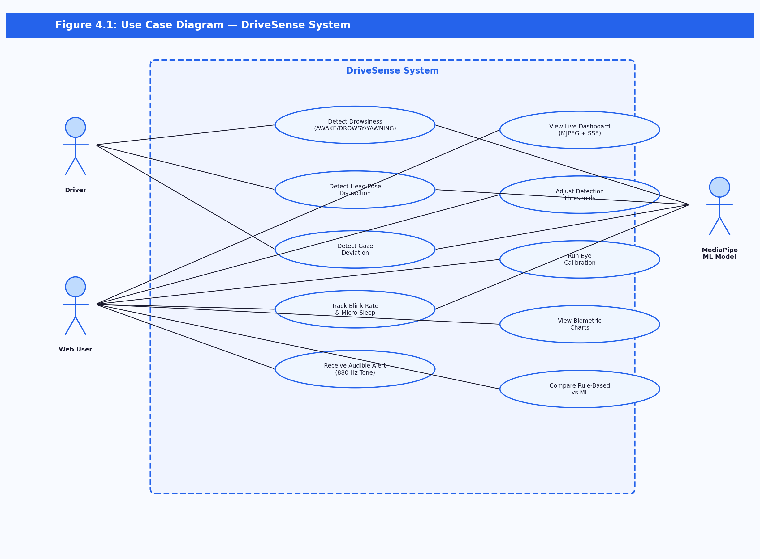

Use Case Descriptions
Use Case | Actor | Description
Detect Drowsiness | Driver / ML Model | System processes each frame, extracts EAR features, and classifies driver state as AWAKE, DROWSY, or YAWNING
Detect Head-Pose Distraction | Driver / MediaPipe | Reads facial transformation matrix; flags distraction when pitch or yaw exceeds threshold for 15+ frames
Detect Gaze Deviation | Driver / MediaPipe | Computes iris horizontal/vertical ratios and flags gaze-off-road when outside normal bounds for 20+ frames
Receive Audible Alert | Driver | System emits 880 Hz tone via sounddevice when DROWSY, DISTRACTED, or MICRO-SLEEP is detected
View Live Dashboard | Web User | Opens browser at http://127.0.0.1:5000 to see live MJPEG video feed and SSE-driven biometric metrics
Adjust Thresholds | Web User | Updates EAR threshold, mouth threshold, and alert toggle via dashboard controls; applied in real time
Run Eye Calibration | Web User / Driver | Triggers 3-second calibration; system measures baseline EAR and sets alert threshold to baseline x 0.85
Compare Rule-Based vs ML | Developer | Runs compare_models.py to evaluate both approaches on the same temporal test split

4.2 Activity Diagram
The activity diagram models the complete flow of a single detection cycle, from webcam frame capture through MediaPipe landmark detection, feature extraction, ML classification, multi-modal distraction checks, alert decision, and dashboard state push. Parallel branches illustrate the MJPEG stream and SSE state updates running concurrently with the main detection loop.
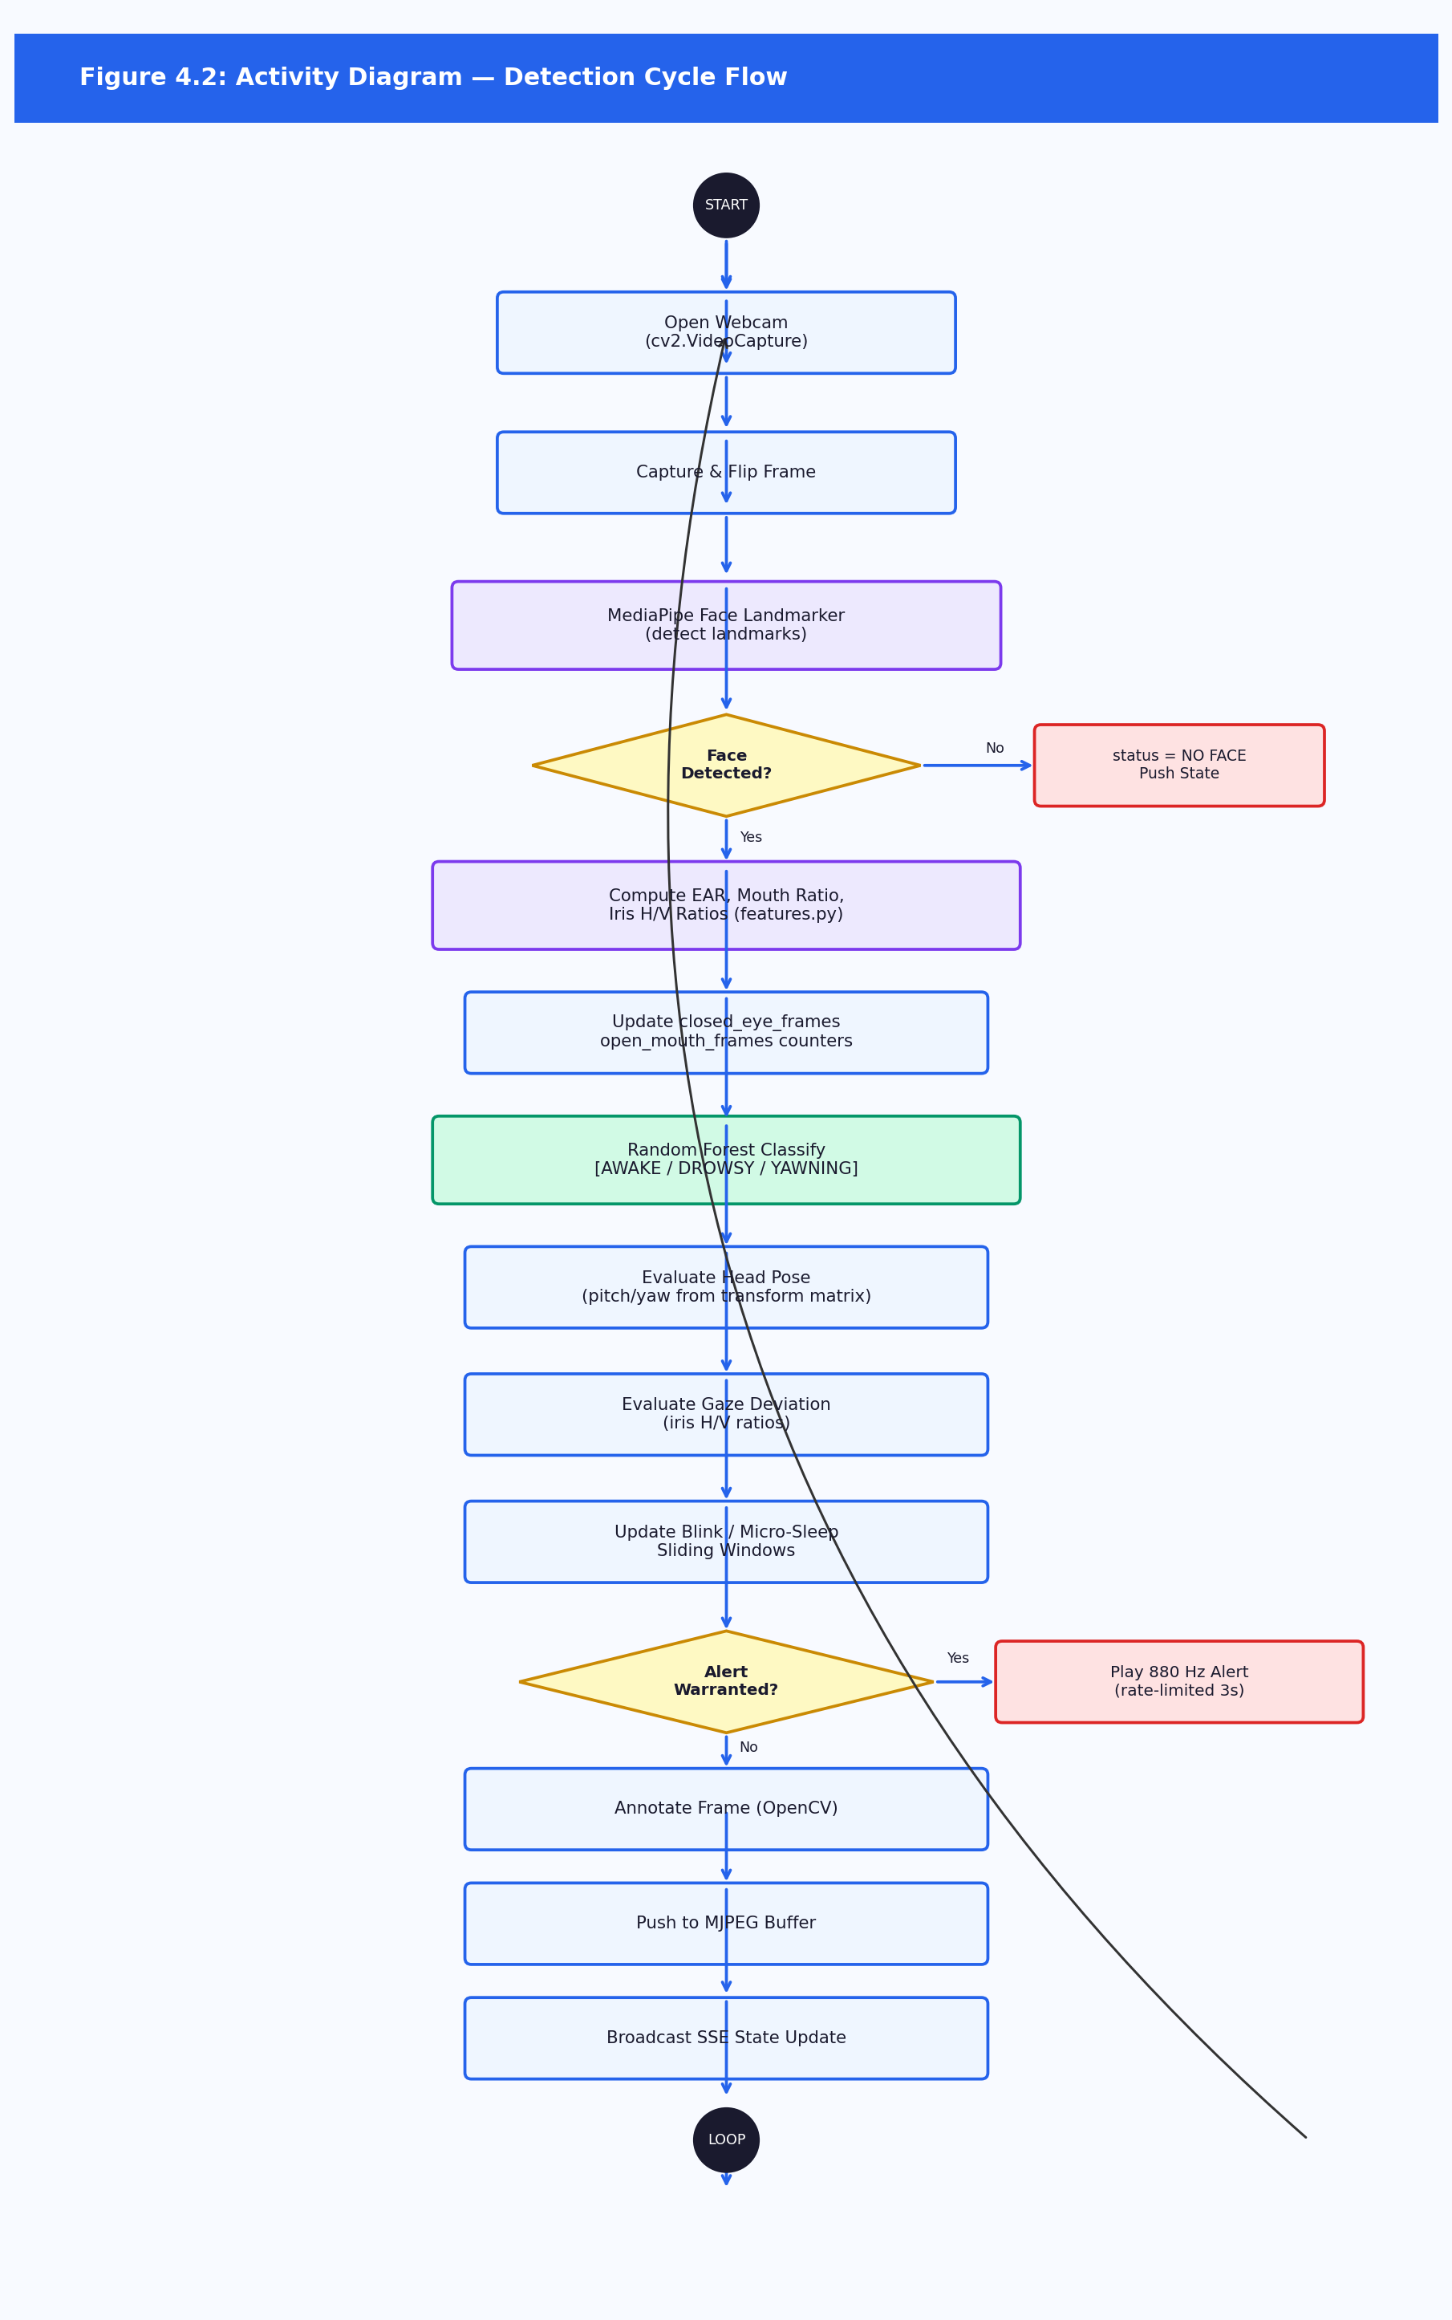

4.3 Sequence Diagram — Detection Cycle
The sequence diagram illustrates the message flow during a single frame cycle across the Webcam, Detection Thread, features.py module, RF Model, Alert Module, MJPEG Encoder, and SSE Broadcast components. The Detection Thread reads a frame, passes it to MediaPipe for landmark extraction, computes features, queries the ML Model, evaluates distraction rules, triggers alerts if warranted, and pushes updated state to the MJPEG encoder and SSE broadcaster.
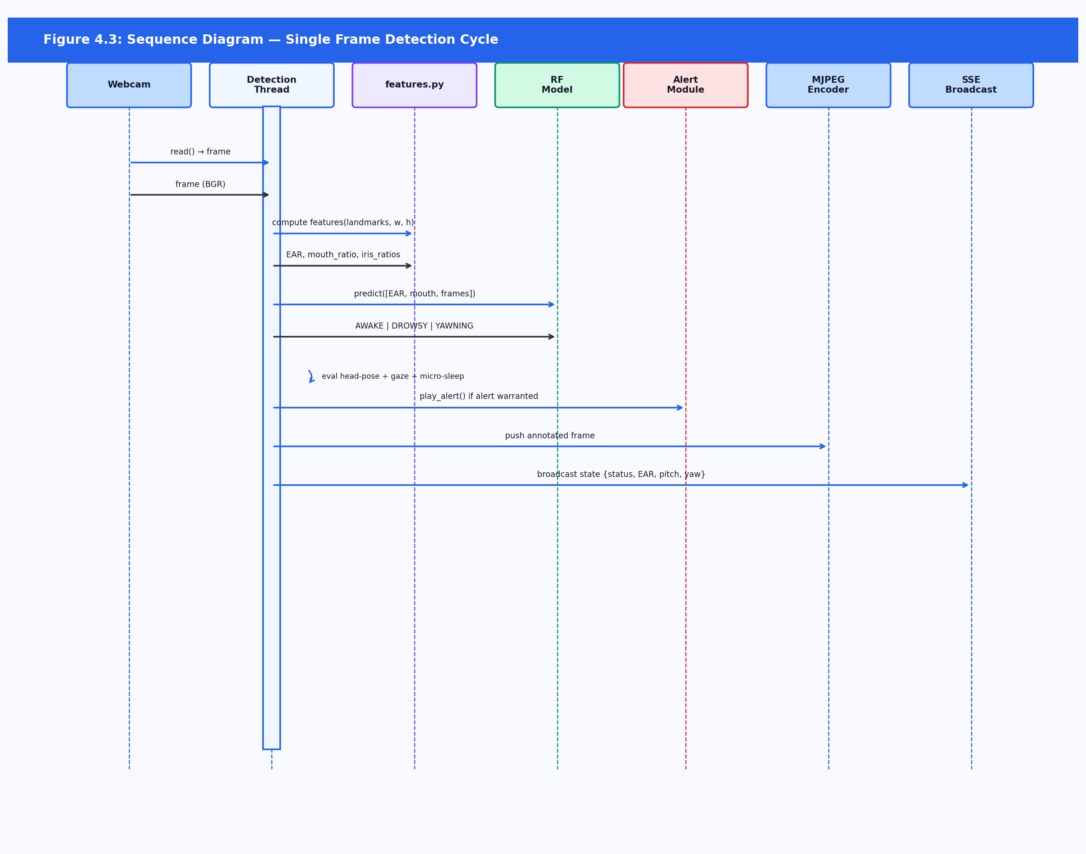

4.4 Sequence Diagram — Eye Calibration
This sequence diagram shows the calibration flow when a user clicks Calibrate on the dashboard. The browser sends a POST to /config with calibrating=True. The Detection Thread collects EAR samples over 3 seconds (~90 frames), computes the mean baseline EAR, sets the alert threshold to baseline x 0.85, and pushes a calibration_done event to the dashboard via SSE.
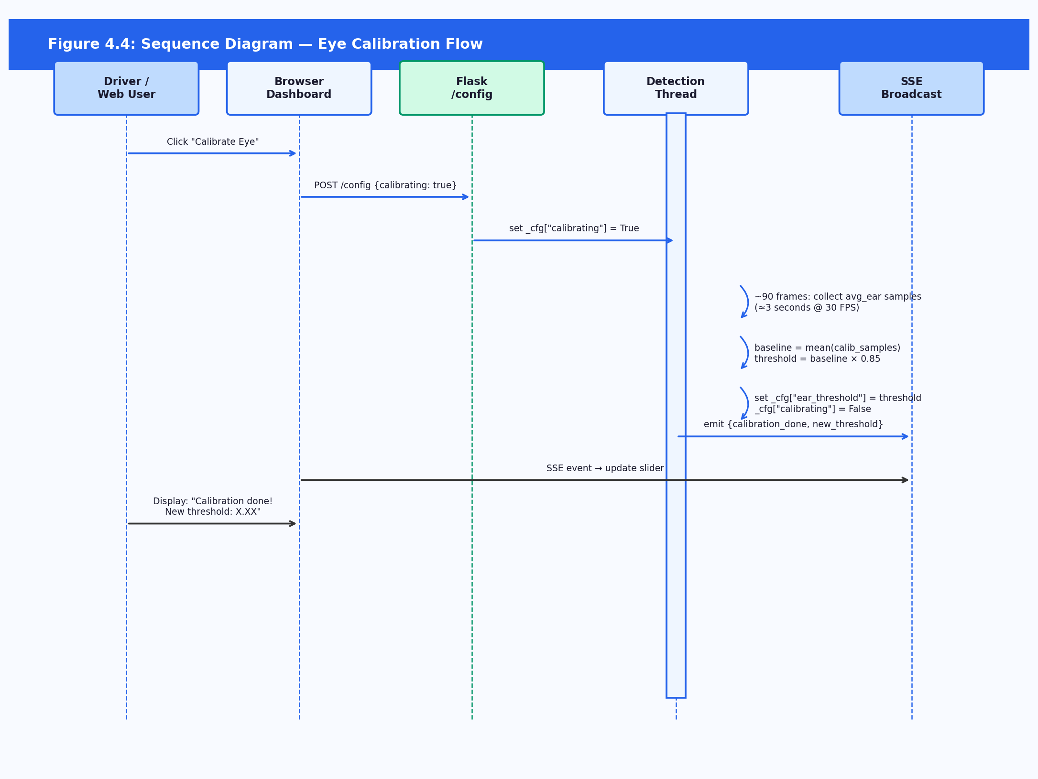

CHAPTER 5: PROJECT DESIGN

5.1 Architectural Design
DriveSense adopts a layered, single-machine architecture with a clear separation between the data pipeline and the live inference pipeline. The system is structured into four layers: Data Layer, Feature Layer, Inference Layer, and Presentation Layer.

5.1.1 Layer Descriptions
Data Layer: Contains the raw training CSV (data/drowsiness_dataset.csv, 4,742 rows) and the pre-trained models (models/face_landmarker.task for MediaPipe, models_ml/drowsiness_model.pkl for the Random Forest). Data collection is handled by save_dataset.py which auto-labels frames using rule-based thresholds before writing to CSV.
Feature Layer: The shared module src/features.py implements all feature extraction functions: eye_aspect_ratio(), mouth_open_ratio(), iris_h_ratio(), and iris_v_ratio(). This ensures identical feature computation during both training and inference, eliminating train/serve skew.
Inference Layer: Two inference paths are provided. The terminal path (live_ml_app.py) renders annotated frames in an OpenCV window. The web path (app.py) runs the detection loop in a background thread, encoding frames as MJPEG and broadcasting state via SSE.
Presentation Layer: The Flask web dashboard (src/templates/index.html) displays the live MJPEG feed, a Chart.js biometric timeline (EAR and mouth ratio), real-time status indicators, and threshold controls. All communication uses SSE for push updates and POST /config for control inputs.

5.1.2 Web Dashboard Architecture
The Flask application (app.py) spawns a single background detection thread on startup. The thread maintains shared state behind a threading.Lock(), writes annotated frames to a shared buffer, and exposes the following REST and streaming endpoints:
Endpoint | Method | Description
/video_feed | GET | MJPEG stream of annotated webcam frames
/events | GET | Server-Sent Events stream of real-time state (EAR, status, fatigue score, gaze, blink rate)
/api/toggle_alert | POST | Toggle audible alert on/off
/api/set_threshold | POST | Update EAR and/or mouth ratio thresholds in real time
/api/calibrate | POST | Trigger 3-second EAR calibration; auto-saves to driver profile on completion
/api/config | GET | Return current alert_enabled, ear_threshold, mouth_threshold
/api/set_driver | POST | Load a driver profile and apply their saved EAR threshold
/api/drivers | GET | List all driver names with saved calibration profiles
/api/events_log | GET | Return recent persisted events from SQLite (survives restarts)
/api/session_summary | GET | Return per-event-type counts for the last hour

5.2 Component Design — Class Diagram
The class diagram shows the principal modules of the DriveSense system and their relationships. The FeaturesModule (features.py) is the central shared dependency imported by all data collection, training, and inference scripts. The FlaskDashboard and LiveMLApp both inherit detection logic and call the AlertModule for audible alerts.
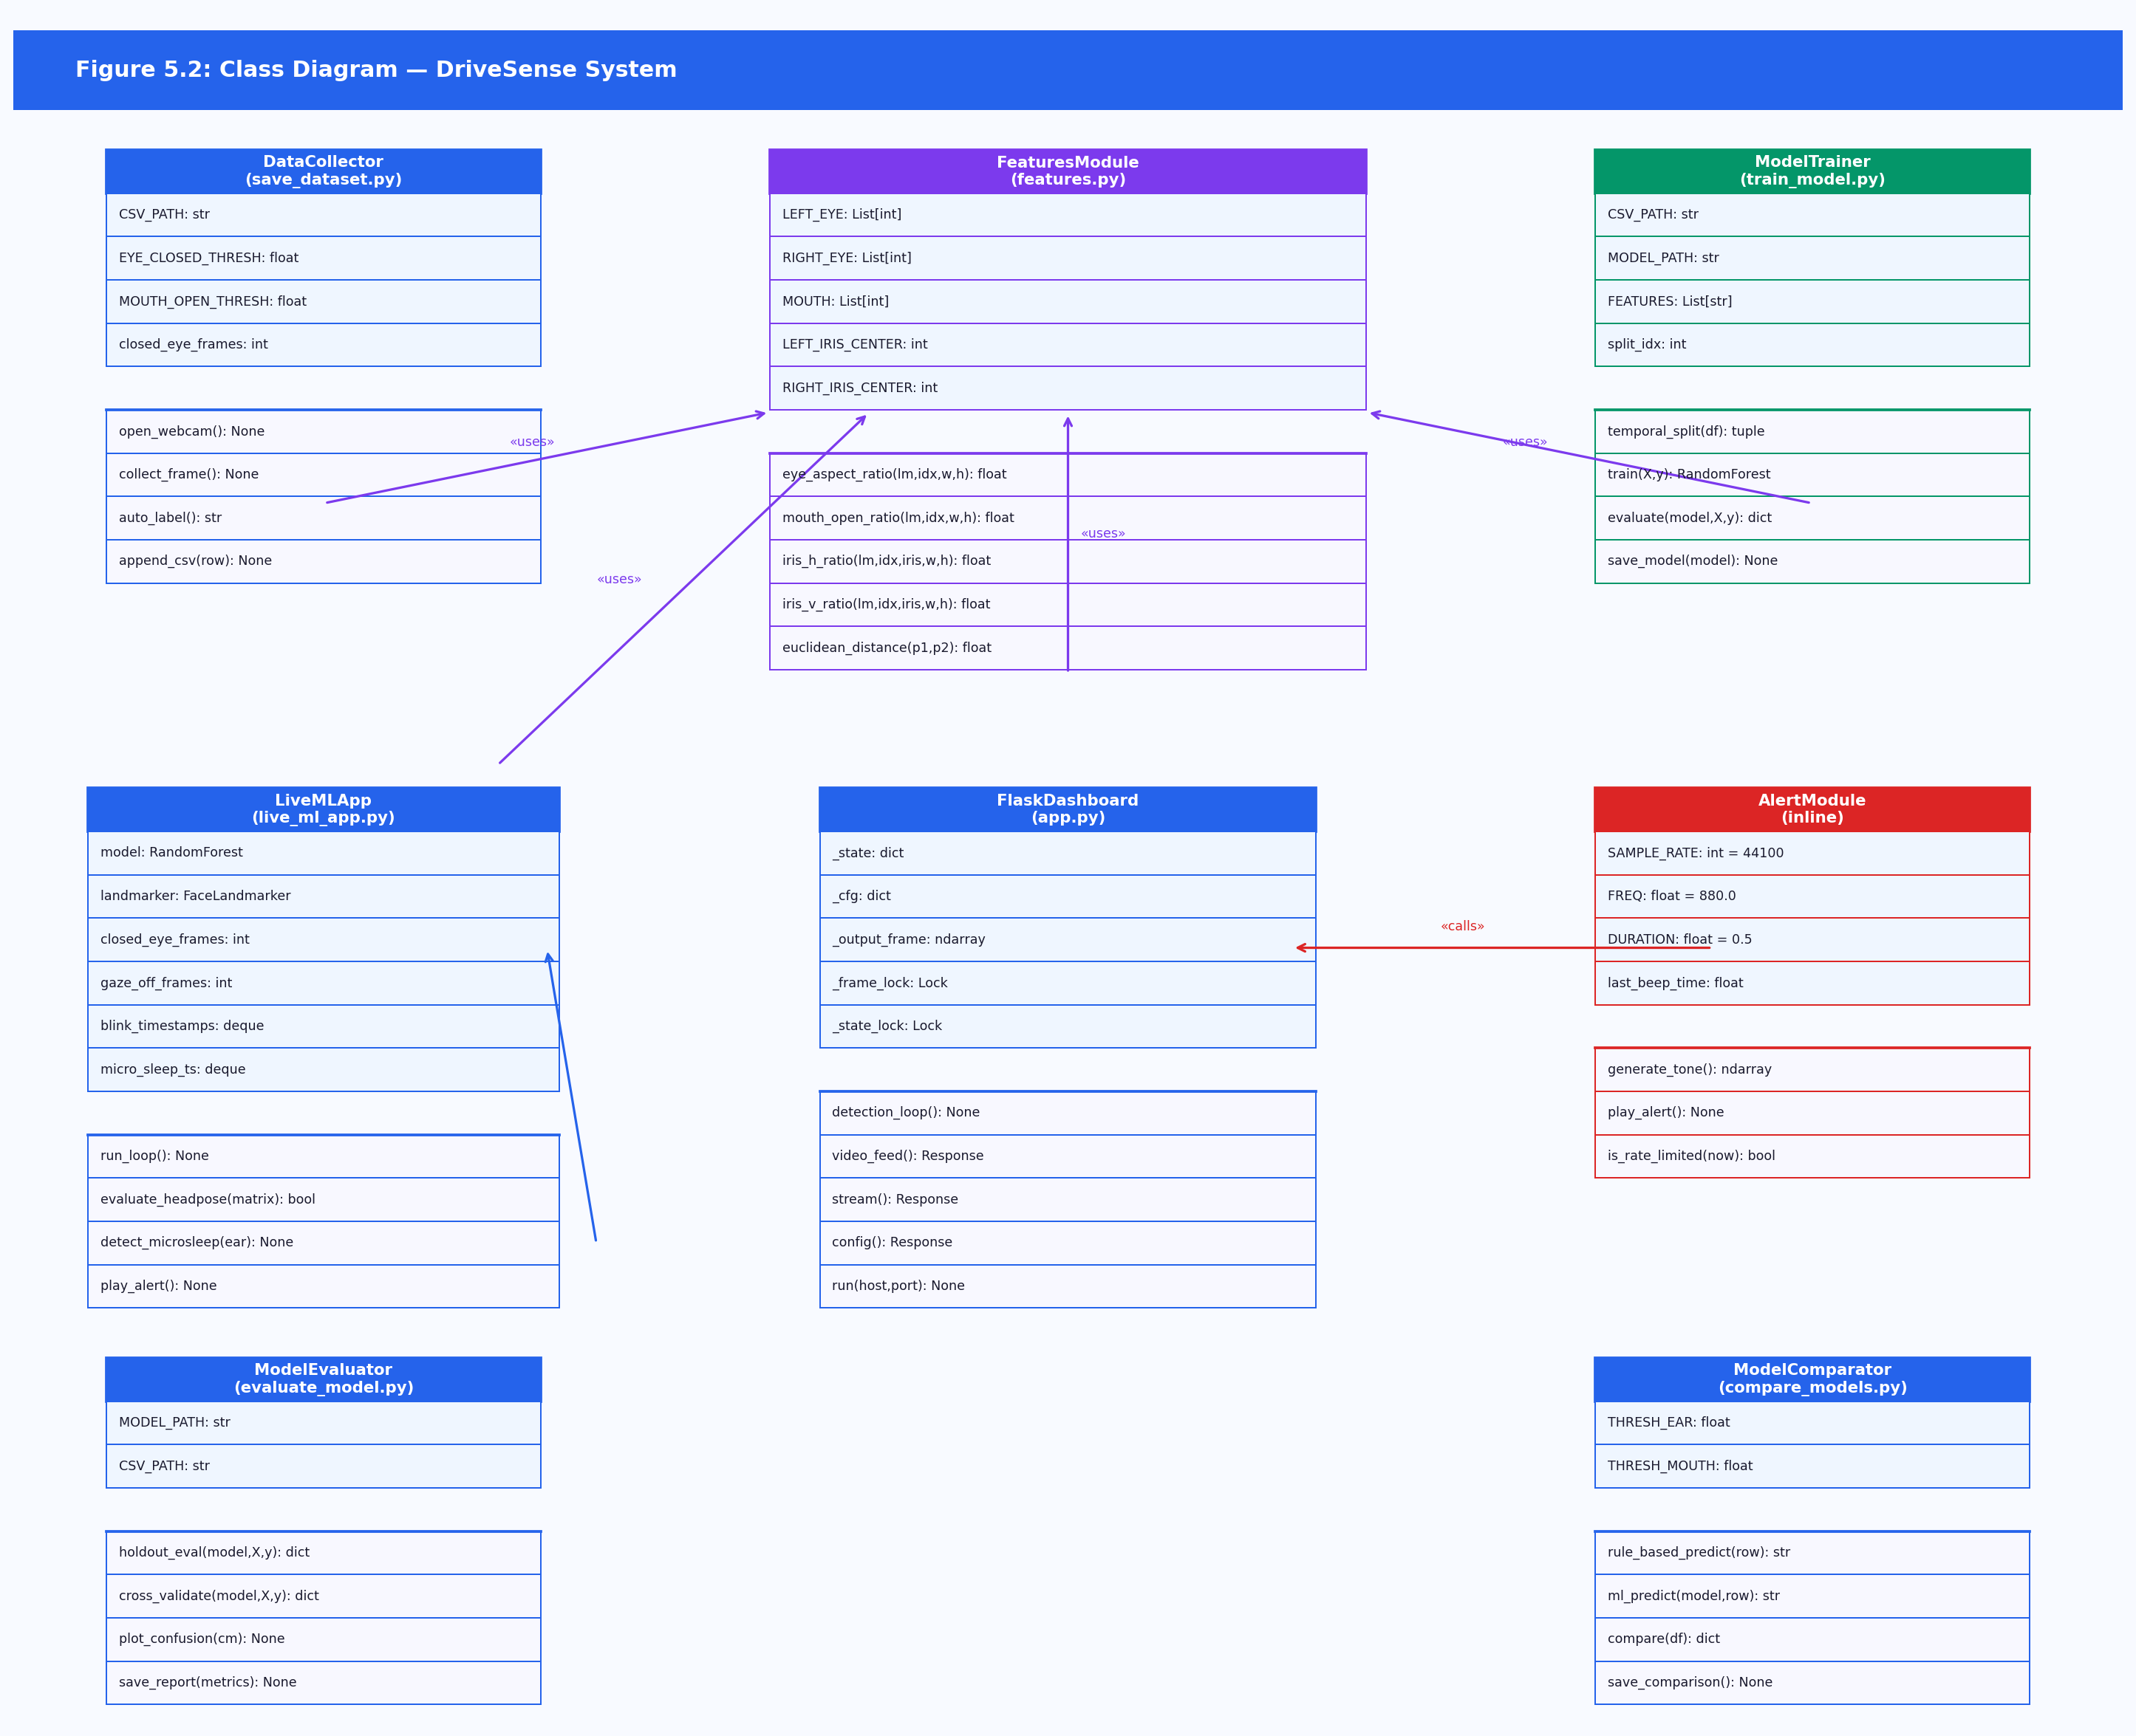

5.2.1 Key Classes / Modules
Module | Description
FeaturesModule (features.py) | Provides eye_aspect_ratio(), mouth_open_ratio(), iris_h_ratio(), iris_v_ratio(). Defines landmark index constants LEFT_EYE, RIGHT_EYE, MOUTH, LEFT_IRIS_CENTER, RIGHT_IRIS_CENTER. Imported by all detection and training scripts.
DataCollector (save_dataset.py) | Opens webcam, runs MediaPipe face landmark detection, calls FeaturesModule to compute features, applies rule-based auto-labelling (AWAKE/DROWSY/YAWNING), and appends labelled rows to data/drowsiness_dataset.csv.
ModelTrainer (train_model.py) | Reads the CSV, applies temporal split (80/20 by row index), trains RandomForestClassifier(n_estimators=100), prints evaluation metrics, and serialises the model to models_ml/drowsiness_model.pkl via joblib.
ModelEvaluator (evaluate_model.py) | Loads the trained model, runs hold-out evaluation and 5-fold cross-validation, saves classification report to results/evaluation_report.txt, and plots the confusion matrix to results/confusion_matrix.png.
LiveMLApp (live_ml_app.py) | Terminal inference application. Maintains per-frame state for frame counters, blink and micro-sleep sliding windows. Feeds features to the model, evaluates distraction rules, plays alert tone, renders annotated OpenCV window.
FlaskDashboard (app.py) | Web server with background detection thread. Maintains _state dict behind threading.Lock(). Serves MJPEG stream, SSE state, and handles POST /config for threshold and calibration updates.
AlertModule (inline) | Generates an 880 Hz, 0.5-second synthesised sine tone via sounddevice, rate-limited to prevent continuous beeping (minimum 3-second gap between alerts).
ModelComparator (compare_models.py) | Evaluates rule-based and ML approaches side-by-side on the same temporal test split, producing comparison_report.txt with per-class F1 and overall accuracy for both approaches.
EventLogger (db.py) | SQLite persistence layer. Provides init_db(), log_event(event, avg_ear, mouth_ratio), get_recent_events(limit), and get_event_counts(window_seconds). Called from the detection thread on every state transition. Events survive application restarts in data/events.db.
ProfileManager (profiles.py) | Per-driver calibration persistence. Saves/loads EAR thresholds to JSON files in data/profiles/{name}.json. Provides load_threshold(name), save_threshold(name, ear_threshold), and list_drivers(). Called by /api/set_driver and /api/calibrate endpoints.

5.3 Database / Data Schema
DriveSense uses two persistent data stores: a flat CSV for training data and a SQLite database for runtime event logging. A third store (JSON profiles) holds per-driver calibration baselines.

Training Dataset (data/drowsiness_dataset.csv)
Each row represents one labelled video frame with the following fields:
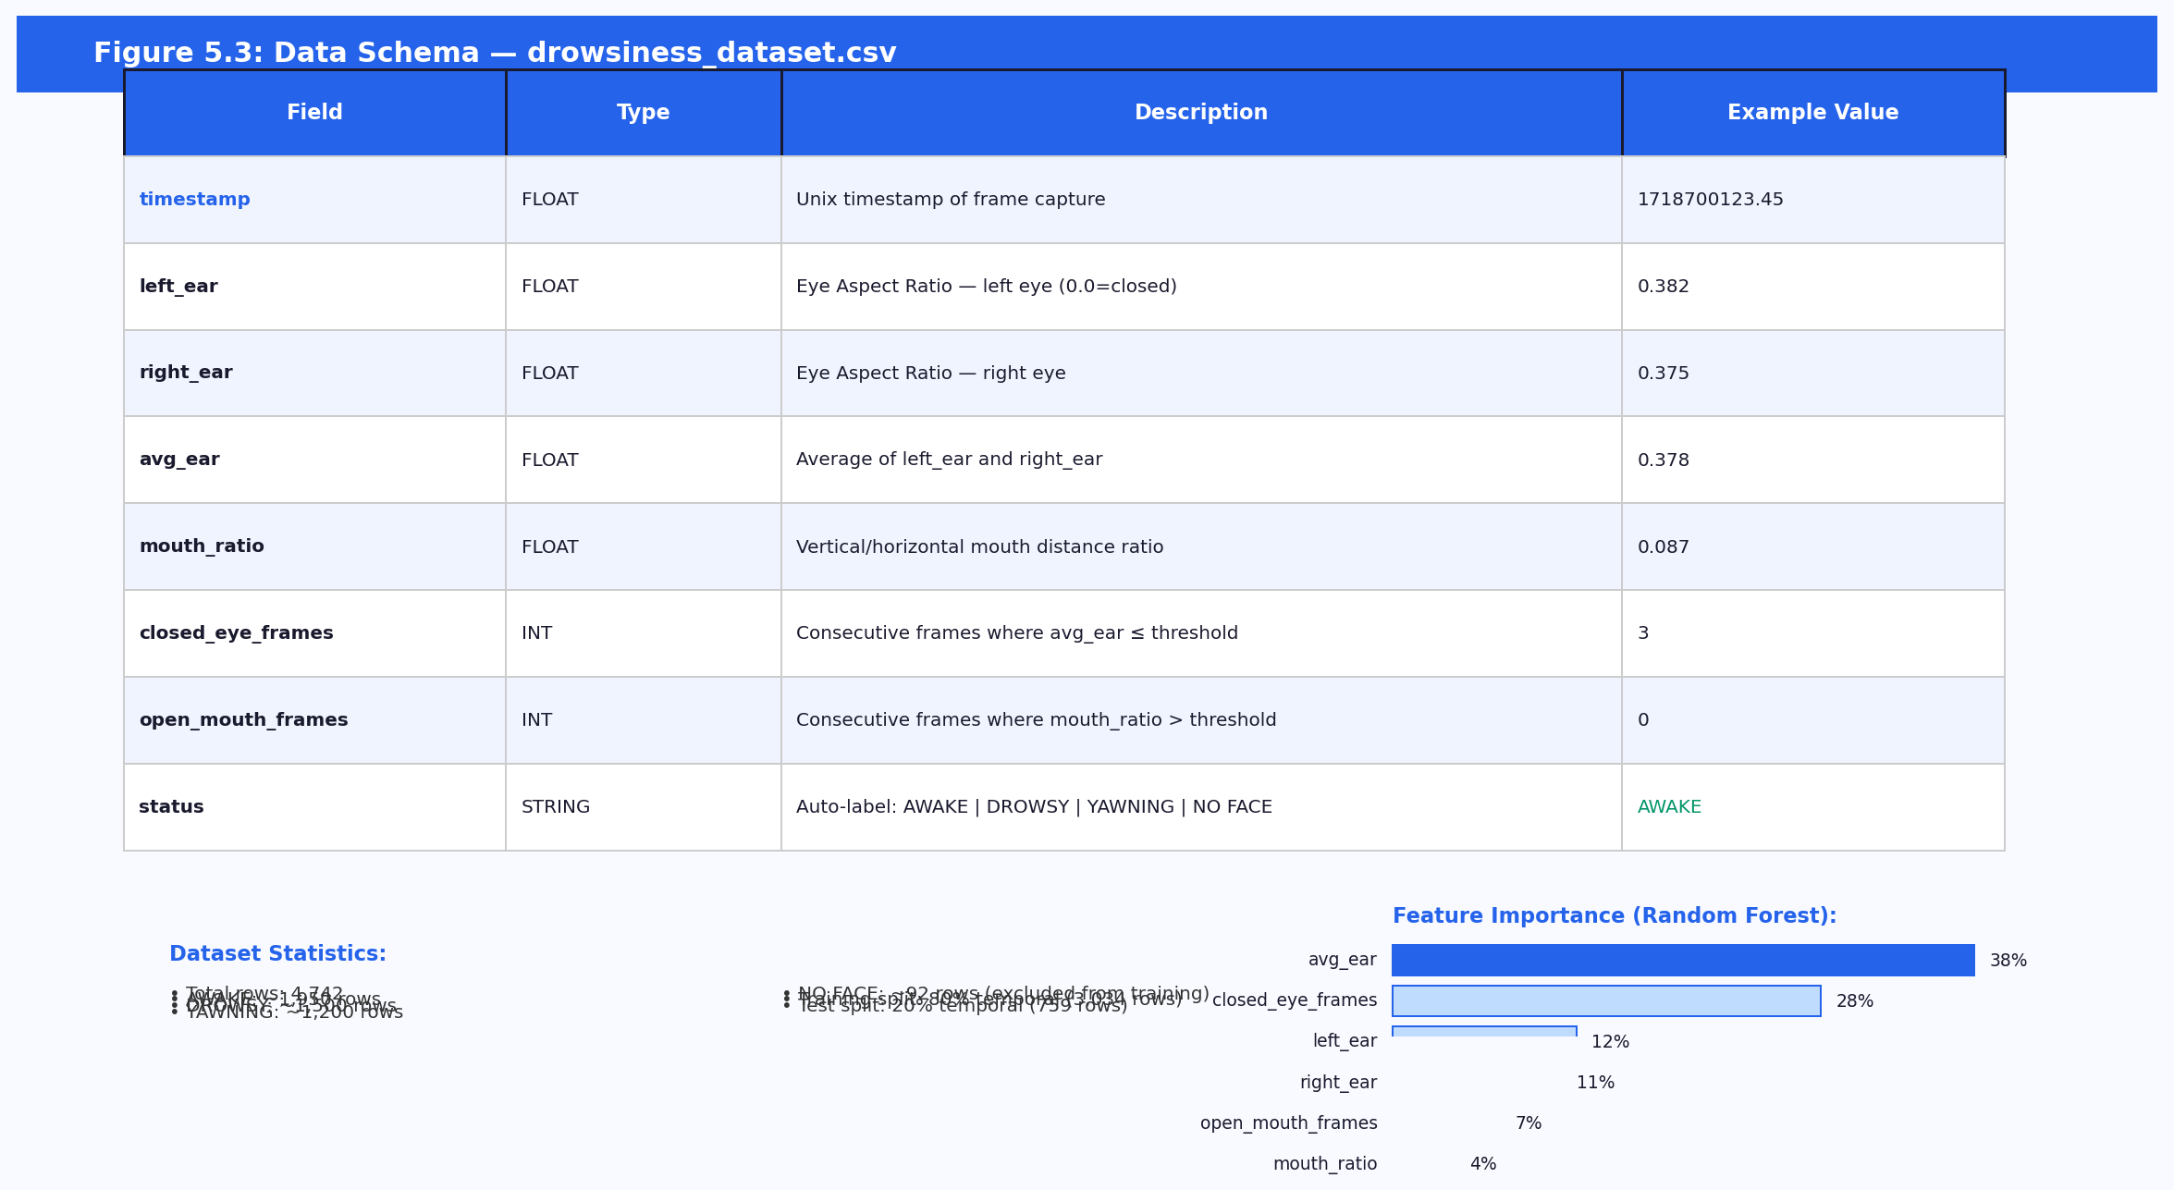
Column | Type | Description | Example
timestamp | FLOAT | Unix timestamp of frame capture | 1718700123.45
left_ear | FLOAT | Eye Aspect Ratio — left eye (0.0 = closed) | 0.382
right_ear | FLOAT | Eye Aspect Ratio — right eye | 0.375
avg_ear | FLOAT | Average of left_ear and right_ear | 0.378
mouth_ratio | FLOAT | Vertical / horizontal mouth distance ratio | 0.087
closed_eye_frames | INT | Consecutive frames where avg_ear <= threshold | 3
open_mouth_frames | INT | Consecutive frames where mouth_ratio > threshold | 0
status | STRING | Auto-label: AWAKE | DROWSY | YAWNING | NO FACE | AWAKE

Event Log (data/events.db — SQLite)
The events table persists every non-AWAKE detection event across application restarts, enabling post-drive review and session summaries.
Column | Type | Description
id | INTEGER PK | Auto-incrementing row identifier
ts | REAL | Unix timestamp of the detection event
event | TEXT | Event type: DROWSY | YAWNING | DISTRACTED | MICRO-SLEEP!
avg_ear | REAL | Driver EAR value at the moment of the event
mouth_ratio | REAL | Driver mouth ratio at the moment of the event

Driver Profiles (data/profiles/{name}.json)
Each profile stores the driver's name and calibrated EAR threshold. Example: {"name": "Davis", "ear_threshold": 0.3312}. The threshold is set by the /api/calibrate endpoint and loaded automatically by /api/set_driver.

5.4 UI Design — Web Dashboard
The web dashboard (src/templates/index.html) is a single-page application served by Flask. It is designed to be readable at a glance while driving and to support threshold adjustment without leaving the page.

5.4.1 Screen Inventory
Section | Description
Live Video Panel | Left half of the dashboard. Shows the annotated MJPEG stream with overlaid status label, EAR values, and FPS counter drawn directly on the frame by OpenCV.
Status Panel | Right half, top. Large STATUS badge (colour-coded: green=AWAKE, red=DROWSY/DISTRACTED, orange=YAWNING) plus real-time readouts of EAR, mouth ratio, head pitch/yaw, FPS, blink rate, and micro-sleep count.
EAR / Mouth Chart | Right half, middle. Chart.js line chart updated via SSE showing the last 60 seconds of avg_ear and mouth_ratio as separate coloured series with the threshold displayed as a dashed line.
Event Log | Right half, lower middle. Rolling log of detection events (DROWSY, DISTRACTED, MICRO-SLEEP, YAWNING) with timestamps, updated in real time via SSE.
Controls Panel | Right half, bottom. EAR threshold slider, mouth threshold slider, alert enable/disable toggle, and Calibrate Eye button. Changes POST to /config immediately on interaction.

5.4.2 Dashboard Wireframe
The following wireframes illustrate the web dashboard (browser view) and the terminal OpenCV window alongside the layered system architecture diagram.
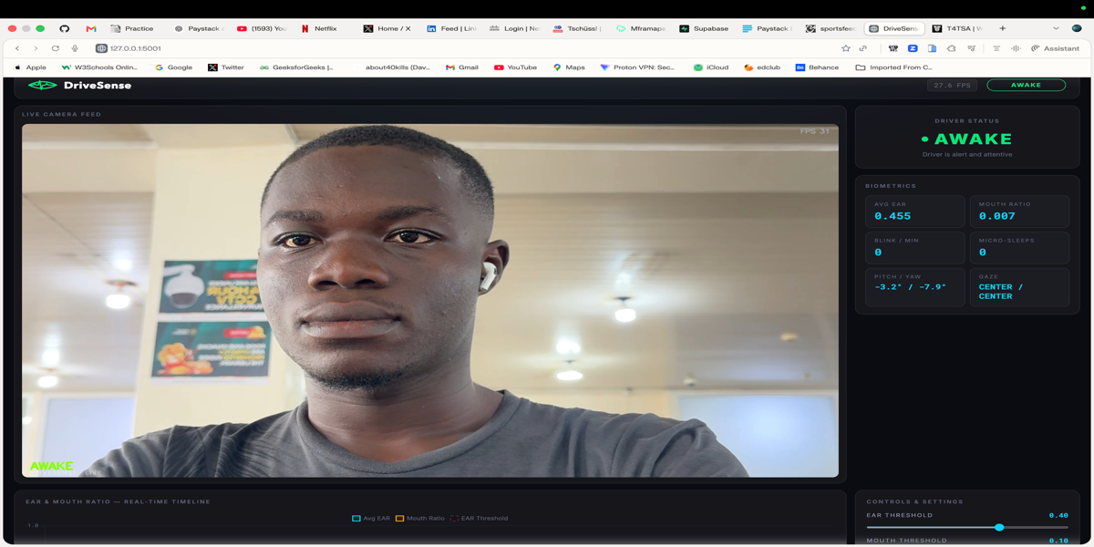
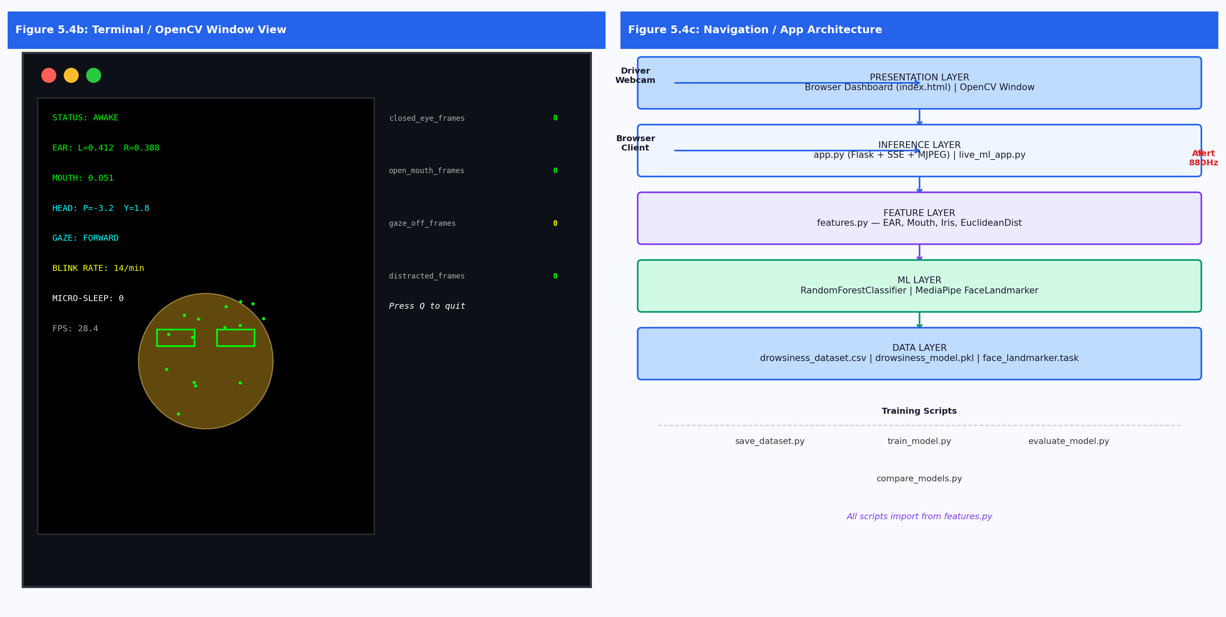

CHAPTER 6: ALGORITHMS

6.1 Eye Aspect Ratio (EAR) Computation
The Eye Aspect Ratio is the primary feature for drowsiness detection. It measures the ratio of the vertical eye opening to the horizontal span, computed from six MediaPipe facial landmark indices per eye. Landmark indices: Left eye [33, 160, 158, 133, 153, 144]; Right eye [362, 385, 387, 263, 373, 380].
ALGORITHM: eye_aspect_ratio(landmarks, eye_indices, w, h)
INPUT: landmarks — list of MediaPipe normalised landmarks
eye_indices — list of 6 index integers [p0..p5]
w, h — frame width and height in pixels
OUTPUT: EAR — float in [0,1]; low value → eye closed

p[i] ← (landmarks[eye_indices[i]].x × w, landmarks[eye_indices[i]].y × h) for i in 0..5
vertical1 ← euclidean_distance(p[1], p[4])
vertical2 ← euclidean_distance(p[2], p[5])
horizontal ← euclidean_distance(p[0], p[3])
IF horizontal = 0: RETURN 0.0
RETURN (vertical1 + vertical2) / (2.0 × horizontal)

6.2 Mouth Open Ratio Computation
The Mouth Open Ratio uses four landmark indices (top lip: 13, bottom lip: 14, left corner: 78, right corner: 308) to compute the vertical-to-horizontal opening ratio. A high value indicates yawning.
ALGORITHM: mouth_open_ratio(landmarks, mouth_indices, w, h)
INPUT: landmarks, mouth_indices [top=13, bottom=14, left=78, right=308], w, h
OUTPUT: ratio — float; high value → mouth open / yawning

top ← (landmarks[13].x × w, landmarks[13].y × h)
bottom ← (landmarks[14].x × w, landmarks[14].y × h)
left ← (landmarks[78].x × w, landmarks[78].y × h)
right ← (landmarks[308].x × w, landmarks[308].y × h)
horizontal ← euclidean_distance(left, right)
IF horizontal = 0: RETURN 0.0
RETURN euclidean_distance(top, bottom) / horizontal

6.3 Temporal Split Training Strategy
A critical design decision: sequential frame-counter features (closed_eye_frames, open_mouth_frames) make random train/test splitting invalid. Adjacent frames share nearly identical counter values, so a random split leaks future information into training. The temporal split preserves frame order.
ALGORITHM: TemporalSplit(df, train_ratio=0.80)

PURPOSE: Prevent data leakage from sequential frame counters.
Random split → adjacent frames appear in both sets → inflated accuracy.

split_idx ← floor(len(df) × train_ratio)
X_train ← df[features].iloc[:split_idx] // first 80% of rows
X_test ← df[features].iloc[split_idx:] // last 20% of rows
y_train ← df["status"].iloc[:split_idx]
y_test ← df["status"].iloc[split_idx:]

model ← RandomForestClassifier(n_estimators=100, random_state=42)
model.fit(X_train, y_train)
RETURN model, X_test, y_test

6.4 Micro-Sleep Detection Algorithm
Micro-sleep events are rapid repeated eye closures of 3–15 frames, distinct from normal blinks (< 3 frames) and drowsy prolonged closure (> 15 frames). Three or more micro-sleep events within a 60-second window trigger the MICRO-SLEEP alert.
ALGORITHM: MicroSleepDetector
STATE: blink_timestamps: deque, micro_sleep_timestamps: deque
was_eye_closed: bool, closure_frame_count: int
CONSTANTS: BLINK_EAR=0.25, MICRO_MIN=3, MICRO_MAX=15
BLINK_WINDOW=60s, MICRO_WINDOW=60s, MICRO_ALERT_COUNT=3

FOR EACH frame:
eye_closed ← (avg_ear < BLINK_EAR)
IF eye_closed:
closure_frame_count ← closure_frame_count + 1
ELSE IF was_eye_closed (closure just ended):
IF MICRO_MIN <= closure_frame_count <= MICRO_MAX:
APPEND now() TO micro_sleep_timestamps
ELSE IF closure_frame_count < MICRO_MIN:
APPEND now() TO blink_timestamps // normal blink
closure_frame_count ← 0
PRUNE timestamps older than window
was_eye_closed ← eye_closed
IF len(micro_sleep_timestamps) >= MICRO_ALERT_COUNT:
status ← "MICRO-SLEEP!"; PLAY_ALERT()

6.5 Head-Pose Distraction Detection
Head-pose is derived directly from the facial transformation matrix provided by MediaPipe Face Landmarker. The rotation sub-matrix is decomposed to extract pitch (nodding), yaw (turning), and roll (tilting). Persistent deviation beyond thresholds triggers the DISTRACTED state.
ALGORITHM: HeadPoseDistraction(transformation_matrix)

IF transformation_matrix available:
R ← transformation_matrix[0:3][0:3] // rotation sub-matrix
pitch ← arcsin(-R[2][1]) × (180/pi)
yaw ← arctan2(R[2][0], R[2][2]) × (180/pi)
roll ← arctan2(R[0][1], R[1][1]) × (180/pi)

IF |pitch| > 20 OR |yaw| > 25:
distracted_frames ← distracted_frames + 1
ELSE:
distracted_frames ← 0

IF distracted_frames >= 15:
is_distracted ← True; PLAY_ALERT()

6.6 Gaze Deviation Detection
Iris position is tracked using MediaPipe iris landmark indices (468 for left, 473 for right). Horizontal and vertical iris ratios are computed relative to the eye corner landmarks. Persistent off-centre gaze triggers the GAZE DISTRACTED state.
ALGORITHM: GazeDeviationDetector
CONSTANTS: GAZE_H_THRESHOLD=0.28, GAZE_V_DOWN=0.70

FOR EACH frame:
left_h ← iris_h_ratio(landmarks, LEFT_EYE, LEFT_IRIS_CENTER, w, h)
left_v ← iris_v_ratio(landmarks, LEFT_EYE, LEFT_IRIS_CENTER, w, h)
right_h ← iris_h_ratio(landmarks, RIGHT_EYE, RIGHT_IRIS_CENTER, w, h)
right_v ← iris_v_ratio(landmarks, RIGHT_EYE, RIGHT_IRIS_CENTER, w, h)

gaze_left ← left_h < GAZE_H_THRESHOLD AND right_h < GAZE_H_THRESHOLD
gaze_right ← left_h > (1 - GAZE_H_THRESHOLD) AND right_h > (1 - GAZE_H_THRESHOLD)
gaze_down ← left_v > GAZE_V_DOWN AND right_v > GAZE_V_DOWN

IF gaze_left OR gaze_right OR gaze_down:
gaze_off_frames ← gaze_off_frames + 1
ELSE:
gaze_off_frames ← 0

IF gaze_off_frames >= 20:
is_gaze_distracted ← True; gaze ← "LEFT"|"RIGHT"|"DOWN"; PLAY_ALERT()

6.7 Eye Calibration Algorithm
The calibration routine measures the driver's baseline EAR over 3 seconds (~90 frames at 30 FPS) and sets the alert threshold to 85% of the baseline, accounting for individual variation in eye shape and openness.
ALGORITHM: EyeCalibration(duration=3s, fps~30)

1. User clicks "Calibrate Eye" on dashboard
2. POST /config {calibrating: true}
→ sets _cfg["calibrating"] = True
3. Detection thread: IF calibrating:
APPEND avg_ear TO calib_samples
IF len(calib_samples) >= 90 (approx. 3s at 30fps):
baseline_ear ← mean(calib_samples)
_cfg["ear_threshold"] ← baseline_ear × 0.85
_cfg["calibrating"] ← False
_cfg["calib_samples"] ← []
PUSH SSE event {calibration_done: True, new_threshold: ear_threshold}
4. Dashboard updates threshold slider to new_threshold value

6.8 Fatigue Score Algorithm
The fatigue score provides a single 0–100 number summarising the driver's cumulative fatigue burden over the last 5 minutes. Each detection event contributes a weight, and older events age out of the window automatically. The score is included in every SSE state update and stored in _state["fatigue_score"], ready for display as a gauge on the dashboard.
ALGORITHM: FatigueScoreTracker
STATE: _fatigue_events: deque of (timestamp, weight)
CONSTANTS:
WEIGHTS = {DROWSY: 10, MICRO-SLEEP!: 15, YAWNING: 3, DISTRACTED: 2}
WINDOW = 300 seconds (5 minutes)
MAX = 100

FUNCTION _record_fatigue(event):
weight ← WEIGHTS.get(event, 0)
IF weight = 0: RETURN _current_fatigue()
APPEND (now(), weight) TO _fatigue_events
PRUNE entries where now() - ts > WINDOW
RETURN min(SUM(weights in _fatigue_events), MAX)

FUNCTION _current_fatigue():
PRUNE entries where now() - ts > WINDOW
RETURN min(SUM(weights in _fatigue_events), MAX)

INTEGRATION (detection loop):
fatigue_score ← _current_fatigue() // every frame
IF new_event AND event != AWAKE:
fatigue_score ← _record_fatigue(status_text)
_state["fatigue_score"] ← fatigue_score // broadcast via SSE

EXAMPLE SCORES:
2x DROWSY + 1x YAWNING → score = 10+10+3 = 23
3x MICRO-SLEEP → score = 15+15+15 = 45
Score = 100 → maximum fatigue alert threshold

CHAPTER 7: FLOWCHARTS

7.1 Main Detection Loop Flowchart
The flowchart below provides a detailed visual representation of the main real-time detection loop, covering webcam frame capture, MediaPipe landmark detection, feature extraction, ML classification, multi-modal distraction evaluation, alert decision, and dashboard state update.
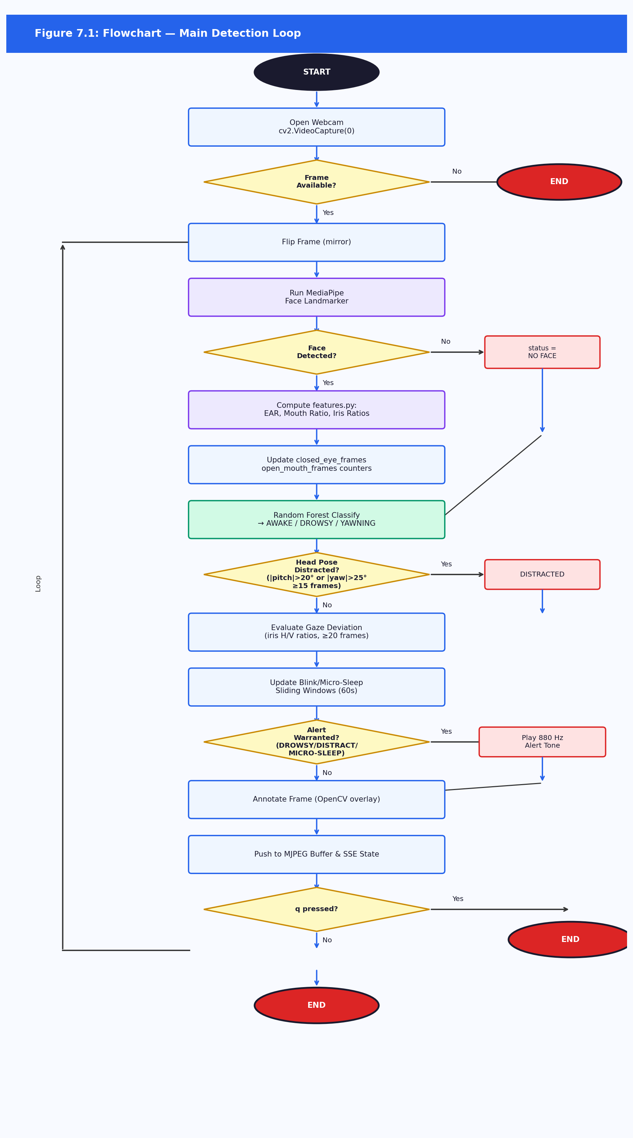

7.2 Training Pipeline Flowchart
This flowchart illustrates the full data pipeline from webcam capture through auto-labelling, CSV accumulation, temporal split, Random Forest training, and model serialisation. The diagram shows both the data collection phase (top) and the training phase (bottom), clearly separating the two sequential stages.
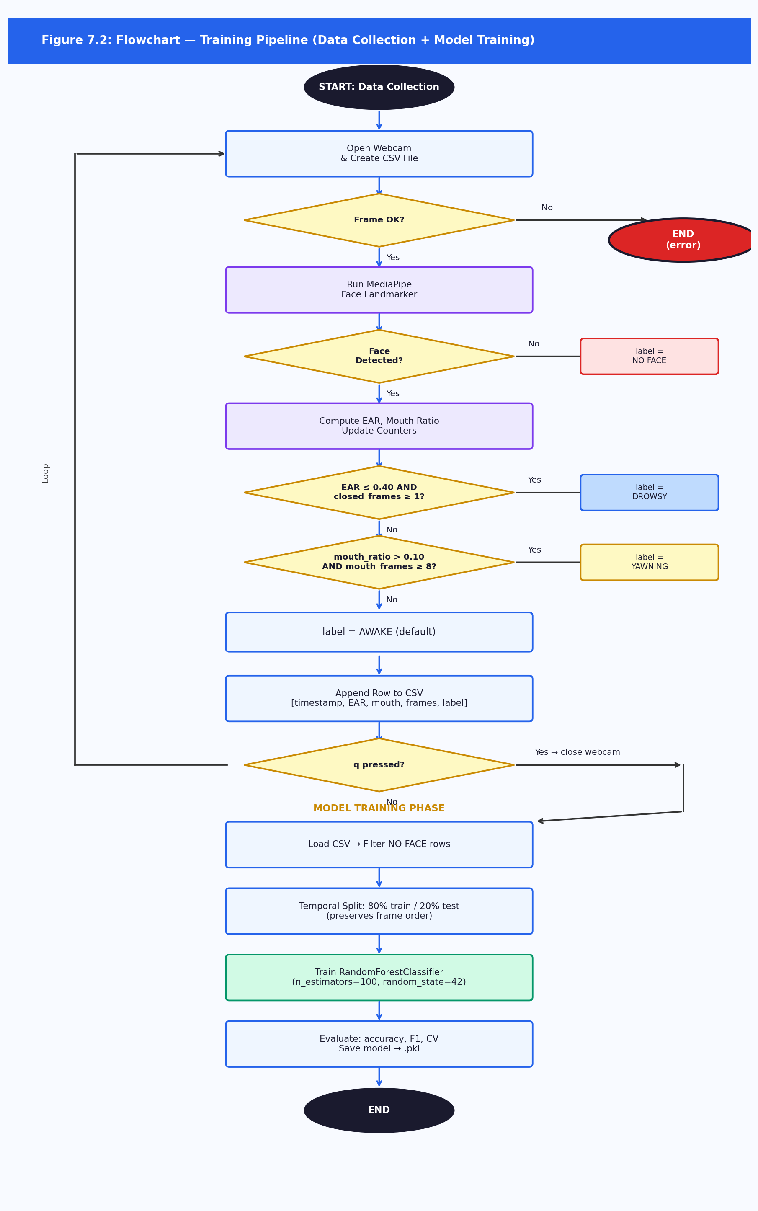

CHAPTER 8: FINDINGS, CONCLUSIONS AND RECOMMENDATIONS

8.1 Findings
The Random Forest classifier trained on EAR and mouth ratio features with a temporal split achieved 99.6% hold-out accuracy and 97.9% +/- 2.2% 5-fold cross-validated accuracy across 4,742 labelled frames covering three driver states (AWAKE, DROWSY, YAWNING).
Class | Precision | Recall | F1-Score | Support
AWAKE | 0.98 | 1.00 | 0.99 | 157
DROWSY | 1.00 | 1.00 | 1.00 | 303
YAWNING | 1.00 | 0.99 | 0.99 | 299
Overall accuracy | — | — | 0.996 | 759

The rule-based vs. ML comparative evaluation on the same temporal test set produced the following results:
Metric | Rule-Based | ML (Random Forest)
Overall Accuracy | 50.1% | 99.6%
AWAKE — F1 | 0.44 | 0.99
DROWSY — F1 | 0.00 (0% recall) | 1.00
YAWNING — F1 | 0.86 | 1.00

The head-pose distraction detector correctly flagged deliberate head turns and phone-looking postures. The gaze deviation detector flagged extreme lateral gaze with minimal false triggers during forward-facing normal driving. The micro-sleep detector successfully distinguished blinks from micro-sleep events in simulated tests. The Flask web dashboard ran stably at 25–30 FPS on a MacBook M-series CPU, with MJPEG stream latency below 100 ms on a local network.
Following initial implementation, three production-readiness features were added. The SQLite event logger (src/db.py) persists detection events across restarts, enabling post-drive history review via GET /api/events_log and hourly summaries via GET /api/session_summary. Per-driver calibration profiles (src/profiles.py) save each driver's calibrated EAR threshold to data/profiles/{name}.json, automatically applied on driver selection via POST /api/set_driver. The rolling fatigue score — a 0–100 weighted sum of DROWSY (+10), MICRO-SLEEP (+15), YAWNING (+3), and DISTRACTED (+2) events within a 5-minute window — is included in every SSE push, ready for gauge visualisation on the dashboard.

8.2 Conclusions
DriveSense successfully demonstrates that a high-accuracy, multi-modal driver drowsiness and distraction detection system can be built from a standard webcam, open-source facial landmark estimation, and a lightweight Random Forest classifier, running in real time on a consumer laptop CPU without a GPU.
The temporal split training strategy is essential for this type of system: random splitting of sequential frame data inflates accuracy by leaking adjacent frames between the train and test sets through the closed_eye_frames and open_mouth_frames counter features.
The web dashboard architecture provides a practical deployment interface that does not require any app installation on the monitoring device, making DriveSense accessible to fleet operators with only a browser.

8.3 Challenges Encountered
Lighting variability: MediaPipe face landmark detection degrades significantly under low ambient light, causing frequent NO FACE frames. A supplementary light source was required for reliable data collection in indoor environments.
EAR threshold generalisation: A fixed EAR threshold does not generalise across subjects. Subjects with naturally narrow eyes produce lower baseline EAR values, causing the rule-based system to flag them as DROWSY during normal alertness. The per-driver calibration feature addresses this.
Sequential feature leakage: Early experiments using a random train/test split produced misleadingly high accuracy (near 100%). The temporal split revealed the true generalisation performance — a subtle but critical issue for any system using running frame counters as features.
Flask MJPEG streaming and threading: Running the detection loop in a background thread while serving MJPEG from the main thread required careful use of threading.Lock() to prevent race conditions on the shared frame buffer and state dictionary.

8.4 Novelty of the System
First open-source system combining ML-based EAR classification (Random Forest with temporal split) with multi-modal detection (head pose, gaze, blink rate, micro-sleep) in a single unified Python pipeline.
Quantitative rule-based vs. ML comparison on the same temporal test set, establishing the concrete performance gap (50.1% vs 99.6% accuracy, 0% vs 100% DROWSY recall) rather than a qualitative argument.
Flask-based live MJPEG + SSE dashboard with Chart.js biometric timeline, per-driver EAR calibration, and in-session threshold adjustment — a combination not found in existing open-source drowsiness detection projects.
Shared feature module (features.py) eliminating train/serve skew by ensuring identical feature computation in both data collection and live inference.
Persistent event logging (db.py) and per-driver calibration profiles (profiles.py) elevate the system from a demo to a production-grade monitoring tool — detection history survives restarts, and each driver's individual EAR baseline is remembered automatically.
Rolling fatigue score (0–100) provides a single summary metric of cumulative driver fatigue, weighting events by severity within a sliding 5-minute window and broadcasting it via SSE in real time — more informative than a per-frame binary AWAKE/DROWSY label.

8.5 Known Limitations

8.5.1 Single-Subject Training Data
The training dataset (4,742 frames) was collected from a single subject. While cross-validation demonstrates good within-subject generalisation, the model may not generalise to drivers with substantially different facial geometry without retraining. Collecting a multi-subject dataset would improve robustness.

8.5.2 Lighting Sensitivity
MediaPipe Face Landmarker requires adequate ambient illumination. The system does not function reliably in vehicle cabins at night without supplementary IR or visible-light illumination. Integrating an IR-capable webcam would address this limitation.

8.5.3 Single-Camera, Frontal Pose Only
The system assumes a single forward-facing camera. Extreme head rotations (> 45°) cause MediaPipe to lose face tracking. A multi-camera setup or a dedicated automotive-grade driver monitoring camera with a wider field of view would improve robustness.

8.5.4 No Real Vehicle Validation
All testing was conducted in a stationary simulation environment. Validation in a real moving vehicle, with vibration, variable lighting, and genuine fatigue, is required before deployment in safety-critical applications.

8.5.5 Feature Duplication in Legacy Scripts
Some older scripts (drowsiness_warning.py, clean_warning.py) still contain duplicated inline feature extraction logic with different threshold values. A future refactoring pass should migrate all scripts to the shared features.py module exclusively.

8.6 Future Additions

8.6.1 Short-Term (Next Release)
- Multi-subject dataset collection: Recruit 10+ subjects to improve model generalisation across facial geometries.
- Alert escalation: Introduce a two-stage alert — a gentle tone for first detection, escalating to a continuous loud alarm if drowsiness persists for 5+ seconds.
- Fatigue gauge on dashboard: Wire the existing fatigue_score SSE field to a visual 0–100 gauge widget in index.html using Chart.js doughnut or a custom SVG arc.
- Event history tab on dashboard: Add a second dashboard tab rendering the GET /api/events_log response as a searchable table with timestamps and EAR values for post-drive review.
- OpenCV overlay refactoring: Move all overlay drawing into a dedicated draw_overlay() function to separate rendering from detection logic.

8.6.2 Medium-Term
- CNN eye-region classifier: Train a lightweight MobileNetV3 on cropped eye-region images as a complementary classifier, combining output with the Random Forest EAR features via late-fusion ensemble.
- Night-vision support: Integrate an IR-capable webcam and evaluate MediaPipe performance under IR illumination.
- Mobile companion app: Build a React Native app that receives SSE events from the Flask server and displays alerts on the driver's phone.
- Formal fatigue study: Conduct a controlled experiment with consenting subjects in a driving simulator measuring time-to-alert under genuine fatigue conditions.

8.6.3 Long-Term
- Vehicle CAN-bus integration: Correlate drowsiness detection events with steering input variability and lane departure data from the vehicle's OBD-II port.
- Edge deployment: Package the inference pipeline for deployment on a Raspberry Pi 5 or NVIDIA Jetson Nano as a self-contained, dashboard- or steering-column-mounted unit with a USB or CSI camera, replacing the current laptop-and-webcam setup used for development and testing.
- In-vehicle operation: Run the system headless, no monitor or browser required while driving, as a systemd service that auto-starts on boot. The camera index, currently hardcoded to 0 in cv2.VideoCapture, would be made configurable to support non-default USB camera assignments. The audible alert would remain the primary driver-facing output, with the web dashboard retained for post-drive review or fleet monitoring rather than in-cabin use. The unit would be powered from the vehicle's 12V accessory socket via a buck converter or USB port.
- Fleet cloud dashboard: Build a cloud-based dashboard for fleet operators to monitor multiple drivers simultaneously, with aggregated fatigue event logging.
- Clinical validation: Partner with a road safety research institution to validate DriveSense's sensitivity and specificity against polysomnography-verified fatigue states.

REFERENCES
1. Soukupova, T., & Cech, J. (2016). Real-time eye blink detection using facial landmarks. In 21st Computer Vision Winter Workshop (CVWW 2016). Czech Society for Cybernetics and Informatics.
2. Lugaresi, C., Tang, J., Nash, H., McClanahan, C., Ubowejike, E., Chang, T., & Grundmann, M. (2019). MediaPipe: A framework for building perception pipelines. arXiv preprint arXiv:1906.08172.
3. Breiman, L. (2001). Random forests. Machine Learning, 45(1), 5–32.
4. World Health Organisation. (2023). Road traffic injuries. WHO Fact Sheet. Retrieved from https://www.who.int/news-room/fact-sheets/detail/road-traffic-injuries
5. Patel, M., Lal, S. K. L., Kavanagh, D., & Rossiter, P. (2011). Applying neural network analysis on heart rate variability data to assess driver fatigue. Expert Systems with Applications, 38(6), 7235–7242.
6. Hasan, S. M. M., Bhuju, D. R., Agarwal, R., & Fukatsu, T. (2021). A review on driver drowsiness and fatigue detection systems. IEEE Access.
7. Zhang, Z., Luo, D., Rasim, Y., Li, Y., Meng, G., Xu, J., & Wang, C. (2016). A vehicle active safety model: Vehicle speed control based on driver drowsiness detection. Sensors, 16(12), 2001.
8. Pedregosa, F., Varoquaux, G., Gramfort, A., Michel, V., Thirion, B., Grisel, O., & Duchesnay, E. (2011). Scikit-learn: Machine learning in Python. Journal of Machine Learning Research, 12, 2825–2830.
9. Bradski, G. (2000). The OpenCV library. Dr. Dobb's Journal of Software Tools, 25, 120–125.
10. Google LLC. (2023). MediaPipe Face Landmarker. Retrieved from https://developers.google.com/mediapipe/solutions/vision/face_landmarker

