SoftNet Lab Cluster
History, structure and management, access and job submission (Hadoop MapReduce, Spark, Flink), Kafka messages

Xenia Arapi, E.DI.P. xenia@softnet.tuc.gr

Lecture structure
- Running Spark, Flink jobs
- SoftNet cluster history and infrastructure
- Hortonworks Data Platform (HDP)
- HDP on SoftNet cluster managed by Ambari
- YARN Resource Manager UI / Applications
- Submitting/Running jobs on SoftNet cluster (Hadoop MapReduce, Spark, Flink)
- Kafka (create / list / delete topics, producing / consuming messages)
- Hortonworks Sandbox for HDP installation and use

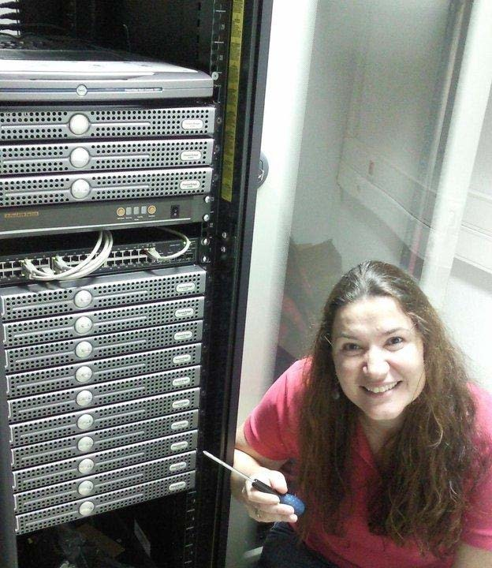
SoftNet cluster - When/How it started

  - 2009 - 5 x Dell PowerEdge R300 Quad Core Xeon X3323 2.5GHz, 4GB RAM, 500GB HDD
  - 2010 - 8 x Dell PowerEdge R300 Quad Core Xeon X3323 2.5GHz, 4GB RAM, 500GB HDD

SoftNet cluster servers
- 1 x Dell PowerEdge R320 Intel Xeon E5-2430 v2 2.50GHz, 32GB RAM, 2 x 1TB HDD (RAID0)
{clu01} - Master node - 2015
Nowadays, the SoftNet cluster is hosted in NOC Data Center and consists of 23 servers:
- 13 x Dell PowerEdge R300 Quad Core Xeon X3323 2.5GHz, 8GB RAM, 500GB HDD {clu11, clu12, clu13, clu14, clu15, clu16, clu17, clu18, clu19, clu20, clu24, clu25, clu26} - 2009/10
- 3 x Dell PowerEdge R310 Quad Core Xeon X3440 2.53GHz, 8GB RAM, 500GB HDD {clu08, clu09, clu10} - 2011
- 3 x Dell PowerEdge R310 Quad Core Xeon X3440 2.53GHz, 16GB RAM, 500GB HDD {clu05, clu06, clu07} - 2011
- 3 x Dell PowerEdge R320 Intel Xeon E5-2430 v2 2.50GHz, 32GB RAM, 1TB HDD {clu02, clu03, clu04} - 2015

Hortonworks Data Platform (HDP)
- With YARN as its architectural center it provides a data platform for multi-workload data processing across an array of processing methods
  - from batch through interactive to real-time, supported by key capabilities required of an enterprise data platform — spanning Governance, Security and Operations
- SoftNet cluster runs the Hortonworks Data Platform (version 3.1.0)
- SoftNet cluster servers OS: Ubuntu Server 16.04 LTS
- HDP is a packaged software Hadoop distribution that aims to ease deployment and management of Hadoop clusters
- Compared with simply downloading the various Apache code bases and trying to run them together in a system, HDP greatly simplifies the use of Hadoop
- Architected, developed, and built completely in the open, HDP provides an enterprise ready data platform that enables organizations to adopt a Modern Data Architecture.

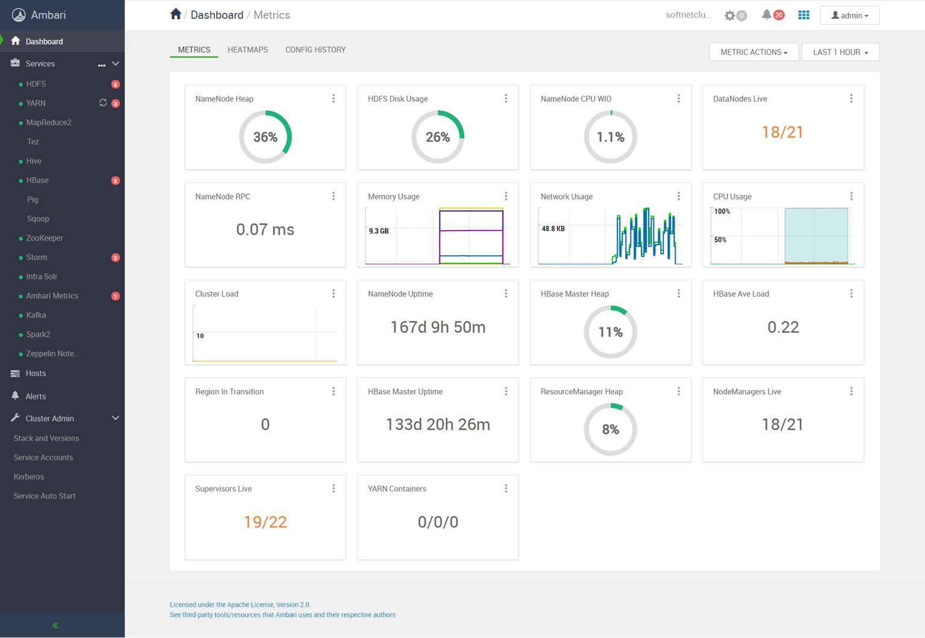
HDP on SoftNet cluster managed by Ambari

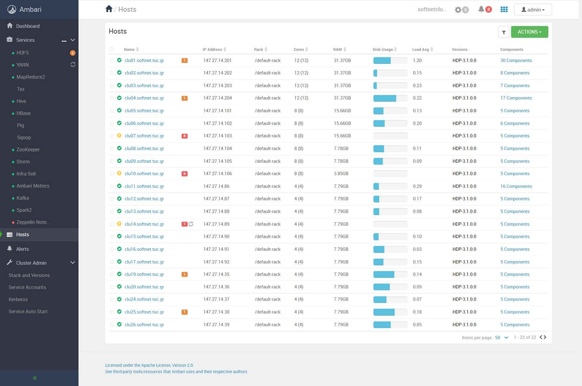
HDP on SoftNet cluster managed by Ambari - Hosts

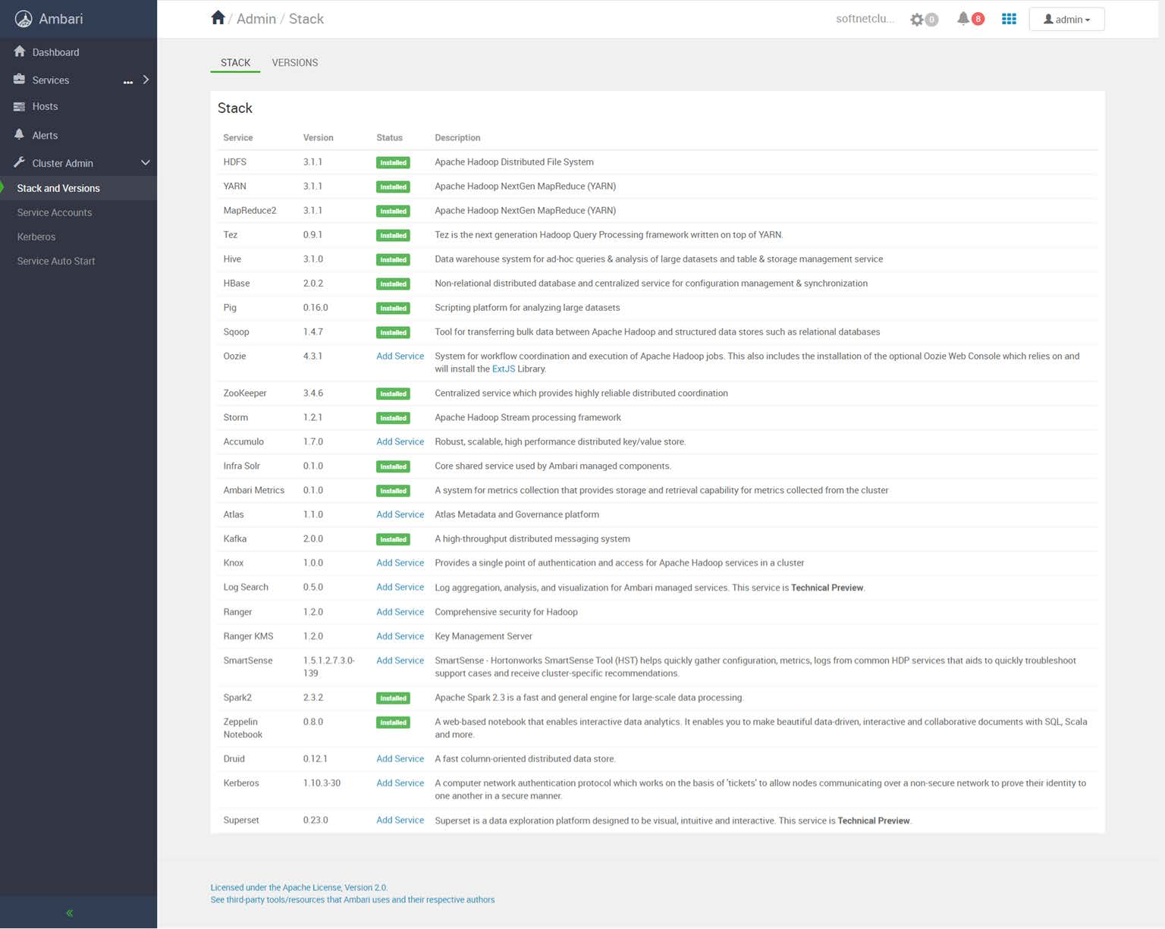
Official Apache component versions for HDP 3.1.0

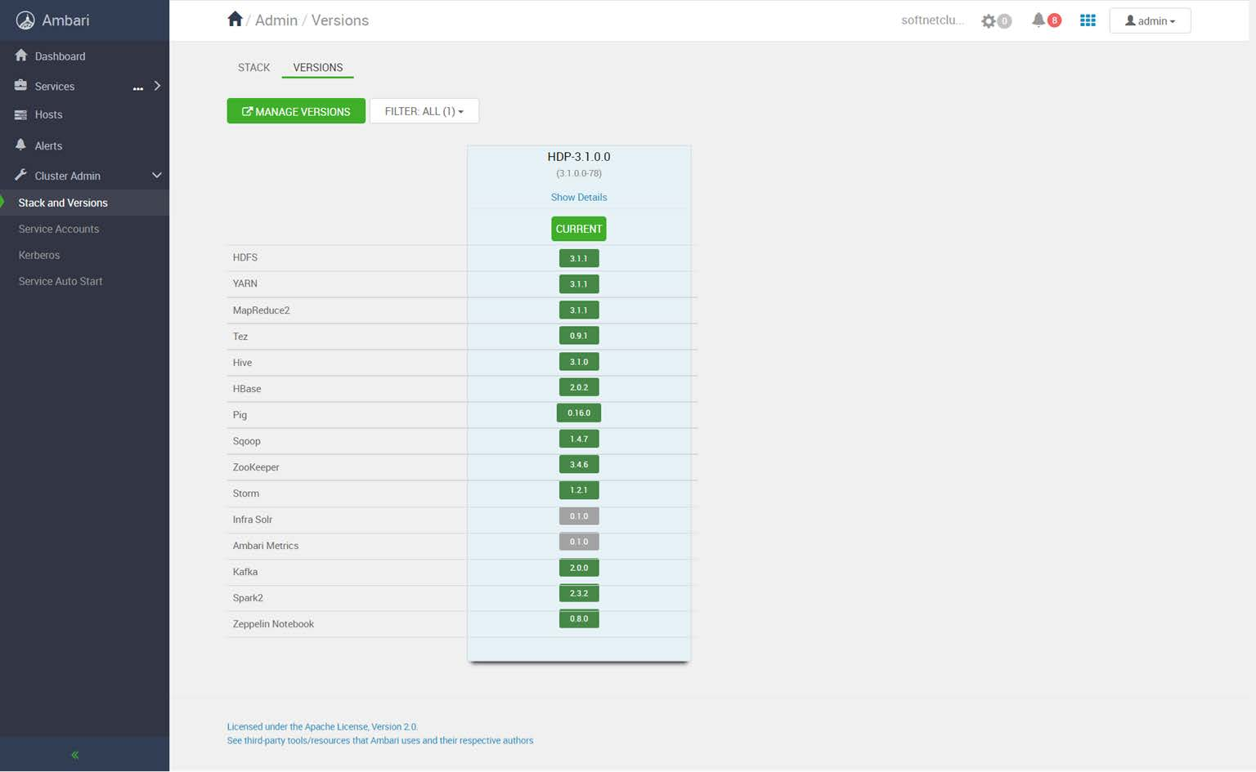

Apache components installed on Softnet Cluster

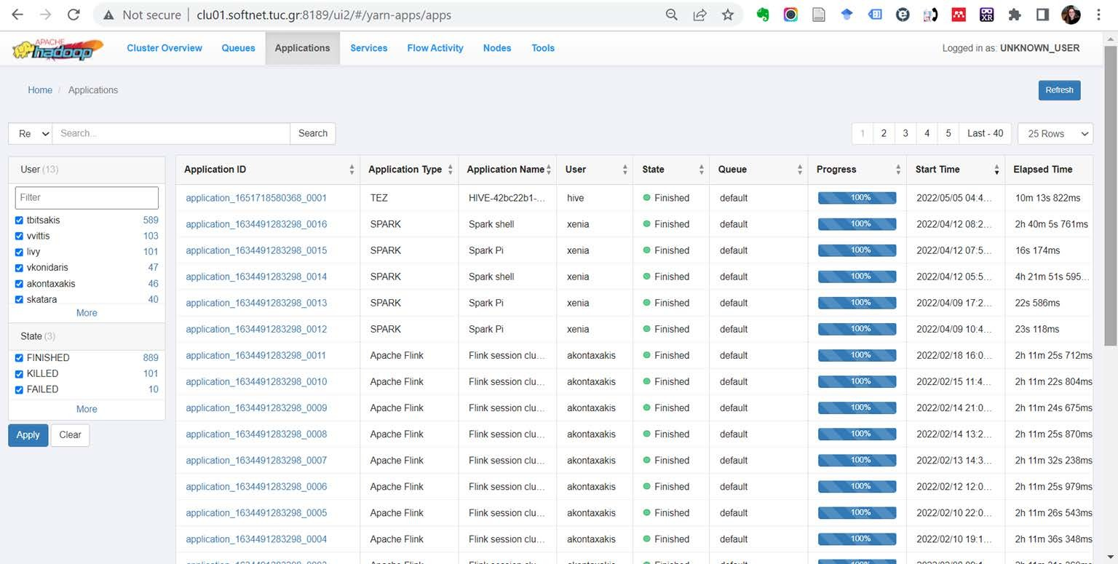
YARN Resource Manager UI / Applications

Running jobs/ applications on SoftNet cluster (Hadoop MapReduce, Spark, Flink)

Upload files to SoftNet cluster / From Linux
- To submit jobs to the SoftNet cluster you must connect with your account* to clu04.softnet.tuc.gr via SSH (if you are outside TUC, you must connect to TUC VPN first)
- Open a terminal on your PC (Ctrl + Alt + T on Ubuntu)
- Upload a file (e.g. your Spark or Flink .jar) from your PC to your home directory on clu04:
scp myjar.jar username@clu04.softnet.tuc.gr:/home/username/
- Upload a folder from your PC to your home directory on clu04:
scp -r myfolder username@clu04.softnet.tuc.gr:/home/username/

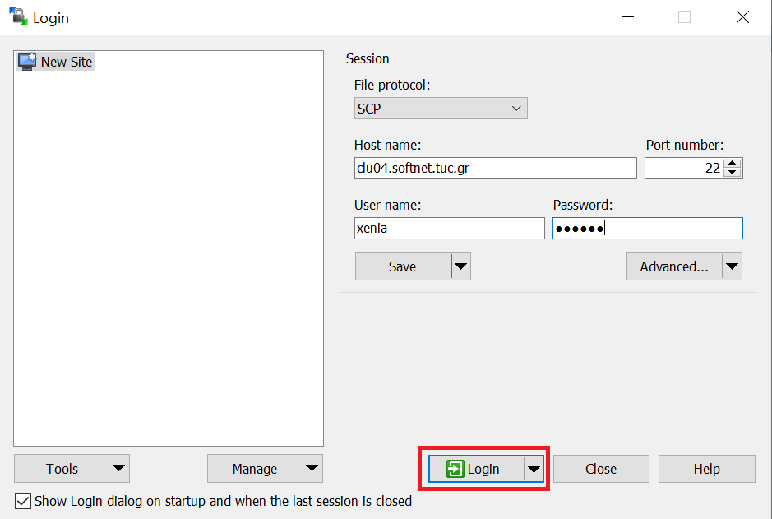
Upload files to SoftNet cluster / From Windows
- If you are outside TUC, you must connect to TUC VPN first
- Install and use WinSCP to connect to clu04.softnet.tuc.gr and transfer the files from your PC to your home directory on clu04 (drag and drop)

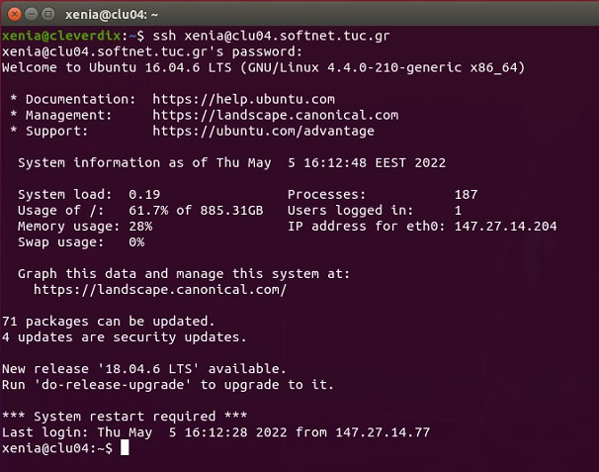
Connect via SSH to SoftNet cluster / From Linux
- If you are outside TUC, you must connect to TUC VPN first
- Open a terminal on your PC (Ctrl + Alt + T on Ubuntu)
- Connect to clu04.softnet.tuc.gr via SSH
ssh username@clu04.softn et.tuc.gr

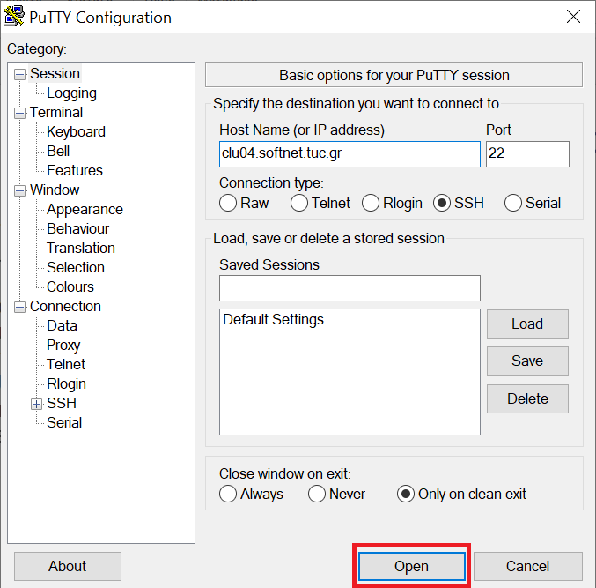
Connect via SSH to SoftNet cluster / From Windows
- To run jobs on SoftNet cluster you must connect with your account to clu04.softnet.tuc.gr via SSH (if you are outside TUC, you must connect to TUC VPN first)
- Install and use Putty on Windows to start an SSH session with clu04.softnet.tuc.gr

Submitting Spark jobs

Submitting Spark jobs
  - To launch a Spark application in cluster mode:
cd /usr/hdp/current/spark2-client
./bin/spark-submit --class path.to.your.Class --master yarn -- deploy-mode cluster [options] <app jar> [app options]

Note: There are two deploy modes that can be used to launch Spark applications on YARN:
- In cluster mode, the Spark driver runs inside an application master process which is managed by YARN on the cluster, and the client can go away after initiating the application.
- In client mode, the driver runs in the client process, and the application master is only used for requesting resources from YARN.
Unlike other cluster managers supported by Spark in which the master’s address is specified in the --master parameter, in YARN mode the ResourceManager’s address is picked up from the Hadoop configuration. Thus, the --master parameter is yarn.





Submitting Spark jobs
SparkPi example calculates pi by “thro ing darts” at a circle. The program generates points in the unit square ((0,0) to (1,1)) and counts ho many points fall ithin the unit circle ithin the square. The result approximates pi.
  - For the needs of this tutorial we will use a given example .jar from HDP (folder
/usr/hdp/current/spark2-client/examples/jars/):
cd /usr/hdp/current/spark2-client
./bin/spark-submit --class org.apache.spark.examples.SparkPi -- master yarn --deploy-mode cluster --driver-memory 4g --num- executors 3 --executor-memory 2g --executor-cores 1
examples/jars/spark-examples*.jar 10

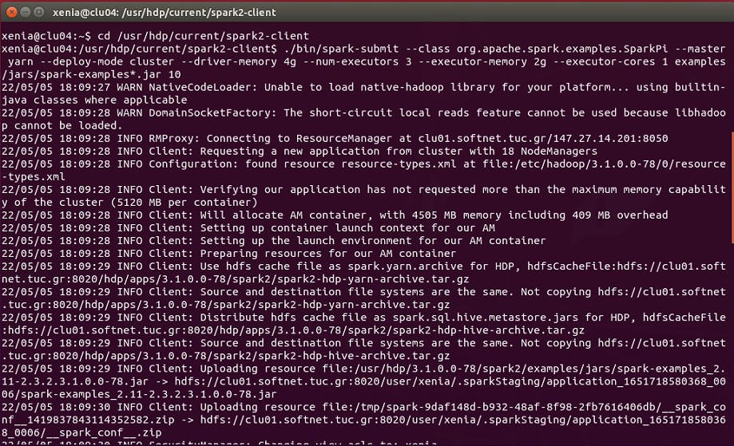
Submitting Spark jobs

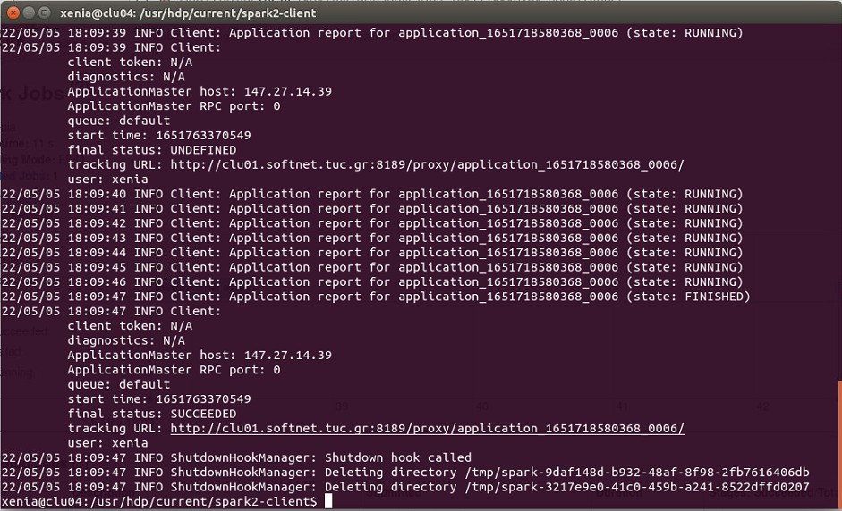
Submitting Spark jobs

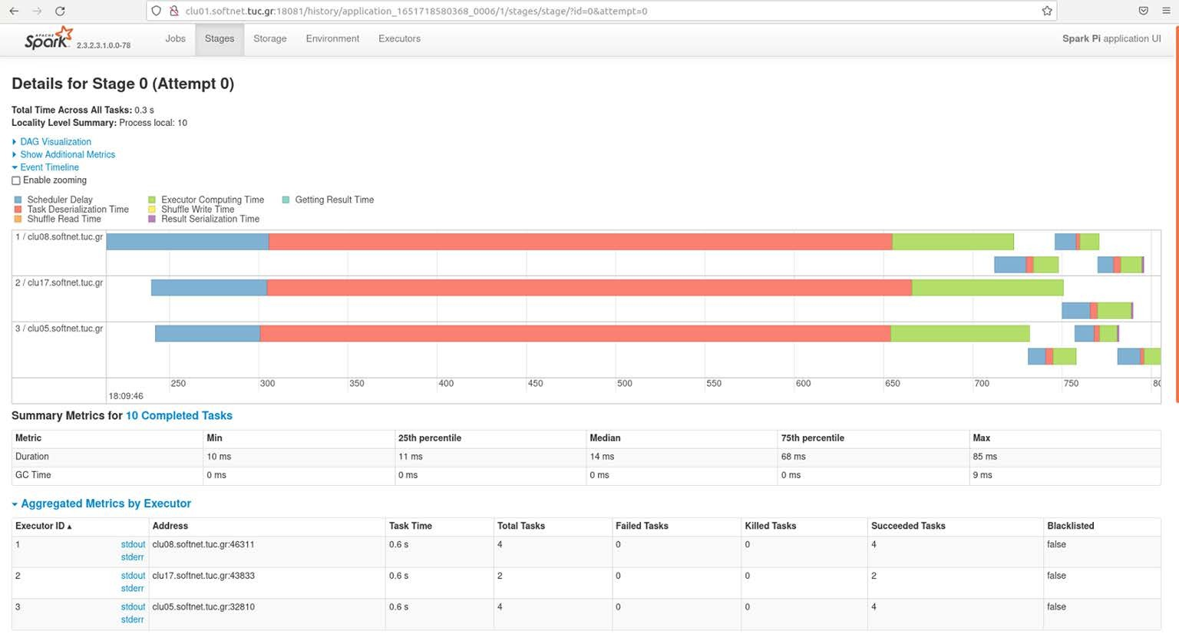
Submitting Spark jobs

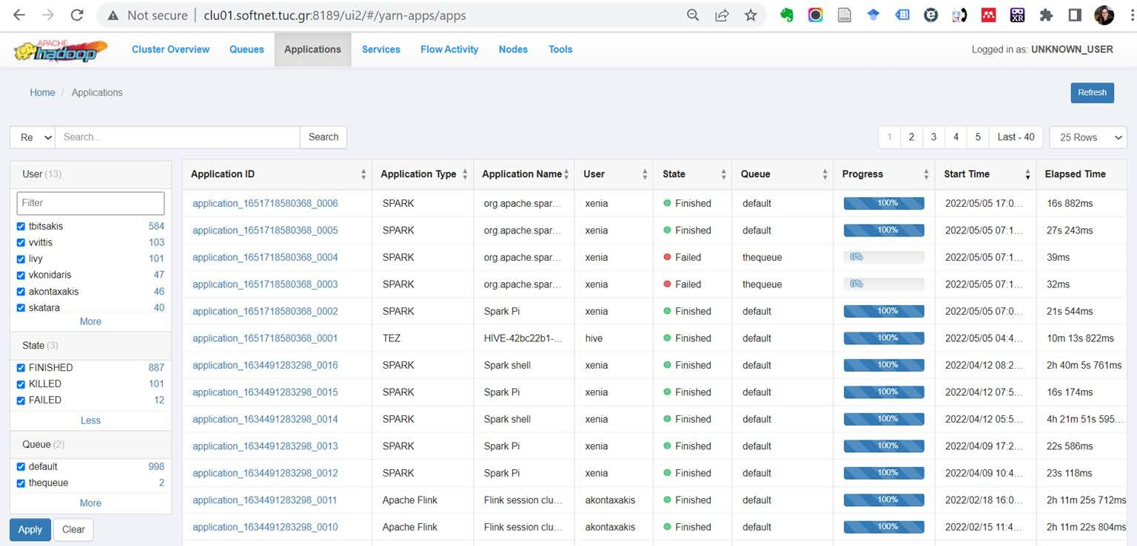
Submitting Spark jobs/ Yarn Resource Manager UI

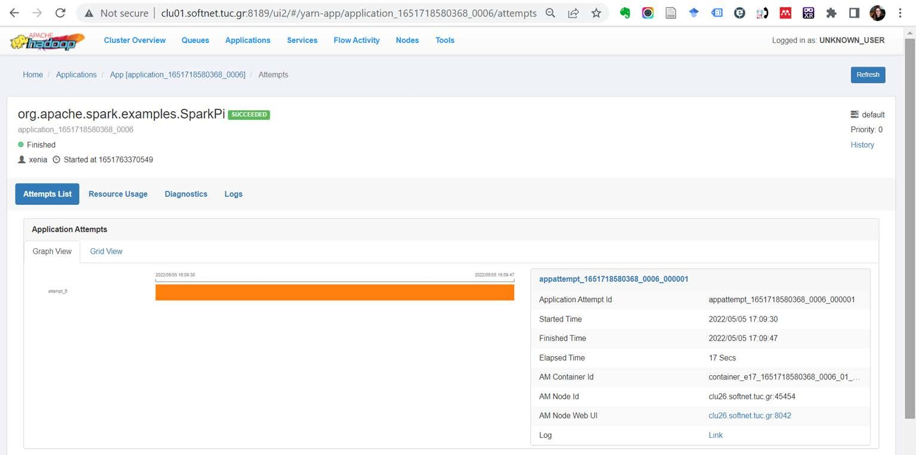
Submitting Spark jobs/ Yarn Resource Manager UI

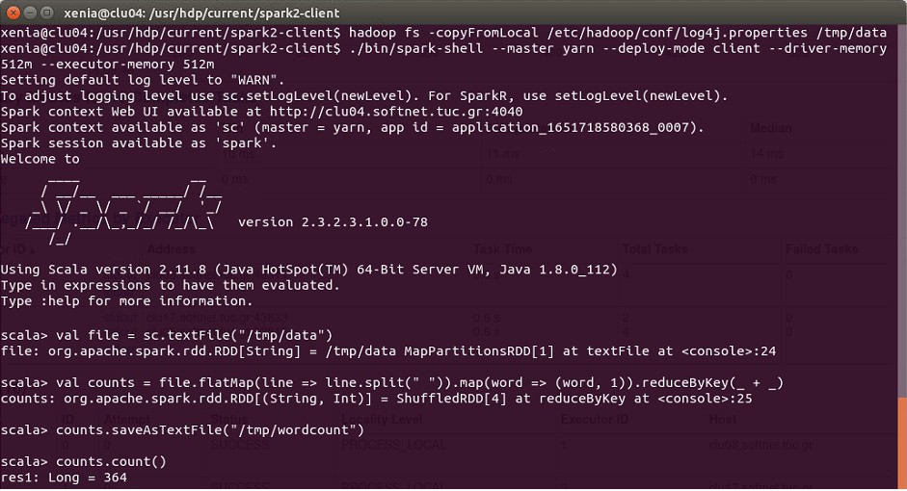
Submitting Spark jobs (client deploy mode)

WordCount example

Submitting Hadoop MapReduce jobs

Submitting Hadoop MapReduce jobs via Yarn
xenia@clu04:~$ cd /usr/hdp/current/hadoop-mapreduce-client
xenia@clu04:/usr/hdp/current/hadoop-mapreduce-client$ yarn jar hadoop-mapreduce-examples.jar
xenia@clu04:/usr/hdp/current/hadoop-mapreduce-client$ yarn jar hadoop-mapreduce-examples.jar pi 16 100000

Submitting Flink jobs

Flink on SoftNet cluster
- Flink is not integrated into HDP and has been installed on SoftNet cluster separately / manually
- Flink 1.10.0 (for Scala 2.12)
- Flink installation path: /usr/local/flink
- 1 Flink cluster master: clu01.softnet.tuc.gr
- 11 Flink cluster slaves with similar system characteristics:
{clu26, clu25, clu24, clu20, clu19, clu17, clu16, clu15, clu13, clu12, clu11} .softnet.tuc.gr
- Flink Web Front End: http://clu01.softnet.tuc.gr:8081

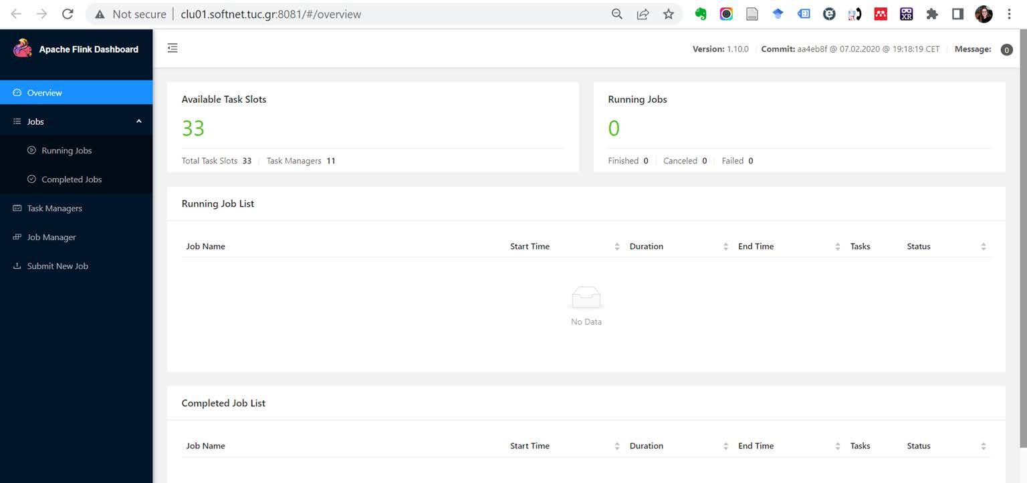
Flink on SoftNet cluster
- Flink Web Front End: http://clu01.softnet.tuc.gr:8081

Submitting Flink jobs
job, as you are going to do with your project
- Submitting a job means uploading the job’s JAR and related dependencies to the Flink cluster and initiating the job execution
- For the sake of this tutorial, we select an example .jar from Apache Flink available at
/usr/local/flink/examples/streaming/, the WordCount.jar
- WordCount computes the frequency of words in a text collection. The algorithm works in two steps: First, splits the text into individual words. Second, the words are grouped and counted.
- More info on these examples can be found at: https://nightlies.apache.org/flink/flink- docs-master/docs/dev/dataset/examples/
- Feel free to select any other JAR archive from the examples/ folder or deploy your own

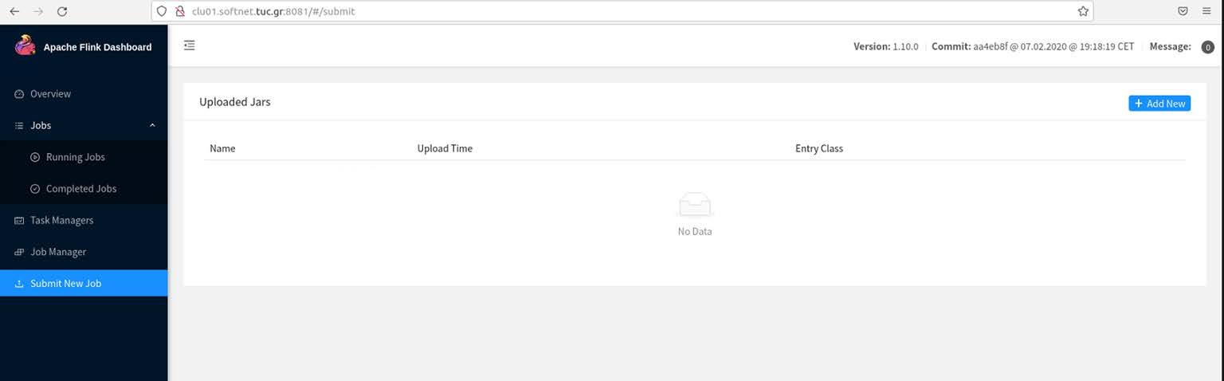
Submitting Flink jobs (1st method - Dashboard)
- Flink Web Front End: http://clu01.softnet.tuc.gr:8081

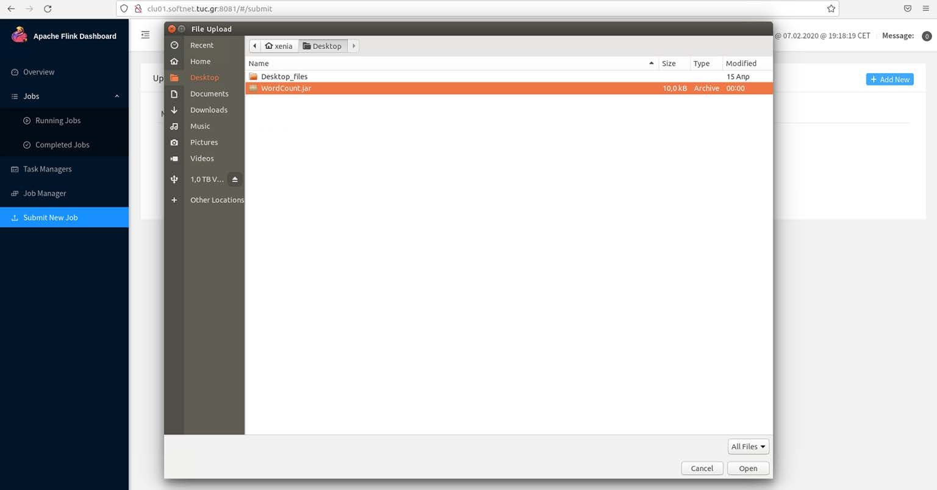
Submitting Flink jobs (1st method - Dashboard)

Submitting Flink jobs (1st method - Dashboard)
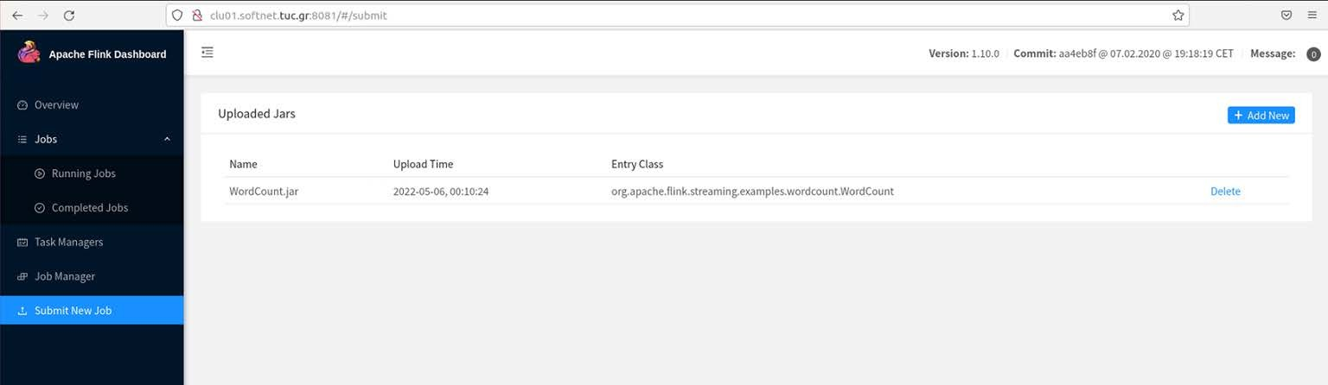
Press on file name

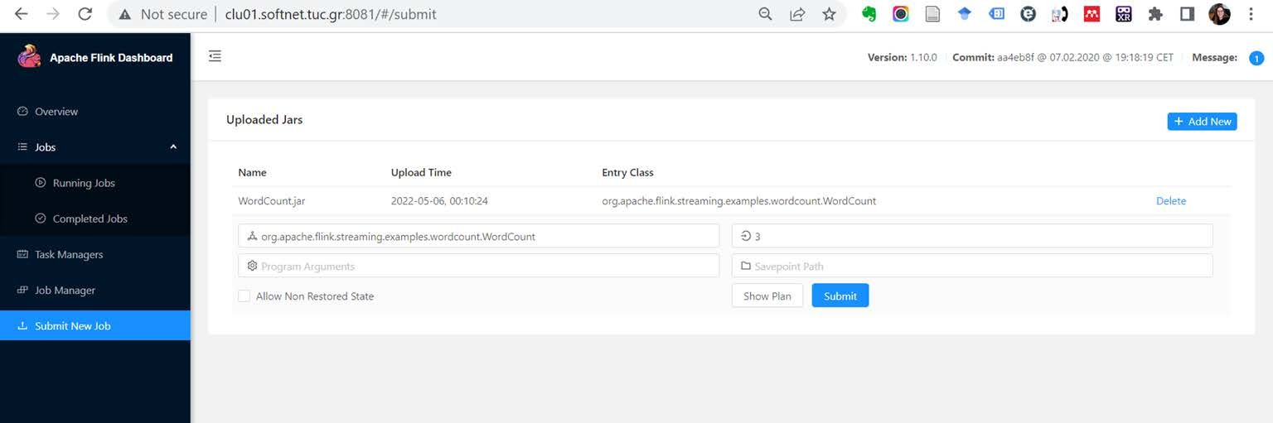
Submitting Flink jobs (1st method - Dashboard)

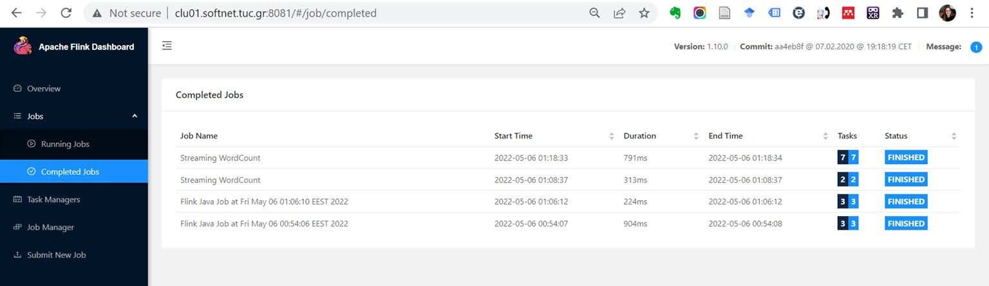
Submitting Flink jobs (1st method - Dashboard)

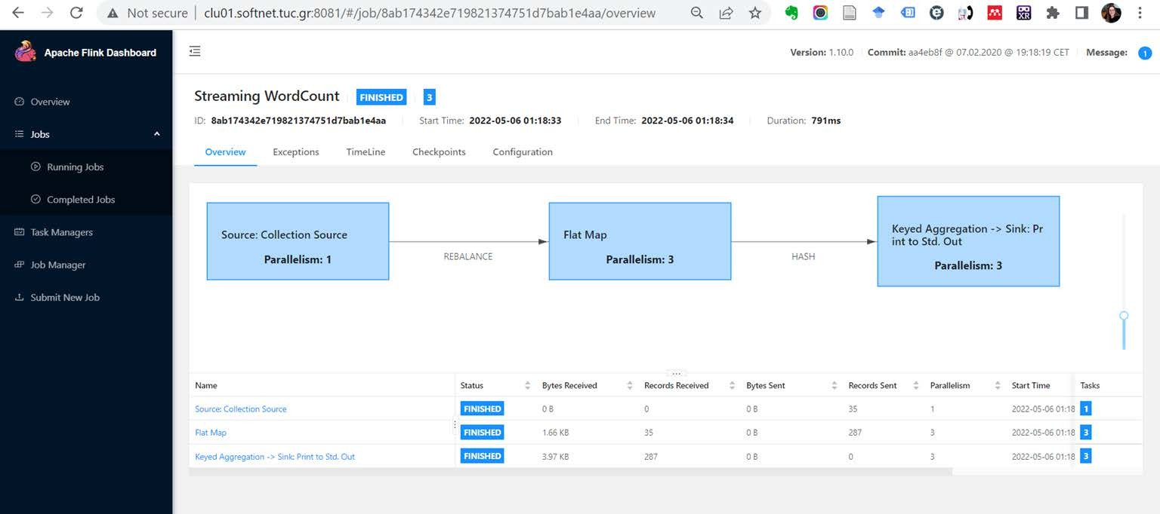
Submitting Flink jobs (1st method - Dashboard)

Submit Flink jobs (2nd method - Command-line interface)
./bin/flink run ./examples/batch/WordCount.jar --input
/path/to/some/text/data --output /path/to/result
- Non-local file systems require a schema prefix, such as hdfs://.
- Upload the Flink project .jar from your PC to your home directory on clu04.softnet.tuc.gr, as already shown on previous slides.
- Connect to clu04.softnet.tuc.gr via SSH
- Submit the Flink job:
cd /usr/local/flink/
./bin/flink run /usr/local/flink/examples/batch/WordCount.jar
- The other examples can be started in a similar way.
- Note that many examples run without passing any arguments for them, by using build- in data. To run WordCount with real data, you have to pass the path to the data:

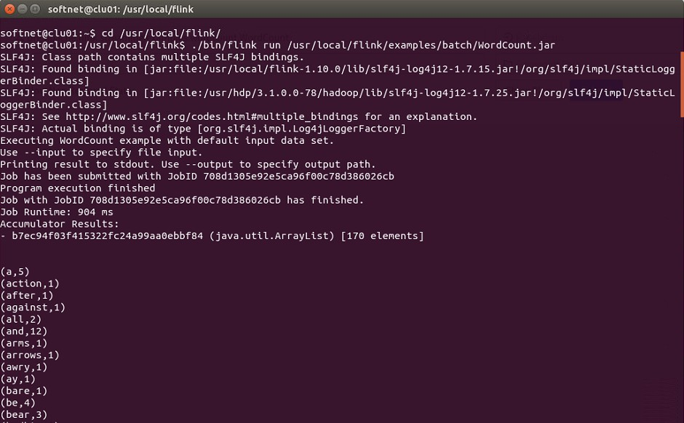
Submit Flink jobs (2nd method - Command-line interface)

Replace softnet@clu01 with yourusername @clu04

Kafka

SoftNet cluster Kafka brokers and Zookeeper servers
- 4 Kafka brokers: {clu02, clu03, clu04, clu06}.softnet.tuc.gr, Port: 6667
- 3 Zookeeper servers: {clu01, clu02, clu03}.softnet.tuc.gr, Port: 2182

Create & list Kafka topics
-list --zookeeper clu01.softnet.tuc.gr:2182
- Create a kafka topic:
xenia@clu04:~$ cd /usr/hdp/current/kafka-broker xenia@clu04:/usr/hdp/current/kafka-broker$ bin/kafka-topics.sh -
-create --zookeeper clu01.softnet.tuc.gr:2182 --replication-
factor 2 --partitions 2 --topic kafkatest Created topic "kafkatest".
- List kafka topics:
xenia@clu04:/usr/hdp/current/kafka-broker$ bin/kafka-topics.sh -

Kafka producer/consumer example

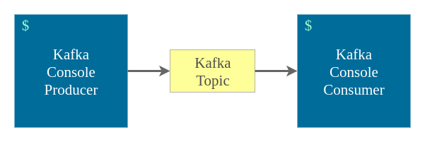

Kafka producer/consumer example
** Note that unlike the other Kafka scripts which specify a Zookeeper instance, the publisher is specifying a broker list.

- Run the producer script. Once it starts, we can enter lines to standard input and they will be published to Kafka:
xenia@clu04:/usr/hdp/current/kafka-broker$ bin/kafka- console-producer.sh --broker-list clu02.softnet.tuc.gr:6667,clu03.softnet.tuc.gr:6667,clu04
.softnet.tuc.gr:6667,clu06.softnet.tuc.gr:6667 --topic kafkatest
>

Kafka producer/consumer example

- Run the sample consumer script. If things go well, you should see the messages that you typed in the producer window show up on the consumer terminal.
- To run the consumer script, open another terminal on your PC and ssh to clu04.softnet.tuc.gr. Then run:
xenia@clu04:~$ cd /usr/hdp/current/kafka-broker xenia@clu04:/usr/hdp/current/kafka-broker$ bin/kafka-console-consumer.sh
--bootstrap-server clu02.softnet.tuc.gr:6667,clu03.softnet.tuc.gr:6667,clu04.softnet.tuc.gr: 6667,clu06.softnet.tuc.gr:6667 --topic kafkatest --from-beginning

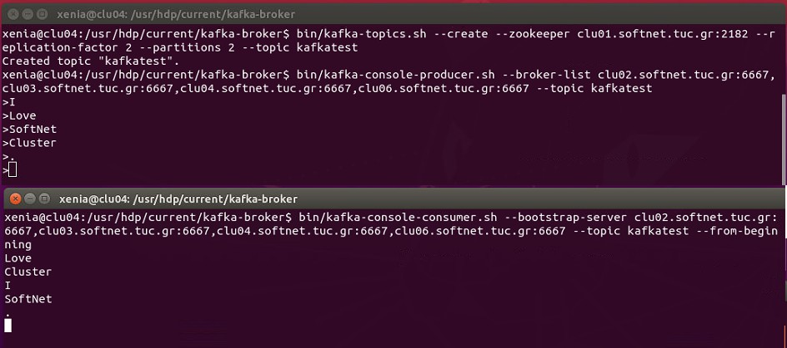
Kafka producer/consumer example

Delete Kafka topics
xenia@clu04:/usr/hdp/current/kafka-broker$ bin/kafka-topics.sh -
-delete --zookeeper clu01.softnet.tuc.gr:2182 --topic kafkatest Topic kafkatest is marked for deletion.
Note: This will have no impact if delete.topic.enable is not set to true.

