92.321 PRACTICE EXAM II

Check week 6 notes
1. Use mathematical induction to prove:
(1 - )(1 - )(1 - ) . . . (1 - 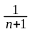) = 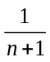 for every positive integer n.
2. (a) Let n be a positive integer. Use the “proof by contradiction” method of proof to prove: (explain the procedure and all steps). If 5n + 6 is an odd integer then n is an odd integer.
(b) Prove the following about integers: x is an odd integer iff x² + 2x + 1 is an even integer. Explain

3. Proofs (direct, by contradiction, iff) like we did in class

4. State and give an example of the principle of Duality for logic also for sets
5. Define the sequence L by L = 5 and for k 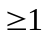, L = 2L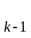 - 7.
- Write out the first four terms of this sequence.
- Prove by induction that L = 7 - 2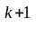is a solution for the above recurrence relation.
6 text section 4.1 exercise 3
7. Theorem 4.2.2
8.. Let A, B, and C be sets. Disprove the following:
a) If A B = A C then B = C
b) A X B = B X A
9. Let A =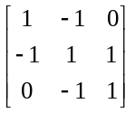, B =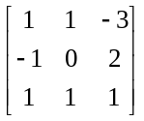 and C =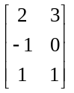
Compute the following using the most efficient possible procedure:
(a) AC + BC
(b) 2A - 3A

10. Let A be n x n matrix of real numbers.
- Define the inverse of the matrix A.
- Use the definition of the inverse of a matrix to prove that (A^{n})⁻¹ = (A⁻¹)^{n}.
- Let A = 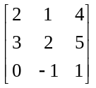 and let B = 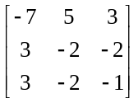. Use the definition in part (a) to determine whether B in the inverse of the matrix A.
11. Let A and B be nxn matrices . Is A² - B² = (A + B) (A - B)? Proof?

12 Exercises from the notes and the text.
13. We did not cover this material for exam 1 so please know it for Quiz 1
(a) Use truth tables to determine whether the following is a tautology:
(¬ p ∧ (p → q)) ⇒ (¬q).
(b) Is the converse of the statement in part (a) a tautology. Explain
(c) Define and give an example of converse. Is the converse of an true “if . . . .then . . . .” statement always true? Explain
(d) ) Define and give an example of contrapositive. Is the contrapositive of an “if . . . .then . . . .” statement always true? Explain
(e) Prove: that an if . . .then . . . statement is not always equivalent to its converse but is equivalent to its contrapositive.

(a) Assume that a expression in logic contains three variables. How many rows will there be in any truth table of this expression? Explain fully.
(b) How many rows will there be if the expression contains n variables? Explain fully.
(c) How many different (non-equivalent logical expressions containing n variables are there? Explain fully.

14. be able to prove any basic logic law or common equivalences

