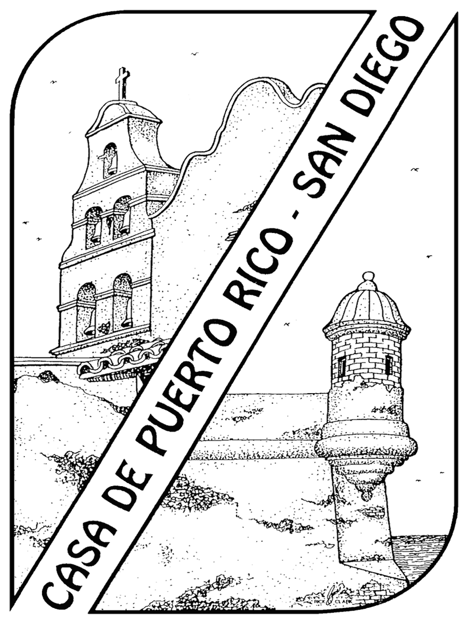
House of Puerto Rico San Diego (HPRSD)
P.O Box 81982
San Diego, CA 92138
(619) 234-3445
www.houseofpuertorico.com
2015 Doña Casilda Pagan/ HPRSD Scholarship

Completed Applications must be postmarked no later than July 31, 2015. Please make sure this application is
signed, dated, complete and mailed to the correct address and received by the due date.

Name ( First Middle Last )

Home Address City State Zipcode

Home Telephone (Include Area Code) Cell phone (Include Area Code)

_________________________________________ _____________________________
E-mail Address Ethnicity
I am related to a House of Puerto Rico San Diego (HPRSD) Board Member or Scholarship Committee Member

No Yes Name of Board member or committee member

The applicant must be a current active member of the House of Puerto Rico San Diego or a San Diego County resident of Puerto Rican descent, who has contributed at least 10 hours of community service through HPRSD within the last year. If you need to complete your volunteer hours please contact Joe Carballo at jcarballo@san.rr.com. I am a resident of San Diego County of Puerto Rican descent or a member of the San Diego House of Puerto Rico who has completed at least 10 hours of community service through HPRSD:

No Yes

You must be currently enrolled or officially accepted into a definite course of study in an academic/vocational program at a recognized, accredited educational institution. Please indicate your educational status:

I am Attending I will be attending

School/Institute/College/University/Other

Address City State Zipcode

The Scholarship awards will be applied for classes that begin
Month/Year
Enrollment in this program is Full-time Part-time Other_________________

Current school of attendance: ____________________________________________________________________

To complete your application, submit verification of your enrollment or acceptance into a definite course of study in an academic/vocational program. (See Scholarship requirements attached) Please submit with this application a 250 word typed essay stating your educational /vocational goals and how the scholarship will assist you with these goals.
Please also include in your essay how you will contribute community service through the House of Puerto Rico.

I certify that all these statements made by me are true, complete, and correct to the best of my knowledge, belief and are made in good faith.

Date Signature of Applicant

Casilda Pagan/HPRSD Scholarship Requirements
The House of Puerto Rico San Diego (HPRSD) sponsors the Casilda Pagan Educational/Vocational Scholarship. In 1972 Casilda Pagan became a co-founder and the first President of the House of Puerto Rico San Diego. She was born in Aguas Buenas, Puerto Rico and moved to San Diego in 1967. This scholarship is being offered to San Diego County Residents of Puerto Rican descent or members of the House of Puerto Rico who are high school seniors/ graduates or college/post-graduate students who have contributed at least 10 hours of community service through HPRSD within the last year. If you need to complete your volunteer hours, please contact Joe Carballo at jcarballo@san.rr.com. With this award, we hope to assist youth or adults in the attainment of their educational and professional goals.
Scholarships are awarded yearly. Interested applicants should submit the following information:
- Personal Essay (250 word minimum) including the following information:
- Your educational /vocational goals
- Your financial needs
- Describe how you will contribute community service through the House of Puerto Rico.
- Describe prior history of community service
- Proof of current enrollment in an educational
or vocational institution for the 2015-2016 school year
- Transcripts reflecting most recent academic achievement. (Those already attending a college/vocational program should submit a transcript showing all courses/grades completed to date. High school seniors should submit most recent transcripts.)
- Three letters of recommendation from teachers, counselors, employers, or community leaders on company letterhead and dated within the past year
- Completed application form
- Any additional materials, which you believe may enhance your application (i.e. awards, community service, etc).

The Committee ranks applications by scoring each candidate in five areas:

- NEED: One of the priorities for the committee is to open doors of opportunity to individuals who might otherwise not have this support, in order to make their contribution to community improvement and society as a whole. Although all areas are given equal value, in the event of a tie, this area is given more weight.
- GOAL: The clarity and focus of the individual’s educational/vocational goals are reviewed. The committee also wants to know what the individual will do upon completion of his/her education and how will it contribute to society as a whole
- MOTIVATION: This area refers to the individual’s drive and commitment toward attaining his/her goal.
- APPLICATION: The application must be complete and contain all the criteria stated above.
- CONTRIBUTION: The Committee wants to know the applicants intended contribution to community service through the San Diego House of Puerto Rico. For a previous winner applying, the committee evaluates their follow through on their stated intent.

The monies will be paid to the individual(s) or to their educational institution(s) on behalf of the recipient upon fulfillment of all specified requirements.

The House of Puerto Rico San Diego Scholarship will be awarded based on all previously mentioned areas.

The individual’s employment status, available family income/support, and/or other financial assistance at their disposal (i.e. other grants, fellowships, and scholarships) determine financial need.

All applications must be postmarked by
July 31, 2015.

Selected applicants will be invited to attend an interview during the month of August. Please forward all completed materials to:

House of Puerto Rico San Diego
Scholarship Committee
PO Box 81982

San Diego, CA 92138

For more information about the House of Puerto Rico San Diego Scholarship or to sign up for community service, please check out our website at www.houseofpuertorico.com.

HPRSD Scholarship Committee’s
Mission Statement:
“The House of Puerto Rico, San Diego is dedicated to motivating, supporting, and empowering our community via education and community service.”

