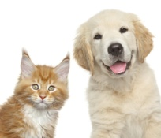 Above Board Pet Travel Ltd

Department for Environment, Food and Rural Affairs

Declaration of Owner

not accompanying pet during its journey

I, the undersigned.......................................................................................................................... (Block Capitals) [owner or natural person responsible for the animal(s) described above, on behalf of the owner] declare that the animal(s) which are identified in the accompanying passport(s) or 3rd country certificate

...................................................................................................................................................................................... [list of passport numbers or 3rd country certificate reference number as appropriate] will accompany me, the owner, or the natural person that I have designated to be responsible for the animal(s) on my behalf, and are not intended to be sold or transferred to another owner

Place and date......................................................

Signature ..............................................................

Further information • www.defra.gov.uk/wildlife-pets/pets/travel/pets/pet-owners/