Science – blockchain

Introduction
This paper sets out how blockchain methodologies and technologies can be combined with science: the ”systematic enterprise that builds and organizes knowledge in the form of testable explanations and predictions about the universe” (wikipedia).
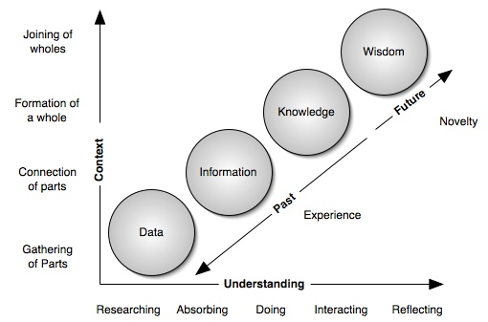

Today, the scientific endeavor is assumed and as far as we know, only human beings hold the capability to learn and apply knowledge. In the future this human centric assumption maybe not hold and thus this paper is Being centric in its outlook. Blockchain ideas are peer to peer based and put the backstop of trust in the hands of the mathematics of cryptography. This makes a perfect protocol for the collection of data from scientific apparatus (sensors), the computation of the data into information forms that can be shared peer to peer, to be reviewed or applied to/in other scientific projects or even applied to the intelligence of other Beings.

Cause and Effect
The holy grail of science is to discover, cause and effects that are repeatable and can be applied across all environments in the cosmos. Such scientific claims can said to have discovered an underlying 'Law of Nature'. There are currently very few such discovered Laws of Nature and even then it is understood these will probably be improved upon with time.

Ganularity of cause and effect shinks with time, earth, courntry, block by block, street by street, house by house, individual by individual
Techs. ability to learn/solve complexity

Time

For example: We can measure the CO2 and CO in a outside area but it is hard to know the long term effect those value have on a runner. However, put runner in a chamber with only CO then we know they are going to die.

Does understanding the cause and effect necessarily mean if we simply reverse the process the state will return to the original? In the case of biology this may not always be possible or attainable. Thus even in a world where every cause and effect is worked out challenges still remain to 'solve' current problems.

Scientific Method
Most scientific research can not claim to have discovered an underlying natural law but the research makes incremental contributions to the stock of scientific knowledge. In a commercial economy the practice of pseudo-science is much in prevalence. An asymmetrical balance of information held on the supply side of a product combined with financial muscle often creates a persuasive case for use of a product. It is envisioned such pseudo-science will disappear once current scientific information is available to all and in real-time.

Intelligence
If pinning down a precise definition for scientific inquiry is difficult then doing the same for the word intelligence is exponentially more so. However, this paper attributes intelligence to each individual autonomous Being rather than to a centralized propriety based monopolization of technology. Further new scientific data and information should be made instantly available across the network of Beings.

Universality of Science

Cosmos
Environment

Life

Rise of open science – citizen science
Many effort going in from mozilla to open source project to establish peer review magaine titles offering data services. All traditional web stack. This paper put forward the case for blockchain decetnralized peer to peer data protocol including concept of proof of science.

