1 Observation & correction:

Before fix:

module ALT_MULTADD(iCLK, iRST_N, iSEL, iA0, iA1, iB0, iB1, oR);
input iCLK, iRST_N, iSEL, iA0, iA1, iB0, iB1;
output oR;

wire iCLK, iRST_N, iSEL;
wire [7:0] iA0, iA1, iB0, iB1;
reg [7:0] A0, A1, B0, B1;
reg [16:0] oR;

always @ (posedge iCLK, negedge iRST_N)begin

A0 <= iA0;
A1 <= iA1;
B0 <= iB0;
B1 <= iB1;
if(iRST_N)begin
if(iSEL) begin
oR <= A0 * B0 + A1 * B1;
end
else begin
oR <= A0 * B0 + A1 * B1 + A0 * A1 * B0 * B1;
end
end
else begin
oR <= 0;
end
end

endmodule

Simulation:
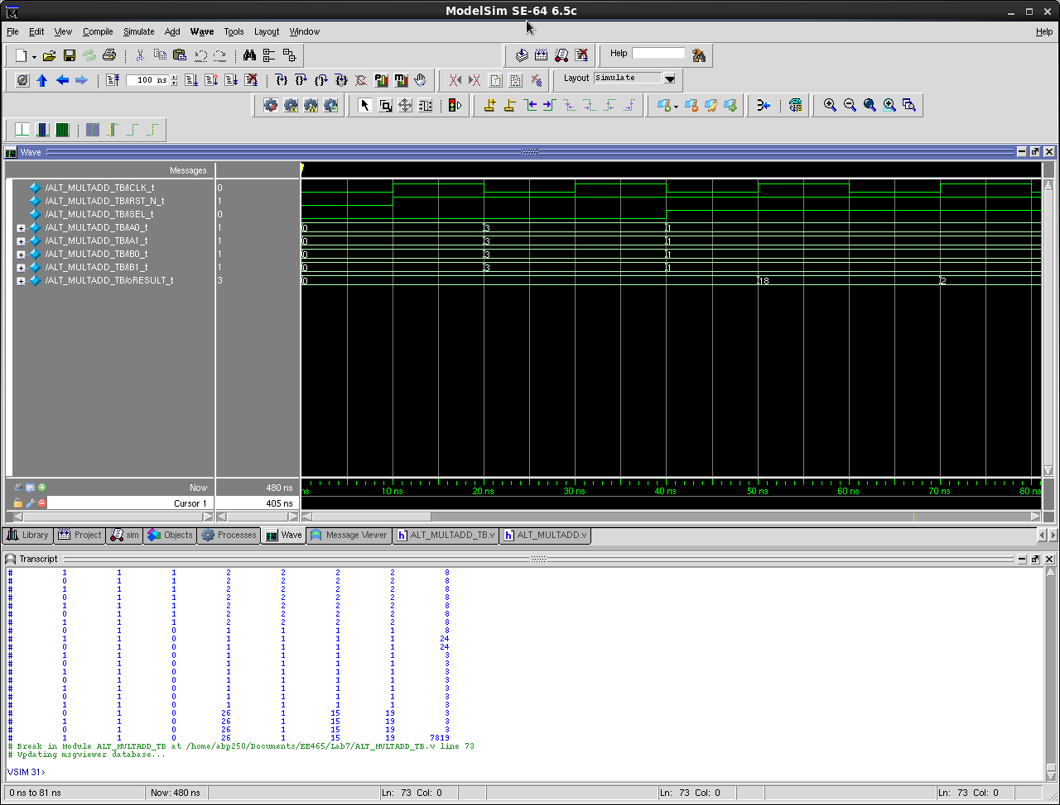
# Test control
# iCLK_t iRST_N_t iSEL_t iA0_t iA1_t iB0_t iB1_t oRESULT_t
# 0 0 0 0 0 0 0 0
# 1 1 0 0 0 0 0 0
# 0 1 0 3 3 3 3 0
# 1 1 0 3 3 3 3 0
# 0 1 1 1 1 1 1 0
# 1 1 1 1 1 1 1 18
# 0 1 1 1 1 1 1 18
# 1 1 1 1 1 1 1 2
# 0 1 1 1 1 1 1 2
# 1 1 1 1 1 1 1 2
# 0 1 1 1 1 1 1 2
# 1 1 1 1 1 1 1 2
# 0 1 1 1 1 1 1 2
# 1 1 1 1 1 1 1 2
# 0 1 0 2 2 2 2 2
# 1 1 0 2 2 2 2 3
# 0 1 0 2 2 2 2 3
# 1 1 0 2 2 2 2 24
# 0 1 0 2 2 2 2 24
# 1 1 0 2 2 2 2 24
# 0 1 0 2 2 2 2 24
# 1 1 0 2 2 2 2 24
# 0 1 0 2 2 2 2 24
# 1 1 0 2 2 2 2 24
# 0 1 1 2 2 2 2 24
# 1 1 1 2 2 2 2 8
# 0 1 1 2 2 2 2 8
# 1 1 1 2 2 2 2 8
# 0 1 1 2 2 2 2 8
# 1 1 1 2 2 2 2 8
# 0 1 1 2 2 2 2 8
# 1 1 1 2 2 2 2 8
# 0 1 1 2 2 2 2 8
# 1 1 1 2 2 2 2 8
# 0 1 0 1 1 1 1 8
# 1 1 0 1 1 1 1 24
# 0 1 0 1 1 1 1 24
# 1 1 0 1 1 1 1 3
# 0 1 0 1 1 1 1 3
# 1 1 0 1 1 1 1 3
# 0 1 0 1 1 1 1 3
# 1 1 0 1 1 1 1 3
# 0 1 0 1 1 1 1 3
# 1 1 0 1 1 1 1 3
# 0 1 0 26 1 15 19 3
# 1 1 0 26 1 15 19 3
# 0 1 0 26 1 15 19 3
# 1 1 0 26 1 15 19 7819

After fix:

module ALT_MULTADD(iCLK, iRST_N, iSEL, iA0, iA1, iB0, iB1, oR);
input iCLK, iRST_N, iSEL, iA0, iA1, iB0, iB1;
output oR;

wire iCLK, iRST_N, iSEL;
wire [7:0] iA0, iA1, iB0, iB1;
reg SEL;
reg [7:0] A0, A1, B0, B1;
reg [16:0] oR;

always @ (posedge iCLK, negedge iRST_N)begin

A0 <= iA0;
A1 <= iA1;
B0 <= iB0;
B1 <= iB1;
SEL <= iSEL;
if(iRST_N)begin
if(SEL) begin
oR <= A0 * B0 + A1 * B1;
end
else begin
oR <= A0 * B0 + A1 * B1 + A0 * A1 * B0 * B1;
end
end
else begin
oR <= 0;
end
end

endmodule

Simulation:

`timescale 10ns/1ns
module ALT_MULTADD_TB ();

reg iCLK_t, iRST_N_t, iSEL_t;
reg [7:0] iA0_t, iA1_t, iB0_t, iB1_t;
wire [16:0] oRESULT_t;

ALT_MULTADD X(iCLK_t, iRST_N_t, iSEL_t, iA0_t, iA1_t, iB0_t, iB1_t, oRESULT_t);

initial $display ("Test control");
initial $display ("%10s %10s %10s %10s %10s %10s %10s %10s",
"iCLK_t", "iRST_N_t", "iSEL_t", "iA0_t", "iA1_t",
"iB0_t", "iB1_t", "oRESULT_t");
initial $monitor ("%10b %10b %10b %10d %10d %10d %10d %10d",
iCLK_t, iRST_N_t, iSEL_t, iA0_t, iA1_t, iB0_t, iB1_t, oRESULT_t);

initial begin

iCLK_t = 0;
iRST_N_t = 0;
iSEL_t = 0;
iA0_t = 0;
iA1_t = 0;
iB0_t = 0;
iB1_t = 0;

#1
iRST_N_t = 1;
#1
iA0_t = 3;
iA1_t = 3;
iB0_t = 3;
iB1_t = 3;

#2
iSEL_t = 1;
iA0_t = 1;
iA1_t = 1;
iB0_t = 1;
iB1_t = 1;

#4
$stop;

end
always #1 iCLK_t = ~iCLK_t;
endmodule
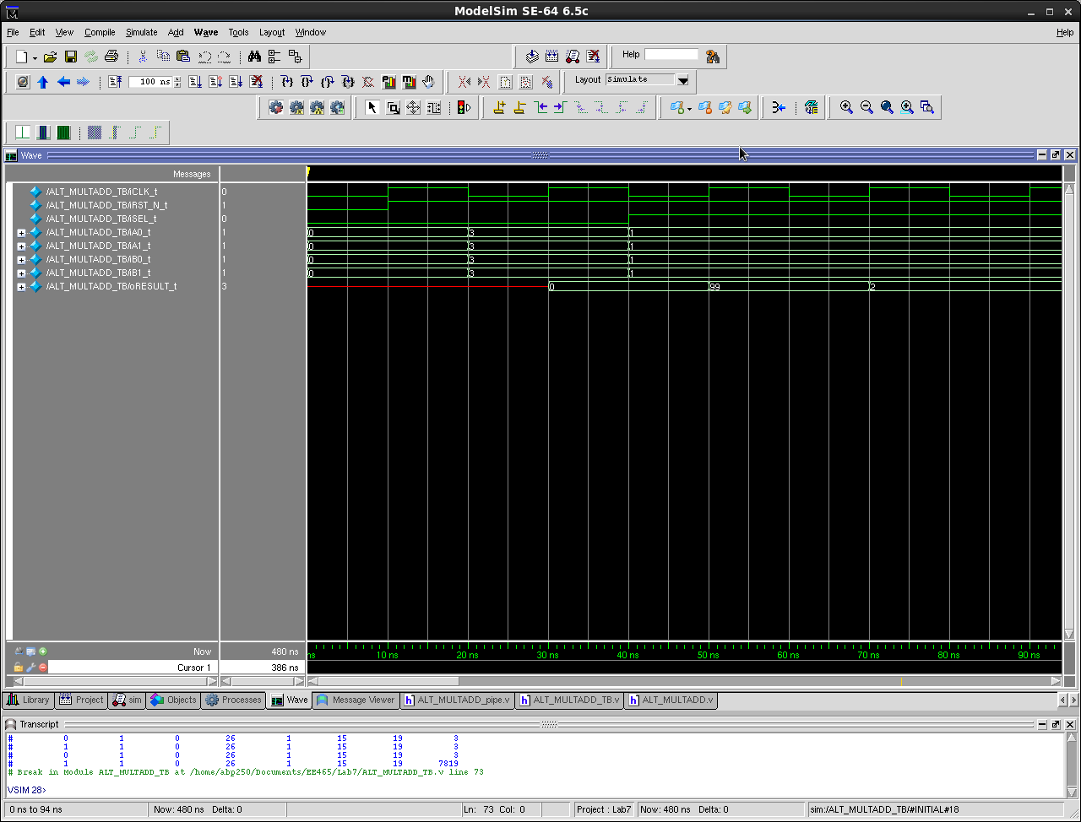
# Test control
# iCLK_t iRST_N_t iSEL_t iA0_t iA1_t iB0_t iB1_t oRESULT_t
# 0 0 0 0 0 0 0 x
# 1 1 0 0 0 0 0 x
# 0 1 0 3 3 3 3 x
# 1 1 0 3 3 3 3 0
# 0 1 1 1 1 1 1 0
# 1 1 1 1 1 1 1 99
# 0 1 1 1 1 1 1 99
# 1 1 1 1 1 1 1 2
# 0 1 1 1 1 1 1 2
# 1 1 1 1 1 1 1 2
# 0 1 1 1 1 1 1 2
# 1 1 1 1 1 1 1 2
# 0 1 1 1 1 1 1 2
# 1 1 1 1 1 1 1 2
# 0 1 0 2 2 2 2 2
# 1 1 0 2 2 2 2 2
# 0 1 0 2 2 2 2 2
# 1 1 0 2 2 2 2 24
# 0 1 0 2 2 2 2 24
# 1 1 0 2 2 2 2 24
# 0 1 0 2 2 2 2 24
# 1 1 0 2 2 2 2 24
# 0 1 0 2 2 2 2 24
# 1 1 0 2 2 2 2 24
# 0 1 1 2 2 2 2 24
# 1 1 1 2 2 2 2 24
# 0 1 1 2 2 2 2 24
# 1 1 1 2 2 2 2 8
# 0 1 1 2 2 2 2 8
# 1 1 1 2 2 2 2 8
# 0 1 1 2 2 2 2 8
# 1 1 1 2 2 2 2 8
# 0 1 1 2 2 2 2 8
# 1 1 1 2 2 2 2 8
# 0 1 0 1 1 1 1 8
# 1 1 0 1 1 1 1 8
# 0 1 0 1 1 1 1 8
# 1 1 0 1 1 1 1 3
# 0 1 0 1 1 1 1 3
# 1 1 0 1 1 1 1 3
# 0 1 0 1 1 1 1 3
# 1 1 0 1 1 1 1 3
# 0 1 0 1 1 1 1 3
# 1 1 0 1 1 1 1 3
# 0 1 0 26 1 15 19 3
# 1 1 0 26 1 15 19 3
# 0 1 0 26 1 15 19 3
# 1 1 0 26 1 15 19 7819

2 Pipelined Schematic

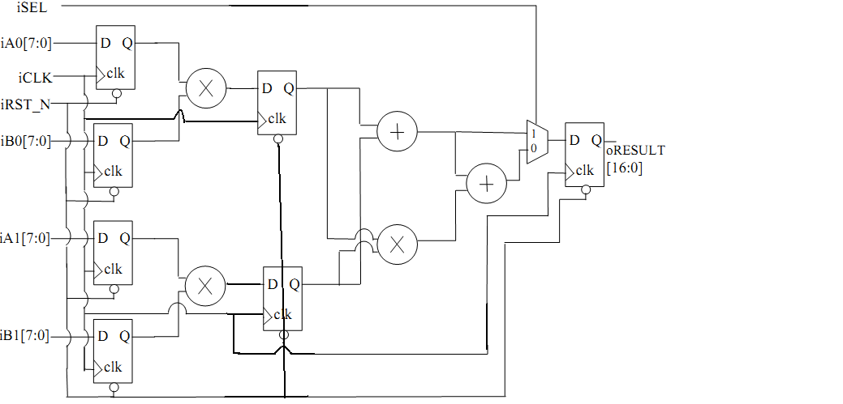
& Code:

module ALT_MULTADD_pipe(iCLK, iRST_N, iSEL, iA0, iA1, iB0, iB1, oR);
input iCLK, iRST_N, iSEL, iA0, iA1, iB0, iB1;
output oR;

wire iCLK, iRST_N, iSEL;
wire [7:0] iA0, iA1, iB0, iB1;
reg SEL, SEL1;
reg [7:0] A0, A1, B0, B1, M0, M1;
reg [16:0] oR;

always @ (posedge iCLK)begin

A0 <= iA0;
A1 <= iA1;
B0 <= iB0;
B1 <= iB1;
M0 <= A0 * B0;
M1 <= A1 * B1;
SEL1 <= iSEL;
SEL <= SEL1;

if(iRST_N)begin
if(SEL) begin
oR <= M0 + M1;
end
else begin
oR <= M0 + M1 + M0 * M1;
end
end
else begin
oR <= 0;
end
end

endmodule

3 Modelsim Simulation Waveform

