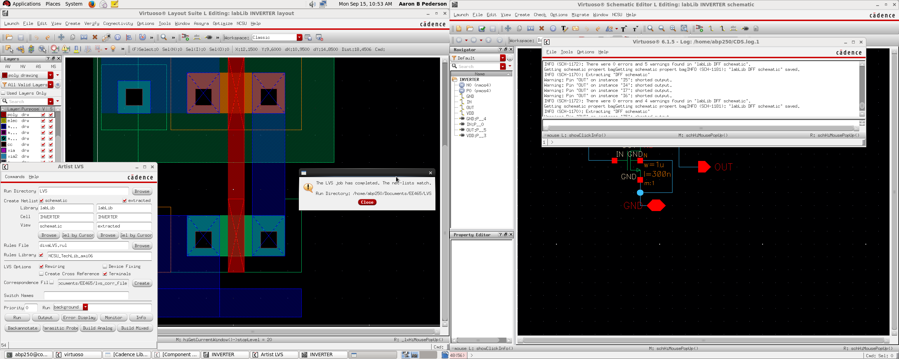
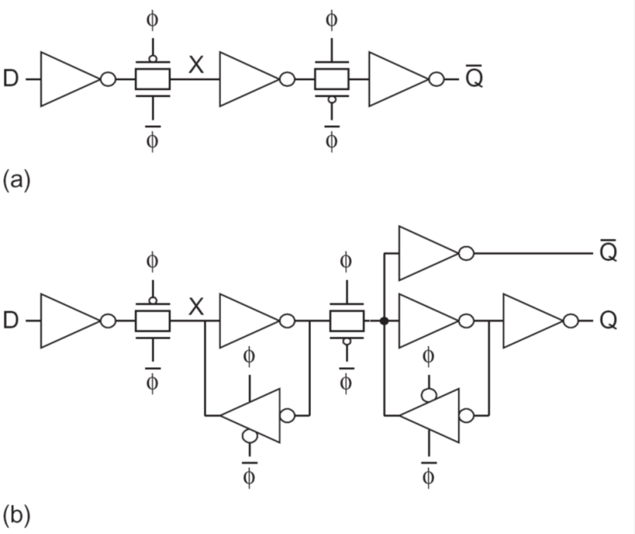
EE 465 LAB 2 REPORT:

The goal of this lab is to make a standard cell of a D flip flop with the following configuration:
In this lab there are three components that make up a D flip flop:

1) The Inverter:

This was fairly simple to make as we have already created this in EE330 and it only requires two transistors.

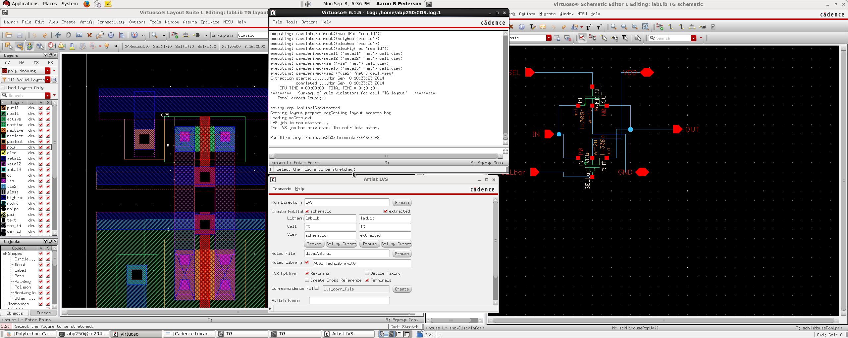
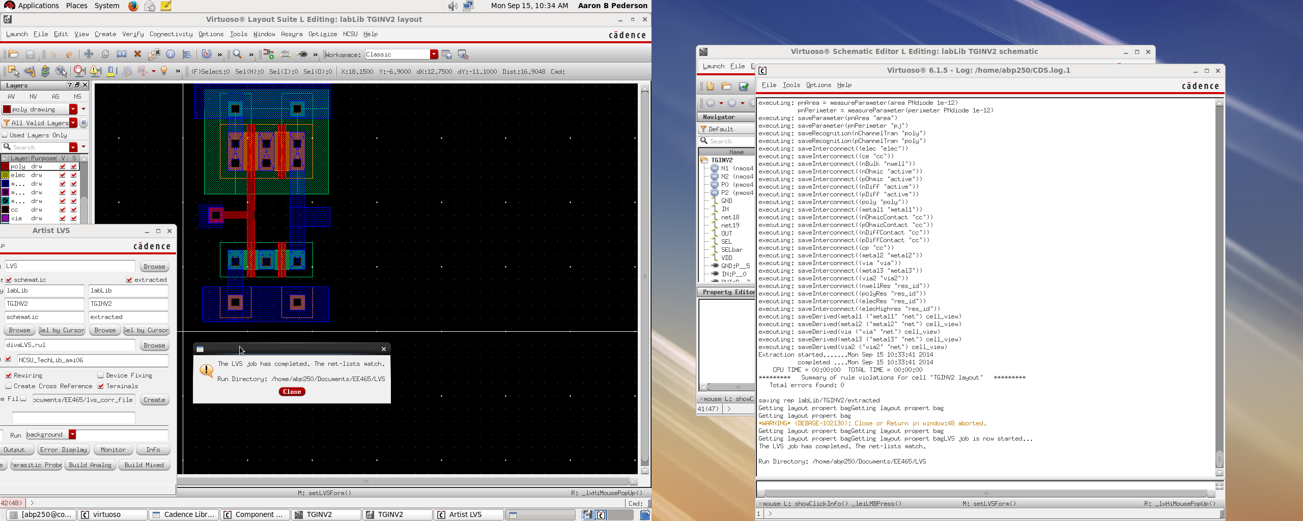
The next component we need is a transmission gate:

The circuit and layout are in the screenshot below with the LVS success showed in the middle terminal.

The next component we need is a transmission buffer:

The transmission buffer is shown below:
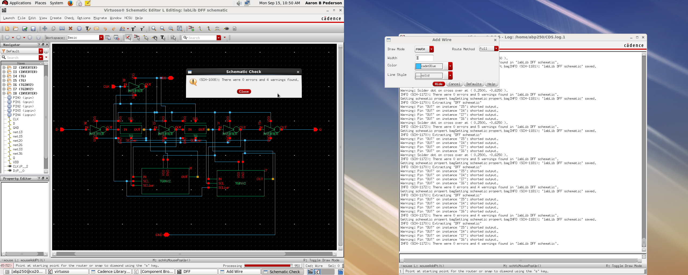
When we put all the components together, We get this resulting circuit which is the D flip flop!

