Albert Padanilam

GitHub Link:

Python anywhere:

All diagrams used in the word document are accessible in the above GitHub link.

The Tool Management System (TMS) application is used to track home improvement tools among friends and family. Often when doing home renovations, it is useful to share tools. However, there isn’t a good way to track which tools are available and have a systematic way to contact the owner of a tool to request it. This application will aim to solve that problem. Friends and family will use the application from a laptop or mobile device with a browser. Users who are approved will be granted access to the application from users with an admin role. A user on the web will not be able to sign up for access to the site unless they are approved from an admin. All registered users will be able to see other tools that other users own (all tool listings). A registered user can modify his or her tools but no other users’ tools.

**Data model**

**Use case diagram**

**Application screenshots with descriptions**

All entities in admin console.

Available entity. This is created by the admin to indicate whether a tool is available.

Tool entity.

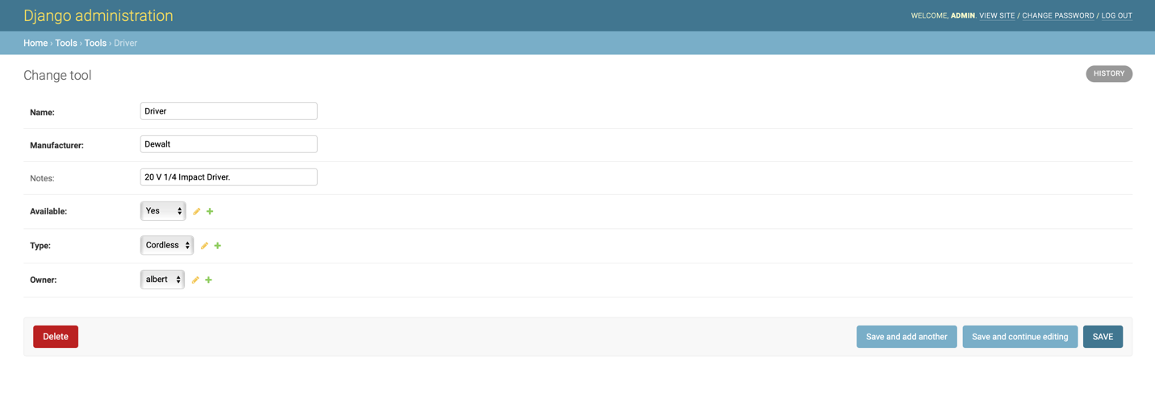

User entity.

Tool type entity:

