EMG Security Monitoring System

# Introduction

Electromyography (EMG) is a technique for monitoring electrical signals produced by the movement of muscles. EMG allows for accurate measurement of muscle activity without the need for intrusive or bulky measurement tools. EMG requires only an electrode placed on the surface directly above the target muscle. When placed on an arm, EMG can detect not only the activity of the arm, but also that of the user’s hand. This project utilizes a Myo Gesture Control Armband that houses eight electrodes for EMG as well as an inertial measurement unit (IMU) to detect movement.

# Problem Statement

The current market for gesture based security systems focuses only on the use of cameras to detect user movement. These systems require heavy processing and restrict the user to gesture only in the field of view of the camera. An EMG based security system eliminates these issues. Users can gesture from anywhere within range of the Bluetooth receiver (up to 300 feet). (THIS PARAGRAPH IS INCOMPLETE)

The ideal use case of an EMG security monitoring system is in small businesses that do not have a dedicated security department. In these businesses, security monitoring is a secondary responsibility of a worker. For example, in convenience stores the cashier is responsible for checking out customers while also watching a security monitor to prevent theft. , Often, there is just one monitor displaying camera feeds from all around the store. In such cases, it can be difficult to clearly see what is happening around the store.

# Functional Description

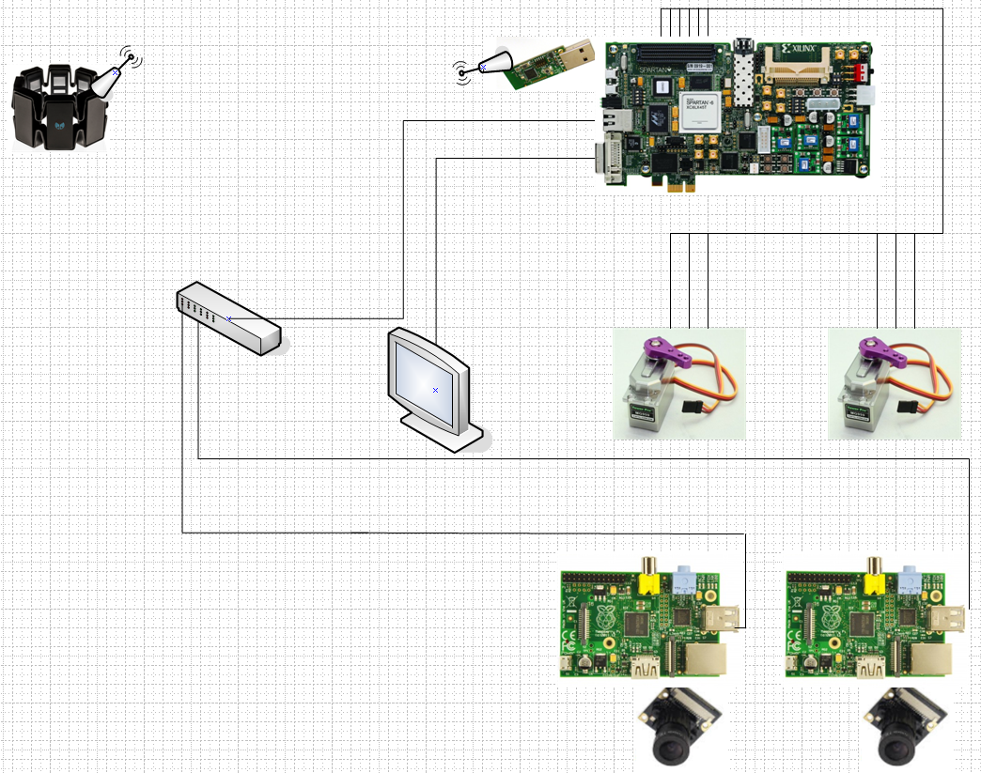

Figure 1: Rough Diagram of System

A Myo Armband will be worn by a user, giving him/her hands-free control of a video camera system. The user will have control of pan, tilt, zoom, and camera selection. The system will utilize electromyographic (EMG) signals and inertial signals. The armband will send Bluetooth signals to an FPGA board that will be responsible for processing the signals to control a video monitoring system.

A Raspberry Pi 3 board, with two servo motors will be used to control each camera system about two axes. An Ethernet network will be setup to transmit information between the Raspberry Pi boards and the FPGA.

## Myo Gesture Control Armband

Produced by Thalmic labs, this armband is worn by the user. It uses eight EMG sensors as well as a nine-axis IMU to detect hand and arm movement. Data is sent in real-time via Bluetooth to an FPGA.

## FPGA

The FPGA functions as the central hub of the EMG Security Monitoring System. It receives user input through a Bluetooth dongle. This input is then processed to identify the gestures made by the user. Based on the gesture, the FPGA can either select a camera feed to display on the monitor or send PWM signals to the servo motors to control their motion. On an IP data link, the FPGA receives the video data captured by the Raspberry Pi cameras.

## Servo Motors

The system includes two pairs of servo motors. Each pair is attached to a Raspberry Pi and camera. The motors are directly connected to the FPGA, receiving PWM signals that control their motion. The motors can rotate about two axes, giving the user the ability to monitor a 180˚ field of view.

## Raspberry Pi and Camera Assembly

There are two Raspberry Pi 3B computers, each with an attached camera. They process the video and send it to the FPGA across the IP data link.

## Monitor

The monitor has three different display modes, one to show both camera feeds at the same time and a full screen mode for each camera. The video feed will be sent to the monitor from the FPGA. The selection of display mode is based on the gestures made by the user.