Adriana Pena

Lab report

Lab 4

Introduction

In this lab what we had to do was just implement the same text we got from lab 3 and implement it into a B-tree. Also during this lab we had to implement two methods the one where you insert into a b tree and get the max anagrams of words you input.

Propose solution design and implementation

First what I did I was able to use the b-tree code that was previously used. Then I did some modifications to it. One of the methods that were added was the max anagrams helper, the max anagrams, and the main changed as well. In my main what I changed now that the tree is being populated as a b-tree. Then I did the max anagrams so go though all the text and find the word that has the most anagrams and also if you put a word in it will create or return the number of anagrams that the word you choose to put in the file or the method to that will create the number of anagrams.

Experimental Results

What I did for the experimental was just change the word that was being search for and the anagrams that were possible with that word changes.

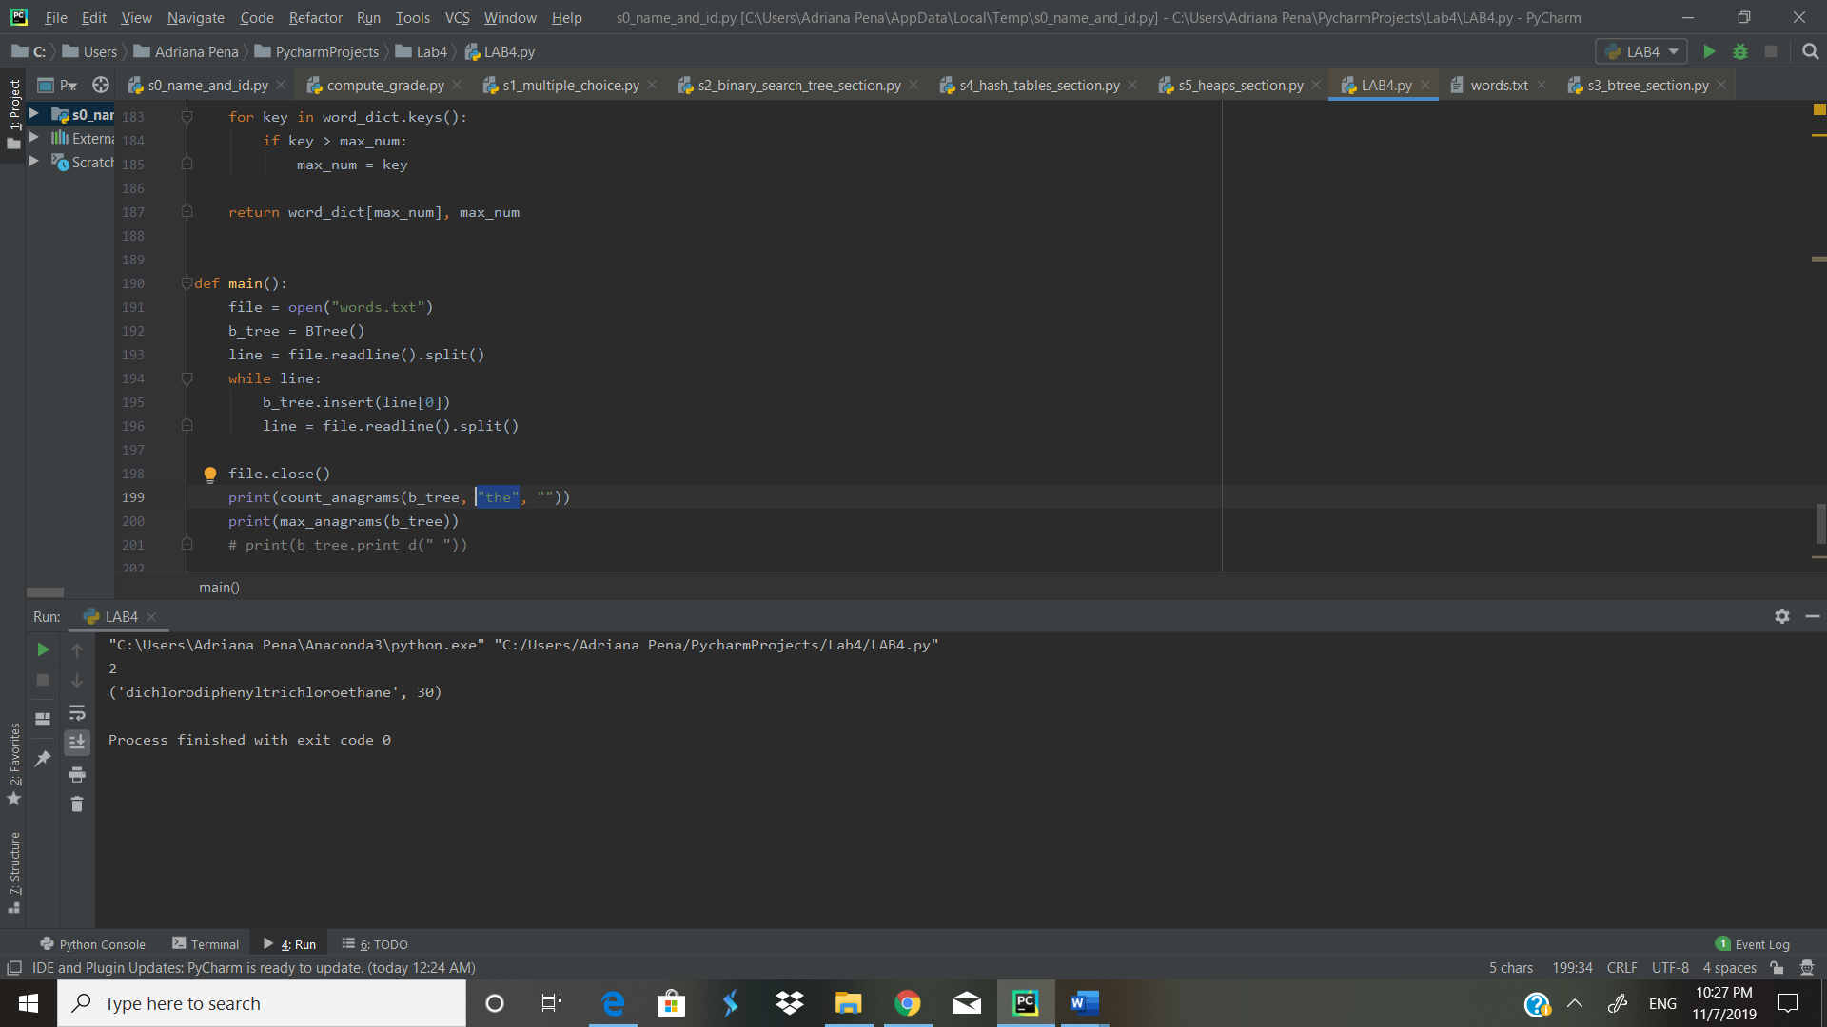 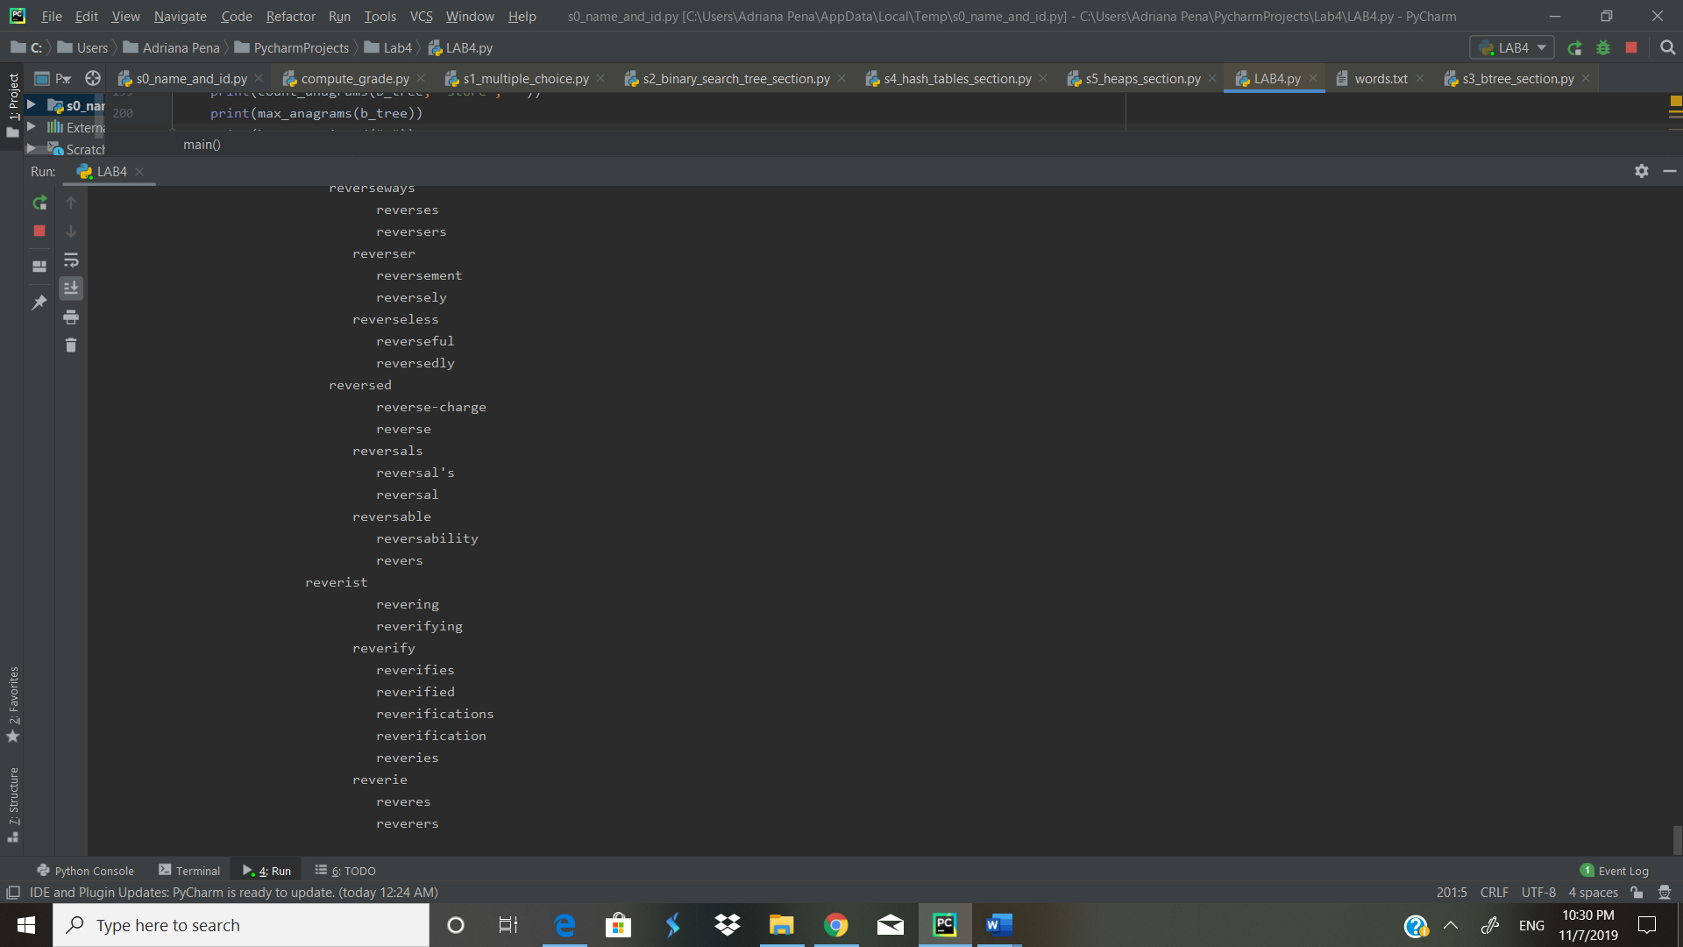

Conclusion

In the processes of making the lab I finally learned how the find anagrams is and how it works because in my last lab I didn’t get to do that part. Also when I printed out the b-tree it shows the whole tree being transformed and demonstrated how the words arrange.

Appendix

<https://github.com/abpena/abpena>