

IoT DOMAIN ANALYST

ECE3502 (L53+l54)

Allen Ben Philipose – 18BIS0043

**Lab FAT**

**Aim**

Create a dataset for predicting the winner of the elections for a respective constituency.

1. Choose an ML algorithm which can be used to predict the results (any ML algorithm of your choice with best outcome is fine)
2. Train your algorithm with the created dataset.
3. Predict the possible winner of the election (you can pick the suitable attributes for this predictions)

**Files**

https://drive.google.com/drive/folders/1qDSaQdHM1zNW5zPrZGy37pAgg4YtQEKh?usp=sharing

**Tools**

* Pandas
* Numpy
* SkLearn

**Platform**

* Google Colab
* Jupyter Notebook

**Output**

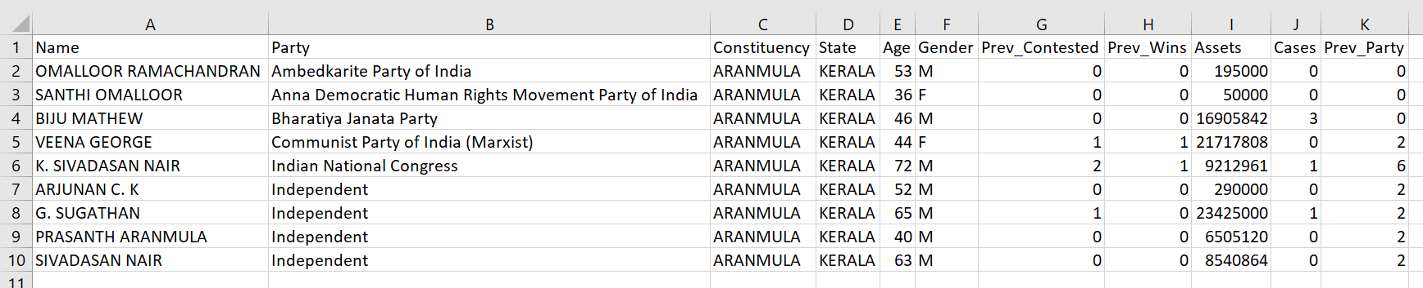

Aranmula constituency in Kerala

***The attached notebook might have lost data, on conversion from T5.ipynb to T5.pdf. For viewing the original files, use the link shared above.***

**Conclusion**

Successfully compiled a dataset containing the name, party and other related information of the candidates participating in state elections – 2021. Using that, we produced a Random Forest model capable of predicting the winning probability of candidates.