1. Introduction

The goal of Lab 2 was to create a counter with decrement, increment, and reset functionality. We accomplished this by using a 8 bit shift register, and a 7-segment LCD. We sampled the time that the button was pushed using a combination of subroutines for delays and register increments.

2. Schematic

Figure 1 shows the provided circuit design that we used to blink two LEDs.

Figure 1: Circuit with two LEDs on PB2 and PB1

3. Discussion

Most time was spent setting up our board and AVR drivers, but upon our first successful flash, we set to work in calculating our needed clock cycle count. To start, we enabled breakpoints to reveal the total cycle count of an unedited loop. We then used that cycle count to derive a formula made up of 3 variables (X1, X 2 , and X 3) to represent the increment counters of our nested loop registers (r23, r24, r25). After incorporating the cycle count of the “nop”, “brne”, “dec”, and “ldi” operations (each taking 4 counts aside from their final execution) we ended up with the following formula:

C = X3 * (4 + (X2 * (4 + ( X1 * 4)))) – (X3 * X2)

By using the default values of 255, 255, and 10, our C output was 2608690, which accurately represented the number given in simulation. We changed our variables around freely until we landed on a C value that was incredibly close to the required .2484s.

Our final values were r23 = 11, r24 = 226, and r25 = 249, as shown below from our formula calculation.

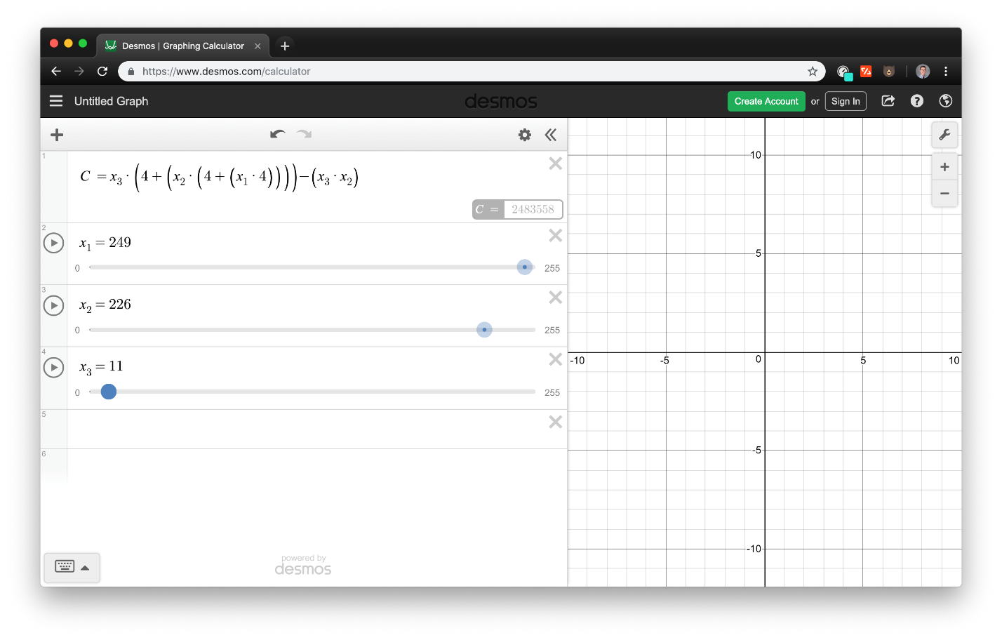

Figure 2: Our resultant calculation

4. Conclusion

In this lab, I grew comfortable calculating cycle counts of individual methods, as well as deploying and simulating assembly code on my own laptop. I also learned proper soldering methods for the first time, which was empowering to have confidence on when headed into future projects.

5. Appendix A: Source Code

A-1: main.asm

;;;;;;;;;;;;;;;;;;;;;;;;;;;;;;;;;;;;;;;;;;;;;;;;;;;;;;;;;;;;;;;;

; Assembly language file for Lab 2 in ECE:3360 (Embedded Systems)

; Spring 2018, The University of Iowa.

; Desc: runs the control logic for a button controlled counter

; B. Mitchinson, A. Powers

;;;;;;;;;;;;;;;;;;;;;;;;;;;;;;;;;;;;;;;;;;;;;;;;;;;;;;;;;;;;;;;;

.include "tn45def.inc"

.include "disp_values.inc" ; file with hex constants for 7-segment display

.dseg

.org 0x0060 ;Tiny45, Start in SRAM

disp_table: .byte 16

.cseg

.org 0x0000

; initialize SRAM

ldi r20, ZERO_DISP

sts disp_table, r20

ldi r20, ONE_DISP

sts disp_table+1, r20

ldi r20, TWO_DISP

sts disp_table+2, r20

ldi r20, THREE_DISP

sts disp_table+3, r20

ldi r20, FOUR_DISP

sts disp_table+4, r20

ldi r20, FIVE_DISP

sts disp_table+5, r20

ldi r20, SIX_DISP

sts disp_table+6, r20

ldi r20, SEVEN_DISP

sts disp_table+7, r20

ldi r20, EIGHT_DISP

sts disp_table+8, r20

ldi r20, NINE_DISP

sts disp_table+9, r20

ldi r20, A_DISP

sts disp_table+10, r20

ldi r20, B_DISP

sts disp_table+11, r20

ldi r20, C_DISP

sts disp_table+12, r20

ldi r20, D_DISP

sts disp_table+13, r20

ldi r20, E_DISP

sts disp_table+14, r20

ldi r20, F_DISP

sts disp_table+15, r20

clr r20

;;;;;;;;;;;;;;;;;;;;;;;;;;;;;;;;;;;;;;;;;;;;;;;;;;;;;;;;;;;;;;;;

.equ SER_IN = 0

.equ SRCK = 1

.equ RCK = 2

.equ PUSH_BUTTON = 4

;;;;;;;;;;;;;;;;;;;;;;;;;;;;;;;;;;;;;;;;;;;;;;;;;;;;;;;;;;;;;;;;

.DEF DISP_REG = r16

.DEF DISP_INS_REG = r17

.DEF PRESS_TIME_REG = r18

.DEF DEC_REG = r19

;;;;;;;;;;;;;;;;;;;;;;;;;;;;;;;;;;;;;;;;;;;;;;;;;;;;;;;;;;;;;;;;

; ATiny - Register Relations

; PB0 = SER_IN

; PB1 = SRCK

; PB2 = RCK

; PB4 = button input

; Configure PB0, PB1, and PB2 as output pins.

; Configure PB4 as input pins

;;;;;;;;;;;;;;;;;;;;;;;;;;;;;;;;;;;;;;;;;;;;;;;;;;;;;;;;;;;;;;;;

sbi DDRB,0

sbi DDRB,1

sbi DDRB,2

cbi DDRB,4

ldi ZL, low(disp_table) ;r30

ldi ZH, high(disp_table) ;r31

;;;;;;;;;;;;;;;;;;;;;;;;;;;;;;;;;;;;;;;;;;;;;;;;;;;;;;;;;;;;;;;;

; main method -- infinite loop to keep the controller responding to input

;;;;;;;;;;;;;;;;;;;;;;;;;;;;;;;;;;;;;;;;;;;;;;;;;;;;;;;;;;;;;;;;

rcall reset_routine ; reset display state

main:

nop

sbis PINB, PUSH_BUTTON ; if button pushed, next line will execute

rcall button_pressed ; react to the button press

rjmp main

;;;;;;;;;;;;;;;;;;;;;;;;;;;;;;;;;;;;;;;;;;;;;;;;;;;;;;;;;;;;;;;;

button_pressed:

clr PRESS_TIME_REG ; set initial state of counter to zero

rcall count_press

rjmp update

; count press sets certain register values associated with the length of button press

;;;;;;;;;;;;;;;;;;;;;;;;;;;;;;;;;;;;;;;;;;;;;;;;;;;;;;;;;;;;;;;;

count_press:

rcall sample_delay

cpi PRESS_TIME_REG, 255

brlo increment_time

sbis PINB, PUSH_BUTTON ; if button is still pressed, execute next line

rjmp count_press ; rjmp to this method

ret

increment_time:

inc PRESS_TIME_REG

sbis PINB, PUSH_BUTTON

rjmp count_press

;;;;;;;;;;;;;;;;;;;;;;;;;;;;;;;;;;;;;;;;;;;;;;;;;;;;;;;;;;;;;;;;

; sample_delay of 80000 cycles

;;;;;;;;;;;;;;;;;;;;;;;;;;;;;;;;;;;;;;;;;;;;;;;;;;;;;;;;;;;;;;;;

sample_delay:

ldi r23,20 ; r23 <-- Counter for outer loop

my_d1: ldi r24,24 ; r24 <-- Counter for level 2 loop

my_d2: ldi r25,41 ; r25 <-- Counter for inner loop

my_d3: dec r25

nop ; no operation

brne my_d3

dec r24

brne my_d2

dec r23

brne my_d1

ret

;;;;;;;;;;;;;;;;;;;;;;;;;;;;;;;;;;;;;;;;;;;;;;;;;;;;;;;;;;;;;;;;

; update the state based on the contents of PRESS_TIME_REG

;;;;;;;;;;;;;;;;;;;;;;;;;;;;;;;;;;;;;;;;;;;;;;;;;;;;;;;;;;;;;;;;

update:

cpi PRESS_TIME_REG, 200

brsh reset_routine

cpi PRESS_TIME_REG, 100

brsh toggle_routine

rjmp move_routine

;;;;;;;;;;;;;;;;;;;;;;;;;;;;;;;;;;;;;;;;;;;;;;;;;;;;;;;;;;;;;;;;

reset_routine:

nop

ldi ZL, 0x60

ld DISP_REG, Z

rcall toggle_dec_off

rjmp main

toggle_routine:

nop

cpi DEC_REG, 0x00

breq toggle_dec_on

cpi DEC_REG, 0x00

brne toggle_dec_off

rjmp main

move_routine:

nop

; branching:

; if dec -> if overflow: edit r30 (or) else dec

; if inc -> if overflow: edit r30 (or) else inc

cpi r30, 0x6F

breq pos_overflow

cpi r30, 0x60

breq neg_overflow

cpi DEC_REG, 0x01

brne pos_counter

cpi DEC_REG, 0x00

brne neg_counter

rjmp main ; saftey

neg_overflow:

cpi DEC_REG, 0x01

breq bottom_overflow

cpi DEC_REG, 0x01

brne pos_counter

rjmp main ; saftey

pos_overflow:

cpi DEC_REG, 0x00

breq reset_routine

cpi DEC_REG, 0x00

brne neg_counter

rjmp main

pos_counter:

ld DISP_REG, Z+

ld DISP_REG, Z

rcall display

rjmp main

neg_counter:

ld DISP_REG, -Z

ld DISP_REG, Z

rcall display

rjmp main

bottom_overflow:

ldi ZL, 0x6F

ld DISP_REG, Z

rcall display

rjmp main

toggle_dec_on:

ldi DEC_REG, 0x01

rcall display

rjmp main

toggle_dec_off:

ldi DEC_REG, 0x00

rcall display

rjmp main

; Display subroutine that prints to the LCD the associate hex value in DISP_REG

;;;;;;;;;;;;;;;;;;;;;;;;;;;;;;;;;;;;;;;;;;;;;;;;;;;;;;;;;;;;;;;;

add_dp:

sbr DISP_REG, 8

rjmp dp_return

remove_dp:

cbr DISP_REG, 8

rjmp dp_return

display:

cpi DEC_REG, 0x00

brne add_dp

cpi DEC_REG, 0x01

brne remove_dp

dp_return:

; backup used registers on stack

push DISP_REG

push DISP_INS_REG

in DISP_INS_REG, SREG

push DISP_INS_REG

ldi DISP_INS_REG, 8

; loop --> test all 8 bits

loop:

rol DISP_REG ;rotate left through Carry

BRCS set_ser_in_1

; branch if Carry set

; put code here to set SER_IN to 0

cbi PORTB, SER_IN

rjmp end

set_ser_in_1:

; put code here to set SER_IN to 1

sbi PORTB, SER_IN

end:

; put code here to generate SRCK pulse

sbi PORTB, SRCK

nop

nop

cbi PORTB, SRCK

dec DISP_INS_REG

brne loop

; put code here to generate RCK pulse

sbi PORTB, RCK

nop

nop

cbi PORTB, RCK

; restore registers from stack

pop DISP_INS_REG

out SREG, DISP_INS_REG

pop DISP_INS_REG

pop DISP_REG

ret

;;;;;;;;;;;;;;;;;;;;;;;;;;;;;;;;;;;;;;;;;;;;;;;;;;;;;;;;;;;;;;;;

; end of program -- should never be reached due to main infinite loop

.exit