Alexander Powers

Prof. Guadalupe Canahuate

ECE:5995 Modern Databases

September 24, 2020

Homework One Report

This homework centered around the creation of eight queries of a relatively small dataset consisting of three tables, users, user_stats, and reviews. The development of these queries used a range of PostgreSQL functionality including functions, and fairly complex SELECT statements to generate the queries of interest.

I made the decision to add my index to the userid attribute of the reviews table. My reasoning for this was to improve the performance of the join operation in queries six and seven. The bar chart below details the performance change of the queries with each type of index. Within each query, there are three bars for each of the three runs (left to right: no index, hash index, clustered b-tree index).

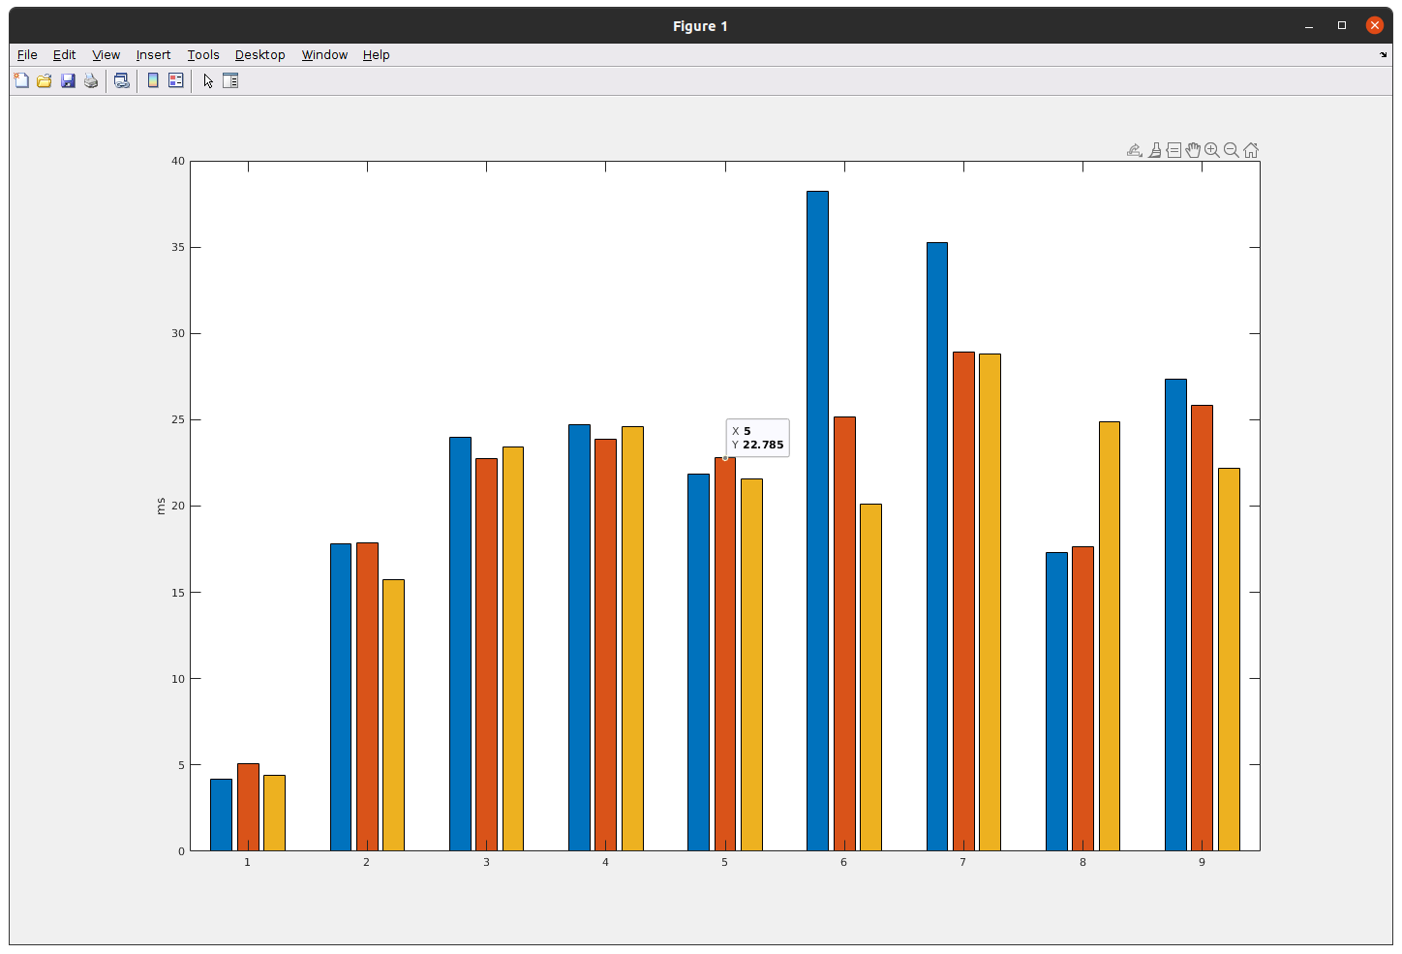

I saw the most drastic changes in queries six and seven. This was expected, as both the hash and clustered b-tree improve the performance of the INNER JOIN operation that is the cornerstone of those queries.

Appendix

*-- create user_stats table*

CREATE TABLE IF NOT EXISTS homework.user_stats (

userid character(20) NOT NULL,

ageGroup character(6), *-- groupX*

averageRating decimal,

reviewCount integer,

lastPosted date,

helpfulNum integer,

helpfulDenum integer,

helpfulnessRate decimal

);

*-- create rule to update the user_stats table*

CREATE

OR REPLACE FUNCTION update_user_stats(

input_userid character(20)

) RETURNS boolean AS $did_insert$

DECLARE

did_insert boolean := false;

the_user_id text;

the_user_age integer;

local_ageGroup character(6); *-- groupX*

local_averageRating decimal;

local_reviewCount integer;

local_lastPosted date;

local_helpfulNum integer;

local_helpfulDenum integer;

local_helpfulnessRate decimal;

BEGIN

*-- determine if the user is already in the user_stats table*

SELECT userid INTO the_user_id

FROM user_stats u

WHERE u.userid = input_userid

LIMIT 1;

*-- compute all of the attributes*

*-- compute ageGroup*

SELECT date_part('year', age(dob)) INTO the_user_age

FROM users u

WHERE u.userid = input_userid

LIMIT 1;

IF the_user_age < 30 THEN

local_ageGroup := 'group1';

ELSEIF 30 <= the_user_age AND the_user_age <= 50 THEN

local_ageGroup := 'group2';

ELSEIF the_user_age > 50 THEN

local_ageGroup := 'group3';

ELSE

local_ageGroup := NULL;

END IF;

*-- compute averageRating*

SELECT AVG(score) INTO local_averageRating

FROM reviews r

WHERE r.userid = input_userid;

*-- compute reviewCount*

SELECT COUNT(*) INTO local_reviewCount

FROM reviews r

WHERE r.userid = input_userid;

*-- compute lastPosted*

SELECT dposted INTO local_lastPosted

FROM reviews r

WHERE r.userid = input_userid

ORDER BY dposted DESC

LIMIT 1;

*-- compute helpfulNumiewCount*

SELECT SUM(helpfulnessnumerator) INTO local_helpfulNum

FROM reviews r

WHERE r.userid = input_userid;

*-- compute helpfulDenum*

SELECT SUM(helpfulnessdenominator) INTO local_helpfulDenum

FROM reviews r

WHERE r.userid = input_userid;

if local_helpfulDenum = 0 THEN

local_helpfulnessRate := 0;

ELSE

local_helpfulnessRate := local_helpfulNum::NUMERIC / local_helpfulDenum::NUMERIC;

END IF;

IF the_user_id IS NULL THEN *-- create new user_stats*

INSERT INTO

user_stats (userid, ageGroup, averageRating, reviewCount, lastPosted, helpfulNum, helpfulDenum, helpfulnessRate)

VALUES

(input_userid, local_ageGroup, local_averageRating, local_reviewCount, local_lastPosted, local_helpfulNum, local_helpfulDenum, local_helpfulnessRate) RETURNING userid INTO the_user_id;

did_insert := true;

ELSE *-- update existing user_stats*

UPDATE

user_stats

SET ageGroup = local_ageGroup, averageRating = local_averageRating, reviewCount = local_reviewCount, lastPosted = local_lastPosted, helpfulNum = local_helpfulNum, helpfulDenum = local_helpfulDenum, helpfulnessRate = local_helpfulnessRate

WHERE

userid = input_userid;

END IF;

RETURN did_insert;

END;

$did_insert$ LANGUAGE plpgsql;

*-- populate the table*

*SELECT update_user_stats(userid) from users;*

Q1

*-- The number of users' birthdays per month*

SELECT date_part('month', dob) AS dob_month, COUNT(userid) AS user_count

FROM users

GROUP BY dob_month

ORDER BY dob_month ASC;

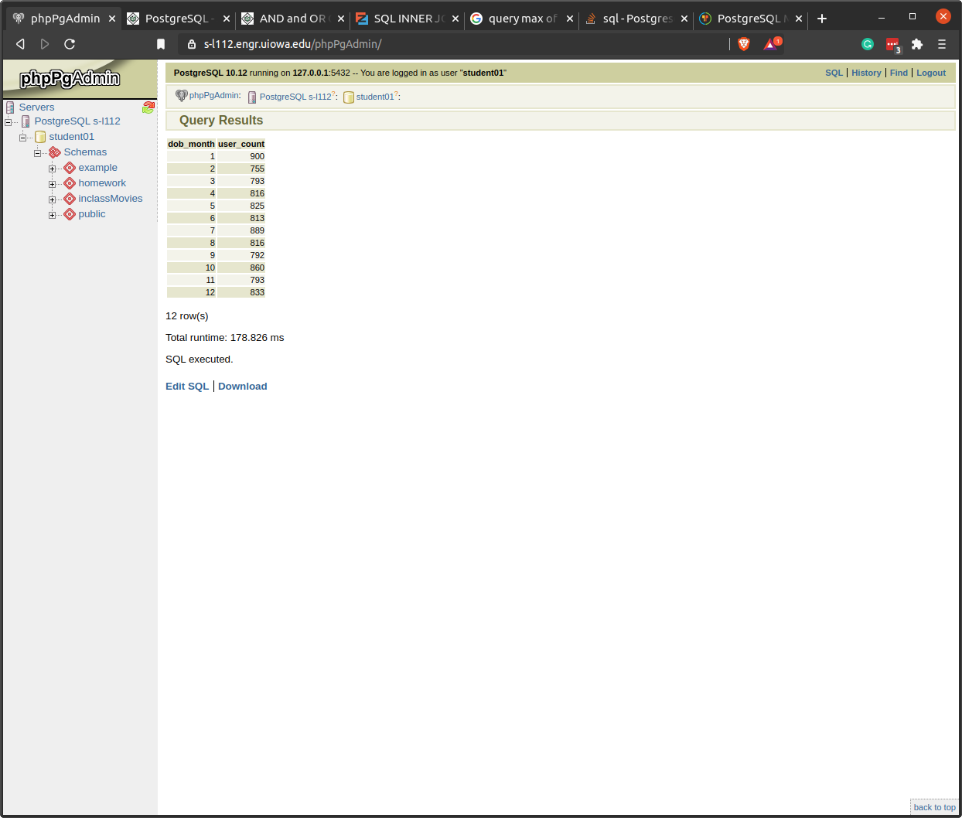

Q2

*-- The number of males/females users per age group.*

SELECT ageGroup, gender, count(*)

FROM users INNER JOIN user_stats ON (users.userid = user_stats.userid)

GROUP BY ageGroup, gender;

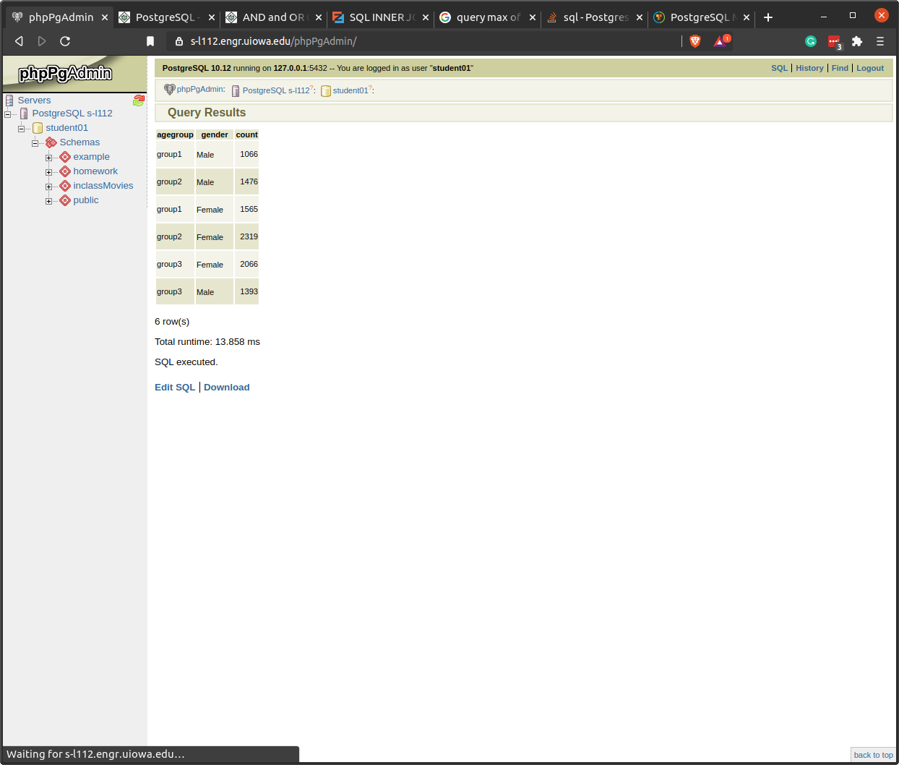

Q3

*-- Who had posted the most reviews? (Full name, email, gender, age, reviewcount)*

SELECT CONCAT(firstname, ' ', lastname) AS fullname, email, AGE(dob) as u_age, reviewCount

FROM users INNER JOIN user_stats ON (users.userid = user_stats.userid)

ORDER BY reviewCount DESC

LIMIT 1;

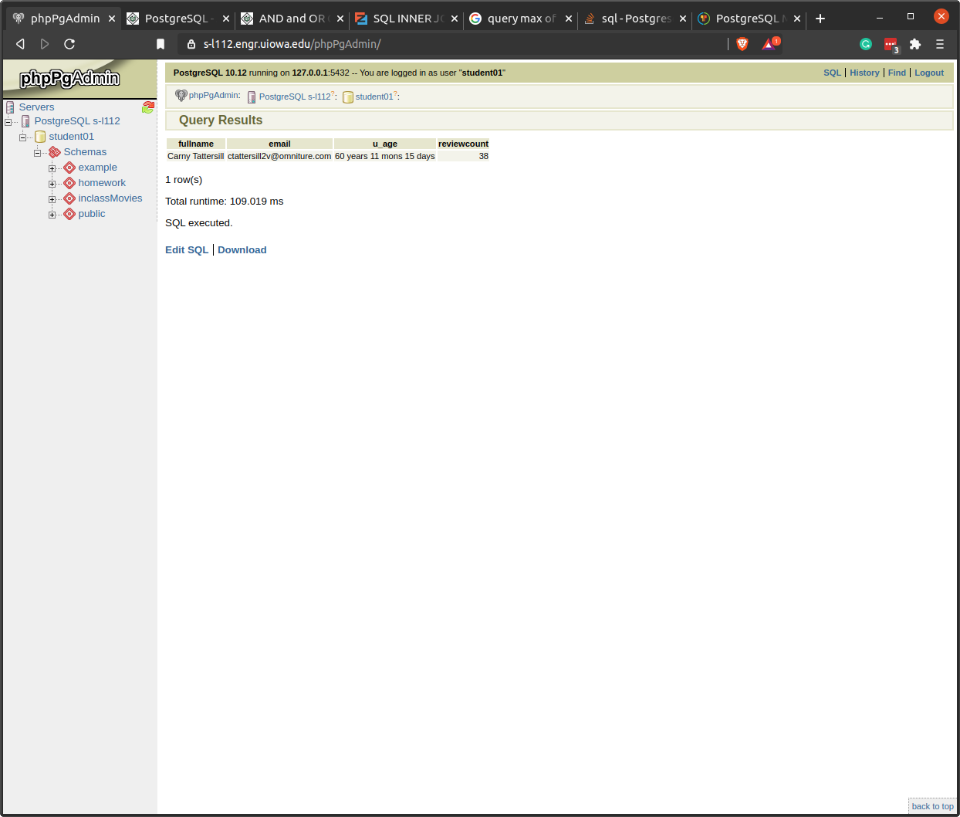

Q4

*--Who writes the most helpful reviews? (Full name, email, gender, age, helfulnessrate, and helpfuldenum) - break the ties using the helpfulDenum.*

SELECT CONCAT(firstname, ' ', lastname) AS fullname, email, AGE(dob) as u_age, helpfulnessRate, helpfulDenum

FROM users INNER JOIN user_stats ON (users.userid = user_stats.userid)

ORDER BY helpfulnessrate DESC NULLS LAST, helpfulDenum DESC

LIMIT 1;

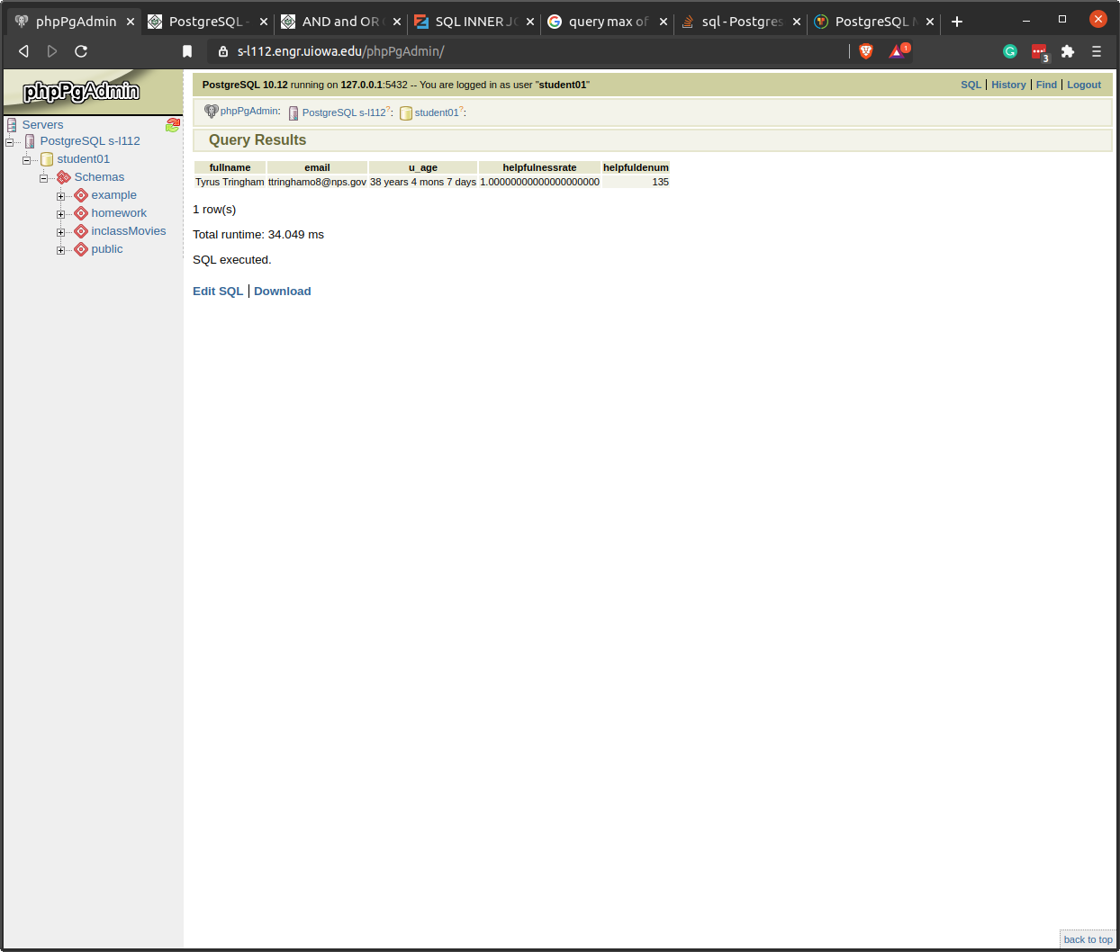

Q5

*-- Who posted last? (Full name, email, gender, age, and lastposted)*

SELECT CONCAT(firstname, ' ', lastname) AS fullname, email, AGE(dob) as u_age, lastPosted

FROM users INNER JOIN user_stats ON (users.userid = user_stats.userid)

ORDER BY lastPosted DESC NULLS LAST

LIMIT 1;

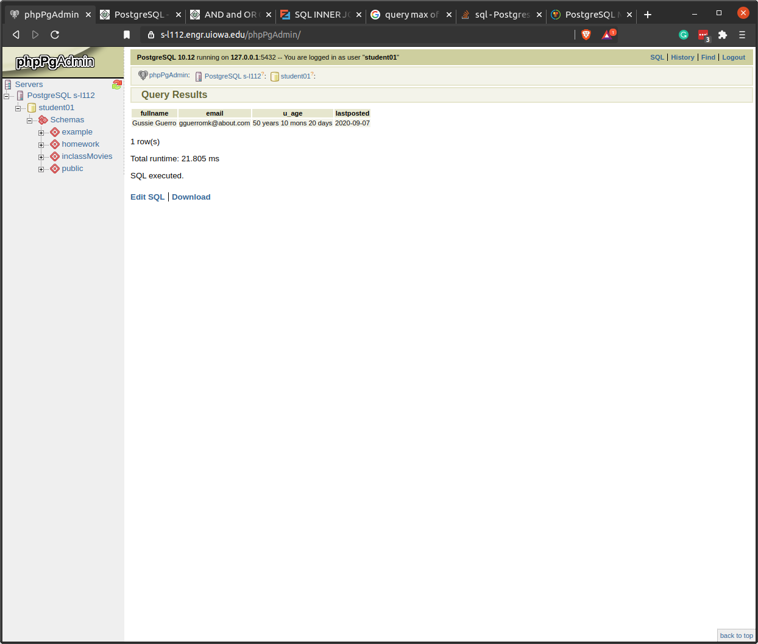

Q6

*-- Find the review count and averageRating per ageGroup for each product.*

*-- Show productid, ageGroup, reviewCount, and averageRating.*

SELECT productid, ageGroup, SUM(reviewCount) AS review_count, AVG(score) AS avg_rating

FROM reviews INNER JOIN user_stats ON (reviews.userid = user_stats.userid)

WHERE

productid = 'B004JRKEH4' OR

productid = 'B004X3VRLG' OR

productid = 'B0026RQTGE' OR

productid = 'B001BM3C0Q' OR

productid = 'B007K449CE'

GROUP BY productid, ageGroup;

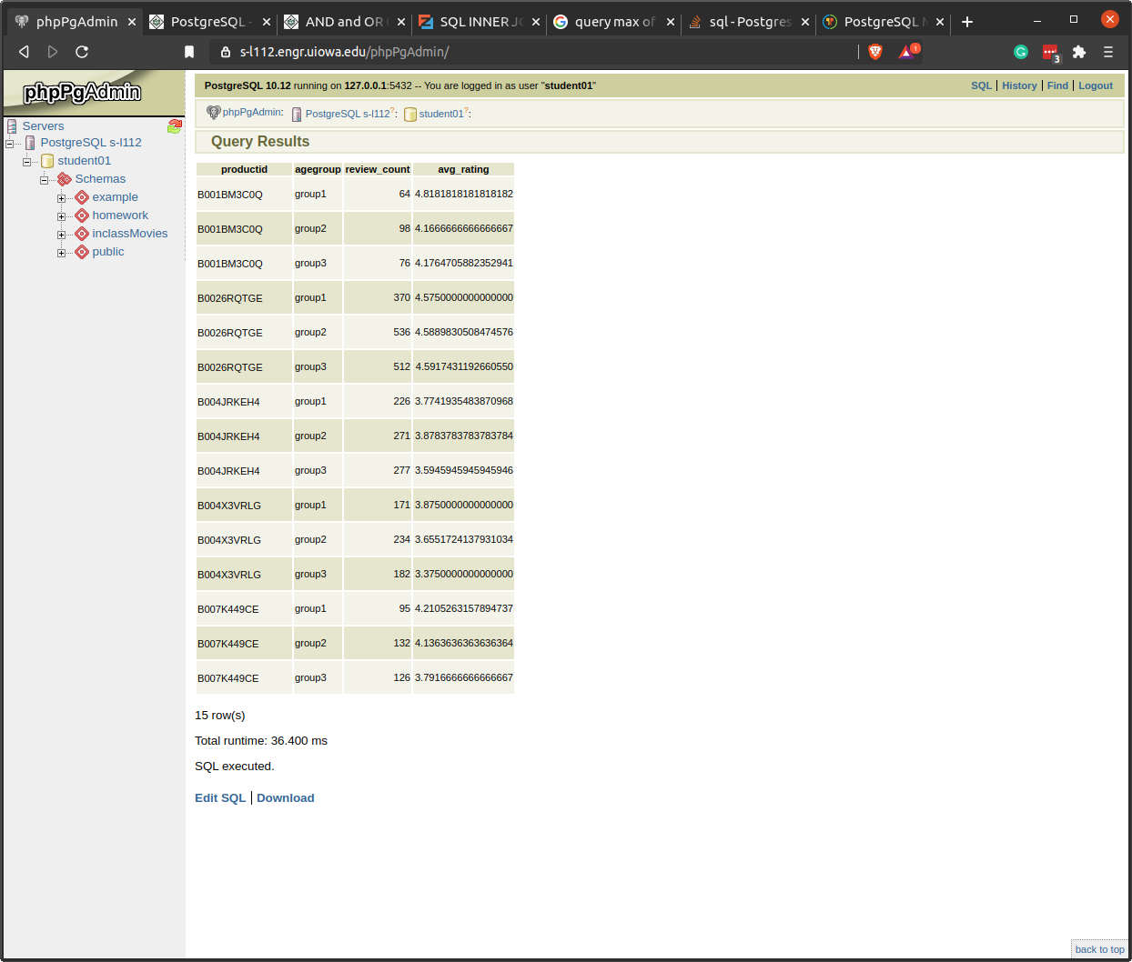

Q7

*-- Find the review count and averageRating per gender for each product.*

*-- Show productid, gender, count, and average rating.*

SELECT productid, gender, SUM(reviewCount) AS review_count, AVG(score) AS avg_rating

FROM reviews

INNER JOIN user_stats ON (reviews.userid = user_stats.userid)

INNER JOIN users ON (reviews.userid = users.userid)

WHERE

productid = 'B004JRKEH4' OR

productid = 'B004X3VRLG' OR

productid = 'B0026RQTGE' OR

productid = 'B001BM3C0Q' OR

productid = 'B007K449CE'

GROUP BY productid, gender;

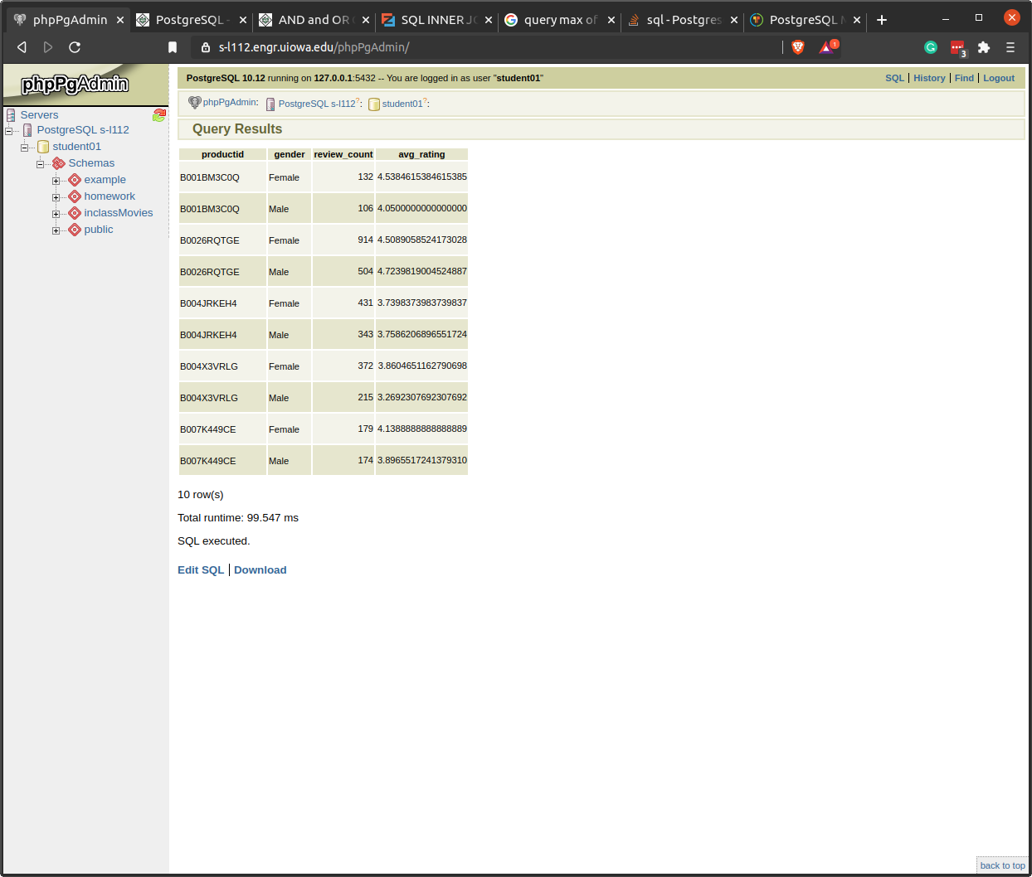

Q8

*-- Find the most helpful, highest rated review and the most helpful, lowest rated review for each product.*

*-- Show the full review (productid, userid, helpfulnessnumerator, helpfulnessdenominator, score, dposted, summary, review).*

*-- best score*

SELECT DISTINCT ON (productid) productid, userid, helpfulnessnumerator, helpfulnessdenominator, score, dposted, summary, review

FROM reviews r

WHERE

productid = 'B004JRKEH4' OR

productid = 'B004X3VRLG' OR

productid = 'B0026RQTGE' OR

productid = 'B001BM3C0Q' OR

productid = 'B007K449CE'

ORDER BY productid,

CASE

WHEN helpfulnessdenominator = 0 THEN 0

WHEN helpfulnessdenominator != 0 THEN helpfulnessnumerator::numeric/NULLIF(helpfulnessdenominator::numeric,0)

END DESC NULLS LAST, score DESC NULLS LAST, helpfulnessdenominator DESC NULLS LAST;

*-- worst score*

SELECT DISTINCT ON (productid) productid, userid, helpfulnessnumerator, helpfulnessdenominator, score, dposted, summary, review

FROM reviews r

WHERE

productid = 'B004JRKEH4' OR

productid = 'B004X3VRLG' OR

productid = 'B0026RQTGE' OR

productid = 'B001BM3C0Q' OR

productid = 'B007K449CE'

ORDER BY productid,

CASE

WHEN helpfulnessdenominator = 0 THEN 0

WHEN helpfulnessdenominator != 0 THEN helpfulnessnumerator::numeric/NULLIF(helpfulnessdenominator::numeric,0)

END DESC NULLS LAST, score ASC NULLS LAST, helpfulnessdenominator DESC NULLS LAST;