Software Requirements Specification
for
YouFeelings
Aspect-Based YouTube Recommender System
Version 3.1 (Final)
Prepared by: Samyak Dubey · Ashab Rahman
Advisor: Prof. Jeff Salvage
Course: CI 491 / 492 / 493 · Senior Project
Department: College of Computing & Informatics, Drexel University
Term: Winter / Spring / Summer 2026

Table of Contents

1. Document History
Name | Date | Reason | Version
Samyak Dubey, Ashab Rahman | Apr 7, 2026 | Initial Draft — Introduction, Scope, Definitions. | 1.0
Samyak Dubey, Ashab Rahman | May 5, 2026 | Full SRS — UI/Functional & Nonfunctional Requirements, System Evolution. Rebranded NetFeelings → YouFeelings. | 2.0
Samyak Dubey, Ashab Rahman | Jun 2026 | Finalized — completed all sections and realigned requirement numbering. | 3.0
Samyak Dubey, Ashab Rahman | Jun 2026 | Revised — switched to Times New Roman; reduced implementation detail (moved to the Design Document); replaced UI prose with product screenshots. | 3.1

2. Introduction

2.1 Purpose
This document specifies the software requirements for YouFeelings, an aspect-based YouTube recommender system. It describes what the system must do, the screens the user interacts with, and how well the system must perform. It is the agreement between the development team (Samyak Dubey and Ashab Rahman) and the project advisor (Prof. Jeff Salvage) about the product's behavior.
Implementation details — system architecture, model designs, algorithms, and deployment — are documented separately in the YouFeelings Design Document. This SRS focuses on requirements (the what), not implementation (the how).

2.2 Overview
Today's YouTube recommendations optimize for engagement signals such as watch time and click-through rate. They do not explain why a video is suggested, and they do not capture the specific qualities that drive individual taste — content quality, entertainment value, creator personality, production quality, or informativeness.
YouFeelings is a hybrid recommender that combines three complementary signals to deliver personalized, explainable recommendations:
- Aspect sentiment: Reads YouTube comments to understand how viewers feel about five aspects — content, entertainment, creator, production, and informativeness.
- Collaborative filtering: Learns taste patterns from watch history (“viewers like you also watched…”).
- Content matching: Matches channels by their characteristics, such as category, popularity, and upload frequency.
These three signals are combined into a single ranked list (default weighting: 40% aspect sentiment, 35% collaborative, 25% content matching), and each recommendation comes with a plain-language reason.
Users interact with the system through a web application. They upload their YouTube watch history (exported via Google Takeout) and receive personalized recommendations with an explanation of why each one was chosen.

2.3 Scope
YouFeelings is developed as a working prototype for CI 491/492/493 (Senior Project) at Drexel University.
In Scope
- Collecting and cleaning YouTube comments for sentiment analysis
- Aspect-level sentiment across five aspects and four sentiment categories
- Collaborative filtering from user watch history (supplemented with synthetic users)
- Content matching using channel characteristics
- A combined, explainable recommendation list
- A web application for uploading watch history and viewing recommendations
Out of Scope
- Real-time integration with YouTube's own recommendation algorithm
- Browser extension or YouTube plugin
- Mobile application
- Non-English comment analysis
- Production-scale deployment or horizontal scaling

2.4 Definitions
Term | Definition
Aspect | A specific dimension of content the system evaluates: content, entertainment, creator, production, or informativeness.
Aspect sentiment (ABSA) | Determining how viewers feel about each aspect, rather than an overall positive/negative judgment.
Collaborative filtering | Recommending based on the behavior of similar users (“people like you also watched…”).
Content matching | Recommending channels that are similar in their characteristics (category, popularity, upload frequency).
Hybrid recommendation | Combining several recommendation signals into one ranked list.
Google Takeout | Google's data-export service; the source of a user's YouTube watch history.
Implicit feedback | Preference inferred from behavior (what a user watches) rather than explicit ratings.
Cold start | Recommending for a new user or channel with little or no history.
Synthetic users | Artificially generated user profiles that mimic real viewing patterns, used to supplement limited real data during training.

2.5 Requirements Apportioning
Priority | Description
Priority 1 | Essential for a functioning prototype. Must be completed and verified before the final presentation.
Priority 2 | Enhances user experience or quality but is not critical to core functionality. Implemented if time permits.
Priority 3 | Future enhancements beyond the current capstone scope.

3. User Interface & Functional Requirements

3.1 User Interface
The application has two main screens: an upload screen and a recommendations screen. Screenshots of the current product follow.

3.1.1 Upload Screen
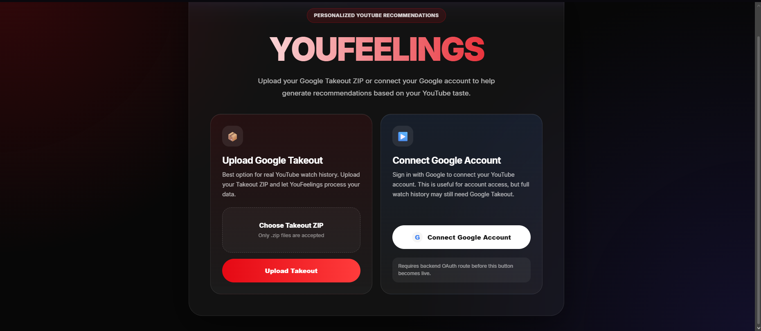
Figure 1. Upload screen — users upload a Google Takeout ZIP or connect their Google account.
Req ID | Description | Priority
R3.1.1.1 | The system shall let the user upload their Google Takeout export as a .zip file. | 1
R3.1.1.2 | The system shall accept only .zip files and show a clear message if the upload fails. | 1
R3.1.1.3 | The system shall provide an option to connect a Google account (where available). | 2
R3.1.1.4 | The system shall guide users to export only their YouTube history to keep the file small. | 2

3.1.2 Recommendations Screen
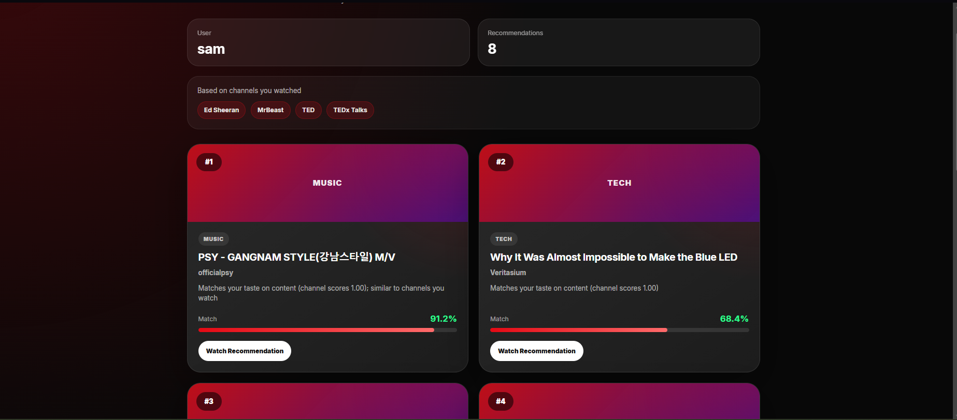
Figure 2. Recommendations screen — ranked cards with category, title, match score, and a reason.
Req ID | Description | Priority
R3.1.2.1 | The system shall display a ranked list of recommended videos/channels as cards. | 1
R3.1.2.2 | Each card shall show the title, a category label, a match percentage, and a short reason for the recommendation. | 1
R3.1.2.3 | The screen shall summarize the channels the recommendations are based on (“Based on channels you watched”). | 1
R3.1.2.4 | Each card shall provide a link to watch the recommendation on YouTube. | 1
R3.1.2.5 | The system shall display at least 10 recommendations per request. | 2

3.2 Data Pipeline Functional Requirements

3.2.1 Comment Collection
Req ID | Description | Priority
R3.2.1.1 | The system shall collect comments from YouTube videos using the YouTube Data API. | 1
R3.2.1.2 | The system shall stay within the daily API quota and stop gracefully before exceeding it. | 1
R3.2.1.3 | The system shall record collection statistics and skip videos that fail (e.g., comments disabled) without halting the batch. | 1

3.2.2 Comment Preprocessing
Req ID | Description | Priority
R3.2.2.1 | The system shall remove non-English, spam, and very short comments before analysis. | 1
R3.2.2.2 | The system shall report how many comments were kept versus filtered, and why. | 1

3.2.3 Watch-History Import
Req ID | Description | Priority
R3.2.3.1 | The system shall import a user's YouTube watch history from a Google Takeout export (HTML or JSON). | 1
R3.2.3.2 | The system shall infer a preference signal from how often a user watches each channel. | 1
R3.2.3.3 | The import shall be covered by an automated test suite. | 1

3.2.4 Synthetic Data Generation
Req ID | Description | Priority
R3.2.4.1 | The system shall generate synthetic users to supplement the limited pool of real users. | 1
R3.2.4.2 | Synthetic users shall preserve the co-viewing patterns found in real data. | 1
R3.2.4.3 | Synthetic users shall be used only for training, never for evaluation. | 1

3.3 Recommendation Functional Requirements

3.3.1 Aspect Sentiment
Req ID | Description | Priority
R3.3.1.1 | The system shall analyze YouTube comments to determine sentiment toward five aspects: content, entertainment, creator, production, and informativeness. | 1
R3.3.1.2 | For each aspect, the system shall classify sentiment as positive, negative, neutral, or none. | 1
R3.3.1.3 | The system shall produce an aspect-level profile for each channel, summarizing sentiment across its comments. | 1

3.3.2 Collaborative Filtering
Req ID | Description | Priority
R3.3.2.1 | The system shall learn user–channel preference patterns from watch history. | 1
R3.3.2.2 | The system shall estimate how likely a user is to enjoy a channel they have not yet watched. | 1

3.3.3 Content Matching
Req ID | Description | Priority
R3.3.3.1 | The system shall recommend channels similar to those a user already watches, based on channel characteristics. | 1
R3.3.3.2 | Content matching shall serve as a fallback for new users with little or no watch history. | 1

3.3.4 Hybrid Recommendation
Req ID | Description | Priority
R3.3.4.1 | The system shall combine the three signals into a single ranked recommendation list. | 1
R3.3.4.2 | The system shall weight the signals (default: 40% aspect sentiment, 35% collaborative, 25% content matching). | 1
R3.3.4.3 | Each recommendation shall include a plain-language explanation of why it was chosen. | 1
R3.3.4.4 | When a signal is unavailable for a user, the system shall produce recommendations from the remaining signals. | 1

3.4 Application & Service Requirements
Req ID | Description | Priority
R3.4.1 | The system shall provide a web service that accepts an uploaded watch history and returns recommendations. | 1
R3.4.2 | The system shall support large upload files without failing on size or timeout. | 1
R3.4.3 | The system shall process uploads in the background and indicate progress to the user. | 2
R3.4.4 | The recommendations response shall contain at least 10 ranked items, each with a score and explanation. | 1

4. Nonfunctional Requirements

4.1 Performance
Req ID | Description | Priority
R4.1.1 | The system shall process a single video's comments within roughly 30 seconds, subject to YouTube API response times. | 1
R4.1.2 | The full pipeline (upload → processing → recommendations) shall complete within about 5 minutes for a typical watch history. | 2
R4.1.3 | The web interface shall display recommendations within about 2 seconds of receiving results. | 1

4.2 API Quota Constraints
Req ID | Description | Priority
R4.2.1 | The system shall not exceed the daily YouTube Data API quota (10,000 units by default). | 1
R4.2.2 | The system shall log API usage and stop before the quota is exhausted. | 1

4.3 Security & Privacy
Req ID | Description | Priority
R4.3.1 | API keys and credentials shall be stored securely and never committed to the source repository. | 1
R4.3.2 | Uploaded watch-history files shall be handled privately, used only for generating recommendations, and removed on request. | 1
R4.3.3 | The system shall validate and sanitize user inputs. | 1
R4.3.4 | Any Google sign-in shall request only the minimum permissions needed. | 2

4.4 Error Handling
Req ID | Description | Priority
R4.4.1 | The system shall continue processing when individual videos or comments fail, rather than aborting. | 1
R4.4.2 | The interface shall show user-friendly messages for upload, processing, and timeout errors. | 1
R4.4.3 | If part of the analysis is unavailable, the system shall still produce recommendations and indicate reduced confidence. | 2

4.5 Operating Environment
Req ID | Description | Priority
R4.5.1 | The system shall run as a cloud-hosted web application. | 1
R4.5.2 | Model training may require GPU resources; everyday use and serving shall run on standard hardware. | 2
R4.5.3 | The user shall access the system through a modern web browser; no installation shall be required. | 1

5. System Overview
At a high level, YouFeelings works as a pipeline:
- The user uploads their YouTube watch history through the web application.
- The system imports the history and analyzes related comments and channel data.
- Three signals — aspect sentiment, collaborative filtering, and content matching — each score candidate channels.
- The signals are combined into a single ranked, explained recommendation list.
- The web application presents the recommendations to the user.
The detailed system architecture, component design, model specifications, and deployment are documented separately in the YouFeelings Design Document.

6. System Evolution

6.1 Known Limitations
The following limitations of the current prototype are documented for transparency:
- Training data imbalance: The current training data over-represents some aspects (e.g., creator) and under-represents others (e.g., production quality), and has few negative and no neutral examples. Additional human-labeled data is needed.
- Metrics pending: Sentiment results to date come from an automatically generated training set used to validate the pipeline. Final quality metrics await human-labeled data.
- Synthetic data accuracy: Synthetic users match real viewers well for popular channels but less so for niche channels; more real users would improve this.
- Recommendation tuning: Combining the three signals so their weights are meaningful is an ongoing tuning task.
- Cold start: Recommending for brand-new users with little history remains challenging; content matching is used as a fallback.

6.2 Planned Improvements (Priority 2)
Req ID | Description | Priority
R6.2.1 | Add human-labeled comments to improve sentiment quality and cover the neutral category. | 2
R6.2.2 | Collect more real users to improve synthetic-data accuracy for less-popular channels. | 2
R6.2.3 | Let users rate recommendations (thumbs up/down) to personalize the experience. | 2
R6.2.4 | Tune how the three signals are combined automatically rather than using fixed weights. | 2

6.3 Future Enhancements (Priority 3)
Req ID | Description | Priority
R6.3.1 | Connect to YouTube directly so users don't need a manual Takeout export. | 3
R6.3.2 | A browser extension that surfaces recommendations on YouTube. | 3
R6.3.3 | A mobile application. | 3
R6.3.4 | Support for non-English comments. | 3
R6.3.5 | Let users give explicit ratings in addition to watch history. | 3

6.4 Verification & Acceptance
- Automated tests: Data import and preprocessing are covered by automated tests (the import suite currently has 35 passing tests).
- Model validation: Recommendation quality is validated on real users held out from training; synthetic users are never used for evaluation.
- Acceptance: Acceptance requires demonstrating the working system and meeting every Priority-1 requirement.
- Status note: Final sentiment-quality metrics are reported as pending until human-labeled data is available.

