**ASSIGNMENT – 2**

**i) There are two nodes A and B. Write a program to determine CPU load of node B from node A.**

// node_b_cpu_load_server.c

#include <stdio.h>

#include <stdlib.h>

#include <string.h>

#include <unistd.h>

#include <sys/socket.h>

#include <netinet/in.h>

#include <arpa/inet.h>

#include <sys/sysinfo.h>

#define PORT 12345

#define BUFFER_SIZE 256

void get_cpu_load(char *buffer) {

struct sysinfo info;

if (sysinfo(&info) == 0) {

snprintf(buffer, BUFFER_SIZE, "Load average: %f, %f, %f",

info.loads[0] / (float)(1 << SI_LOAD_SHIFT),

info.loads[1] / (float)(1 << SI_LOAD_SHIFT),

info.loads[2] / (float)(1 << SI_LOAD_SHIFT));

} else {

snprintf(buffer, BUFFER_SIZE, "Failed to get CPU load.");

}

}

int main() {

int server_fd, new_socket;

struct sockaddr_in address;

int addrlen = sizeof(address);

char buffer[BUFFER_SIZE] = {0};

// Create socket

if ((server_fd = socket(AF_INET, SOCK_STREAM, 0)) == 0) {

perror("Socket creation error");

exit(EXIT_FAILURE);

}

// Set up the server address structure

address.sin_family = AF_INET;

address.sin_addr.s_addr = INADDR_ANY;

address.sin_port = htons(PORT);

// Bind the socket to the address and port

if (bind(server_fd, (struct sockaddr *)&address, sizeof(address)) < 0) {

perror("Bind failed");

close(server_fd);

exit(EXIT_FAILURE);

}

// Listen for incoming connections

if (listen(server_fd, 3) < 0) {

perror("Listen failed");

close(server_fd);

exit(EXIT_FAILURE);

}

printf("Waiting for connection...\n");

// Accept a connection

if ((new_socket = accept(server_fd, (struct sockaddr *)&address, (socklen_t*)&addrlen)) < 0) {

perror("Accept failed");

close(server_fd);

exit(EXIT_FAILURE);

}

// Get CPU load and send it to the client

get_cpu_load(buffer);

send(new_socket, buffer, strlen(buffer), 0);

printf("CPU load sent to the client: %s\n", buffer);

close(new_socket);

close(server_fd);

return 0;

}



// node_a_cpu_load_client.c

#include <stdio.h>

#include <stdlib.h>

#include <string.h>

#include <unistd.h>

#include <sys/socket.h>

#include <netinet/in.h>

#include <arpa/inet.h>

#define PORT 12345

#define BUFFER_SIZE 256

int main(int argc, char *argv[]) {

int sock = 0;

struct sockaddr_in serv_addr;

char buffer[BUFFER_SIZE] = {0};

if (argc != 2) {

fprintf(stderr, "Usage: %s <server_ip>\n", argv[0]);

return EXIT_FAILURE;

}

// Create socket

if ((sock = socket(AF_INET, SOCK_STREAM, 0)) < 0) {

perror("Socket creation error");

return EXIT_FAILURE;

}

serv_addr.sin_family = AF_INET;

serv_addr.sin_port = htons(PORT);

// Convert IP address from text to binary form

if (inet_pton(AF_INET, argv[1], &serv_addr.sin_addr) <= 0) {

perror("Invalid address/ Address not supported");

close(sock);

return EXIT_FAILURE;

}

// Connect to the server

if (connect(sock, (struct sockaddr *)&serv_addr, sizeof(serv_addr)) < 0) {

perror("Connection failed");

close(sock);

return EXIT_FAILURE;

}

// Read the CPU load from the server

read(sock, buffer, sizeof(buffer));

printf("Received from server: %s\n", buffer);

close(sock);

return 0;

}

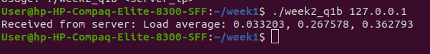

**ii) Write a server C program using shared memory and semaphore (server increments counter between sem_wait() and sem_post()). Create shared memory using mmap.**

// shared_memory_server.c

#include <stdio.h>

#include <stdlib.h>

#include <unistd.h>

#include <sys/mman.h>

#include <fcntl.h>

#include <sys/stat.h>

#include <semaphore.h>

#include <sys/types.h>

#define SHARED_MEM_NAME "/my_shm"

#define SEM_NAME "/my_sem"

#define SHM_SIZE sizeof(int)

int main() {

int fd;

int *counter;

sem_t *sem;

// Create or open the shared memory

fd = shm_open(SHARED_MEM_NAME, O_CREAT | O_RDWR, 0666);

if (fd == -1) {

perror("shm_open");

exit(EXIT_FAILURE);

}

ftruncate(fd, SHM_SIZE);

// Map shared memory

counter = mmap(NULL, SHM_SIZE, PROT_READ | PROT_WRITE, MAP_SHARED, fd, 0);

if (counter == MAP_FAILED) {

perror("mmap");

exit(EXIT_FAILURE);

}

// Initialize the counter

*counter = 0;

// Create or open semaphore

sem = sem_open(SEM_NAME, O_CREAT, 0666, 1);

if (sem == SEM_FAILED) {

perror("sem_open");

exit(EXIT_FAILURE);

}

// Increment the counter with semaphore protection

while (1) {

sem_wait(sem);

(*counter)++;

printf("Counter incremented to %d\n", *counter);

sem_post(sem);

sleep(1);

}

// Clean up

sem_close(sem);

sem_unlink(SEM_NAME);

munmap(counter, SHM_SIZE);

shm_unlink(SHARED_MEM_NAME);

return 0;

}

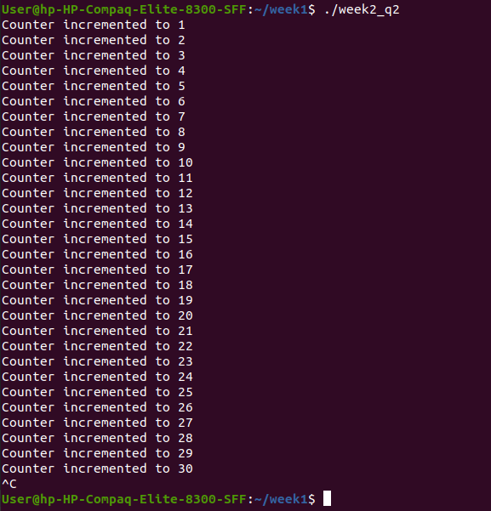

**iii) Write a client C program that reads counter value between sem_wait() and sem_post(). Access shared memory using open().**

// shared_memory_client.c

#include <stdio.h>

#include <stdlib.h>

#include <unistd.h>

#include <sys/mman.h>

#include <fcntl.h>

#include <sys/stat.h>

#include <semaphore.h>

#define SHARED_MEM_NAME "/my_shm"

#define SEM_NAME "/my_sem"

#define SHM_SIZE sizeof(int)

int main() {

int fd;

int *counter;

sem_t *sem;

// Open the shared memory

fd = shm_open(SHARED_MEM_NAME, O_RDWR, 0666);

if (fd == -1) {

perror("shm_open");

exit(EXIT_FAILURE);

}

// Map shared memory

counter = mmap(NULL, SHM_SIZE, PROT_READ, MAP_SHARED, fd, 0);

if (counter == MAP_FAILED) {

perror("mmap");

exit(EXIT_FAILURE);

}

// Open semaphore

sem = sem_open(SEM_NAME, 0);

if (sem == SEM_FAILED) {

perror("sem_open");

exit(EXIT_FAILURE);

}

// Read the counter value

while (1) {

sem_wait(sem);

printf("Current counter value: %d\n", *counter);

sem_post(sem);

sleep(1);

}

// Clean up

sem_close(sem);

munmap(counter, SHM_SIZE);

return 0;

}

