Custom List [ ] – General Guide & Usage

By Abraham Sanchez Namespace: Custom_List

Minus Operator Overload –

Subtracts the right side object/s from the left side of the minus sign. Returns the leftover value in a new custom_list.

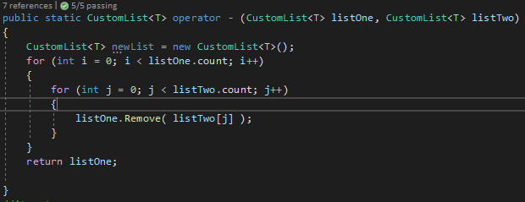

Parameters –

1st parameter – CustomList<T> listOne | 2nd parameter – CustomList<T> listTwo

The minus operator has two parameters, both of which are of the CustomList<T> class. The first parameter is the list that appears on the left-hand side of the minus operator and is the object that will be getting subtracted from. The second parameter is the list that appears on the right of the minus operator. This holds the values that will be removed from the first parameter if values match.

Return Type –

new CustomList<T>

The returned value will be a newly created list with the values left over from the first parameter. If none of the values match between listOne and listTwo, then the result is a new identical list to listOne.

Examples –

The following below demonstrates the minus operator in action using the CustomList<T> object.

