**INFORMATION PRACTICES PROJECT**

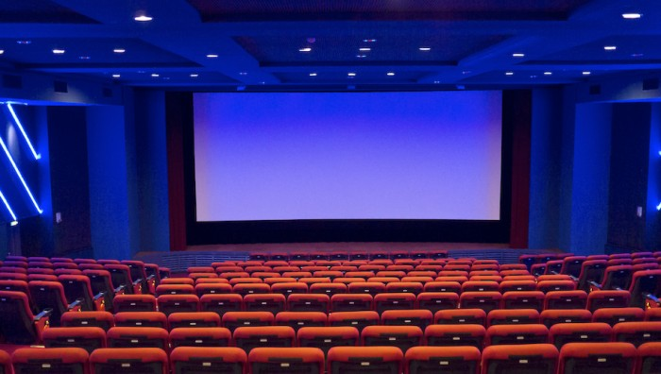

**An Online Movie Ticket Booking Portal**

**Name:** Abraham Kuriakose

**CONTENTS**

|  |  |  |
| --- | --- | --- |
| **Serial Number** | **Topic** | **Page Number** |
|  |  |  |
| **1.** | **Certificate** | **2** |
|  |  |  |
| **2.** | **Acknowledgement** | **3** |
|  |  |  |
| **3.** | **Table of Contents** | **4** |
|  |  |  |
| **4.** | **System Requirements** | **5** |
| 4.1 | Hardware Requirements | 5 |
| 4.2 | Software Requirements | 5 |
|  |  |  |
| **5.** | **About The Project** | **6** |
|  |  |  |
| **6.** | **Source Code and Screenshots** |  |
| 6.1 | Login Page | 7-8 |
| 6.2 | Sign-Up Page | 9-10 |
| 6.3 | Movies | 11-14 |
| 6.4 | Seats | 15-18 |
| 6.5 | Confirmation Page | 19-22 |
| 6.6 | Receipt Page | 23-24 |
|  |  |  |
| **7.** | **MySQL Table Description** | 25 |
|  |  |  |
| **8.** | **Bibliography** | 26 |
|  |  |  |
| **9.** | **CD Containing the Program** |  |
|  |  |  |

**SYSTEM REQUIREMENTS**

***HARDWARE REQUIREMENTS: -***

1. Processor: Intel® Core™ i3 CPU
2. Installed Memory(RAM): 4.00GB
3. System Type: 32 – bit Operating System
4. Hard Disk: 40GB
5. Printer

***SOFTWARE REQUIREMENTS: -***

1. IDE: NetBeans v.6.9
2. JAVA: JDK v.1.6.0
3. Database: MySQL v.5.1
4. Operating System: Windows 7 Ultimate
5. Documentation: Microsoft Office Word 2007

**ABOUT THE PROJECT**

“Book Your Show” as the name suggests is an application designed for conveniently booking tickets for your favourite and most recent movies. It is a connectivity based program that has been created using java based IDE ‘NetBeans’ for the Graphical Front-End and database ‘MySQL’ as the Back-End. The Front-End provides a simple, user-friendly, and easy-to-use interactive interface, while using the Back-End for data storage and manipulation.

This program allows the user to choose a movie, enter a date, and select the time and theatre where he wants to watch the movie. Once the user selects the seats, proceeds through the payment gateway, and confirms the booking, the user’s movie details get stored along with his email_id for verification. The user can also get a receipt of his booking by simply entering his account info.

The entire concept of the application is inspired from “BookMyShow” and isn’t to take complicated, intense, and deep processes of internet payments and booking systems, but rather to create a prototype of such an application to a level that would satisfy the criteria of a professional application.

**SOURCE CODE AND SCREENSHOTS**

***IMPORTING JAVA PACKAGES:***

import java.sql.*;

import javax.swing.*;

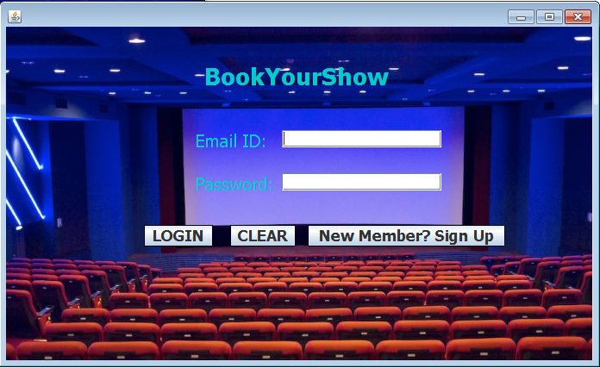

***GLOBAL VARIABLES:***

public class LOGIN extends javax.swing.JFRAME {

public LOGIN () {

initComponents (); }

**# LOGIN**

private void LOGINActionPerformed(java.awt.event.ActionEvent evt) {

int c = 0;

String Email = tf1.getText();

String Password = new String (pf1.getPassword());

if(Email.trim().isEmpty()||Password.trim().isEmpty()) {

JOptionPane.showMessageDialog(this, "Please enter both fields properly.");

tf1.setText("");

pf1.setText(""); }

else {

try {

Class.forName("java.sql.DriverManager");

Connection con = (Connection)

DriverManager.getConnection("jdbc:mysql://localhost:3306/bys","root","123");

Statement stmt = (Statement) con.createStatement();

String query = "Select Email,Password from contact where Email = '"+Email+"' and Password =

'"+Password+"';";

ResultSet res = stmt.executeQuery(query);

if(res.next())

c++;

if(c>0) {

JOptionPane.showMessageDialog(this, "Login Successful.");

tf1.setText("");

pf1.setText("");

new MOVIES(Email).setVisible(true);

this.setVisible(false); }

else {

JOptionPane.showMessageDialog(this, "Login Unsuccessful.");

tf1.setText("");

pf1.setText(""); } }

catch(Exception e) {

JOptionPane.showMessageDialog(this, e.getMessage()); } } }

**# CLEAR**

private void CLEARActionPerformed(java.awt.event.ActionEvent evt) {

tf1.setText("");

pf1.setText(""); }

**# SIGNUP**

private void SIGNUPActionPerformed(java.awt.event.ActionEvent evt) {

new SignUp().setVisible(true);

this.setVisible(false); } }

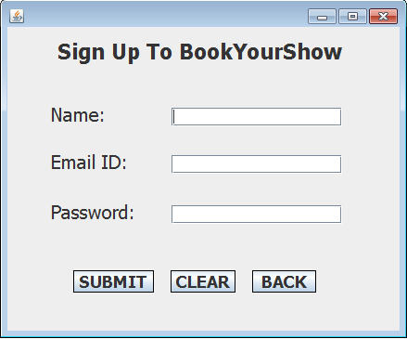

***GLOBAL VARIABLES:***

public class SignUp extends javax.swing.JFrame {

public SignUp() {

initComponents(); }

**# SUBMIT**

private void SUBMITActionPerformed(java.awt.event.ActionEvent evt) {

String Name = tf1.getText();

String Email = tf2.getText();

String Password = new String(pf1.getPassword());

if(Password.trim().length()<8) {

JOptionPane.showMessageDialog(this, "Password Should contain at least 8 characters");

pf1.setText(""); }

else if(Name.trim().isEmpty()||Email.trim().isEmpty()) {

JOptionPane.showMessageDialog(this, "Please enter all the required fields properly.");

pf1.setText(""); }

else {

try {

Class.forName("java.sql.DriverManager");

Connection con = (Connection)

DriverManager.getConnection("jdbc:mysql://localhost:3306/bys","root","123");

Statement stmt = (Statement) con.createStatement();

String query = "Insert into contact values('"+Name+"','"+Email+"','"+Password+"');";

String q = "Select Email from contact where Email = '"+Email+"';";

ResultSet res = stmt.executeQuery(q);

if(res.next()) {

JOptionPane.showMessageDialog(this, "An account with this Email already exists.\n Please try again.");

tf1.setText("");

tf2.setText("");

pf1.setText(""); }

else {

stmt.executeUpdate(query);

JOptionPane.showMessageDialog(this, "Sign Up Successful");

tf1.setText("");

tf2.setText("");

pf1.setText("");

new LOGIN().setVisible(true);

this.setVisible(false); } }

catch(Exception e) {

JOptionPane.showMessageDialog(this, e.getMessage()); } } }

**# CLEAR**

private void CLEARActionPerformed(java.awt.event.ActionEvent evt) {

tf1.setText("");

tf2.setText("");

pf1.setText(""); }

**# BACK**

private void BACKActionPerformed(java.awt.event.ActionEvent evt) {

new LOGIN().setVisible(true);

this.setVisible(false); } }

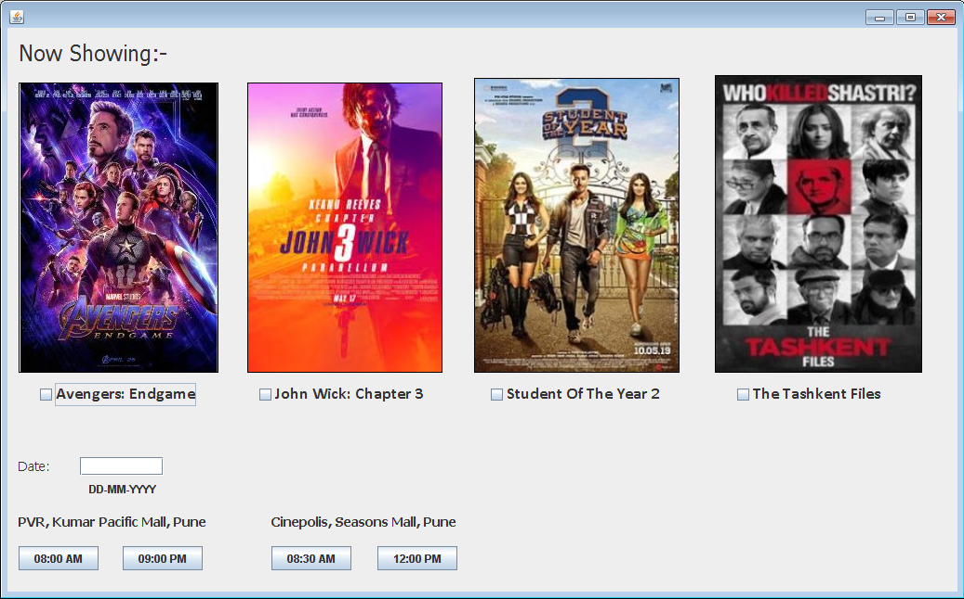

***GLOBAL VARIABLES:***

public class MOVIES extends javax.swing.JFrame {

public MOVIES() {

initComponents(); }

String Email, Time, Theatre, Movie;

public MOVIES(String a) {

initComponents();

this.Email = a; }

**# b1**

private void b1ActionPerformed(java.awt.event.ActionEvent evt) {

String Date = tf1.getText();

if(cb1.isSelected()||cb2.isSelected()||cb3.isSelected()||cb4.isSelected()) {

if(cb1.isSelected())

Movie = "Avengers: Endgame";

else if(cb2.isSelected())

Movie = "John Wick: Chapter 3";

else if(cb3.isSelected())

Movie = "Student Of The Year 2";

else if(cb4.isSelected())

Movie = "The Tashkent Files";

if(Date.trim().isEmpty())

JOptionPane.showMessageDialog(null, "Enter the Date on which you want to watch the movie.");

else {

Time = "08:00 AM";

Theatre = "PVR, Kumar Pacific Mall,Pune";

new Seats(Email, Movie, Date, Time, Theatre).setVisible(true);

this.setVisible(false); } }

else

JOptionPane.showMessageDialog(null, "Select the movie you want to watch."); }

**# b2**

private void b2ActionPerformed(java.awt.event.ActionEvent evt) {

String Date = tf1.getText();

if(cb1.isSelected()||cb2.isSelected()||cb3.isSelected()||cb4.isSelected()) {

if(cb1.isSelected())

Movie = "Avengers: Endgame";

else if(cb2.isSelected())

Movie = "John Wick: Chapter 3";

else if(cb3.isSelected())

Movie = "Student Of The Year 2";

else if(cb4.isSelected())

Movie = "The Tashkent Files";

if(Date.trim().isEmpty())

JOptionPane.showMessageDialog(null, "Enter the Date on which you want to watch the movie.");

else {

Time = "09:00 PM";

Theatre = "PVR, Kumar Pacific Mall,Pune";

new Seats(Email, Movie, Date, Time, Theatre).setVisible(true);

this.setVisible(false); } }

else

JOptionPane.showMessageDialog (null, "Select the movie you want to watch."); }

**# b3**

private void b3ActionPerformed(java.awt.event.ActionEvent evt) {

String Date = tf1.getText();

if(cb1.isSelected()||cb2.isSelected()||cb3.isSelected()||cb4.isSelected()) {

if(cb1.isSelected())

Movie = "Avengers: Endgame";

else if(cb2.isSelected())

Movie = "John Wick: Chapter 3";

else if(cb3.isSelected())

Movie = "Student Of The Year 2";

else if(cb4.isSelected())

Movie = "The Tashkent Files";

if(Date.trim().isEmpty())

JOptionPane.showMessageDialog(null, "Enter the Date on which you want to watch the movie.");

else {

Time = "08:30 AM";

Theatre = "Cinepolis, Seasons Mall,Pune";

new Seats(Email, Movie, Date, Time, Theatre).setVisible(true);

this.setVisible(false); } }

else

JOptionPane.showMessageDialog (null, "Select the movie you want to watch."); }

**# b4**

private void b4ActionPerformed(java.awt.event.ActionEvent evt) {

String Date = tf1.getText();

if(cb1.isSelected()||cb2.isSelected()||cb3.isSelected()||cb4.isSelected())

{

if(cb1.isSelected())

Movie = "Avengers: Endgame";

else if(cb2.isSelected())

Movie = "John Wick: Chapter 3";

else if(cb3.isSelected())

Movie = "Student Of The Year 2";

else if(cb4.isSelected())

Movie = "The Tashkent Files";

if(Date.trim().isEmpty())

JOptionPane.showMessageDialog(null, "Enter the Date on which you want to watch the movie.");

else

{

Time = "12:00 PM";

Theatre = "Cinepolis, Seasons Mall,Pune";

new Seats(Email, Movie, Date, Time, Theatre).setVisible(true);

this.setVisible(false);

}

}

else

JOptionPane.showMessageDialog(null, "Select the movie you want to watch."); } }

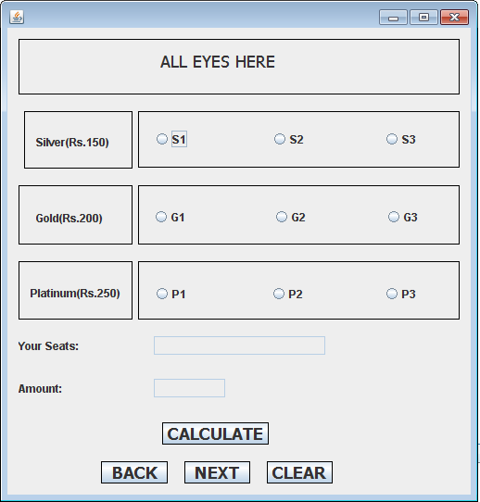

***GLOBAL VARIABLES:***

public class Seats extends javax.swing.JFrame {

public Seats() {

initComponents(); }

String Email, Time, Theatre, Movie, Date, sts;

public Seats(String a, String b, String c, String d, String e) {

initComponents();

this.Email = a;

this.Movie = b;

this.Date = c;

this.Time = d;

this.Theatre = e; }

int S = 0, G = 0, P = 0, Seats = 0, Amount = 0;

**# CALCULATE**

private void CALCULATEActionPerformed(java.awt.event.ActionEvent evt) {

tf1.setText("");

Seats=0; S=0; G=0; P=0; sts="";

if(rb1.isSelected()) {

S++;Seats++;

sts = tf1.getText()+"S1 ";

tf1.setText("");

tf1.setText(sts); }

if(rb2.isSelected()) {

S++;Seats++;

sts = tf1.getText()+"S2 ";

tf1.setText("");

tf1.setText(sts); }

if(rb3.isSelected()) {

S++;Seats++;

sts = tf1.getText()+"S3 ";

tf1.setText("");

tf1.setText(sts); }

if(rb4.isSelected()) {

G++;Seats++;

sts = tf1.getText()+"G1 ";

tf1.setText("");

tf1.setText(sts); }

if(rb5.isSelected()) {

G++;Seats++;

sts = tf1.getText()+"G2 ";

tf1.setText("");

tf1.setText(sts); }

if(rb6.isSelected()) {

G++;Seats++;

sts = tf1.getText()+"G3 ";

tf1.setText("");

tf1.setText(sts); }

if(rb7.isSelected()) {

P++;Seats++;

sts = tf1.getText()+"P1 ";

tf1.setText("");

tf1.setText(sts); }

if(rb8.isSelected()) {

P++;Seats++;

sts = tf1.getText()+"P2 ";

tf1.setText("");

tf1.setText(sts); }

if(rb9.isSelected()) {

P++;Seats++;

sts = tf1.getText()+"P3 ";

tf1.setText("");

tf1.setText(sts); }

Amount = (150*S)+(200*G)+(250*P);

tf2.setText(""+Amount); }

**# BACK**

private void BACKActionPerformed(java.awt.event.ActionEvent evt) {

new MOVIES().setVisible(true);

this.setVisible(false); }

**# NEXT**

private void NEXTActionPerformed(java.awt.event.ActionEvent evt) {

new CONFIRMATION(Email, Movie, Date, Time, Theatre, sts, Seats, Amount).setVisible(true);

this.setVisible(false); }

**# CLEAR**

private void CLEARActionPerformed(java.awt.event.ActionEvent evt) {

tf1.setText("");

tf2.setText("");

rb1.setSelected(false);

rb2.setSelected(false);

rb3.setSelected(false);

rb4.setSelected(false);

rb5.setSelected(false);

rb6.setSelected(false);

rb7.setSelected(false);

rb8.setSelected(false);

rb9.setSelected(false); } }

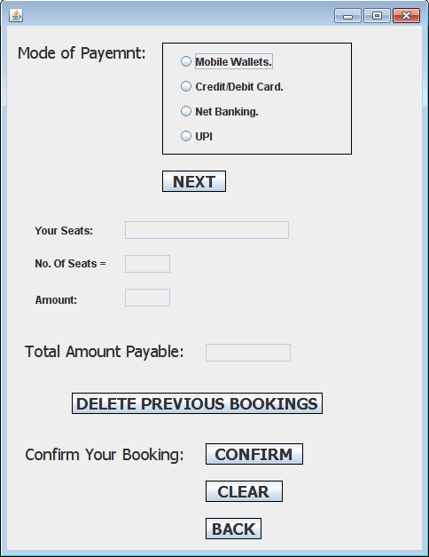

***GLOBAL VARIABLES:***

public class CONFIRMATION extends javax.swing.JFrame {

public CONFIRMATION() {

initComponents(); }

String Email, Movie, Date, Time, Theatre, sts;

int Seats, Amount;

public CONFIRMATION(String a, String b, String c, String d, String e, String f, int g, int h) {

initComponents();

this.Email = a;

this.Movie = b;

this.Date = c;

this.Time = d;

this.Theatre = e;

this.sts = f;

this.Seats = g;

this.Amount = h; }

**# NEXT**

private void NEXTActionPerformed(java.awt.event.ActionEvent evt) {

tf3.setText(sts);

tf2.setText(Integer.toString(Seats));

tf4.setText(Integer.toString(Amount));

if(rb1.isSelected()||rb2.isSelected()||rb3.isSelected()||rb4.isSelected()) {

if(rb2.isSelected()) {

int dis = 40*Seats;

Amount = Amount - dis;

JOptionPane.showMessageDialog(this, "You have earned a discount of Rs."+dis+" on paying with a card.");

tf1.setText(Integer.toString(Amount));

} else

tf1.setText(Integer.toString(Amount));

} else {

JOptionPane.showMessageDialog(this, "Select your Method Of Payment"); } }

**# DELETE**

private void DELETEActionPerformed(java.awt.event.ActionEvent evt) {

try {

Class.forName("java.sql.DriverManager");

Connection con = (Connection) DriverManager.getConnection("jdbc:mysql://localhost:3306/bys","root","123");

Statement stmt = con.createStatement();

String query3 = "Delete from detail where Email = '"+Email+"';";

stmt.executeUpdate(query3);

JOptionPane.showMessageDialog(this, "Your previous bookings have been deleted. Please re-start your

Booking process.");

new MOVIES().setVisible(true);

this.setVisible(false); }

catch(Exception e) {

JOptionPane.showMessageDialog(this, e.getMessage()); } }

**# CONFIRM**

private void CONFIRMActionPerformed(java.awt.event.ActionEvent evt) {

int c = 0;

if(tf1.getText().isEmpty()) {

JOptionPane.showMessageDialog(this, "Click on the 'NEXT' button above to check your Total Amount."); }

else {

try {

Class.forName("java.sql.DriverManager");

Connection con = (Connection)

DriverManager.getConnection("jdbc:mysql://localhost:3306/bys","root","123");

Statement stmt = con.createStatement();

String query2 = "Select Email from detail where Email = '"+Email+"';";

ResultSet res = stmt.executeQuery(query2);

if(res.next())

c++;

if(c>0) {

JOptionPane.showMessageDialog(this, "You already have a booking by your name. If you want to continue

with the current booking, first delete your previous one."); }

else {

String query = "insert into detail values('"+Email+'",'"+Movie+'",'"+Date+'",'"+Time+'",'"+Theatre+'",

'"+sts+'", '"+Amount+"');";

stmt.executeUpdate(query);

JOptionPane.showMessageDialog(this, "Your Tickets for:-\nMovie: "+Movie+"\nDate: "+Date+"\nTime:

"+Time+"\nSeats: "+sts+"\nTheatre: "+Theatre+" have been booked successfully");

new RECEIPT().setVisible(true);

this.setVisible(false); } }

catch(Exception e) {

JOptionPane.showMessageDialog(this, e.getMessage()); } } }

**# CLEAR**

private void CLEARActionPerformed(java.awt.event.ActionEvent evt) {

tf1.setText("");

tf2.setText("");

tf3.setText("");

tf4.setText("");

bg1.clearSelection(); }

**# BACK**

private void BACKActionPerformed(java.awt.event.ActionEvent evt) {

new Seats().setVisible(true);

this.setVisible(false); } }

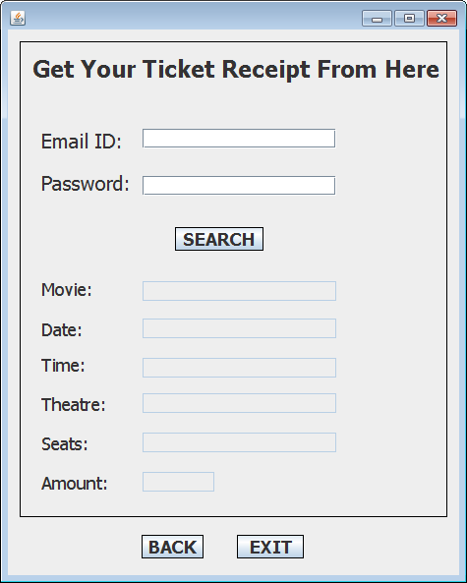

***GLOBAL VARIABLES:***

public class RECEIPT extends javax.swing.JFrame {

public RECEIPT() {

initComponents(); }

String mov, date, time, theatre, amount, seats;

**# SEARCH**

private void SEARCHActionPerformed(java.awt.event.ActionEvent evt) {

String Email = tf1.getText();

String Password = pf1.getText();

if(Email.trim().isEmpty()||Password.trim().isEmpty()) {

JOptionPane.showMessageDialog(this, "Please enter both fields properly."); }

else { try {

Class.forName("java.sql.DriverManager");

Connection con = (Connection)

DriverManager.getConnection("jdbc:mysql://localhost:3306/bys","root","123");

Statement stmt = (Statement) con.createStatement();

String query = "Select Password from contact where Email = '"+Email+"';";

ResultSet res = stmt.executeQuery(query);

if(res.next()) {

String pswd = res.getString("Password");

if(pswd.compareTo(Password)==0) {

JOptionPane.showMessageDialog(this, "Movie Details Fetched."); }

else {

JOptionPane.showMessageDialog(this, "The Password you have entered is incorrect.\nPlease enter

your Password again.");

pf1.setText(""); } }

String q = "Select Movie, Date, Time, Theatre, Seats, Amount from detail where Email = '"+Email+"';";

ResultSet rs = stmt.executeQuery(q);

if(rs.next()) {

mov = rs.getString("Movie");

date = rs.getString("Date");

time = rs.getString("Time");

theatre = rs.getString("Theatre");

amount = rs.getString("Amount");

seats = rs.getString("Seats");

tf2.setText(mov);

tf3.setText(date);

tf4.setText(time);

tf5.setText(theatre);

tf7.setText(amount);

tf8.setText(seats); } }

catch(Exception e) {

JOptionPane.showMessageDialog(this, e.getMessage()); } } }

**# BACK**

private void BACKActionPerformed(java.awt.event.ActionEvent evt) {

new CONFIRMATION().setVisible(true); this.setVisible(false); }

**# EXIT**

private void EXITActionPerformed(java.awt.event.ActionEvent evt) {

System.exit(0); } }

**MySQL TABLE DESCRIPTION**

create database bys;

use bys;

create table contact (Name varchar(50), Email varchar(50), Password varchar(50));

create table detail (Email varchar(50), Movie varchar(30), Date varchar(10), Time varchar(10), Theatre varchar(40), Seats varchar(60), Amount varchar(5));

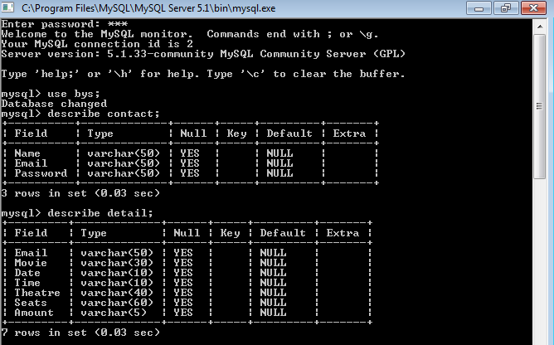

**BIBLIOGRAPHY**

1. Informatics Practices a Textbook for class XI: - Sumita Arora
2. Informatics Practices a Textbook for class XII: - Sumita Arora
3. Google Images