Linux commands
1.Man
man command in Linux is used to display the user manual of any command that we can run on the terminal. It provides a detailed view of the command which includes NAME, SYNOPSIS, DESCRIPTION, OPTIONS, EXIT STATUS, RETURN VALUES, ERRORS, FILES,
commands:
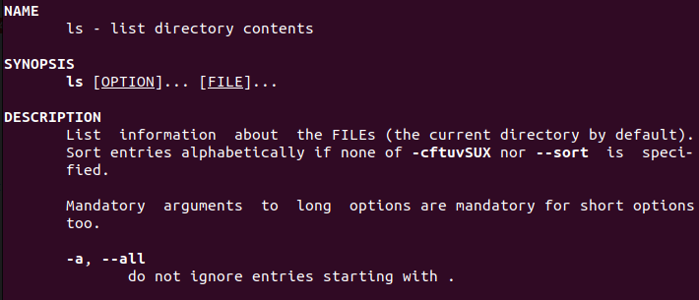
2. ls, echo, read
2.1. ls
This command displays the manual page for the ls command, which is used to list files and directories.
syntax of the ls command is:
ls [options] [file(s) or directory]
Example:
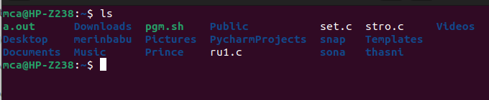
2.2.echo
The echo command in Linux is used to display text or output to the terminal. It is a simple and frequently used command, often employed within shell scripts or directly in the command line.
syntax of the echo command is:
echo [options] [text]
Example:
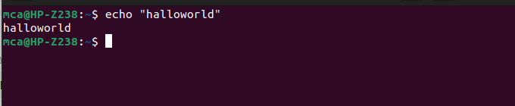
2.3.read
The read command in Linux is used to read input from the user within a shell script. It allows you to prompt the user for input and store the entered value in a variable.
syntax of the read command is:
read [options] [variable]
Example:
