Step 1: Source Profiling and Azure Setup
Healthcare Data Pipeline · Bootcamp Project 1 · Anupa

1. What this step does
Before building anything, the four sample files were profiled to understand their columns, keys and quality. Then all the Azure resources the pipeline needs were created: a virtual machine that holds the source files, a Self-hosted Integration Runtime so Data Factory can read from that VM, an ADLS Gen2 storage account for the Landing and Staging layers, a Key Vault for passwords, and the Data Factory itself.
The full source inventory, schemas, keys, relationships and the 27 data quality rules are in the companion document Step_1_Source_Inventory_and_DQ_Rules.docx.

2. Profiling result (short)
File | Rows | Columns | Business key | Issues found
patient_raw.csv | 5 | 6 | patient_id | None in sample
hospital_raw.csv | 5 | 4 | hospital_id | None in sample
diagnosis_raw.csv | 5 | 2 | diagnosis_code | None in sample
visit_raw.csv | 8 | 7 | visit_id | None; all references match

Because the sample is clean, extra test files with deliberate problems were made for future testing (Code/test_data). They test blank IDs, bad dates, negative cost, unknown references, duplicates, an empty file, an extra column, and SCD Type 1 changes.

3. Steps
- Profiled each column of the four provided CSV files.
- Drew the architecture diagram (Documentation/Step_0_Architecture_Diagram.png).
- Created resource group rs_Bt_Anupa.
- Created Windows VM vmhealthcare (Central India). Connected to it with Remote Desktop, locally copied the four provided CSV files onto the VM, and saved them on the C: drive in the folder C:\Healthcaresource.
- Created Data Factory adf-healthcare-anupa79 (East US).
- In ADF, created Self-hosted Integration Runtime shir-healthcare-vm, installed it on the VM and registered it with the auth key.
- Created storage account sthealthcareanupa79 with Hierarchical namespace ON (this makes it ADLS Gen2), then containers landing and staging.
- Created Key Vault kv-healthcare-anupa79 and added the VM password as secret vm-password.
- Gave the ADF managed identity two roles: Key Vault Secrets User (on Key Vault) and Storage Blob Data Contributor (on storage).
- Created linked services ls_keyvault, ls_adls and ls_vm_files, and tested each connection.

4. Configuration
Item | Value
Resource group | rs_Bt_Anupa
Source VM | vmhealthcare (Central India), auto-shutdown 12:00 AM ET
Source folder on VM | C:\Healthcaresource (patient_raw.csv, hospital_raw.csv, diagnosis_raw.csv, visit_raw.csv)
Self-hosted IR | shir-healthcare-vm (installed on vmhealthcare)
Data Factory | adf-healthcare-anupa79 (East US)
Storage (ADLS Gen2) | sthealthcareanupa79, containers: landing, staging
Key Vault | kv-healthcare-anupa79, secret: vm-password (value never shown)
ADF identity roles | Key Vault Secrets User; Storage Blob Data Contributor
ls_keyvault | Azure Key Vault, managed identity
ls_adls | Azure Data Lake Storage Gen2, managed identity
ls_vm_files | File system, connect via shir-healthcare-vm, password from Key Vault secret vm-password

5. Code snippets
Command run on the VM so the SHIR may read a local folder (run as Administrator):
cd "C:\Program Files\Microsoft Integration Runtime\5.0\Shared"
.\dmgcmd.exe -DisableLocalFolderPathValidation

ls_vm_files password comes from Key Vault, not typed in (shape of the JSON):
"password": {
"type": "AzureKeyVaultSecret",
"store": { "referenceName": "ls_keyvault", "type": "LinkedServiceReference" },
"secretName": "vm-password"
}

6. Challenges and fixes
Challenge | Cause | How it was fixed
Diagram too detailed | First version showed too many operational details | Made a minimal approval version for the professor; kept the detailed one for the submission
Lucidchart limit | Free plan allows too few objects | Switched to diagrams.net (draw.io), which is free
VM and SHIR not ready | VM auto-shuts down at midnight; SHIR shows Offline while VM is stopped | Start vmhealthcare in the portal before every run and wait about 2 minutes until the SHIR shows Running
Copy failed: AccessToOnPremFileSystemDenied | SHIR blocks reading local C:\ folders by default | Ran dmgcmd -DisableLocalFolderPathValidation on the VM (listed as a known limitation; production would use a network share)

7. Evidence (Screenshots folder)
Screenshot file | What it shows
Step_1_Screenshot_1.png | Architecture diagram
Step_1_Screenshot_2.png | VM vmhealthcare deployment complete
Step_1_Screenshot_3.png | SHIR node registered on the VM
Step_1_Screenshot_4.png | shir-healthcare-vm status Running in ADF
Step_1_Screenshot_5.png | Storage account deployment complete
Step_1_Screenshot_6.png | Containers landing and staging
Step_1_Screenshot_7.png | Key Vault deployment complete
Step_1_Screenshot_8.png | Key Vault role assignments (ADF has Secrets User)
Step_1_Screenshot_9.png | Secret vm-password created (value hidden)
Step_1_Screenshot_10.png | Storage role assignment (ADF has Blob Data Contributor)
Step_1_Screenshot_11.png | Linked services in ADF

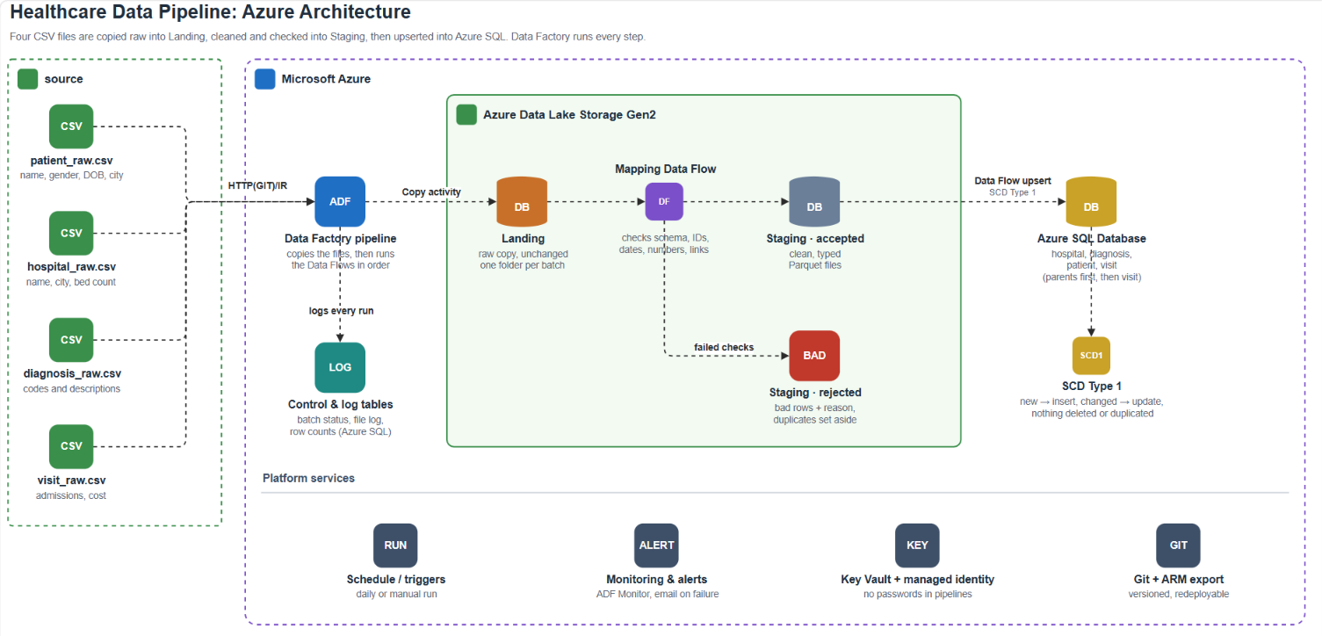
Step_1_Screenshot_1.png: Architecture diagram
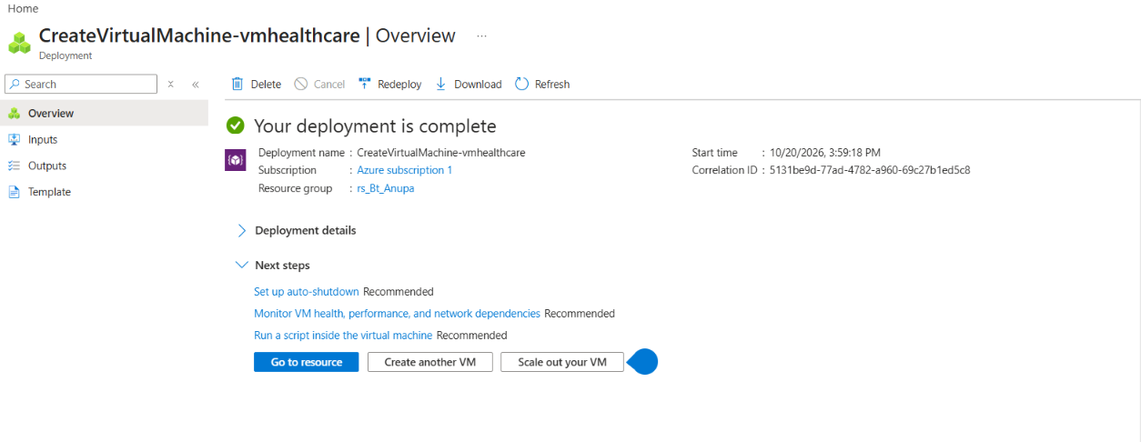
Step_1_Screenshot_2.png: VM vmhealthcare deployment complete
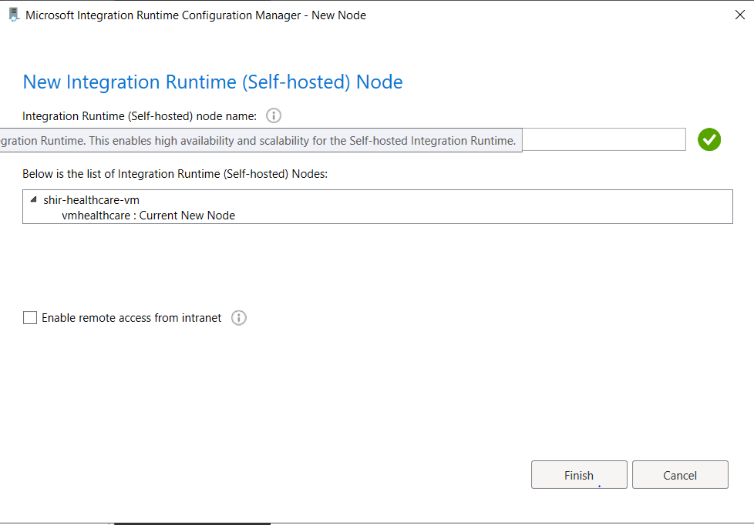
Step_1_Screenshot_3.png: SHIR node registered on the VM
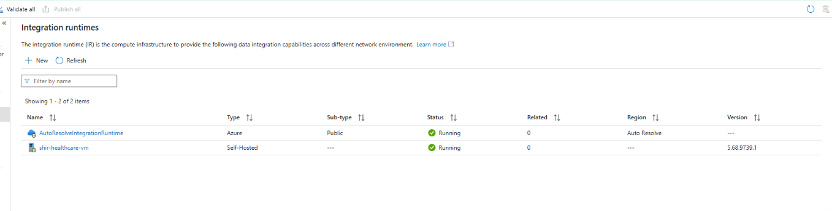
Step_1_Screenshot_4.png: shir-healthcare-vm status Running in ADF
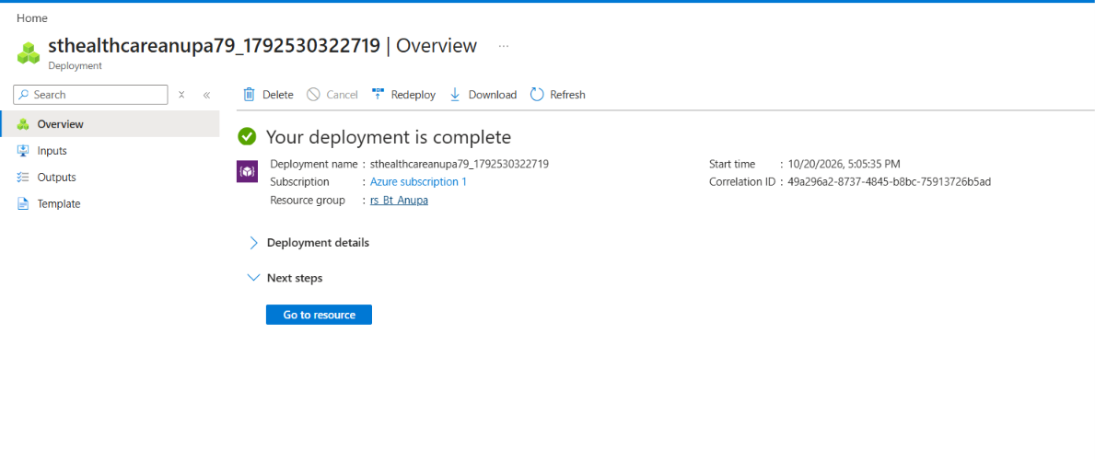
Step_1_Screenshot_5.png: Storage account deployment complete
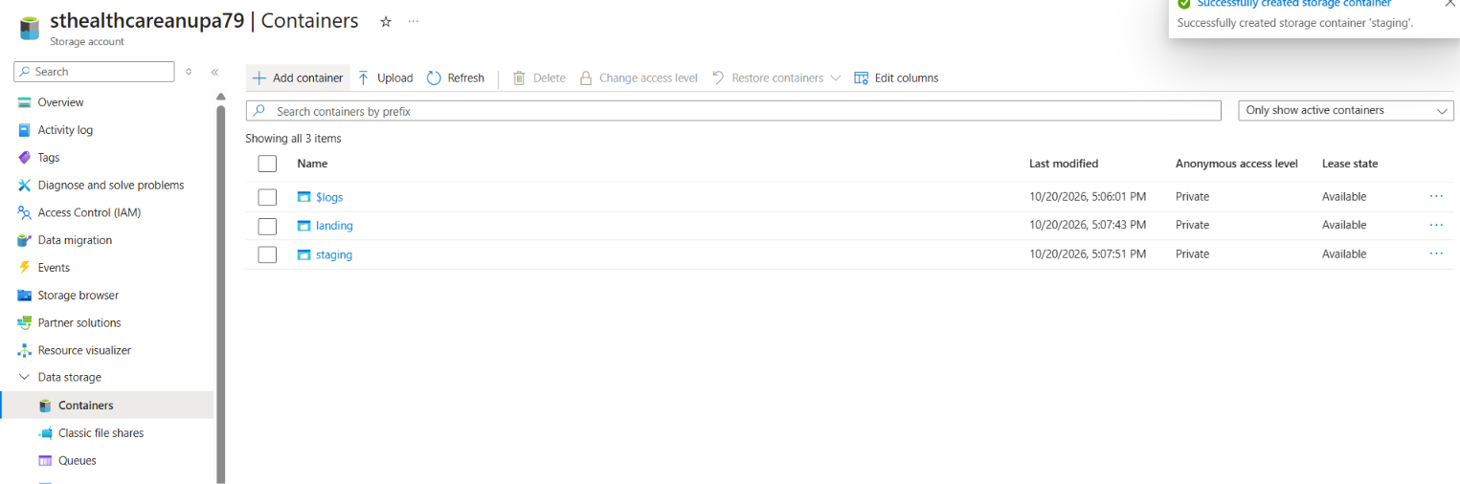
Step_1_Screenshot_6.png: Containers landing and staging
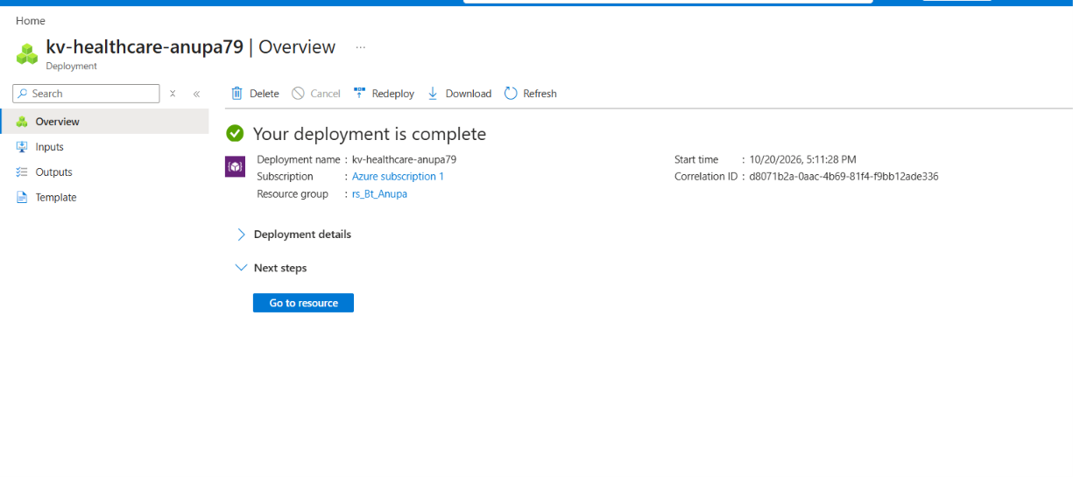
Step_1_Screenshot_7.png: Key Vault deployment complete
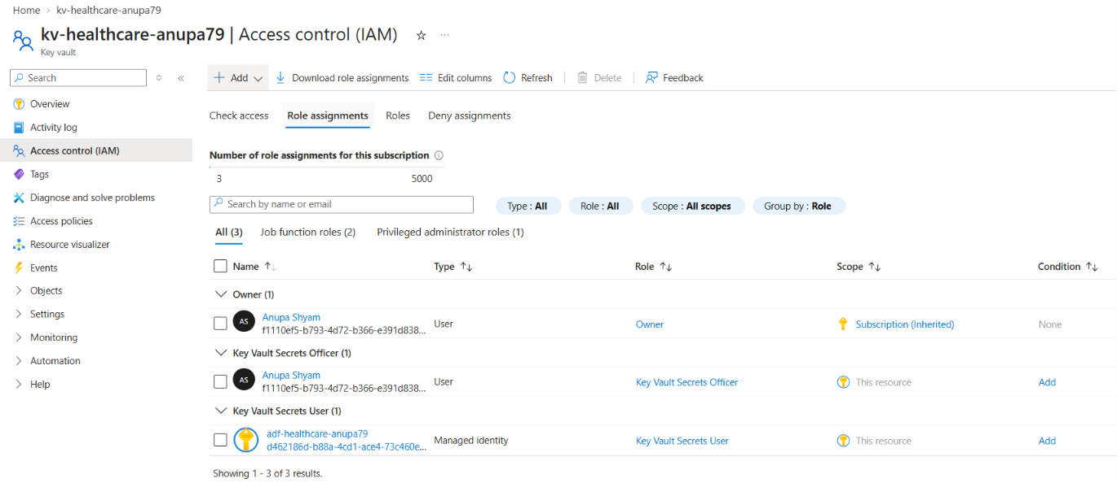
Step_1_Screenshot_8.png: Key Vault role assignments (ADF has Secrets User)
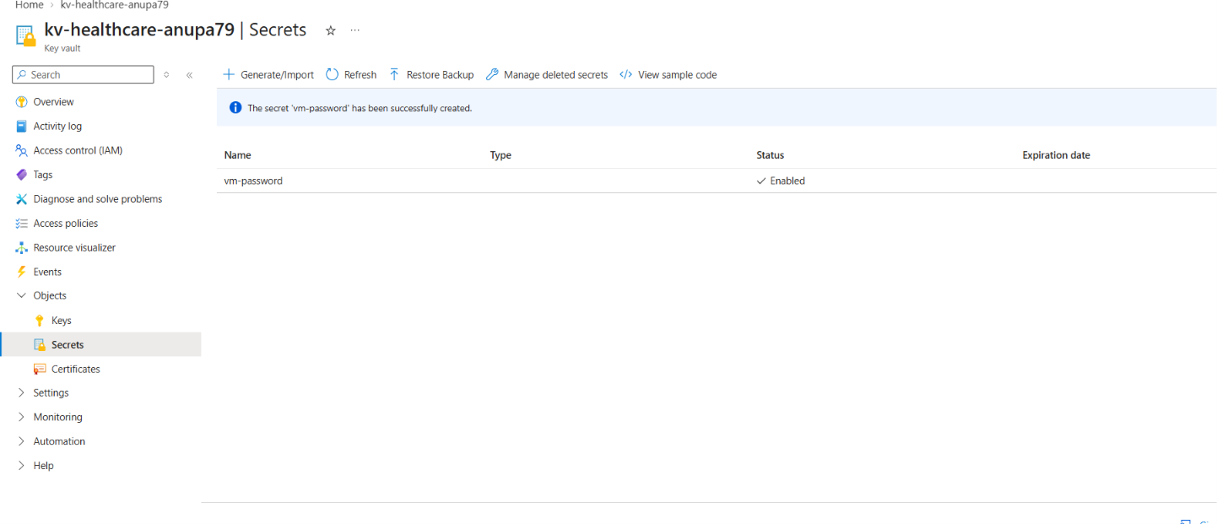
Step_1_Screenshot_9.png: Secret vm-password created (value hidden)
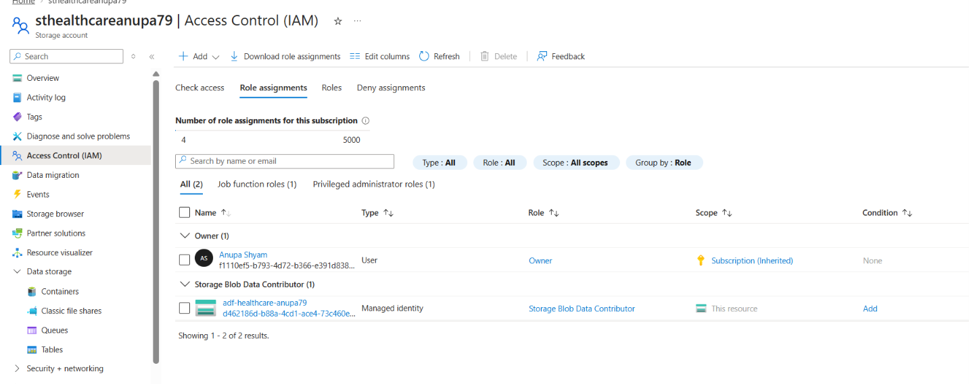
Step_1_Screenshot_10.png: Storage role assignment (ADF has Blob Data Contributor)
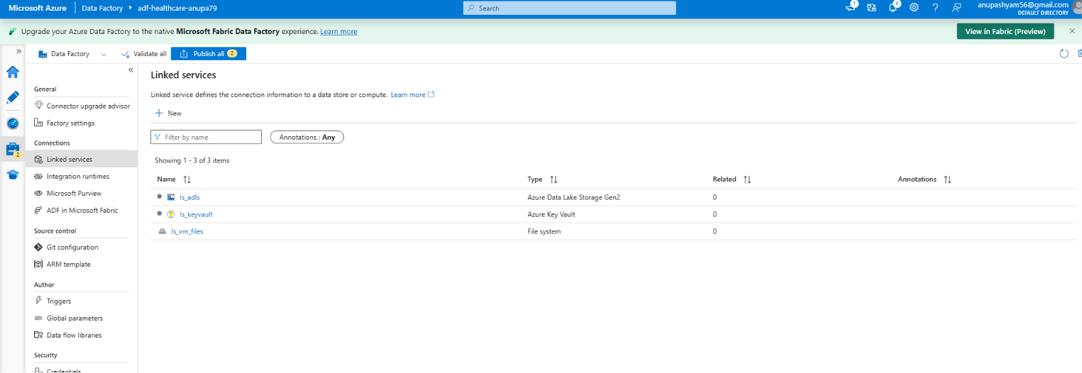
Step_1_Screenshot_11.png: Linked services in ADF

