Step 2: Landing Ingestion
Healthcare Data Pipeline · Bootcamp Project 1 · Anupa

1. What this step does
Landing keeps an exact, unchanged copy of each source file. One reusable pipeline, pl_ingest_landing, copies all four files from the VM into the landing container. Each run writes into its own folder, so a later delivery never overwrites an earlier raw copy.

2. Steps
- Created Binary dataset ds_vm_source on ls_vm_files with parameter fileName. Binary means the file is copied byte for byte, with no parsing or changes.
- Created Binary dataset ds_landing on ls_adls with parameters folderPath and fileName. File path: landing / @dataset().folderPath / @dataset().fileName.
- Created pipeline pl_ingest_landing with parameter fileList (type Array).
- Added a ForEach activity over @pipeline().parameters.fileList.
- Inside the ForEach, added one Copy activity: source ds_vm_source (fileName = @item()), sink ds_landing.
- Set the sink folderPath to <dataset>/<yyyy-MM-dd>/<RunId>, so every batch gets a new folder.
- Debugged, then clicked Publish all.

3. Configuration
Item | Value
Pipeline | pl_ingest_landing
Parameter | fileList (Array) e.g. ["patient_raw.csv","hospital_raw.csv","diagnosis_raw.csv","visit_raw.csv"]
Source folder | C:\Healthcaresource on vmhealthcare (the four provided files, locally copied onto the VM)
Source dataset | ds_vm_source (Binary, ls_vm_files, param fileName)
Sink dataset | ds_landing (Binary, ls_adls, params folderPath, fileName)
Folder convention | landing/<dataset>/<yyyy-MM-dd>/<pipeline RunId>/<file>.csv
Batch identifier | The ADF pipeline RunId (unique for every run)
First batch RunId | 38682d12-454e-4ea8-9ccc-11e66ab5069a

4. Code snippets
ForEach items:
@pipeline().parameters.fileList

Copy source, ds_vm_source fileName:
@item()

Copy sink, ds_landing folderPath (dataset name taken from the file name, e.g. patient):
@concat(split(item(),'_')[0], '/',
formatDateTime(utcnow(),'yyyy-MM-dd'), '/',
pipeline().RunId)

Example result:
landing/patient/2026-10-21/38682d12-454e-4ea8-9ccc-11e66ab5069a/patient_raw.csv

5. Design decisions
Topic | Decision
Keep raw file unchanged | Binary copy; no columns added. Metadata is kept outside the file.
Ingestion metadata | Captured by ADF Monitor for every run: RunId (batch id), file name, start and end time, status, files read and written, bytes copied, error message.
Repeated delivery | Each run writes to a new RunId folder, so nothing is overwritten. Reloading the same data later is safe because SQL uses upsert (Step 4).
Missing file | Copy activity fails, so the pipeline fails and the failure alert emails the owner (Step 5). Nothing downstream runs.
Empty file (header only) | Copied to Landing as received; Staging then produces 0 rows, so nothing changes in SQL (absence never deletes). Test file: patient_empty_test.csv.
Unexpected columns | Staging reads with an explicit schema, so only the defined columns are used. Test file: visit_extra_column_test.csv.

6. Challenges and fixes
Challenge | Cause | How it was fixed
Dataset path set up wrong | In ds_landing the folderPath expression was put in the wrong box | Fixed file path to landing / @dataset().folderPath / @dataset().fileName
Parameter type error | fileList was first created as String, so ForEach could not loop over it | Changed fileList to type Array
AccessToOnPremFileSystemDenied | SHIR blocks local folders by default | dmgcmd -DisableLocalFolderPathValidation on the VM (see Step 1)
Run fails when VM is off | VM auto-shutdown at midnight | Start the VM and wait for SHIR to show Running before running

7. Evidence (Screenshots folder)
Screenshot file | What it shows
Step_2_Screenshot_1.png | pl_ingest_landing canvas: ForEach with Copy activity
Step_2_Screenshot_2.png | pl_ingest_landing run: ForEach and 4 Copy activities Succeeded
Step_2_Screenshot_3.png | landing container with one folder per dataset (diagnosis, hospital, patient, visit)

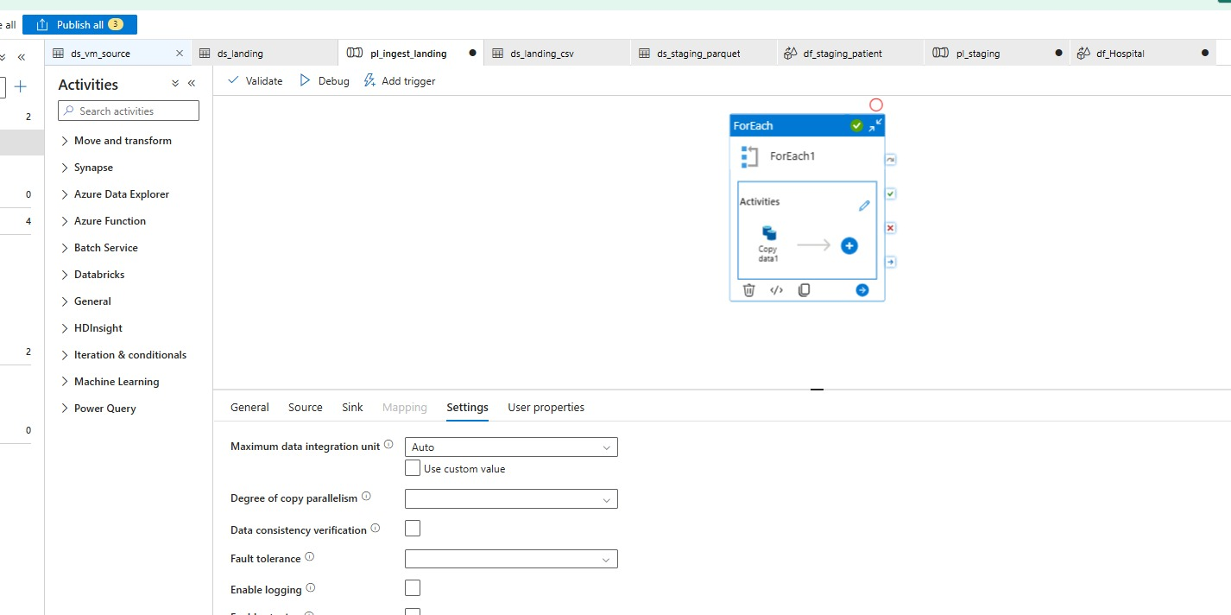
Step_2_Screenshot_1.png: pl_ingest_landing canvas: ForEach with Copy activity
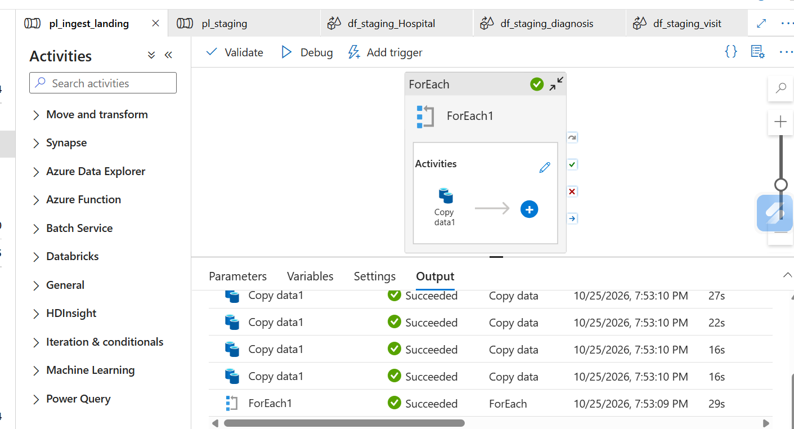
Step_2_Screenshot_2.png: pl_ingest_landing run: ForEach and 4 Copy activities Succeeded
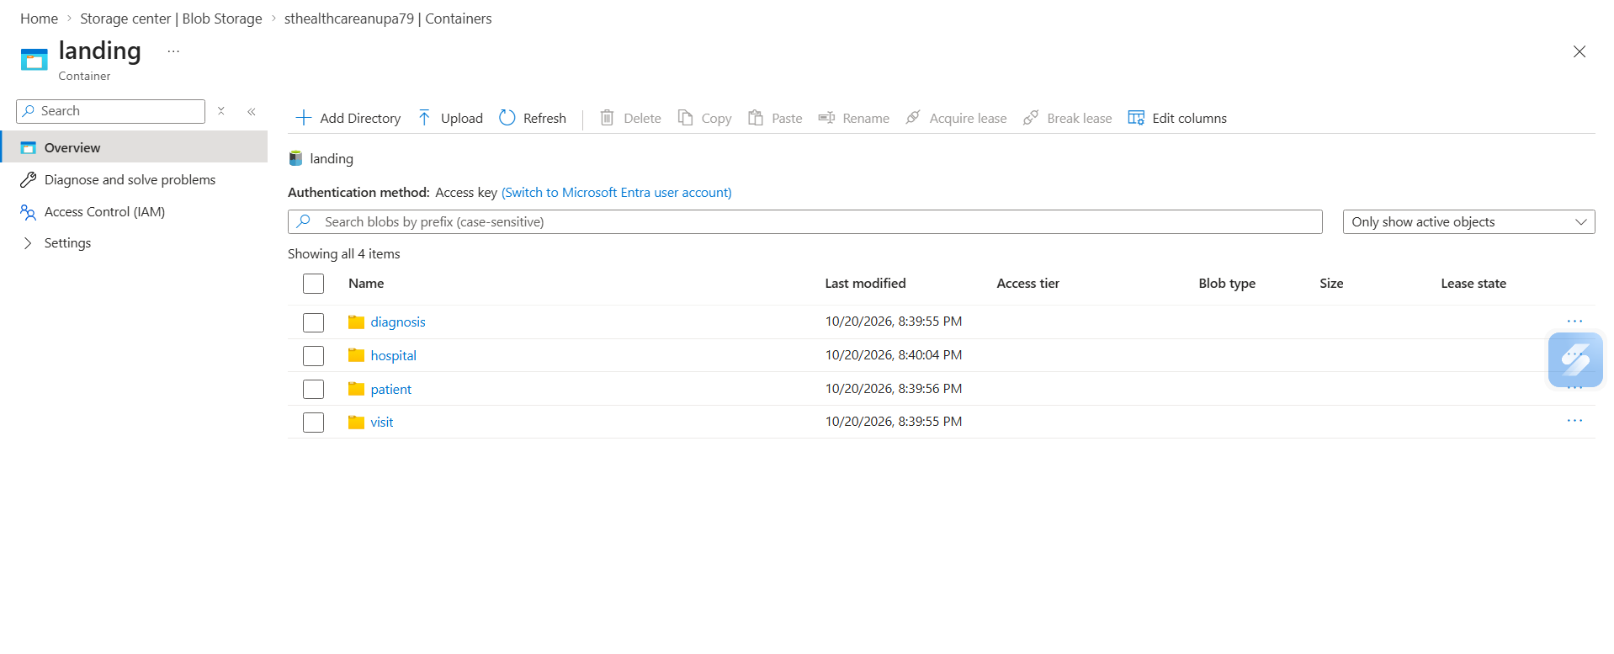
Step_2_Screenshot_3.png: landing container with one folder per dataset (diagnosis, hospital, patient, visit)

