Step 3: Staging Validation (Mapping Data Flows)
Healthcare Data Pipeline · Bootcamp Project 1 · Anupa

1. What this step does
Staging turns the raw Landing CSVs into clean, typed data. One Mapping Data Flow per dataset reads the CSV with an explicit schema, cleans the text, checks the rules, removes duplicates, and writes two outputs: accepted rows as Parquet, and rejected rows with a reason. Pipeline pl_staging runs the four flows in the right order.

2. Steps
- Created DelimitedText dataset ds_landing_csv on ls_adls (landing / folderPath / fileName, comma, first row as header, quote character ").
- Created Parquet dataset ds_staging_parquet on ls_adls (staging / folderPath, snappy compression).
- Built df_staging_patient: source → clean (Derived Column) → check (Conditional Split) → rejected branch adds reject_reason → sink; accepted branch → dedup (Aggregate) → Parquet sink.
- Set the source Projection by hand (explicit schema), e.g. dob as date, bed_count as integer, cost as decimal.
- Built df_staging_hospital and df_staging_diagnosis the same way.
- Built df_staging_visit with extra Lookups to the accepted patient, hospital and diagnosis outputs of the same batch; visits with no match go to rejected with reason 'unknown patient/hospital/diagnosis'.
- Added data flow parameter runId to every flow; used it for batch_id and for the output folders.
- Created pipeline pl_staging: df_patient, df_hospital, df_diagnosis run in parallel, then df_visit runs after all three succeed.
- Debugged pl_staging, checked the Parquet output, then Publish all.

3. Configuration
Item | Value
Data flows | df_staging_patient, df_staging_hospital, df_staging_diagnosis, df_staging_visit
Data flow parameter | runId (string) → written into column batch_id
Pipeline | pl_staging, parameters runId and runDate (defaults = first batch)
Input | landing/<dataset>/<runDate>/<runId>/<dataset>_raw.csv
Accepted output | staging/<dataset>/accepted/<runId>/ (Parquet)
Rejected output | staging/<dataset>/rejected/<runId>/ (with reject_reason, batch_id)
Order | patient, hospital, diagnosis (parallel) → visit
Schema drift | Off; explicit projection is the schema contract

4. Explicit schemas
Dataset | Columns and types
patient | patient_id string, first_name string, last_name string, gender string, dob date, city string
hospital | hospital_id string, hospital_name string, city string, bed_count integer
diagnosis | diagnosis_code string, diagnosis_desc string
visit | visit_id string, patient_id string, hospital_id string, admission_date date, discharge_date date, diagnosis_code string, cost decimal

5. Code snippets (data flow expressions)
cleanPatient (Derived Column):
first_name = trim(first_name)
last_name = trim(last_name)
city = initCap(trim(city))
gender = upper(trim(gender))
patient_id = upper(trim(patient_id))
batch_id = $runId

checkPatient (Conditional Split, first matching condition) → stream 'rejected':
isNull(patient_id) || isNull(dob) || dob > currentDate() || !in(['M','F'], gender)

addReasonToReject (Derived Column) – example of the reason column:
reject_reason = case(isNull(patient_id), 'missing patient_id',
isNull(dob), 'invalid dob',
dob > currentDate(),'dob in future',
'invalid gender')

dedupPatient (Aggregate): group by patient_id, keep one row:
Group by: patient_id
Aggregates: first_name = first(first_name), last_name = first(last_name),
gender = first(gender), dob = first(dob), city = first(city),
batch_id = first(batch_id)

pl_staging – data flow parameter and paths built from pipeline parameters:
runId (data flow param): @pipeline().parameters.runId
source folderPath: @concat('patient/', pipeline().parameters.runDate, '/', pipeline().parameters.runId)
accepted folder: @concat('patient/accepted/', pipeline().parameters.runId)
rejected folder: @concat('patient/rejected/', pipeline().parameters.runId)

6. Business keys and policies
Topic | Policy
Business keys | patient_id, hospital_id, diagnosis_code, visit_id
Duplicates | Same key more than once in a file: one row kept (Aggregate), the rest counted as duplicates
Required fields missing | Rejected with reason (e.g. missing patient_id)
Invalid dates / numbers | Rejected (bad dob, discharge before admission, negative cost or bed_count)
Text formatting | Fixed, not rejected: trim, initCap for names/cities, upper for IDs and gender
Incomplete visit (no discharge_date) | Accepted as an open visit; updated later when discharge arrives
Unmatched visit reference | Checked in df_staging_visit with Lookups; rejected with reason, can be reprocessed later
Reconciliation | input rows = accepted + rejected + duplicates

7. Processing counts (batch 1)
Dataset | Input | Accepted | Rejected | Duplicates
patient | 5 | 5 | 0 | 0
hospital | 5 | 5 | 0 | 0
diagnosis | 5 | 5 | 0 | 0
visit | 8 | 8 | 0 | 0

The sample data had no bad rows, so 0 rows were rejected. The rejected branch and reject_reason are built in every flow and are shown in the data flow screenshots; Code/test_data holds extra bad-data files for future testing.

8. Challenges and fixes
Challenge | Cause | How it was fixed
pl_staging parameter errors | Paths were typed as fixed text, and expressions mixed text and parameters | Built every path with @concat(..., pipeline().parameters.runId / runDate)
Parquet file looks like gibberish in portal | Parquet is a binary format, not text | Normal; checked contents with Data preview in the data flow instead
Visit checks need the other datasets | Lookups read accepted patient/hospital/diagnosis output | pl_staging runs df_visit only after the other three succeed
Data flow debug is slow to start | Spark debug cluster takes a few minutes | Turned Data flow debug on before starting work; turned it off afterwards to save cost

9. Evidence (Screenshots folder)
Screenshot file | What it shows
Step_3_Screenshot_1.png | ds_landing_csv dataset settings
Step_3_Screenshot_2.png | ds_staging_parquet dataset settings
Step_3_Screenshot_3.png | df_staging_patient source
Step_3_Screenshot_4.png | Explicit schema (Projection) for patient
Step_3_Screenshot_5.png | cleanPatient Derived Column expressions
Step_3_Screenshot_6.png | Data preview after cleaning, with batch_id
Step_3_Screenshot_7.png | checkPatient Conditional Split rule
Step_3_Screenshot_8.png | dedupPatient preview (5 rows)
Step_3_Screenshot_9.png | Full patient flow with accepted and rejected sinks
Step_3_Screenshot_10.png | df_patient debug run Succeeded
Step_3_Screenshot_11.png | Parquet file in staging/patient/accepted/<runId>
Step_3_Screenshot_12.png | runId data flow parameter
Step_3_Screenshot_13.png | pl_staging canvas
Step_3_Screenshot_14.png | df_staging_hospital flow
Step_3_Screenshot_15.png | df_staging_diagnosis flow
Step_3_Screenshot_16.png | df_staging_visit with Lookups (8 rows)
Step_3_Screenshot_17.png | df_staging_visit full flow (unknownRef split)
Step_3_Screenshot_18.png | pl_staging Monitor: all 4 data flows Succeeded
Step_3_Screenshot_19.png | pl_staging pipeline status Succeeded
Step_3_Screenshot_20.png | staging container with one folder per dataset

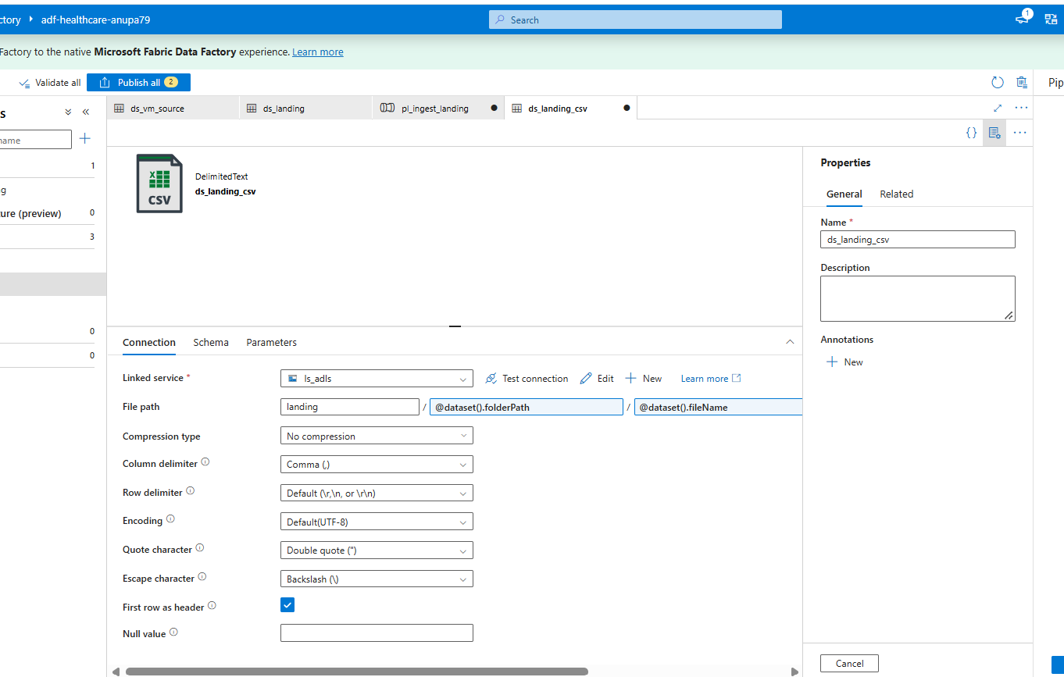
Step_3_Screenshot_1.png: ds_landing_csv dataset settings
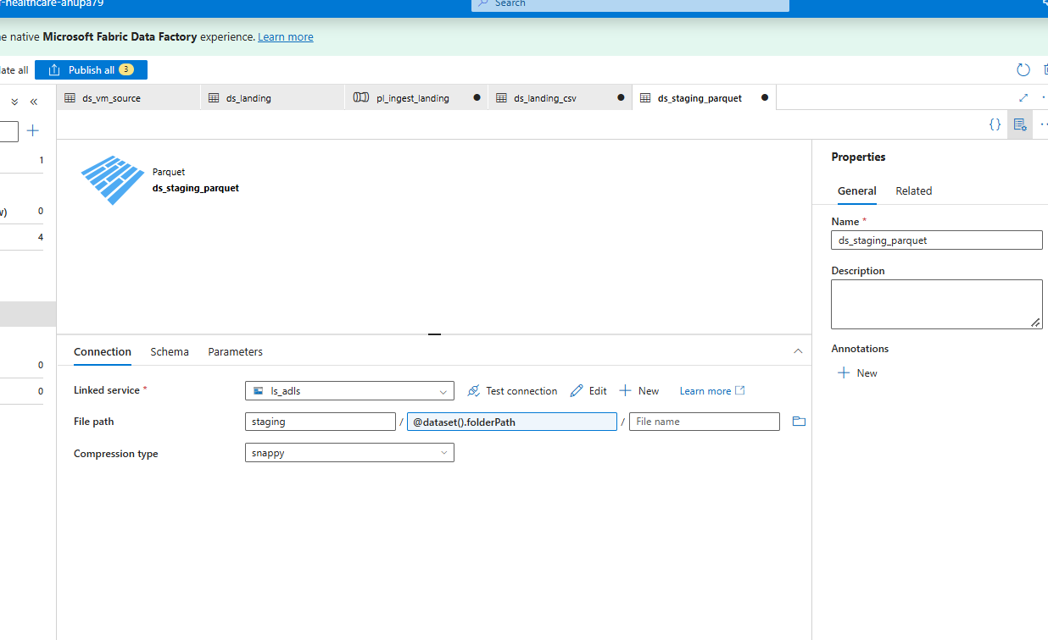
Step_3_Screenshot_2.png: ds_staging_parquet dataset settings
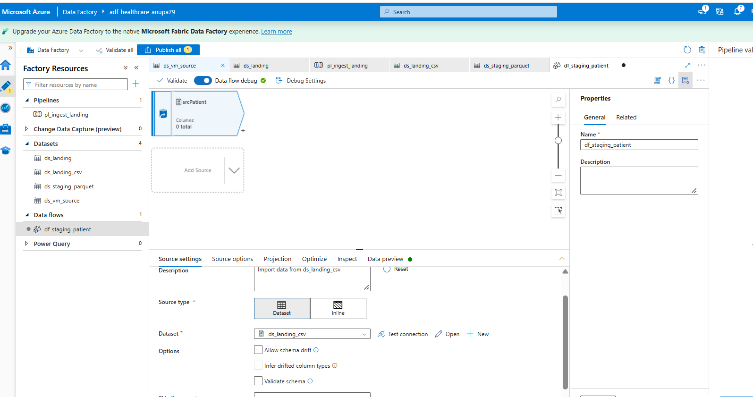
Step_3_Screenshot_3.png: df_staging_patient source
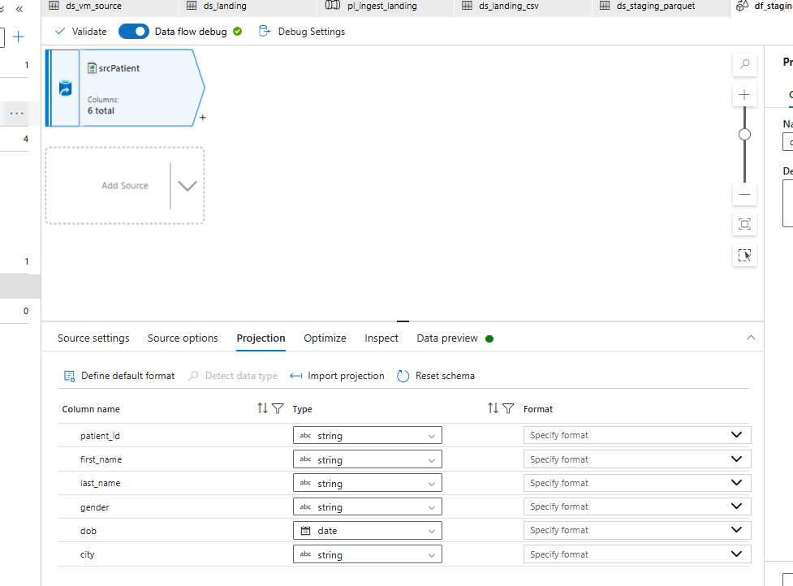
Step_3_Screenshot_4.png: Explicit schema (Projection) for patient
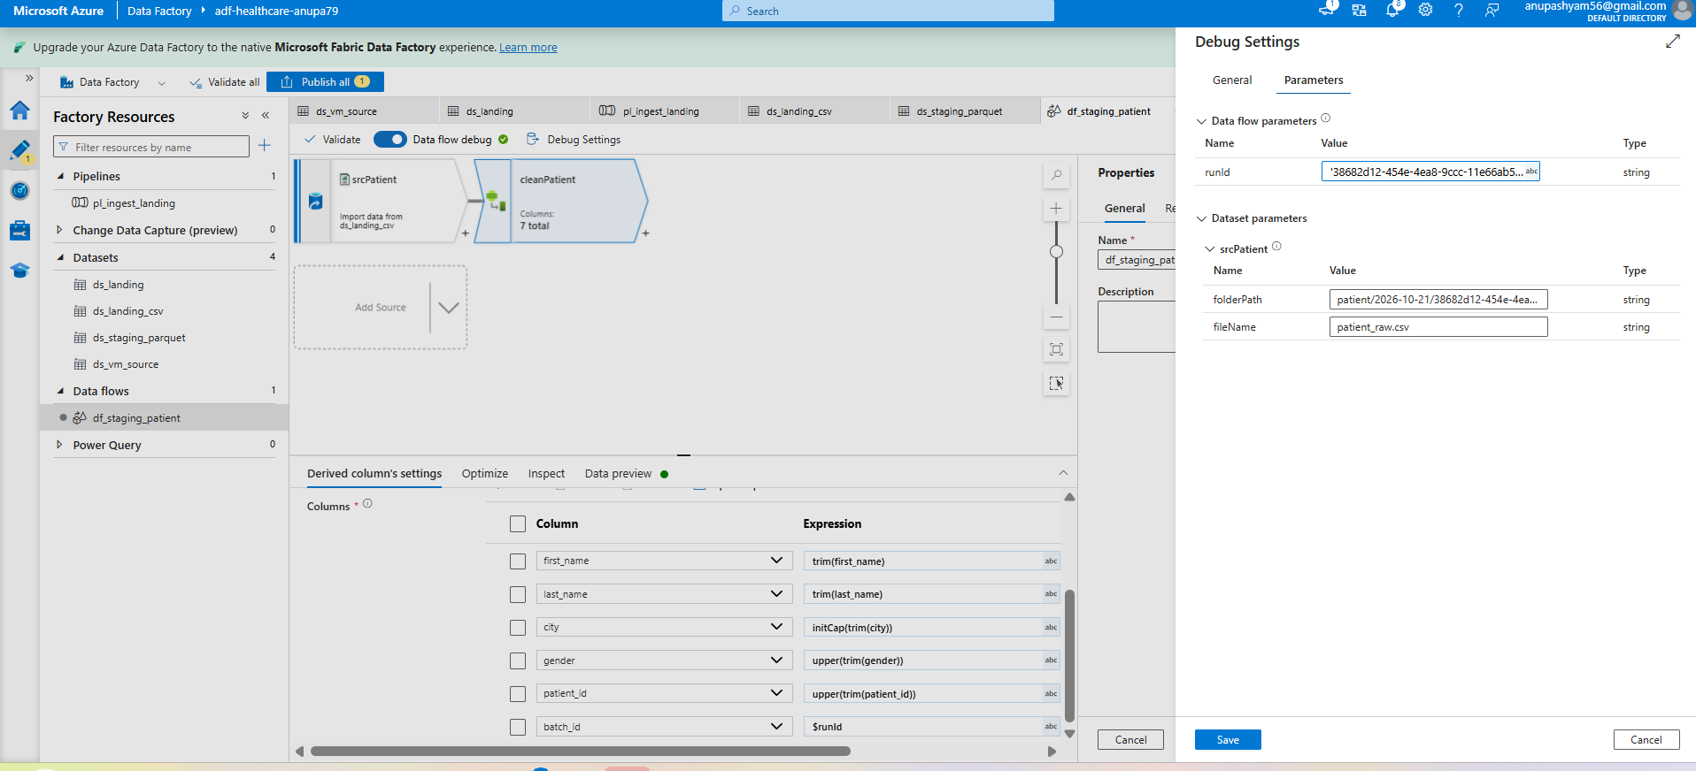
Step_3_Screenshot_5.png: cleanPatient Derived Column expressions
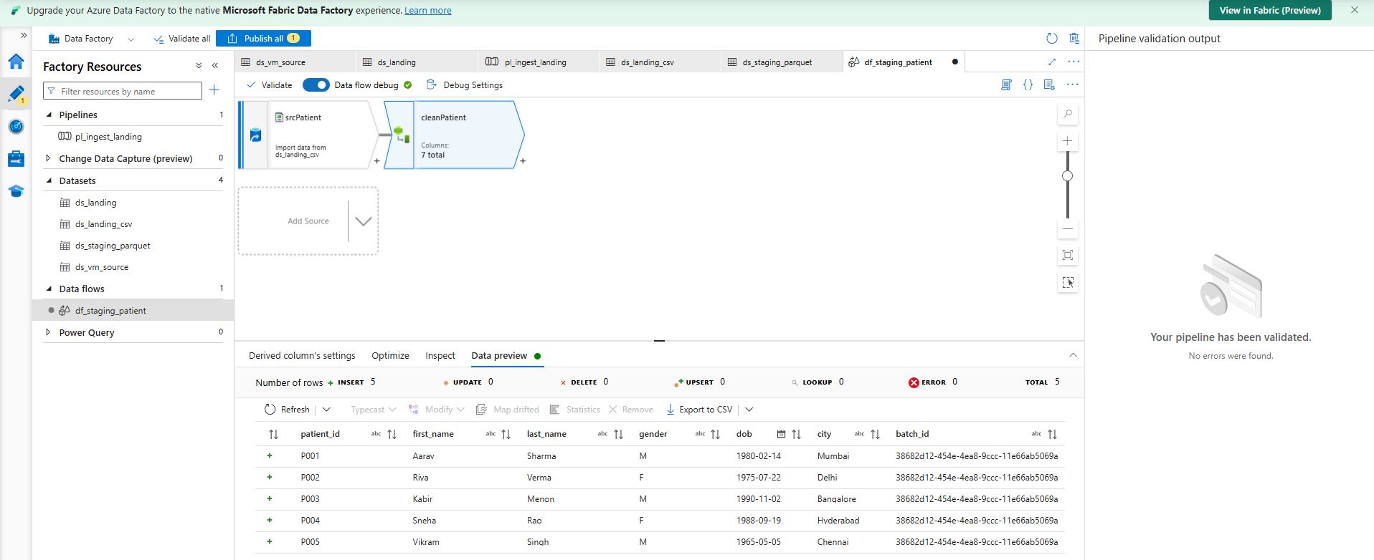
Step_3_Screenshot_6.png: Data preview after cleaning, with batch_id
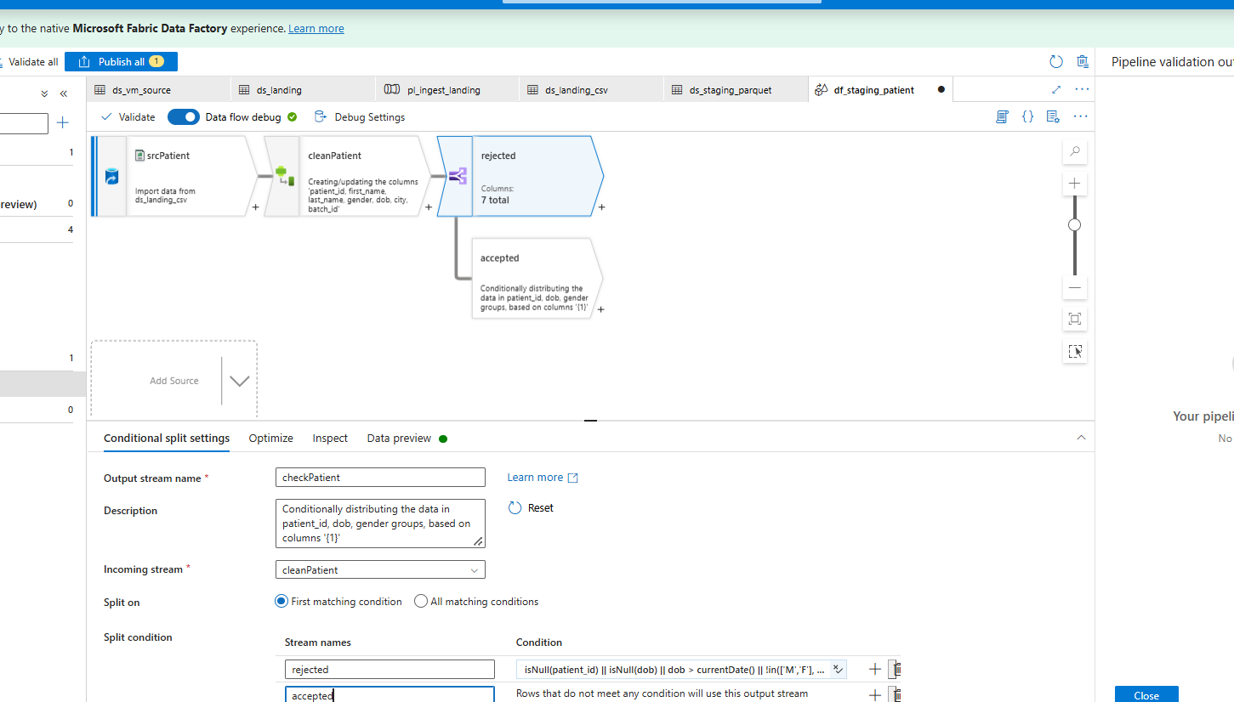
Step_3_Screenshot_7.png: checkPatient Conditional Split rule
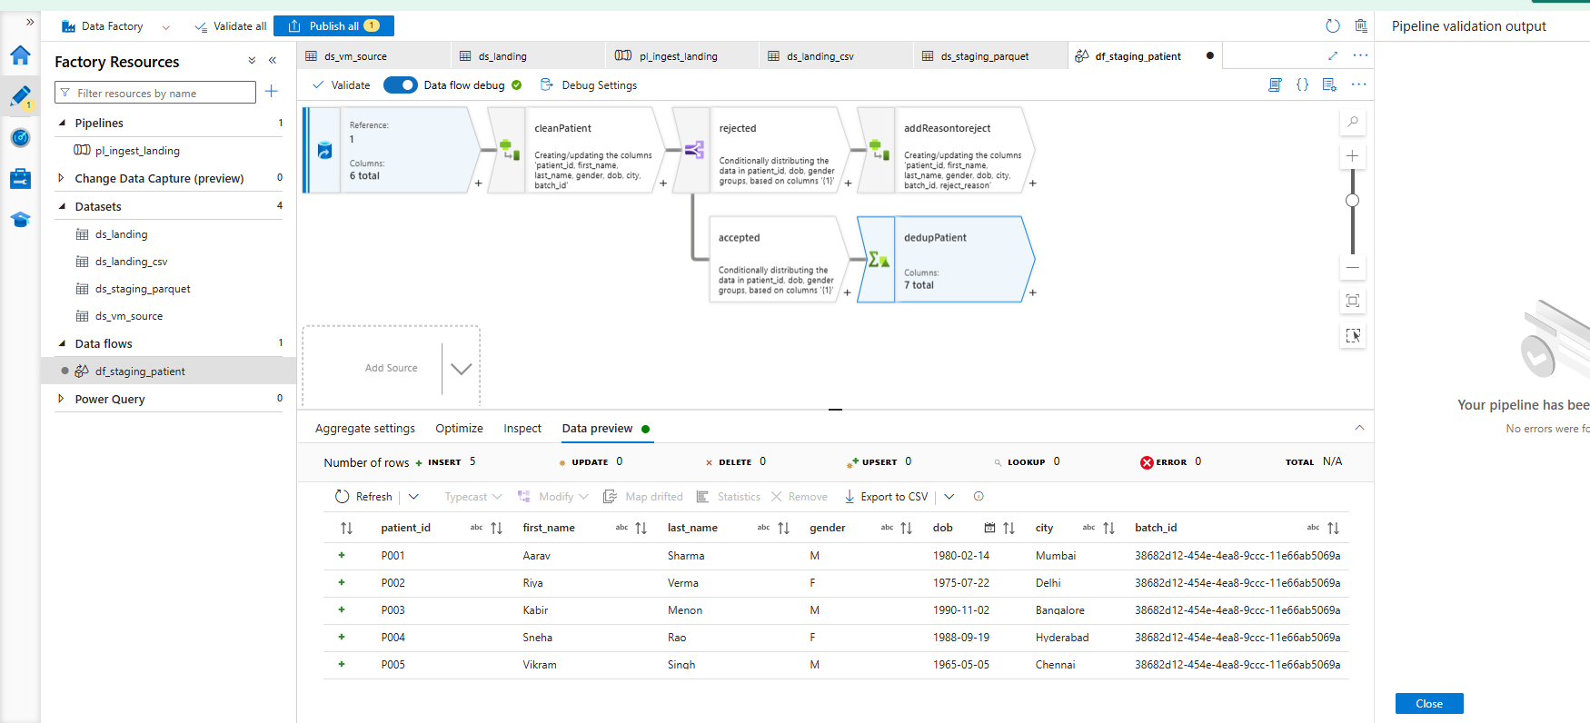
Step_3_Screenshot_8.png: dedupPatient preview (5 rows)
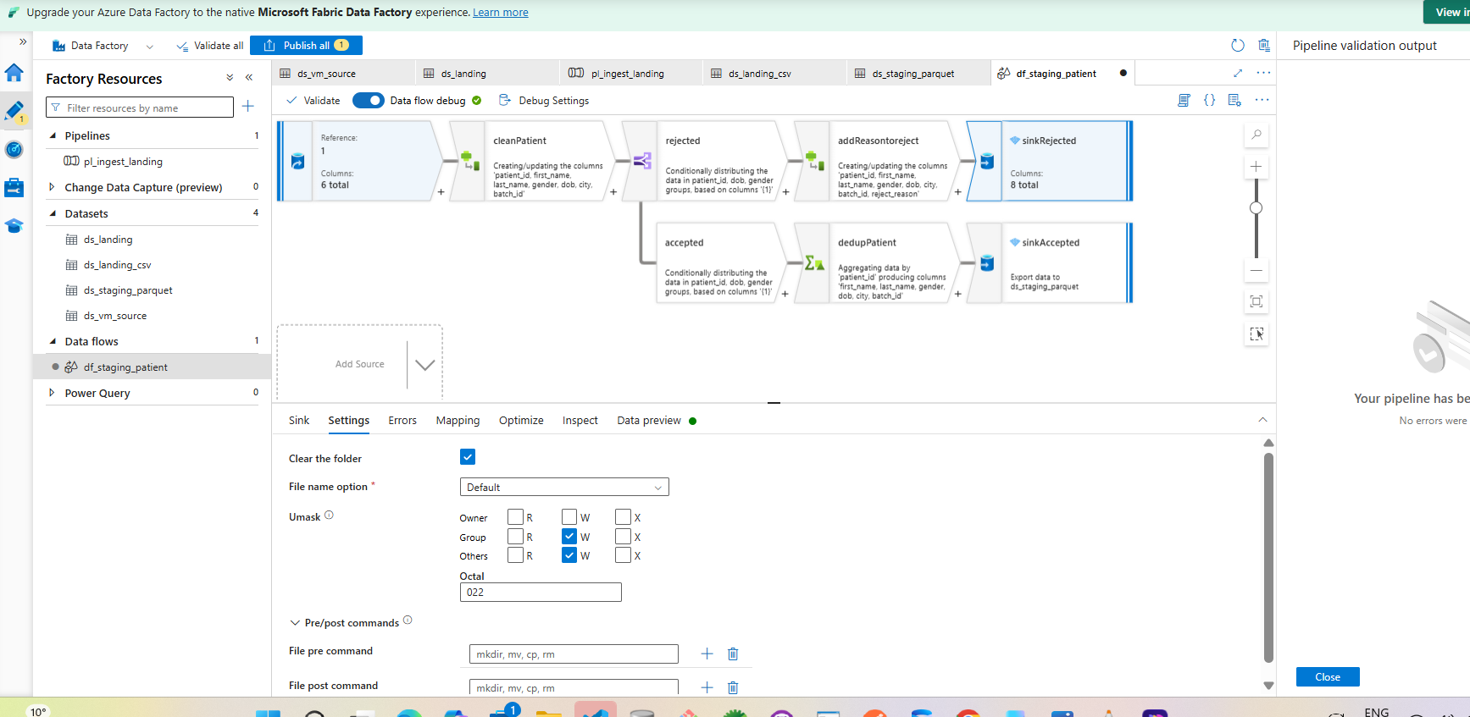
Step_3_Screenshot_9.png: Full patient flow with accepted and rejected sinks
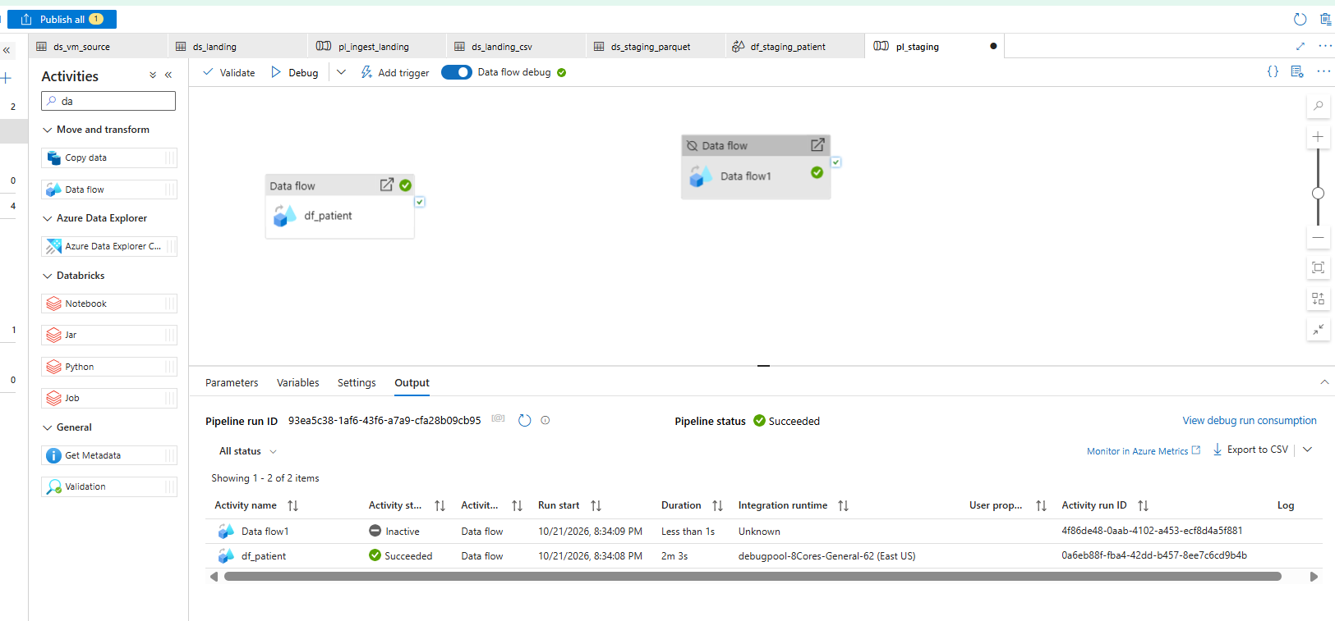
Step_3_Screenshot_10.png: df_patient debug run Succeeded
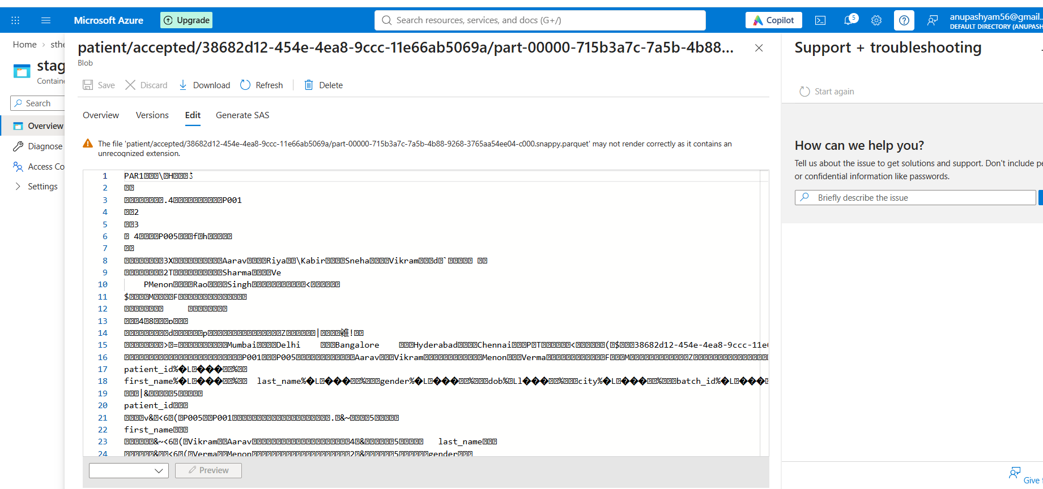
Step_3_Screenshot_11.png: Parquet file in staging/patient/accepted/<runId>
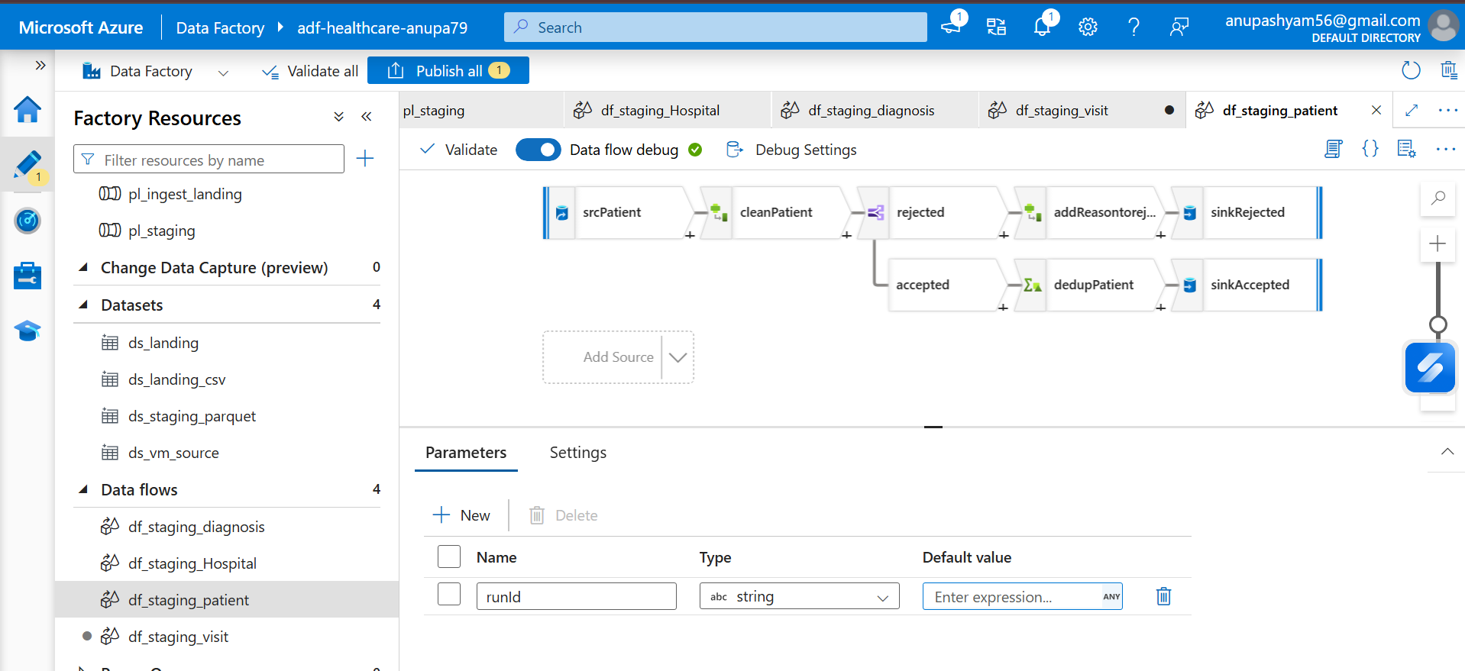
Step_3_Screenshot_12.png: runId data flow parameter
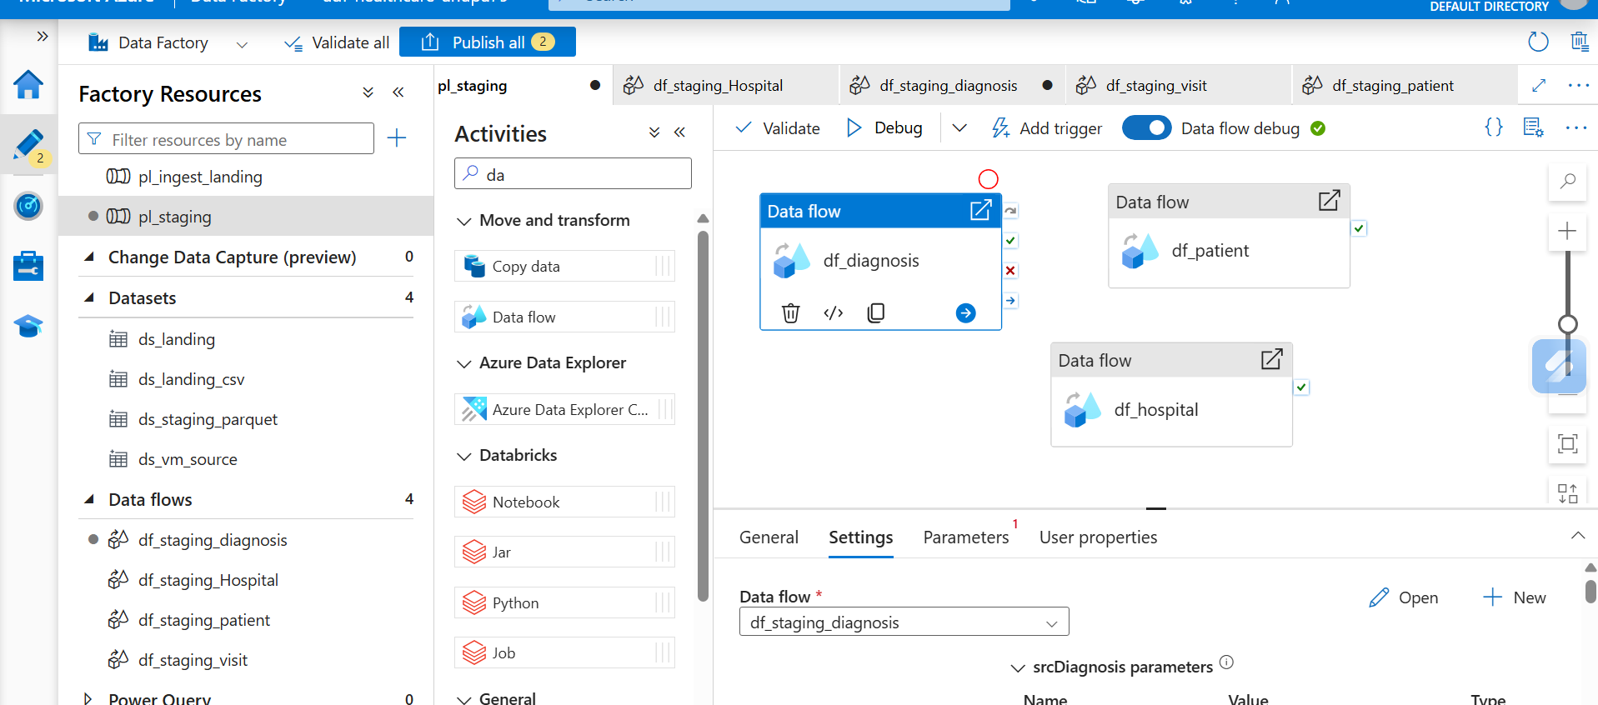
Step_3_Screenshot_13.png: pl_staging canvas
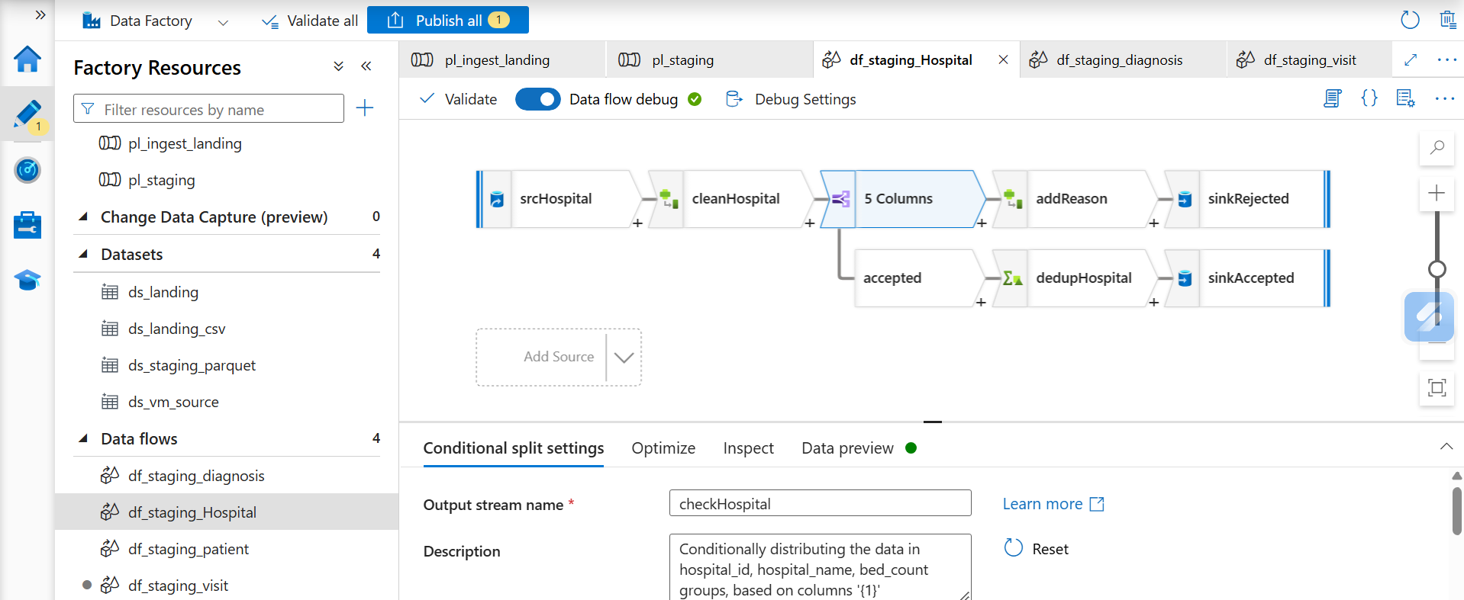
Step_3_Screenshot_14.png: df_staging_hospital flow
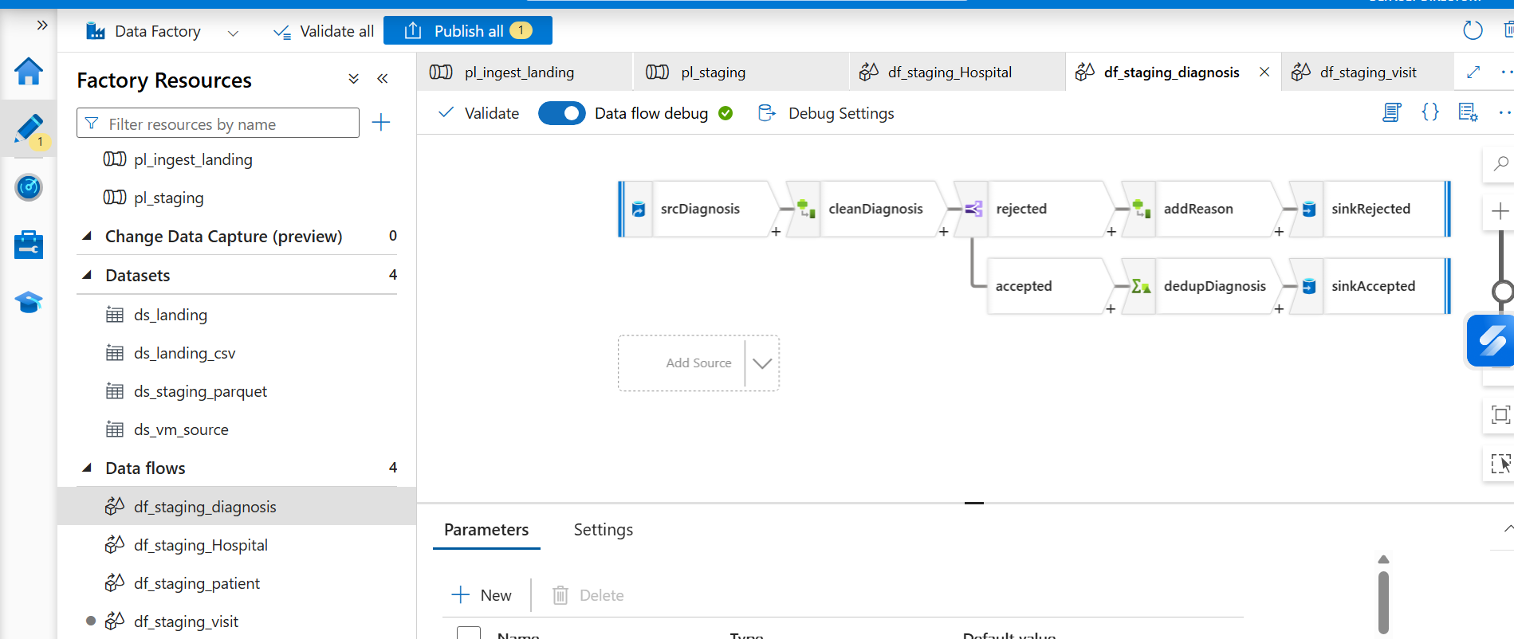
Step_3_Screenshot_15.png: df_staging_diagnosis flow
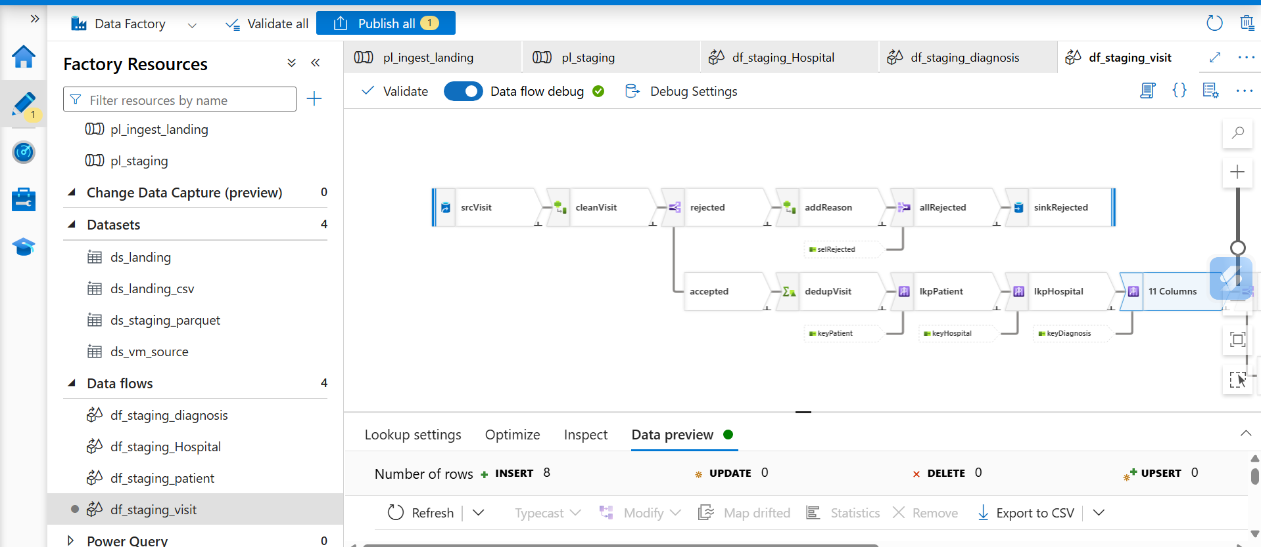
Step_3_Screenshot_16.png: df_staging_visit with Lookups (8 rows)
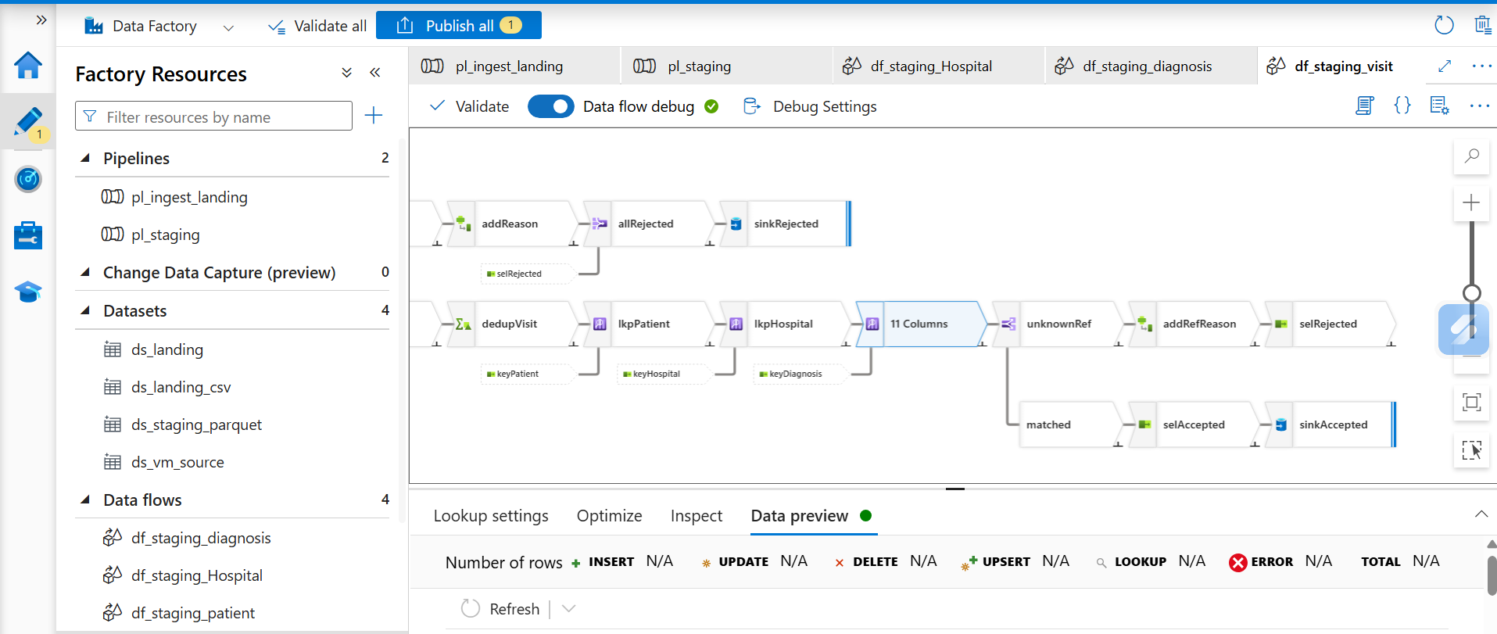
Step_3_Screenshot_17.png: df_staging_visit full flow (unknownRef split)
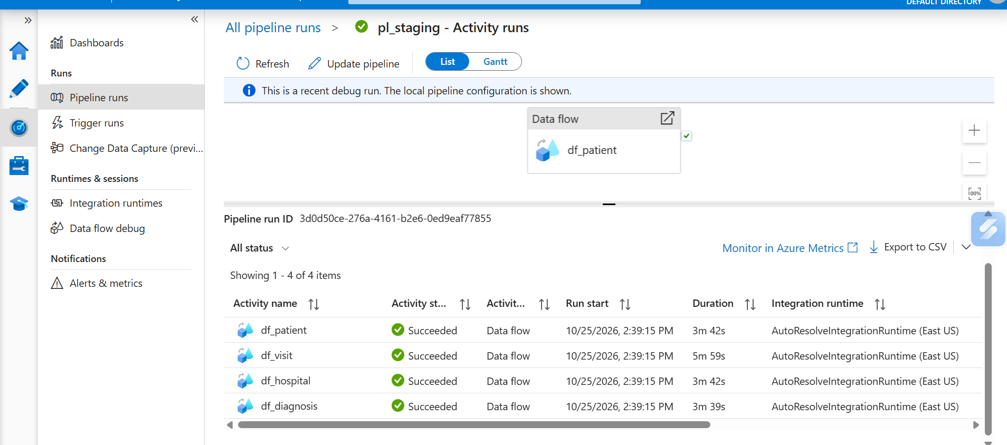
Step_3_Screenshot_18.png: pl_staging Monitor: all 4 data flows Succeeded
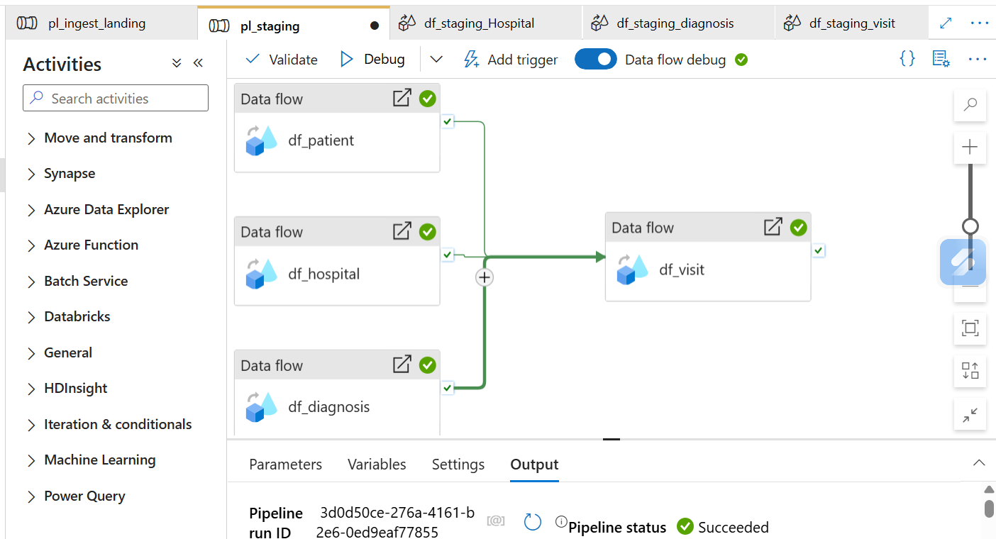
Step_3_Screenshot_19.png: pl_staging pipeline status Succeeded
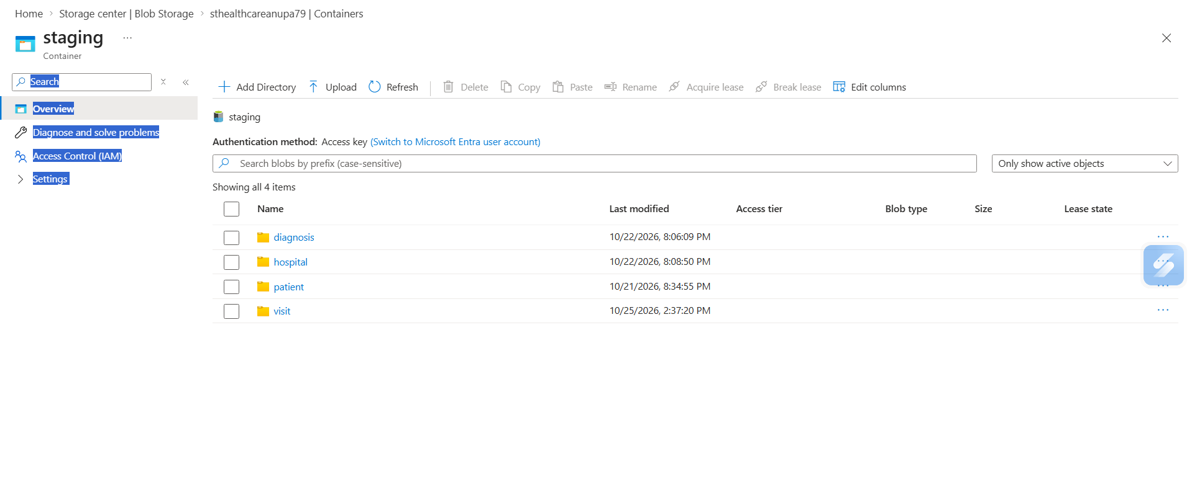
Step_3_Screenshot_20.png: staging container with one folder per dataset

