Step 4: Azure SQL Load with SCD Type 1
Healthcare Data Pipeline · Bootcamp Project 1 · Anupa

1. What this step does
The accepted Parquet files from Staging are loaded into four Azure SQL tables. The load uses SCD Type 1: a new key is inserted, an existing key is overwritten with the latest values, and nothing is ever deleted just because it is missing from a later file. Pipeline pl_load_sql does this with Copy activities in Upsert mode.

2. Steps
- Created Azure SQL server abraham32 and database sqldb-healthcare (Basic tier) with SQL authentication.
- Stored the SQL login password in Key Vault as secret sql-password.
- Created linked service ls_sql (Azure SQL Database, password from Key Vault).
- Ran Code/sql/create_tables.sql in Query editor to create patient, hospital, diagnosis and visit.
- Created dataset ds_sql_table on ls_sql with parameter tableName.
- Created pipeline pl_load_sql with parameter runId and four Copy activities: cp_patient, cp_hospital, cp_diagnosis, then cp_visit.
- Source of each Copy: ds_staging_parquet, folder <dataset>/accepted/<runId>, wildcard *.parquet.
- Sink of each Copy: ds_sql_table, Write behavior = Upsert, key column = the business key.
- Audit columns (professor's request): ran Code/sql/alter_add_audit_columns.sql to add updated_date and updated_by to all 4 tables. In each Copy activity, Source > Additional columns adds updated_date = @utcnow() and updated_by = @concat(pipeline().Pipeline, ' - ', pipeline().RunId), and these are mapped to the SQL columns.
- Connected cp_visit to run only on Success of the other three (foreign keys).
- Debugged, checked counts with Code/sql/validation_queries.sql, then Publish all.

3. Configuration
Item | Value
SQL server / database | abraham32 / sqldb-healthcare (Basic)
Authentication | SQL authentication; password in Key Vault secret sql-password
Linked service | ls_sql (Azure SQL Database)
Sink dataset | ds_sql_table (param tableName)
Pipeline | pl_load_sql (param runId)
Copy source | ds_staging_parquet, wildcard path <dataset>/accepted/<runId>/*.parquet
Copy sink | Write behavior Upsert, key columns below
Load order | cp_patient, cp_hospital, cp_diagnosis (parallel) → cp_visit

4. SCD Type 1 design
Table | Match key | Updatable attributes
patient | patient_id | first_name, last_name, gender, dob, city, batch_id, updated_date, updated_by
hospital | hospital_id | hospital_name, city, bed_count, batch_id, updated_date, updated_by
diagnosis | diagnosis_code | diagnosis_desc, batch_id, updated_date, updated_by
visit | visit_id | patient_id, hospital_id, admission_date, discharge_date, diagnosis_code, cost, batch_id, updated_date, updated_by

- New key: inserted.
- Changed record: all attributes overwritten with the new values (no history kept).
- Unchanged record: plain Upsert rewrites every row in the file, so the data values stay the same but batch_id, updated_date and updated_by get the latest run. So updated_date means 'last loaded', not 'last changed'.
- Audit: last_updated = created date (SQL default, set once on insert); updated_date and updated_by = when and which pipeline run last wrote the row.
- Record absent from a later file: left untouched. Absence never deletes data.
- Rerun of the same batch: upsert matches on the key, so no duplicate rows are created.

5. Code snippets
Table example (full script: Code/sql/create_tables.sql):
CREATE TABLE dbo.patient (
patient_id VARCHAR(20) NOT NULL PRIMARY KEY,
first_name VARCHAR(50),
last_name VARCHAR(50),
gender VARCHAR(10),
dob DATE,
city VARCHAR(50),
batch_id VARCHAR(50),
last_updated DATETIME2 DEFAULT SYSUTCDATETIME(), -- created date
updated_date DATETIME2, -- set by ADF
updated_by VARCHAR(100) -- set by ADF
);

Copy source folder (cp_patient):
@concat('patient/accepted/', pipeline().parameters.runId) wildcard file name: *.parquet

Copy source > Additional columns (all 4 Copy activities):
updated_date = @utcnow()
updated_by = @concat(pipeline().Pipeline, ' - ', pipeline().RunId)

Copy sink (cp_patient):
tableName = patient Write behavior = Upsert Key columns = patient_id

Count check after load:
SELECT 'patient' AS tbl, COUNT(*) AS cnt FROM dbo.patient
UNION ALL SELECT 'hospital', COUNT(*) FROM dbo.hospital
UNION ALL SELECT 'diagnosis', COUNT(*) FROM dbo.diagnosis
UNION ALL SELECT 'visit', COUNT(*) FROM dbo.visit;

6. Load results
Table | Source rows (Staging accepted) | Target rows (SQL) | Status
patient | 5 | 5 | Succeeded
hospital | 5 | 5 | Succeeded
diagnosis | 5 | 5 | Succeeded
visit | 8 | 8 | Succeeded

7. SCD Type 1 demonstration
To keep the demo simple, the patient source file on the VM was edited and pl_master was run again. The original file was backed up first (C:\original), so the sample data stays intact.
- Backed up patient_raw.csv from C:\Healthcaresource to C:\original.
- BEFORE: the patient table had 5 rows with P001 city = Mumbai (counts in Step_4_Screenshot_11).
- Edited C:\Healthcaresource\patient_raw.csv: changed P001 city from Mumbai to Pune (update), and added a new row P006, Ananya, Singh, F, 1965-05-05, Chennai (insert).
- Ran pl_master (new batch id, new Landing folder, new Staging folder, upsert into SQL).
- Ran the same query again and took the AFTER screenshot, then the duplicate check (query 2).
Check | Before | After | Result
Patient rows | 5 | 6 | P006 inserted
P001 city | Mumbai | Pune | Overwritten (SCD Type 1, no history row)
P002 to P005 | Present | Present, unchanged | Unchanged rows stay the same
Duplicate keys | 0 | 0 | Upsert on patient_id, no duplicates

Second run, after adding the audit columns (Step_4_Screenshot_15): the original patient_raw.csv (5 rows, no P006) was restored on the VM and pl_master was run again on 26 Oct 2026. This shows both SCD Type 1 rules in one picture:
- P001 to P005 were in the file, so they were overwritten with the latest values: P001's city went back to Mumbai, and updated_date (2026-10-26 19:46) and updated_by ('pl_load_sql - <run id>') were stamped on all five rows.
- P006 was not in the file, so it was kept, not deleted. Its updated_date and updated_by stay NULL because no run has written it since the audit columns were added.
- last_updated (created date) did not change for any existing row, and the table still has 6 rows with no duplicates.

8. Challenges and fixes
Challenge | Cause | How it was fixed
SQL database create failed | The default/serverless tier chosen was not allowed on the free trial subscription | Chose the Basic tier
Entra vs SQL authentication | Entra-only needs the ADF identity added as a database user with extra setup | Used SQL authentication and kept the password in Key Vault (decision kept simple)
Copy could not read Staging folder | Pointing the source at the folder did not pick up the Spark part files correctly | Used wildcard file name *.parquet
Foreign key error on visit | cp_visit ran at the same time as the parent tables | Connected cp_visit on Success of cp_patient, cp_hospital and cp_diagnosis

9. Evidence (Screenshots folder)
Screenshot file | What it shows
Step_4_Screenshot_1.png | SQL database deployment complete
Step_4_Screenshot_2.png | Key Vault secrets sql-password and vm-password (values hidden)
Step_4_Screenshot_3.png | Linked services including ls_sql
Step_4_Screenshot_4.png | CREATE TABLE run in Query editor
Step_4_Screenshot_5.png | ds_sql_table, connection successful
Step_4_Screenshot_6.png | cp_patient column mapping
Step_4_Screenshot_7.png | cp_patient run Succeeded
Step_4_Screenshot_8.png | cp_visit mapping
Step_4_Screenshot_9.png | pl_load_sql Succeeded
Step_4_Screenshot_10.png | All four copy activities Succeeded
Step_4_Screenshot_11.png | SQL counts: 5, 5, 5, 8
Step_4_Screenshot_13.png | SCD1 AFTER: 6 patients, P001 city Pune (updated, created date unchanged), P006 added with a new created date, no duplicates. updated_date/updated_by are NULL here because the audit columns were added after this run.
Step_4_Screenshot_15.png | Second run with original file: P001-P005 overwritten (P001 back to Mumbai) with updated_date and updated_by stamped; P006 kept, not deleted

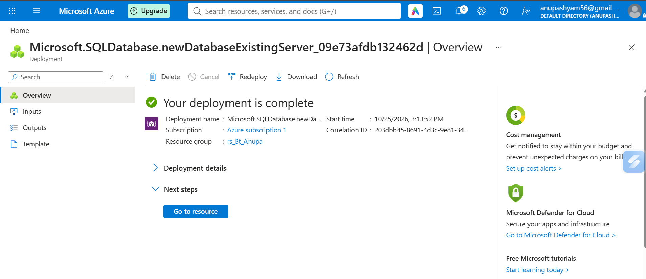
Step_4_Screenshot_1.png: SQL database deployment complete
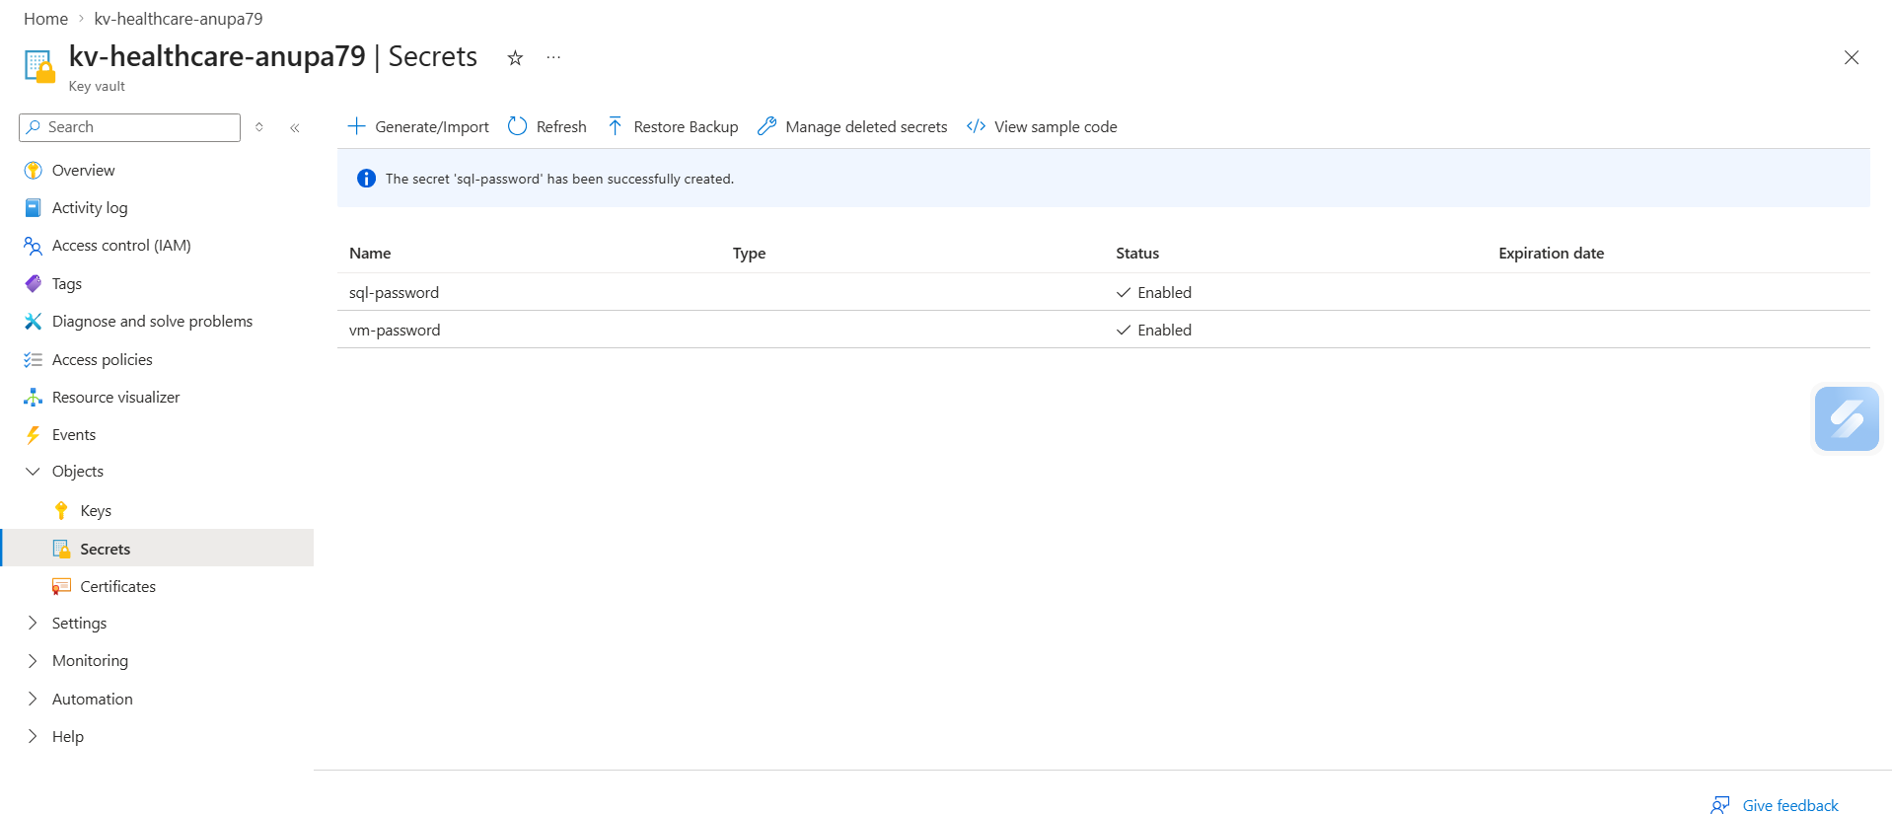
Step_4_Screenshot_2.png: Key Vault secrets sql-password and vm-password (values hidden)
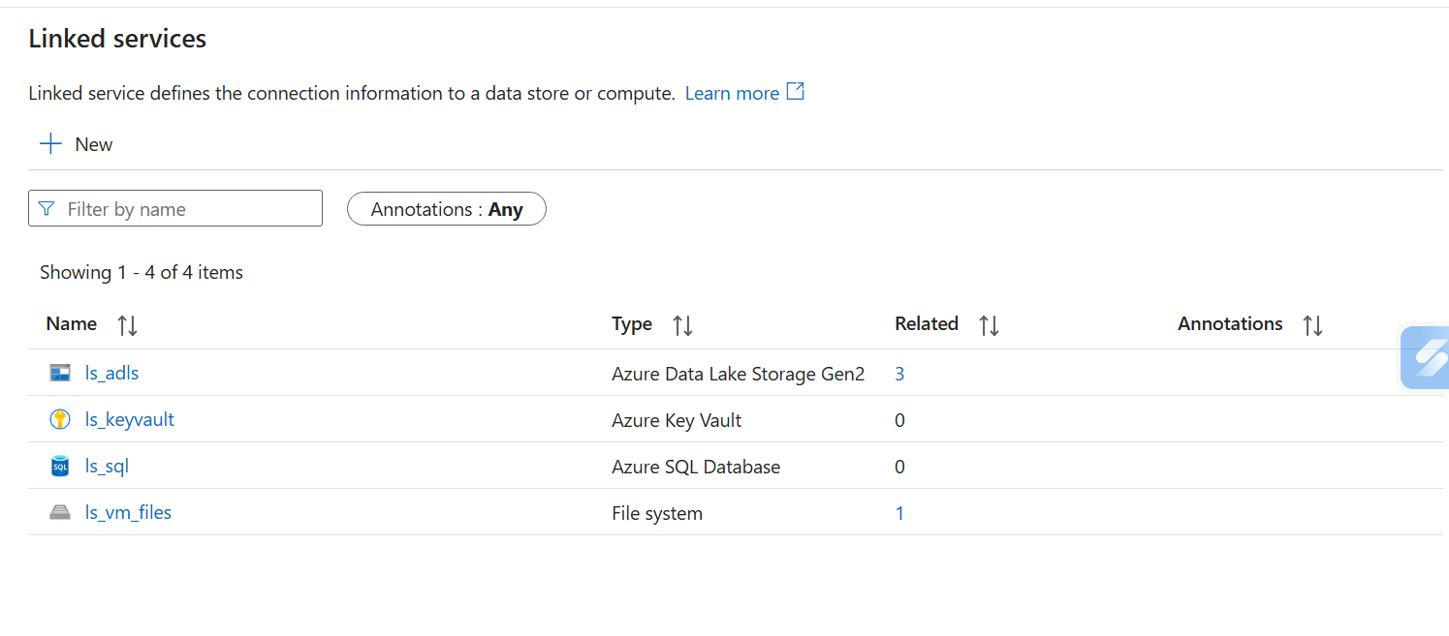
Step_4_Screenshot_3.png: Linked services including ls_sql
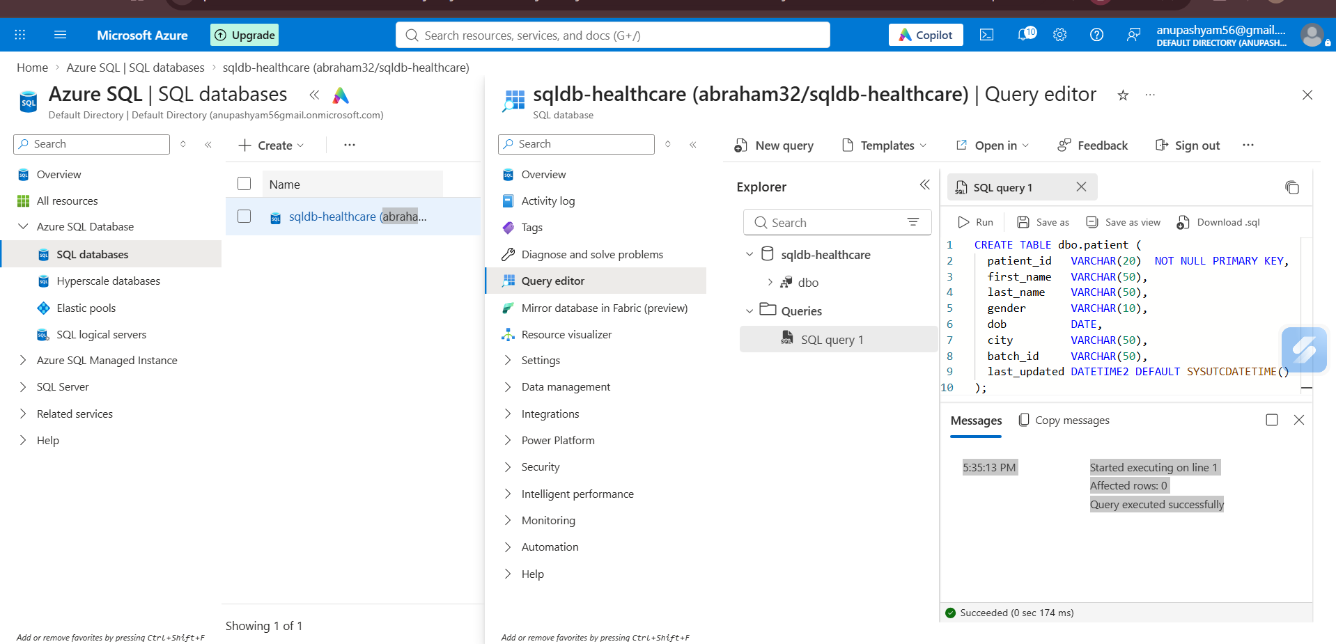
Step_4_Screenshot_4.png: CREATE TABLE run in Query editor
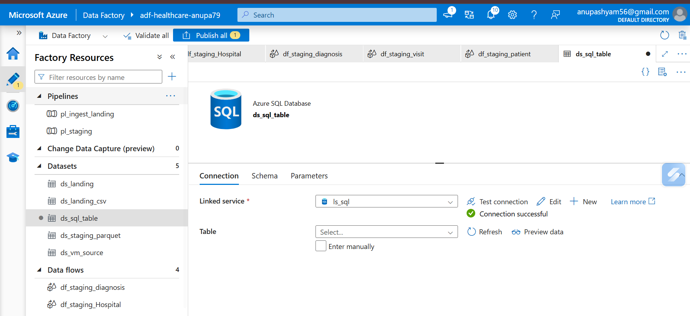
Step_4_Screenshot_5.png: ds_sql_table, connection successful
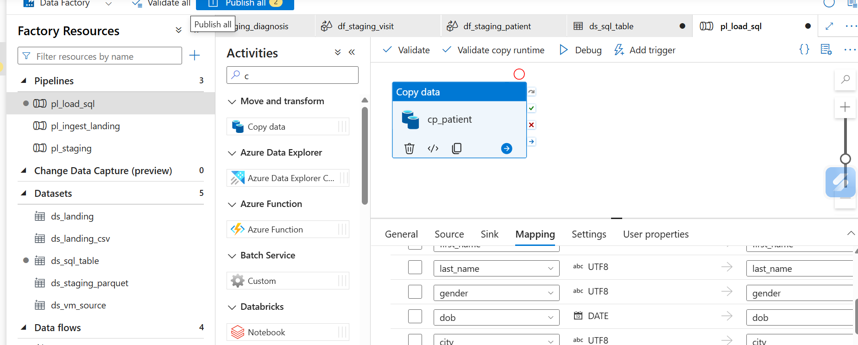
Step_4_Screenshot_6.png: cp_patient column mapping
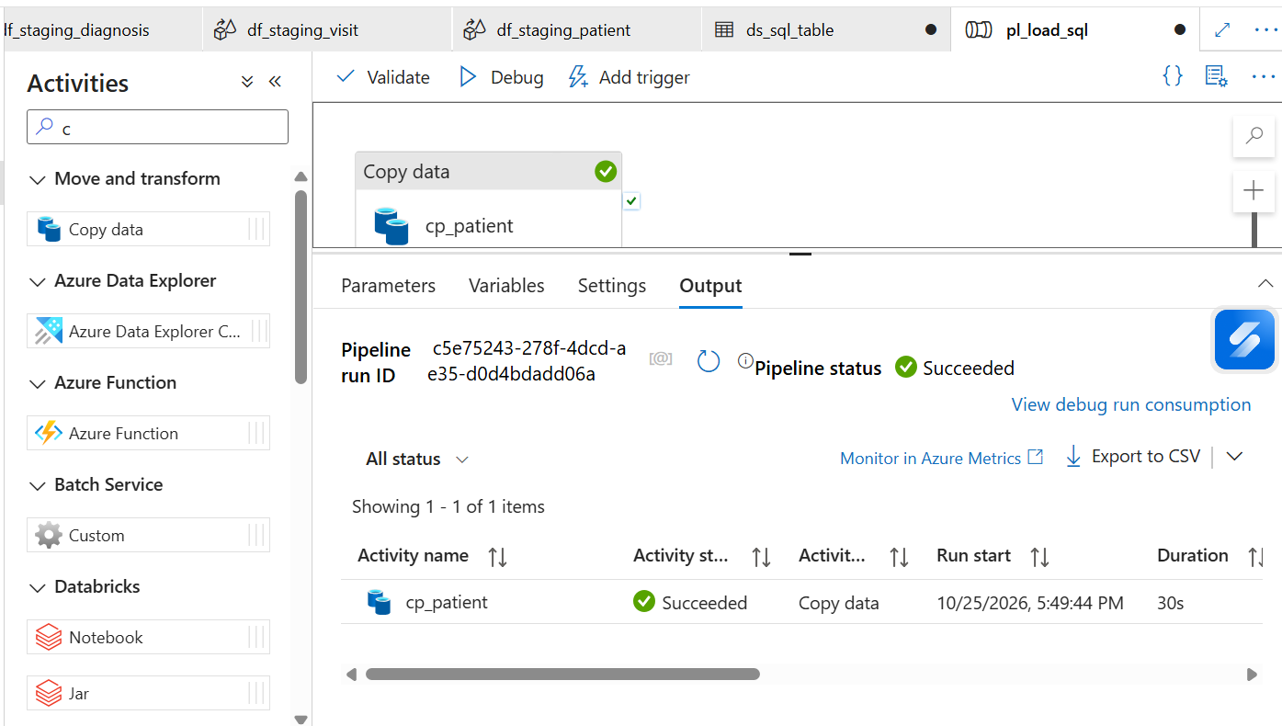
Step_4_Screenshot_7.png: cp_patient run Succeeded
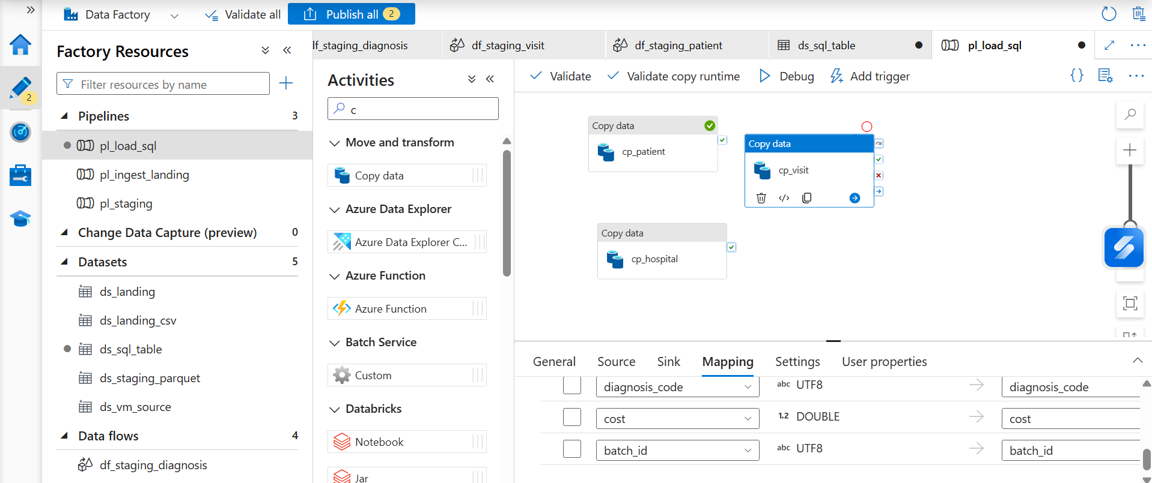
Step_4_Screenshot_8.png: cp_visit mapping
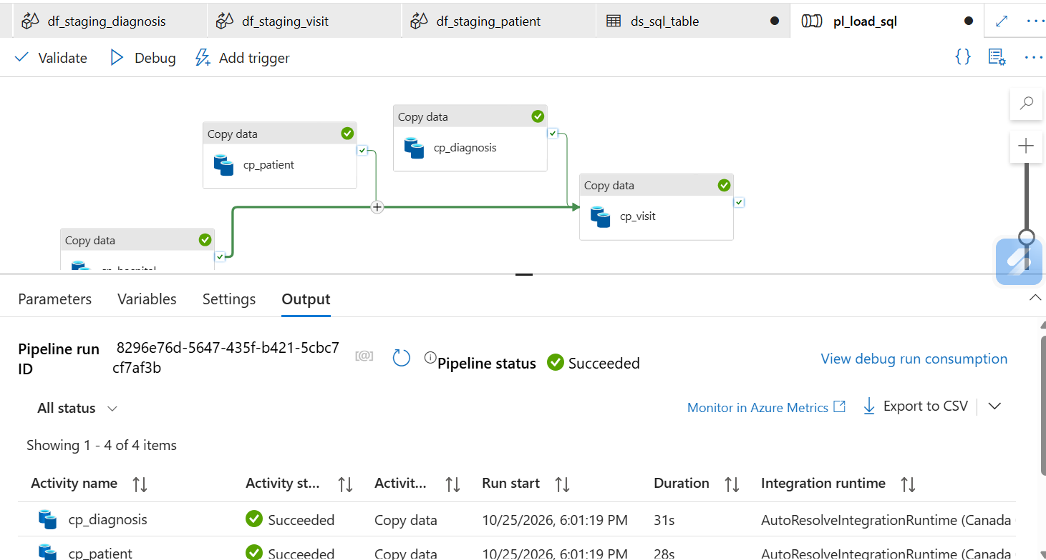
Step_4_Screenshot_9.png: pl_load_sql Succeeded
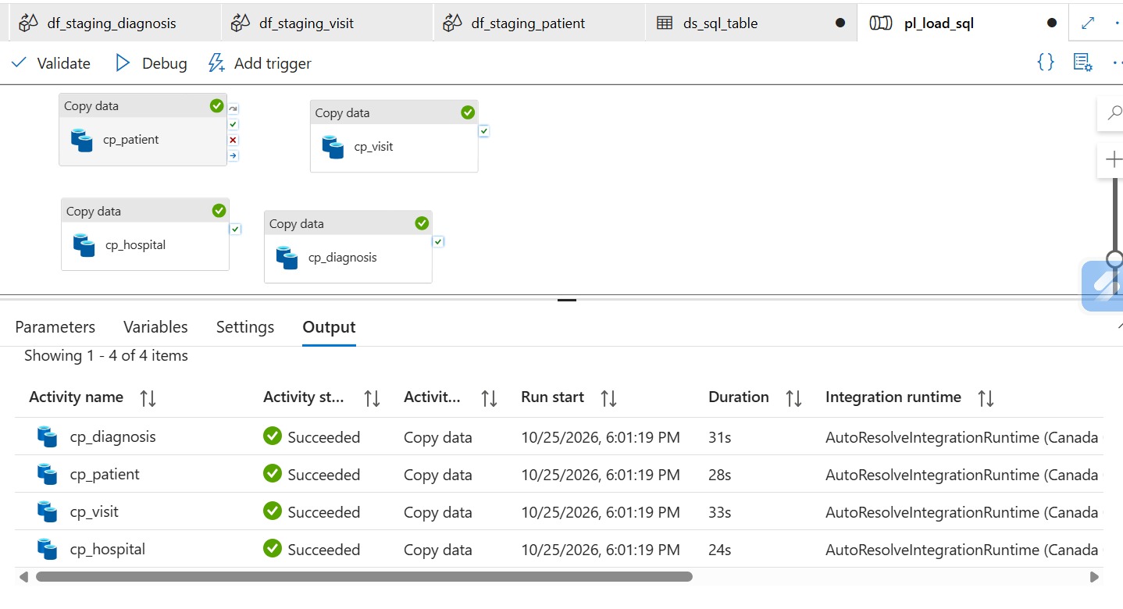
Step_4_Screenshot_10.png: All four copy activities Succeeded
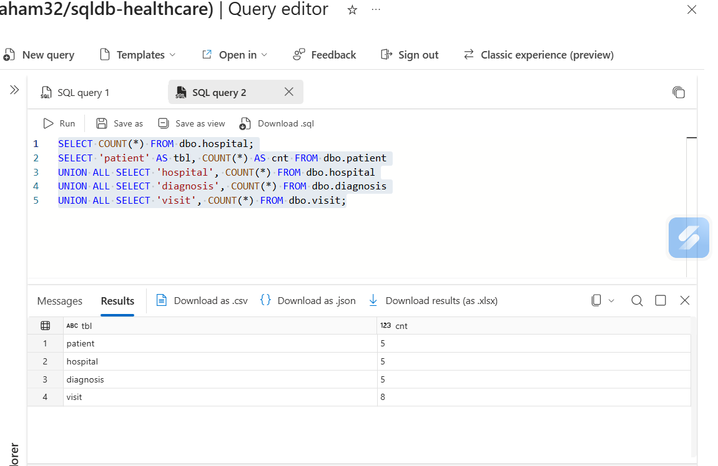
Step_4_Screenshot_11.png: SQL counts: 5, 5, 5, 8
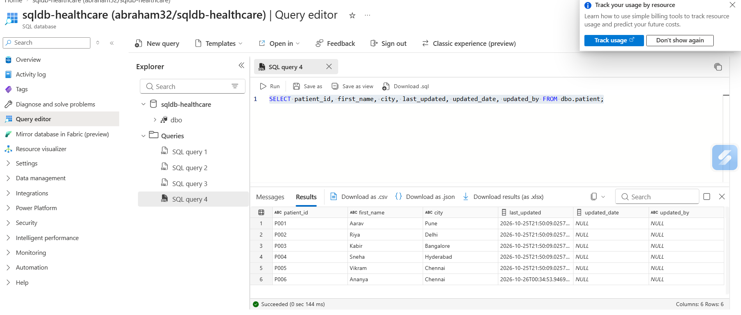
Step_4_Screenshot_13.png: SCD1 AFTER: 6 patients, P001 city Pune (updated, created date unchanged), P006 added with a new created date, no duplicates. updated_date/updated_by are NULL here because the audit columns were added after this run.
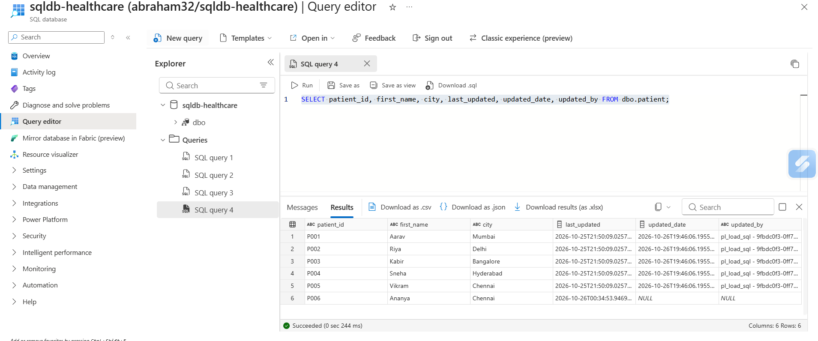
Step_4_Screenshot_15.png: Second run with original file: P001-P005 overwritten (P001 back to Mumbai) with updated_date and updated_by stamped; P006 kept, not deleted

