Step 5: Orchestration, Monitoring and Alerts
Healthcare Data Pipeline · Bootcamp Project 1 · Anupa

1. What this step does
A master pipeline, pl_master, runs the whole process in the right order with one click: ingest to Landing, validate into Staging, then load SQL. Each step starts only if the previous one succeeded, so bad data is never published to SQL. ADF Monitor records every run, and an Azure Monitor alert emails the owner when any pipeline fails.

2. Steps
- Created pipeline pl_master with three Execute Pipeline activities: run_ingest → run_staging → run_load_sql, each on Success, with 'Wait on completion' ticked.
- run_ingest passes fileList = the four file names.
- run_staging and run_load_sql receive the RunId of run_ingest as runId, so all three layers use the same batch id.
- Debugged pl_master and confirmed all three activities Succeeded, then Publish all. The parameterized version (runId passed from run_ingest) ran end to end and Succeeded on 25 Oct 2026.
- Registered resource provider microsoft.insights on the subscription.
- Created alert rule alert_pipeline_failed on the data factory: metric Failed pipeline runs > 0, checked every 5 minutes, Severity 1.
- Created action group ag_healthcare with an email notification to the owner.

3. Configuration
Item | Value
Master pipeline | pl_master: run_ingest → run_staging → run_load_sql
Batch id flow | runId = @activity('run_ingest').output.pipelineRunId
Alert rule | alert_pipeline_failed: Failed pipeline runs > 0, 5 min, Sev 1
Action group | ag_healthcare (email)
Run logging | ADF Monitor: pipeline and activity status, start/end time, duration, rows read/written, error details

4. Code snippets
run_ingest parameter:
fileList = @createArray('patient_raw.csv','hospital_raw.csv','diagnosis_raw.csv','visit_raw.csv')

run_staging parameters:
runId = @activity('run_ingest').output.pipelineRunId
runDate = @formatDateTime(utcnow(),'yyyy-MM-dd')

run_load_sql parameter:
runId = @activity('run_ingest').output.pipelineRunId

5. Execution order
# | Activity | Runs pipeline | Starts when
1 | run_ingest | pl_ingest_landing | pl_master is triggered
2 | run_staging | pl_staging | run_ingest Succeeded
3 | run_load_sql | pl_load_sql | run_staging Succeeded

6. Failure and recovery
- A failure stops the chain, so SQL is never loaded from a failed or half-validated batch.
- The alert emails the owner within about 5 minutes.
- Open Monitor > Pipeline runs, click the failed run, read the error on the failed activity.
- Fix the cause (for example start the VM, correct the file, fix the expression), then use Rerun from failed activity, or rerun pl_staging / pl_load_sql with the same runId.
- Reruns are safe: Landing keeps every batch in its own folder, Staging rewrites the same runId folder, and SQL uses upsert so no duplicates appear.

7. Challenges and fixes
Challenge | Cause | How it was fixed
Alert creation failed | Resource provider microsoft.insights was not registered | Subscription > Resource providers > register microsoft.insights
Lost work | Laptop broke; changes that were not published were lost | Rebuilt the work; now click Publish all after every step
Pipeline fails at night | VM auto-shutdown 12 AM ET stops the SHIR | Start the VM before every run (listed in the README)
Same batch id across layers | Each child pipeline has its own RunId | Passed run_ingest's pipelineRunId into the next two pipelines

8. Evidence (Screenshots folder)
Screenshot file | What it shows
Step_5_Screenshot_1.png | pl_master: run_ingest, run_staging, run_load_sql all Succeeded
Step_5_Screenshot_2.png | Alert rule condition (Failed pipeline runs > 0)
Step_5_Screenshot_3.png | Action group ag_healthcare with email
Step_5_Screenshot_4.png | alert_pipeline_failed enabled
Step_5_Screenshot_5.png | Parameterized pl_master (batch id passed between pipelines) Succeeded, 25 Oct 2026

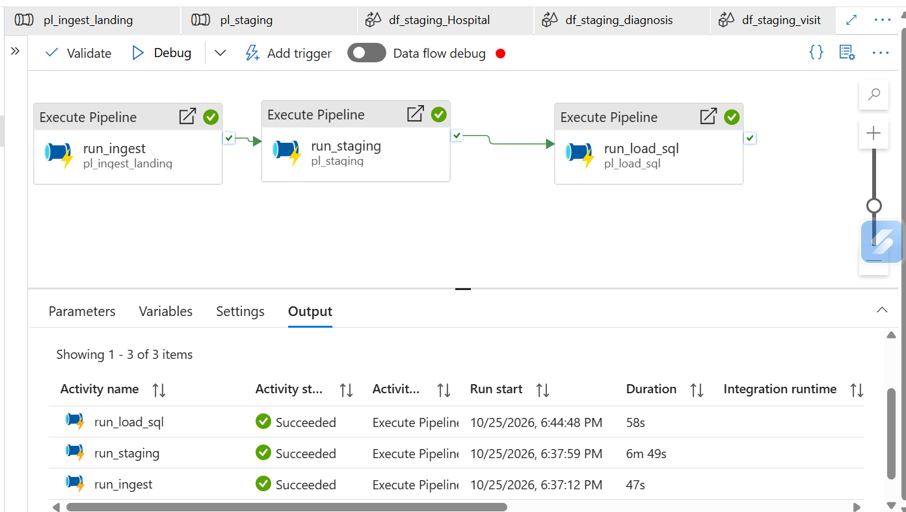
Step_5_Screenshot_1.png: pl_master: run_ingest, run_staging, run_load_sql all Succeeded
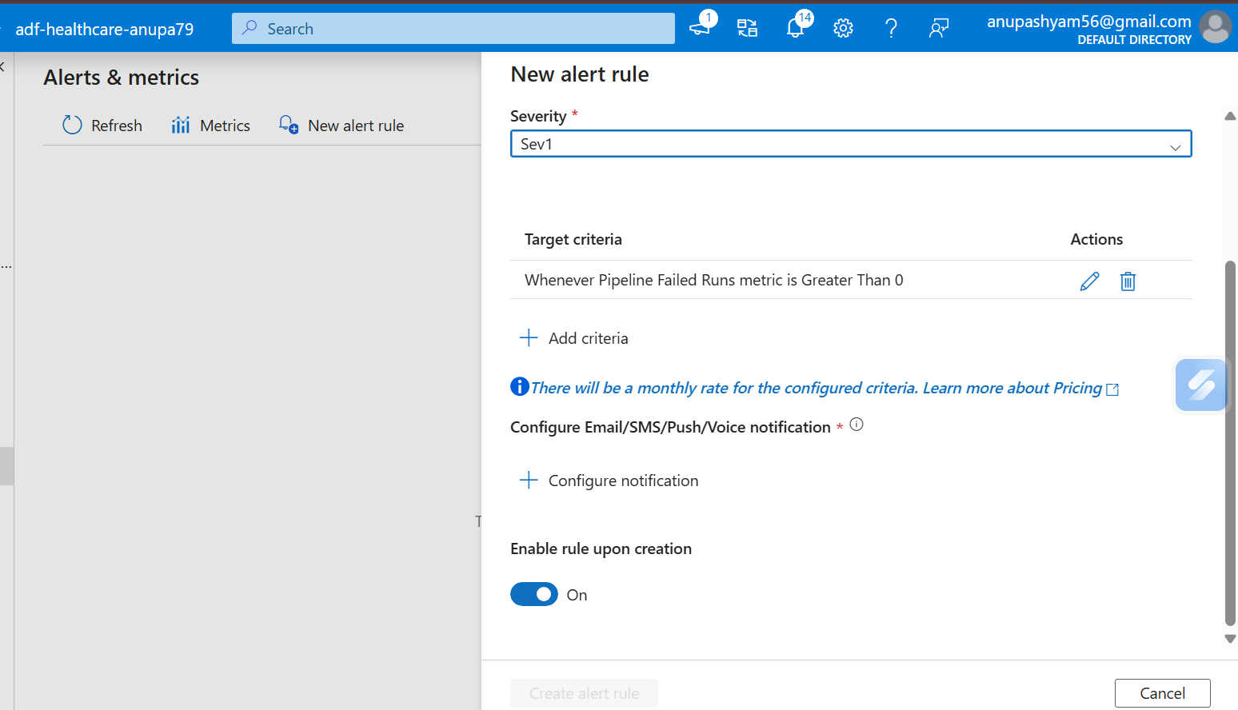
Step_5_Screenshot_2.png: Alert rule condition (Failed pipeline runs > 0)
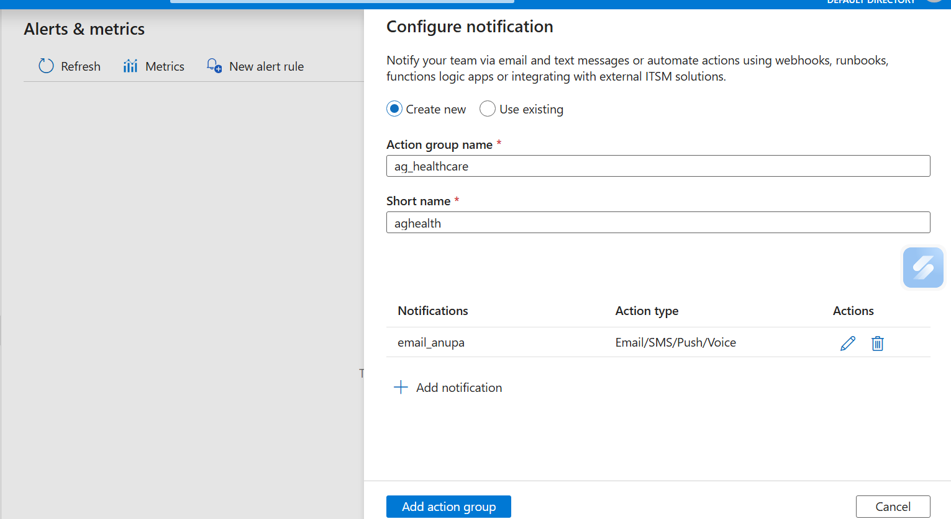
Step_5_Screenshot_3.png: Action group ag_healthcare with email
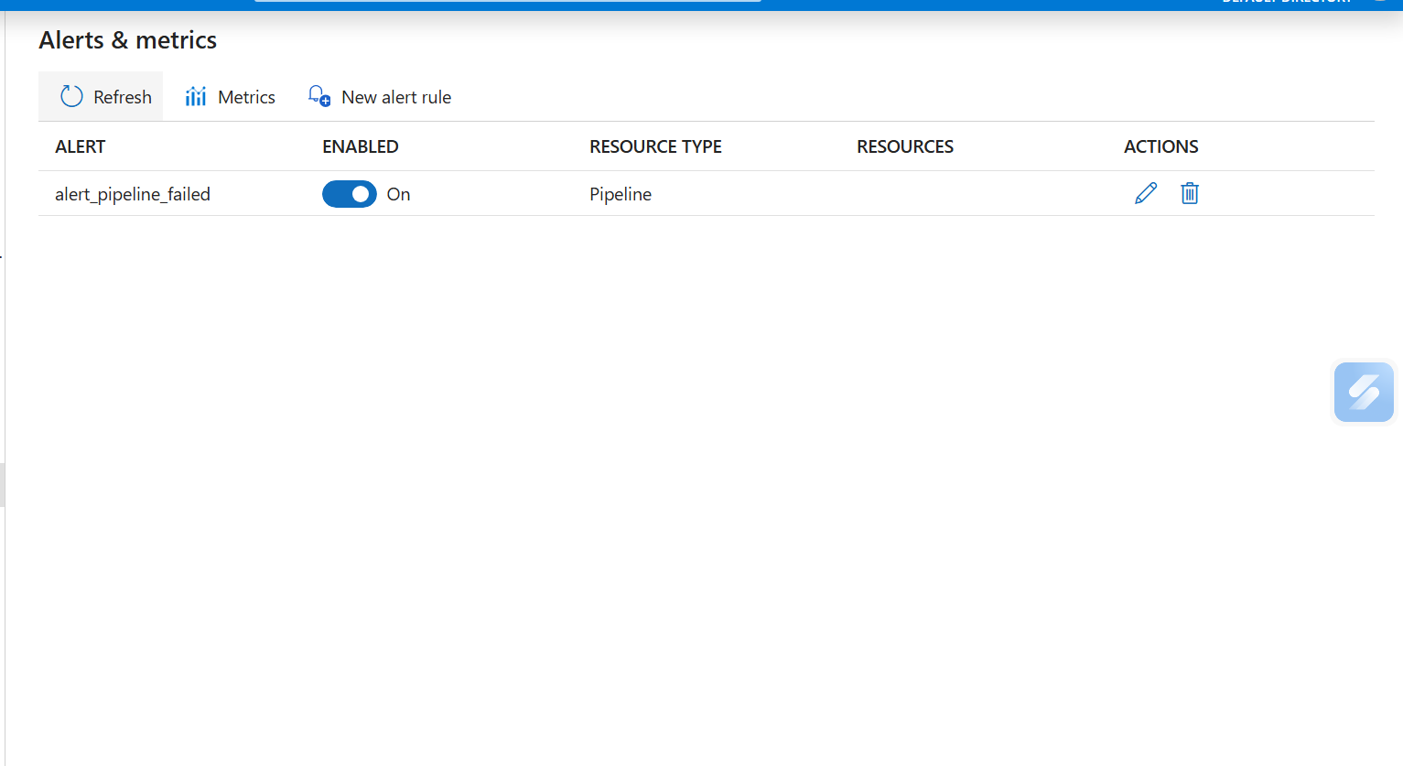
Step_5_Screenshot_4.png: alert_pipeline_failed enabled
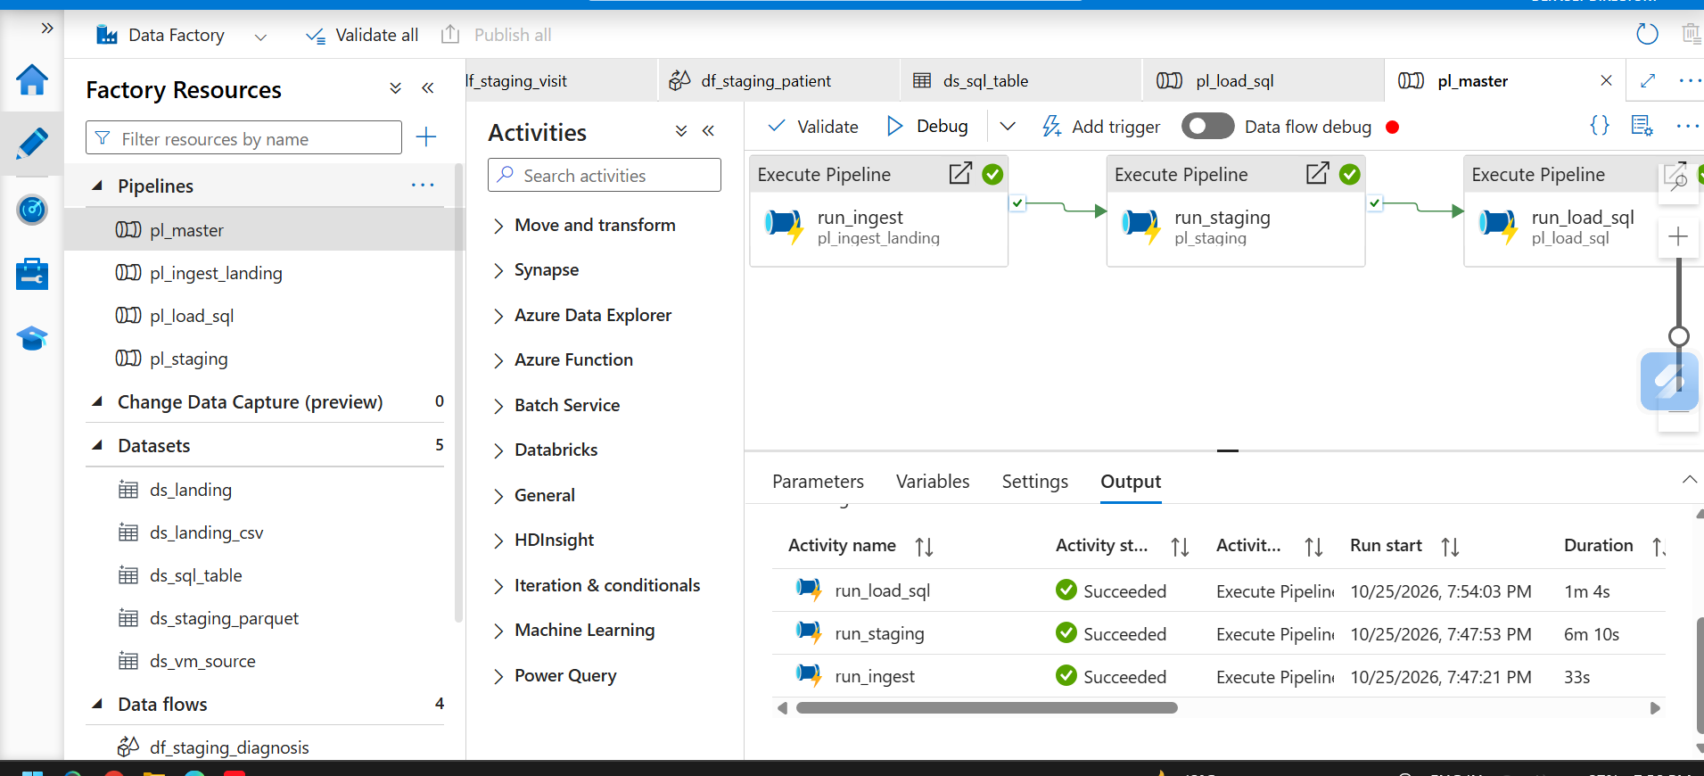
Step_5_Screenshot_5.png: Parameterized pl_master (batch id passed between pipelines) Succeeded, 25 Oct 2026

