Step 1: Source Profiling and Azure Setup
Healthcare Data Pipeline · Bootcamp Project 1 · Anupa

1. What this step does
Before building anything, the four sample files were profiled to understand their columns, keys and quality. Then all the Azure resources the pipeline needs were created: a virtual machine that holds the source files, a Self-hosted Integration Runtime so Data Factory can read from that VM, an ADLS Gen2 storage account for the Landing and Staging layers, a Key Vault for passwords, and the Data Factory itself.
The full source inventory, schemas, keys, relationships and the 27 data quality rules are in the companion document Step_1_Source_Inventory_and_DQ_Rules.docx.

2. Profiling result (short)
File | Rows | Columns | Business key | Issues found
patient_raw.csv | 5 | 6 | patient_id | None in sample
hospital_raw.csv | 5 | 4 | hospital_id | None in sample
diagnosis_raw.csv | 5 | 2 | diagnosis_code | None in sample
visit_raw.csv | 8 | 7 | visit_id | None; all references match

Because the sample is clean, extra test files with deliberate problems were made for future testing (Code/test_data). They test blank IDs, bad dates, negative cost, unknown references, duplicates, an empty file, an extra column, and SCD Type 1 changes.

3. Steps
- Profiled each column of the four provided CSV files.
- Drew the architecture diagram (Documentation/Step_0_Architecture_Diagram.png).
- Created resource group rs_Bt_Anupa.
- Created Windows VM vmhealthcare (Central India). Connected to it with Remote Desktop, locally copied the four provided CSV files onto the VM, and saved them on the C: drive in the folder C:\Healthcaresource.
- Created Data Factory adf-healthcare-anupa79 (East US).
- In ADF, created Self-hosted Integration Runtime shir-healthcare-vm, installed it on the VM and registered it with the auth key.
- Created storage account sthealthcareanupa79 with Hierarchical namespace ON (this makes it ADLS Gen2), then containers landing and staging.
- Created Key Vault kv-healthcare-anupa79 and added the VM password as secret vm-password.
- Gave the ADF managed identity two roles: Key Vault Secrets User (on Key Vault) and Storage Blob Data Contributor (on storage).
- Created linked services ls_keyvault, ls_adls and ls_vm_files, and tested each connection.

4. Configuration
Item | Value
Resource group | rs_Bt_Anupa
Source VM | vmhealthcare (Central India), auto-shutdown 12:00 AM ET
Source folder on VM | C:\Healthcaresource (patient_raw.csv, hospital_raw.csv, diagnosis_raw.csv, visit_raw.csv)
Self-hosted IR | shir-healthcare-vm (installed on vmhealthcare)
Data Factory | adf-healthcare-anupa79 (East US)
Storage (ADLS Gen2) | sthealthcareanupa79, containers: landing, staging
Key Vault | kv-healthcare-anupa79, secret: vm-password (value never shown)
ADF identity roles | Key Vault Secrets User; Storage Blob Data Contributor
ls_keyvault | Azure Key Vault, managed identity
ls_adls | Azure Data Lake Storage Gen2, managed identity
ls_vm_files | File system, connect via shir-healthcare-vm, password from Key Vault secret vm-password

5. Code snippets
Command run on the VM so the SHIR may read a local folder (run as Administrator):
cd "C:\Program Files\Microsoft Integration Runtime\5.0\Shared"
.\dmgcmd.exe -DisableLocalFolderPathValidation

ls_vm_files password comes from Key Vault, not typed in (shape of the JSON):
"password": {
"type": "AzureKeyVaultSecret",
"store": { "referenceName": "ls_keyvault", "type": "LinkedServiceReference" },
"secretName": "vm-password"
}

6. Challenges and fixes
Challenge | Cause | How it was fixed
Diagram too detailed | First version showed too many operational details | Made a minimal approval version for the professor; kept the detailed one for the submission
Lucidchart limit | Free plan allows too few objects | Switched to diagrams.net (draw.io), which is free
VM and SHIR not ready | VM auto-shuts down at midnight; SHIR shows Offline while VM is stopped | Start vmhealthcare in the portal before every run and wait about 2 minutes until the SHIR shows Running
Copy failed: AccessToOnPremFileSystemDenied | SHIR blocks reading local C:\ folders by default | Ran dmgcmd -DisableLocalFolderPathValidation on the VM (listed as a known limitation; production would use a network share)

7. Evidence (Screenshots folder)
Screenshot file | What it shows
Step_1_Screenshot_1.png | Architecture diagram
Step_1_Screenshot_2.png | VM vmhealthcare deployment complete
Step_1_Screenshot_3.png | SHIR node registered on the VM
Step_1_Screenshot_4.png | shir-healthcare-vm status Running in ADF
Step_1_Screenshot_5.png | Storage account deployment complete
Step_1_Screenshot_6.png | Containers landing and staging
Step_1_Screenshot_7.png | Key Vault deployment complete
Step_1_Screenshot_8.png | Key Vault role assignments (ADF has Secrets User)
Step_1_Screenshot_9.png | Secret vm-password created (value hidden)
Step_1_Screenshot_10.png | Storage role assignment (ADF has Blob Data Contributor)
Step_1_Screenshot_11.png | Linked services in ADF

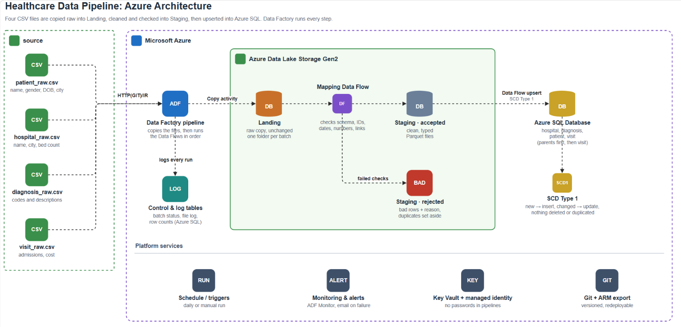
Step_1_Screenshot_1.png: Architecture diagram
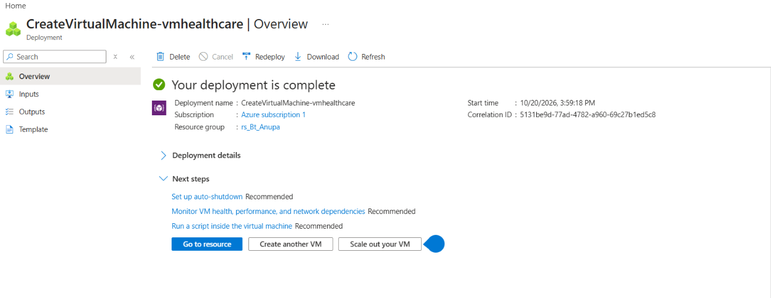
Step_1_Screenshot_2.png: VM vmhealthcare deployment complete
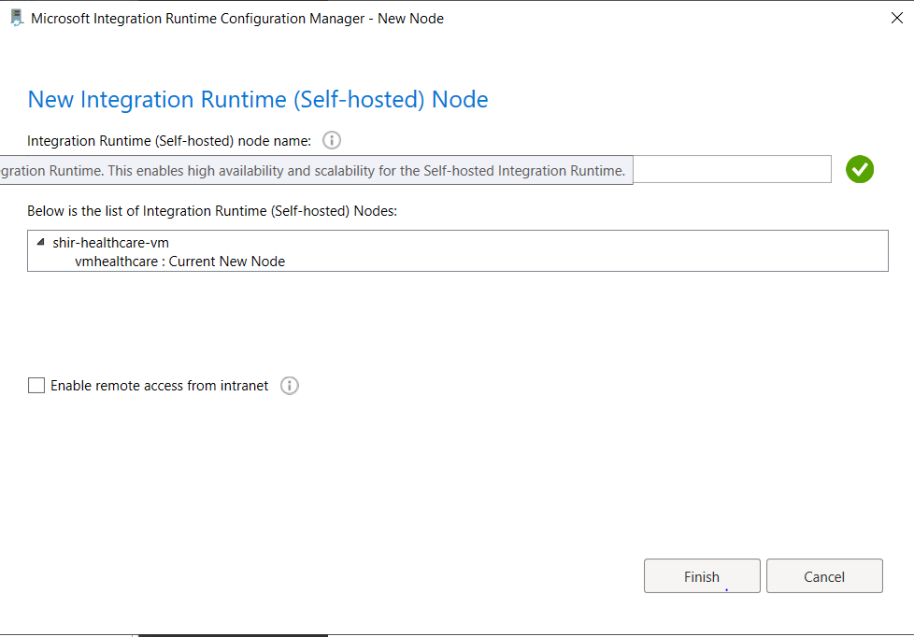
Step_1_Screenshot_3.png: SHIR node registered on the VM
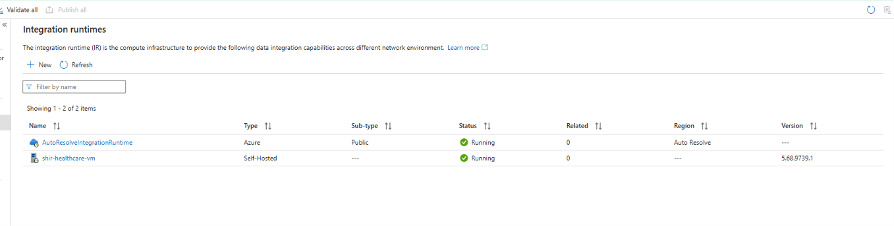
Step_1_Screenshot_4.png: shir-healthcare-vm status Running in ADF
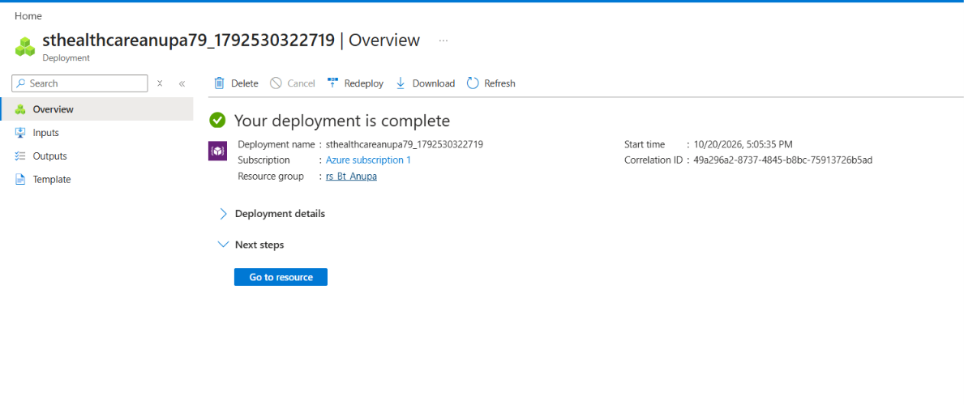
Step_1_Screenshot_5.png: Storage account deployment complete
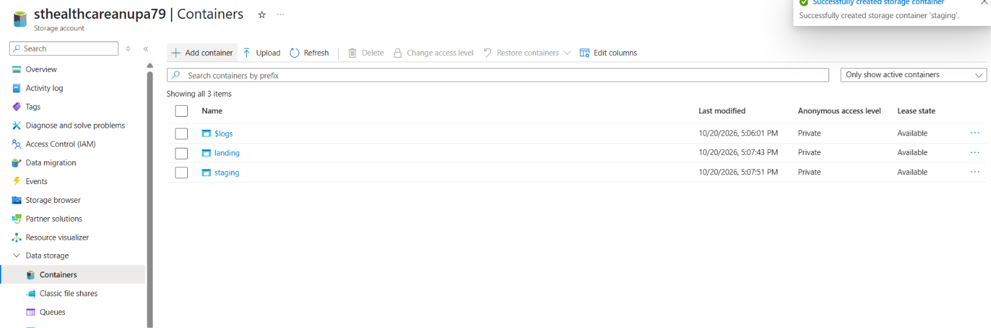
Step_1_Screenshot_6.png: Containers landing and staging
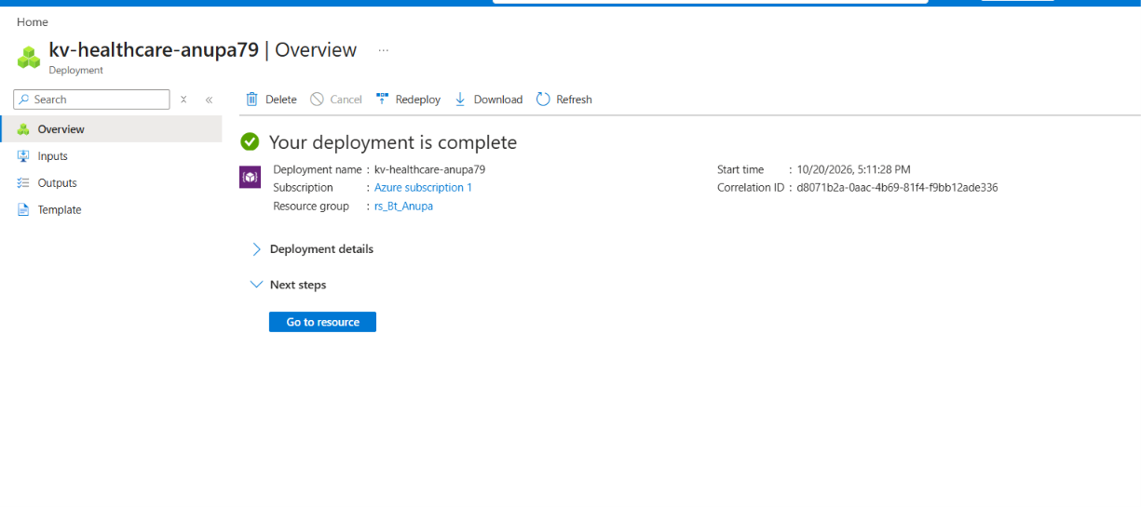
Step_1_Screenshot_7.png: Key Vault deployment complete
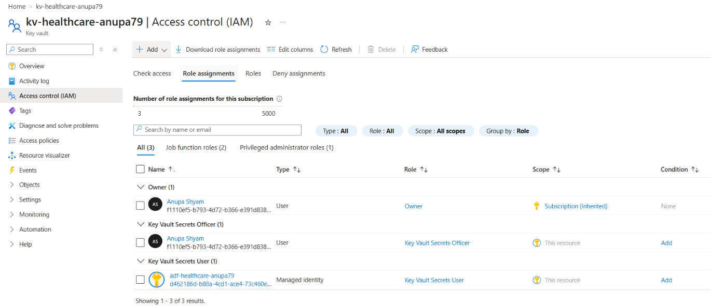
Step_1_Screenshot_8.png: Key Vault role assignments (ADF has Secrets User)
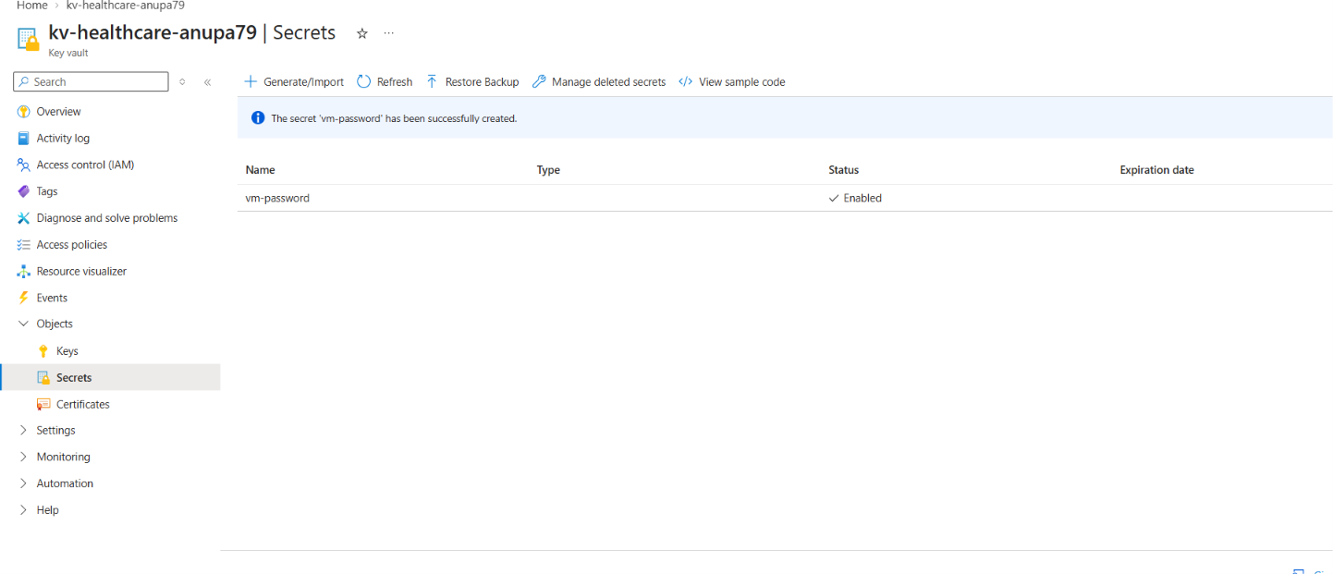
Step_1_Screenshot_9.png: Secret vm-password created (value hidden)
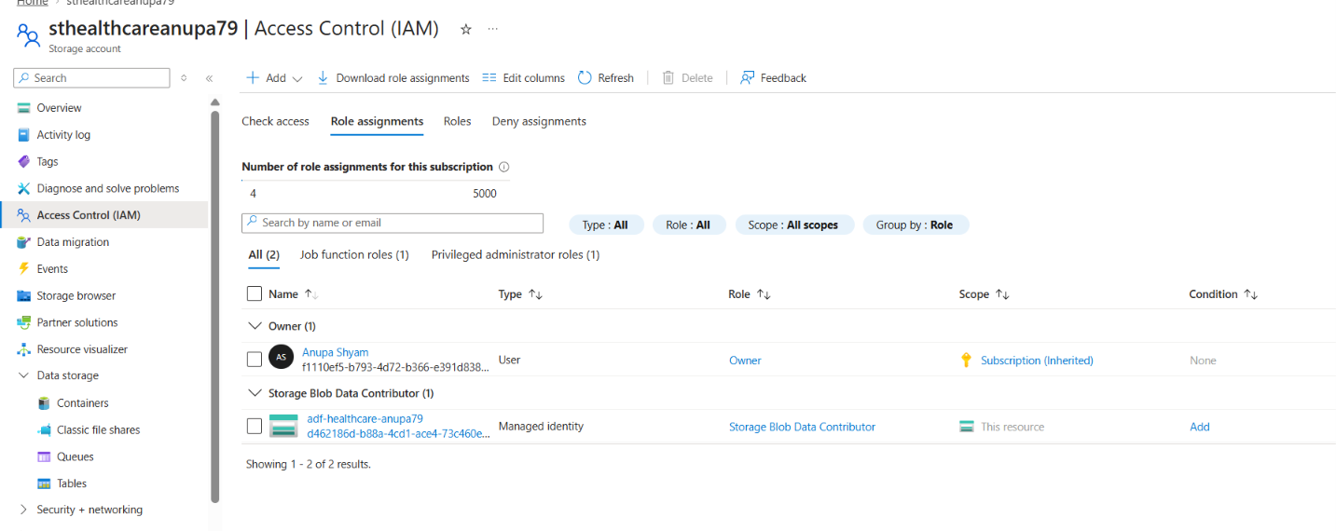
Step_1_Screenshot_10.png: Storage role assignment (ADF has Blob Data Contributor)
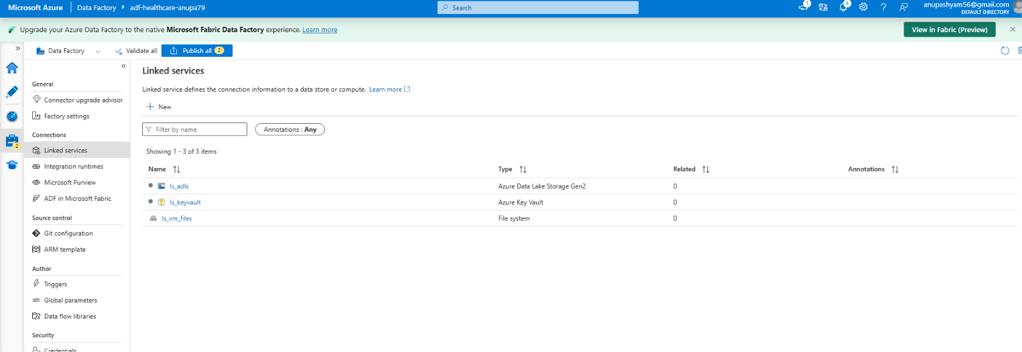
Step_1_Screenshot_11.png: Linked services in ADF

Step 2: Landing Ingestion
Healthcare Data Pipeline · Bootcamp Project 1 · Anupa

1. What this step does
Landing keeps an exact, unchanged copy of each source file. One reusable pipeline, pl_ingest_landing, copies all four files from the VM into the landing container. Each run writes into its own folder, so a later delivery never overwrites an earlier raw copy.

2. Steps
- Created Binary dataset ds_vm_source on ls_vm_files with parameter fileName. Binary means the file is copied byte for byte, with no parsing or changes.
- Created Binary dataset ds_landing on ls_adls with parameters folderPath and fileName. File path: landing / @dataset().folderPath / @dataset().fileName.
- Created pipeline pl_ingest_landing with parameter fileList (type Array).
- Added a ForEach activity over @pipeline().parameters.fileList.
- Inside the ForEach, added one Copy activity: source ds_vm_source (fileName = @item()), sink ds_landing.
- Set the sink folderPath to <dataset>/<yyyy-MM-dd>/<RunId>, so every batch gets a new folder.
- Debugged, then clicked Publish all.

3. Configuration
Item | Value
Pipeline | pl_ingest_landing
Parameter | fileList (Array) e.g. ["patient_raw.csv","hospital_raw.csv","diagnosis_raw.csv","visit_raw.csv"]
Source folder | C:\Healthcaresource on vmhealthcare (the four provided files, locally copied onto the VM)
Source dataset | ds_vm_source (Binary, ls_vm_files, param fileName)
Sink dataset | ds_landing (Binary, ls_adls, params folderPath, fileName)
Folder convention | landing/<dataset>/<yyyy-MM-dd>/<pipeline RunId>/<file>.csv
Batch identifier | The ADF pipeline RunId (unique for every run)
First batch RunId | 38682d12-454e-4ea8-9ccc-11e66ab5069a

4. Code snippets
ForEach items:
@pipeline().parameters.fileList

Copy source, ds_vm_source fileName:
@item()

Copy sink, ds_landing folderPath (dataset name taken from the file name, e.g. patient):
@concat(split(item(),'_')[0], '/',
formatDateTime(utcnow(),'yyyy-MM-dd'), '/',
pipeline().RunId)

Example result:
landing/patient/2026-10-21/38682d12-454e-4ea8-9ccc-11e66ab5069a/patient_raw.csv

5. Design decisions
Topic | Decision
Keep raw file unchanged | Binary copy; no columns added. Metadata is kept outside the file.
Ingestion metadata | Captured by ADF Monitor for every run: RunId (batch id), file name, start and end time, status, files read and written, bytes copied, error message.
Repeated delivery | Each run writes to a new RunId folder, so nothing is overwritten. Reloading the same data later is safe because SQL uses upsert (Step 4).
Missing file | Copy activity fails, so the pipeline fails and the failure alert emails the owner (Step 5). Nothing downstream runs.
Empty file (header only) | Copied to Landing as received; Staging then produces 0 rows, so nothing changes in SQL (absence never deletes). Test file: patient_empty_test.csv.
Unexpected columns | Staging reads with an explicit schema, so only the defined columns are used. Test file: visit_extra_column_test.csv.

6. Challenges and fixes
Challenge | Cause | How it was fixed
Dataset path set up wrong | In ds_landing the folderPath expression was put in the wrong box | Fixed file path to landing / @dataset().folderPath / @dataset().fileName
Parameter type error | fileList was first created as String, so ForEach could not loop over it | Changed fileList to type Array
AccessToOnPremFileSystemDenied | SHIR blocks local folders by default | dmgcmd -DisableLocalFolderPathValidation on the VM (see Step 1)
Run fails when VM is off | VM auto-shutdown at midnight | Start the VM and wait for SHIR to show Running before running

7. Evidence (Screenshots folder)
Screenshot file | What it shows
Step_2_Screenshot_1.png | pl_ingest_landing canvas: ForEach with Copy activity
Step_2_Screenshot_2.png | pl_ingest_landing run: ForEach and 4 Copy activities Succeeded
Step_2_Screenshot_3.png | landing container with one folder per dataset (diagnosis, hospital, patient, visit)

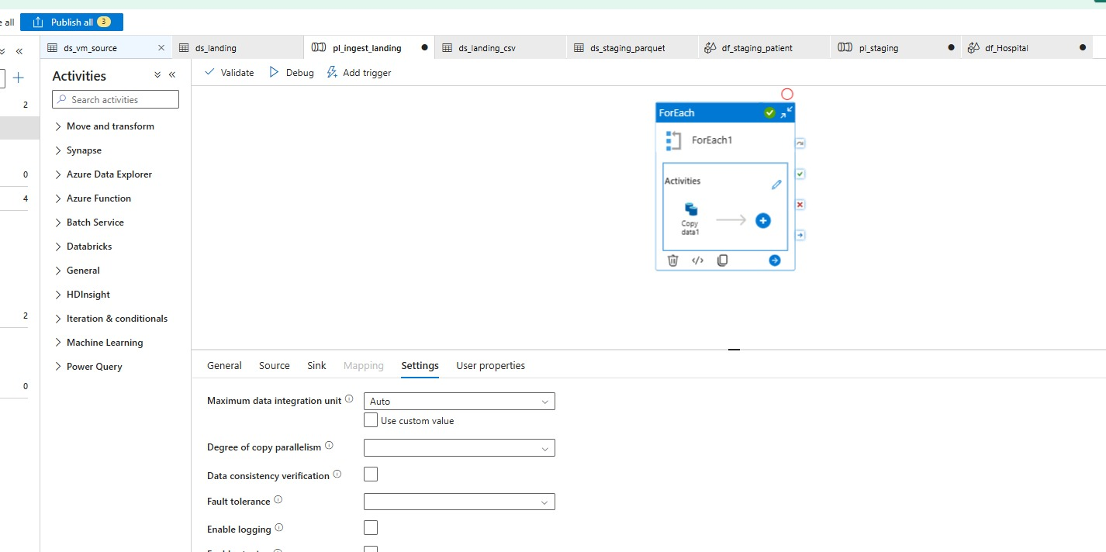
Step_2_Screenshot_1.png: pl_ingest_landing canvas: ForEach with Copy activity
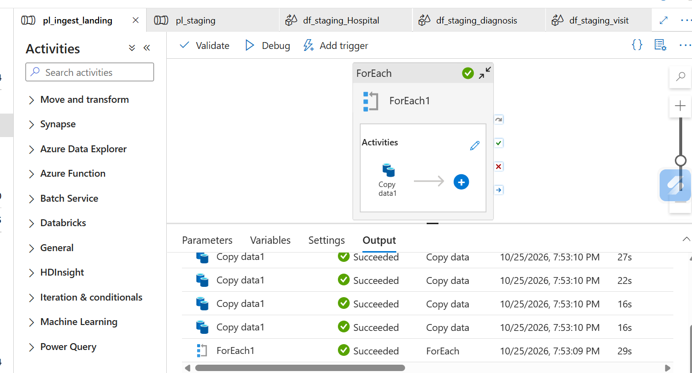
Step_2_Screenshot_2.png: pl_ingest_landing run: ForEach and 4 Copy activities Succeeded
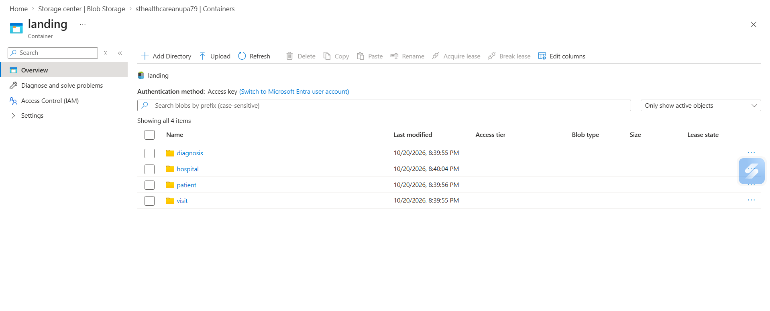
Step_2_Screenshot_3.png: landing container with one folder per dataset (diagnosis, hospital, patient, visit)

Step 3: Staging Validation (Mapping Data Flows)
Healthcare Data Pipeline · Bootcamp Project 1 · Anupa

1. What this step does
Staging turns the raw Landing CSVs into clean, typed data. One Mapping Data Flow per dataset reads the CSV with an explicit schema, cleans the text, checks the rules, removes duplicates, and writes two outputs: accepted rows as Parquet, and rejected rows with a reason. Pipeline pl_staging runs the four flows in the right order.

2. Steps
- Created DelimitedText dataset ds_landing_csv on ls_adls (landing / folderPath / fileName, comma, first row as header, quote character ").
- Created Parquet dataset ds_staging_parquet on ls_adls (staging / folderPath, snappy compression).
- Built df_staging_patient: source → clean (Derived Column) → check (Conditional Split) → rejected branch adds reject_reason → sink; accepted branch → dedup (Aggregate) → Parquet sink.
- Set the source Projection by hand (explicit schema), e.g. dob as date, bed_count as integer, cost as decimal.
- Built df_staging_hospital and df_staging_diagnosis the same way.
- Built df_staging_visit with extra Lookups to the accepted patient, hospital and diagnosis outputs of the same batch; visits with no match go to rejected with reason 'unknown patient/hospital/diagnosis'.
- Added data flow parameter runId to every flow; used it for batch_id and for the output folders.
- Created pipeline pl_staging: df_patient, df_hospital, df_diagnosis run in parallel, then df_visit runs after all three succeed.
- Debugged pl_staging, checked the Parquet output, then Publish all.

3. Configuration
Item | Value
Data flows | df_staging_patient, df_staging_hospital, df_staging_diagnosis, df_staging_visit
Data flow parameter | runId (string) → written into column batch_id
Pipeline | pl_staging, parameters runId and runDate (defaults = first batch)
Input | landing/<dataset>/<runDate>/<runId>/<dataset>_raw.csv
Accepted output | staging/<dataset>/accepted/<runId>/ (Parquet)
Rejected output | staging/<dataset>/rejected/<runId>/ (with reject_reason, batch_id)
Order | patient, hospital, diagnosis (parallel) → visit
Schema drift | Off; explicit projection is the schema contract

4. Explicit schemas
Dataset | Columns and types
patient | patient_id string, first_name string, last_name string, gender string, dob date, city string
hospital | hospital_id string, hospital_name string, city string, bed_count integer
diagnosis | diagnosis_code string, diagnosis_desc string
visit | visit_id string, patient_id string, hospital_id string, admission_date date, discharge_date date, diagnosis_code string, cost decimal

5. Code snippets (data flow expressions)
cleanPatient (Derived Column):
first_name = trim(first_name)
last_name = trim(last_name)
city = initCap(trim(city))
gender = upper(trim(gender))
patient_id = upper(trim(patient_id))
batch_id = $runId

checkPatient (Conditional Split, first matching condition) → stream 'rejected':
isNull(patient_id) || isNull(dob) || dob > currentDate() || !in(['M','F'], gender)

addReasonToReject (Derived Column) – example of the reason column:
reject_reason = case(isNull(patient_id), 'missing patient_id',
isNull(dob), 'invalid dob',
dob > currentDate(),'dob in future',
'invalid gender')

dedupPatient (Aggregate): group by patient_id, keep one row:
Group by: patient_id
Aggregates: first_name = first(first_name), last_name = first(last_name),
gender = first(gender), dob = first(dob), city = first(city),
batch_id = first(batch_id)

pl_staging – data flow parameter and paths built from pipeline parameters:
runId (data flow param): @pipeline().parameters.runId
source folderPath: @concat('patient/', pipeline().parameters.runDate, '/', pipeline().parameters.runId)
accepted folder: @concat('patient/accepted/', pipeline().parameters.runId)
rejected folder: @concat('patient/rejected/', pipeline().parameters.runId)

6. Business keys and policies
Topic | Policy
Business keys | patient_id, hospital_id, diagnosis_code, visit_id
Duplicates | Same key more than once in a file: one row kept (Aggregate), the rest counted as duplicates
Required fields missing | Rejected with reason (e.g. missing patient_id)
Invalid dates / numbers | Rejected (bad dob, discharge before admission, negative cost or bed_count)
Text formatting | Fixed, not rejected: trim, initCap for names/cities, upper for IDs and gender
Incomplete visit (no discharge_date) | Accepted as an open visit; updated later when discharge arrives
Unmatched visit reference | Checked in df_staging_visit with Lookups; rejected with reason, can be reprocessed later
Reconciliation | input rows = accepted + rejected + duplicates

7. Processing counts (batch 1)
Dataset | Input | Accepted | Rejected | Duplicates
patient | 5 | 5 | 0 | 0
hospital | 5 | 5 | 0 | 0
diagnosis | 5 | 5 | 0 | 0
visit | 8 | 8 | 0 | 0

The sample data had no bad rows, so 0 rows were rejected. The rejected branch and reject_reason are built in every flow and are shown in the data flow screenshots; Code/test_data holds extra bad-data files for future testing.

8. Challenges and fixes
Challenge | Cause | How it was fixed
pl_staging parameter errors | Paths were typed as fixed text, and expressions mixed text and parameters | Built every path with @concat(..., pipeline().parameters.runId / runDate)
Parquet file looks like gibberish in portal | Parquet is a binary format, not text | Normal; checked contents with Data preview in the data flow instead
Visit checks need the other datasets | Lookups read accepted patient/hospital/diagnosis output | pl_staging runs df_visit only after the other three succeed
Data flow debug is slow to start | Spark debug cluster takes a few minutes | Turned Data flow debug on before starting work; turned it off afterwards to save cost

9. Evidence (Screenshots folder)
Screenshot file | What it shows
Step_3_Screenshot_1.png | ds_landing_csv dataset settings
Step_3_Screenshot_2.png | ds_staging_parquet dataset settings
Step_3_Screenshot_3.png | df_staging_patient source
Step_3_Screenshot_4.png | Explicit schema (Projection) for patient
Step_3_Screenshot_5.png | cleanPatient Derived Column expressions
Step_3_Screenshot_6.png | Data preview after cleaning, with batch_id
Step_3_Screenshot_7.png | checkPatient Conditional Split rule
Step_3_Screenshot_8.png | dedupPatient preview (5 rows)
Step_3_Screenshot_9.png | Full patient flow with accepted and rejected sinks
Step_3_Screenshot_10.png | df_patient debug run Succeeded
Step_3_Screenshot_11.png | Parquet file in staging/patient/accepted/<runId>
Step_3_Screenshot_12.png | runId data flow parameter
Step_3_Screenshot_13.png | pl_staging canvas
Step_3_Screenshot_14.png | df_staging_hospital flow
Step_3_Screenshot_15.png | df_staging_diagnosis flow
Step_3_Screenshot_16.png | df_staging_visit with Lookups (8 rows)
Step_3_Screenshot_17.png | df_staging_visit full flow (unknownRef split)
Step_3_Screenshot_18.png | pl_staging Monitor: all 4 data flows Succeeded
Step_3_Screenshot_19.png | pl_staging pipeline status Succeeded
Step_3_Screenshot_20.png | staging container with one folder per dataset

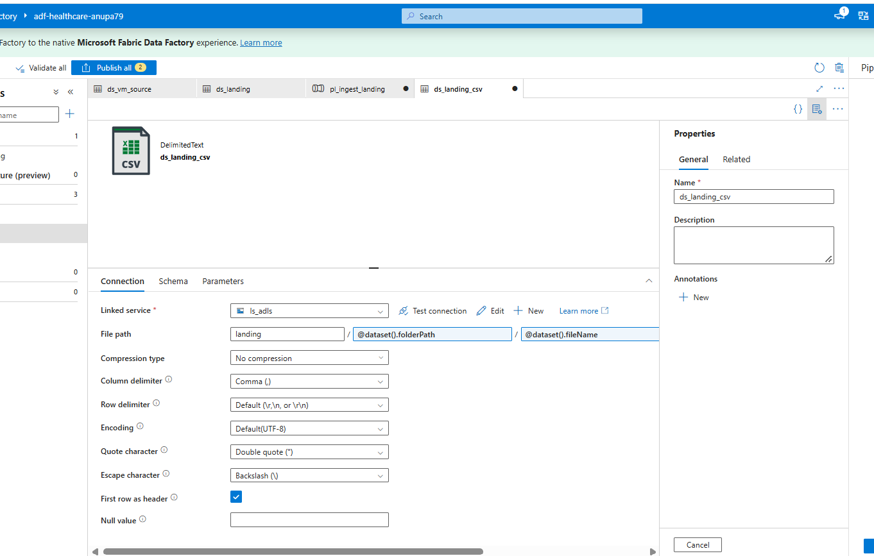
Step_3_Screenshot_1.png: ds_landing_csv dataset settings
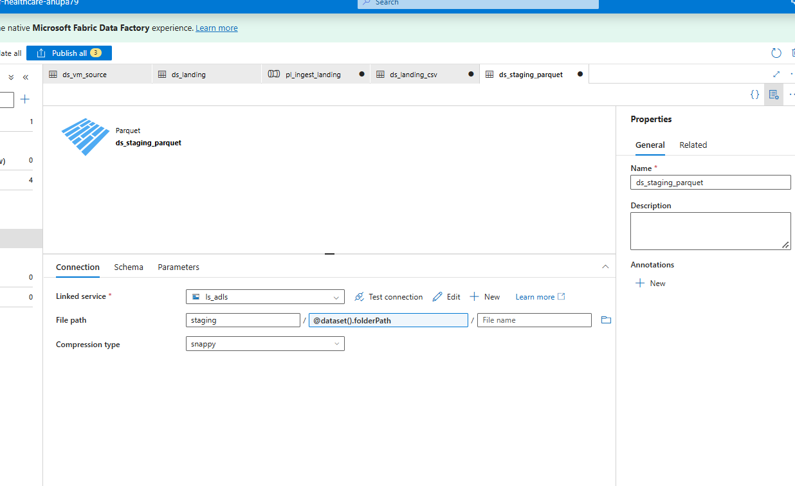
Step_3_Screenshot_2.png: ds_staging_parquet dataset settings
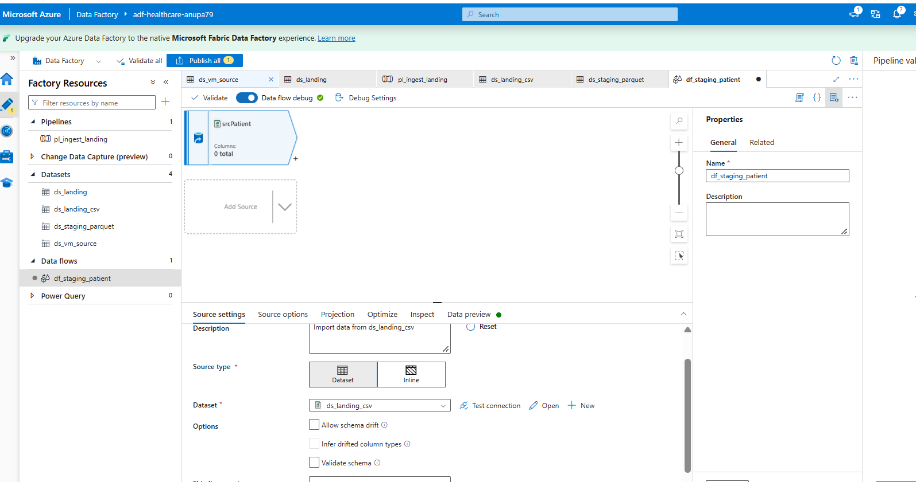
Step_3_Screenshot_3.png: df_staging_patient source
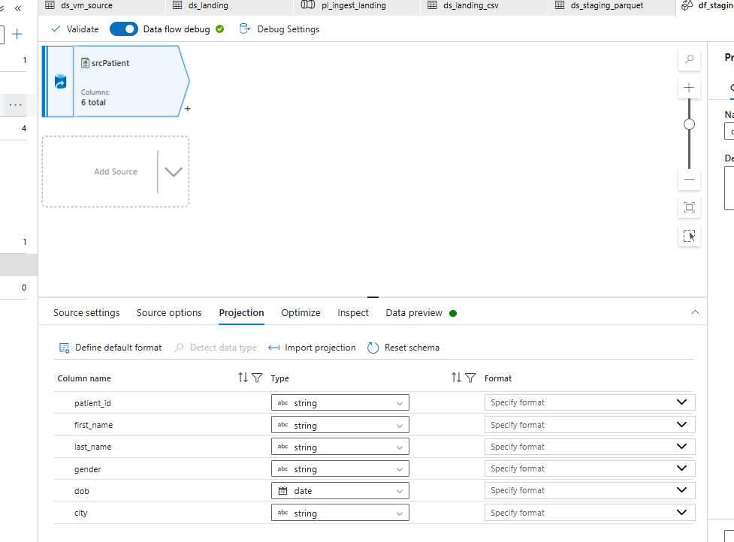
Step_3_Screenshot_4.png: Explicit schema (Projection) for patient
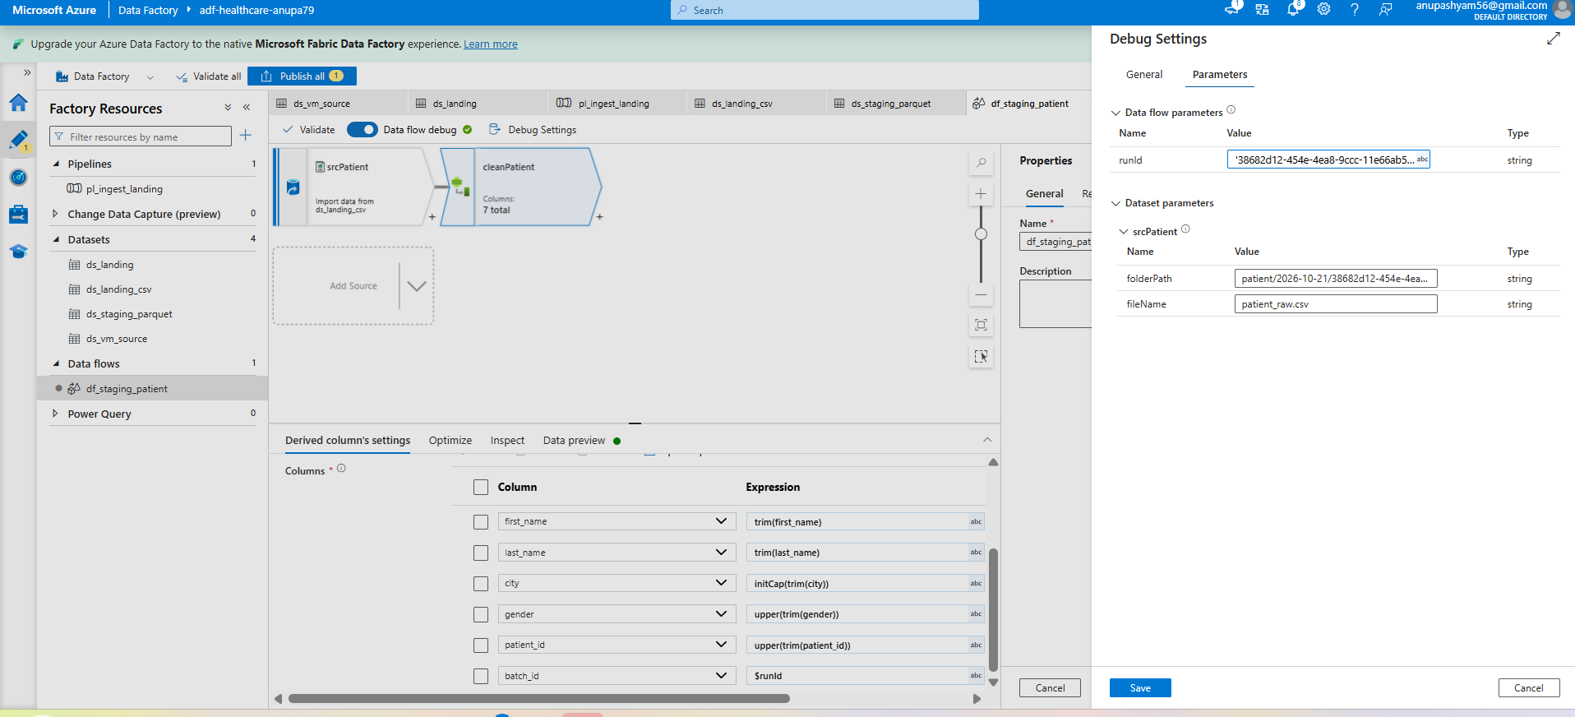
Step_3_Screenshot_5.png: cleanPatient Derived Column expressions
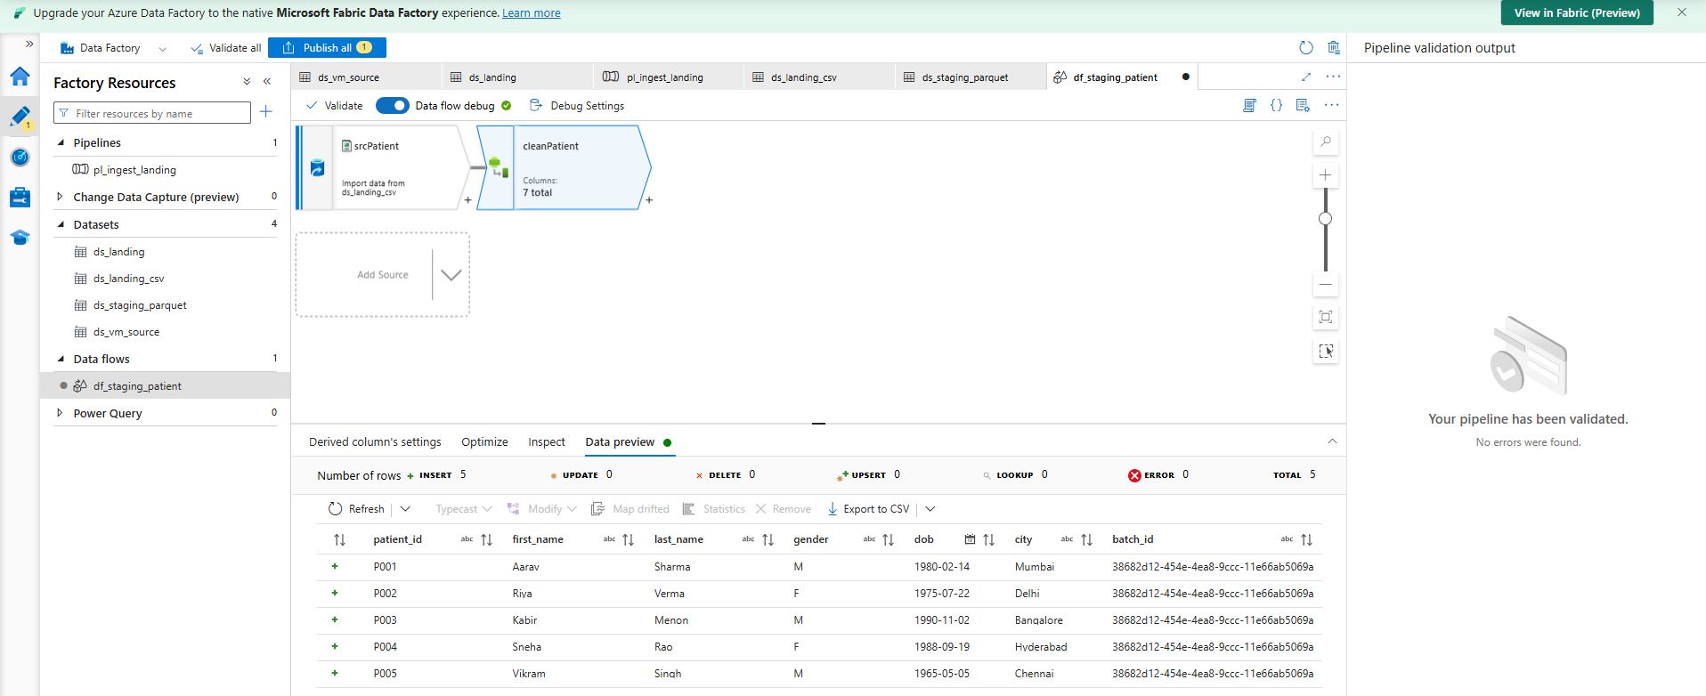
Step_3_Screenshot_6.png: Data preview after cleaning, with batch_id
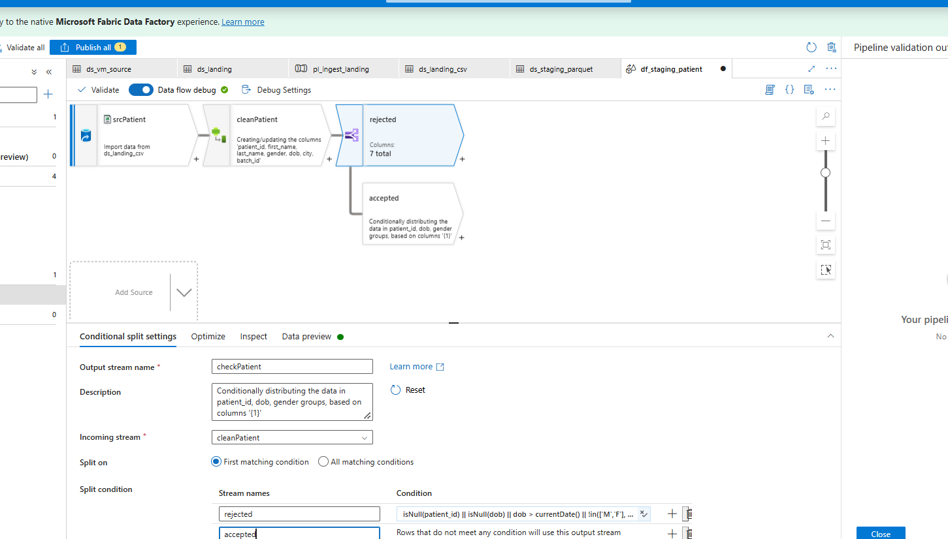
Step_3_Screenshot_7.png: checkPatient Conditional Split rule
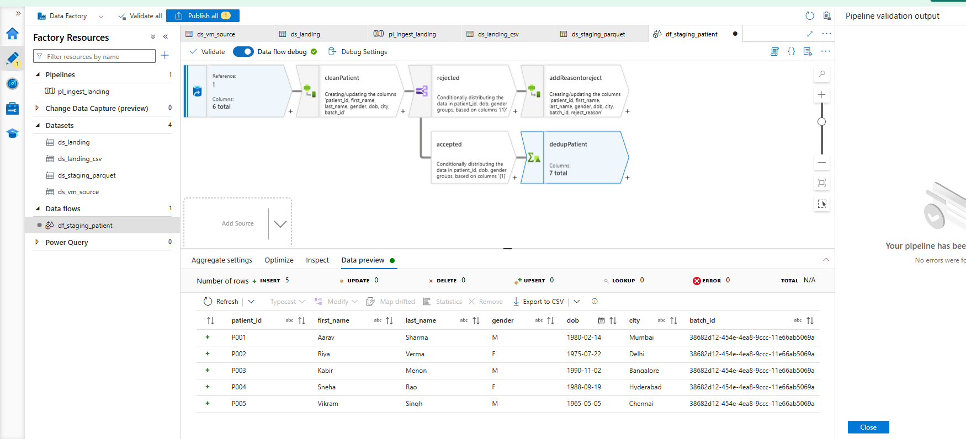
Step_3_Screenshot_8.png: dedupPatient preview (5 rows)
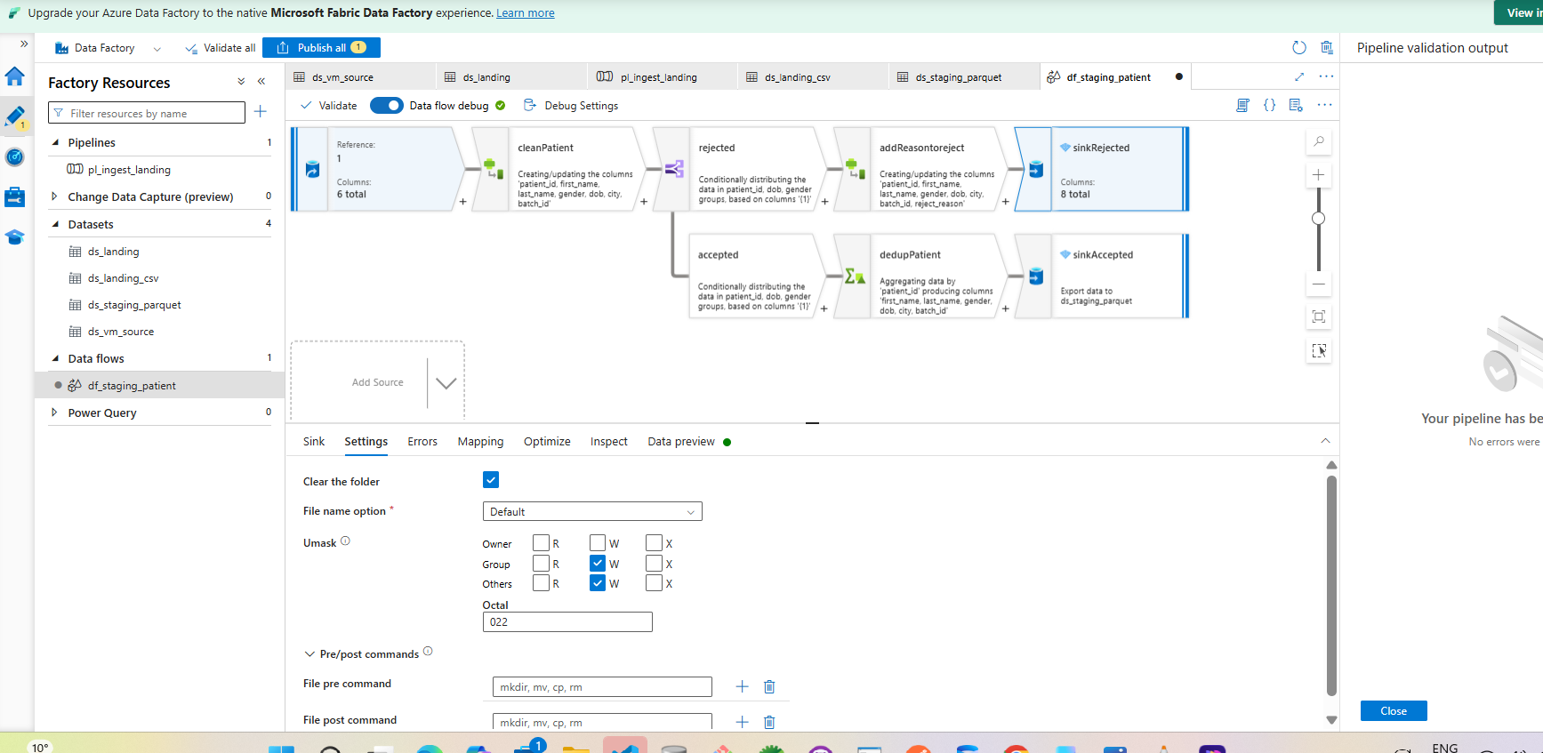
Step_3_Screenshot_9.png: Full patient flow with accepted and rejected sinks
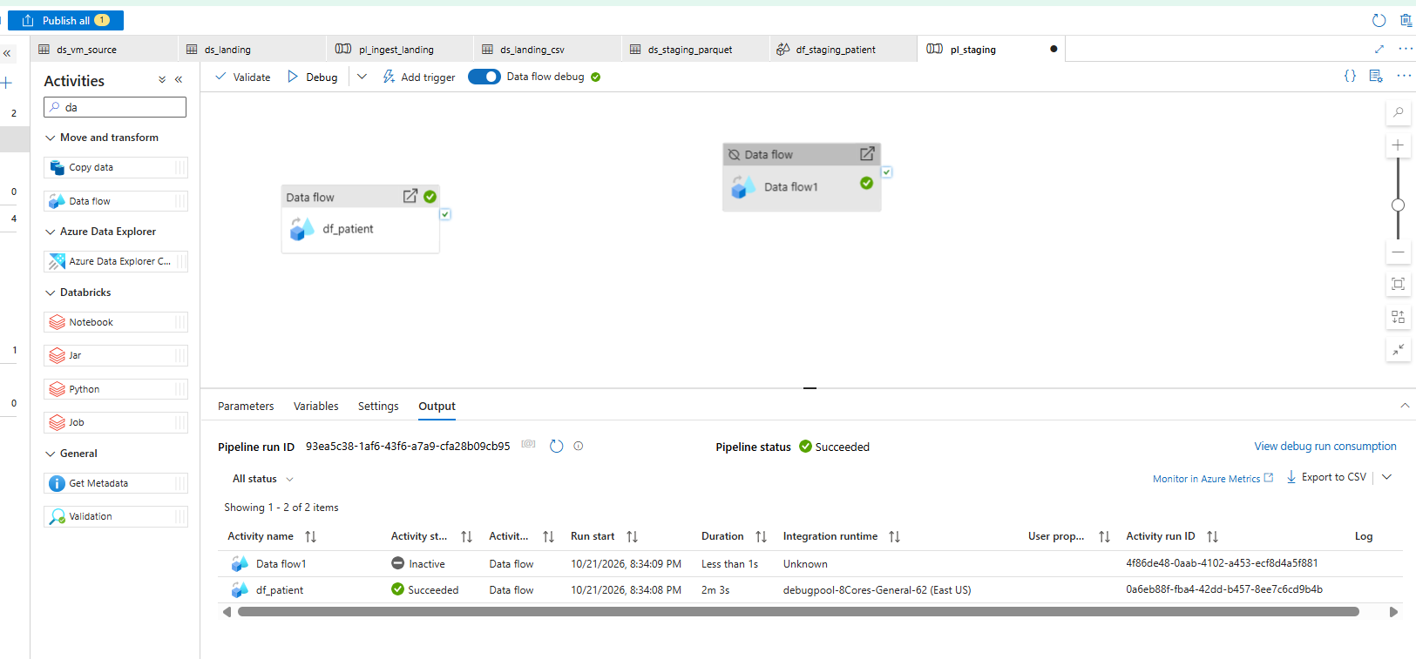
Step_3_Screenshot_10.png: df_patient debug run Succeeded
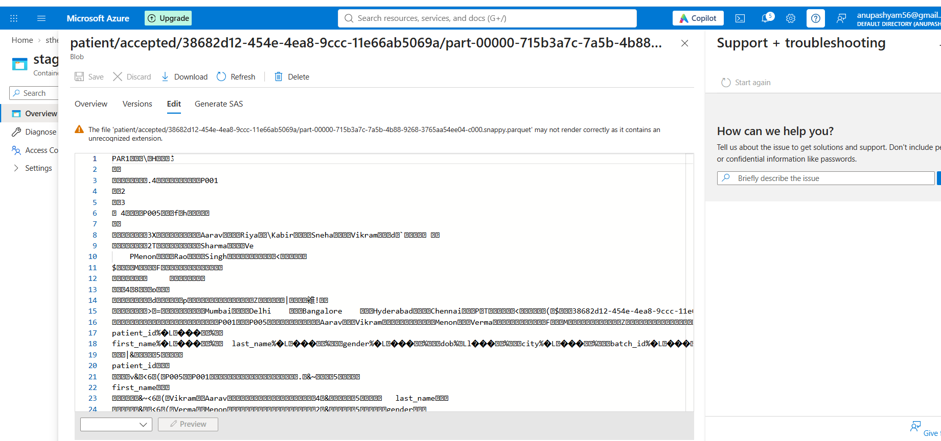
Step_3_Screenshot_11.png: Parquet file in staging/patient/accepted/<runId>
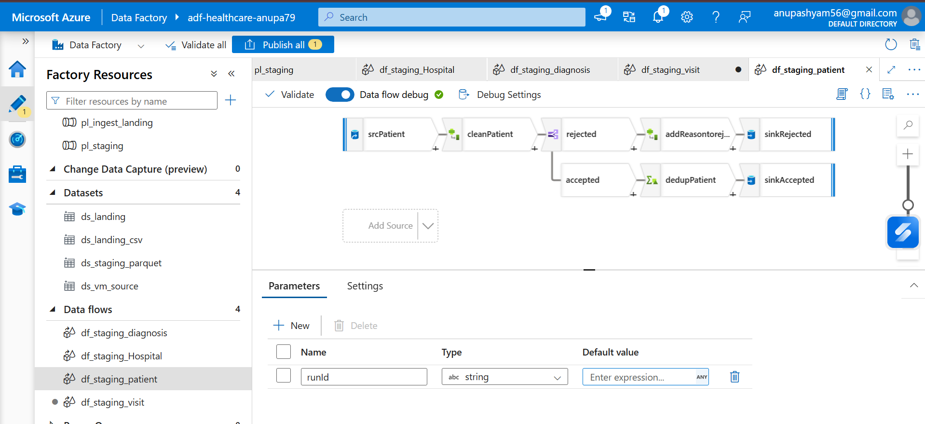
Step_3_Screenshot_12.png: runId data flow parameter
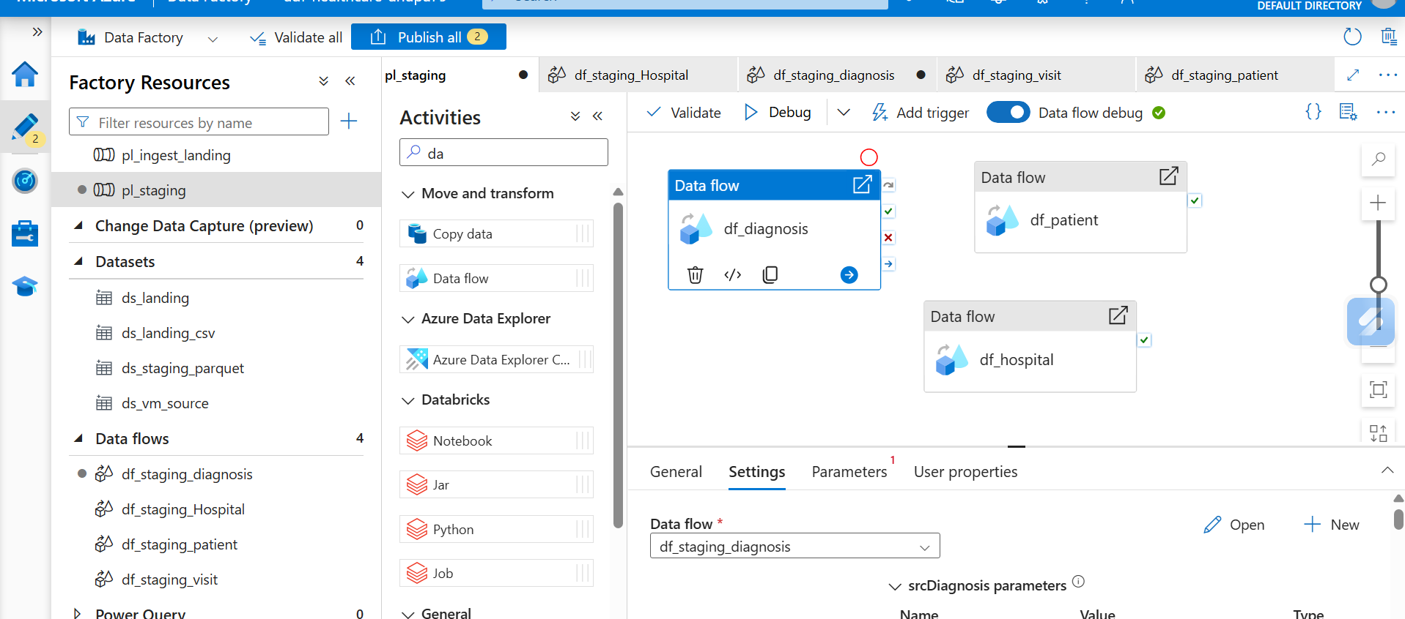
Step_3_Screenshot_13.png: pl_staging canvas
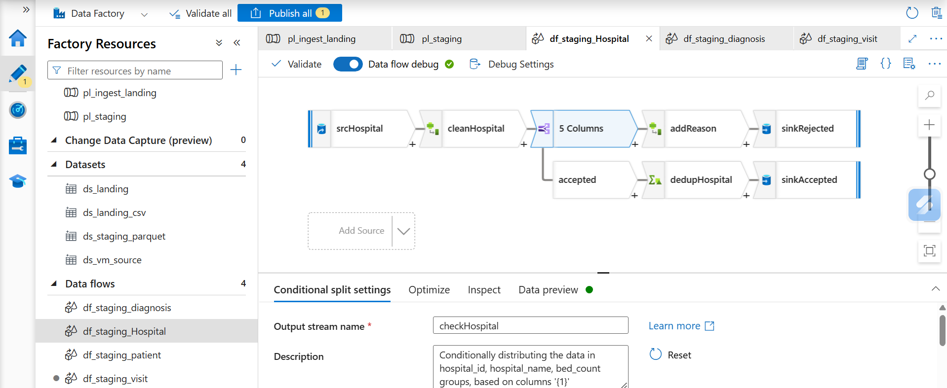
Step_3_Screenshot_14.png: df_staging_hospital flow
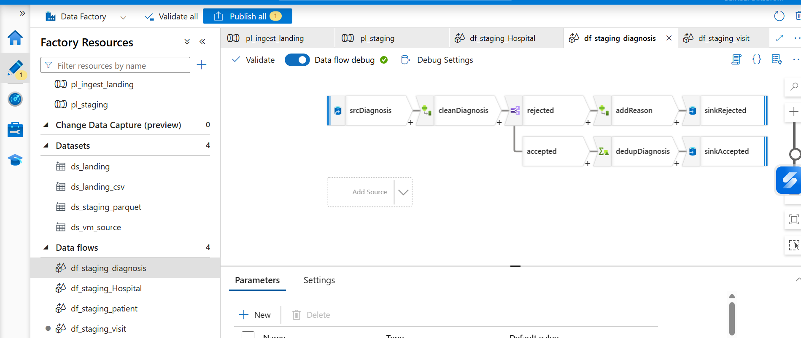
Step_3_Screenshot_15.png: df_staging_diagnosis flow
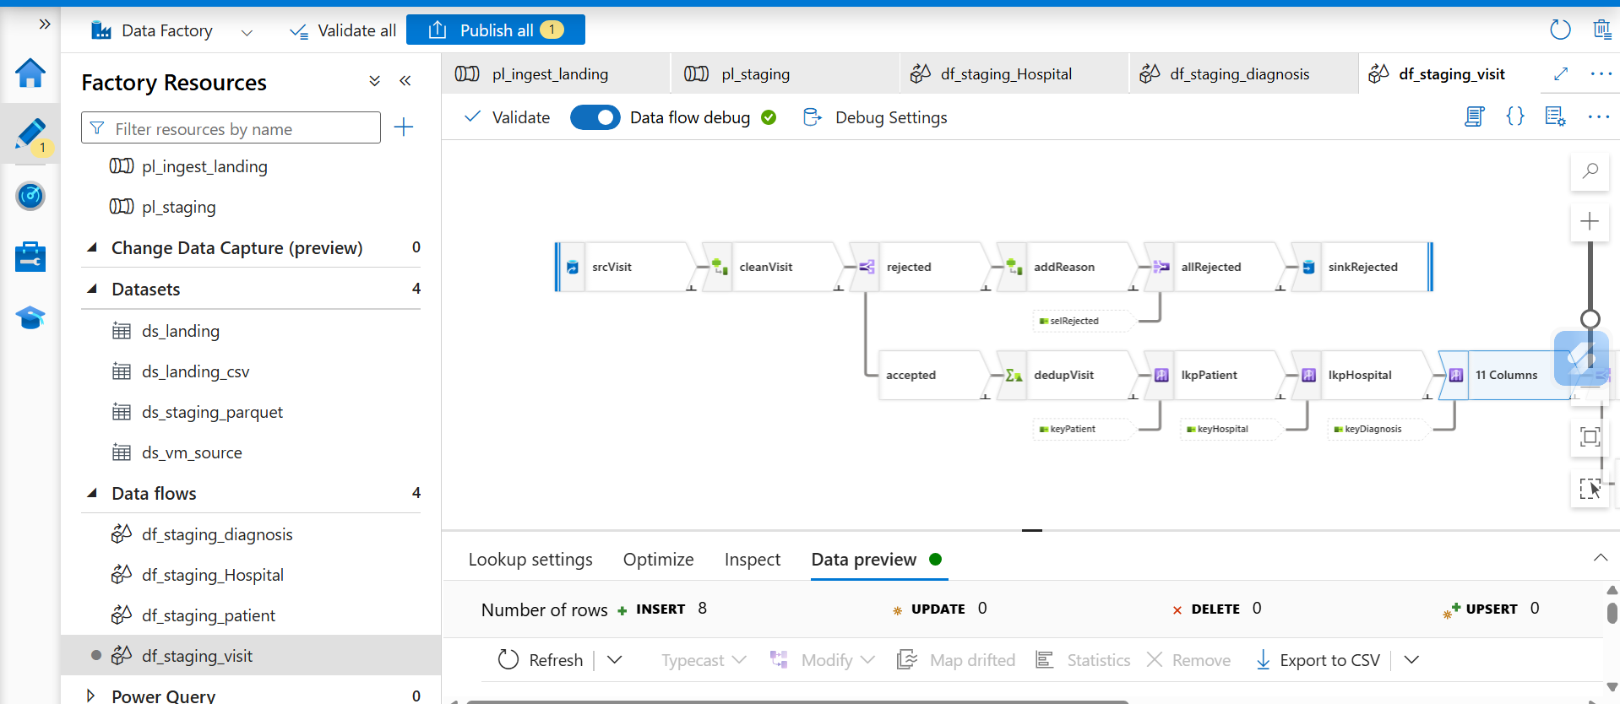
Step_3_Screenshot_16.png: df_staging_visit with Lookups (8 rows)
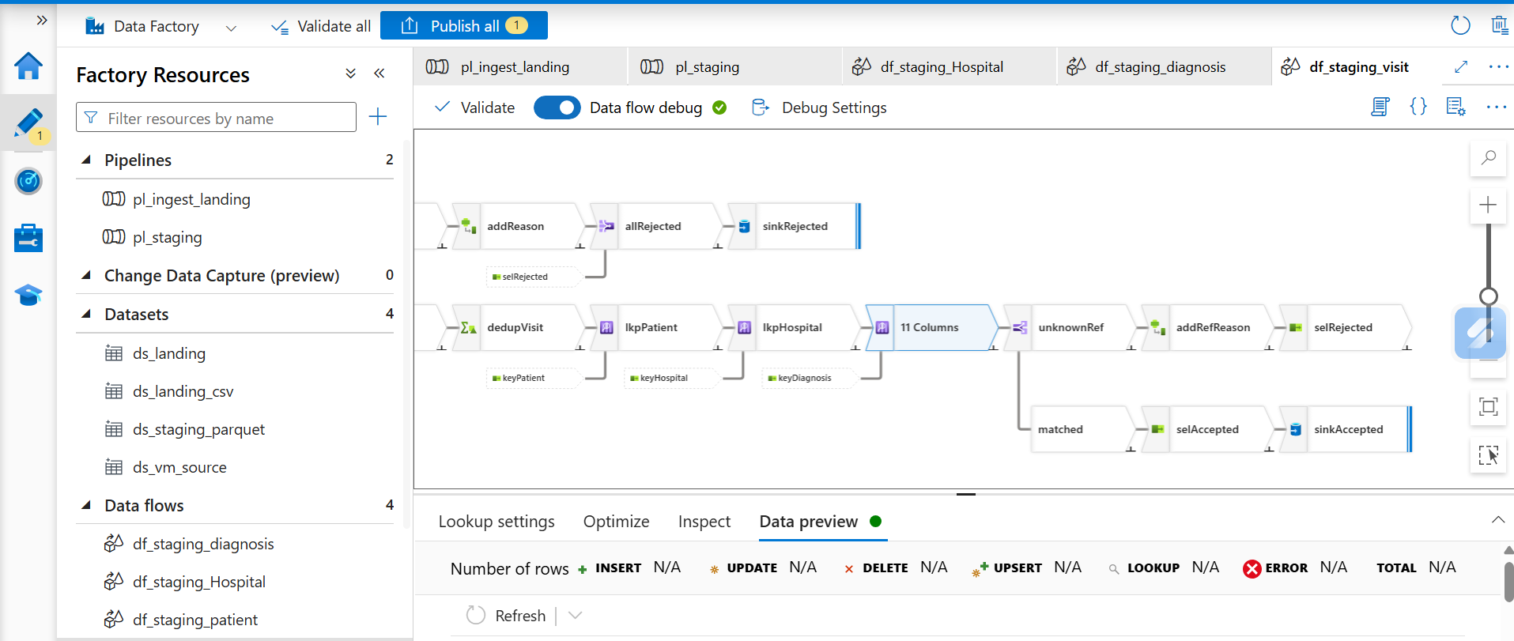
Step_3_Screenshot_17.png: df_staging_visit full flow (unknownRef split)
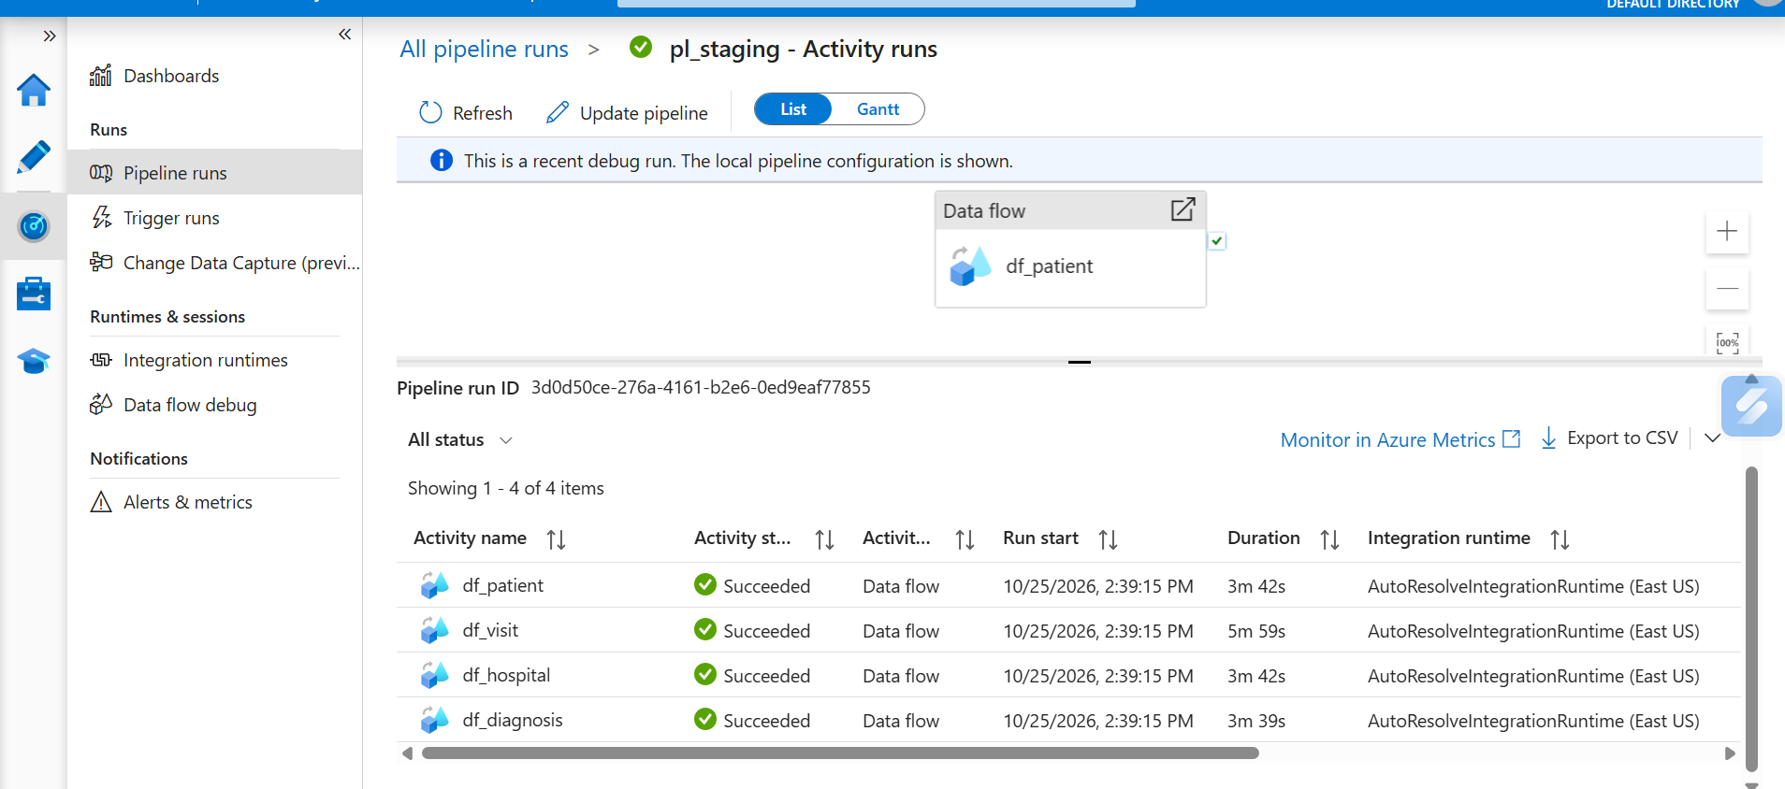
Step_3_Screenshot_18.png: pl_staging Monitor: all 4 data flows Succeeded
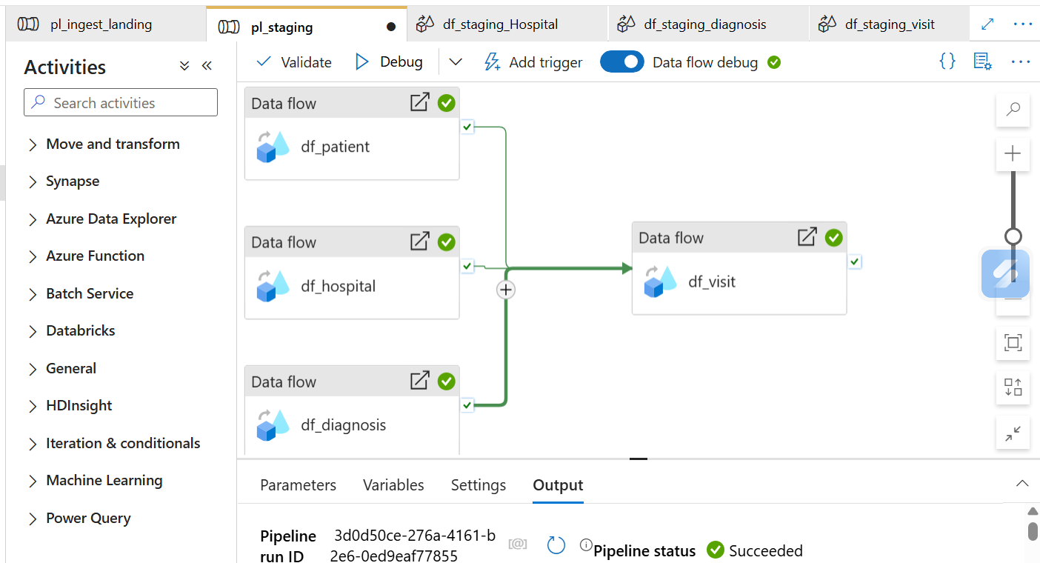
Step_3_Screenshot_19.png: pl_staging pipeline status Succeeded
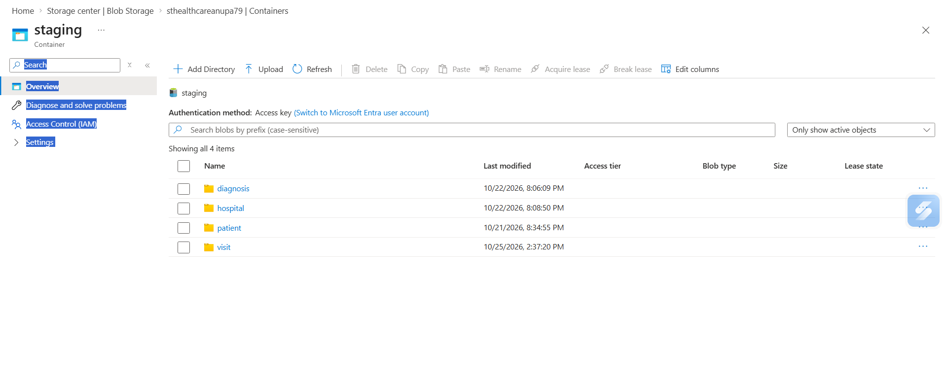
Step_3_Screenshot_20.png: staging container with one folder per dataset

Step 4: Azure SQL Load with SCD Type 1
Healthcare Data Pipeline · Bootcamp Project 1 · Anupa

1. What this step does
The accepted Parquet files from Staging are loaded into four Azure SQL tables. The load uses SCD Type 1: a new key is inserted, an existing key is overwritten with the latest values, and nothing is ever deleted just because it is missing from a later file. Pipeline pl_load_sql does this with Copy activities in Upsert mode.

2. Steps
- Created Azure SQL server abraham32 and database sqldb-healthcare (Basic tier) with SQL authentication.
- Stored the SQL login password in Key Vault as secret sql-password.
- Created linked service ls_sql (Azure SQL Database, password from Key Vault).
- Ran Code/sql/create_tables.sql in Query editor to create patient, hospital, diagnosis and visit.
- Created dataset ds_sql_table on ls_sql with parameter tableName.
- Created pipeline pl_load_sql with parameter runId and four Copy activities: cp_patient, cp_hospital, cp_diagnosis, then cp_visit.
- Source of each Copy: ds_staging_parquet, folder <dataset>/accepted/<runId>, wildcard *.parquet.
- Sink of each Copy: ds_sql_table, Write behavior = Upsert, key column = the business key.
- Audit columns (professor's request): ran Code/sql/alter_add_audit_columns.sql to add updated_date and updated_by to all 4 tables. In each Copy activity, Source > Additional columns adds updated_date = @utcnow() and updated_by = @concat(pipeline().Pipeline, ' - ', pipeline().RunId), and these are mapped to the SQL columns.
- Connected cp_visit to run only on Success of the other three (foreign keys).
- Debugged, checked counts with Code/sql/validation_queries.sql, then Publish all.

3. Configuration
Item | Value
SQL server / database | abraham32 / sqldb-healthcare (Basic)
Authentication | SQL authentication; password in Key Vault secret sql-password
Linked service | ls_sql (Azure SQL Database)
Sink dataset | ds_sql_table (param tableName)
Pipeline | pl_load_sql (param runId)
Copy source | ds_staging_parquet, wildcard path <dataset>/accepted/<runId>/*.parquet
Copy sink | Write behavior Upsert, key columns below
Load order | cp_patient, cp_hospital, cp_diagnosis (parallel) → cp_visit

4. SCD Type 1 design
Table | Match key | Updatable attributes
patient | patient_id | first_name, last_name, gender, dob, city, batch_id, updated_date, updated_by
hospital | hospital_id | hospital_name, city, bed_count, batch_id, updated_date, updated_by
diagnosis | diagnosis_code | diagnosis_desc, batch_id, updated_date, updated_by
visit | visit_id | patient_id, hospital_id, admission_date, discharge_date, diagnosis_code, cost, batch_id, updated_date, updated_by

- New key: inserted.
- Changed record: all attributes overwritten with the new values (no history kept).
- Unchanged record: plain Upsert rewrites every row in the file, so the data values stay the same but batch_id, updated_date and updated_by get the latest run. So updated_date means 'last loaded', not 'last changed'.
- Audit: last_updated = created date (SQL default, set once on insert); updated_date and updated_by = when and which pipeline run last wrote the row.
- Record absent from a later file: left untouched. Absence never deletes data.
- Rerun of the same batch: upsert matches on the key, so no duplicate rows are created.

5. Code snippets
Table example (full script: Code/sql/create_tables.sql):
CREATE TABLE dbo.patient (
patient_id VARCHAR(20) NOT NULL PRIMARY KEY,
first_name VARCHAR(50),
last_name VARCHAR(50),
gender VARCHAR(10),
dob DATE,
city VARCHAR(50),
batch_id VARCHAR(50),
last_updated DATETIME2 DEFAULT SYSUTCDATETIME(), -- created date
updated_date DATETIME2, -- set by ADF
updated_by VARCHAR(100) -- set by ADF
);

Copy source folder (cp_patient):
@concat('patient/accepted/', pipeline().parameters.runId) wildcard file name: *.parquet

Copy source > Additional columns (all 4 Copy activities):
updated_date = @utcnow()
updated_by = @concat(pipeline().Pipeline, ' - ', pipeline().RunId)

Copy sink (cp_patient):
tableName = patient Write behavior = Upsert Key columns = patient_id

Count check after load:
SELECT 'patient' AS tbl, COUNT(*) AS cnt FROM dbo.patient
UNION ALL SELECT 'hospital', COUNT(*) FROM dbo.hospital
UNION ALL SELECT 'diagnosis', COUNT(*) FROM dbo.diagnosis
UNION ALL SELECT 'visit', COUNT(*) FROM dbo.visit;

6. Load results
Table | Source rows (Staging accepted) | Target rows (SQL) | Status
patient | 5 | 5 | Succeeded
hospital | 5 | 5 | Succeeded
diagnosis | 5 | 5 | Succeeded
visit | 8 | 8 | Succeeded

7. SCD Type 1 demonstration
To keep the demo simple, the patient source file on the VM was edited and pl_master was run again. The original file was backed up first (C:\original), so the sample data stays intact.
- Backed up patient_raw.csv from C:\Healthcaresource to C:\original.
- BEFORE: the patient table had 5 rows with P001 city = Mumbai (counts in Step_4_Screenshot_11).
- Edited C:\Healthcaresource\patient_raw.csv: changed P001 city from Mumbai to Pune (update), and added a new row P006, Ananya, Singh, F, 1965-05-05, Chennai (insert).
- Ran pl_master (new batch id, new Landing folder, new Staging folder, upsert into SQL).
- Ran the same query again and took the AFTER screenshot, then the duplicate check (query 2).
Check | Before | After | Result
Patient rows | 5 | 6 | P006 inserted
P001 city | Mumbai | Pune | Overwritten (SCD Type 1, no history row)
P002 to P005 | Present | Present, unchanged | Unchanged rows stay the same
Duplicate keys | 0 | 0 | Upsert on patient_id, no duplicates

Second run, after adding the audit columns (Step_4_Screenshot_15): the original patient_raw.csv (5 rows, no P006) was restored on the VM and pl_master was run again on 26 Oct 2026. This shows both SCD Type 1 rules in one picture:
- P001 to P005 were in the file, so they were overwritten with the latest values: P001's city went back to Mumbai, and updated_date (2026-10-26 19:46) and updated_by ('pl_load_sql - <run id>') were stamped on all five rows.
- P006 was not in the file, so it was kept, not deleted. Its updated_date and updated_by stay NULL because no run has written it since the audit columns were added.
- last_updated (created date) did not change for any existing row, and the table still has 6 rows with no duplicates.

8. Challenges and fixes
Challenge | Cause | How it was fixed
SQL database create failed | The default/serverless tier chosen was not allowed on the free trial subscription | Chose the Basic tier
Entra vs SQL authentication | Entra-only needs the ADF identity added as a database user with extra setup | Used SQL authentication and kept the password in Key Vault (decision kept simple)
Copy could not read Staging folder | Pointing the source at the folder did not pick up the Spark part files correctly | Used wildcard file name *.parquet
Foreign key error on visit | cp_visit ran at the same time as the parent tables | Connected cp_visit on Success of cp_patient, cp_hospital and cp_diagnosis

9. Evidence (Screenshots folder)
Screenshot file | What it shows
Step_4_Screenshot_1.png | SQL database deployment complete
Step_4_Screenshot_2.png | Key Vault secrets sql-password and vm-password (values hidden)
Step_4_Screenshot_3.png | Linked services including ls_sql
Step_4_Screenshot_4.png | CREATE TABLE run in Query editor
Step_4_Screenshot_5.png | ds_sql_table, connection successful
Step_4_Screenshot_6.png | cp_patient column mapping
Step_4_Screenshot_7.png | cp_patient run Succeeded
Step_4_Screenshot_8.png | cp_visit mapping
Step_4_Screenshot_9.png | pl_load_sql Succeeded
Step_4_Screenshot_10.png | All four copy activities Succeeded
Step_4_Screenshot_11.png | SQL counts: 5, 5, 5, 8
Step_4_Screenshot_13.png | SCD1 AFTER: 6 patients, P001 city Pune (updated, created date unchanged), P006 added with a new created date, no duplicates. updated_date/updated_by are NULL here because the audit columns were added after this run.
Step_4_Screenshot_15.png | Second run with original file: P001-P005 overwritten (P001 back to Mumbai) with updated_date and updated_by stamped; P006 kept, not deleted

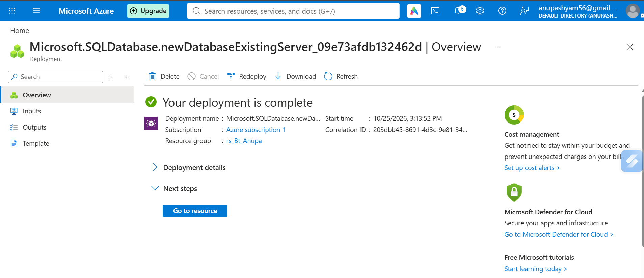
Step_4_Screenshot_1.png: SQL database deployment complete
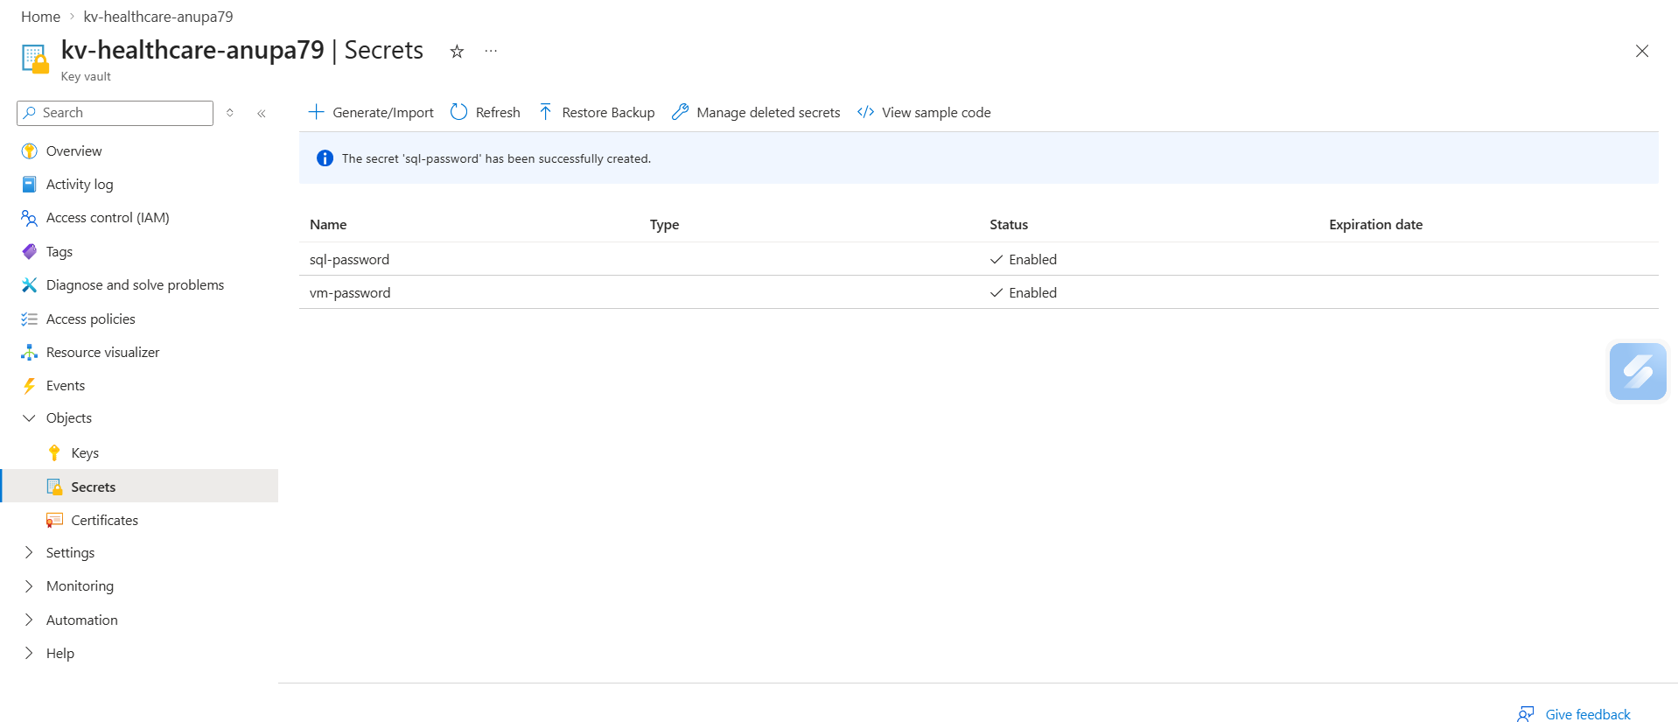
Step_4_Screenshot_2.png: Key Vault secrets sql-password and vm-password (values hidden)
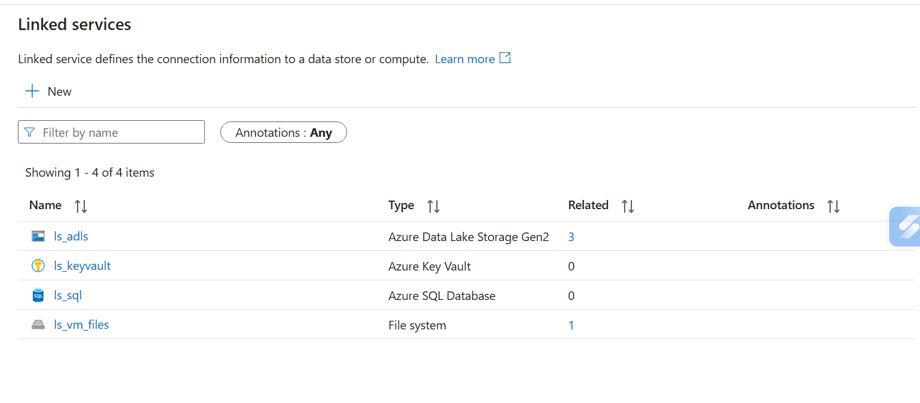
Step_4_Screenshot_3.png: Linked services including ls_sql
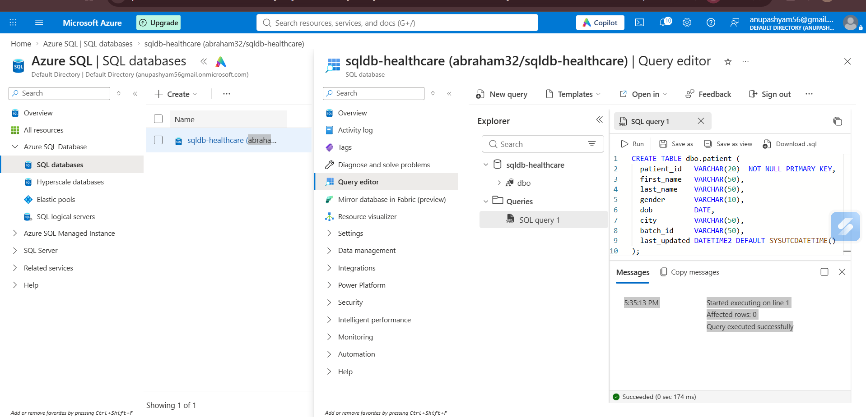
Step_4_Screenshot_4.png: CREATE TABLE run in Query editor
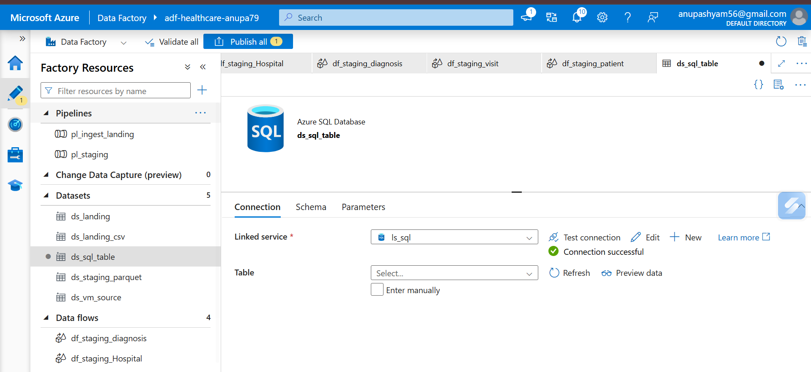
Step_4_Screenshot_5.png: ds_sql_table, connection successful
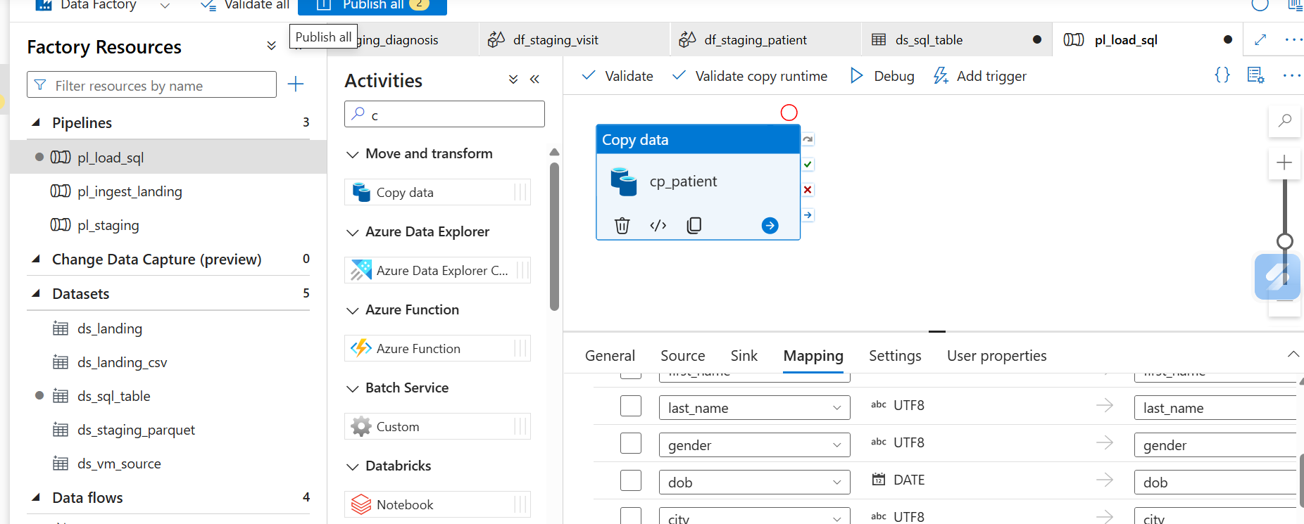
Step_4_Screenshot_6.png: cp_patient column mapping
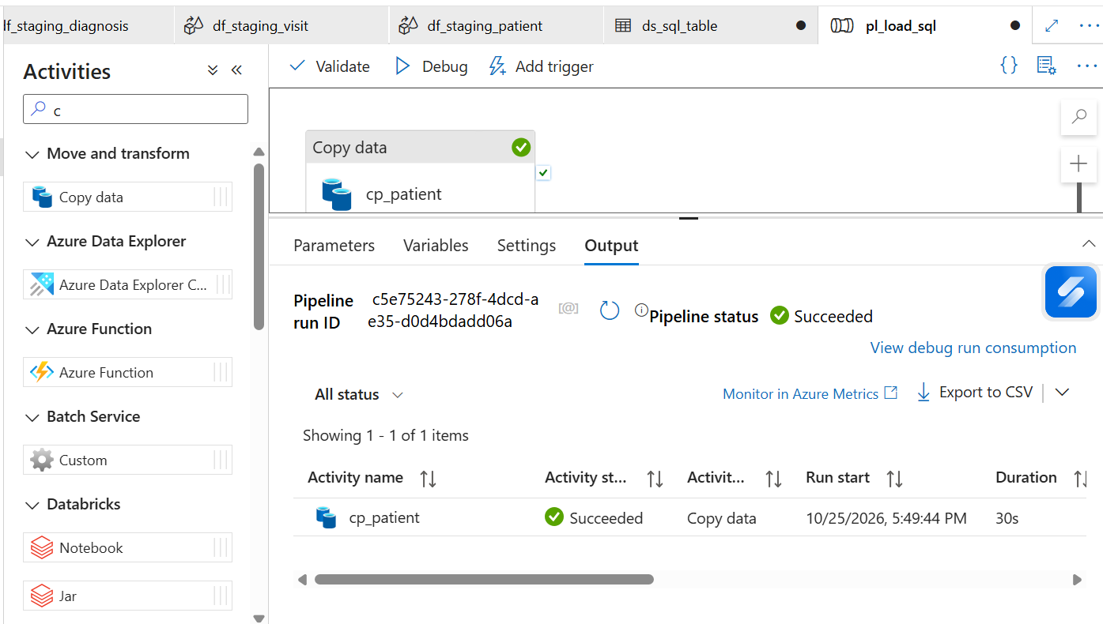
Step_4_Screenshot_7.png: cp_patient run Succeeded
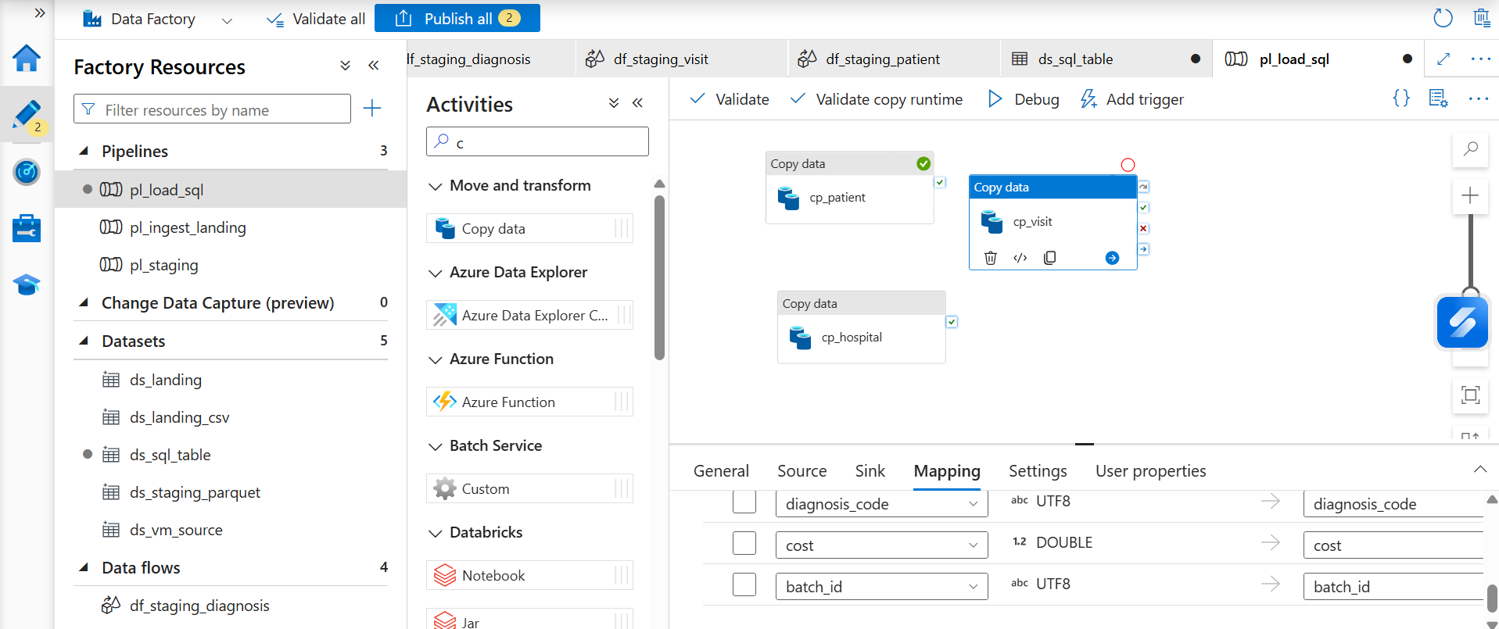
Step_4_Screenshot_8.png: cp_visit mapping
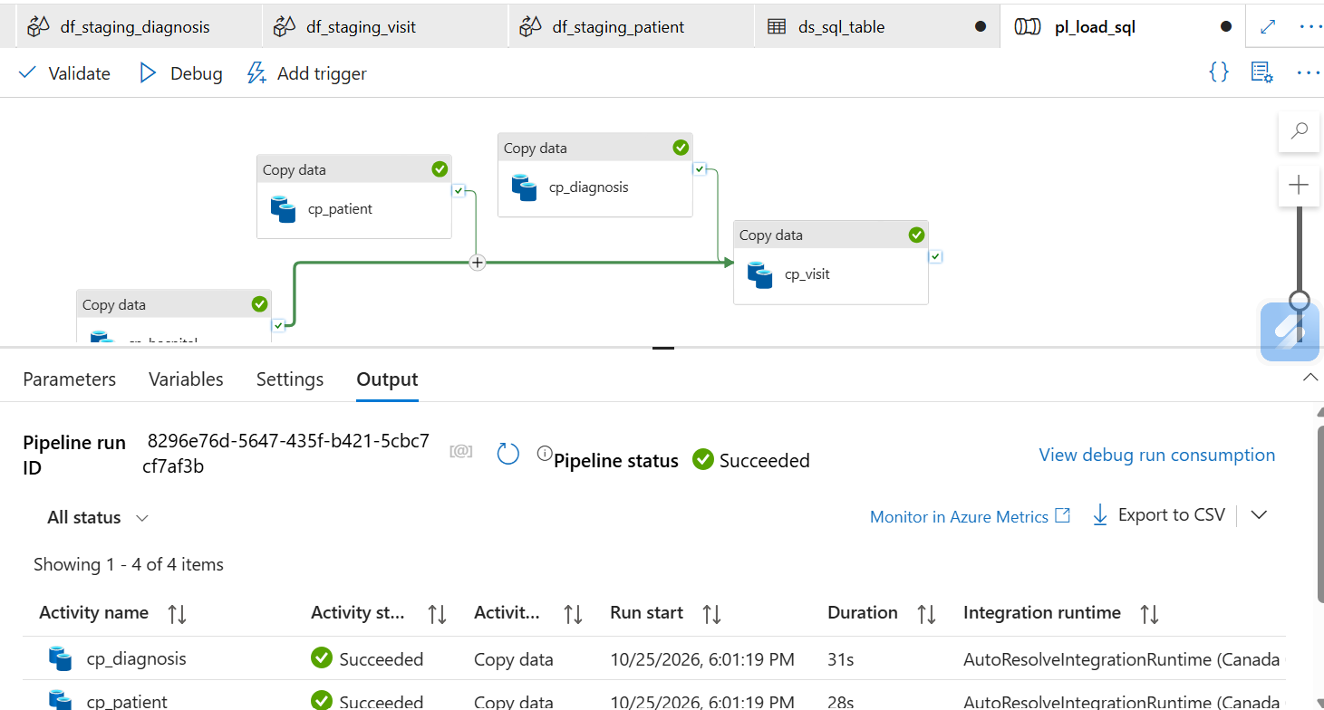
Step_4_Screenshot_9.png: pl_load_sql Succeeded
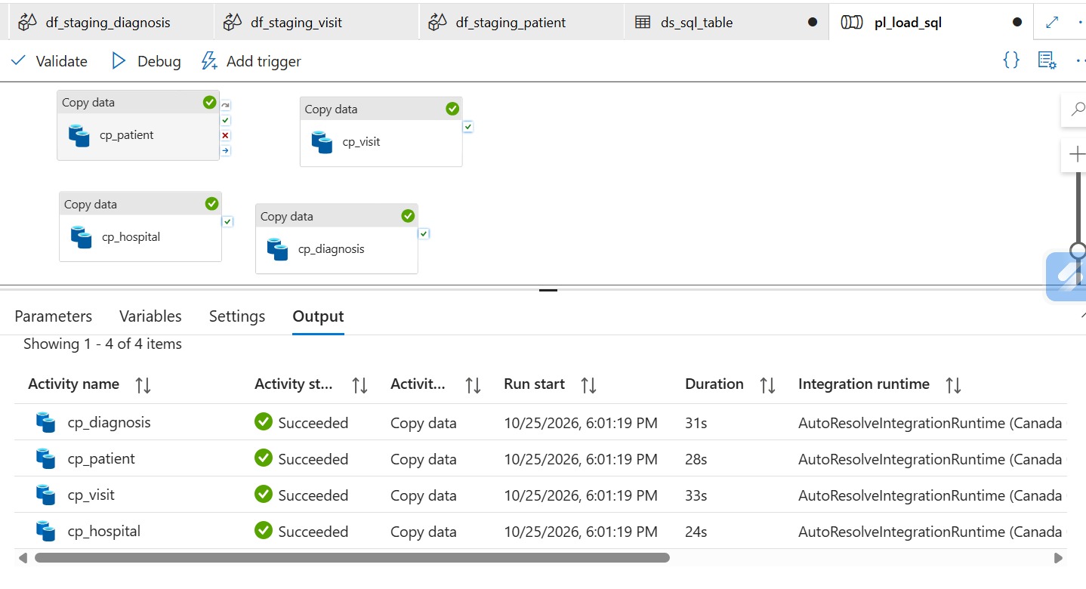
Step_4_Screenshot_10.png: All four copy activities Succeeded
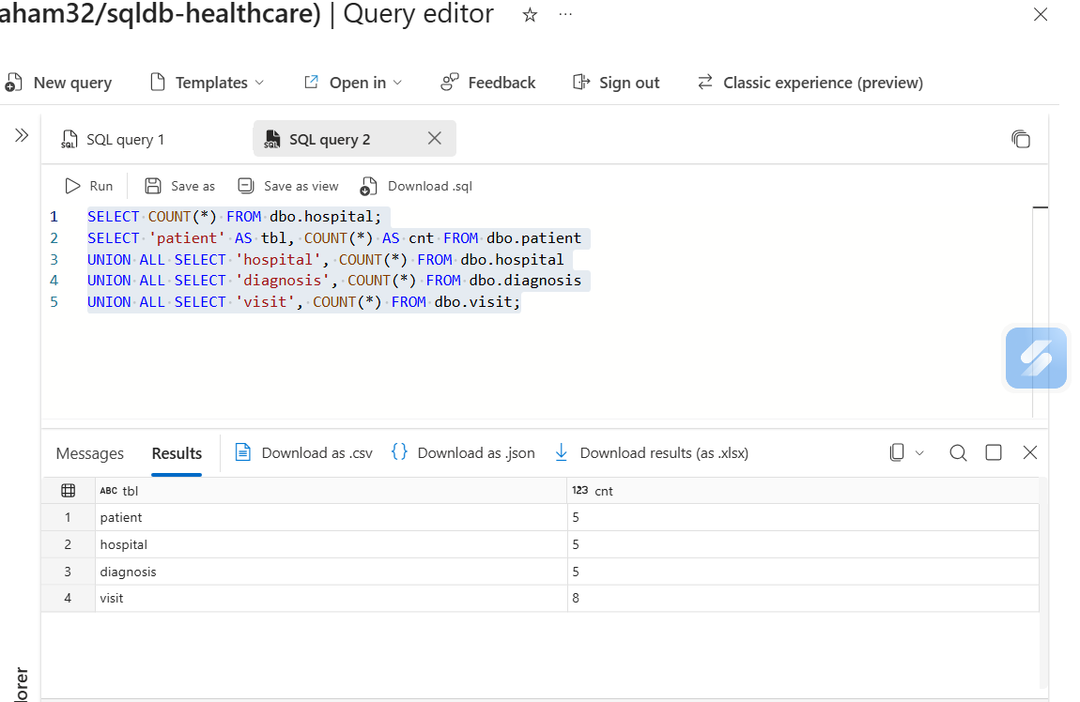
Step_4_Screenshot_11.png: SQL counts: 5, 5, 5, 8
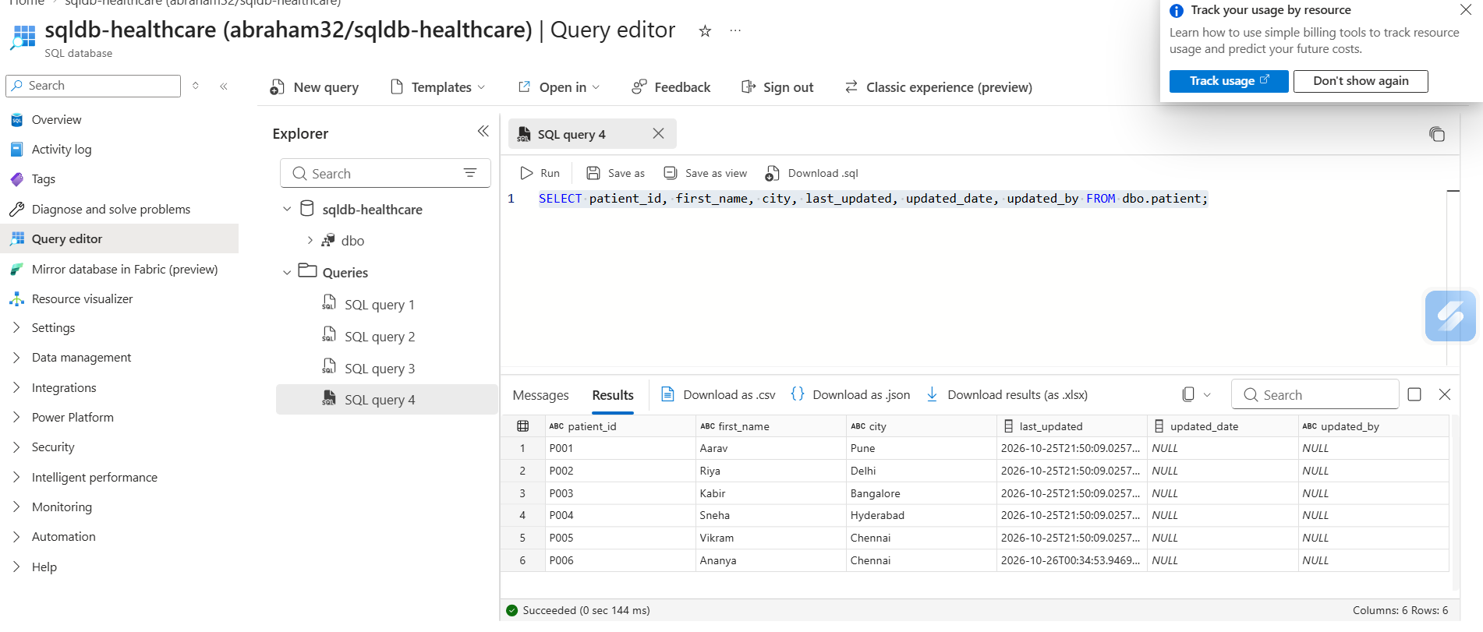
Step_4_Screenshot_13.png: SCD1 AFTER: 6 patients, P001 city Pune (updated, created date unchanged), P006 added with a new created date, no duplicates. updated_date/updated_by are NULL here because the audit columns were added after this run.
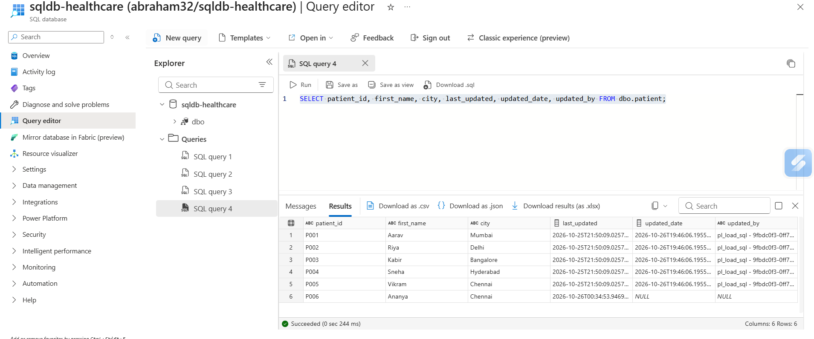
Step_4_Screenshot_15.png: Second run with original file: P001-P005 overwritten (P001 back to Mumbai) with updated_date and updated_by stamped; P006 kept, not deleted

Step 5: Orchestration, Monitoring and Alerts
Healthcare Data Pipeline · Bootcamp Project 1 · Anupa

1. What this step does
A master pipeline, pl_master, runs the whole process in the right order with one click: ingest to Landing, validate into Staging, then load SQL. Each step starts only if the previous one succeeded, so bad data is never published to SQL. ADF Monitor records every run, and an Azure Monitor alert emails the owner when any pipeline fails.

2. Steps
- Created pipeline pl_master with three Execute Pipeline activities: run_ingest → run_staging → run_load_sql, each on Success, with 'Wait on completion' ticked.
- run_ingest passes fileList = the four file names.
- run_staging and run_load_sql receive the RunId of run_ingest as runId, so all three layers use the same batch id.
- Debugged pl_master and confirmed all three activities Succeeded, then Publish all. The parameterized version (runId passed from run_ingest) ran end to end and Succeeded on 25 Oct 2026.
- Registered resource provider microsoft.insights on the subscription.
- Created alert rule alert_pipeline_failed on the data factory: metric Failed pipeline runs > 0, checked every 5 minutes, Severity 1.
- Created action group ag_healthcare with an email notification to the owner.

3. Configuration
Item | Value
Master pipeline | pl_master: run_ingest → run_staging → run_load_sql
Batch id flow | runId = @activity('run_ingest').output.pipelineRunId
Alert rule | alert_pipeline_failed: Failed pipeline runs > 0, 5 min, Sev 1
Action group | ag_healthcare (email)
Run logging | ADF Monitor: pipeline and activity status, start/end time, duration, rows read/written, error details

4. Code snippets
run_ingest parameter:
fileList = @createArray('patient_raw.csv','hospital_raw.csv','diagnosis_raw.csv','visit_raw.csv')

run_staging parameters:
runId = @activity('run_ingest').output.pipelineRunId
runDate = @formatDateTime(utcnow(),'yyyy-MM-dd')

run_load_sql parameter:
runId = @activity('run_ingest').output.pipelineRunId

5. Execution order
# | Activity | Runs pipeline | Starts when
1 | run_ingest | pl_ingest_landing | pl_master is triggered
2 | run_staging | pl_staging | run_ingest Succeeded
3 | run_load_sql | pl_load_sql | run_staging Succeeded

6. Failure and recovery
- A failure stops the chain, so SQL is never loaded from a failed or half-validated batch.
- The alert emails the owner within about 5 minutes.
- Open Monitor > Pipeline runs, click the failed run, read the error on the failed activity.
- Fix the cause (for example start the VM, correct the file, fix the expression), then use Rerun from failed activity, or rerun pl_staging / pl_load_sql with the same runId.
- Reruns are safe: Landing keeps every batch in its own folder, Staging rewrites the same runId folder, and SQL uses upsert so no duplicates appear.

7. Challenges and fixes
Challenge | Cause | How it was fixed
Alert creation failed | Resource provider microsoft.insights was not registered | Subscription > Resource providers > register microsoft.insights
Lost work | Laptop broke; changes that were not published were lost | Rebuilt the work; now click Publish all after every step
Pipeline fails at night | VM auto-shutdown 12 AM ET stops the SHIR | Start the VM before every run (listed in the README)
Same batch id across layers | Each child pipeline has its own RunId | Passed run_ingest's pipelineRunId into the next two pipelines

8. Evidence (Screenshots folder)
Screenshot file | What it shows
Step_5_Screenshot_1.png | pl_master: run_ingest, run_staging, run_load_sql all Succeeded
Step_5_Screenshot_2.png | Alert rule condition (Failed pipeline runs > 0)
Step_5_Screenshot_3.png | Action group ag_healthcare with email
Step_5_Screenshot_4.png | alert_pipeline_failed enabled
Step_5_Screenshot_5.png | Parameterized pl_master (batch id passed between pipelines) Succeeded, 25 Oct 2026

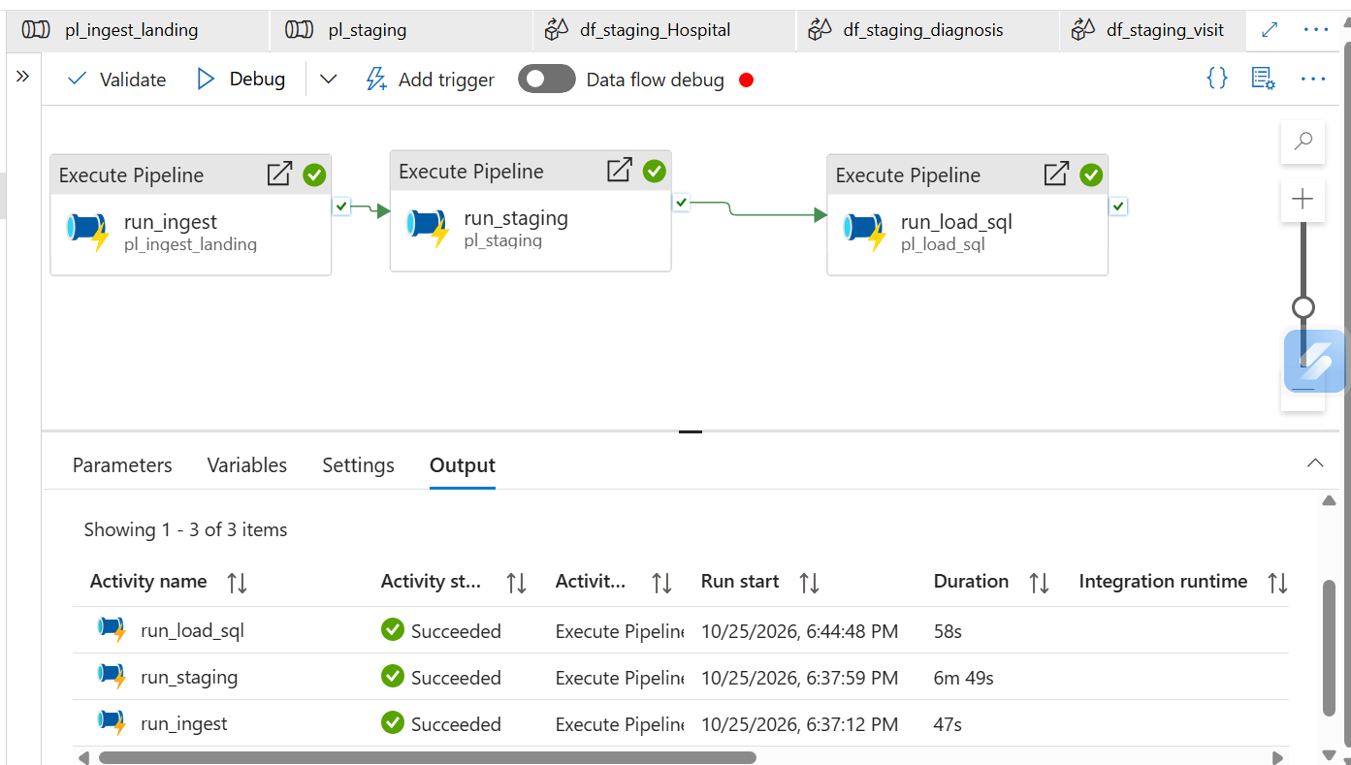
Step_5_Screenshot_1.png: pl_master: run_ingest, run_staging, run_load_sql all Succeeded
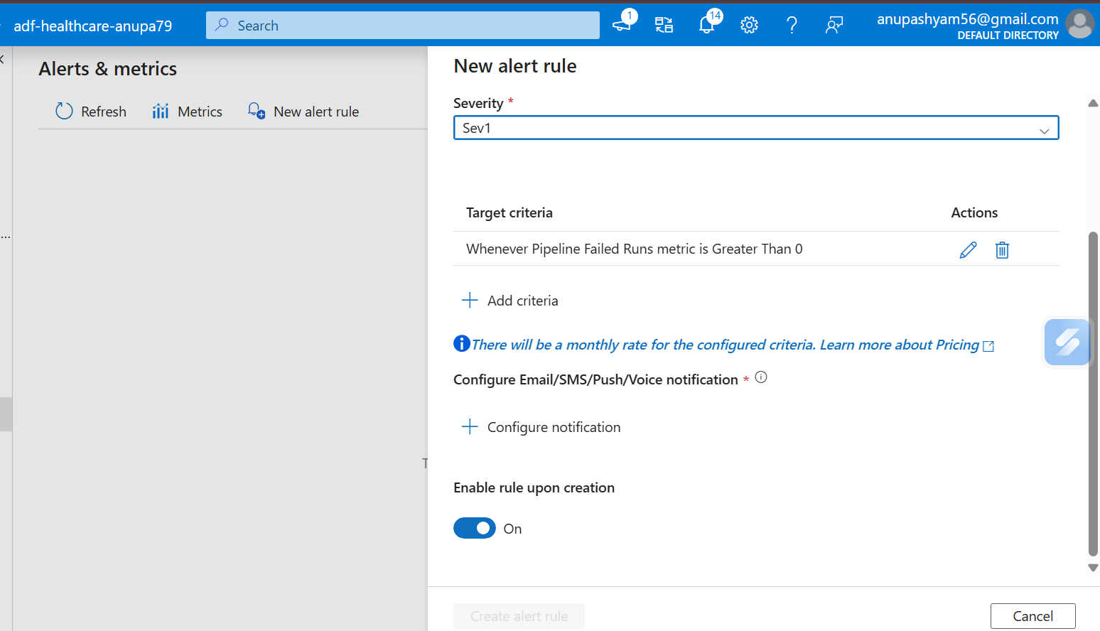
Step_5_Screenshot_2.png: Alert rule condition (Failed pipeline runs > 0)
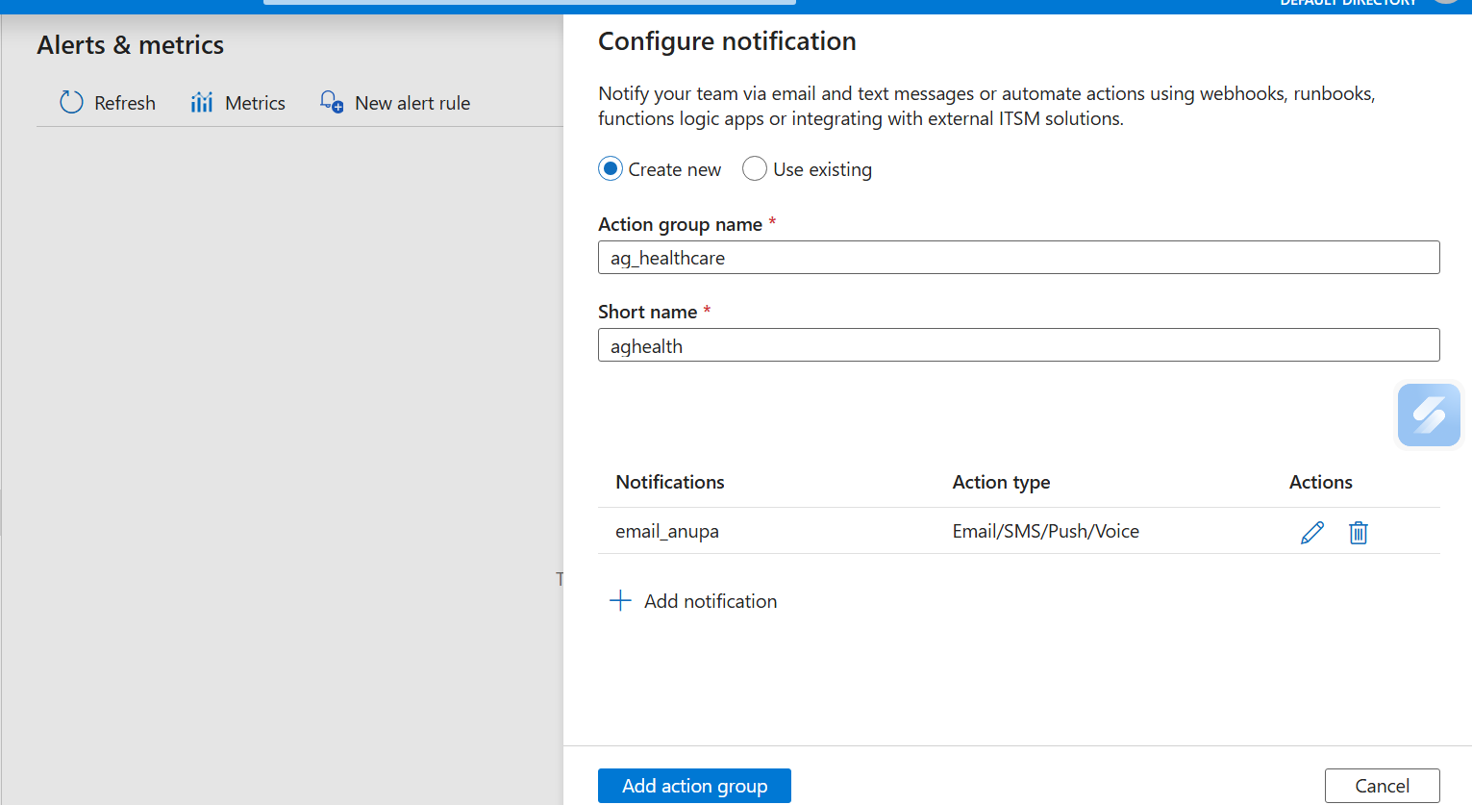
Step_5_Screenshot_3.png: Action group ag_healthcare with email
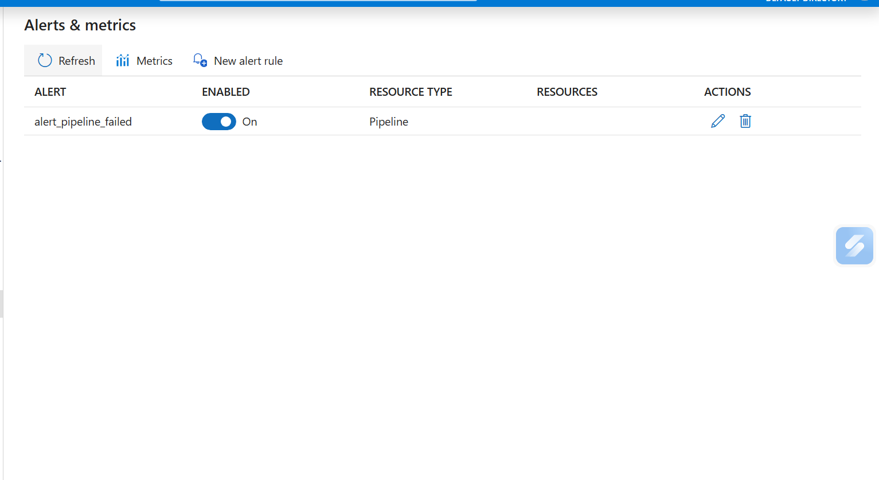
Step_5_Screenshot_4.png: alert_pipeline_failed enabled
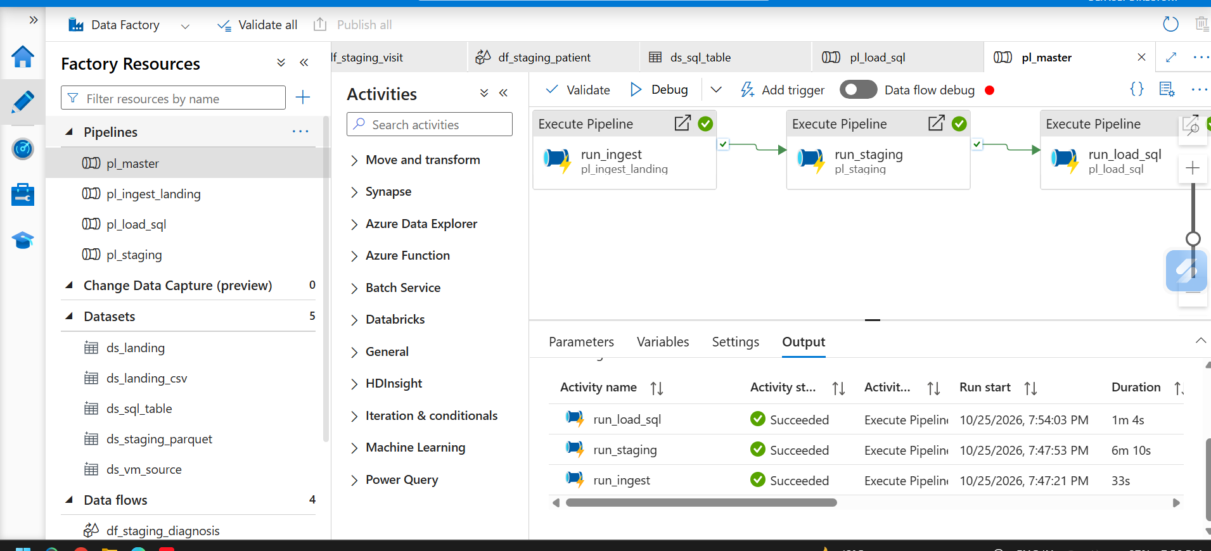
Step_5_Screenshot_5.png: Parameterized pl_master (batch id passed between pipelines) Succeeded, 25 Oct 2026

