**Pricing and guide quotes**

**What do we want to achieve?**

OSV want to display guide price ranges for vehicles on the website based on rates books that we receive on a regular basis. The rates books would automatically update the pricing on the website which would enable customers to request a guide price for a particular vehicle and the guide price range would be returned based on the best price in the rates book.

**How do we see this working?**

At the beginning of a quarter we would upload the rates books for ALD. These rates books include CAP codes so they can match the vehicles on the website. The ALD rates books would act as a default price range for each vehicle.

Throughout the month we would upload various other rates books that come in on a daily basis and upload these into the backend of the website. There will need to be a simple upload field in the back end for OSV to submit rates books.

There will end up being multiple rates for each car. The best price that is uploaded for a vehicle will need to be shown to the user in the front end. This can be matched by CAP code which will be included in the rates book when uploaded. For example if the new rates book has a cheaper rate on an Audi A5 compared to the ALD rates book the new rates book price would be shown to the customer.

If the rate expires we need to be able to select the vehicle that the rate has expired and press a button that turns this back to the default ALD rates book price that was uploaded at the beginning of the quarter.

The same needs to be available to manually update a particular rate should there be a special offer running on a particular vehicle. If this expires we would again need to be able to press a button to return it to the ALD rates book price.

The system built would therefore have to pick the best price throughout the quarter, unless specifically defaulted back to ALD rates by clicking a ‘return to default’ button.

OSV would need a search function in the back end so that they can filter my make, model and expiry date.

At the end of every quarter we need to be able to clear the rates books and upload the ALD rates for the new quarter where the process will start again. Rates from previous quarters and old rates books should now not be taken into consideration. Only rates uploaded in the same quarter should be searched for the best price and returned to the user.

**How would this look in the back end?**

When uploading a rates book it would look something like this:

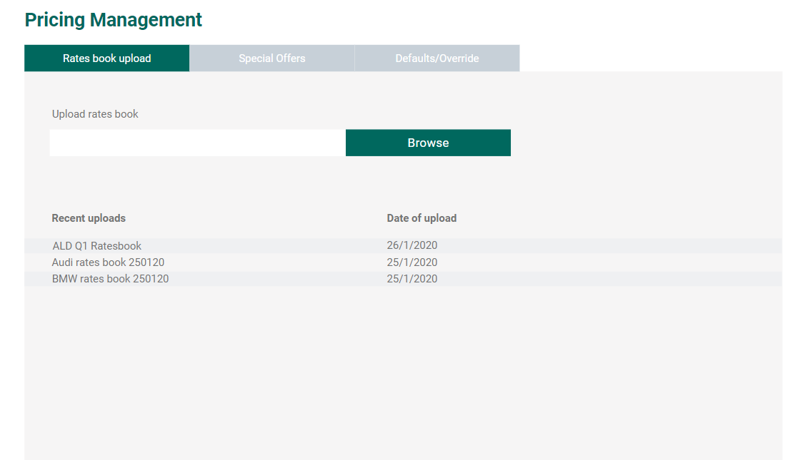

All rates books will be recorded with their upload date and file name in the recent upload section. Browse will open up your files allowing you to upload a new rates book.

When adding special offers this will look something like this:

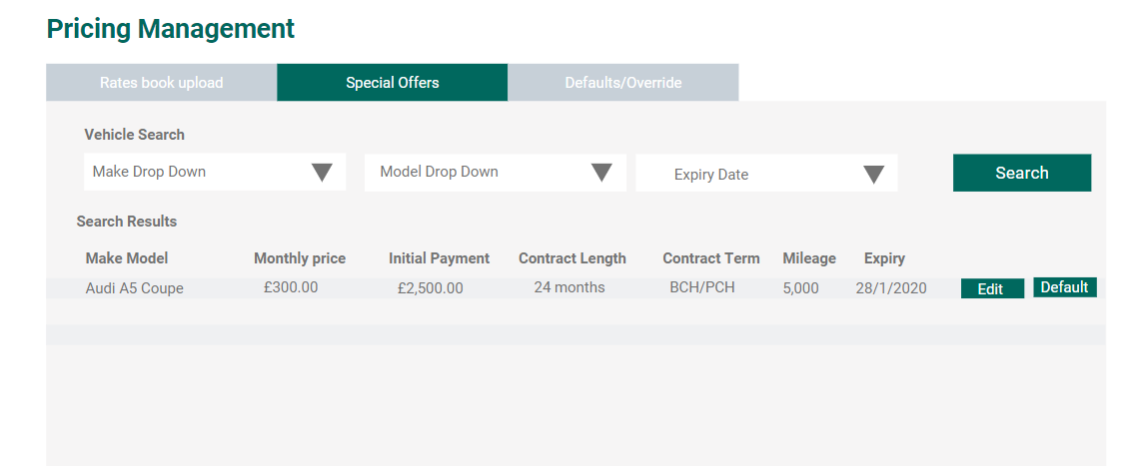

The tab will consist of a vehicle search function to find the make and model. The relevant vehicles will show up in the results below and the OSV employee can ‘edit’ the pricing by selecting the ‘edit’ button next to the quote. This will enable them to update the pricing and contract to match the special offer that has just come in.

This area would be checked daily and filtered by expiry date to enable them to see what is expiring and what needs to be ‘defaulted’. This will mean if the offer has expired, they can filter by todays date, it will show and they can press the ‘default’ button. This will return the rates back to the ALD defaulted rates book pricing or a cheaper price should there be another one in the rates books. You can only default special offers from this section.

We could take this one step further and include a special offer sticker that is included on any vehicle in the special offers list and once updated will appear in the corner of the image on the front end, for example:

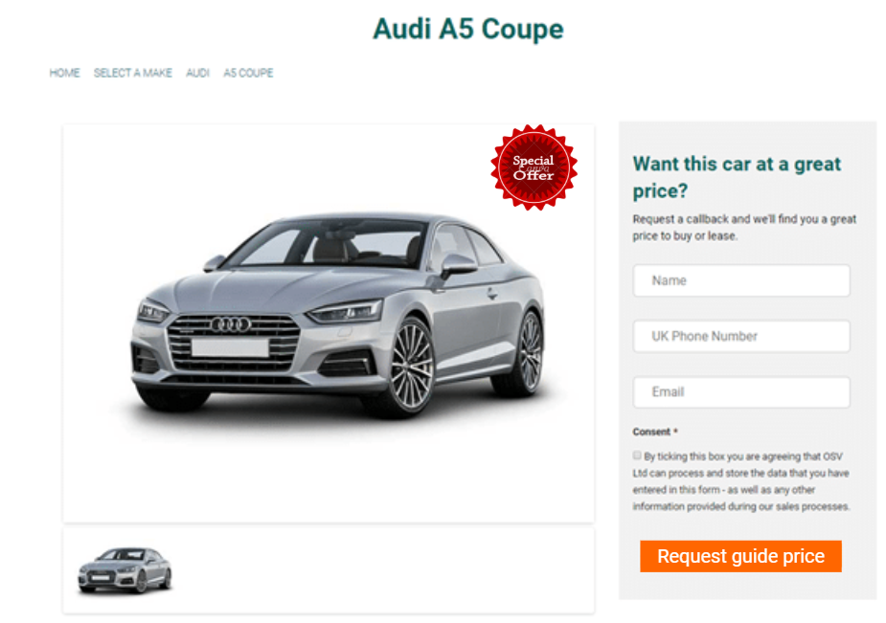

When the offer is defaulted, the special offer sticker would automatically be removed.

If particular vehicles need to be manually overridden or defaulted for example if all needs to be defaulted at the end of the quarter and the new ALD rates books for the next quarter need to be uploaded, this will all be done in the Defaults/Override tab. For example:

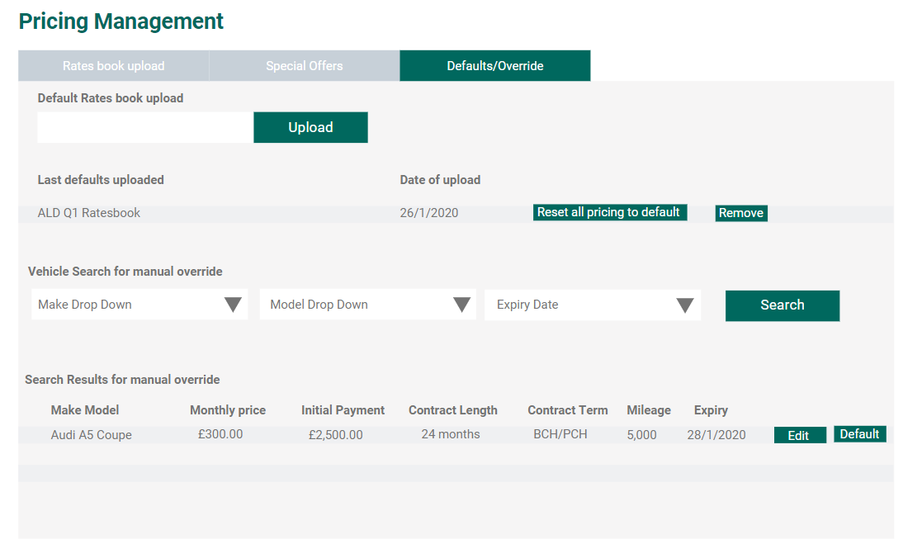Special offers are not shown in the override/default tab, these are only prices outside of special offers that need to be manually overridden because there has been a change to the terms, if changed in the special offers tab they will be stamped with the special offers sticker. This would be changed by pressing edit. If you wanted to default this back to the ALD rates book you would press default.

Above there is the default rates book upload where you select the ALD rates book that will act as the default. This will then be displayed in the last defaults uploaded list with a date. You can remove the rates book if you are uploading the next quarter’s rate book or override all pricing by defaulting everything on the site back to ALD rates. This will override all special offers and manual changes.

All rates books will be uploaded in the form of an excel document.

**How would this look on the front end?**

On the front end there needs to be two ways in which these price ranges are returned. The first is on model pages when the customer fills in their details such as ‘name, email and phone number’ please see screen shot:

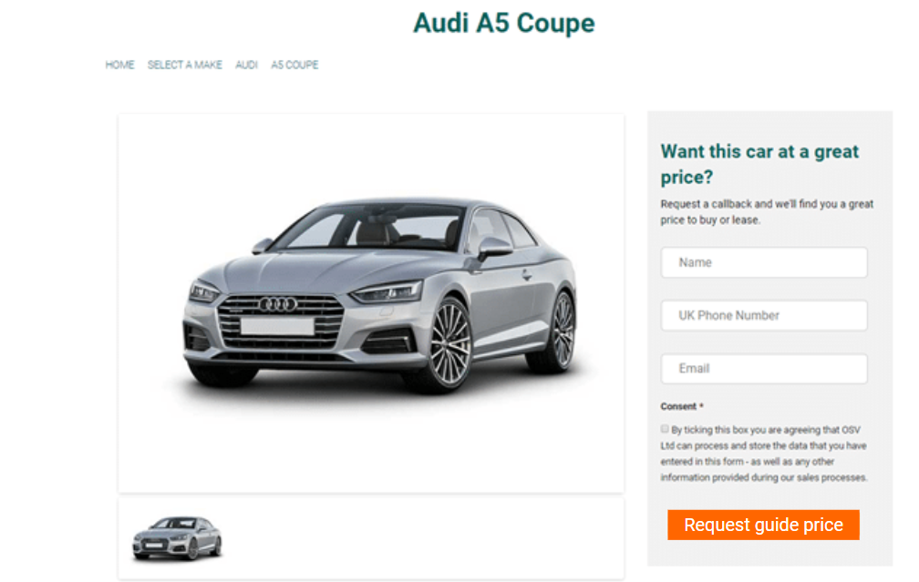

The request a call back button would be replaced with ‘Request a guide price’. This would then change the form to display the best price that is pulled from the rates book for that vehicle. Please see below:

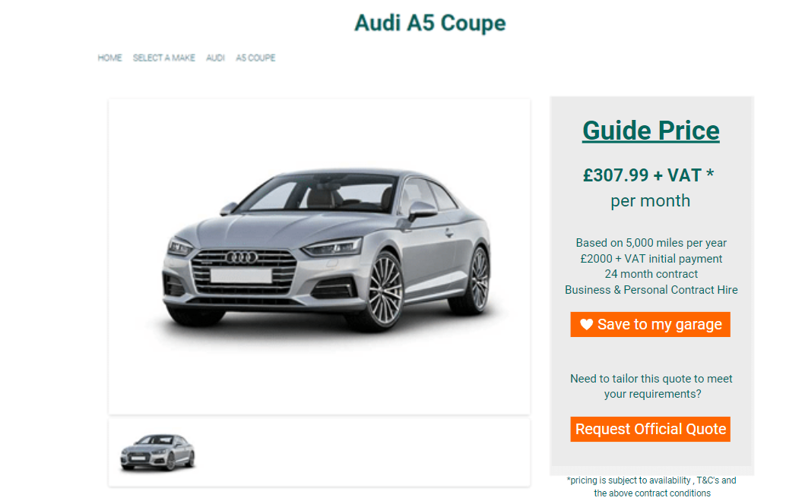

The price would be pulled in along with the mileage, initial payment, contract length and contract type.

There would be a button for the customer to save the quote to their garage ‘save to my garage’ which will save the quote to their account created using the details entered when requesting the price. If the user selects the ‘save to my garage’ it will ask them to create a password which will generate their garage which will be their account where all quotes will be saved. For example:

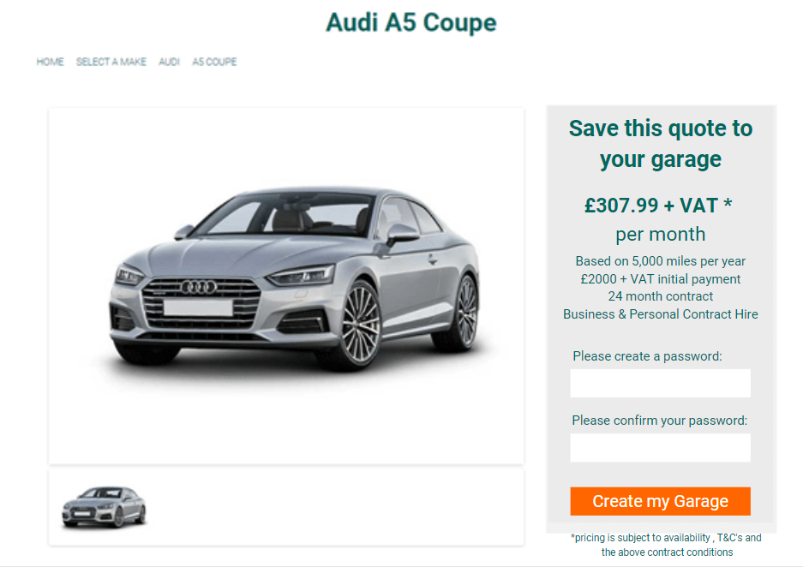

Users will be able to return to their garage to view their guide priced quotes and view, amend or remove the quote from their account area. Please see mock up below:

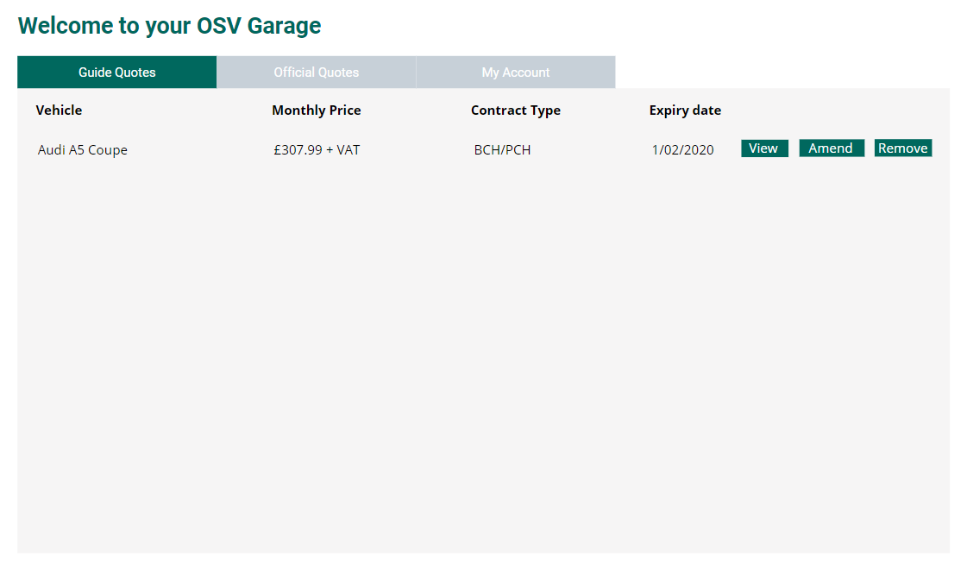

The user would view their quote which would take them to a page where they can see the details, images of the vehicle and be able to request a call back regarding the specific quote. See mock up below:

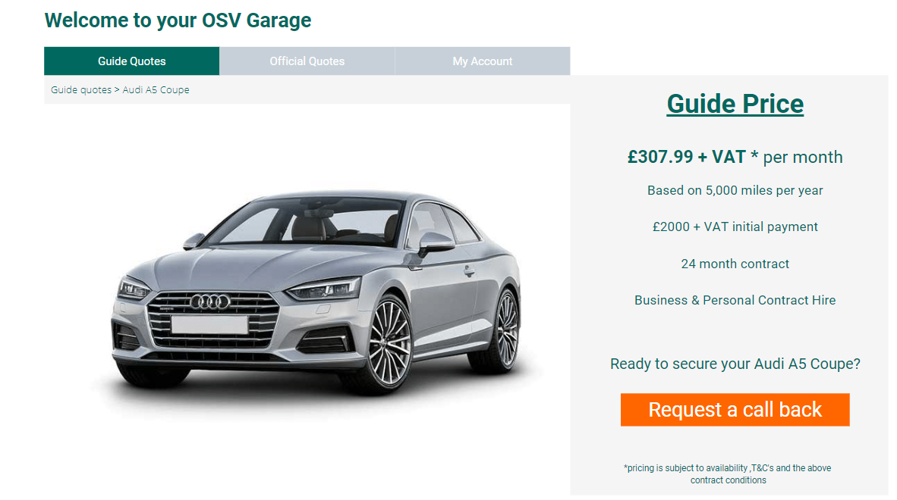

If the user requests a call back they will be sent to the following page:

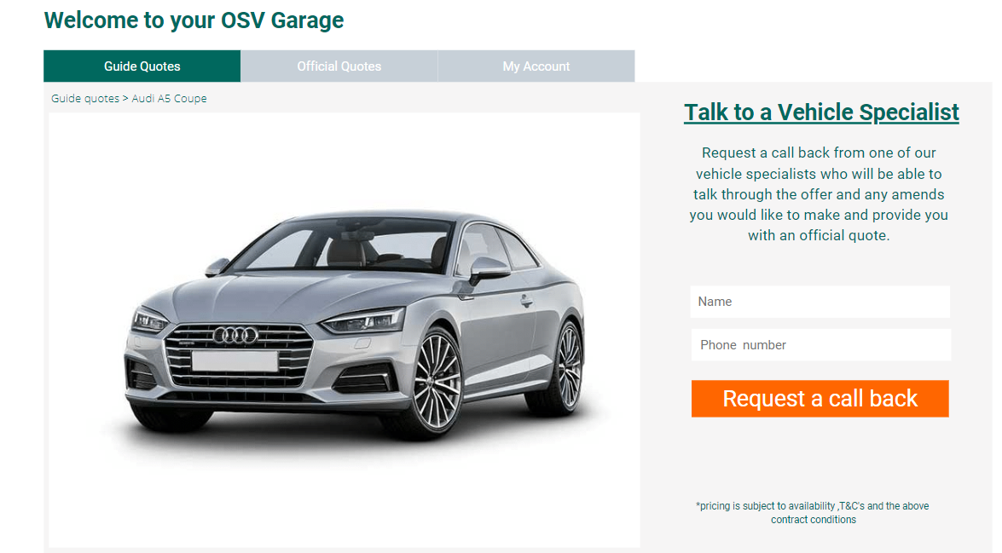

The user can also amend their quote which will take them to a form where they request a call back to chat through the amends they want to make. Please see mock up:

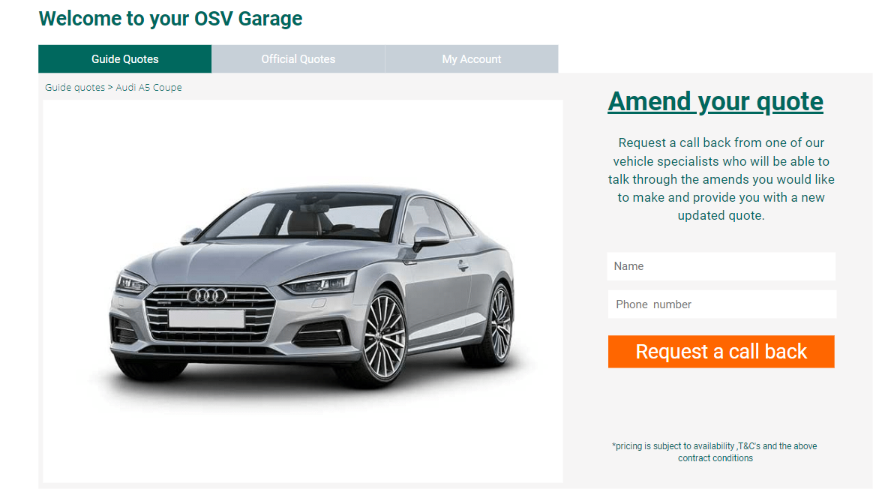

When the user enters their details this is submitted to [amanda.lelliott@osv.ltd.uk](mailto:amanda.lelliott@osv.ltd.uk) as an email with the following information:

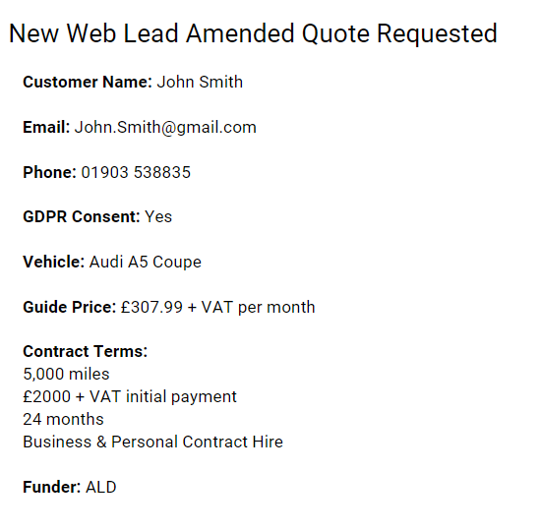

If the user wants to remove the quote they select the ‘remove’ button. If the expiry date has passed the date will change to expired and the button will change from ‘view’ and ‘amend’ to ‘update quote’.

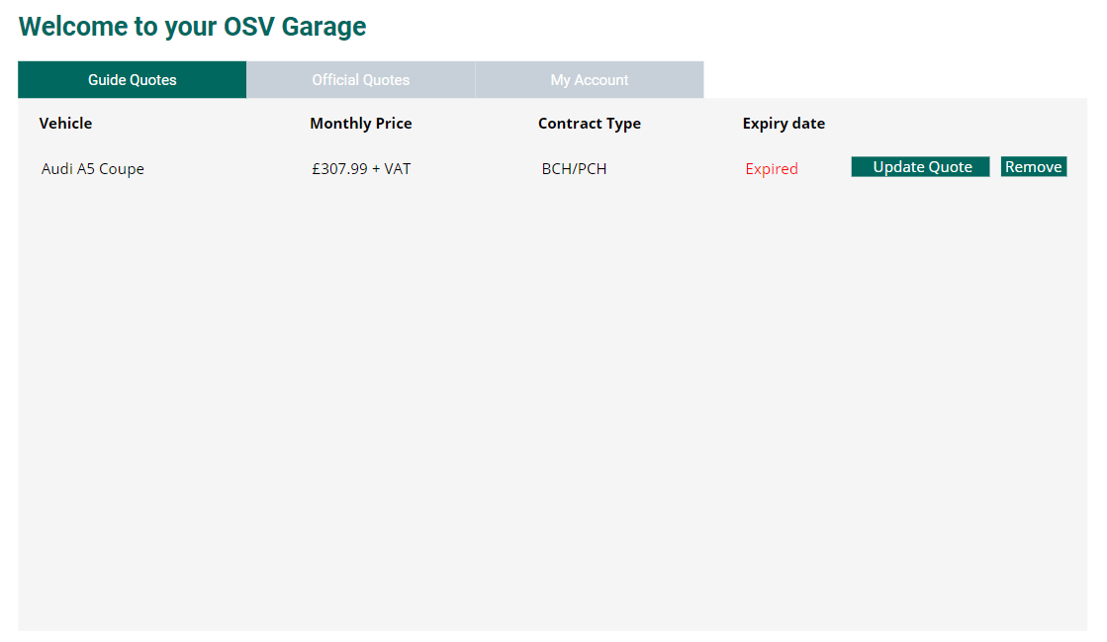

When a deal has expired the user can remove the quote from their account or ‘update quote’. This will take them to the model page where the price is displayed. They would not have to enter their details if they are already logged in. They would just see this page:



And by selecting ‘save to my garage’ the quote would be saved directly to their garage.

If the user wants to tailor the quote or confirm specification they will need to select the ‘request official quote’ button. This will send the quote information along with their contact details entered in the guide quote form to [amanda.lelliott@osv.ltd.uk](mailto:amanda.lelliott@osv.ltd.uk) which will provide her with the following information to set up as a lead:

* Name
* Email
* Telephone number
* GDPR Consent
* Vehicle Make and Model
* Guide Price
* Contract terms
* Funder

This will need to be in the form of an email that looks something like this:

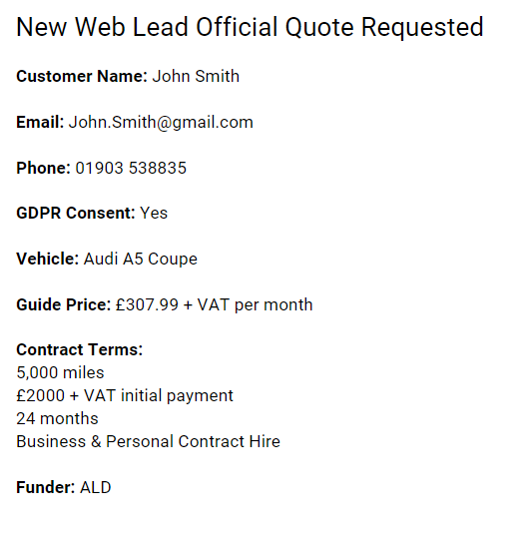

**Embedding the Quotes onto other pages of the site**

We would need a short code to enable us to embed the guide prices onto other pages of the website, for example in car reviews, blogs etc. The quotes that are pulled through would need to be updated automatically taking the best price from the database. These would also need to be updated automatically when the rates books are replaced each quarter.

The embed needs to look something like this:

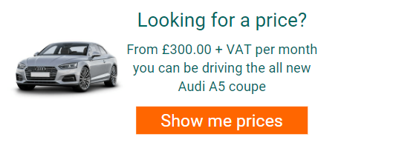

The car would be pulled in from CAP data and the monthly price and vehicle name would be pulled in from the rates books/CAP data.

“From [rates book monthly price] + VAT per month you can be driving the all new [CAP Data Make and model]”

This will need to be a simple short code that is generated when we select the make and model of vehicle. For example in the back end we select Make: Audi Model: A5 coupe and it searches the rates book for the best price and generates a short code that generates the above CTA with the car image included.

This CTA would then need to link to the model page where the customer will enter their details to get the breakdown of the price. Please see below:



**Search function**

On the website we could also have a section specific to ‘Get your guide quote’. This would be a page with a search function like this:

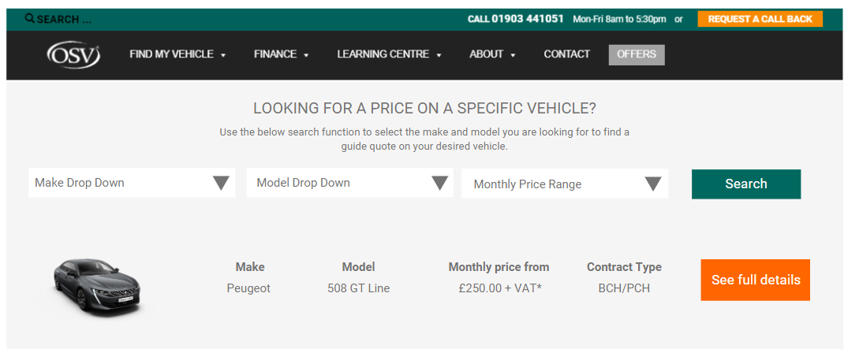

The customer would then select ‘see full details’ which would take them to the model page:



On the above page we would need to tailor the text to ensure that it explains to view the guide price they must enter their name, email and phone number.

**Customer Journey**

As seen above there are many ways in which the customer can view guide pricing and request official quotes/ a call back/ consultation.

The idea is that quotes can be embedded in articles across the learning centre and car reviews and on all model pages there will be the option to request a quote. All of these lead to the final outcome of requesting a call back/consultation in order to secure/finalise the quote.

Therefore we are ensuring that the site directs the user down the funnel to getting in contact and along the way we have collected their information.

We then need to be able to take the information that they have entered for example their email address and the vehicles they are interested in so that we can remarket to them to aim to re-engage should they have not been active in their quote portal.

Please refer to the flow chart for full customer journey.

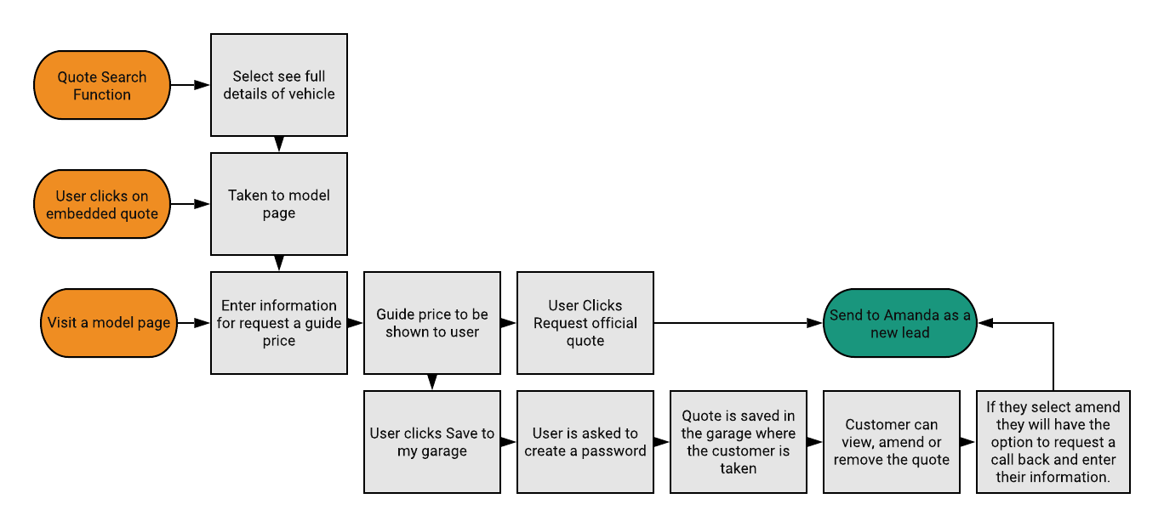

**What OSV need to supply**

OSV would need to supply rates books for the back end of the website to ensure pricing is kept up to date. These would need to be updated as soon as they come and our commissions would need to be built in to these.

OSV would also need to do spot checks to ensure that pricing across the website is correct and the right prices are being overridden and replaced where necessary.

OSV would need to manually update vehicles with special offers that have come in and ensure they keep track of when these need to be returned to the default ALD price.

OSV would also need to provide the graphics such as the special offer sticker etc.

This section of the Digital Showroom will not need any input from the sales team. It will be solely the marketing teams responsibility to keep this up to date and receive the most up to date rates books to ensure the site reflects the most recent pricing.

**Overall goal from project**

As an overall goal and to make this project possible we need to generate at least 83 leads per month to fuel the sales team and be able to take on a new team member to keep the rates updated as and when they come in.