TF-GNN Fraud Detection
Measured results, engineering lessons, and a path to customer adoption
Main result: the graph helped through explicit features, not through learned GNN embeddings.
The best comparable configuration was XGBoost with nine time-aware behaviour features: 0.5631 test AUC-PR. Static engineered graph features added a small but reliable gain. R-GCN and TGN representations added no measurable fraud signal after controlling for the features already given to XGBoost.

22.5M  transactions evaluated | 36.4%  test rows with a new card or merchant | 0.5631  best test AUC-PR | 436x  better than random AUC-PR
What was measured
Every configuration used the same train, validation, and test rows. AUC-PR is the primary metric because fraud prevalence was only 0.129% in test; a random ranking would score about 0.00129. Differences were measured with paired 95% bootstrap intervals, so the report focuses on incremental value rather than isolated scores.
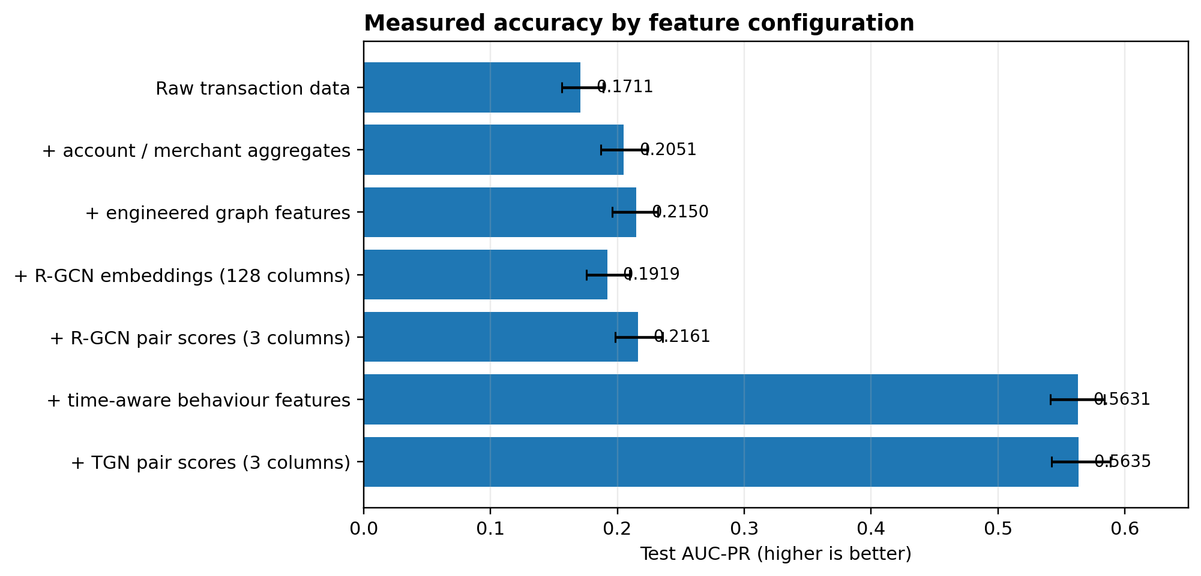
Change tested | AUC-PR change | 95% interval | Conclusion
Aggregates added | +0.0341 | [+0.0232, +0.0452] | Useful
Engineered graph features added | +0.0098 | [+0.0025, +0.0171] | Small, reliable
Time-aware behaviour features added | +0.3482 | [+0.3253, +0.3698] | Dominant result
R-GCN embeddings added | -0.0231 | [-0.0325, -0.0129] | Worse
R-GCN pair scores added | +0.0011 | [-0.0063, +0.0079] | No measurable gain
TGN pair scores added | +0.0003 | [-0.0077, +0.0078] | No measurable gain

1. What we built and how the embeddings were produced
The pipeline starts with one TigerGraph instance and one read-only transaction fact table. Graph and behavioural features are computed in GSQL, stored on Card, Merchant, Category, Community and Resolved Entity vertices, and joined back to each transaction. Six forward-chaining snapshots ensure that a row only receives information available before that row occurred.
R-GCN-style static embeddings
- Inputs: each node receives the same aggregate features already available to the XGBoost baseline; unseen entities receive a ones-vector. There are no learnable node-ID lookup embeddings, so new cards and merchants remain scoreable.
- Graph learning: a heterogeneous PyTorch Geometric model uses relation-specific SAGEConv message passing over nine allowed relation types. It is trained without fraud labels using link prediction.
- Output: 64 values for the card and 64 for the merchant. The wide form adds all 128 values to XGBoost. A compact form instead adds three relationship measures: dot product, cosine similarity and Euclidean distance.
TGN temporal embeddings
- Inputs: every event carries 27 usable transaction, graph and time-aware features plus 27 missing-value flags. A time encoding, the current card memory and merchant memory are combined into a 354-value message.
- State update: a GRU folds each event into a 100-value memory per card and merchant. TransformerConv attends over the 10 most recent neighbours. Memory snapshots are exported at each forward-chaining cutoff.
- Comparable output: the label-free link objective produces 100 values per card and 100 per merchant. The measured XGBoost comparison uses the same three relationship measures rather than all 200 raw values.
Why the learned representations did not improve XGBoost
Both networks compressed information that the star-schema join already supplied exactly. The static model received aggregates that XGBoost already had; the temporal model received the same nine time-aware features that XGBoost already had. The 128-column static representation also diluted useful inputs because a tree splits one column at a time. Compressing it to three pair scores recovered 0.0242 AUC-PR, proving dilution was real, but the compact result still added only 0.0011 - effectively zero new information.
Separate result: TGN as a streaming fraud scorer
A supervised TGN that scored transactions directly achieved 0.3241 test AUC-PR. It is not included in the controlled feature comparison because it trains on the fraud label, sees a narrower input set, and updates memory while scoring. Its value is operational: O(batch) training, stateful updates and native handling of new accounts. On this dataset it trades accuracy for streaming capability; it does not beat the 0.5631 XGBoost configuration.
What the negative GNN result means
It does not show that GNNs are generally ineffective. It shows that this graph, this self-supervised link task and this downstream interface did not create information beyond the engineered join. The card-merchant graph is about 27% dense, making edge-existence prediction weak and producing many false negatives during random negative sampling. Two architectures failed under the same pretext task, which points more strongly to objective/data mismatch than to a broken implementation.

2. Staying true to ARCHITECTURE.md while adapting to evidence
ARCHITECTURE.md was preserved as the pre-build design record. The implementation did not follow it mechanically; PLAN_VS_BUILT.md records 212 commitments, of which 47 were kept and 165 changed, abandoned, reversed or remain unbuilt. This traceability is a strength: the report can distinguish the original intent from the system that was actually measured.
Architectural principle | How it appears in the measured system
One shared graph and one feature pipeline | Kept. All configurations reuse the same TigerGraph data and GSQL-derived features.
No-pollution / identical evaluation rows | Kept and strengthened with forward-chaining cutoffs and runtime count gates.
R-GCN followed by XGBoost | Kept as the static learned-representation test.
Temporal GNN stage | Kept in intent; TGN was selected using the observed importance of recency.
Common evaluation | Kept and expanded: AUC-PR, ROC-AUC, operating threshold and paired intervals.
Deliberate changes from the original plan
Area | Original design | Measured implementation
Dataset | TabFormer / NVIDIA benchmark context | Generated payment corpus; only within-dataset comparisons are valid.
Graph feature code | Run solution-kit queries as-is | 57 project-specific GSQL scripts; no kit query runs unmodified.
GNN framework | tg-gnn, torchrun, cuGraph-PyG | Single-process PyTorch Geometric exports and training. cuGraph is detected but not used.
Experiment design | Four cells in a 2 x 2 | Eight configurations to separate addition, replacement, information content and dimensional dilution.
Isolation mechanism | Fresh instance per stage | One instance with cutoff-correct exports, build IDs and state gates.
Why the result is credible
- Six forward-chaining builds: no training row reads a feature fitted on itself or on later transactions.
- The cutoff is enforced on timestamped edges; load-time and build-time gates verify the edge and transaction ordering agree.
- Inductive evaluation: 36.4% of test rows contain a card or merchant absent from training, and learnable ID embeddings are forbidden.
- The fraud label is excluded from both comparable GNN objectives. The supervised TGN is clearly marked and reported separately.
- All feature comparisons use identical rows and paired resampling of the difference, not unrelated single-model confidence intervals.
- Sentinel values are converted to missing values rather than zero, preventing unseen entities from becoming a hidden calendar signal.
Audit limitation in the supplied bundle
REPORT_BRIEF.md says run.log contains the raw top-feature gain table, memory trace and early-stopping record, but run.log was not included in the archive. The headline metrics are fully present in JSON. The project documentation identifies row_pair_gap_seconds (first card-merchant visit / recency) as the leading temporal signal, but this report does not reproduce a full feature-ranking table without the log.

3. How to improve the project and make GNNs usable on customer data
Recommendation: productize the evaluation framework, not this exact graph or model.
The reusable asset is the leakage-safe comparison harness: schema mapping, forward-chaining exports, strong tabular and engineered-graph baselines, GNN representation tests, and paired uncertainty. A customer should first receive a Graph Value Assessment; a GNN is adopted only when it proves incremental value or solves an operational requirement that the baseline cannot.
A customer graph will be structurally different
Do not force every dataset into Card -> Transaction -> Merchant. Introduce a schema adapter based on roles rather than names:
Canonical role | Customer examples | Required mapping question
Actor / account | customer, card, wallet, user, policyholder | Who initiates or owns activity?
Event | payment, login, transfer, claim, application | What is scored, and when is it visible?
Counterparty / target | merchant, beneficiary, device, provider | What relationship may carry risk?
Context entity | IP, address, phone, email, terminal, location | Which shared entities create meaningful paths?
Outcome | chargeback, confirmed fraud, loss | When does the label become available?
Recommended delivery sequence
1. Graph fitness check: Profile node and relation counts, degree skew, density, connected components, time coverage, label delay, cold-start rate and leakage risks. Reject meaningless relations early.
2. Baseline first: Build raw, aggregate, time-aware and engineered-graph baselines on forward time splits. This establishes whether the graph already pays without a GNN.
3. Select an aligned learning task: Choose a task tied to the customer mechanism: next interaction / recency, suspicious shared-entity prediction, temporal contrastive learning, anomaly scoring, or supervised fraud training when governance permits. Do not default to edge existence on a dense graph.
4. Test the interface: Compare raw embeddings, compact pair scores, replacement of engineered features, and direct online scoring. Require a paired interval and an operational reason for every added component.
5. Production gate: Add single-event inference, exactly-once state updates, memory checkpoints, delayed-label handling, drift monitoring, feature lineage and rollback. A notebook score is not a deployable GNN.
Highest-value technical improvements for this repository
- Replace random link prediction with a time-aligned pretext task, starting with time-to-next card-counterparty interaction or recency-aware contrastive learning.
- Add automatic graph diagnostics that warn when density, hub concentration or negative-sample collision makes the chosen objective uninformative.
- Make the relation allowlist, node features, time attributes and labels declarative so a customer schema can be mapped without rewriting the training code.
- Prefer compact relationship scores or a direct GNN scorer over hundreds of raw embedding columns unless a downstream model is designed to consume vectors.
- Build an online inference path for TGN and measure whether its streaming and cold-start benefits justify its lower offline accuracy at customer scale.
Decision for engineering leadership
Treat the current run as a successful negative result. Ship the temporal and engineered graph feature pipeline as the performance baseline. Continue GNN work only through customer-specific graph diagnostics and an objective that matches the customer fraud mechanism. The commercial message should be: "we measure whether a GNN earns its place on your data," not "we add a GNN to every fraud graph."
Primary bundle sources: stage1_comparison.json; stage2_metrics.json; stage4_metrics_link.json; stage4_metrics_fraud.json; README.md; SUMMARY.md; ARCHITECTURE.md; PLAN_VS_BUILT.md; DECISIONS_LEAK_CONTROL.md.

