Shortcut.exe Software Introduction

Feature Overview
If you are a Windows user troubled by the following daily hassles, Shortcut.exe is the perfect solution and will become an indispensable tool for your daily work and life:

- Too many frequently visited web pages, requiring you to repeatedly open the browser and manually enter or select URL links.
- Having to memorize various login usernames and passwords.
- Needing to browse through multiple folders to locate and open different documents.
- Having to navigate folders to launch different applications.
- Spending a lot of time reconfiguring and restoring saved web links and personal settings after reinstalling or switching to a new Windows system.

Shortcut.exe can record all the above information in one go.You only need 3 simple steps to complete those repetitive manual operations, greatly cutting down redundant daily work and significantly improving your work and life efficiency.
Press Ctrl+Alt+R to instantly bring up/hide the Shortcut.exe interface.The program runs silently in the background and supports Windows auto-start.
- Quickly search for targets by name on the interface (keyword search supported);
- Click to launch the selected item directly.
- For migration to a new Windows system:Simply copy Shortcut.exe and default.INI to the new Windows computer, and you can use all your saved shortcuts immediately.
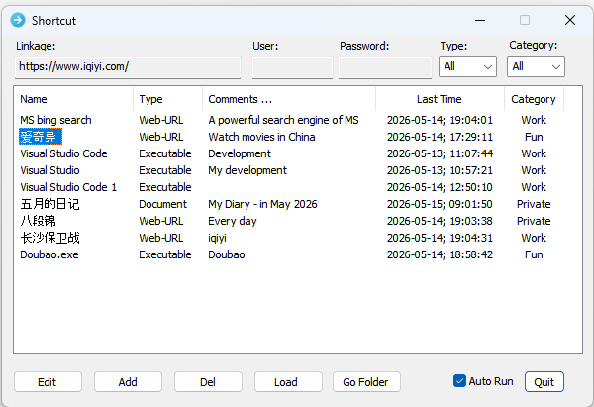

Usage Instructions
- Create a blank dedicated folder on your Windows local drive.
- Download and place Shortcut.exe into this folder.
- Place default.INI into the same folder (optional):
  - The default.INI file stores all your pre-configured shortcut item settings.
  - If default.INI does not exist in the folder, launching Shortcut.exe will automatically generate a new default.INI file and initialize default shortcut entries automatically.
- Directly run Shortcut.exe inside the folder. No formal system installation or registry modification is required.

Button Function Descriptions

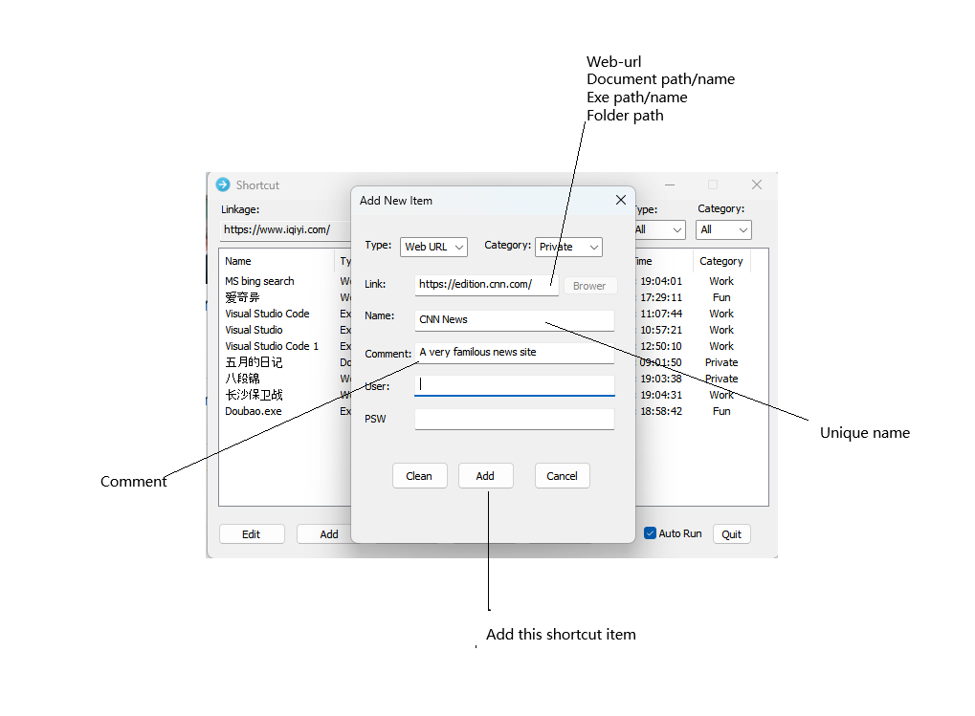
- Add: Add a new shortcut item
- Edit: Modify the currently selected shortcut item
- Del: Delete the currently selected shortcut item
- Load: Import shortcut items from another INI configuration file
- Go Folder: Open the file path of the selected item
- Auto Run: When checked, the program will run silently in the background automatically after Windows startup; you may press Ctrl+Alt+R to pop up the interface at any time. When unchecked, you need to launch the program manually after Windows starts.
- Quit: Exit the program

Basic Operation Guide
- Press Ctrl+Alt+R to pop up the main interface.
- Click the Name column to select a target shortcut item; you can quickly locate items by entering the initial letter or text. Click the Name column again to sort all entries.
- Double-click a shortcut item to launch it directly.
- Press Ctrl+Alt+R to hide the main interface.
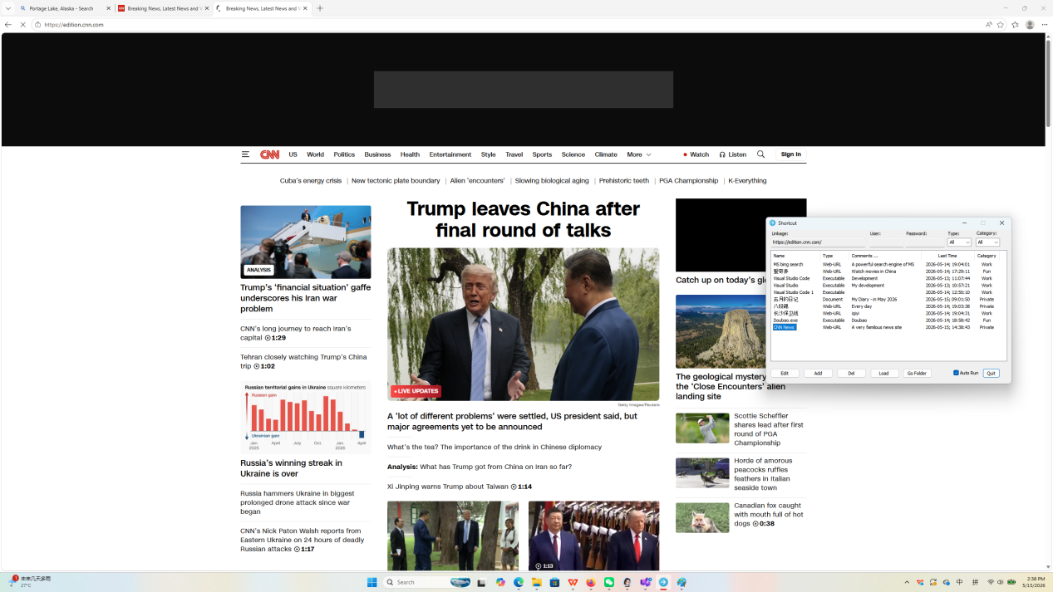

Author

Shortcut is a freeware independently developed in full by Abraham Chen, a senior developer residing in Shanghai.
With over 30 years of professional experience, he has previously served at Trident Micro, Intel, Dell, IBM and Lenovo. He retired officially in May 2026, and completed the development of Shortcut.exe within merely 20 days at home. He loves crafting lightweight applications for Windows and Linux platforms.
Donations are warmly welcomed if this software brings you practical value.For feedback, suggestions,business cooperation or donations, contact Abraham at: abcchenzejun@hotmail.com

