**Installing**

1 ) In the www folder of your web server, extract the files. It should look like this.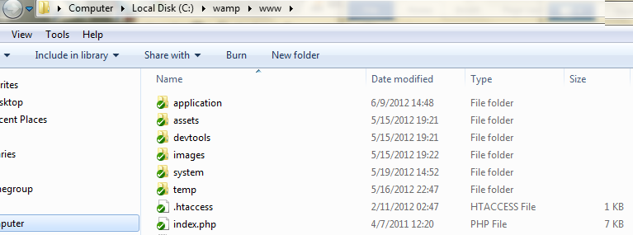

2) Open application/config/config.php to key in MySQL DB username and password and set encryption key.

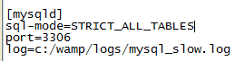3) If possible, then, in your MySQL configuration file in [mysqld] section add this:

sql-mode=STRICT_ALL_TABLES

This is an additional step in securing your system.

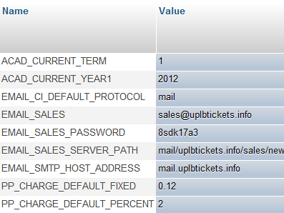4) Open PHPMyAdmin and import “uplb_xts.sql”.

5) System Settings ( table `system_settings` )

* If you want the functionality of associating classes to events to be operating correctly, edit the entries: ACAD_CURRENT_TERM and ACAD_CURRENT_YEAR appropriately. For the earlier, the valid values are 1, 2 and 3 (integer) that stands for First Semester, 2nd Semester and Summer respectively. The last constant should be obvious.
* If you want the email functionality operating correctly, edit the entries whose names are starting with ‘EMAIL’. The values for these are typically provided by your web hosting provider.

6) Make sure that the PHP module “SimpleXML” is enabled – needed for some info exchange between URIs/functions.

7) It would be nice if you the PHP unlink() command can successfully do its task – i.e., delete permissions in /assets/xmltemp is set for the web server. This is to delete temporary XML files.

**Admin Stuffs**

**Specifying Payment Modes**

* For all payment modes, the following WIN5 type data are required to be in the internal_data field:

|  |  |
| --- | --- |
| processor | What is the online payment processor. Valid values are “paypal”, “2co”, “moneybookers”. However, the implementation at the meantime is for PayPal only. |

* For PayPal payment modes, the following WIN5 type data are allowed in the internal_data field (take note of the required ones though):

|  |  |  |  |
| --- | --- | --- | --- |
| specifier | requirement | description | valid values |
| merchant_email | required | The email address of the Paypal recipient. | Email address |
| testmode | optional | Non-presence indicates FALSE – the PayPal transaction is not done in a sandbox (i.e., real money is involved). | “false”, “true” |

**Manage Booking**

**Session Activity Data when accessing the ff features:**

* Change showing time
* Upgrade ticket class
* Change seat

For all of these, when a section is not meant to be accessed, a value of “0” is assigned to it. For example. User just clicked “Change showing time”. The function that handles it should set “ticketclass”, “seat”, and “newcost” to “0”. However, if after that setting part and it was determined that those values be changed, then do it. The corresponding values are allowed.

|  |  |  |
| --- | --- | --- |
| Name & constant | Description | Values / Meaning/Constant in _constants.inc |
| showingtime | MB_STAGEPASS1_SHOWTIME |  | 0 – not meant to pass | MB_STAGESTAT_NOTMEANT  1 – can pass this | MB_STAGESTAT_CANPASS  2 – should pass this |  MB_STAGESTAT_SHOULDPASS  3 – have passed It | MB_STAGESTAT_PASSED  4 – have passed and there were changes compared to the current booking | MB_STAGESTAT_CHANGED |
| ticketclass | MB_STAGEPASS2_TICKETCLASS |  |
| seat | MB_STAGEPASS3_SEAT |  |
| newcost | MB_STAGEPASS4_NEWCOST |  |