Table of Contents

prototype demonstration 2

1.Prototype for Client Registration 2

2.Prototype for Viewing the Client Profile 3

3. Client Enrolment Prototype 4

4. Client Search Prototype 4

# prototype demonstration

# 1.Prototype for Client Registration

This page allows adding new clients to the system. It will store the client's name, email, and phone number in the clients table.

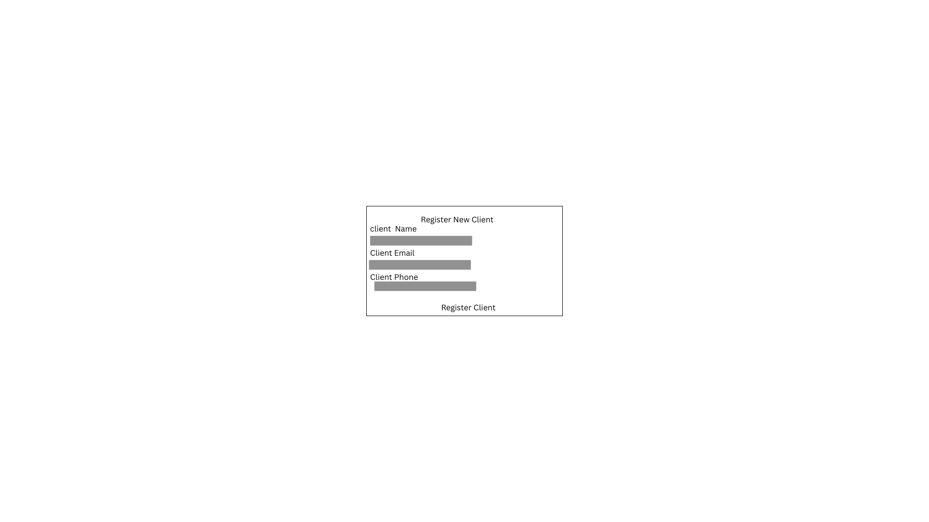

Figure 1:client Registration

# 2.Prototype for Viewing the Client Profile

This page retrieves the client's profile and their enrolled programs. It assumes that the client has been registered, and you pass the client_id via the URL to display their information.

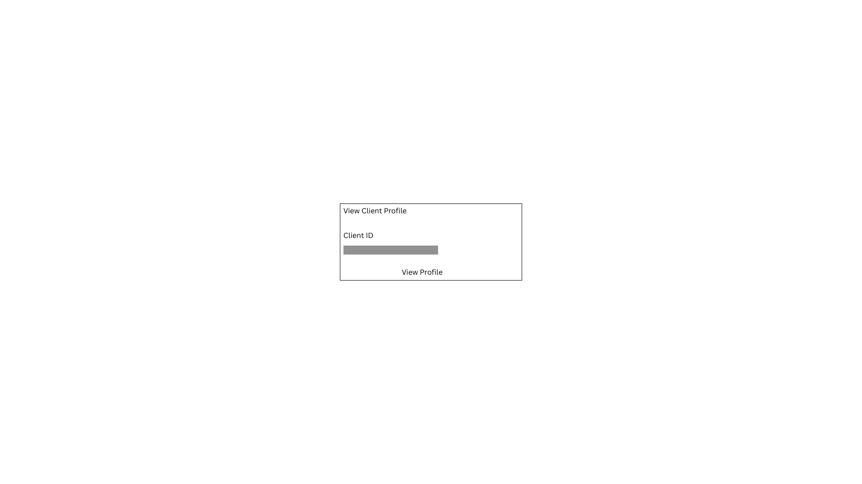

Figure 2:Client Profile

# 3. Client Enrolment Prototype

The Client Enrolment Prototype is a basic model demonstrating how new clients register into the system with an assigned Client ID and select the Program they are enrolling in (e.g., Malaria, TB, HIV).

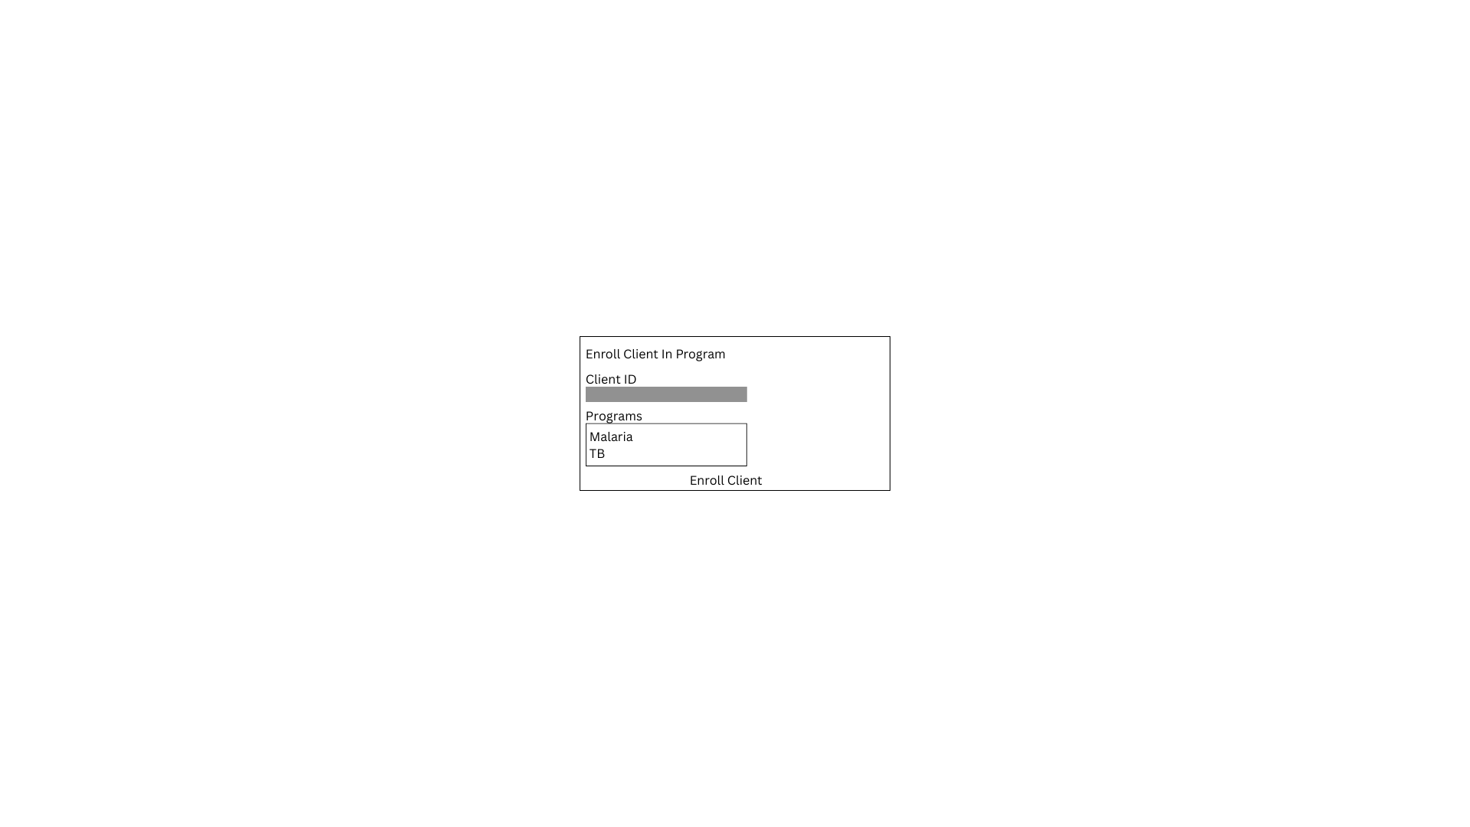

Figure 3:Client Enrollement

# 4. Client Search Prototype

The Client Search Prototype demonstrates how system users (like users or health workers) can search for a client using the client's name.

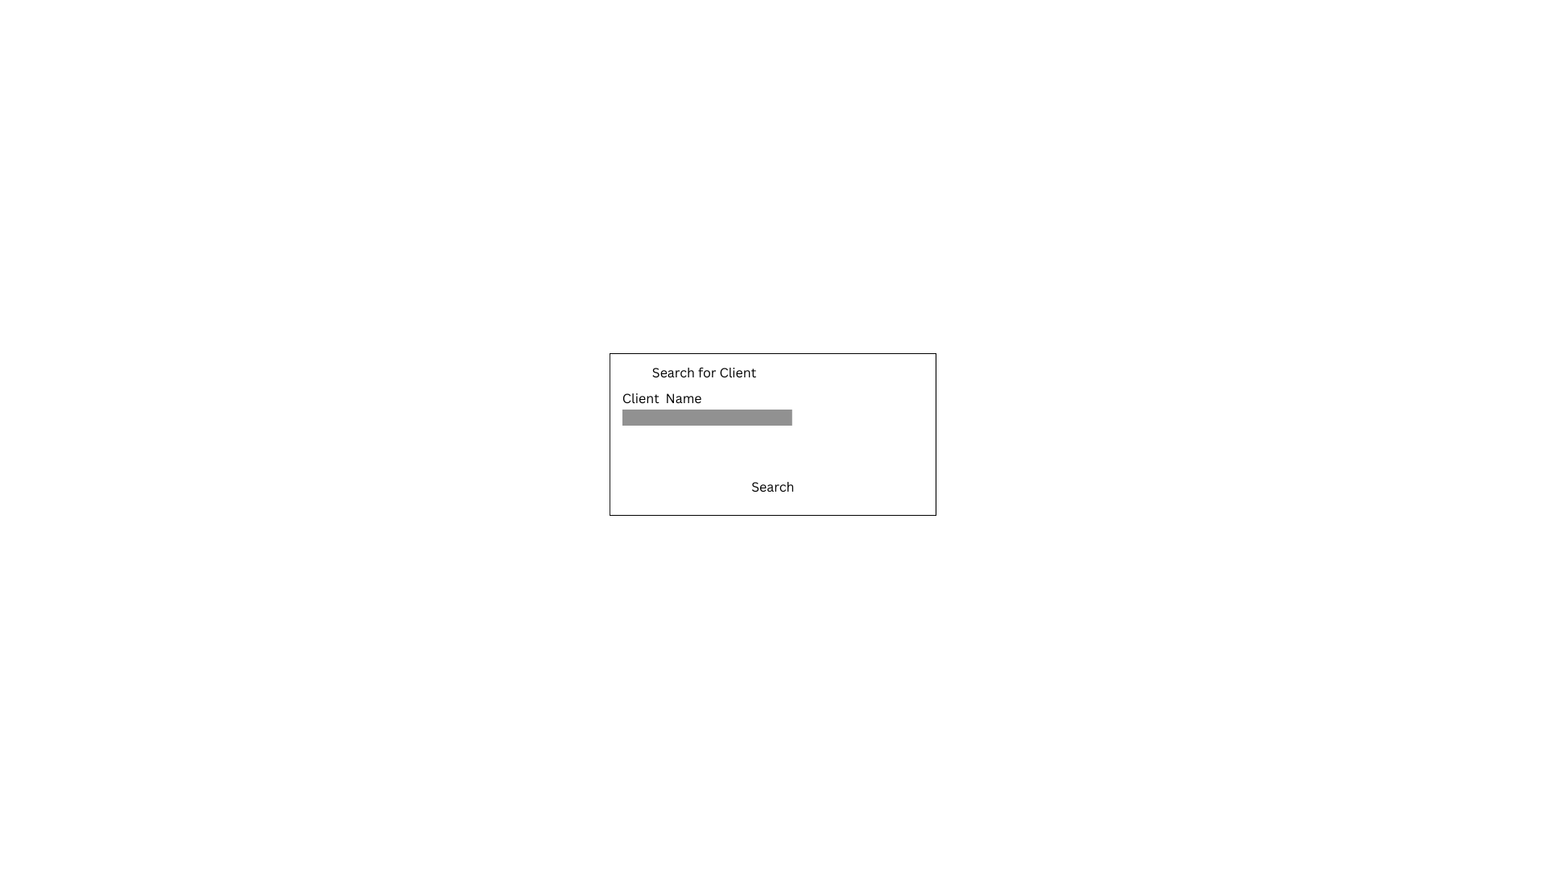

Figure 4:Client Search