IFRS Foundation Alert
eIFRS Professional—Access the 2015 IFRS A Briefing for CEOs, Audit Committees and Boards of Directors
eIFRS is the only source for the authoritative and annotated versions of Standards, as well as thousands of other supporting documents including examples and guidance. Highlights of the redesigned service include:  - Immediate access to all the latest IFRS publications including the  2015 IFRS A Briefing for Chief Executives, Audit Committees and Boards of Directors, the 2015 Financial Instruments Guide, and the entire publication directory;  - Any document from the vast eIFRS archive is now made accessible in seconds with new searching and sophisticated filtering options;  - The Standards Comparison Tool will show the differences between the Standards as effective for this year, last year and next year  - A simplified and streamlined user interface; and  - Our terminology look-up tool has been updated with the latest terms from our official translations of IFRS in: Albanian, Arabic, Traditional Chinese, English, French, Hebrew, Japanese, Kazakh, Brazilian Portuguese, Romanian, Serbian, Spanish, Turkish and Uzbek.
  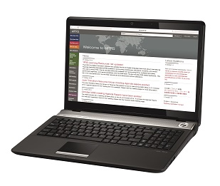
  Questions or comments?
  For publications and subscriptions, contact: publications@ifrs.org
  Website: www.ifrs.org
  Email alerts
  To manage your alerts click here.
These new features combine to make your financial reporting quicker and more efficient. A video showing all the new features of the re-launched service is available to view here.
eIFRS Professional is priced at £295 per user and discounts are available for: multiple copies, academics/students and residents of middle and low-income countries. For further details on the content ofeIFRS Professional, please visit the webshop where you may also place your order. If you have any feedback regarding our subscription services please email publications@ifrs.org.

Products and services sold by the IFRS Foundation are provided subject to our terms and conditions.
Information you provide, may be used to keep you informed about the Foundation’s products.
To unsubscribe from this list click here.

