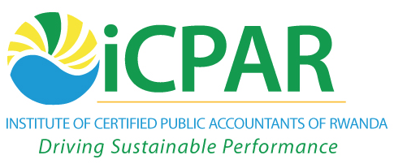

**CERTIFIED ACCOUNTING TECHNICIAN**

**LEVEL 1 EXAMINATION**

**L1.3: BUSINESS MANAGEMENT, ETHICS AND ENTREPRENEURSHIP**

**THURSDAY, 6 DECEMBER 2012**

**INSTRUCTIONS:**

1. **Time Allowed: 3 hours 15 minutes** (15 minutes reading and 3 hours writing).
2. This examination has **seven** questions and only **five** questions are to be attempted.
3. Marks allocated to each question are shown at the end of the question.

© iCPAR

***Attempt any five questions.***

**QUESTION ONE**

(a) Explain the assumptions of theory X and theory Y as proposed by Douglas McGregor.

**(12 marks)**

(b) A business manager is in the process of improving the control process in his organisation.

Discuss the **four** steps involved in the control process.

**(8 marks)**

**(Total 20 marks)**

**QUESTION TWO**

1. List the roles of human resource management within an organization.

**(5 marks)**

1. Explain **five** challenges faced by human resource managers.

**(10 marks)**

1. Suggest solutions of overcoming the above challenges.

**(5marks)**

**(Total 20 marks)**

**QUESTION THREE**

(a) Define the term “conflict of interest”.

**(3 marks)**

(b) Explain **three** basic conflicts of interest that a director of a company is exposed to while rendering services to a company.

**(9 marks)**

(c) Describe **four** sources of business ideas.

**(8 marks)**

**(Total 20 marks)**

**QUESTION FOUR**

Write explanatory notes on the marketing concepts listed below:

|  |  |  |
| --- | --- | --- |
|  | The production concept. | **(4 marks)** |
|  | The product concept. | **(4 marks)** |
|  | The selling concept. | **(4 marks)** |
|  | The marketing concept. | **(4 marks)** |
|  | The societal marketing concept. | **(4 marks)** |

**(Total 20 marks)**

**QUESTION FIVE**

(a) Clearly explain the following terms used in business management.

|  |  |  |
| --- | --- | --- |
| (i) | The mission. | **(3 marks**) |
| (ii) | Values. | **(3 marks)** |
| (iii) | Objectives. | **(3 marks)** |
| (iv) | Vision | **(3 marks)** |

(b) Discuss **four** limitations of franchising.

**(8 marks)**

**(Total: 20 marks)**

**QUESTION SIX**

|  |  |  |
| --- | --- | --- |
| (a) | State and describe the **three** levels of management | **(6 marks)** |
| (b) | Analyse the **three** categories of Management skills | **(6 marks)** |
| (c) | Explain **three** characteristics of effective leaders, | **(6 marks)** |

**(Total 20 marks)**

**QUESTION SEVEN**

(a) Explain, with examples, **five** barriers of communication.

**(10 marks)**

(b) Suggest the ways to overcome the barriers in (a) above.

**(10 marks)**

**(Total 20 marks)**

**End of question paper**