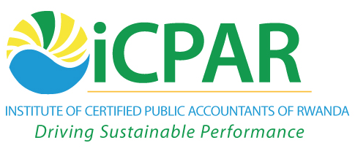

**CERTIFIED PUBLIC ACCOUNTANT**

**FOUNTATION 1 EXAMINATION**

**F1.4: BUSINESS MANAGEMENT, ETHICS AND ENTREPRENEURSHIP**

**THURSDAY, 6 DECEMBER 2012**

**INSTRUCTIONS:**

1. **Time Allowed: 3 hours 15 minutes** (15 minutes reading and 3 hours writing).
2. This examination has **seven** questions and only **five** questions are to be attempted.
3. Marks allocated to each question are shown at the end of the question.

© iCPAR

***Attempt any five questions***

**QUESTION ONE**

1. List **five** factors that can act as a barrier to organizational change

**(5 marks)**

1. What can be done to address the **five** barriers you have listed in (a) above

**(15 marks)**

**(Total 20 marks)**

**QUESTION TWO**

Michael Porter’s framework states that competition in an industry is a composite of **five** competitive forces.

**Required**

Using examples describe each of the **five** forces?  **(Total: 20 marks)**

**QUESTION THREE**

Good governance is essential for business success. Discuss.

**(Total: 20 marks)**

**QUESTION FOUR**

1. Explain three different conditions under which managers make problem solving decisions.

**(6 marks)**

1. Discuss the three specific needs proposed under David McClelland’s acquired needs

theory.

**(6 marks**

1. Describe four elements of an effective reward system that is required in an organisation

to motivate behavior.

**(8 marks)**

**(Total: 20 marks)**

**QUESTION FIVE**

1. Define the term management by Objectives (MBO)

**(4marks)**

1. Management by Objectives involves a continuous cycle of interrelated activities. State and describe the various logical activities involved in MBO

**(16 marks)**

**(Total 20 marks)**

**QUESTION SIX**

The primary purpose of Communication in an organization is to achieve co-ordinated action, information and decision making.

**Required:**

Name and define the various elements in the Communication Process **(20 marks)**

**QUESTION SEVEN**

A professional accountant acting in public interest shall observe and comply with *IFAC code of ethics for professional accountant.* The code of ethicshasestablished five fundamental principles requirements of professional accountants.

**Required**:

1. List any three of the five principles of the *IFAC code of ethics for professional accountant*.

**(3 marks)**

1. Explain using examples the three principles listed in (a) **(17 marks)**

**(Total 20 marks)**

**End of question paper**