071526_Abraham_SQL_WindowFunctions

Use Case | Window Function | Example
Ranking | RANK(), DENSE_RANK(), ROW_NUMBER() | Top-selling products
Running Totals | SUM() OVER() | Cumulative monthly sales
Lead & Lag | LAG(), LEAD() | Compare current month's sales with last month
Percentiles & Bucketing | NTILE(), PERCENT_RANK(), CUME_DIST() | Divide customers into spending tiers

Function | Purpose | Example
ROW_NUMBER() | Unique numbering | Top 1 per department
RANK() | Ranking with gaps | Competition ranking
DENSE_RANK() | Ranking without gaps | Leaderboards
SUM() OVER() | Running or total sum | Revenue
AVG() OVER() | Average | Department average
COUNT() OVER() | Count rows | Employees per department
MIN()/MAX() | Minimum/Maximum | Lowest/highest salary
LAG() | Previous row | Month-over-month comparison
LEAD() | Next row | Forecasting and comparisons
FIRST_VALUE() | First value in frame | Highest salary (with descending order)
LAST_VALUE() | Last value in frame | Last value in a partition (with explicit frame)
NTH_VALUE() | Nth value in frame | Third-highest score
PERCENT_RANK() | Relative rank (0–1) | Student ranking
CUME_DIST() | Cumulative distribution | Score analysis
NTILE(n) | Divide into buckets | Customer segmentation

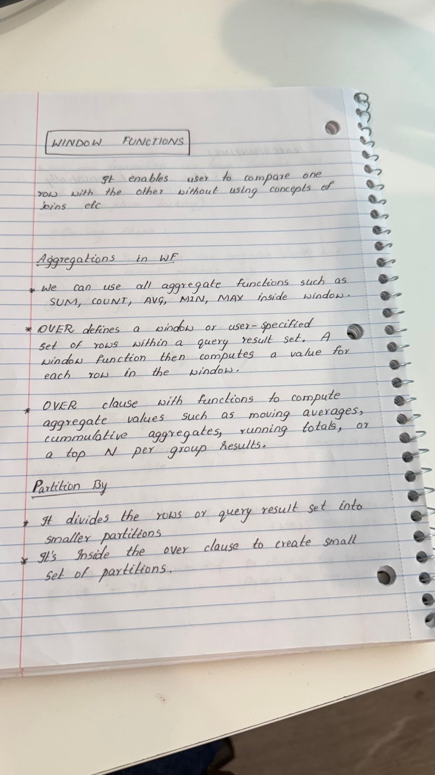

Absolutely. We can do it chapter by chapter, and each chapter will be copy-paste ready for your notes. This will be much better than trying to fit everything into one response.

SQL Window Functions — Complete Notes (Brief Version)

1. What are Window Functions?
A Window Function performs calculations across a set of rows (called a window) that are related to the current row without reducing the number of rows returned.
Unlike GROUP BY, every row remains in the output.

Example Table
Employee | Department | Salary
Alice | HR | 5000
Bob | HR | 6000
Charlie | IT | 7000
David | IT | 8000
If we want to show each employee along with the average salary of their department, we use a window function.
SELECT
Employee,
Department,
Salary,
AVG(Salary) OVER(PARTITION BY Department) AS AvgSalary
FROM Employees;
Output
Employee | Department | Salary | AvgSalary
Alice | HR | 5000 | 5500
Bob | HR | 6000 | 5500
Charlie | IT | 7000 | 7500
David | IT | 8000 | 7500
Notice that all employee rows are preserved.

2. Why Use Window Functions?
Window functions are used for analytical calculations without collapsing rows.
Common uses:
- Ranking
- Running totals
- Moving averages
- Previous/next row comparison
- Top N per category
- Percentiles
- Customer segmentation
- Time-series analysis

3. GROUP BY vs Window Functions

GROUP BY
Reduces rows.
SELECT Department,
AVG(Salary)
FROM Employees
GROUP BY Department;
Output
Department | AvgSalary
HR | 5500
IT | 7500
Only two rows remain.

Window Function
SELECT Employee,
Salary,
AVG(Salary) OVER(PARTITION BY Department)
FROM Employees;
All rows remain.

Rule
Use GROUP BY for summaries.
Use Window Functions for analytics.

4. Window Function Syntax
Function_Name(Expression)
OVER(
PARTITION BY Column
ORDER BY Column
ROWS/RANGE ...
)
The OVER() clause defines the window.

5. OVER()
OVER() converts an aggregate function into a window function.
Without OVER
SELECT SUM(Salary)
FROM Employees;
Output
18000

With OVER
SELECT
Employee,
Salary,
SUM(Salary) OVER() AS TotalSalary
FROM Employees;
Output
Employee | Salary | TotalSalary
Alice | 5000 | 18000
Bob | 6000 | 18000
Charlie | 7000 | 18000

6. PARTITION BY
Splits rows into groups.
Think of it as GROUP BY without collapsing rows.
Example
AVG(Salary)
OVER(
PARTITION BY Department
)
Each department gets its own calculation.

7. ORDER BY inside OVER()
Determines the order of calculation.
Example
SUM(Salary)
OVER(
ORDER BY Salary
)
Often used for running totals.
Don't confuse it with the final ORDER BY, which only sorts the output.

8. Window Frames
A window frame defines exactly which rows are included in the calculation for the current row.

Running Total
ROWS BETWEEN UNBOUNDED PRECEDING
AND CURRENT ROW

Previous 2 Rows
ROWS BETWEEN 2 PRECEDING
AND CURRENT ROW

Entire Partition
ROWS BETWEEN UNBOUNDED PRECEDING
AND UNBOUNDED FOLLOWING
Frames are mainly used with aggregate window functions.

9. Ranking Functions

ROW_NUMBER()
Assigns a unique number.
ROW_NUMBER()
OVER(ORDER BY Salary DESC)
Salary | Row_Number
9000 | 1
8000 | 2
8000 | 3
7000 | 4
Duplicates get different numbers.

RANK()
RANK()
OVER(ORDER BY Salary DESC)
Salary | Rank
9000 | 1
8000 | 2
8000 | 2
7000 | 4
Ranks are skipped after ties.

DENSE_RANK()
DENSE_RANK()
OVER(ORDER BY Salary DESC)
Salary | DenseRank
9000 | 1
8000 | 2
8000 | 2
7000 | 3
No gaps.

10. Aggregate Window Functions
All aggregate functions can be used as window functions.
Examples
SUM()

AVG()

COUNT()

MIN()

MAX()
Example
AVG(Salary)
OVER(PARTITION BY Department)

11. Value Functions

FIRST_VALUE()
Returns first row in the window.
FIRST_VALUE(Salary)
OVER(ORDER BY Salary DESC)
Returns highest salary.

LAST_VALUE()
Returns last value in the frame.
LAST_VALUE(Salary)
OVER(
ORDER BY Salary
ROWS BETWEEN UNBOUNDED PRECEDING
AND UNBOUNDED FOLLOWING
)

NTH_VALUE()
Returns nth value.
NTH_VALUE(Salary,3)
OVER(ORDER BY Salary DESC)
Returns third highest salary.

12. Offset Functions

LAG()
Returns previous row.
LAG(Salary)
OVER(ORDER BY Month)
Month | Sales | Previous
Jan | 100 | NULL
Feb | 120 | 100
Mar | 150 | 120
Useful for month-over-month comparisons.

LEAD()
Returns next row.
LEAD(Salary)
OVER(ORDER BY Month)
Month | Sales | Next
Jan | 100 | 120
Feb | 120 | 150
Mar | 150 | NULL
Useful for future comparisons.

13. Distribution Functions

PERCENT_RANK()
Shows relative ranking from 0 to 1.
PERCENT_RANK()
OVER(ORDER BY Salary)
Formula
(Rank-1)

------------

(TotalRows-1)

CUME_DIST()
Shows percentage of rows less than or equal to the current row.
CUME_DIST()
OVER(ORDER BY Salary)
Formula
Rows <= Current Row

-------------------

Total Rows

14. Bucketing

NTILE()
Divides rows into equal groups.
Example
NTILE(4)
OVER(ORDER BY Salary)
Output
Salary | Quartile
3000 | 1
5000 | 1
7000 | 2
8000 | 2
9000 | 3
10000 | 3
11000 | 4
12000 | 4
Useful for customer segmentation.

15. Named Windows
Instead of repeating the same OVER() clause:
SELECT
Employee,
SUM(Salary) OVER w,
AVG(Salary) OVER w
FROM Employees
WINDOW w AS (
PARTITION BY Department
ORDER BY Salary
);
Makes queries cleaner and easier to maintain. (Supported in databases like PostgreSQL and MySQL 8.0; not available in SQL Server.)

16. Real-World Examples

Running Total
SUM(Sales)
OVER(
ORDER BY Month
)

Department Average
AVG(Salary)
OVER(PARTITION BY Department)

Highest Salary per Department
ROW_NUMBER()
OVER(
PARTITION BY Department
ORDER BY Salary DESC
)
Filter
WHERE rn=1

Month-over-Month Growth
Sales -
LAG(Sales)
OVER(
ORDER BY Month
)

Moving Average
AVG(Sales)
OVER(
ORDER BY Month
ROWS BETWEEN 2 PRECEDING
AND CURRENT ROW
)

17. Performance Tips
- Create indexes on columns used in PARTITION BY and ORDER BY when appropriate.
- Filter data before applying window functions.
- Avoid unnecessary partitions.
- Window functions often require sorting, which can be expensive on large datasets.

18. Common Mistakes
❌ Thinking PARTITION BY removes rows.
❌ Confusing ORDER BY inside OVER() with the final ORDER BY.
❌ Using ROW_NUMBER() when ties should have the same rank.
❌ Forgetting to specify a window frame when using LAST_VALUE().
❌ Using GROUP BY when you need row-level output.

19. Cheat Sheet
Function | Purpose | Example
ROW_NUMBER() | Unique numbering | Top employee
RANK() | Ranking with gaps | Competition
DENSE_RANK() | Ranking without gaps | Leaderboard
SUM() OVER() | Running/total sum | Revenue
AVG() OVER() | Average | Department average
COUNT() OVER() | Count rows | Employees per department
MIN()/MAX() | Min/Max value | Lowest/Highest salary
FIRST_VALUE() | First value | Highest salary
LAST_VALUE() | Last value | Last value in partition
NTH_VALUE() | Nth value | Third highest salary
LAG() | Previous row | Sales comparison
LEAD() | Next row | Future comparison
PERCENT_RANK() | Relative rank | Student ranking
CUME_DIST() | Cumulative distribution | Percent of values at or below current
NTILE(n) | Equal-sized buckets | Customer tiers

Easy Memory Trick
Think of every window function as answering three questions:
- Which rows belong together? → PARTITION BY
- In what order should they be processed? → ORDER BY
- Which rows should be included in the calculation? → ROWS or RANGE (window frame)
Then SQL applies a function such as SUM(), RANK(), LAG(), or NTILE() to that window and returns a result for every row.
One-line definition to remember for interviews:
A window function performs calculations across a set of related rows while preserving every row in the result set.

