Image Processing Using Fourier Transforms

Luke Dewees and Abraham Paroya  
[tul69453@temple.edu](mailto:tul69453@temple.edu), abraham.paroya@temple.edu

# Introduction

The purpose of this project is to explore image processing by using fast Fourier transforms to analyze the frequency contents of different images. In this project, high and low pass filters will be observed as to how they affect the quality of the images produced. To complete this project, a firm understanding of the output of Fourier transforms, and how high and low filters work is necessary to answer the questions asked. In addition to this an understanding of plotting the outputs of these mathematic concepts is beneficial in completing the actual analysis.

# Methods

For part one of this project, we produced the original images and Fourier transform graphs for the given image files numbered 1-5. We did a 2-dimensional Fourier transform of all the given images and then plotted the results. The five images and their respective Fourier transforms can be seen in the results sections labeled Figures 1-5.

For part two, we took the given data for the moon image and then displayed the original image. We then created a low-pass filter that would process the image and create a new version of the image that excluded all the frequencies after the designated cut-off frequency.

For part three, we took the given data for the moon image and then displayed the original image. We then created a high-pass filter that would process the image and create a new version of the image that excluded frequencies before the designated cut-off frequency.

# Results

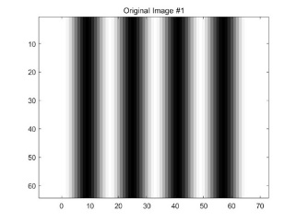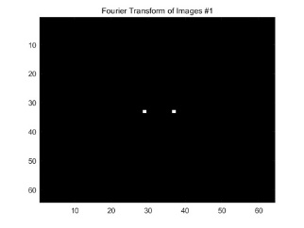

*Figure 1: Image 1 and Image 1 Fourier Transform*

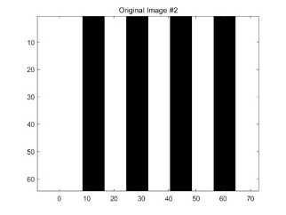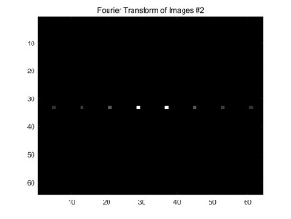

*Figure 2: Image 2 and Image 2 Fourier Transform*

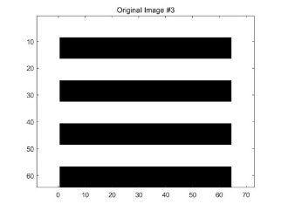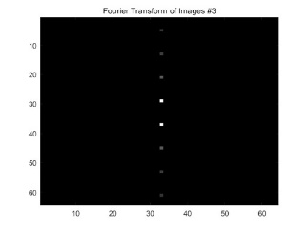

*Figure 3: Image 3 and Image 3 Fourier Transform*

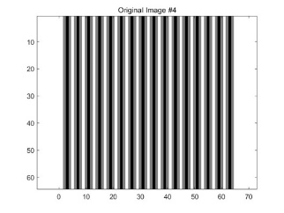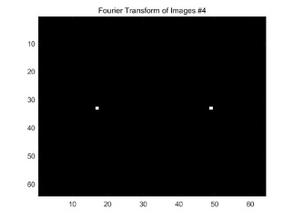

*Figure 4: Image 4 and Image 4 Fourier Transform*

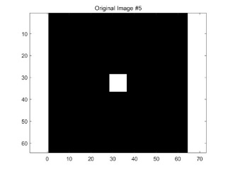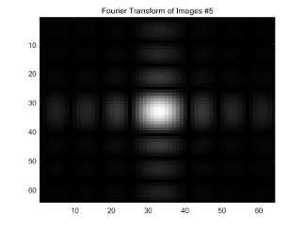

*Figure 5: Image 5 and Image 5 Fourier Transform*

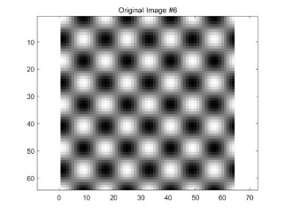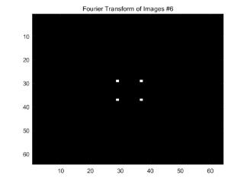

*Figure 6: Image 6 and Image 6 Fourier Transform*

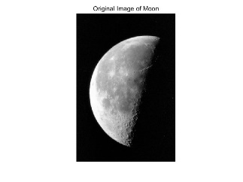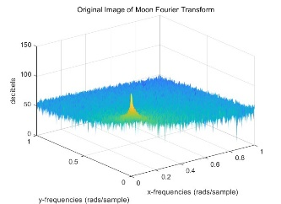

*Figure 7: Moon Image and Fourier Transform*

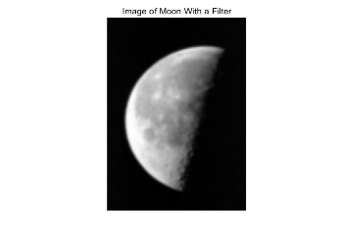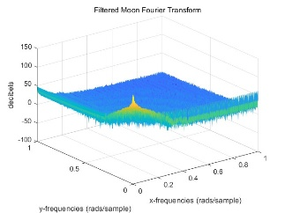

*Figure 8:Moon Image after Low-pass Filter*

*Figure 9: Moon Image after High-pass Filter*

# Discussion

The purpose of this project was to explore the concept of image processing by looking at the Fourier transforms of different images and applying filters to see how the signals that make up images affect the images output.

1. Image 1 is a gradient image, fading from bright to dark while Image 2 is comprised of 2 shades only, one bright, one dark. This is because Image 2 is comprised of more signals, which accentuates the bright/dark shades, creating a sharper change in shades. This can be seen in the Fourier transform, where Image 2’s transform shows multiple points, while Image 1 only has 2 points. Each point represents one half of a signal that is a component of the image. We can find the frequency of image 1 by looking at the Fourier transform and subtract it by the middle value of 33. This would be 64/(37-33) = 16 for the frequency in the x-axis explaining the four dark lines.

2. The 90-degree rotation can be seen very clearly in the Fourier transform plots, as the points are also rotated 90 degrees.

3. The points on the Fourier transform plot for Image 4 are much more spaced out compared to Image 1’s. This is because the frequency of Image 4 is 4 pixels per period while Image 1’s is 16 pixels per period.

4. There are pulses along the x axis and the y axis because there are multiple signals travelling along the x axis, and multiple signals travelling along the y axis making up the image. This results in multiple points on the Fourier transformation along each axis.

5. Image 2 is composed of signals with varying frequencies that only exist in the x-axis. Image 3 is composed of signals of varying frequencies existing in the y-axis. When these two groups of signals are multiplied with each other the two prominent frequencies are multiplied with each other to create

Part 2:

When a low pass filter is applied on Figure 6, the image becomes blurry. This is because only the low frequency cosine waves are retained, meaning that the oscillations are slower, and the peaks of the waves are further apart. This means there is more space where there is grey, rather than black and white, causing a blurring effect. This is evident in the Fourier transform seen in Figure 7. We can see that as the frequencies in the x and y direction increase their decibel values are lower. If we increase the value of the cut-off frequency, we will see a blurrier image as we will be cutting out more high frequency.

Part 3:

When a high pass filter is applied on Figure 6, only the sharp edges of the image are retained, such as the outline of the moon, and certain shapes on the moon from a drastic change in the shade of the image. This is because higher frequency signals produce the darker lines in the image. If we increase the cut-off frequency the image will be less sharp.