EWA408510 – E-Commerce and Web
Application

Final Project Report
Student: Abraham Saryon
Course: EWA408510 – E-Commerce and Web Application
Instructor: Eric Maniraguha
Academic Year: 2025–2026 Submission Date: July 2026

Introduction
AB WebStore is a full-stack e-commerce web application developed as the final project for the course EWA408510 – E-Commerce and Web Application. The platform enables customers in Rwanda and beyond to browse products across multiple categories, manage a shopping cart, place orders, and track their purchases online. The system also includes a fully featured admin dashboard for managing products, orders, customers, reviews, and site settings.
The application was built using modern web technologies including Next.js 14 for the frontend, Node.js with Express.js for the backend API, and MySQL as the relational database. It is fully deployed online, containerized with Docker, and integrated with a CI/CD pipeline using GitHub Actions.

Problem Statement
Many local businesses in Rwanda still rely on physical stores and manual processes to sell their products. This limits their reach to local foot traffic and makes it difficult to scale. Customers face challenges such as limited product visibility, no ability to compare prices, and no convenient way to place orders remotely.
There is a clear need for a modern, accessible, and reliable e-commerce platform that allows businesses to list their products online, accept orders digitally, and manage their operations efficiently — while giving customers a seamless and professional shopping experience from any device.

Project Objectives
The main objectives of this project are:
- Design and develop a complete, responsive e-commerce web application
- Implement full product management with categories, search, and filtering
- Build a functional shopping cart and checkout process with order confirmation
- Integrate a secure user authentication system with role-based access control
- Develop a comprehensive admin dashboard for store management
- Deploy the application online and ensure it remains accessible
- Implement a CI/CD pipeline using GitHub Actions for automated builds and testing
- Containerize the application using Docker and Docker Compose
- Follow best practices in security, code structure, and documentation

System Features

Customer-Facing Features
Homepage with dynamic hero banner carousel, category navigation, and featured products
Product listing with search by keyword and filter by category, with pagination Product detail page with multiple images, variants (size/color), ratings, and verified reviews
Shopping cart — add, remove, update quantity, auto-calculated totals Checkout — shipping information form, order summary, payment method selection (Cash on Delivery)
Order confirmation page with order details and status tracking
Order history — customers can view all past orders and their statuses
User authentication — register, login, JWT-based session management Customer dashboard — profile management, password change, order history, reviews
WhatsApp Buy Button — direct ordering via WhatsApp for selected products
Site notice banner — dismissible announcement bar at the top of every page

Admin Features
Dashboard overview — stats cards (products, orders, revenue, customers), revenue chart (last 30 days), orders by status breakdown
Product management — full CRUD, multi-image upload (drag & drop or URL), product variants, WhatsApp toggle, low stock indicator, search and pagination Order management — view all orders, filter by status, inline status update, perstatus count cards, pagination
Customer management — view profiles with order history, create/edit/delete, suspend/activate accounts, pagination
Review moderation — approve/reject/delete reviews, filter by status, verified purchase badge
Site settings — site name, logo, tagline, hero banners (with reorder), site notice, contact info, social media links
Account settings — admin profile edit, password change, admin team management

Technologies Used
Layer | Technology | Purpose
Frontend | Next.js 14 | React framework with SSR/SSG support
Styling | Tailwind CSS | Utility-first CSS framework
Backend | Node.js + Express.js | RESTful API server
Database | MySQL 8 | Relational database
Authentication | JWT + bcryptjs | Secure token-based auth + password hashing
Image Storage | Cloudinary | Cloud image upload and storage
HTTP Client | Axios | API requests from frontend
Notifications | react-hot-toast | User feedback toasts
Icons | lucide-react | UI icon library
Deployment (Frontend) | Vercel | Serverless Next.js hosting
Deployment (Backend) | Render | Node.js API hosting
Deployment (Database) | Railway | Managed MySQL hosting
Containerization | Docker + Docker  Compose | Multi-service containerization
CI/CD | GitHub Actions | Automated build, test, and Docker pipeline
Version Control | Git + GitHub | Source code management

System Architecture
The application follows a three-tier architecture:
CLIENT LAYER
Next.js 14 (React) — Vercel
Pages: Home, Products, Cart, Checkout, Orders,
Auth, Dashboard, Admin
HTTPS (Axios)

API LAYER
Node.js + Express.js — Render
Routes: /auth /products /orders /users
/reviews /settings /banners /upload
Middleware: JWT Auth, Admin Guard
mysql2

DATABASE LAYER
MySQL 8 — Railway
Tables: users, categories, products,
orders, order_items, product_images,
product_variants, reviews, banners,
settings
Request Flow:
- User interacts with the Next.js frontend
- Frontend sends HTTP requests to the Express API via Axios
- API validates JWT tokens via middleware
- Controllers query the MySQL database via mysql2 connection pool
- Response is returned as JSON and rendered in the UI Docker Architecture (Local):
docker-compose.yml
db (mysql:8) port 3306
backend (node:20-alpine) port 5000
frontend (node:20-alpine) port 3000

Database Design
The database consists of 10 tables with proper relationships enforced via foreign keys.

Entity Relationship Summary
users
orders
order_items
products

reviews

product_images
product_variants
categories
banners (standalone)
settings (standalone — key/value store)

Table Descriptions
Table | Key Columns | Description
users | id, name, email, password, role, status | Customers and admins
categories | id, name, description | Product categories
products | id, name, price, stock, category_id, whatsapp_enabled | Product catalog
product_images | id, product_id, url, is_primary | Multiple images per product
product_variants | id, product_id, name, value, price_modifier, stock | Size/color variants
orders | id, user_id, total_amount, status, payment_method, shipping_address | Customer orders
order_items | id, order_id, product_id, quantity, price | Line items per order
reviews | id, product_id, user_id, rating, comment, status, verified_purchase | Product reviews
banners | id, title, image_url, active, sort_order | Homepage hero banners
settings | key, value | Site-wide configuration

Key Relationships
products.category_id categories.id (ON DELETE SET NULL) orders.user_id users.id (ON DELETE SET NULL) order_items.order_id orders.id (ON DELETE CASCADE) order_items.product_id products.id (ON DELETE CASCADE) reviews.product_id products.id (ON DELETE CASCADE) reviews.user_id users.id (ON DELETE CASCADE) product_images.product_id products.id (ON DELETE CASCADE) product_variants.product_id products.id (ON DELETE CASCADE)

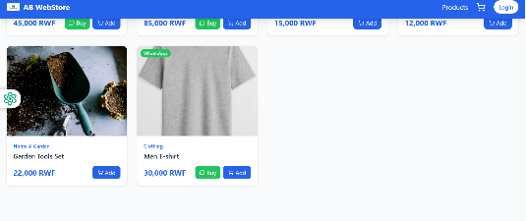
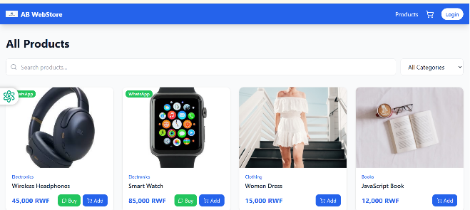
Screenshots of the Application
Home Page
Home Page
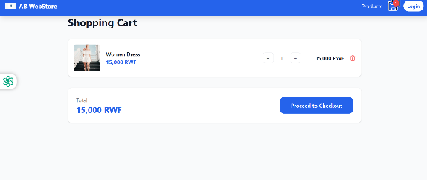
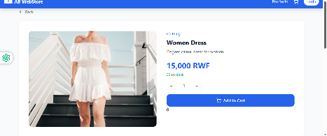
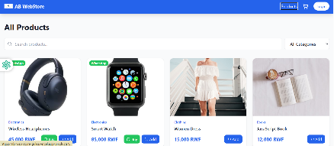
Product-details

Product-page

cart

- Checkout page with order summary
- Order confirmation page
- Admin dashboard with revenue chart
- Admin products management page
- Admin orders management page
- Admin review moderation page
- Customer dashboard

GitHub Repository Link
Repository: https://github.com/abrahamsaryon/ab_web_store The repository contains:
Full source code for frontend and backend
README.md with setup instructions and documentation docker-compose.yml and individual Dockerfile files .github/workflows/ci.yml CI/CD pipeline configuration backend/src/config/schema.sql database script .env.example files for both frontend and backend
Meaningful commit history documenting all development stages

Deployment Link
Service | URL
Frontend (Live) | https://ab-web-store-gules.vercel.app
Backend API (Live) | https://ab-webstore-backend.onrender.com
Local Frontend | http://localhost:3000 (Docker)
Local Backend API | http://localhost:5000 (Docker)
Deployment Platforms:
Vercel — hosts the Next.js frontend with automatic deployments on every push to main
Render — hosts the Node.js/Express backend API as a web service
Railway — hosts the MySQL database with persistent storage

CI/CD Implementation
The CI/CD pipeline is implemented using GitHub Actions and is defined in
.github/workflows/ci.yml . It triggers automatically on every push or pull request to the main branch.

Pipeline Stages
Trigger:

push

/

pull_request

main

Job 1:

Build

&

Test

Backend

Checkout

code

Setup

Node.js

20

npm

install

Start

server

(
smoke

test)

Job 2:

Build

Frontend

Checkout

code

Setup

Node.js

20

npm

install

npm

run

build

(
Next.js

production

build)

Job 3:

Docker

Build

runs
(

after

Jobs

1

&

2
)

docker

build

./backend

docker

build

./frontend

Key Features
Parallel execution — backend and frontend jobs run simultaneously
Dependency chain — Docker build only runs if both build jobs succeed ( needs:
[test-backend, test-frontend] )
npm caching — speeds up subsequent runs using cache: npm
Environment variables — NEXT_PUBLIC_API_URL injected from GitHub Secrets
Automatic Vercel deployment — Vercel auto-deploys on every successful push to main
(Add screenshot of green GitHub Actions workflow run here)

Docker Implementation
The application is fully containerized using Docker with a multi-service setup managed by Docker Compose.
Dockerfile — Backend (
backend/Dockerfile
)
FROM
node:
20
-
alpine
WORKDIR
/app
COPY
package*.json ./
RUN
npm install --production
COPY
. .
EXPOSE

5000
CMD
[
"node"
,
"src/index.js"
]
Dockerfile — Frontend (
frontend/Dockerfile
)
FROM
node:
20
-
alpine
WORKDIR
/app
COPY
package*.json ./
RUN
npm install
COPY
. .
RUN
npm run build
EXPOSE

3000
CMD
[
"npm"
,
"start"
]
Docker Compose (
docker-compose.yml
)
Three services are defined:
Service | Image | Port | Description
db | mysql:8 | 3306 | MySQL database with schema auto-init
backend | Custom (node:20-alpine) | 5000 | Express API server
frontend | Custom (node:20-alpine) | 3000 | Next.js production server
Key features:
db service mounts schema.sql to /docker-entrypoint-initdb.d/ for automatic
database initialization
backend depends on db , frontend depends on backend (startup order
enforced)
Named volume mysql_data persists database data across container restarts
All environment variables injected via environment block

Running Locally with Docker
git
clone
https://github.com/abrahamsaryon/ab_web_store.git
cd
ab_web_store
docker-compose up --build
Frontend:
http://localhost:300
0
Backend API:
http://localhost:500
0
(
Add screenshot of
docker-compose up --build
successful output here)

Challenges Encountered
Challenge | Solution
CORS errors between frontend and backend on different domains | Configured Express CORS middleware with FRONTEND_URL environment variable
JWT token expiry causing silent logouts | Added Axios interceptor to catch 401 responses and redirect to login
MySQL connection pooling on  Railway with connection limits | Used mysql2 connection pool with proper release() in all queries
Next.js hydration errors from server/client mismatch | Added "use client" directives and export const dynamic = "force-dynamic" where
 | needed
Docker virtualization not enabled on development machine | Enabled Hyper-V and WSL2 via PowerShell, updated BIOS settings
SSH push failures to GitHub | Generated new ed25519 SSH key, added to GitHub, configured ~/.ssh/config
Admin dashboard crash when new stats API not yet deployed | Added graceful fallback with try/catch to derive stats from orders list
Image uploads requiring cloud storage | Integrated Cloudinary for persistent image storage across deployments

Future Enhancements
- Mobile Money Payment Integration — MTN Mobile Money and Airtel Money payment gateway for Rwanda
- Real-Time Notifications — WebSocket-based order status updates pushed to customers
- AI Product Recommendations — Suggest products based on browsing and purchase history
- Progressive Web App (PWA) — Offline support and installable app experience
- Multi-Vendor Marketplace — Allow multiple sellers to list products on the platform
- Advanced Analytics — Sales trends, top products, customer retention metrics with date range filtering
- Email Notifications — Automated order confirmation and status update emails
- Inventory Alerts — Automatic low-stock notifications to admin
- Product Reviews with Images — Allow customers to upload photos with their reviews
- CSV/PDF Export — Export orders and customer data for reporting

Conclusion
AB WebStore successfully demonstrates a complete, production-ready e-commerce web application that meets all the requirements of the EWA408510 final project. The platform covers the full e-commerce lifecycle — from product browsing and cart management to order placement, tracking, and admin management.
The project was built using industry-standard technologies (Next.js, Node.js, MySQL), deployed on professional cloud platforms (Vercel, Render, Railway), containerized with Docker for portability, and integrated with a GitHub Actions CI/CD pipeline for automated builds and deployments.
Beyond the core requirements, the application includes several innovative features such as a WhatsApp ordering system, an analytics dashboard with revenue charts, product variants and multi-image support, admin review moderation with verified purchase enforcement, and dynamic site settings management.
This project has provided valuable hands-on experience in full-stack web development, DevOps practices, database design, cloud deployment, and software engineering principles — skills that are directly applicable to real-world software development careers.

Report prepared by Abraham Saryon | EWA408510 | Academic Year 2025–2026

