Major Mentors Study:

A Completion Report

Prepared for: Dr.Lindsay Head

Prepared by: Janeel Abrahams, Lucia Casas, Kiana Lettman, Nashaly Melendez

October 21st, 2020

ABSTRACT

“Giving students the second chance that they may need.”

At this time, the retention rates of Universities and colleges nationwide are approximately 78% and this number is steadily decreasing. Our interactions with students on campus greatly affects their decision to stay enrolled or to leave. The opportunities presented to them are also another contributing factor as to whether they deem it necessary to stay enrolled. Students are simply just that: students, individuals in search of a mentor. They don’t know what they want to do when they just enter the tertiary institution, many just randomly select a major. This report describes a pilot project to help students who are undecided on their major, uncomfortable in their current major or simply just want a second chance - that is to change their major. The report describes the process used to create the different stages of the project.

Table of Contents

Title Page……………………………………………………………………. 1

Abstract……………………………………………………………………….2

Executive summary……………………………………………………...4

Introduction………………………………………………………………...5

Research………………………………………………………………………6 - 7

Results………………………………………………………………………….8 - 9

Conclusions…………………………………………………………………..10

Recommendation………………………………………………………….11

References……………………………………………………………………12

Appendix……………………………………………………………………....13 - 14

EXECUTIVE SUMMARY

Florida International University is an institution that prides itself for its academic and athletic success. Located in the heart of south Florida, it is the home to a diverse student body and in attempts to accommodate this diverse population there has been an extensive selection of courses- be it majors, minors or simply electives and certifications- for the students to choose from. With more than 190 degree programs being offered and multiple campuses being located across Miami and online FIU’ student life is vibrant.

Unfortunately, regardless of our broad variety it seems like some students are still unable to select a suitable major. As a result they are leaving the institution and are going into the workforce inadequately prepared. Instead of motivating our students to freely select it seems our variety induces feelings of confusion and frustrations which in turn results in more built up pressure for students to select a suitable major. We are proud of our focus on student needs and long-term growth and goals as well as our focus on our student’s satisfaction in our institution, on all campuses. We feel that the institution’s commitment to student life and the student population as a whole is what differentiates us from other institutions. Yet, we are currently unable to keep the student body thriving and the students satisfied.

We researched options to actively engage the students so that we may gain a better understanding of their concerns and why so many students are having difficulties deciding and sticking to a major. We concluded that by offering the students more hand-on opportunities and real in person experiences in multiple fields then they would be able to decide on a major. By distributing questionnaires and doing focus groups we identified several reasons why students are having a hard time selecting a major and we also identified possible courses of action to get them engaged and interested in trying to overcome this difficulty.

After analyzing the data collected, we recommended creating an app containing all the information the students would require, this would include links, career information,and networking opportunities. As a temporary solution we host a weekly Zoom meeting so that the students could have an interactive platform on which to voice their concerns and be surrounded by others sharing a similar dilemma, also every month we would hold informational events for students seeking help with their majors and to gain networking opportunities. When it is safe to hold events in-persons these activities will be transitioned to in-person events approximating a total budget of $5,000. Offering the aforementioned options would add yet another innovative aspect to our institution while addressing the concerns of our students.

Introduction

On October 12th 2020, we received approval of our proposal on whether the implementation of Major Mentors could help the student body, both seasoned individuals and incoming students, deciding on their major and helping them navigate their future. This report presents the findings of our research of the student body at FIU. We researched the student body’s dissatisfaction and confusion with deciding their major and considered what we could do to help guide them towards the right decision. We researched different options and concluded that polling the student body would best help narrow down their needs. We polled freshmen, sophomores, juniors and seniors to get a better estimate on their point of view.

The problem we studied is that, based on our survey, the majority of students feel unsure about their major and don’t know whether or not they like something else. Moreover, many students made comments about being unsure of their major but they wouldn’t change it. Another problem we found was that many students feel limited in their options and will feel overwhelmed by the amounts of information Major Mentors could unload on them. This might make them uninterested in our program and will turn away from us. Not only that, there are career fairs held at FIU. Those could potentially lower our ratings.

Considering the problem, we discussed and researched ways our program could be more helpful and inviting to the student body. We decided to consult with a bunch of students via WhatsApp and got their feedback on events around campus. Not only that, we surveyed the student body again on what they’d feel more comfortable and open to.

We concluded, per their answers, that having our events catered more to the student’s year and interest would be more helpful. Not only that, we decided on making a website that is more hands-on for the students. On our website, we will have a quiz that the student can take to understand what their interests and goals are. With that in mind, we will have a live chat button if the student has any questions. We, also, concluded that having monthly zoom meetings with alums will help students feel more comfortable and understood.

In the following sections, we provide additional information and details about our research methods, the results we obtained, the conclusions we drew from those results, and our recommendation.

Research Method

To better understand the student body’s concerns and consider our options, we performed the following research:

1. We investigated the extent of the problem by determining if the current options in place for students are effective. This is what we found:

* Advising: research from Microsoft Surface found that 61% of students said they were concerned about finding work after university with a lack of career guidance being one of the main reasons for their fears. A further 31% believed that the guidance focused too much on securing a job soon after graduation, rather than a long term career.
* Advising: research from a website named Wisr stated that students sometimes feel like advisors give advice that is too general where the students come out with more questions than answers. Some advisors also have an issue with lack of time to pay attention to individual students and poor quality academic advising, and the perceived coddling of students.

2. In order to investigate how many students had an issue with majors at FIU specifically, we sent out a survey to the class comprised of 23 students.

* We used a survey to verify the number of students who decided on their major before entering college and considered changing their major or not while in college. - If students did consider changing majors, we asked how many times they have done it. - If students didn’t consider changing majors, we asked if they are currently happy with the major they chose and how they made the decision to pursue the major.
* We also used the same survey to verify the number of students who actually feel conflicted, frustrated, or uncomfortable about their current major. - We asked how many students feel pressure to study something they don’t want to and if they worry about finding a job within their major.

3. We identify recent research into why students change their majors.

* According to the National Center for Education Statistics, college students change their majors at least three times over the course of their college career. - Lost interest in the subject - Found the major difficult - Major isn’t in demand and harder to find jobs

4. We identify recent research into how students pick their majors.

* Benefit the career they want to pursue.
* Subjects they’re passionate about.
* Parents choose for them.
* Pick a major that they think will provide the most money, but they’re not very interested in.

Results

In this section, we present the results of our research. The following results correspond to the tasks described in the Research section. We cover the extent of our student body’s confusion and/frustration in trying to select a suitable major.

1. Investigating the Extent of the Problem

Each student has a choice of which area they would like to study, what they decide may heavily influence their future and possibly the outcome of their life. For most it is the biggest decision they make at that point in their life and is one that most have great difficulty doing as in Figure 1 below.

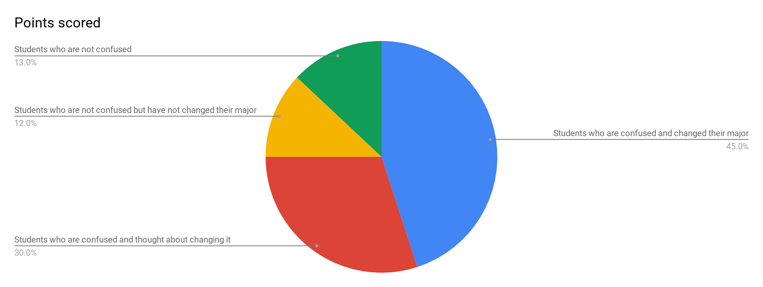

Figure 1. Student Survey

Of the 23 students who were surveyed 45% were students who were confused about their major and changed it and 30% were students who were confused and thought about changing it thus making it 75% of students who are confused.

2. Identifying the Best Options

Though there are advisors that are great in many ways, based on the research above, we saw that there are and can be issues when it comes to advising. Based on experience and the research and results above, we saw that there is also an issue about choosing majors and worrying about jobs. Because of this, we knew that we could come up with more instead of continuing to use the same systems already in place such as HandShake & advisors. Our plan was to determine how to make these issues less stressful and worrisome.

* According to USA Funds, although just 6% of respondents reported seeking advice about their major online, their survey found that the use of online tools was almost twice as likely among more recent college attendees. - Based on this information, we as mentors decided to come up with a program called Major Mentors. For students to obtain more information about majors and jobs they can get from them, we came up with an idea to create a website where one can take a survey based on their goals, interests, and hobbies. After completing the survey, they would get a result of a major that best matches their criteria. If they still have any questions about that choice of major, the website would also provide a chat feature where students can connect with us mentors or even others such as alumni, advisors, and the Career Center at FIU to gain more advice. As part of our survey that we conducted, we asked that if we were to host events on campus where one can explore careers and interests, if those students would attend. Based on that we found that __ number of students said__. If students prefer more of a face to face interaction, we would also provide them with in - person events in the future once it is safe to do so with the results of Covid - 19.

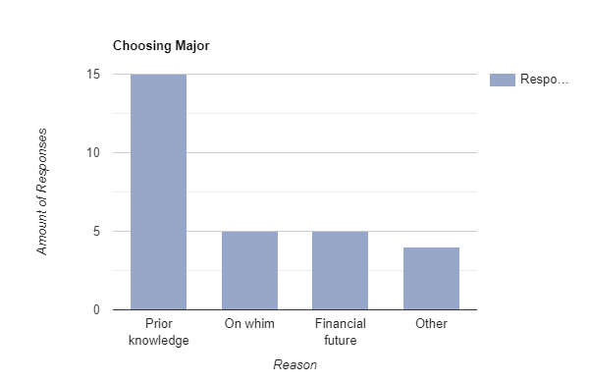

Figure 2: Student Survey

Out of the students who were surveyed, these results were based on the students who didn’t consider changing majors. We asked how they made the decision to pursue the major. 15 students said they chose based on prior knowledge, 5 said on a whim and financial future, and about 4 said other.

Conclusion

The current system that the institution has in place is not allowing the students to fall and make mistakes. There are no security measures for the what-ifs and unpredictable nature of life, with the Major Mentor’s plan the students will be given the confidence to move ahead all whilst having the security to make mistakes. The virtual events as a safety feature until in-person events are possible will help us to gauge the interested students beyond that of mere surveys and it will also allow the students to be vocal and begin the initial stages of interactions. It will also allow them to begin gaining confidence, knowledge, and networking skills.

With the growing globalization of technology, the creation of the website for easier access to all the information would ultimately be advantageous as more and more sectors in the institution would slowly be transferred online.

Although Handshake, the current application available helps to connect the students with jobs, our application would not only provide the students with jobs but networking opportunities and exclusive links to our online meetings and platforms. It would also give them the opportunity to get internships and interact with alumni as well as do virtual shadowing if desired.

Recommendations

We recommend implementing the Major Mentor’s Second Chances proposal plan even as a pilot project to see how the students are affected. This should be done in collaboration with the Stress Relievers proposal as both projects focus on the livelihood of the student and thus the student population. We think the Major Mentor’s Second Chances proposal would work well with the Stress Reliver’s proposal because second Chances surrounds the theme of stress while stress relieves tries to reduce that said stress.

Table # : Cost of Second Chances Pilot Program

|  |  |  |
| --- | --- | --- |
| Task | Hours | Cost |
| Website Designer | N/A | $1,000 |
| Catering | N/A | $2,000 |
| Event Organizers (5) | 15 each | $900 |
| Venue | 9 | $1,000 |
| Other Miscellaneous | N/A | $100 |
| Total: |  | $5,000 |

Pilot program will last for a semester.

Cost does not include applicable taxes and shipping costs.

We conclude that offering a collective pilot program between Major Mentors and Stress Reliever to the students could most likely address the challenges they face in selecting a suitable major.

References

Alexander, E. (2018, May 18). Why Do Students Change Their Majors, and Are They Right for Doing It? Retrieved October 19, 2020, from https://studybreaks.com/college/students-change-majors/

Engelmyer, L. (2020, June 26). College Retention Rates and Graduation Rates Explained. Retrieved October 19, 2020, from https://www.collegeraptor.com/find-colleges/articles/college-comparisons/2-key-statistics-for-comparing-colleges-graduation-rate-and-retention-rate-explained/

Fain, P. (2017, September 25). Where Students Get Advice in Picking a Major. Retrieved October 19, 2020, from https://www.insidehighered.com/quicktakes/2017/09/25/where-students-get-advice-picking-major

Marcus, J. (2018, December 7). Switching majors is adding time and tuition to the high cost of college. Retrieved October 19, 2020, from https://hechingerreport.org/switching-majors-is-adding-time-and-tuition-to-the-already-high-cost-of-college/

Ramos, Y. (2013, March 15). College students tend to change majors when they find the one they really love. Retrieved October 19, 2020, from https://borderzine.com/2013/03/college-students-tend-to-change-majors-when-they-find-the-one-they-really-love/

The Challenges of Student Academic Advisor Matching: Wisr: Student Engagement. (2018, June 9). Retrieved November 02, 2020, from https://getwisr.com/incoming-college-students/the-challenges-of-student-academic-advisor-matching

Appendix: Member Questionnaire

This is a copy of the Questionnaire we asked 23 students to complete. We received ## completed questionnaires.

Major Mentors Questionnaire - Choosing Majors

1. When entering college did you struggle to choose a major?

* Yes
* No

1. Was it difficult to choose your major?

* Yes
* No
* A little bit

1. How did you make the decision to pursue the major you choose?

* Prior knowledge about the major
* On a whim
* Financial future/outcome
* Other:__________________

1. Why did you choose the major you did?

Student Survey

1. Have you ever considered changing your major?

* Yes, very often
* Sometimes
* Once or Twice
* Never

1. How many times have you changed your major?

* 3-4
* 1-2
* Once
* Never

1. Did you decide on your major before entering college/university?

* Yes
* No
* Sort of

1. Are you happy with your current major?

* Very Much So
* I have few doubts but I’m sticking to it
* Not really

1. Do you feel pressured to study something you don’t want to?

* Yes
* No

1. Do you worry about finding a job within your major?

* Yes
* No
* Sort of

1. If Major Mentors hosted events on campus, in which you could explore other careers and interests, would you attend?

* Extremely likely
* Very likely
* Somewhat likely
* Not so likely
* Not at all likely