Visual Studio DEMO using Syncfusion CAB Enabling Kit

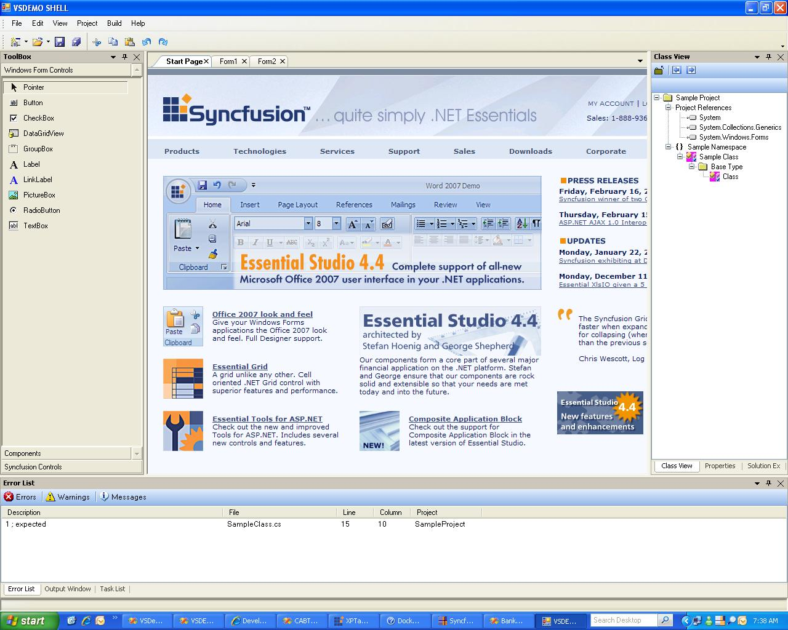

VSDemo sample illustrates the usage of Syncfusion CAB controls in developing high end CAB projects. It gives lots of flexibility in controlling the view of Syncfusion controls in CAB environment.

- Workspaces
    - DockableWorkspace
    - TabbedMDIManagerWorkspace
    - GroupBarWorkspace
    - SplashPanelWorkspace
- UIElements
    - XPMenus
    - StatusBar
    - TreeViewAdv

Shell Diagram for VSDemo_CAB

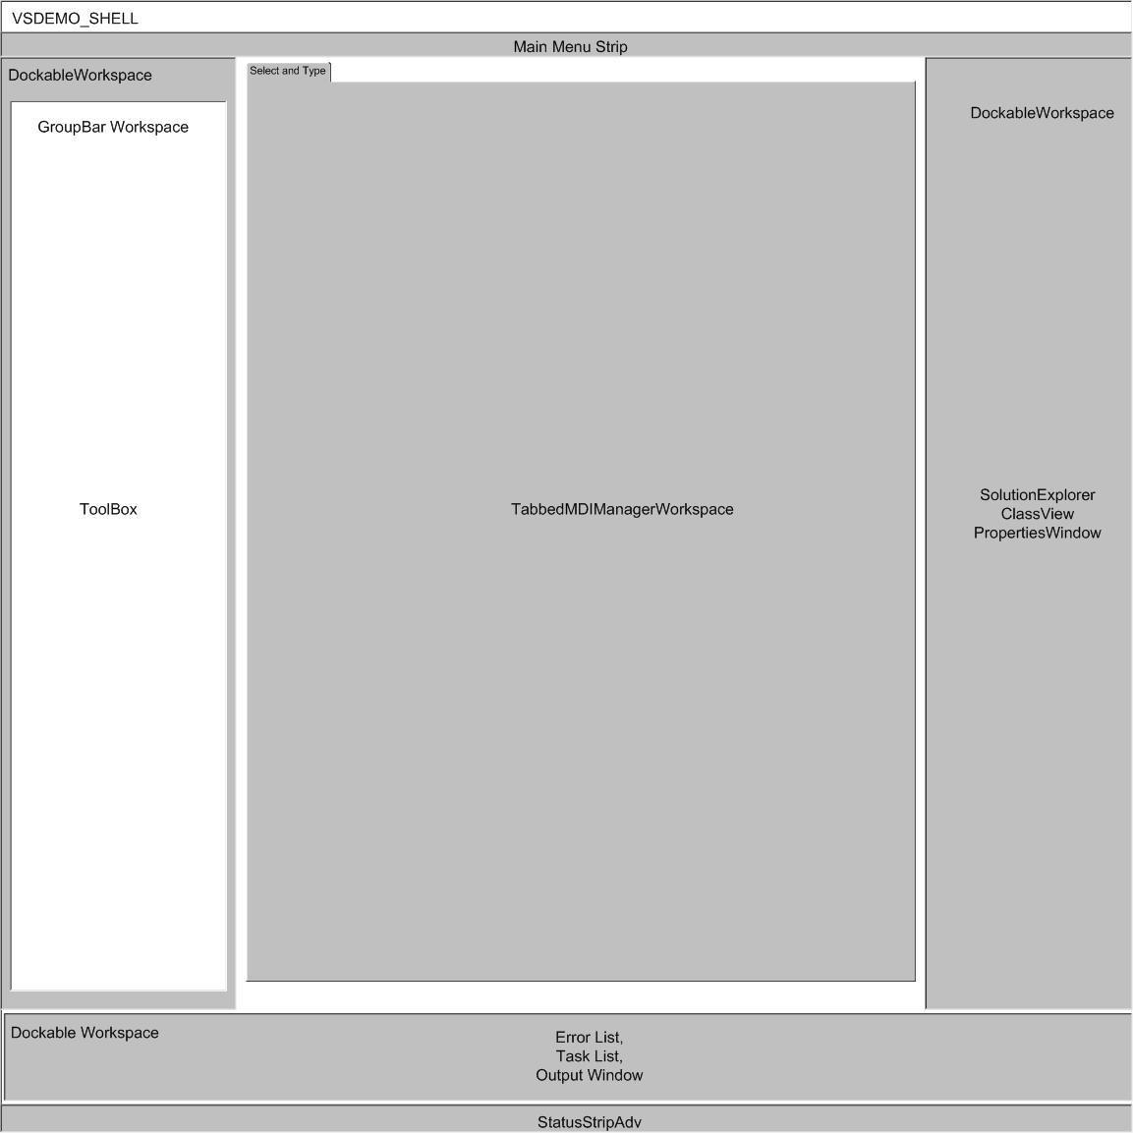

Implementing Dockable Workspace:

- Docking manager component is to be dragged onto the shell form
- Add the following code to initialize the docking manager act as a workspace
private DockableWorkSpace dockWorkspace;
this.dockWorkspace = new DockableWorkSpace(this.dockingManager1, this, true);
- Add the workspace to the workitem
this.rootWorkItem.Workspaces.Add(dockWorkspace, VSDemoCommon.WorkspaceNames.DockableWorkspace);

- Use the Show method of the Workitem and pass the string id used to identify the dockable workspace to show the control in the dockable workspace

DockingSmartPartInfo smartPartInfo;
smartPartInfo = new DockingSmartPartInfo();
smartPartInfo.Title = "Task List";
smartPartInfo.DockStyle = DockingSmartPartInfo.DockingStyle.Bottom;
smartPartInfo.Height = 200;
workspace.Show(taskList, smartPartInfo);

Implementing the TabbedMDIManager workspace:

- Initialize the TabbedMDIManager instance object as given below and associate it with the shell form, then add it to the RootWorkItem

private TabbedMDIManagerWorkspace tabbedMdiManagerWorkspace;
this.tabbedMdiManagerWorkspace = new TabbedMDIManagerWorkspace(this);
this.rootWorkItem.Workspaces.Add(tabbedMdiManagerWorkspace, VSDemoCommon.WorkspaceNames.TabbedMDIWorkspace);

- use the Show method of the workspace along with its smartpartinfo to display the control in the TabbedMDIManager
- In this sample, Click Project-> Add Windows Form to view the new form in Tabbed manner

Implementing GroupBar Workspace and SplashPanel Workspace:

- Drag and drop the groupbar workspace onto the form, and use the Show of method along with its smartpartinfo object to have a customized view of the control.
- Drag and drop the splashpanel workspace onto the form and use the Show method along with its smartpartinfo object to display it as you need.

GroupBarWorkspace Code

Syncfusion.CAB.WinForms.SmartPartInfos.GroupBarSmartPartInfo gpSmartPartInfo;
gpSmartPartInfo = new Syncfusion.CAB.WinForms.SmartPartInfos.GroupBarSmartPartInfo();
gpSmartPartInfo.BarDisplayText = "Windows Form Controls";

SplashPanelWorkspace Code

Syncfusion.CAB.WinForms.SmartPartInfos.SplashPanelSmartPartInfo info = new Syncfusion.CAB.WinForms.SmartPartInfos.SplashPanelSmartPartInfo();
info.BackgroundColor = new Syncfusion.Drawing.BrushInfo();
info.AnimationSpeed = 25;
info.DesktopAlignment = Syncfusion.Windows.Forms.Tools.SplashAlignment.Center;
info.TimerInterval = 1500;
info.SlideStyle = Syncfusion.Windows.Forms.Tools.SlideStyle.FadeIn;
rootWorkItem.Workspaces[VSDemoCommon.WorkspaceNames.SplashPanelWorkspace].Show(rootWorkItem.Items.AddNew<SplashMessageView>(), info);

