**Block Diagram**

**MC_02**

**Grace Matera, Greyson Jones, Adam Brandt, Devon Kooker**

**Student Link**

**Block Diagram**

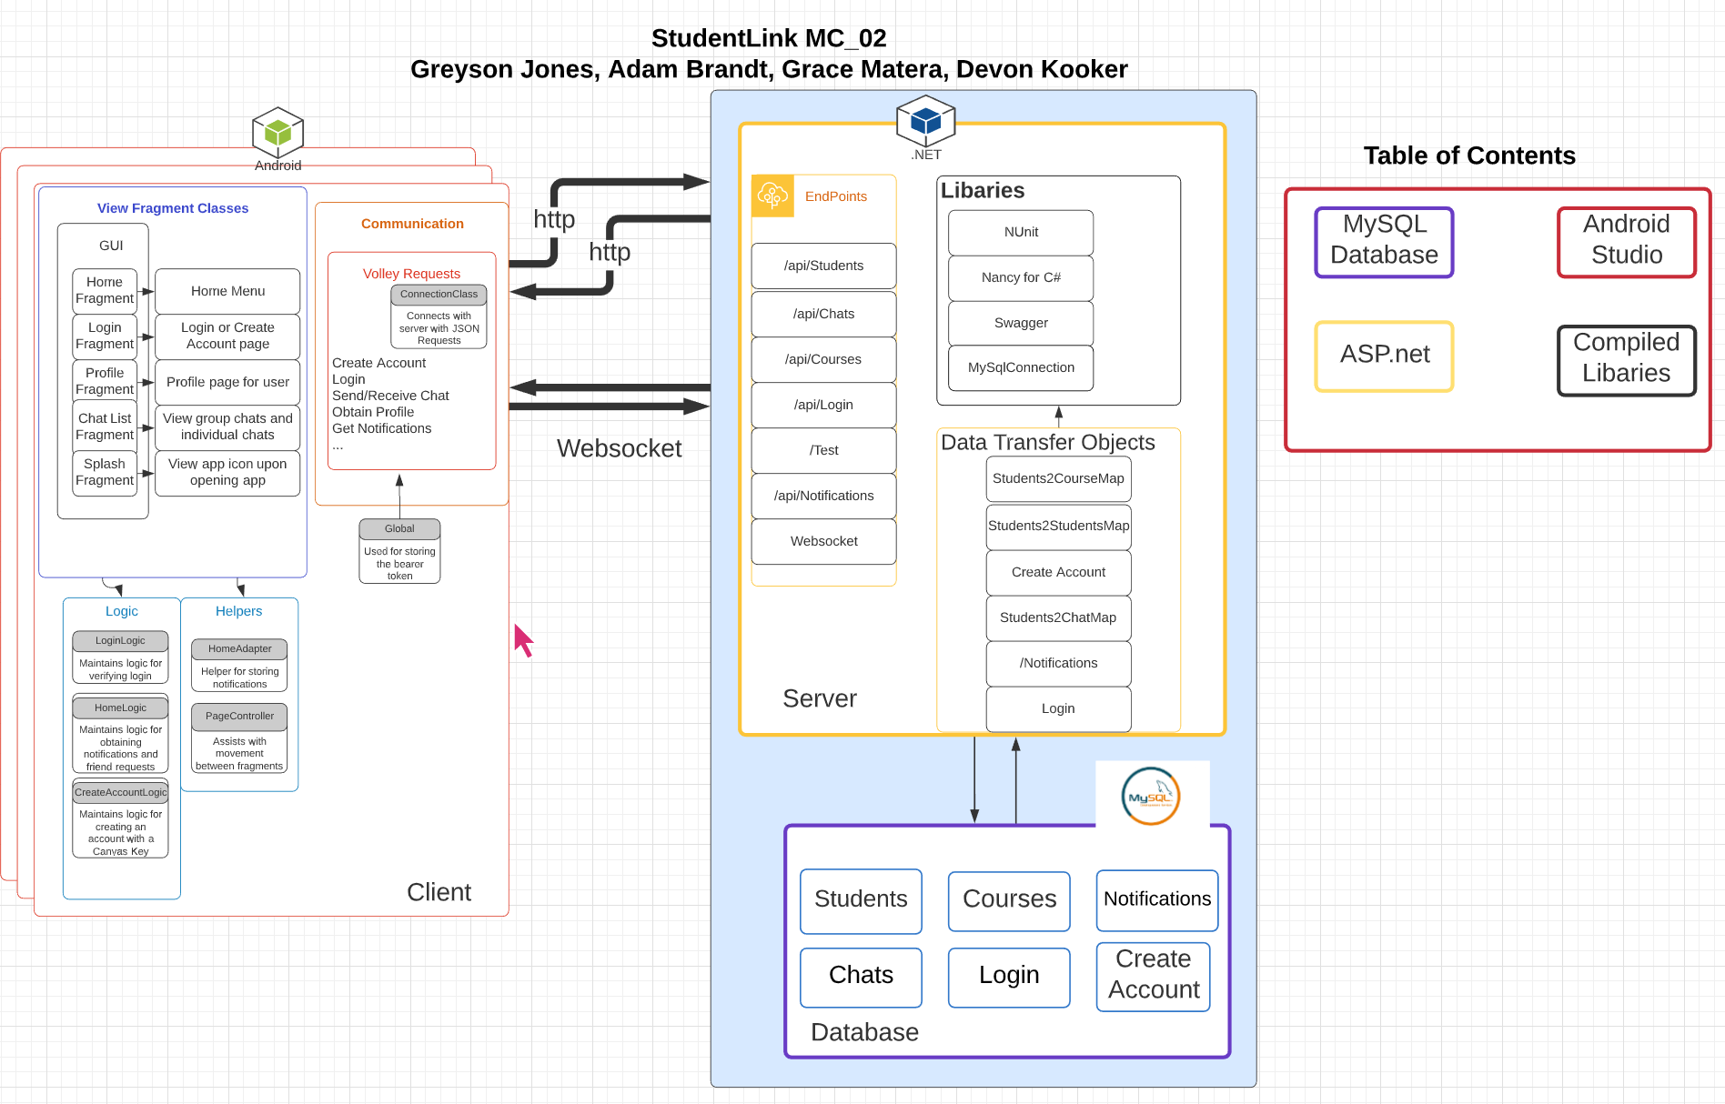

**Design Description**

***Android Frontend:***

The application consists of various pages to deliver the required functionality: Home, Chat lists, Login, Profile and Splash Page. These pages are made visible to the user with fragments. The functionality of the pages is connected through their respective logic classes. To traverse these pages, a PageController is used with a sidebar. The client connects to the server via the ConnectionClass with JSONObjectRequests through Volley, which is used for creating an account, logging in, getting notifications, etc. Connecting to the server properly requires a bearer token to access a certain user. This bearer token is stored in a static variable in the class named Global. Lastly, the Home page has a specific helper class named HomeAdapter to display the notifications to the user on the Home page with two different views depending on the type.

***Backend****:*

***ASP.net Framework:***

The asp.net framework will handle the hosting of the app and managing the MySQL database. The tables of the database contain the information for logging in, chats, courses, and notifications.

The server allows connections to the method in the through the endpoint open to the internet. The names of the endpoints are associated with the data objects that are in the database. Each endpoint handles the appropriate operation of the given object based on the https request type. The websocket handles the live interaction of the chats feature. The websocket sends data to the correct frontend connection, whenever there is a new chat based on the person who sent the chat. Also, if there is a new notification then the websocket will notify the correct user.

**Relationships Diagram**

