SCOPE OF WORK
Yamaha Eid Offer AR Experience
Web AR Microsite | 3D Showroom | AR Bike View | Price Reveal | Lead Generation
Project Name | Yamaha Eid Offer AR
Prepared For | Yamaha Bangladesh
Project Type | Web-based Augmented Reality Campaign Experience
Document Purpose | Scope definition for vendor briefing, production planning, and approval alignment

1. Project Overview
Yamaha Bangladesh will develop a Web-based Augmented Reality microsite for the Yamaha Eid Offer campaign. The experience will be accessed through a QR code placed on digital advertisements and campaign creatives.
After scanning the QR code, users will enter a Web AR environment where a 3D Yamaha virtual showroom appears. The showroom will follow a section-based layout inspired by the locked reference image, with each area representing a Yamaha motorcycle category such as FZ Series, R Series, MT Series, and other agreed product categories.
Users will be able to explore bikes, view selected models in AR within their own environment, check product details, reveal the regular MRP and Eid offer price, and submit purchase interest through a lead-generation form.
2. Project Objectives
- Create an engaging digital experience around Yamaha Eid Offers.
- Allow users to explore Yamaha motorcycles through an interactive 3D showroom.
- Enable users to view selected bikes in AR within their real environment.
- Communicate bike details, MRP, and Eid offer prices in a premium format.
- Generate qualified customer leads through a Book an Interest form.
- Support digital PR, social media engagement, dealer communication, and sales funnel contribution.
3. Project Platform
The project will be developed as a Web AR microsite. Users should not need to download any mobile application. The experience should open directly through a browser after scanning the QR code.
Required Compatibility
- Android smartphones
- iPhones
- Chrome browser
- Safari browser
- Mobile-first browsing experience
- QR-based access from digital and offline touchpoints
4. User Journey
Step | User Action | Experience Output
1 | User sees Yamaha Eid Offer digital advertisement | QR code is visible on the creative
2 | User scans QR code | User is redirected to the Web AR microsite
3 | Microsite loads | A 3D Yamaha virtual showroom appears
4 | User explores showroom | Bike categories are visible in different sections
5 | User selects a category | Bikes under that category are displayed
6 | User clicks on a bike | Bike pops up in AR in the user’s real environment
7 | User taps the bike | Bike details and interaction options appear
8 | User clicks Price Reveal | MRP and Eid offer price are shown
9 | User clicks Book an Interest | User is taken to a lead form
10 | User submits information | Yamaha team receives customer lead data

5. Detailed Scope of Work
5.1 Web AR Microsite Development
The vendor will develop a fully functional Web AR microsite for the Yamaha Eid Offer campaign. The microsite should be lightweight, responsive, visually premium, and easy to use for a general audience.
- QR code-based entry
- Mobile-first landing experience
- 3D virtual showroom environment
- Category-based bike navigation
- AR bike placement in user environment
- Bike detail interface
- Price reveal interaction
- Lead-generation form
- Thank-you/confirmation screen
- Analytics and lead tracking support
5.2 3D Virtual Yamaha Showroom
The vendor will create a 3D virtual showroom inspired by the attached reference layout. The showroom should look like a premium miniature Yamaha display environment with multiple dedicated sections for different bike categories.
- FZ Series
- R Series
- MT Series
- Scooter category, if required
- Additional Yamaha categories as agreed

Locked 3D Showroom Design Reference
The attached reference image is locked as the primary showroom structure direction. It should guide the miniature layout, section-based zoning, top-view exploration, and category-style navigation. Medical/lab elements from the reference must not be copied; they must be replaced with Yamaha motorcycle showroom sections, Yamaha blue accents, and premium automotive styling.
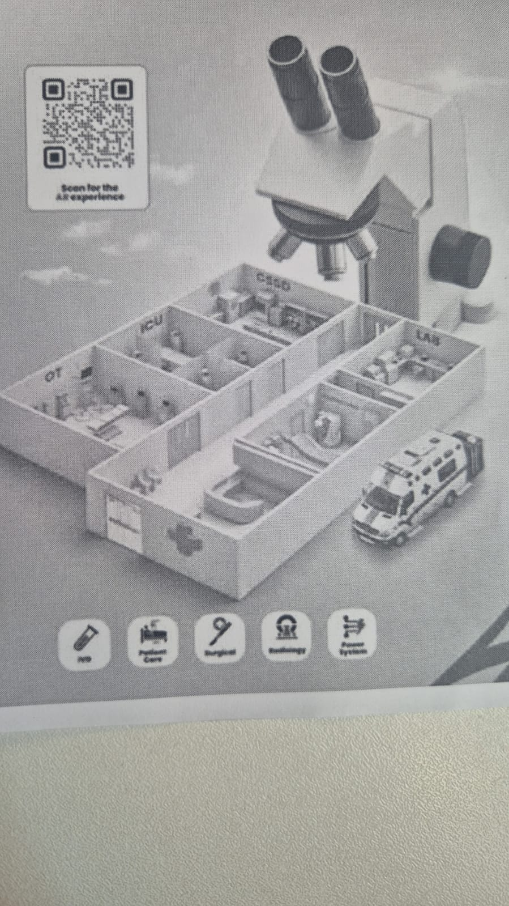

Reference-Based Design Requirements
- Miniature, section-based 3D environment style
- Category-wise room or zone division
- Premium Yamaha-inspired visual treatment
- Clear product placement zones
- Smooth mobile-first navigation
- Modern lighting and material treatment
- High-quality but optimized 3D assets
- No unrelated elements such as microscope, lab rooms, ambulance, or medical icons

5.3 Bike Category Navigation
The showroom will include different bike category sections. Each section should allow users to select and explore bikes from that category.
Category | Possible Bike Models
FZ Series | FZS FI, FZS V4, FZ-X, FZ 25
R Series | R15 V4, R15M
MT Series | MT-15
Scooter Series | RayZR, Fascino, if applicable

The final model list will be provided by Yamaha before production.
5.4 3D Bike Model Development / Optimization
The vendor will create, convert, or optimize 3D bike models for the agreed Yamaha motorcycles. Each bike model must be accurate and aligned with official Yamaha product references.
- Bike body shape, color, decals, Yamaha logo, model logo, and overall proportions must be accurate.
- Headlight design, fuel tank shape, wheel design, exhaust, seat, handlebar, and side panels must be preserved.
- No creative alteration should be made to the bikes without Yamaha’s written approval.
- Models must be optimized for smooth mobile performance without visible quality loss.
5.5 AR Bike Placement
Once a user selects a bike, the bike should appear in the user’s real environment through AR.
- Bike placement on floor/surface
- Realistic scale and proportion
- Rotation or angle adjustment
- Smooth viewing from different angles
- Tap-based interaction
- Clear CTA for bike details and price reveal
5.6 Bike Detail Interaction
After the user clicks on a bike, the system should show key bike information. Product copy and technical details will be provided or approved by Yamaha.
- Model name
- Engine capacity
- Key features
- Color options
- Regular MRP
- Eid offer price
- Campaign CTA
5.7 Price Reveal Feature
The AR experience must include a dedicated Price Reveal interaction. The reveal should feel exciting but clean, premium, and campaign-appropriate.
- User clicks on the bike.
- Bike detail panel appears.
- User clicks the Price Reveal button.
- Regular MRP is shown.
- New Eid offer price is revealed with a premium animation.
- Book an Interest button becomes visible.
5.8 Lead Generation Form
After clicking Book an Interest, the user will be redirected outside the AR view to a form where they can submit their information.
- Full name
- Mobile number
- District/city
- Preferred Yamaha model
- Preferred showroom/dealer, if required
- Purchase timeline, if required
- Consent checkbox for future communication
After submission, users should see a confirmation message: “Thank you for your interest. Yamaha team will contact you soon.”
5.9 Lead Data Management
The vendor must ensure that all submitted lead data is properly collected and accessible to Yamaha. All customer lead data will be owned by Yamaha. The vendor cannot reuse, sell, or share this data with any third party.
- Admin dashboard
- Google Sheet integration
- CSV export
- Email notification
- CRM integration, if agreed separately
5.10 QR Code Development
The vendor will generate a QR code that redirects users to the Web AR microsite. If required, multiple QR codes may be created for different campaign channels to track performance separately.
- Facebook creatives
- Instagram creatives
- TikTok content
- YouTube description or community posts
- Dealer posters
- Event materials
- Digital PR materials
- Website banners
5.11 UI/UX Design
The AR microsite and interaction screens should follow Yamaha’s premium brand identity. The user should be able to understand the experience without complex instruction.
- Mobile-first design
- Clean navigation
- Yamaha brand color usage
- Premium typography
- Clear CTA buttons
- Easy category selection
- Smooth product browsing
- Simple price reveal flow
- Simple lead submission flow
- Minimal clutter
- Fast loading experience
5.12 Analytics and Tracking
The vendor should include basic analytics tracking to measure campaign performance and identify which bikes/categories generate the highest interest.
- QR scan/landing page visits
- Unique users
- Showroom load completion
- Category clicks
- Bike model clicks
- AR bike view interactions
- Price reveal clicks
- Book Interest clicks
- Form submissions
- Drop-off points
6. Testing and Quality Assurance
The vendor will conduct full testing before final deployment. Yamaha will provide final approval after reviewing the complete user journey.
- QR code functionality
- Microsite loading
- Android device testing
- iPhone testing
- Chrome browser testing
- Safari browser testing
- AR placement testing
- Bike scale testing
- Category navigation testing
- Bike detail accuracy checking
- Price reveal testing
- Lead form testing
- Data export testing
- Performance and loading speed testing
7. Hosting and Deployment
The vendor will be responsible for deploying the final Web AR microsite. The hosting duration, domain/subdomain responsibility, server support, security requirements, and maintenance period must be finalized before project confirmation.
- Hosting setup
- Domain/subdomain setup, if required
- SSL/security setup
- Live deployment
- Server maintenance during campaign period
- Bug fixing during support period
- Final handover documentation
8. Key Deliverables
Deliverable | Description
Web AR microsite | Complete browser-based AR experience
3D virtual showroom | Category-based Yamaha showroom environment
Bike category sections | FZ Series, R Series, MT Series, and agreed categories
3D bike models | Optimized models of selected Yamaha bikes
AR bike experience | Bike pop-up in user’s real environment
Bike detail panel | Model details, features, and color/options
Price reveal feature | MRP and Eid offer price reveal interaction
Lead form | Customer interest submission form
QR code | Campaign QR code for digital and offline use
Analytics setup | User journey and lead tracking
Testing report | Device, browser, and functionality testing summary
Final deployment | Live campaign-ready microsite
Handover files | Documentation, access, and lead management process

9. Responsibilities
9.1 Yamaha Responsibilities
- Final list of bike models
- Official bike images and references
- Bike specifications
- MRP and Eid offer prices
- Yamaha logo and brand guidelines
- Campaign key visual, if available
- Content/copy approval
- Dealer/showroom information, if required
- Feedback and approval at each stage
- Access to analytics or CRM tools, if needed
9.2 Vendor Responsibilities
- Requirement analysis
- Technical planning
- UI/UX design
- 3D showroom creation
- 3D bike modeling/optimization
- Web AR development
- QR code generation
- Price reveal interaction
- Lead form development
- Analytics integration
- Testing and bug fixing
- Hosting and deployment
- Maintenance support during campaign period
- Final project handover
10. Approval Stages
Stage | Approval Requirement
Stage 1 | Project flow and wireframe approval
Stage 2 | UI/UX design approval
Stage 3 | 3D showroom design approval
Stage 4 | 3D bike model accuracy approval
Stage 5 | AR prototype approval
Stage 6 | Price reveal and form flow approval
Stage 7 | Final testing approval
Stage 8 | Live deployment approval

No final deployment should happen without Yamaha’s written approval.
11. Suggested Project Timeline
Phase | Task | Estimated Duration
Phase 1 | Requirement finalization and flow confirmation | 2–3 working days
Phase 2 | Wireframe and UI/UX design | 5–7 working days
Phase 3 | 3D showroom development | 7–10 working days
Phase 4 | 3D bike model preparation | 10–15 working days
Phase 5 | Web AR development | 15–20 working days
Phase 6 | Lead form and analytics integration | 3–5 working days
Phase 7 | Testing and revisions | 5–7 working days
Phase 8 | Final deployment | 2–3 working days

Estimated Duration
Total estimated timeline: 35–50 working days, depending on the number of bike models and complexity of 3D assets.
12. Out of Scope
The following items will not be included unless agreed separately:
- Mobile app development
- Paid media boosting
- Social media creative design
- Video production
- Voiceover production
- Advanced CRM integration
- Dealer-wise automated lead distribution
- Additional bike models beyond the agreed list
- Major design change after approval
- New campaign module after development starts
- Offline event booth setup
- Physical QR standee production
- Long-term hosting beyond agreed campaign duration
- Post-campaign maintenance beyond agreed support period
13. Quality and Performance Requirements
The final experience must meet the following standards:
- Fast loading on mobile devices
- Smooth AR placement
- Premium showroom look and feel
- Accurate Yamaha bike representation
- Clear product information
- Functional price reveal button
- Functional lead form
- Clean data capture
- No broken links
- No distorted bike models
- No incorrect Yamaha branding
- No low-quality rendering
- No unnecessary visual clutter
14. Final Project Summary
The Yamaha Eid Offer AR project will allow users to scan a QR code from campaign advertisements and enter a Web AR microsite featuring a 3D Yamaha showroom. Users can browse bike categories, select a Yamaha motorcycle, view the bike in AR within their real environment, explore product details, reveal the Eid offer price, and submit purchase interest through a lead form.
The final output should be a premium, interactive, mobile-first AR experience that supports both brand engagement and lead generation for Yamaha Bangladesh during the Eid Offer campaign.
Strategic Recommendation
Position this not as an AR gimmick, but as a digital-first Yamaha showroom experience that turns offer communication into measurable customer leads.

