*Heaven’s light is our guide*



RAJSHAHI UNIVERSITY OF ENGINEERING & TECHNOLOGY

Department of Mechatronics Engineering

Lab Report

**Course No :** MTE 1102

**Course Title :** Mechatronics System Sessional

**Experiment No :** 01

**Experiment Title :** Study of the basic equipment of Mechatronics System.

**Submitted To:**

Prangon Das

Lecturer

Department of Mechatronics Engineering

Rajshahi University of Engineering & Technology, Rajshahi.

### Subrata Kumar Sarker

Lecturer

Department of Mechatronics Engineering

Rajshahi University of Engineering & Technology, Rajshahi.

**Submitted By:**

*Group-5*

Mamun Or Rashid 2008025

Nazib Abrar 2008026

1. M. Al Meraz 2008027

Md. Akkhor Hasan 2008028

Md. Emdadul Haque Emon 2008029

Md. Maherul Islam Maruf 2008030

**Date Of Experiment :** 16 March, 2022

**Date Of Submission :** 28 March, 2022

**Experiment No.:** 01

**Name of the Experiment:** Study of basic equipment of Mechatronics.

**Introduction:**

**Objectives:**

1. To learn about the basic mechatronics systems.
2. To identify the input devices, output devices, and control systems.
3. To visualize the practical working areas and the applications of these basic mechatronics equipment.
4. To know the various pneumatic components used in a pneumatic system and to understand their workings.

**Input Devices:**

1. **Gas Sensor:**

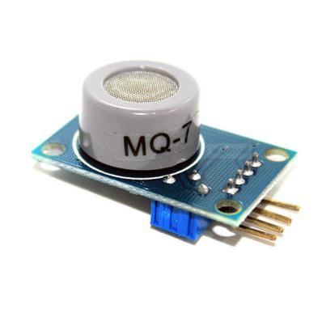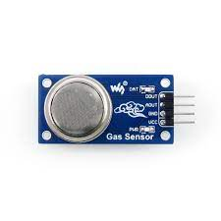

Figure 1: MQ-7 Gas Sensor and MQ-135 Gas Sensor.

Specifications**:**

|  |  |  |
| --- | --- | --- |
| **Parameter name** | **Technical Condition**  **(MQ-7)** | **Technical Condition**  **(MQ-135)** |
| Circuit voltage | 5V±0.1 | 5V±0.1 |
| Heating voltage (high) | 5V±0.1 | 5V±0.1 |
| Load resistance | Can adjust | Can adjust |
| Heating resistance | 33Ω±5% | 33Ω±5% |
| Heating consumption | About 350mW | less than 800mw |

Table 1: Specifications of MQ-7 and MQ-135 Gas Sensor

Applications:

1. Gas sensors are used in protection of individuals working in hazardous environments where the presence of dangerous gases can be found.
2. Gas sensors are used in monitoring indoor air quality.
3. Aerospace environments utilize gas sensors specifically to monitor for in-flight conditions and air quality maintenance to ensure crew productivity, as well as overall passenger comfort.
4. Gas sensors are also used in agricultural sector to ensure suitable environment in greenhouses for the growth of crops.
5. **Ultrasonic Sensor:**

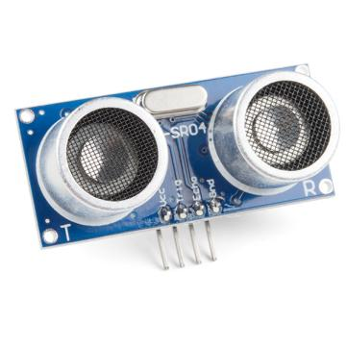

Figure 2: HC-SR04 Ultrasonic Distance Sensor.

Specifications:

|  |  |
| --- | --- |
| **Parameter name** | **Technical condition** |
| Working Voltage | DC 5 V |
| Working Current | 15mA |
| Working Frequency | 40Hz |
| Max Range | 4m |
| Min Range | 2cm |
| Measuring Angle | 15 degree |
| Trigger Input Signal | 10uS TTL pulse |
| Echo Output Signal | Input TTL lever signal and the range in proportion |
| Dimension | 45*20*15mm |

Table 2: Specifications of HC-SR04 Ultrasonic Sensor

Applications:

1. Ultrasonic sensors are used for measuring the liquid level in various industries for automated control.
2. Modern vehicles use ultrasonic sensors to measure the distance between the car and the surrounding elements of the road for understanding the environment and drive accordingly.
3. Ultrasonic sensors can be applied to the manufacturing process for automated process control on the factory floor while also being an indispensable tool for companies to maximize efficiency through precise measurement and control.
4. **Keypad:**

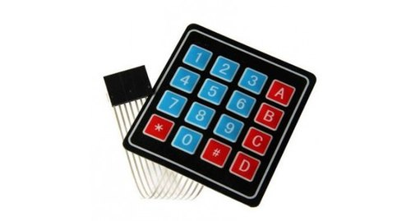

Figure 3: COM-16038 4x4 Matrix Membrane Keypad

Specifications**:**

|  |  |
| --- | --- |
| **Parameter Name** | **Technical Condition** |
| Maximum Rating | 24 VDC, 30 mA |
| Interface | 8-pin access to 4x4 matrix |
| Operating temperature | 32 to 122° F |
| Dimensions | Keypad: 2.7 x 3.0 in  Cable: .78 x 3.5 in |

Table 3: Specifications of COM-16038 4x4 Matrix Membrane Keypad

Applications:

1. These type of keyboards are used as input in control systems where human interaction is needed.
2. To implement password protection in any door lock system, this keypad is needed.
3. This keypad could be used in electronic voting machines.
4. **Temperature Sensor:**

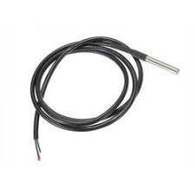

Figure 4: DFR-0198 Digital Temperature Sensor

Specifications**:**

|  |  |
| --- | --- |
| **Parameter Name** | **Technical Condition** |
| Voltage Range | 3.0V to 5.5V |
| Accuracy | ±0.5°C from -10° to +85°C |
| Usable Temperature Range | -55°C to 125°C |
| Resolution | 9 to 12 bit selectable |

Table 4: DFR-0198 Digital Temperature Sensor

Applications:

1. Temperature sensors are mostly used for detection of industrial component’s heat measurement for detecting overheating issues.
2. Inside computers, temperature sensors are used to detect overheating of the electronic components and regulate the cooler fan speed accordingly.
3. In 3D printers, temperature sensors are used for measuring the temperature of the melted material for ensuring proper performance and durability of the printed product.
4. **DC Power Supply:**

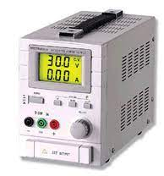

Figure 5: Protek PL-3003S power supply

Specifications**:**

|  |  |
| --- | --- |
| **Parameter Name** | **Technical Condition** |
| Output Power | 90W |
| Output Voltage | 0-30V |
| Output Current | 0-3A |
| Output Port Type | Single Type |
| Display Type | Back Light 3 Digit LCD |

Table 5: Specifications of Protek PL-3003S power supply

Applications:

1. Power supplies are used as precise voltage and current source for a system.
2. For testing and fixing broken systems, where variable power source is needed, these type of power sources are used.

**Output Devices:**

1. **Servo Motor:**

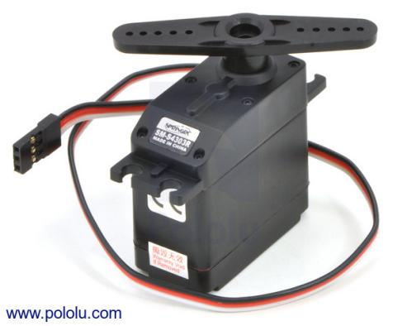

Figure 6: SM-S4303 Continuous Rotation Servo Motor

Specifications**:**

|  |  |
| --- | --- |
| **Parameter Name** | **Technical Condition** |
| Speed | 54 rpm at 6V  43 rpm at 4.8V |
| Stall Torque | 71 oz |
| Lead length | 11 inch |
| Weight | 41 g |

Table 6: Specifications of SM-S4303 Continuous Rotation Servo Motor

Applications:

1. Servo motors are used in industrial production robots to work accurately in the manufacture process.
2. In digital cameras servo motors are used for auto focusing and self balancing.
3. In elevator technology, servo motors are used for proper accurate height and speed adjustments.
4. In robotics, servos are used for precise actuation.
5. **DC Motor:**

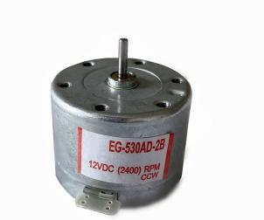

Figure 7: EG-530AD-2B DC motor

Specifications**:**

|  |  |
| --- | --- |
| **Parameter Name** | **Technical Condition** |
| Speed | 2400 rpm (max) |
| Current | 73mA - 130 mA |
| Starting Torque | 37.2/4.2V |
| Voltage | 6V-12V |

Table 7: Specifications of EG-530AD-2B DC motor

Applications:

1. DC motors are used for actuation of robots.
2. In automated vehicles, DC motors are used for various safety features.
3. In industries, DC motors are used as electronic locomotives.
4. In cranes, DC motors are used for hoisting heavy things as these motors have high staring torque capability.
5. **Display:**



Figure 6: SM-S4303 Continuous Rotation Servo Motor

Specifications**:**

|  |  |
| --- | --- |
| **Parameter Name** | **Technical Condition** |
| Speed | 54 rpm at 6V  43 rpm at 4.8V |
| Stall Torque | 71 oz |
| Lead length | 11 inch |
| Weight | 41 g |

Table 6: Specifications of SM-S4303 Continuous Rotation Servo Motor

Applications:

1. Servo motors are used in industrial production robots to work accurately in the manufacture process.
2. In digital cameras servo motors are used for auto focusing and self balancing.
3. In elevator technology, servo motors are used for proper accurate height and speed adjustments.

In robotics, servos are used for precise actuation.

**Controllers:**

**Applications:**

1. **Industrial Robotic Arm:**

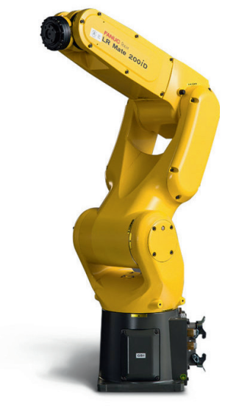

Figure : FANUC LR-Mate 200ID

Specifications**:**

|  |  |
| --- | --- |
| **Parameter Name** | **Technical Condition** |
| Controlled Axes | 6 |
| Max Payload | 7kg |
| Repeatability | 0.01mm |
| Mounting Method | Floor/Upside Down/Angle |
| Reach | 717 |

Table 6:Specifications of FANUC LR-Mate 200ID

Applications:

1. FANUC robots are used in factories around the globe to help manufacturers improve quality, increase capacity and overcome skills shortages.
2. This type of robots build products too intricate for human hands to assemble, prepare pharmaceuticals in aseptic conditions and protect workers from dangerous or harmful environments.
3. FANUC Robotics produces industrial robots that can be used in wielding automation and robotic assembly applications.

**Precautions:**

1. When observing the lab equipment, careful measures were taken.
2. All high voltage parts and connections were kept out of the way from accidental touching.
3. Whether the connections with the load were causing sparks was carefully checked.
4. Rubber floor mates were used to insulate ourselves from the ground when working in the lab.
5. After finishing the observation, all connections to the power supply was removed.

**Discussion & Conclusion:**

Sample text