**Rectifier**

In a large number of electronic circuits, we require DC voltage for operation. We can easily convert the AC voltage or AC current into DC voltage or DC current by using a device called [P-N junction diode](https://www.physics-and-radio-electronics.com/electronic-devices-and-circuits/semiconductor-diodes/pnjunctionsemiconductordiode.html).

One of the most important applications of a P-N junction diode is the rectification of [Alternating Current (AC)](http://www.physics-and-radio-electronics.com/blog/alternating-current-ac/) into [Direct Current (DC)](http://www.physics-and-radio-electronics.com/blog/direct-current-dc/). A P-N junction diode allows electric current in only forward bias condition and blocks electric current in reverse bias condition. In simple words, a diode allows electric current in one direction. This unique property of the diode allows it to acts like a rectifier.

Rectifier definition

A rectifier is an electrical device that converts an Alternating Current (AC) into a Direct Current (DC) by using one or more P-N junction diodes.

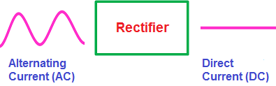

What is a rectifier?

When the voltage is applied to the P-N junction diode in such a way that the positive terminal of the battery is connected to the p-type semiconductor and the negative terminal of the battery is connected to the n-type semiconductor, the diode is said to be [forward biased](https://www.physics-and-radio-electronics.com/electronic-devices-and-circuits/semiconductor-diodes/forwardbiasedpnjunctionsemiconductordiode.html).

When this forward bias voltage is applied to the P-N junction diode, a large number of [free electrons](https://www.physics-and-radio-electronics.com/electronic-devices-and-circuits/introduction/free-electrons.html) (majority carriers) in the [n-type semiconductor](https://www.physics-and-radio-electronics.com/electronic-devices-and-circuits/semiconductor/extrinsic-semiconductor/n-type-semiconductor.html) experience a repulsive force from the negative terminal of the battery similarly a large number of [holes](https://www.physics-and-radio-electronics.com/electronic-devices-and-circuits/semiconductor/hole.html) (majority carriers) in the [p-type semiconductor](https://www.physics-and-radio-electronics.com/electronic-devices-and-circuits/semiconductor/extrinsic-semiconductor/p-type-semiconductor.html) experience a repulsive force from the positive terminal of the battery.

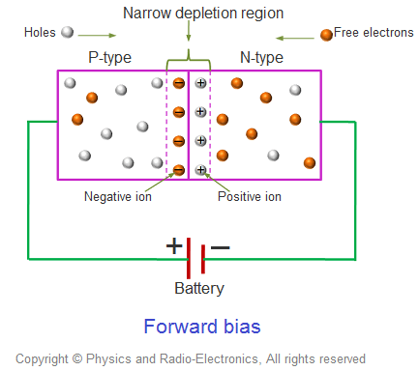

As a result, the free electrons in the n-type semiconductor start moving from n-side to p-side similarly the holes in the p-type semiconductor start moving from p-side to n-side.

We know that electric current means the flow of charge carriers (free electrons and holes). Therefore, the flow of electrons from n-side to p-side and the flow of holes from p-side to n-side conduct electric current. The majority carriers produce the electric current in forward bias condition. So the electric current produced in forward bias condition is also known as majority current.

When the voltage is applied to the P-N junction diode in such a way that the positive terminal of the battery is connected to the n-type semiconductor and the negative terminal of the battery is connected to the p-type semiconductor, the diode is said to be [reverse biased](https://www.physics-and-radio-electronics.com/electronic-devices-and-circuits/semiconductor-diodes/reversebiaseddiode.html).

When this reverse bias voltage is applied to the P-N junction diode, a large number of free electrons (majority carriers) in the n-type semiconductor experience an attractive force from the positive terminal of the battery similarly a large number of holes (majority carriers) in the p-type semiconductor experience an attractive force from the negative terminal of the battery.

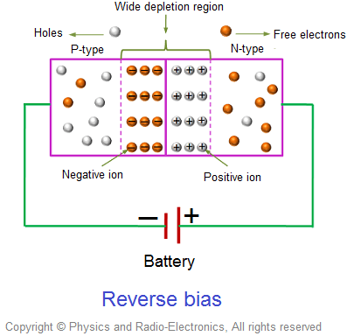

As a result, the free electrons (majority carriers) in the n-type semiconductor moves away from the P-N junction and attracted to the positive terminal of the battery similarly the holes (majority carriers) in the p-type semiconductor moves away from the P-N junction and attracted to the negative terminal of the battery.

Therefore, the electric current flow does not occur across the [P-N junction](https://www.physics-and-radio-electronics.com/electronic-devices-and-circuits/semiconductor-diodes/p-n-junction-introduction.html). However, the minority carriers (free electrons) in the p-type semiconductor experience a repulsive force from the negative terminal of the battery similarly the minority carriers (holes) in the n-type semiconductor experience a repulsive force from the positive terminal of the battery.

As a result, the minority carriers free electrons in the p-type semiconductor and the minority carriers holes in the n-type semiconductor starts flowing across the junction. Thus, electric current is produced in the reverse bias diode due to the minority carriers. However, the electric current produced by the minority carriers is very small. So the minority carrier current in the reverse bias condition is neglected.

Thus, the P-N junction diode allows electric current in forward bias condition and blocks electric current in reverse bias condition. In simple words, a P-N junction diode allows electric current in only one direction. This unique property of the diode allows it to acts like a rectifier.

The forward bias and reverse bias voltage applied to the diode is nothing but a DC voltage. A DC voltage produces a current which always flows in one direction (either forward direction or backward direction).

But an AC voltage produces a current which always reverses its direction many times a second (forward to backward and backward to forward).

We have observed how a diode behaves when DC voltage (forward bias voltage and reverse bias voltage) is applied to it. Now let’s take look at a P-N junction diode when AC voltage is applied to it.

The AC voltage or AC current is often represented by a sinusoidal waveform whereas the DC current is represented by a straight horizontal line.

In the sinusoidal waveform, the upper half cycle represents the positive half cycle and the lower half cycle represents the negative half cycle.

The positive half cycle of the AC voltage is analogous to the forward bias DC voltage and the negative half cycle of the AC voltage is analogous to the reverse bias DC voltage.

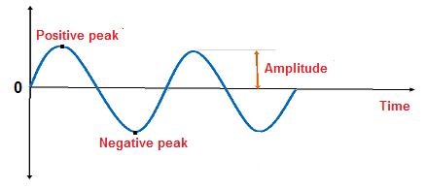

The alternating current starts from zero and grows to peak forward current or peak positive current. The positive peak of the sinusoidal waveform represents the maximum or peak forward current. After reaching the peak forward current, it starts decreasing and reaches to zero.

After a short period, the alternating current starts increasing in the reverse or negative direction and grows to peak reverse current or peak negative current. The negative peak of the sinusoidal waveform represents the maximum or peak reverse current. After reaching the peak reverse current, it starts decreasing and reaches to zero. Likewise, the alternating current continuously changes its direction in a short period.

When AC voltage or AC current is applied across the P-N junction diode, during the positive half cycle the diode is forward biased and allows electric current through it. However, when the AC current reverses its direction to negative half cycle, the diode is reverse biased and does not allow electric current through it. In simple words, during the positive half cycle, the diode allows current and during the negative half cycle, the diode blocks current. Thus, electric current flows through the diode only during the positive half cycle of the AC current.

This current which flows across the diode is nothing but a DC current. Thus, the P-N junction diode acts like a rectifier by converting the AC current into DC current.

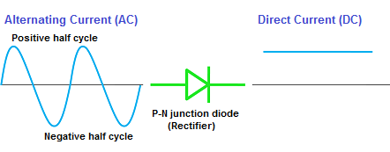

However, the DC current produced by a basic rectifier (half wave rectifier) is not a pure DC current. It is a pulsating DC current.

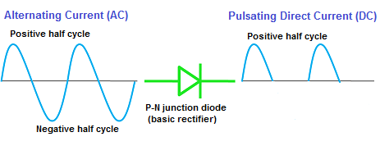

The pulsating direct current is a type of DC current whose value changes over a short period.

The pulsating DC current starts from zero and grows to the maximum forward current (peak level), and decreases to zero. However, the pulsating DC current does not change its direction periodically like AC current.

The pulsating DC current always flows in one direction like the pure DC current. However, the value of pulsating DC current or pulsating DC voltage slightly changes over a given period. The electric current produced by batteries, power supplies, and solar panels is a pure DC current.

By using the combination of components such as capacitors, inductors, and resistors in the circuit, we can achieve the smoothening of pulsating DC to pure DC.

Types of rectifiers

The rectifiers are mainly classified into two types:

* Half wave rectifier
* Full wave rectifier

Half wave rectifier

As the name suggests, the [half wave rectifier](https://www.physics-and-radio-electronics.com/electronic-devices-and-circuits/rectifier/halfwaverectifier.html) is a type of rectifier which converts half of the AC input signal (positive half cycle) into pulsating DC output signal and the remaining half signal (negative half cycle) is blocked or lost. In half wave rectifier circuit, we use only a single diode.

Full wave rectifier

The [full wave rectifier](https://www.physics-and-radio-electronics.com/electronic-devices-and-circuits/rectifier/fullwaverectifier.html) is a type of rectifier which converts the full AC input signal (positive half cycle and negative half cycle) to pulsating DC output signal. Unlike the half wave rectifier, the input signal is not wasted in full wave rectifier. The efficiency of full wave rectifier is high as compared to the half wave rectifier.

Rectifier practical example

In our houses, almost all the electronic appliances use AC current. However, some electronic appliances such as laptops or notebook computers convert this AC current into DC current before they consume the power.

The AC adapter of the laptop connected to the AC source converts the high AC voltage or high AC current into low DC voltage or low DC current. This low DC current is supplied to the laptop battery and this is what we called laptop charging. However, the laptop will not turn on unless you manually turned it on by pressing the on button. When you press the laptop "power on" button, the laptop battery starts supplying DC current.

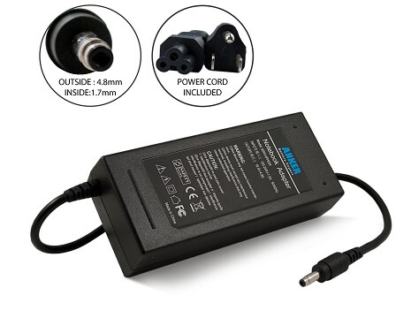

We have forgotten an important step; how the AC adapters convert high AC voltage or high AC current into low DC voltage or low DC current.

The AC adapters consist of all the essential components needed for AC to DC conversion.

These components are a transformer, capacitor, and several diodes. Out of these components, the main key component is a diode which converts the alternating current into direct current.

The transformer in the AC adapter reduces the high AC voltage to a low AC voltage.

The rectifier (made up of diodes) converts this low AC voltage or AC current into low DC voltage or DC current. However, the converted current is not pure DC current. It is a pulsating DC current.

The capacitor filters this pulsating DC current to pure DC current.

**Half wave Rectifier**

A [rectifier](https://www.physics-and-radio-electronics.com/electronic-devices-and-circuits/rectifier/rectifier-whatisrectifier.html) is nothing but a simple [diode](https://www.physics-and-radio-electronics.com/electronic-devices-and-circuits/semiconductor-diodes/pnjunctionsemiconductordiode.html) or group of diodes which converts the [Alternating Current (AC)](http://www.physics-and-radio-electronics.com/blog/alternating-current-ac/) into [Direct Current (DC)](http://www.physics-and-radio-electronics.com/blog/direct-current-dc/).

We know that a diode allows electric current in one direction and blocks electric current in another direction. We are using this principle to construct various types of rectifiers.

Rectifiers are classified into different types based on the number of diodes used in the circuit or arrangement of diodes in the circuit. The basic types of rectifiers are: half wave rectifier and [full wave rectifier](https://www.physics-and-radio-electronics.com/electronic-devices-and-circuits/rectifier/fullwaverectifier.html).

Let's take a look at the half wave rectifier....

Half wave rectifier definition

A half wave rectifier is a type of rectifier which converts the positive half cycle (positive current) of the input signal into pulsating DC (Direct Current) output signal.

or

A half wave rectifier is a type of rectifier which allows only half cycle (either positive half cycle or negative half cycle) of the input AC signal while the another half cycle is blocked.

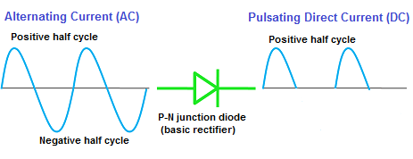

For example, if the positive half cycle is allowed then the negative half cycle is blocked. Similarly, if the negative half cycle is allowed then the positive half cycle is blocked. However, a half wave rectifier will not allow both positive and negative half cycles at the same time.

Therefore, the half cycle (either positive or negative) of the input signal is wasted.

What is half wave rectifier?

The half wave rectifier is the simplest form of the rectifier. We use only a single diode to construct the half wave rectifier.

The half wave rectifier is made up of an AC source, transformer (step-down), diode, and [resistor](https://www.physics-and-radio-electronics.com/electronic-devices-and-circuits/passive-components/resistors/resistors.html) (load). The diode is placed between the transformer and resistor (load).

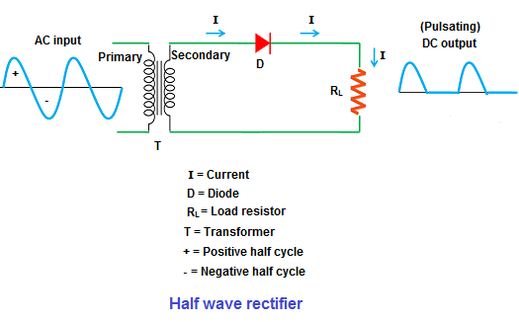

AC source

The AC source supplies Alternating Current to the circuit. The alternating current is often represented by a sinusoidal waveform.

Transformer

Transformer is a device which reduces or increases the AC voltage. The step-down transformer reduces the AC voltage from high to low whereas the step-up transformer increases the AC voltage from low to high. In half wave rectifier, we generally use a step-down transformer because the [voltage](https://www.physics-and-radio-electronics.com/electromagnetics/electrostatics/potential-difference.html) needed for the diode is very small. Applying a large AC voltage without using transformer will permanently destroy the diode. So we use step-down transformer in half wave rectifier. However, in some cases, we use a step-up transformer.

In the step-down transformer, the primary winding has more turns than the secondary winding. So the step-down transformer reduces the voltage from primary winding to secondary winding.

Diode

A diode is a two terminal device that allows electric current in one direction and blocks electric current in another direction.

Resistor

A resistor is an electronic component that restricts the current flow to a certain level.

Half wave rectifier operation

Positive half wave rectifier

When high AC voltage (60 Hz) is applied, the step-down transformer reduces this high voltage into low voltage. Thus, a low voltage is produced at the secondary winding of the transformer. The low voltage produced at the secondary winding of the transformer is called secondary voltage (VS). The AC voltage or AC signal applied to the transformer is nothing but an input AC signal or input AC voltage.

The low AC voltage produced by the step-down transformer is directly applied to the diode.

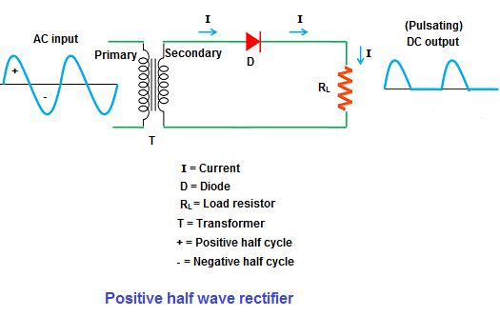

When low AC voltage is applied to the diode (D), during the positive half cycle of the signal, the diode is [forward biased](https://www.physics-and-radio-electronics.com/electronic-devices-and-circuits/semiconductor-diodes/forwardbiasedpnjunctionsemiconductordiode.html) and allows electric current whereas, during the negative half cycle, the diode is [reverse biased](https://www.physics-and-radio-electronics.com/electronic-devices-and-circuits/semiconductor-diodes/reversebiaseddiode.html) and blocks electric current. In simple words, the diode allows the positive half-cycle of the input AC signal and blocks the negative half-cycle of the input AC signal.

The positive half-cycle of the input AC signal or AC voltage applied to the diode is analogous to the forward DC voltage applied to the p-n junction diode similarly the negative half-cycle of the input AC signal applied to the diode is analogous to the reverse DC voltage applied to the p-n junction diode.

We know that diode allows electric current when it is forward biased and blocks electric current when it is reverse biased. Similarly, in an AC circuit, the diode allows electric current during the positive half cycle (forward biased) and blocks electric current during the negative half cycle (reverse biased).

The positive half wave rectifier does not completely block the negative half cycles. It allows a small portion of negative half cycles or small negative current. This current is produced by the minority carriers in the diode.

The current produced by the minority carriers is very small. So it is neglected. We can’t visually see the small portion of negative half cycles at the output.

In an ideal diode, the negative half cycles or negative current is zero.

The resistor placed at the output consumes the DC current generated by the diode. Hence, the resistor is also known as an electrical load. The output DC voltage or DC current is measured across the load resistor RL.

The electrical load is nothing but an electrical component of a circuit that consumes electric current. In half wave rectifier, the resistor consumes the DC current generated by the diode. So the resistor in half wave rectifier is known as a load.

Sometimes, the load is also refers to the power consumed by the circuit.

The load resistors are used in half wave rectifiers to restrict or block the unusual excess DC current produced by the diode.

Thus, the half wave rectifier allows positive half cycles and blocks negative half cycles. The half wave rectifier which allows positive half cycles and blocks negative half cycles is called a positive half wave rectifier. The output DC current or DC signal produced by a positive half wave rectifier is a series of positive half cycles or positive sinusoidal pulses.

Now let’s take a look at the negative half wave rectifier........

Negative half wave rectifier

The construction and working of negative half wave rectifier is almost similar to the positive half wave rectifier. The only thing we change here is the direction of a diode.

When AC voltage is applied, the step-down transformer reduces the high voltage to low voltage. This low voltage is applied to the diode.

Unlike the positive half wave rectifier, the negative half wave rectifier allows electric current during the negative half-cycle of input AC signal and blocks electric current during the positive half-cycle of the input AC signal.

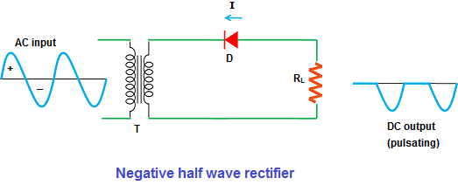

During the negative half cycle, the diode is forward biased and during the positive half cycle the diode is reverse biased, so the negative half wave rectifier allows electric current only during the negative half cycle.

Thus, the negative half wave rectifier allows negative half cycles and blocks positive half cycles.

The negative half wave rectifier does not completely block the positive half cycles. It allows a small portion of positive half cycles or small positive current. This current is produced by the minority carriers in the diode.

The current produced by the minority carriers is very small. So it is neglected. We can’t visually see this small positive half cycles at the output.

In an ideal diode, the positive half cycle or positive current is zero.

The DC current or DC voltage produced by the negative half wave rectifier is measured across the load resistor RL. The output DC current or DC signal produced by a negative half wave rectifier is a series of negative half cycles or negative sinusoidal pulses.

Thus, a negative half wave rectifier produces a series of negative sinusoidal pulses.

In a perfect or ideal diode, the positive half cycle or negative half cycle at the output is exactly same as the input positive half cycle or negative half cycle. However, in practice, the positive half cycle or negative half cycle at the output is slightly different from the input positive half cycle or negative half cycle. But this difference is negligible. So we can’t see the difference with our eyes.

Thus, the half wave rectifier produces a series of positive sinusoidal pulses or negative sinusoidal pulses. This series of positive pulses or negative pulses is not a pure direct current. It is a pulsating direct current.

The pulsating direct current changes its value over a short period of time. But our aim is to produce a direct current which does not change its value over a short period of time. Therefore, the pulsating direct current is not much useful.

Half wave rectifier with capacitor filter

A filter converts the pulsating direct current into pure direct current. In half wave rectifiers, a [capacitor](https://www.physics-and-radio-electronics.com/electronic-devices-and-circuits/passive-components/capacitors/capacitorconsutructionandworking.html) or inductor is used as a filter to convert the pulsating DC to pure DC.

The output voltage produced by a half wave rectifier is not constant; it varies with respect to time. In practical applications, a constant DC supply voltage is needed.

In order to produce a constant DC voltage, we need to suppress the ripples of a DC voltage. This can be achieved by using either a capacitor filter or inductor filter at the output side. In the below circuit, we are using the capacitor filter. The capacitor placed at the output side smoothen the pulsating DC to pure DC.

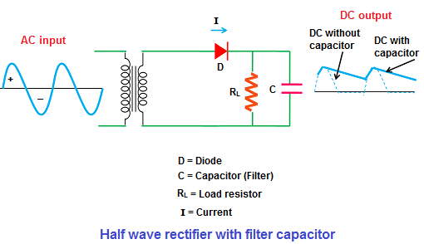

Characteristics of half wave rectifier

Ripple factor

The direct current (DC) produced by a half wave rectifier is not a pure DC but a pulsating DC. In the output pulsating DC signal, we find ripples. These ripples in the output DC signal can be reduced by using filters such capacitors and inductors.

In order to measure how much ripples are there in the output DC signal we use a factor known as ripple factor. The ripple factor is denoted by **γ**.

The ripple factor tells us the amount of ripples present in the output DC signal.

A large ripple factor indicates a high pulsating DC signal while a low ripple factor indicates a low pulsating DC signal.

If the ripple factor is very low then it indicates that the output DC current is closer to the pure DC current. In simple words, the lower the ripple factor the smoother the output DC signal.

Ripple factor can be mathematically defined as the ratio of rms value of AC component of the output voltage to the DC component of the output voltage.

Ripples factor = rms value of AC component of the output voltage / DC component of the output voltage

Where, rms = root mean square

or

The ripple factor is also simply defined as the ratio of ripple voltage to the DC voltage

Ripple factor = Ratio of ripple voltage / DC voltage

The ripple factor should be kept as minimum as possible to construct a good rectifier.

The ripple factor is given as

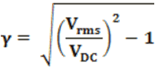

Finally, we get

**γ = 1.21**

The unwanted ripple present in the output along with the DC voltage is 121% of the DC magnitude. This indicates that the half wave rectifier is not an efficient AC to DC converter. The high ripples in the half wave rectifier can be reduced by using filters.

DC current

The DC current is given by,

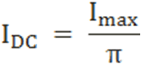

  Where,   
 Imax = maximum DC load current

Output DC voltage (VDC)

The output DC voltage (VDC) is the voltage appeared at the load resistor (RL). This voltage is obtained by multiplying the output DC current with load resistance RL.

It can be mathematically written as,

VDC = IDC RL

The output DC voltage is given by,

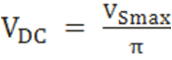

Where, VSmax = Maximum secondary voltage

Peak inverse voltage (PIV)

Peak inverse voltage is the maximum reverse bias voltage up to which a diode can withstand. If the applied voltage is greater than the peak inverse voltage, the diode will be destroyed.

During the positive half cycle, the diode is forward biased and allow electric current. This current is dropped at the resistor load (RL). However, during the negative half cycle, the diode is reverse biased and does not allows electric current, so the input AC current or AC voltage is dropped at the diode.

The maximum voltage dropped at the diode is nothing but an input voltage.

Therefore, peak inverse voltage (PIV) of diode = VSmax

Rectifier efficiency

Rectifier efficiency is defined as the ratio of output DC power to the input AC power.

The rectifier efficiency of a half wave rectifier is 40.6%

Root mean square (RMS) value of load current IRMS

The root mean square (RMS) value of load current in a half wave rectifier is

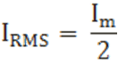

Root mean square (RMS) value of output load voltage VRMS

The root mean square (RMS) value of output load voltage in a half wave rectifier is

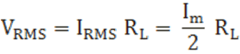

Form factor

Form factor is defined as the ratio of RMS value to the DC value

It can be mathematically written as

F.F = RMS value / DC value

The form factor of a half wave rectifier is

F.F = 1.57

Advantages of half wave rectifier

* We use very few components to construct the half wave rectifier. So the cost is very low.
* Easy to construct

Disadvantages of half wave rectifier

* Power loss

The half wave rectifier either allows the positive half cycle or negative half cycle. So the remaining half cycle is wasted. Approximately half of the applied voltage is wasted in half wave rectifier.

* Pulsating direct current

The direct current produced by the half wave rectifier is not a pure direct current; it is a pulsating direct current which is not much useful.

* Produces low output voltage.

**Full wave rectifier**

The process of converting the [AC current](http://www.physics-and-radio-electronics.com/blog/alternating-current-ac/) into [DC current](http://www.physics-and-radio-electronics.com/blog/direct-current-dc/) is called rectification. Rectification can be achieved by using a single [diode](https://www.physics-and-radio-electronics.com/electronic-devices-and-circuits/semiconductor-diodes/pnjunctionsemiconductordiode.html) or group of diodes. These diodes which convert the AC current into DC current are called rectifiers.

Rectifiers are generally classified into two types: [half wave rectifier](https://www.physics-and-radio-electronics.com/electronic-devices-and-circuits/rectifier/halfwaverectifier.html) and full wave rectifier.

A half wave rectifier uses only a single diode to convert AC to DC. So it is very easy to construct the half wave rectifier. However, a single diode in half wave rectifier only allows either a positive half cycle or a negative half cycle of the input AC signal and the remaining half cycle of the input AC signal is blocked. As a result, a large amount of power is wasted. Furthermore, the half wave rectifiers are not suitable in the applications which need a steady and smooth DC voltage. So the half wave rectifiers are not efficient AC to DC converters.

We can easily overcome this drawback by using another type of rectifier known as a full wave rectifier. The full wave rectifier has some basic advantages over the half wave rectifier. The average DC output voltage produced by the full wave rectifier is higher than the half wave rectifier. Furthermore, the DC output signal of the full wave rectifier has fewer ripples than the half wave rectifier. As a result, we get a smoother output DC voltage.

Let’s take a look at full wave rectifier………..

Full wave rectifier definition

A full wave rectifier is a type of rectifier which converts both half cycles of the AC signal into pulsating DC signal.

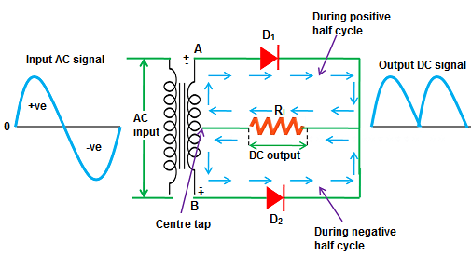

As shown in the above figure, the full wave rectifier converts both positive and negative half cycles of the input AC signal into output pulsating DC signal.

The full wave rectifier is further classified into two types: center tapped full wave rectifier and full wave bridge rectifier.

In this tutorial, center tapped full wave rectifier is explained.

Before going to the working of a center tapped full wave rectifier, let’s first take a look at the center tapped transformer. Because the center tapped transformer plays a key role in the center tapped full wave rectifier.

Center tapped transformer

When an additional wire is connected across the exact middle of the secondary winding of a transformer, it is known as a center tapped transformer.

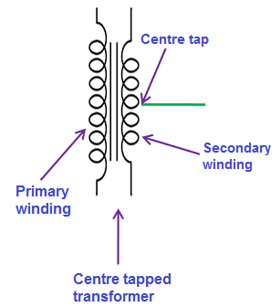

The wire is adjusted in such a way that it falls in the exact middle point of the secondary winding. So the wire is exactly at zero volts of the AC signal. This wire is known as the center tap.

The center tapped transformer works almost similar to a normal transformer. Like a normal transformer, the center tapped transformer also increases or reduces the AC voltage. However, a center tapped transformer has another important feature. That is the secondary winding of the center tapped transformer divides the input AC current or AC signal (VP) into two parts.

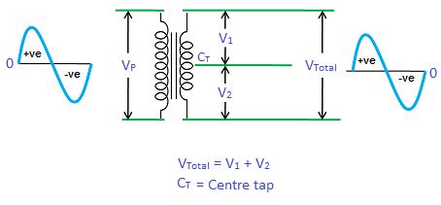

The upper part of the secondary winding produces a positive voltage V1 and the lower part of the secondary winding produces a negative voltage V2. When we combine these two voltages at output load, we get a complete AC signal.

I.e. VTotal = V1 + V2

The voltages V1 and V2 are equal in magnitude but opposite in direction. That is the voltages (V1 and V2 ) produced by the upper part and lower part of the secondary winding are 180 degrees out of phase with each other. However, by using a full wave rectifier with center tapped transformer, we can produce the [voltages](https://www.physics-and-radio-electronics.com/electromagnetics/electrostatics/potential-difference.html) that are in phase with each other. In simple words, by using a full wave rectifier with center tapped transformer, we can produce a current that flows only in single direction.

What is center tapped full wave rectifier

A center tapped full wave rectifier is a type of rectifier which uses a center tapped transformer and two diodes to convert the complete AC signal into DC signal.

The center tapped full wave rectifier is made up of an AC source, a center tapped transformer, two diodes, and a load resistor.

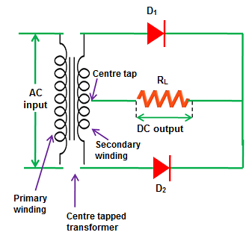

The AC source is connected to the primary winding of the center tapped transformer. A center tap (additional wire) connected at the exact middle of the the secondary winding divides the input voltage into two parts.

The upper part of the secondary winding is connected to the diode D1 and the lower part of the secondary winding is connected to the diode D2. Both diode D1 and diode D2 are connected to a common load RL with the help of a center tap transformer. The center tap is generally considered as the ground point or the zero voltage reference point.

How center tapped full wave rectifier works

The center tapped full wave rectifier uses a center tapped transformer to convert the input AC voltage into output DC voltage.

When input AC voltage is applied, the secondary winding of the center tapped transformer divides this input AC voltage into two parts: positive and negative.

During the positive half cycle of the input AC signal, terminal A become positive, terminal B become negative and center tap is grounded (zero volts). The positive terminal A is connected to the p-side of the diode D1 and the negative terminal B is connected to the n-side of the diode D1. So the diode D1 is forward biased during the positive half cycle and allows electric current through it.

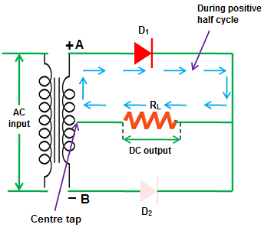

On the other hand, the negative terminal B is connected to the p-side of the diode D2 and the positive terminal A is connected to the n-side of the diode D2. So the diode D2 is reverse biased during the positive half cycle and does not allow electric current through it.

The diode D1 supplies DC current to the load RL. The DC current produced at the load RL will return to the secondary winding through a center tap.

During the positive half cycle, current flows only in the upper part of the circuit while the lower part of the circuit carry no current to the load because the diode D2 is reverse biased. Thus, during the positive half cycle of the input AC signal, only diode D1 allows electric current while diode D2 does not allow electric current.

During the negative half cycle of the input AC signal, terminal A become negative, terminal B become positive and center tap is grounded (zero volts). The negative terminal A is connected to the p-side of the diode D1 and the positive terminal B is connected to the n-side of the diode D1. So the diode D1 is reverse biased during the negative half cycle and does not allow electric current through it.

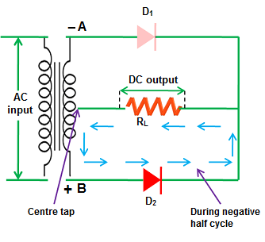

On the other hand, the positive terminal B is connected to the p-side of the diode D2 and the negative terminal A is connected to the n-side of the diode D2. So the diode D2 is forward biased during the negative half cycle and allows electric current through it.

The diode D2 supplies DC current to the load RL. The DC current produced at the load RL will return to the secondary winding through a center tap.

During the negative half cycle, current flows only in the lower part of the circuit while the upper part of the circuit carry no current to the load because the diode D1 is reverse biased. Thus, during the negative half cycle of the input AC signal, only diode D2 allows electric current while diode D1 does not allow electric current.

Thus, the diode D1 allows electric current during the positive half cycle and diode D2 allows electric current during the negative half cycle of the input AC signal. As a result, both half cycles (positive and negative) of the input AC signal are allowed. So the output DC voltage is almost equal to the input AC voltage.



A small voltage is wasted at the diode D1 and diode D2 to make them conduct. However, this voltage is very small as compared to the voltage appeared at the output. So this voltage is neglected.

The diodes D1 and D2 are commonly connected to the load RL. So the load current is the sum of individual diode currents.

We know that a diode allows electric current in only one direction. From the above diagram, we can see that both the diodes D1 and D2 are allowing current in the same direction.

We know that a current that flows in only single direction is called a direct current. So the resultant current at the output (load) is a direct current (DC). However, the direct current appeared at the output is not a pure direct current but a pulsating direct current.

The value of the pulsating direct current changes with respect to time. This is due to the ripples in the output signal. These ripples can be reduced by using filters such as capacitor and inductor.

The average output DC voltage across the load resistor is double that of the single half wave rectifier circuit.

Output waveforms of full wave rectifier

The output waveforms of the full wave rectifier is shown in the below figure.

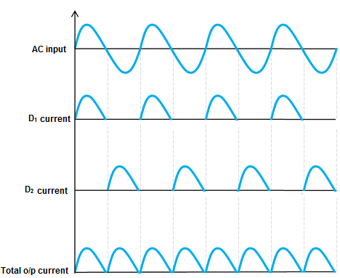

The first waveform represents an input AC signal. The second waveform and third waveform represents the DC signals or DC current produced by diode D1 and diode D2. The last waveform represents the total output DC current produced by diodes D1and D2. From the above waveforms, we can conclude that the output current produced at the load resistor is not a pure DC but a pulsating DC.

Characteristics of full wave rectifier

Ripple factor

The ripple factor is used to measure the amount of ripples present in the output DC signal. A high ripple factor indicates a high pulsating DC signal while a low ripple factor indicates a low pulsating DC signal.

Ripple factor is defined as the ratio of ripple voltage to the pure DC voltage

The ripple factor is given by



Finally, we get

**γ** = 0.48

Rectifier efficiency

Rectifier efficiency indicates how efficiently the rectifier converts AC into DC. A high percentage of rectifier efficiency indicates a good rectifier while a low percentage of rectifier efficiency indicates an inefficient rectifier.

Rectifier efficiency is defined as the ratio of DC output power to the AC input power.

It can be mathematically written as

                                              η = output PDC / input PAC

The rectifier efficiency of a full wave rectifier is 81.2%.

The rectifier efficiency of a full wave rectifier is twice that of the half wave rectifier. So the full wave rectifier is more efficient than a half wave rectifier

Peak inverse voltage (PIV)

Peak inverse voltage or peak reverse voltage is the maximum voltage a diode can withstand in the reverse bias condition. If the applied voltage is greater than the peak inverse voltage, the diode will be permanently destroyed.

The peak inverse voltage (PIV) = 2Vsmax

DC output current

At the output load resistor RL, both the diode D1 and diode D2 currents flow in the same direction. So the output current is the sum of D1 and D2 currents.

The current produced by D1 is Imax / π and the current produced by D2 is Imax / π.

So the output current IDC = 2Imax / π  
                           Where,   
 Imax = maximum DC load current

DC output voltage

The DC output voltage appeared at the load resistor RL  is given as

                                   VDC = 2Vmax /π  
                                    Where,  
 Vmax = maximum secondary voltage

Root mean square (RMS) value of load current IRMS

The root mean square (RMS) value of load current in a full wave rectifier is

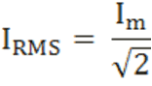

Root mean square (RMS) value of the output load voltage VRMS

The root mean square (RMS) value of output load voltage in a full wave rectifier is

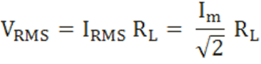

Form factor

Form factor is the ratio of RMS value of current to the DC output current

It can be mathematically written as

                                           F.F = RMS value of current / DC output current

The form factor of a full wave rectifier is

                                            F.F = 1.11

Advantages of full wave rectifier with center tapped transformer

High rectifier efficiency

Full wave rectifier has high rectifier efficiency than the half wave rectifier. That means the full wave rectifier converts AC to DC more efficiently than the half wave rectifier.

Low power loss

In a half wave rectifier, only half cycle (positive or negative half cycle) is allowed and the remaining half cycle is blocked. As a result, more than half of the voltage is wasted. But in full wave rectifier, both half cycles (positive and negative half cycles) are allowed at the same time. So no signal is wasted in a full wave rectifier.

Low ripples

The output DC signal in full wave rectifier has fewer ripples than the half wave rectifier.

Disadvantages of full wave rectifier with center tapped transformer

High cost

The center tapped transformers are expensive and occupy a large space.

**Full wave rectifier with filter**

To overcome these problems, we use filters at the output. Even though we use filters at the output, the DC signal obtained at the output is not a pure DC. Furthermore, the power loss is high in half wave rectifier. Therefore, to reduce the power loss and reduce the ripples at the output, we go for another type of rectifier known as full wave rectifier.

As the name suggests, the full wave rectifier rectifies both positive and negative half cycles of the input AC signal.

Even though the full wave rectifier rectify both positive and negative half cycles, the DC signal obtained at the output still contains some ripples. To reduce these ripples at the output, we use a filter.

The filter is an electronic device that converts the pulsating Direct Current into pure Direct Current.

The filter is made up of a combination of electronic components such as resistors, capacitors, and inductors. The property of inductor is that it allows the DC components and blocks the AC components. The property of a capacitor is that it allows the AC components and blocks the DC components.

In this tutorial, a center tapped full wave rectifier with a filter made up of capacitor and resistor is explained. The filter made up of capacitor and resistor is known as capacitor filter.

In the circuit diagram, the capacitor C is placed across the load resistor RL.

The working of the full wave rectifier with filter is almost similar to that of the half wave rectifier with filter. The only difference is that in the half wave rectifier only one half cycle (either positive or negative) of the input AC current will charge the [capacitor](https://www.physics-and-radio-electronics.com/electronic-devices-and-circuits/passive-components/capacitors/capacitorconsutructionandworking.html) but the remaining half cycle will not charge the capacitor. But in full wave rectifier, both positive and negative half cycles of the input AC current will charge the capacitor.

The main duty of the capacitor filter is to short the ripples to the ground and blocks the pure DC (DC components), so that it flows through the alternate path and reaches output load resistor RL.

When input AC voltage is applied, during the positive half cycle, the diode D1 is forward biased and allows [electric current](https://www.physics-and-radio-electronics.com/electronic-devices-and-circuits/introduction/electriccurrent-howelectriccurrentproduced.html) whereas the diode D2 is reverse biased and blocks electric current. On the other hand, during the negative half cycle the diode D2 is forward biased (allows electric current) and the diode D1 is reverse biased (blocks electric current).

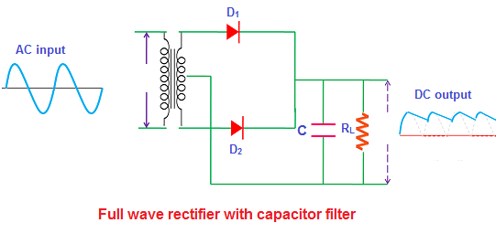

During the positive half cycle, the diode (D1) current reaches the filter and charges the capacitor. However, the charging of the capacitor happens only when the applied AC voltage is greater than the capacitor voltage.

Initially, the capacitor is uncharged. That means no [voltage](https://www.physics-and-radio-electronics.com/electromagnetics/electrostatics/potential-difference.html) exists between the plates of the capacitor. So when the voltage is turned on, the charging of the capacitor happens immediately.

During this conduction period, the capacitor charges to the maximum value of the input supply voltage. The capacitor stores a maximum charge exactly at the quarter positive half cycle in the waveform. At this point, the supply voltage is equal to the capacitor voltage.

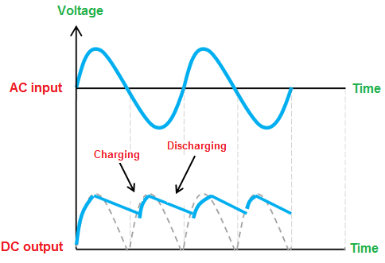

When the AC voltage starts decreasing and becomes less than the capacitor voltage, then the capacitor starts slowly discharging.

The discharging of the capacitor is very slow as compared to the charging of the capacitor. So the capacitor does not get enough time to completely discharged. Before the complete discharge of the capacitor happens, the charging again takes place. So only half or more than half of the capacitor charge get discharged.

When the input AC supply voltage reaches the negative half cycle, the diode D1 is reverse biased (blocks electric current) whereas the diode D2 is forward biased (allows electric current).

During the negative half cycle, the diode (D2) current reaches the filter and charges the capacitor. However, the charging of the capacitor happens only when the applied AC voltage is greater than the capacitor voltage.

The capacitor is not completely uncharged, so the charging of the capacitor does not happens immediately. When the supply voltage becomes greater than the capacitor voltage, the capacitor again starts charging.

In both positive and negative half cycles, the current flows in the same direction across the load resistor RL. So we get either complete positive half cycles or negative half cycles. In our case, they are complete positive half cycles.

How exactly the capacitor filter removes the ripples in the signal

The pulsating Direct Current (DC) produced by the full wave rectifier contains both AC and DC components.

We know that the capacitor allows the AC components and blocks the DC components of the current. When the DC current that contains both DC components and AC components reaches the filter, the DC components experience a high resistance from the capacitor whereas the AC components experience a low resistance from the capacitor.

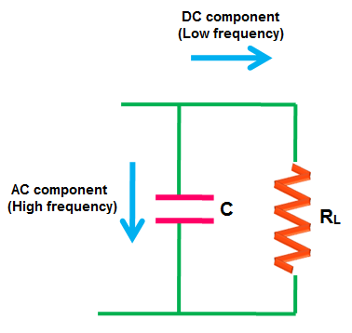

Electric current always prefers to flow through a low resistance path. So the AC components will flow through the capacitor whereas the DC components are blocked by the capacitor. Therefore, they find an alternate path and reach the output load resistor RL. The flow of AC components through the capacitor is nothing but the charging of a capacitor.

Thus, the filter converts the pulsating DC into pure DC.

**Bridge Rectifier**

Before going to bridge rectifier, we need to know what actually a [rectifier](https://www.physics-and-radio-electronics.com/electronic-devices-and-circuits/rectifier/rectifier-whatisrectifier.html) is and what is the need for a rectifier. So first let’s take a look at the evolution of rectifiers.

Evolution of rectifiers

Rectifiers are mainly classified into three types: [Half-wave rectifier](https://www.physics-and-radio-electronics.com/electronic-devices-and-circuits/rectifier/halfwaverectifier.html), [Center tapped full-wave rectifier](https://www.physics-and-radio-electronics.com/electronic-devices-and-circuits/rectifier/fullwaverectifier.html) and Bridge rectifier. All these three rectifiers have a common aim that is to convert [Alternating Current (AC)](http://www.physics-and-radio-electronics.com/blog/alternating-current-ac/) into [Direct Current (DC)](http://www.physics-and-radio-electronics.com/blog/direct-current-dc/).

Not all these three rectifiers efficiently convert the Alternating Current (AC) into Direct Current (DC), only the center tapped full-wave rectifier and bridge rectifier efficiently convert the Alternating Current (AC) into Direct Current (DC).

In half wave rectifier, only 1 half cycle is allowed and the remaining half cycle is blocked. As a result, nearly half of the applied power is wasted in half wave rectifier. In addition to this, the output [current](https://www.physics-and-radio-electronics.com/electronic-devices-and-circuits/introduction/electriccurrent-howelectriccurrentproduced.html) or [voltage](https://www.physics-and-radio-electronics.com/electromagnetics/electrostatics/potential-difference.html) produced by half wave rectifier is not a pure DC but a pulsating DC which is not much useful.



In order to overcome this problem, scientists developed a new type of rectifier known as center tapped full wave rectifier.

The main advantage of center tapped full wave rectifier is that it allows electric current during both positive and negative half cycles of the input AC signal. As a result, the DC output of the center tapped full wave rectifier is double of that of a half-wave rectifier. In addition to this, the DC output of center tapped full wave rectifier contains very fewer ripples. As a result, the DC output of the center tapped full wave rectifier is smoother than the half wave rectifier.



However, the center tapped full wave rectifier has one drawback that is the center-tapped transformer used in it is very expensive and occupies large space.

To cut this extra cost, scientists developed a new type of rectifier known as a bridge rectifier. In bridge rectifier, center tap is not required. If stepping down or stepping up of voltage is not required, then even the transformer can be eliminated in the bridge rectifier.

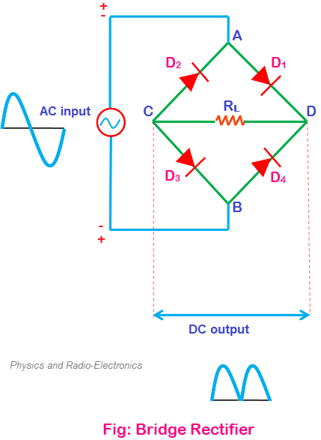

The rectifier efficiency of a bridge rectifier is almost equal to the center tapped full wave rectifier. The only advantage of bridge rectifier over center tapped full wave rectifier is the reduction in cost.

In bridge rectifier, instead of using the center-tapped transformer, four diodes are used.

Now we get an idea about the three types of rectifiers. The half wave rectifier and the center tapped full wave rectifier (full wave rectifier) are already discussed in the previous tutorials. This tutorial is mainly focused on the bridge rectifier.

Let’s take a look at the bridge rectifier …!

Bridge rectifier definition

A bridge rectifier is a type of full wave rectifier which uses four or more [diodes](https://www.physics-and-radio-electronics.com/electronic-devices-and-circuits/semiconductor-diodes/pnjunctionsemiconductordiode.html) in a bridge circuit configuration to efficiently convert the Alternating Current (AC) into Direct Current (DC).

Bridge rectifier construction

The construction diagram of a bridge rectifier is shown in the below figure. The bridge rectifier is made up of four [diodes](https://www.physics-and-radio-electronics.com/electronic-devices-and-circuits/semiconductor-diodes/pnjunctionsemiconductordiode.html) namely D1, D2, D3, D4 and load resistor RL. The four diodes are connected in a closed loop (Bridge) configuration to efficiently convert the Alternating Current (AC) into Direct Current (DC). The main advantage of this bridge circuit configuration is that we do not require an expensive center tapped transformer, thereby reducing its cost and size.



The input AC signal is applied across two terminals A and B and the output DC signal is obtained across the load [resistor](https://www.physics-and-radio-electronics.com/electronic-devices-and-circuits/passive-components/resistors/resistors.html) RL which is connected between the terminals C and D.

The four diodes D1, D2, D3, D4 are arranged in series with only two diodes allowing [electric current](https://www.physics-and-radio-electronics.com/electronic-devices-and-circuits/introduction/electriccurrent-howelectriccurrentproduced.html) during each half cycle. For example, diodes D1 and D3 are considered as one pair which allows electric current during the positive half cycle whereas diodes D2 and D4 are considered as another pair which allows electric current during the negative half cycle of the input AC signal.

How bridge rectifier works?

When input AC signal is applied across the bridge rectifier, during the positive half cycle diodes D1 and D3 are forward biased and allows electric current while the diodes D2 and D4 are reverse biased and blocks electric current. On the other hand, during the negative half cycle diodes D2 and D4 are forward biased and allows electric current while diodes D1 and D3 are reverse biased and blocks electric current.

During the positive half cycle, the terminal A becomes positive while the terminal B becomes negative. This causes the diodes D1 and D3 forward biased and at the same time, it causes the diodes D2 and D4 reverse biased.

The current flow direction during the positive half cycle is shown in the figure A (I.e. A to D to C to B).

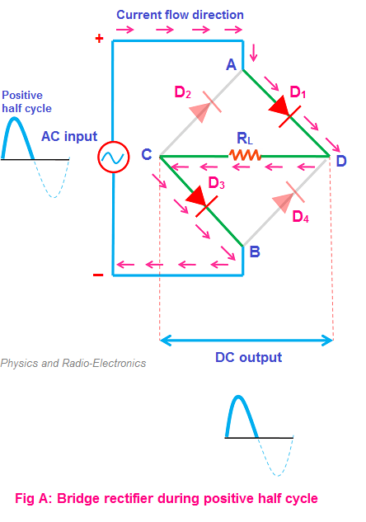

During the negative half cycle, the terminal B becomes positive while the terminal A becomes negative. This causes the diodes D2 and D4 forward biased and at the same time, it causes the diodes D1 and D3 reverse biased.

The current flow direction during negative half cycle is shown in the figure B (I.e. B to D to C to A).

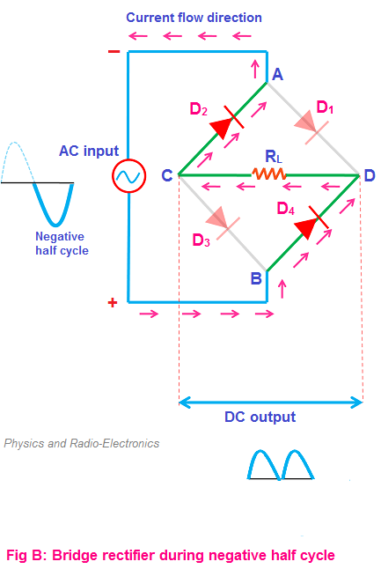

From the above two figures (A and B), we can observe that the direction of current flow across load resistor RL is same during the positive half cycle and negative half cycle. Therefore, the polarity of the output DC signal is same for both positive and negative half cycles. The output DC signal polarity may be either completely positive or negative. In our case, it is completely positive. If the direction of diodes is reversed then we get a complete negative DC voltage.

Thus, a bridge rectifier allows electric current during both positive and negative half cycles of the input AC signal.

The output waveforms of the bridge rectifier is shown in the below figure.

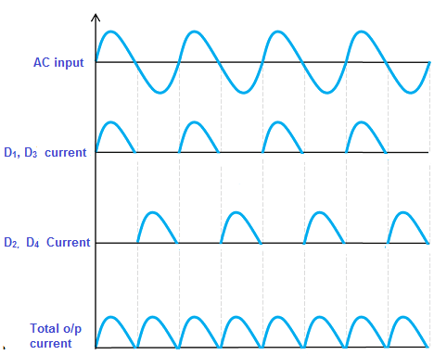

Characteristics of bridge rectifier

Peak Inverse Voltage (PIV)

The maximum voltage a diode can withstand in the reverse bias condition is called Peak Inverse Voltage (PIV)

or

The maximum voltage that the non-conducting diode can withstand is called Peak Inverse Voltage (PIV).

During the positive half cycle, the diodes D1 and D3 are in the conducting state while the diodes D2 and D4 are in the non-conducting state. On the other hand, during the negative half cycle, the diodes D2 and D4 are in the conducting state while the diodes D1 and D3 are in the non-conducting state.

The Peak Inverse Voltage (PIV) for a bridge rectifier is given by

PIV = VSmax

Ripple factor

The smoothness of the output DC signal is measured by using a factor known as ripple factor. The output DC signal with very fewer ripples is considered as the smooth DC signal while the output DC signal with high ripples is considered as the high pulsating DC signal.

Ripple factor is mathematically defined as the ratio of ripple voltage to the pure DC voltage.

The ripple factor for a bridge rectifier is given by



The ripple factor of the bridge rectifier is 0.48 which is same as the center tapped full wave rectifier.

Rectifier efficiency

The rectifier efficiency determines how efficiently the rectifier converts Alternating Current (AC) into Direct Current (DC).

High rectifier efficiency indicates a most reliable rectifier while the low rectifier efficiency indicates a poor rectifier.

Rectifier efficiency is defined as the ratio of the DC output power to the AC input power.

Rectifier efficiency is defined as the ratio of the DC output power to the AC input power.

The maximum rectifier efficiency of a bridge rectifier is 81.2% which is same as the center tapped full wave rectifier.

Advantages of bridge rectifier

Low ripples in the output DC signal

The DC output signal of the bridge rectifier is smoother than the half wave rectifier. In other words, the bridge rectifier has fewer ripples as compared to the half wave rectifier. However, the ripple factor of the bridge rectifier is same as the center tapped full wave rectifier.

High rectifier efficiency

The rectifier efficiency of the bridge rectifier is very high as compared to the half wave rectifier. However, the rectifier efficiency of bridge rectifier and center tapped full wave rectifier is same.

Low power loss

In half wave rectifier only one half cycle of the input AC signal is allowed and the remaining half cycle of the input AC signal is blocked. As a result, nearly half of the applied input power is wasted.

However, in the bridge rectifier, the electric current is allowed during both positive and negative half cycles of the input AC signal. So the output DC power is almost equal to the input AC power.

Disadvantages of bridge rectifier

Bridge rectifier circuit looks very complex

In a half wave rectifier, only a single diode is used whereas in a center tapped full wave rectifier two diodes are used. But in the bridge rectifier, we use four diodes for the circuit operation. So the bridge rectifier circuit looks more complex than the half wave rectifier and center tapped full wave rectifier.

More power loss as compared to the Center tapped full wave rectifier

In electronic circuits, the more diodes we use the more voltage drop will occur. The power loss in bridge rectifier is almost equal to the center tapped full wave rectifier. However, in a bridge rectifier, the voltage drop is slightly high as compared to the center tapped full wave rectifier. This is due to two additional diodes (total four diodes).

In center tapped full wave rectifier, only one diode conducts during each half cycle. So the voltage drop in the circuit is 0.7 volts. But in the bridge rectifier, two diodes which are connected in series conduct during each half cycle. So the voltage drop occurs due to two diodes which is equal to 1.4 volts (0.7 + 0.7 = 1.4 volts). However, the power loss due to this voltage drop is very small.

**Bridge rectifier with filter**

In [center tapped full wave rectifier](https://www.physics-and-radio-electronics.com/electronic-devices-and-circuits/rectifier/fullwaverectifier.html), both positive and negative half cycles are rectified. So no [voltage](https://www.physics-and-radio-electronics.com/electromagnetics/electrostatics/potential-difference.html) is wasted at the output. Furthermore, the DC output produced by center tapped full wave rectifier is smoother than the half wave rectifier output.



However, the center tapped full wave rectifier has one drawback. That is the transformer used in the center tapped full wave rectifier is very costly and it occupies large space. So to overcome this drawback, a new type of rectifier was developed called [bridge rectifier](https://www.physics-and-radio-electronics.com/electronic-devices-and-circuits/rectifier/bridgerectifier.html).



In bridge rectifier, the transformer is not needed. However, two extra diodes (total four diodes) are needed to operate the bridge rectifier.

The overall cost of the bridge rectifier is low as compared to the center tapped full wave rectifier.

Like the center tapped full wave rectifier, the output [Direct Current (DC)](http://www.physics-and-radio-electronics.com/blog/direct-current-dc/) of the bridge rectifier contains small ripples. These small ripples can be reduced if we use the filter at the output.

The filter converts the pulsating Direct Current (DC) into pure Direct Current (DC). The filter is made up of a combination of components such as [capacitors](https://www.physics-and-radio-electronics.com/electronic-devices-and-circuits/passive-components/capacitors/capacitorconsutructionandworking.html), [resistors](https://www.physics-and-radio-electronics.com/electronic-devices-and-circuits/passive-components/resistors/resistors.html), and inductors.

In this tutorial, a bridge rectifier made up of capacitor filter is explained.

Like the center tapped full wave rectifier, the bridge rectifier also rectifies both positive and negative half cycles of the input AC signal. However, the construction of bridge rectifier is different from the center tapped full wave rectifier. In bridge rectifier, the [diodes](https://www.physics-and-radio-electronics.com/electronic-devices-and-circuits/semiconductor-diodes/pnjunctionsemiconductordiode.html) are arranged in the bridge circuit configuration.

The bridge rectifier is made up of four diodes namely D1, D2, D3 and D4. The input signal is applied across the two terminals A and B while the DC output is obtained across the load resistor RL connected between the terminals C and D.

The pulsating DC output obtained across the load resistor RL contains small ripples. To reduce these ripples, we use a filter at the output.

The filter normally used in the bridge rectifier is a capacitor filter. In the below circuit diagram, the capacitor filter is connected across the load resistor RL..

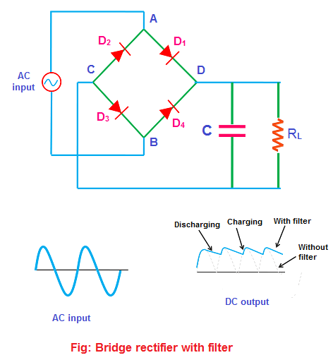

When input AC signal is applied, during the positive half cycle both diodes D1 and D3 are forward biased. At the same time, diodes D2 and D4 are reverse biased.

On the other hand, during the negative half cycle, diodes D2 and D4 are forward biased. At the same time, diodes D1 and D3 arereverse biased.

Thus, the bridge rectifier allows both positive and negative half cycles of the input AC signal.

The DC output produced by the bridge rectifier is not a pure DC but a pulsating DC. This pulsating DC contains both AC and DC components.

The AC components fluctuate with respect to time while the DC components remain constant with respect to time. So the AC components present in the pulsating DC is an unwanted signal.



The capacitor filter present at the output removes the unwanted AC components. Thus, a pure DC is obtained at the load resistor RL.