**Transistors**

Introduction

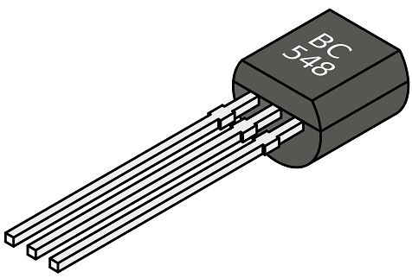The development of electronics industry as we see today started with the invention of a transistor. The working of the transistor can be understood easily if you already have the knowledge about [semiconductor diodes](https://www.physics-and-radio-electronics.com/electronic-devices-and-circuits/semiconductor-diodes/pnjunctionsemiconductordiode.html). If you don’t have any knowledge about diodes, don’t worry. This tutorial will provide a complete guide about transistors which helps beginners to easily understand the concept.

In the previous tutorials, we saw that diodes are made up of the combination of [n-type](https://www.physics-and-radio-electronics.com/electronic-devices-and-circuits/semiconductor/extrinsic-semiconductor/n-type-semiconductor.html) and [p-type semiconductor](https://www.physics-and-radio-electronics.com/electronic-devices-and-circuits/semiconductor/extrinsic-semiconductor/p-type-semiconductor.html). When a p-type semiconductor is joined with the n-type semiconductor, a [p-n junction](https://www.physics-and-radio-electronics.com/electronic-devices-and-circuits/semiconductor-diodes/p-n-junction-introduction.html) is formed between them. This p-n junction forms a most popular device known as a semiconductor diode. An addition of another layer to a p-n junction diode forms a three terminal device called a transistor. The term transistor normally refers to a Bipolar Junction Transistor (BJT).

Like a p-n junction diode, a transistor is also made up of the combination of the p-type and n-type semiconductor layers. However, unlike the p-n junction diode, the transistor contains either one p-type and two n-type semiconductor layers or one n-type and two p-type semiconductor layers.

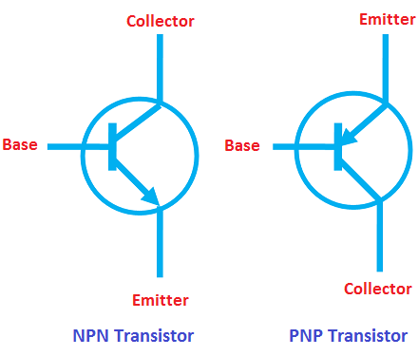The transistor that is made up of one p-type and two n-type semiconductor layers is known as n-p-n transistor whereas the transistor that is made up of one n-type and two p-type semiconductor layers is known as p-n-p transistor.

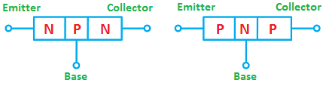N-type and p-type semiconductors are the [extrinsic semiconductors](https://www.physics-and-radio-electronics.com/electronic-devices-and-circuits/semiconductor/extrinsic-semiconductor/extrinsic-semiconductors.html). In the n-type semiconductor, [free electrons](https://www.physics-and-radio-electronics.com/electronic-devices-and-circuits/introduction/free-electrons.html) are the majority charge carriers and [holes](https://www.physics-and-radio-electronics.com/electronic-devices-and-circuits/semiconductor/hole.html) are the minority charge carriers whereas in the p-type semiconductor, holes are the majority charge carriers and free electrons are the minority charge carriers. Therefore, in n-type semiconductor free electrons carry most of the [current](https://www.physics-and-radio-electronics.com/electronic-devices-and-circuits/introduction/electriccurrent-howelectriccurrentproduced.html) whereas in p-type semiconductor holes carry most of the current.

Transistor definition

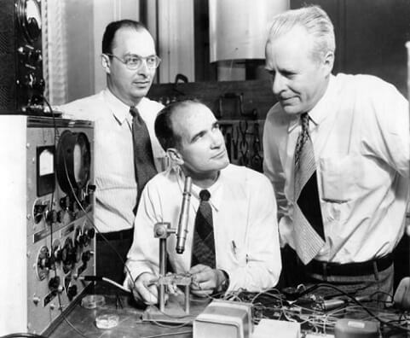A transistor is a three-terminal semiconductor device that amplifies or switches the flow of current. Or , A transistor is an electronic device that controls the current flow or switches the current flow. Or ,A transistor is an electronic device that controls the movement of electrons (charge carriers). Or ,A transistor is a small electronic device that controls the flow of electric current.

Brief history of transistors

The transistor was successfully demonstrated on December 23, 1947 at Bell Laboratories, New Jersey. The three individuals credited with the invention of the transistor were John Bardeen, William Shockley, and Walter Brattain. Among these three individuals, William Shockley played a key role in the invention of the transistor.

What is transistor?

A transistor is a three-terminal semiconductor device that amplifies the electronic signals such as radio and television signals. Before the transistors came into existence, [vacuum tubes](https://www.physics-and-radio-electronics.com/electronic-devices-and-circuits/vacuum-tubes/whatisvacuumtube.html) are used to amplify the electronic signals. But nowadays vacuum tubes are replaced by transistors because of its various advantages over vacuum tubes.

The various advantages and disadvantages of transistors and vacuum tubes are as follows:

Advantages of vacuum tubes

* Vacuum tubes can be easily replaced.
* Tolerant of large overloads and [voltage](https://www.physics-and-radio-electronics.com/electromagnetics/electrostatics/potential-difference.html) spikes
* Superior sound quality

Disadvantages of vacuum tubes

* High power consumption
* High cost
* Vacuum tubes are very bulky. So they occupy more space.
* High voltage is needed to operate the vacuum tubes.
* Produce large heat
* Lower efficiency

Advantages of transistors

* Low power consumption
* Low cost
* Small size
* Higher efficiency
* Low voltage is needed to operate the transistors
* High physical ruggedness than vacuum tubes
* Produce far less heat than vacuum tubes
* Transistors are lighter than vacuum tubes

Disadvantages of transistors

* Less tolerant of overloads and voltage spikes than vacuum tubes
* Maintenance is very difficult
* It is difficult to replace the transistor

Classification of transistors

The transistors classification can be understood by observing the below tree diagram.

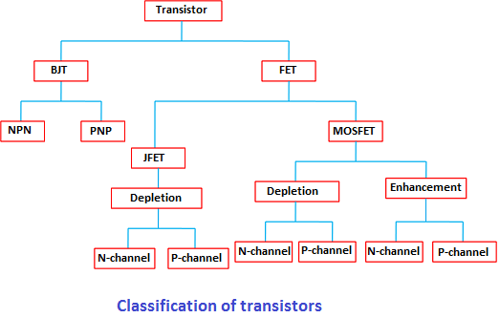

The transistors are mainly classified into two types: Bipolar Junction Transistor (BJT) and Field Effect Transistor (FET). In Bipolar Junction Transistor (BJT), both free electrons and holes conduct electric current whereas in Field Effect Transistor (FET) either free electrons or holes conduct electric current.

The Bipolar Junction Transistors (BJTs) are again classified into two types: they are NPN and PNP transistors.

The Field Effect Transistors (FETs) are classified into two types: JFET and MOSFET. JFET stands for Junction Field Effect Transistor and MOSFET stands for Metal Oxide Semiconductor Field Effect Transistor.

The Junction Field Effect Transistors (JFETs) in depletion mode are classified into two types: N-channel and P-channel.

The MOSFET transistors are classified into two types: depletion mode MOSFET and enhancement mode MOSFET.

The depletion mode MOSFET is classified into two types: N-channel and P-channel.

The enhancement mode MOSFET is classified into two types: N-channel and P-channel.

**Bipolar Junction Transistor**

Introduction

Bipolar junction transistor definition

A bipolar junction transistor or BJT is a three terminal electronic device that amplifies the flow of [current](https://www.physics-and-radio-electronics.com/electronic-devices-and-circuits/introduction/electriccurrent-howelectriccurrentproduced.html). It is a current controlled device. In bipolar junction transistor, electric current is conducted by both [free electrons](https://www.physics-and-radio-electronics.com/electronic-devices-and-circuits/introduction/free-electrons.html) and [holes](https://www.physics-and-radio-electronics.com/electronic-devices-and-circuits/semiconductor/hole.html).

Unlike a normal [pn junction diode](https://www.physics-and-radio-electronics.com/electronic-devices-and-circuits/semiconductor-diodes/pnjunctionsemiconductordiode.html), the [transistor](https://www.physics-and-radio-electronics.com/electronic-devices-and-circuits/transistors/transistors-introduction.html) has two [p-n junctions](https://www.physics-and-radio-electronics.com/electronic-devices-and-circuits/semiconductor-diodes/p-n-junction-introduction.html).

Types of Bipolar Junction Transistors (BJTs)

The bipolar junction transistors are formed by sandwiching either [n-type](https://www.physics-and-radio-electronics.com/electronic-devices-and-circuits/semiconductor/extrinsic-semiconductor/n-type-semiconductor.html) or [p-type semiconductor layer](https://www.physics-and-radio-electronics.com/electronic-devices-and-circuits/semiconductor/extrinsic-semiconductor/p-type-semiconductor.html) between pairs of opposite polarity semiconductor layers.

Bipolar junction transistors are classified into two types based on their construction: They are

* NPN transistor
* PNP transistor

NPN transistor

When a single p-type semiconductor layer is sandwiched between two n-type semiconductor layers, the transistor is said to be an npn transistor

PNP transistor

When a single n-type semiconductor layer is sandwiched between two p-type semiconductor layers, the transistor is said to be a pnp transistor.

Both PNP and NPN transistors consist of three terminals: they are emitter, base, and collector.

Terminals of BJT

Emitter:

As the name suggests, the emitter section supplies the charge carriers. The emitter section is heavily doped so that it can inject a large number of charge carriers into the base. The size of the emitter is always greater than the base.

Base:

The middle layer is called base. The base of the transistor is very thin as compared to emitter and collector. It is very lightly doped.

Collector:

The function of the collector is to collect charge carriers. It is moderately doped. That is the doping level of the collector section is in between emitter and base. The size of the collector is always greater than emitter and base. The collector area in the transistor is considerably larger than the emitter area. This is because the collector region has to handle more power than the emitter does and more surface area is required for heat dissipation.

In transistor, the amplification is achieved by passing input current from a region of low resistance to a region of high resistance.

Applications of bipolar junction transistor

The various applications of bipolar junction transistors include:

* Televisions
* Mobile phones
* Computers
* Radio transmitters
* Audio amplifiers

BJT operation modes

The transistor can be operated in three modes:

* Cut-off mode
* Saturation mode
* Active mode

In order to operate transistor in one of these regions, we have to supply dc voltage to the npn or pnp transistor. Based on the polarity of the applied dc [voltage](https://www.physics-and-radio-electronics.com/electromagnetics/electrostatics/potential-difference.html), the transistor operates in any one of these regions.

Applying dc voltage to the transistor is nothing but the biasing of transistor.

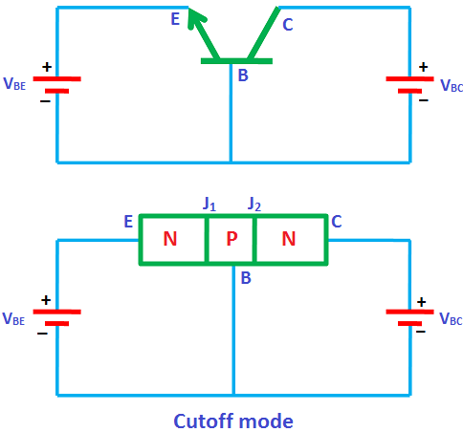Cutoff mode

In the cutoff mode, both the junctions of the transistor (emitter to base and collector to base) are [reverse biased](https://www.physics-and-radio-electronics.com/electronic-devices-and-circuits/semiconductor-diodes/reversebiaseddiode.html). In other words, if we assume two [p-n junctions](https://www.physics-and-radio-electronics.com/electronic-devices-and-circuits/semiconductor-diodes/p-n-junction-introduction.html) as two [p-n junction diodes](https://www.physics-and-radio-electronics.com/electronic-devices-and-circuits/semiconductor-diodes/pnjunctionsemiconductordiode.html), both the diodes are reverse biased in cutoff mode. We know that in reverse bias condition, no [current](https://www.physics-and-radio-electronics.com/electronic-devices-and-circuits/introduction/electriccurrent-howelectriccurrentproduced.html) flows through the device. Hence, no current flows through the transistor. Therefore, the transistor is in off state and acts like an open switch.

The cutoff mode of the transistor is used in switching operation for switch OFF application.

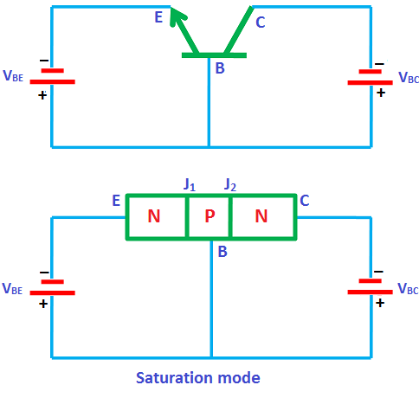Saturation mode

In the saturation mode, both the junctions of the transistor (emitter to base and collector to base) are [forward biased](https://www.physics-and-radio-electronics.com/electronic-devices-and-circuits/semiconductor-diodes/forwardbiasedpnjunctionsemiconductordiode.html). In other words, if we assume two p-n junctions as two p-n junction diodes, both the diodes are forward biased in saturation mode. We know that in forward bias condition, current flows through the device. Hence, electric current flows through the transistor.

In saturation mode, [free electrons](https://www.physics-and-radio-electronics.com/electronic-devices-and-circuits/introduction/free-electrons.html) (charge carriers) flows from emitter to base as well as from collector to base. As a result, a huge current will flow to the base of transistor.

Therefore, the transistor in saturation mode will be in on state and acts like a closed switch.

The saturation mode of the transistor is used in switching operation for switch ON application.

From the above discussion, we can say that by operating the transistor in saturation and cutoff region, we can use the transistor as an ON/OFF switch.

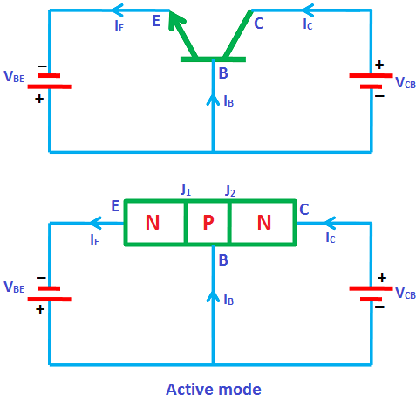Active mode

In the active mode, one junction (emitter to base) is forward biased and another junction (collector to base) is reverse biased. In other words, if we assume two p-n junctions as two p-n junction diodes, one diode will be forward biased and another diode will be reverse biased.

The active mode of operation is used for the amplification of current.

From the above discussion, we can say that the transistor works as an ON/OFF switch in saturation and cutoff modes whereas it works as an amplifier of current in active mode.

NPN transistor

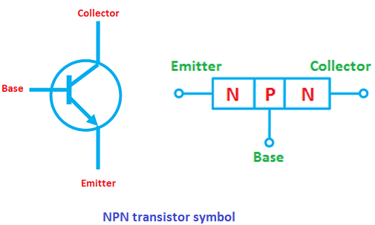When a single [p-type semiconductor layer](https://www.physics-and-radio-electronics.com/electronic-devices-and-circuits/semiconductor/extrinsic-semiconductor/p-type-semiconductor.html) is sandwiched between two [n-type semiconductor layers](https://www.physics-and-radio-electronics.com/electronic-devices-and-circuits/semiconductor/extrinsic-semiconductor/n-type-semiconductor.html), an npn transistor is formed.

NPN transistor symbol

The circuit symbol and [diode](https://www.physics-and-radio-electronics.com/electronic-devices-and-circuits/semiconductor-diodes/pnjunctionsemiconductordiode.html) analogy of npn transistor is shown in the below figure.

In the above figure, it is shown that the [electric current](https://www.physics-and-radio-electronics.com/electronic-devices-and-circuits/introduction/electriccurrent-howelectriccurrentproduced.html) always flows from p-region to n-region.

NPN transistor construction

The npn transistor is made up of three semiconductor layers: one p-type semiconductor layer and two n-type semiconductor layers.

The p-type semiconductor layer is sandwiched between two n-type semiconductor layers.

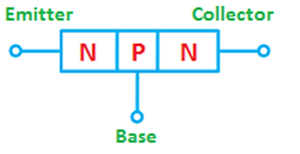

The npn transistor has three terminals: emitter, base and collector. The emitter terminal is connected to the left side n-type layer. The collector terminal is connected to the right side n-type layer. The base terminal is connected to the p-type layer.

The npn transistor has two [p-n junctions](https://www.physics-and-radio-electronics.com/electronic-devices-and-circuits/semiconductor-diodes/p-n-junction-introduction.html). One junction is formed between the emitter and the base. This junction is called emitter-base junction or emitter junction. The other junction is formed between the base and the collector. This junction is called collector-base junction or collector junction.

Working of a npn transistor

Unbiased npn transistor

When no [voltage](https://www.physics-and-radio-electronics.com/electromagnetics/electrostatics/potential-difference.html) is applied to a transistor, it is said to be an unbiased transistor. At the left side n-region (emitter) and right side n-region (collector), [free electrons](https://www.physics-and-radio-electronics.com/electronic-devices-and-circuits/introduction/free-electrons.html) are the majority carriers and [holes](https://www.physics-and-radio-electronics.com/electronic-devices-and-circuits/semiconductor/hole.html) are the minority carriers whereas in p-region (base), holes are the majority carriers and free electrons are the minority carriers.

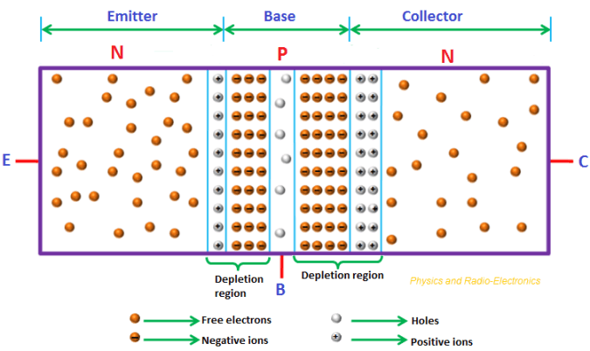

We know that the charge carriers (free electrons and holes) always try to move from higher concentration region to lower concentration region.

For free electrons, n-region is the higher concentration region and p-region is the lower concentration region. Similarly, for holes, p-region is the higher concentration region and n-region is the lower concentration region.

Therefore, the free electrons at the left side n-region (emitter) and right side n-region (collector) experience a repulsive force from each other. As a result, the free electrons at the left side and right side n-regions (emitter and collector) will move into the p-region (base).

During this process, the free electrons meet the holes in the p-region (base) near the junction and fill them. As a result, [depletion region](https://www.physics-and-radio-electronics.com/electronic-devices-and-circuits/semiconductor-diodes/depletion-region.html) (positive and negative ions) is formed at the emitter to base junction and base to collector junction.

At emitter to base junction, the depletion region is penetrated more towards the base side, similarly; at base to collector junction, the depletion region is penetrated more towards the base side.

This is because at emitter to base junction, the emitter is heavily doped and base is lightly doped so the depletion region is penetrated more towards the base side and less towards the emitter side. Similarly, at base to collector junction, the collector is heavily doped and base is lightly doped so the depletion region is penetrated more towards the base side and less towards the collector side.

The collector region is lightly doped than the emitter region, so the depletion layer width at the collector side is more than the depletion layer width at emitter side.

Why depletion region penetrates more towards lightly doped side than the heavily doped side?

We know that doping is the process of adding impurities to the intrinsic semiconductor to improve its electrical conductivity. The electrical conductivity of the semiconductor is depends on the doping level added to it.

If the semiconductor material is heavily doped, its electrical conductivity is very high. That means the heavily doped semiconductor material has a large number of charge carriers which conduct electric current.

If the semiconductor material is lightly doped, its electrical conductivity is very low. That means the lightly doped semiconductor material has a small number of charge carriers which conduct electric current.

We know that in n-type semiconductor, free electrons are the majority charge carriers and holes are the minority charge carriers.

In npn transistor, the left side n-region (emitter) is heavily doped. So the emitter has a large number of free electrons.

We know that in p-type semiconductor, holes are the majority charge carriers and free electrons are the minority charge carriers.

The p-region (base) is lightly doped. So the base has a small number of holes.

The right side n-region (collector) is moderately doped. Its doping level lies between that of emitter and base.

When the [atom](https://www.physics-and-radio-electronics.com/electronic-devices-and-circuits/introduction/atom.html) loses or donates an electron, it becomes a positive ion. On the other hand, when the atom gains or accepts an electron, it becomes a negative ion.

The atoms which donate electrons are known as donors and the atoms which accept electrons are known as acceptors.

Emitter-base junction:

Let us assume that, at left side n-region (emitter), each atom has three free electrons, and at p-region, each atom has one hole.

During the [diffusion](https://www.physics-and-radio-electronics.com/electronic-devices-and-circuits/semiconductor/diffusion-current.html) process, the free electrons move from emitter (n-region) to base (p-region). Similarly, the holes move from base (p-region) to emitter (n-region).



At emitter-base junction, when the n-region (emitter) atoms meet the p-region (base) atoms, each n-region atom donates three free electrons to three p-region atoms. As a result, the n-region (emitter) atom which donates three free electrons will become a positive ion and the three p-region (base) atoms which accepts (each accept one free electron) three free electrons will become negative ions. Thus, each n-region (emitter) positive ion produces three p-region (base) negative ions.

Therefore, the depletion region at the emitter-base junction contains more negative ions than the positive ions. The negative ions reside at the p-region (base) near the junction and the positive ions reside at the n-region (emitter) near the junction.

Therefore, the depletion region is penetrated more towards the p-region (base) than the n-region (emitter).

Base-collector junction:

Let us assume that, at right side n-region (collector), each atom has two free electrons, and at p-region, each atom has one hole.

During the diffusion process, the free electrons move from collector (n-region) to base (p-region). Similarly, the holes move from base (p-region) to collector (n-region).

At base-collector junction, when the n-region (collector) atoms meet the p-region (base) atoms, each n-region (collector) atom donates two free electrons to two p-region (base) atoms. As a result, the n-region (collector) atom which donates two free electrons will become a positive ion and the two p-region (base) atoms which accepts (each accept one free electron) two free electrons will become negative ions. Thus, each n-region (collector) positive ion produces two p-region (base) negative ions.

Therefore, the depletion region at the base-collector junction contains more negative ions than the positive ions. The negative ions reside at the p-region (base) near the junction and the positive ions reside at the n-region (collector) near the junction.

Therefore, the depletion region is penetrated more towards the p-region (base) than the n-region (collector).

However, the depletion layer width at the collector side is more than the depletion layer width at emitter side. This is because the collector region is lightly doped than the emitter region.

Biased npn transistor

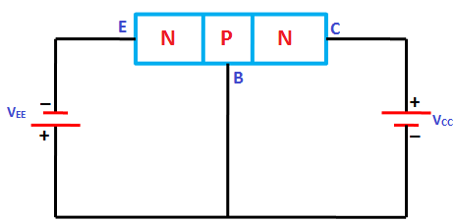When external voltage is applied to an npn transistor, it is said to be a biased npn transistor. Depending on the polarity of the applied voltage, the [npn transistor can be operated in three modes](https://www.physics-and-radio-electronics.com/electronic-devices-and-circuits/transistors/bipolarjunctiontransistor/bjtoperationmodes.html): active mode, cutoff mode and saturation mode.

So let’s see how an npn transistor works in active mode.

Let us consider an npn transistor as shown in the below figure. In the below figure, the emitter-base junction is forward biased by the DC voltage VEE and base-collector junction is reverse biased by the DC voltage VCC.

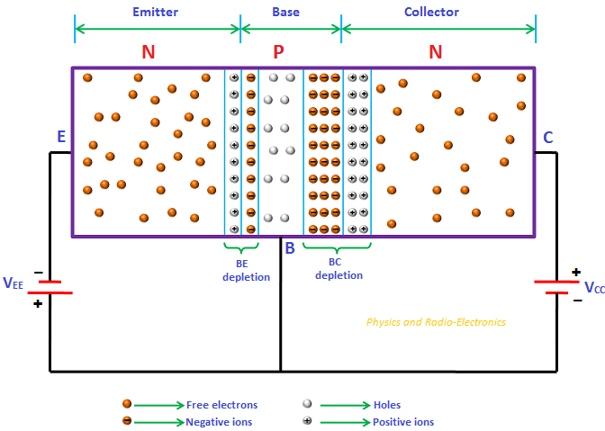

Emitter-base junction:

Due to the forward bias, a large number of free electrons in the left side n-region (emitter) experience a repulsive force from the negative terminal of the DC battery and also they experience an attractive force from the positive terminal of the battery. As a result, the free electrons start flowing from emitter to base. In the similar way, holes in base experience a repulsive force from the positive terminal of the battery and also experience an attractive force from the negative terminal of the battery. As a result, the holes start flowing from base to emitter.



Due to the applied external voltage, each emitter atom has more than one or two free electrons. Hence, each emitter atom donates more than one or two free electrons to more positive ions. As a result, the positive ions become neutral. Similarly, each base atom accepts more number of electrons from more negative ions. As a result, the negative ions become neutral. We know that depletion region is nothing but combination of positive ions and negative ions.

Thus, the depletion width at the emitter-base junction reduces by applying the forward bias voltage.

We know that electric current means flow of charge carriers. The free electrons (negative charge carriers) flow from emitter to base whereas holes (positive charge carriers) flow from base to emitter. These charge carriers conduct electric current. However, the [conventional current](https://www.physics-and-radio-electronics.com/electronic-devices-and-circuits/semiconductor/intrinsic-semiconductor/conventional-current.html) direction is same as the direction of holes.

Thus, the electric current flows from base to emitter.

Base-collector junction:

Due to the reverse bias, a large number of free electrons in the right side n-region (collector) experience an attractive force from the positive terminal of the battery. Hence, the free electrons move away from the junction and flow towards the positive terminal of the battery. As a result, a large number of neutral collector atoms loses electrons and becomes positive ions. On the other hand, holes in the p-region (base) experience an attractive force from the negative terminal of the battery. Hence, the holes move away from the junction and flow towards the negative terminal of the battery. As a result, a large number of neutral base atoms gains electrons and becomes negative ions.

Thus, the width of depletion region increases at base-collector junction. In other words, the number of positive and negative ions increases at the base-collector junction.

Collector-base-emitter current:



The free electrons that are flowing from emitter to base due to forward bias will combine with the holes in the base. However, the base is very thin and lightly doped. So only, a small percentage of emitter free electrons combines with the holes in the base region. The remaining large number of free electrons will cross the base region and reaches to the collector region. This is due to the positive supply voltage applied at collector. Hence, free electrons flow from emitter to collector. At collector, both the emitter free electrons and collector free electrons produces current by flowing towards the positive terminal of the battery. Therefore, an amplified current is produced at the output.

In npn transistor, the electric current is majorly conducted by free electrons.

**Bipolar Junction Transistor**

PNP transistor

When a single [n-type semiconductor](https://www.physics-and-radio-electronics.com/electronic-devices-and-circuits/semiconductor/extrinsic-semiconductor/n-type-semiconductor.html) layer is sandwiched between two [p-type semiconductor](https://www.physics-and-radio-electronics.com/electronic-devices-and-circuits/semiconductor/extrinsic-semiconductor/p-type-semiconductor.html) layers, a pnp transistor is formed.

PNP transistor symbol

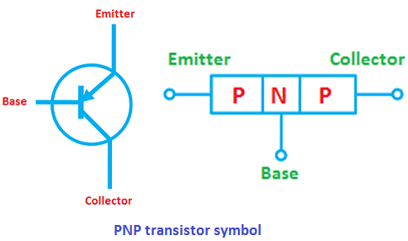The circuit symbol and [diode](https://www.physics-and-radio-electronics.com/electronic-devices-and-circuits/semiconductor-diodes/pnjunctionsemiconductordiode.html) analogy of pnp transistor is shown in the below figure.

PNP transistor construction

The pnp transistor is made up of three semiconductor layers: one n-type semiconductor layer and two p-type semiconductor layers.

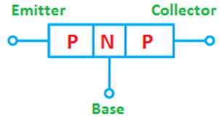The n-type semiconductor layer is sandwiched between two p-type semiconductor layers.

The pnp transistor has three terminals: emitter, base and collector. The emitter terminal is connected to the left side p-type layer. The collector terminal is connected to the right side p-type layer. The base terminal is connected to the n-type layer.

The pnp transistor has two [p-n junctions](https://www.physics-and-radio-electronics.com/electronic-devices-and-circuits/semiconductor-diodes/p-n-junction-introduction.html). One junction is formed between the emitter and the base. This junction is called emitter-base junction or emitter junction. The other junction is formed between the base and the collector. This junction is called collector-base junction or collector junction.

Working of a pnp transistor

Unbiased pnp transistor

When no [voltage](https://www.physics-and-radio-electronics.com/electromagnetics/electrostatics/potential-difference.html) is applied to a pnp transistor, it is said to be an unbiased pnp transistor. At the left side p-region (emitter) and right side p-region (collector), [holes](https://www.physics-and-radio-electronics.com/electronic-devices-and-circuits/semiconductor/hole.html) are the majority carriers and [free electrons](https://www.physics-and-radio-electronics.com/electronic-devices-and-circuits/introduction/free-electrons.html) are the minority carriers whereas in n-region (base), free electrons are the majority carriers and holes are the minority carriers.

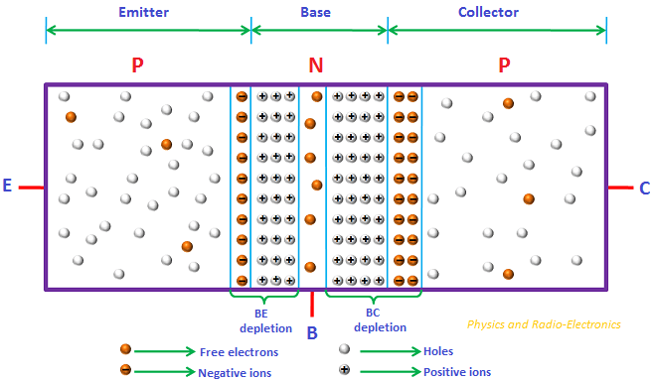

We know that the charge carriers (free electrons and holes) always try to move from higher concentration region to lower concentration region.

For holes, p-region is the higher concentration region and n-region is the lower concentration region. Similarly, for free electrons, n-region is the higher concentration region and p-region is the lower concentration region.

Therefore, the holes at the left side p-region (emitter) and right side p-region (collector) experience a repulsive force from each other. As a result, the holes at the left side and right side p-regions (emitter and collector) will move into the n-region (base).

During this process, the holes meet the free electrons in the n-region (base) and recombines with them. As a result, [depletion region](https://www.physics-and-radio-electronics.com/electronic-devices-and-circuits/semiconductor-diodes/depletion-region.html) (positive and negative ions) is formed at the emitter to base junction and base to collector junction.

At emitter to base junction, the depletion region is penetrated more towards the base side, similarly; at base to collector junction, the depletion region is penetrated more towards the base side.

This is because at emitter to base junction, the emitter is heavily doped and base is lightly doped so the depletion region is penetrated more towards the base side and less towards the emitter side. Similarly, at base to collector junction, the collector is heavily doped and base is lightly doped so the depletion region is penetrated more towards the base side and less towards the collector side.

The collector region is lightly doped than the emitter region, so the depletion layer width at the collector side is more than the depletion layer width at emitter side.

Biased pnp transistor

When external voltage is applied to a pnp transistor, it is said to be a biased pnp transistor. Depending on the polarity of the applied voltage, the [pnp transistor can be operated in three modes](https://www.physics-and-radio-electronics.com/electronic-devices-and-circuits/transistors/bipolarjunctiontransistor/bjtoperationmodes.html): active mode, cutoff mode and saturation mode.

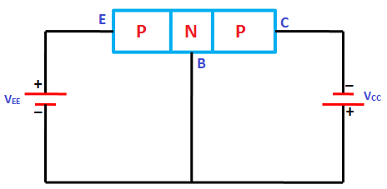

The pnp transistor is often operated in active mode because in active mode the pnp transistor amplifies the [electric current](https://www.physics-and-radio-electronics.com/electronic-devices-and-circuits/introduction/electriccurrent-howelectriccurrentproduced.html).

So let’s see how a pnp transistor works in active mode.

Let us consider a pnp transistor as shown in the below figure. In the below figure, the emitter-base junction is forward biased by the DC voltage VEE and base-collector junction is reverse biased by the DC voltage VCC.

Emitter-base junction:

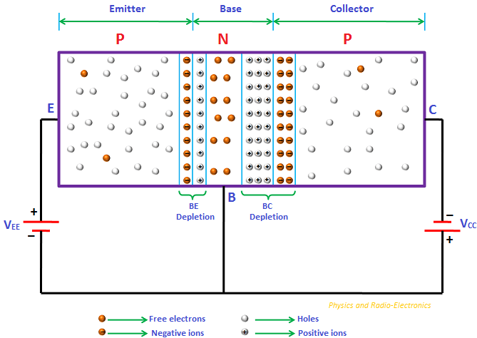

Due to the forward bias, a large number of holes in the left side p-region (emitter) experience a repulsive force from the positive terminal of the DC battery and also they experience an attractive force from the negative terminal of the battery. As a result, the holes start flowing from emitter to base. In the similar way, free electrons in base experience a repulsive force from the negative terminal of the battery and also experience an attractive force from the positive terminal of the battery. As a result, the free electrons start flowing from base to emitter.

The majority carriers holes carry most of the current from emitter to base. Thus, the electric current flows from emitter to base.

This electric current flow reduces the width of the depletion region at emitter-base junction.

Base-collector junction:

Due to the reverse bias, a large number of holes in the right side n-region (collector) experience an attractive force from the negative terminal of the battery. Hence, the holes move away from the junction and flow towards the negative terminal of the battery. As a result, a large number of neutral collector [atoms](https://www.physics-and-radio-electronics.com/electronic-devices-and-circuits/introduction/atom.html) gains electrons and becomes negative ions. On the other hand, free electrons in the n-region (base) experience an attractive force from the positive terminal of the battery. Hence, the free electrons move away from the junction and flow towards the positive terminal of the battery. As a result, a large number of neutral base atoms loses electrons and becomes positive ions.

Thus, the width of depletion region increases at base-collector junction. In other words, the number of positive and negative ions increases at the base-collector junction.

Emitter-base-collector current:

The holes that are flowing from emitter to base due to forward bias will combines with the free electrons in the base. However, the base is very thin and lightly doped. So only, a small percentage of emitter holes will combine with the free electrons in the base region. The remaining large number of holes will cross the base region and reaches to the collector region. This is due to the negative supply voltage applied at collector. Hence, the holes flow from emitter to collector. At collector, both the emitter holes and collector holes produces current by flowing towards the negative terminal of the battery. Therefore, an amplified current is produced at the output.

In pnp transistor, the electric current is majorly conducted by holes.

Transistor Construction

The transistor can be constructed by using one of the five basic techniques. Based on these techniques, they are classified as:

* Grown junction transistor
* Alloy junction transistor
* Diffusion junction transistor
* Epitaxial junction transistor
* Point contact junction transistor

Grown junction transistor

The grown junction transistor was developed on June 23, 1948, by William Shockley. It was developed six months after the first bipolar point-contact transistor.

The Czochralski technique is used to form the two [p-n junctions](https://www.physics-and-radio-electronics.com/electronic-devices-and-circuits/semiconductor-diodes/p-n-junction-introduction.html) of a grown junction transistor.

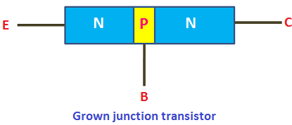

The NPN grown junction transistor is made up of a single crystal of [semiconductor](https://www.physics-and-radio-electronics.com/electronic-devices-and-circuits/semiconductor.html) material (silicon or germanium). The impurity concentration of this semiconductor material is changed during the crystal drawing operation by adding n-type or p-type atoms as required.

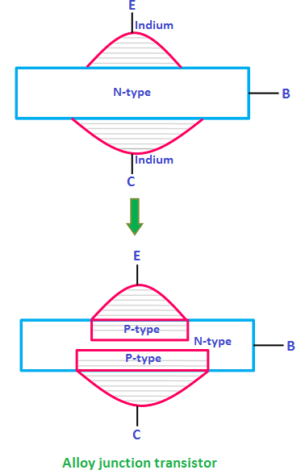Alloy junction transistor

The alloy transistor or alloy junction transistor is a germanium BJT (bipolar junction transistor) developed at General Electric and RCA in 1951 as an improvement over the earlier grown junction transistor. The alloy junction technique is also called the fused technique.

The alloy junction transistor is made up of a thin wafer of n-type germanium material forming the base, with two dots of indium (acceptor atoms) attached to opposite sides of the n-type material.

The whole structure is raised to a high temperature, above the melting point of indium but below that of germanium.

A tiny portion of indium dissolves and enters into the wafer of [n-type material](https://www.physics-and-radio-electronics.com/electronic-devices-and-circuits/semiconductor/extrinsic-semiconductor/n-type-semiconductor.html). Thus, the [p-type material](https://www.physics-and-radio-electronics.com/electronic-devices-and-circuits/semiconductor/extrinsic-semiconductor/p-type-semiconductor.html) is created at two sides of the n-type wafer.

The upper p-type material is the emitter, the lower p-type material is the collector, and the center thin n-type material is the base.

The collector (lower p-type material) is made larger than the emitter (upper p-type material) to withstand the heavy [current](https://www.physics-and-radio-electronics.com/electronic-devices-and-circuits/introduction/electriccurrent-howelectriccurrentproduced.html).

Diffusion junction transistor

The diffusion junction transistor was developed by Bell Laboratories in 1954.

The diffusion junction transistor is a transistor which is formed when the n-type silicon wafer called substrate is exposed to p-type and n-type gaseous impurities.

[Diffusion](https://www.physics-and-radio-electronics.com/electronic-devices-and-circuits/semiconductor/diffusion-current.html) is the process by which charged particles flows from a higher concentration region to a lower concentration region. The diffusion junction transistors use this diffusion technique to form the transistor.

In this technique, an n-type substrate is placed in gaseous acceptor impurities and heated. The acceptor impurities diffuse into the n-type substrate (collector) to form a p-type layer (base) on it.

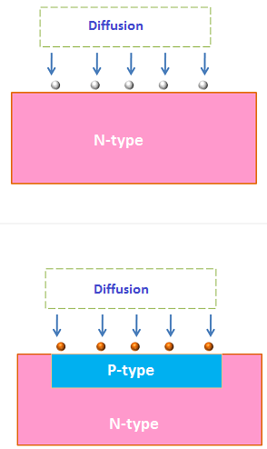

Thus, a p-type layer (base) is created on the n-type layer (collector).

The entire system is exposed to the gaseous donor impurities and again heated. The donor impurities diffuse into the p-type layer (base) to form an n-type layer (emitter) on it.

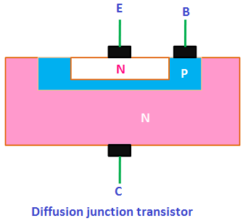

Thus, an n-type layer (emitter) is created on the p-type layer (base).

At last, a thin layer of silicon dioxide is grown over the entire surface and photoetched, so that aluminum contacts can be made for the emitter and base leads.

Epitaxial junction transistor

The term Epitaxy is a Greek word composed of two parts, namely ‘epi’ which means ‘on’ and ‘taxy’ which means ‘ordered arrangement’. Thus, Epitaxy refers to ordered arrangement on some materials.

In this technique, a very thin layer of [p-type semiconductor](https://www.physics-and-radio-electronics.com/electronic-devices-and-circuits/semiconductor/extrinsic-semiconductor/p-type-semiconductor.html) or [n-type semiconductor](https://www.physics-and-radio-electronics.com/electronic-devices-and-circuits/semiconductor/extrinsic-semiconductor/n-type-semiconductor.html) is grown on a heavily doped substrate of the same material. If the substrate is n-type, a thin n-type semiconductor layer is grown on the substrate. In a similar way, if the substrate is p-type, a thin p-type semiconductor layer is grown on the substrate.

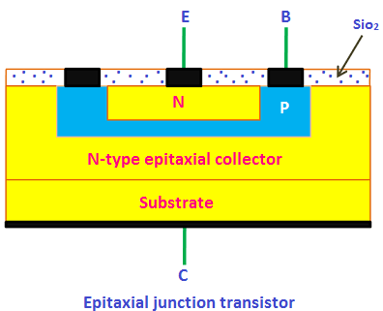

This single n-type or p-type semiconductor layer forms the collector on which the base and emitter regions may be diffused.

The most commonly used epitaxial techniques are grown diffused types, diffused alloy types, and alloy emitter epitaxial types base transistors.

Point contact junction transistor

The point contact transistor was the first type of transistor ever constructed. It was developed by Walter Brattain, John Bardeen, and William Shockley at Bell Laboratories in December 1947.

The point contact transistor consists of a block of Germanium semiconductor, with two very closely spaced gold contacts held against it by a spring. A small strip of gold foil is attached over the point of a plastic triangle.

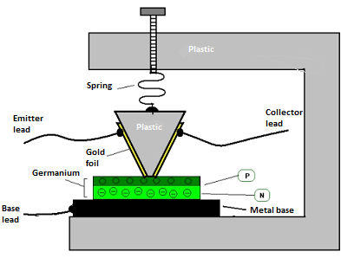

The germanium material has an excess of electrons. When an electrical signal passes through the gold foil, it injects holes into the n-type germanium. This creates a thin p-type semiconductor layer over the n-type semiconductor layer.

A small current applied to one of the two contacts had an influence on the current flows between the other contact and the base upon which the block of germanium was mounted.

A small change in the first contact current causes a greater change in the second contact current. Thus, it acts as an amplifier.

The first contact is the emitter and the second contact is the collector. The low current input terminal is the emitter while the high current output terminals are the base and collector.

Transistor Currents

We know that in [transistors](https://www.physics-and-radio-electronics.com/electronic-devices-and-circuits/transistors/transistors-introduction.html) and [diodes,](https://www.physics-and-radio-electronics.com/electronic-devices-and-circuits/semiconductor-diodes/pnjunctionsemiconductordiode.html) [electric current](https://www.physics-and-radio-electronics.com/electronic-devices-and-circuits/introduction/electriccurrent-howelectriccurrentproduced.html) is carried by both [free electrons](https://www.physics-and-radio-electronics.com/electronic-devices-and-circuits/introduction/free-electrons.html) and [holes](https://www.physics-and-radio-electronics.com/electronic-devices-and-circuits/semiconductor/hole.html). Free electrons and holes travel in opposite directions. For example, if free electrons flow from left to right then the holes will flow from right to left.

However, the direction of holes is assumed as same as the direction of the current.

When Benjamin Franklin started doing experiments on electricity, he believed that something is moving through the electrical wires. He named these moving things as charge. At that time, people did not know about electrons and protons.

Franklin assumed that there was only one type of charge and this charge will always flow from higher concentration region (excess charge carriers) to the lower concentration region (fewer charge carriers). He called the higher concentration region as positive and the lower concentration region as negative.

So according to Franklin, the charge always flows from positive to negative. We know that electric current means the flow of charge. So the electric current direction is from positive to negative.

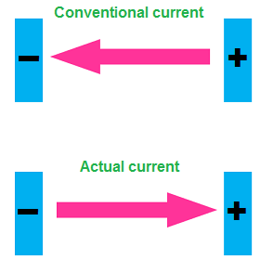

However, after the discovery of electrons and protons, scientists realized that the conventional current direction is wrong. The electric current is actually carried by the free electrons which flow from negative to positive. Thus, the actual current direction is from negative to positive. However, in honor of Franklin’s discovery, we still following his [conventional current](https://www.physics-and-radio-electronics.com/electronic-devices-and-circuits/semiconductor/intrinsic-semiconductor/conventional-current.html) direction (I.e. from positive to negative).

The conventional current direction of npn and pnp transistor is shown in the below figure.

Conventional current direction in pnp transistor

Consider the [pnp transistor](https://www.physics-and-radio-electronics.com/electronic-devices-and-circuits/transistors/bipolarjunctiontransistor/pnptransistor.html) as shown in the below figure. The emitter-base junction (p-n junction) or emitter junction is forward biased and the base-collector junction (n-p junction) or collector junction is reverse biased.

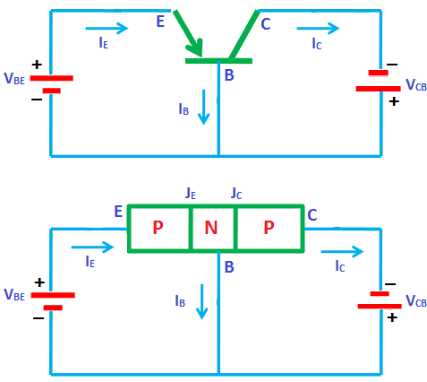

The emitter current (IE) direction which is represented by an arrow shows that the emitter current is flowing into the transistor. On the other hand, the base current (IB) and collector current (IC) are flowing outwards the transistor.

Conventional current direction in npn transistor

Consider the [npn transistor](https://www.physics-and-radio-electronics.com/electronic-devices-and-circuits/transistors/bipolarjunctiontransistor/npntransistor.html) as shown in the below figure. The emitter-base junction (n-p junction) is forward biased and the base-collector junction (p-n junction) is reverse biased.

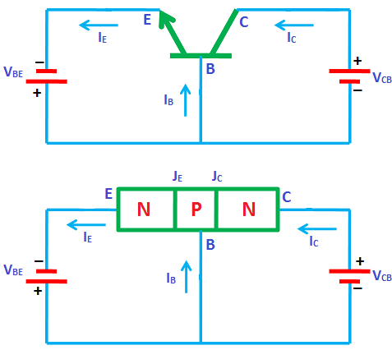

The emitter current IE direction which is represented by an arrow shows that the emitter current is flowing outwards the transistor. On the other hand, the base current IB and collector current IC are flowing into the transistor.

Transistor current components

The various current components in the pnp transistor which flow across the forward biased emitter junction JE and the reverse biased collector junction JC are shown in the below figure.

The emitter current IE consists of hole current IpE (majority carriers holes crossing from emitter into base) and electron current InE (majority carriers electrons crossing from base into emitter).

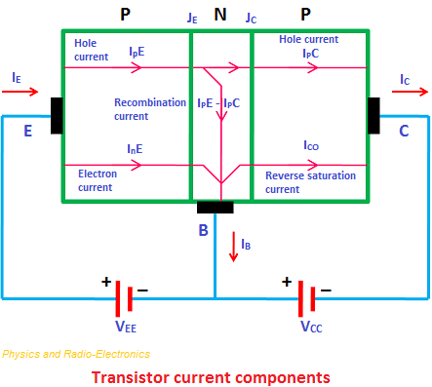

Therefore the total emitter current IE is the sum of hole current IpE and electron current InE

**IE = IpE + InE**

The ratio of hole to electron currents, IpE / InE, crossing the emitter junction is proportional to the ratio of the conductivity of the p material to that of the n material. We know that conductivity is directly proportional to the doping level. If doping level is more, conductivity is more similarly if doping level is less, conductivity is less.

In a commercial transistor, the doping of the emitter is made much larger than the doping of the base. Hence, in a pnp transistor the emitter current consists almost entirely of holes.

The holes crossing the emitter junction JE and reaching the collector junction JC constitutes hole current IpC in collector.

Not all the holes crossing the emitter junction JE reaches the collector junction JC, because some of them combine with the electrons in the n-type base.

We know that base is very thin and lightly doped. So only a small number of holes combine with the electrons in the n-type base, constituting the base current IPE - IPC. The remaining large number of holes cross the base region and enters into the collector region, constituting the hole current IpC in collector region.



Consider, for the moment, an open circuited emitter, while the collector junction remains reverse biased. When emitter is open circuited, the emitter current is zero IE = 0 and therefore hole current in collector is also zero IpC = 0.

In such condition, the collector-base junction JC acts as a reverse biased diode and the collector current IC is equal to the reverse saturation current or reverse saturation collector current ICO.

Now let us return to the situation where the emitter is forward biased.

When the emitter junction JE is forward biased and collector junction JC is reverse biased, the total collector current IC will be the sum of hole current in collector IpC and reverse saturation collector current ICO.

**IC = IpC + ICO**

Transistor terminal voltages

The supply [voltage](https://www.physics-and-radio-electronics.com/electromagnetics/electrostatics/potential-difference.html) polarities for [npn](https://www.physics-and-radio-electronics.com/electronic-devices-and-circuits/transistors/bipolarjunctiontransistor/npntransistor.html) and [pnp](https://www.physics-and-radio-electronics.com/electronic-devices-and-circuits/transistors/bipolarjunctiontransistor/pnptransistor.html) transistors are shown in the below figures.

Supply voltage polarities for npn transistor

The npn transistor is formed by sandwiching the single [p-type semiconductor layer](https://www.physics-and-radio-electronics.com/electronic-devices-and-circuits/semiconductor/extrinsic-semiconductor/p-type-semiconductor.html) between the two [n-type semiconductor layers](https://www.physics-and-radio-electronics.com/electronic-devices-and-circuits/semiconductor/extrinsic-semiconductor/n-type-semiconductor.html).

The supply voltage polarities for npn transistor is shown in the below figure.

The supply voltage between the base and the emitter is denoted by VBE. The base is biased positive with respect to the emitter and the arrowhead points from the positive base to the negative emitter. The arrowhead direction represents the direction of [current](https://www.physics-and-radio-electronics.com/electronic-devices-and-circuits/introduction/electriccurrent-howelectriccurrentproduced.html) flow.

The supply voltage between the collector and the base is denoted by VCB. The collector is biased to a higher positive level than the base to keep the collector-base junction reverse biased.

Supply voltage polarities for pnp transistor

The pnp transistor is formed by sandwiching the single n-type semiconductor layer between the two p-type semiconductor layers.

The supply voltage polarities for pnp transistor is shown in the below figure.

The supply voltage between the base and the emitter is denoted by VBE. The base is biased negative with respect to the emitter and the arrowhead points from the positive emitter to the negative base. The arrowhead direction represents the direction of current flow.

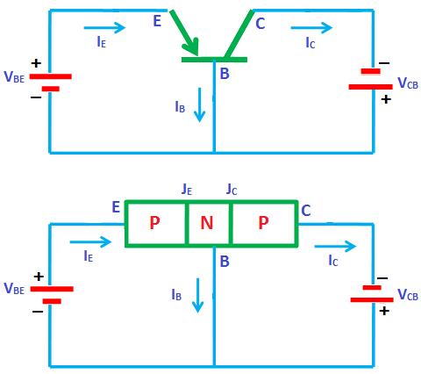

The supply voltage between the collector and the base is denoted by VCB. The collector is biased to a higher negative level than the base to keep the collector-base junction reverse biased

Typical voltages for a transistor

Base-emitter voltages (VBE) for npn and pnp transistors

The transistor is normally operated in the active region for amplifying the electric current. In active region, the emitter junction (JE) is forward biased and the collector junction (JC) is reverse biased.

The typical base-emitter voltages (VBE) for both npn and pnp transistors are as follows:

If the transistor is made up of a silicon material, the base-emitter voltage (VBE) will be 0.7 V.

If the transistor is made up of a germanium material, the base-emitter voltage (VBE) will be 0.3 V.

Collector-base voltages (VCB) for npn and pnp transistors

The typical collector-base voltages (VCB) for both npn and pnp transistors will be anywhere between 3 V to 20 V.

Types of Transistor Configuration

[Transistor](https://www.physics-and-radio-electronics.com/electronic-devices-and-circuits/transistors/transistors-introduction.html) is an electronic device which is primarily used to amplify the [electric current](https://www.physics-and-radio-electronics.com/electronic-devices-and-circuits/introduction/electriccurrent-howelectriccurrentproduced.html).

We know that transistor has three terminals namely emitter (E), base (B), and collector (C). But to connect a transistor in the circuit, we need four terminals: two terminals for input and other two terminals for output.

But the transistor does not have four terminals, then how do we connect transistor in a circuit. It is not as difficult as you think. One of the three terminals is used as common to both input and output.

When a transistor is to be connected in a circuit, one terminal is used as the input terminal, the other terminal is used as the output terminal and the third terminal is common to the input and output.

That means here input is applied between the input terminal and common terminal, and the corresponding output is taken between the output terminal and common terminal.

Depending upon the terminal which is used as a common terminal to the input and output terminals, the transistor can be connected in the following three configurations. They are:

* [Common base (CB) configuration](https://www.physics-and-radio-electronics.com/electronic-devices-and-circuits/transistors/bipolarjunctiontransistor/commonbaseconfiguration.html)
* [Common emitter (CE) configuration](https://www.physics-and-radio-electronics.com/electronic-devices-and-circuits/transistors/bipolarjunctiontransistor/commonemitterconfiguration.html)
* Common collector (CC) configuration

In every configuration, the base-emitter junction JE is always forward biased and the collector-base junction JC is always reverse biased to operate the transistor as a current amplifier.

Common base (CB) configuration

In [common base configuration](https://www.physics-and-radio-electronics.com/electronic-devices-and-circuits/transistors/bipolarjunctiontransistor/commonbaseconfiguration.html), emitter is the input terminal, collector is the output terminal, and base is the common terminal. The base terminal is grounded in the common base configuration. So the common base configuration is also known as grounded base configuration.

Common emitter (CE) configuration

In [common emitter configuration](https://www.physics-and-radio-electronics.com/electronic-devices-and-circuits/transistors/bipolarjunctiontransistor/commonemitterconfiguration.html), base is the input terminal, collector is the output terminal, and emitter is the common terminal. The emitter terminal is grounded in the common emitter configuration. So the common emitter configuration is also known as grounded emitter configuration.

Common collector (CC) configuration

In common collector configuration, base is the input terminal, emitter is the output terminal, and collector is the common terminal. The collector terminal is grounded in the common collector configuration. So the common collector configuration is also known as grounded collector configuration.

**Bipolar Junction Transistor**

Common Base Configuration

In common base configuration, emitter is the input terminal, collector is the output terminal and base terminal is connected as a common terminal for both input and output. That means the emitter terminal and common base terminal are known as input terminals whereas the collector terminal and common base terminal are known as output terminals.

In common base configuration, the base terminal is grounded so the common base configuration is also known as grounded base configuration. Sometimes common base configuration is referred to as common base amplifier, CB amplifier, or CB configuration.

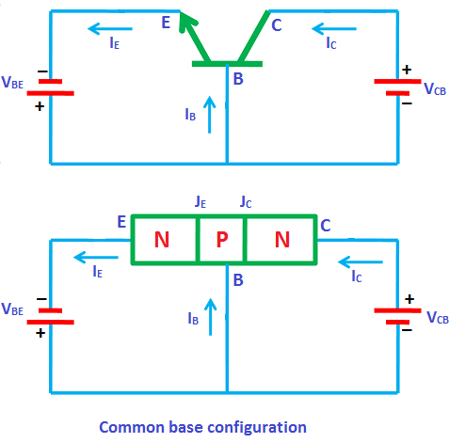

The input signal is applied between the emitter and base terminals while the corresponding output signal is taken across the collector and base terminals. Thus the base terminal of a transistor is common for both input and output terminals and hence it is named as common base configuration.

The supply [voltage](https://www.physics-and-radio-electronics.com/electromagnetics/electrostatics/potential-difference.html) between base and emitter is denoted by VBE while the supply voltage between collector and base is denoted by VCB.

As mentioned earlier, in every configuration, the base-emitter junction JE is always forward biased and collector-base junction JC is always reverse biased. Therefore, in common base configuration, the base-emitter junction JE is forward biased and collector-base junction JC is reverse biased.

The common base configuration for both [NPN](https://www.physics-and-radio-electronics.com/electronic-devices-and-circuits/transistors/bipolarjunctiontransistor/npntransistor.html) and [PNP transistors](https://www.physics-and-radio-electronics.com/electronic-devices-and-circuits/transistors/bipolarjunctiontransistor/pnptransistor.html) is shown in the below figure.

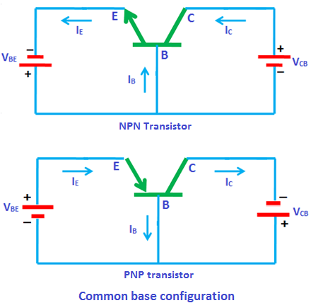

From the above circuit diagrams of npn and pnp transistors, it can be seen that for both npn and pnp transistors, the input is applied to the emitter and the output is taken from the collector. The common terminal for both the circuits is the base.

Current flow in common base amplifier

For the sake of understanding, let us consider NPN transistor in common base configuration.

The npn transistor is formed when a single [p-type semiconductor layer](https://www.physics-and-radio-electronics.com/electronic-devices-and-circuits/semiconductor/extrinsic-semiconductor/p-type-semiconductor.html) is sandwiched between two [n-type semiconductor layers](https://www.physics-and-radio-electronics.com/electronic-devices-and-circuits/semiconductor/extrinsic-semiconductor/n-type-semiconductor.html).



The base-emitter junction JE is forward biased by the supply voltage VBE while the collector-base junction JC is reverse biased by the supply voltage VCB.

Due to the forward bias voltage VBE, the [free electrons](https://www.physics-and-radio-electronics.com/electronic-devices-and-circuits/introduction/free-electrons.html) (majority carriers) in the emitter region experience a repulsive force from the negative terminal of the battery similarly [holes](https://www.physics-and-radio-electronics.com/electronic-devices-and-circuits/semiconductor/hole.html) (majority carriers) in the base region experience a repulsive force from the positive terminal of the [battery](http://www.physics-and-radio-electronics.com/blog/battery-battery-works/).

As a result, free electrons start flowing from emitter to base similarly holes start flowing from base to emitter. Thus free electrons which are flowing from emitter to base and holes which are flowing from base to emitter conducts [electric current](https://www.physics-and-radio-electronics.com/electronic-devices-and-circuits/introduction/electriccurrent-howelectriccurrentproduced.html). The actual current is carried by free electrons which are flowing from emitter to base. However, we follow the [conventional current direction](https://www.physics-and-radio-electronics.com/electronic-devices-and-circuits/semiconductor/intrinsic-semiconductor/conventional-current.html) which is from base to emitter. Thus electric current is produced at the base and emitter region.

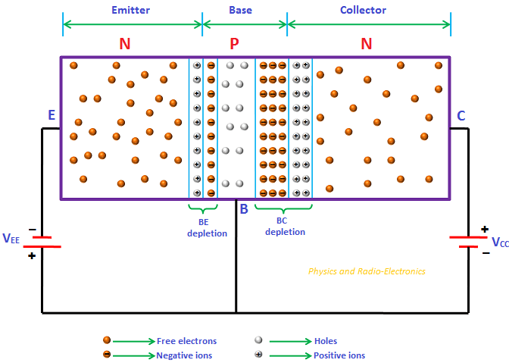

The free electrons which are flowing from emitter to base will combine with the holes in the base region similarly the holes which are flowing from base to emitter will combine with the electrons in the emitter region.

From the above figure, it is seen that the width of the base region is very thin. Therefore, only a small percentage of free electrons from emitter region will combine with the holes in the base region and the remaining large number of free electrons cross the base region and enters into the collector region. A large number of free electrons which entered into the collector region will experience an attractive force from the positive terminal of the battery. Therefore, the free electrons in the collector region will flow towards the positive terminal of the battery. Thus, electric current is produced in the collector region.

The electric current produced at the collector region is primarily due to the free electrons from the emitter region similarly the electric current produced at the base region is also primarily due to the free electrons from emitter region. Therefore, the emitter current is greater than the base current and collector current. The emitter current is the sum of base current and collector current.

IE = IB + IC

We know that emitter current is the input current and collector current is the output current.

The output collector current is less than the input emitter current, so the current gain of this amplifier is actually less than 1. In other words, the common base amplifier attenuates the electric current rather than amplifying it.

The base-emitter junction JE at input side acts as a [forward biased diode](https://www.physics-and-radio-electronics.com/electronic-devices-and-circuits/semiconductor-diodes/forwardbiasedpnjunctionsemiconductordiode.html). So the common base amplifier has a low input impedance (low opposition to incoming current). On the other hand, the collector-base junction JC at output side acts somewhat like a [reverse biased diode](https://www.physics-and-radio-electronics.com/electronic-devices-and-circuits/semiconductor-diodes/reversebiaseddiode.html). So the common base amplifier has high output impedance.

Therefore, the common base amplifier provides a low input impedance and high output impedance.

[Transistors](https://www.physics-and-radio-electronics.com/electronic-devices-and-circuits/transistors/transistors-introduction.html) with low input impedance and high output impedance provide a high voltage gain.

Even though the voltage gain is high, the current gain is very low and the overall power gain of the common base amplifier is low as compared to the other transistor amplifier configurations.

The common base transistor amplifiers are primarily used in the applications where low input impedance is required.

The common base amplifier is mainly used as a voltage amplifier or current buffer.

This type of transistor arrangement is not very common and is not as widely used as the other two transistor configurations.

The working principle of pnp transistor with CB configuration is same as the npn transistor with CB configuration. The only difference is in npn transistor free electrons conduct most of the current whereas in pnp transistor the holes conduct most of the current.

To fully describe the behavior of a transistor with CB configuration, we need two set of characteristics: they are

* Input characteristics
* Output characteristics.

Input characteristics

The input characteristics describe the relationship between input current (IE) and the input voltage (VBE).

First, draw a vertical line and horizontal line. The vertical line represents y-axis and horizontal line represents x-axis. The input current or emitter current (IE) is taken along the y-axis (vertical line) and the input voltage (VBE)is taken along the x-axis (horizontal line).

To determine the input characteristics, the output voltage VCB (collector-base voltage) is kept constant at zero volts and the input voltage VBE is increased from zero volts to different voltage levels. For each voltage level of the input voltage (VBE), the input current (IE) is recorded on a paper or in any other form.

A curve is then drawn between input current IE and input voltage VBE at constant output voltage VCB (0 volts).

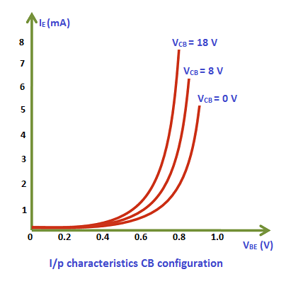

Next, the output voltage (VCB) is increased from zero volts to a certain voltage level (8 volts) and kept constant at 8 volts. While increasing the output voltage (VCB), the input voltage (VBE) is kept constant at zero volts. After we kept the output voltage (VCB) constant at 8 volts, the input voltage VBE is increased from zero volts to different voltage levels. For each voltage level of the input voltage (VBE), the input current (IE) is recorded on a paper or in any other form.

A curve is then drawn between input current IE and input voltage VBE at constant output voltage VCB (8 volts).

This is repeated for higher fixed values of the output voltage (VCB).

When output voltage (VCB) is at zero volts and emitter-base junction JE is forward biased by the input voltage (VBE), the emitter-base junction acts like a normal p-n junction diode. So the input characteristics are same as the forward characteristics of a normal pn junction diode.

The cut in voltage of a silicon transistor is 0.7 volts and germanium transistor is 0.3 volts. In our case, it is a silicon transistor. So from the above graph, we can see that after 0.7 volts, a small increase in input voltage (VBE) will rapidly increase the input current (IE).

When the output voltage (VCB) is increased from zero volts to a certain voltage level (8 volts), the emitter current flow will be increased which in turn reduces the depletion region width at emitter-base junction. As a result, the cut in voltage will be reduced. Therefore, the curves shifted towards the left side for higher values of output voltage VCB.

Output characteristics

The output characteristics describe the relationship between output current (IC) and the output voltage (VCB).

First, draw a vertical line and a horizontal line. The vertical line represents y-axis and horizontal line represents x-axis. The output current or collector current (IC) is taken along the y-axis (vertical line) and the output voltage (VCB)is taken along the x-axis (horizontal line).

To determine the output characteristics, the input current or emitter current IE is kept constant at zero mA and the output voltage VCB is increased from zero volts to different voltage levels. For each voltage level of the output voltage VCB, the output current (IC) is recorded.

A curve is then drawn between output current IC and output voltage VCB at constant input current IE (0 mA).

When the emitter current or input current IE is equal to 0 mA, the transistor operates in the cut-off region.

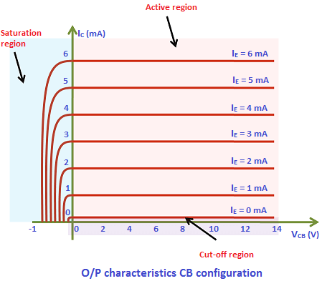

Next, the input current (IE) is increased from 0 mA to 1 mA by adjusting the input voltage VBE and the input current IE is kept constant at 1 mA. While increasing the input current IE, the output voltage VCB is kept constant.

After we kept the input current (IE) constant at 1 mA, the output voltage (VCB) is increased from zero volts to different voltage levels. For each voltage level of the output voltage (VCB), the output current (IC) is recorded.

A curve is then drawn between output current IC and output voltage VCB at constant input current IE (1 mA). This region is known as the active region of a transistor.

This is repeated for higher fixed values of input current IE (I.e. 2 mA, 3 mA, 4 mA and so on).

From the above characteristics, we can see that for a constant input current IE, when the output voltage VCB is increased, the output current IC remains constant.

At saturation region, both emitter-base junction JE and collector-base junction JC are forward biased. From the above graph, we can see that a sudden increase in the collector current when the output voltage VCB makes the collector-base junction JC forward biased.

Early effect

Due to forward bias, the base-emitter junction JE acts as a forward biased diode and due to reverse bias, the collector-base junction JC acts as a reverse biased diode.

Therefore, the width of the [depletion region](https://www.physics-and-radio-electronics.com/electronic-devices-and-circuits/semiconductor-diodes/depletion-region.html) at the base-emitter junction JE is very small whereas the width of the depletion region at the collector-base junction JC is very large.

If the output voltage VCB applied to the collector-base junction JC is further increased, the depletion region width further increases. The base region is lightly doped as compared to the collector region. So the depletion region penetrates more into the base region and less into the collector region. As a result, the width of the base region decreases. This dependency of base width on the output voltage (VCB) is known as an early effect.

If the output voltage VCB applied to the collector-base junction JC is highly increased, the base width may be reduced to zero and causes a voltage breakdown in the transistor. This phenomenon is known as punch through.

Transistor parameters

Dynamic input resistance (ri)

Dynamic input resistance is defined as the ratio of change in input voltage or emitter voltage (VBE) to the corresponding change in input current or emitter current (IE), with the output voltage or collector voltage (VCB) kept at constant.

Dynamic input resistance is defined as the ratio of change in input voltage or emitter voltage (VBE) to the corresponding change in input current or emitter current (IE), with the output voltage or collector voltage (VCB) kept at constant.

The input resistance of common base amplifier is very low.

Dynamic output resistance (ro)

Dynamic output resistance is defined as the ratio of change in output voltage or collector voltage (VCB) to the corresponding change in output current or collector current (IC), with the input current or emitter current (IE) kept at constant.

Dynamic output resistance is defined as the ratio of change in output voltage or collector voltage (VCB) to the corresponding change in output current or collector current (IC), with the input current or emitter current (IE) kept at constant.

The output resistance of common base amplifier is very high.

Current gain (α)

The current gain of a transistor in CB configuration is defined as the ratio of output current or collector current (IC) to the input current or emitter current (IE).

The current gain of a transistor in CB configuration is defined as the ratio of output current or collector current (IC) to the corresponding input current or emitter current (IE).

The current gain of a transistor in CB configuration is less than unity. The typical current gain of a common base amplifier is 0.98.

Common Emitter Configuration

In common emitter configuration, base is the input terminal, collector is the output terminal and emitter is the common terminal for both input and output. That means the base terminal and common emitter terminal are known as input terminals whereas collector terminal and common emitter terminal are known as output terminals.

In common emitter configuration, the emitter terminal is grounded so the common emitter configuration is also known as grounded emitter configuration. Sometimes common emitter configuration is also referred to as CE configuration, common emitter amplifier, or CE amplifier. The common emitter (CE) configuration is the most widely used transistor configuration.

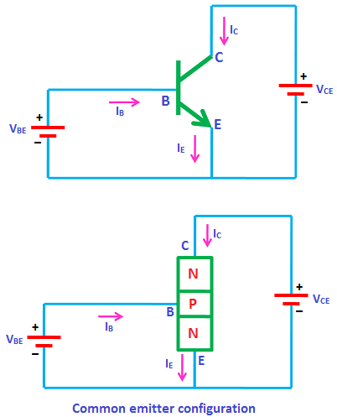

The common emitter (CE) amplifiers are used when large current gain is needed.

The input signal is applied between the base and emitter terminals while the output signal is taken between the collector and emitter terminals. Thus, the emitter terminal of a transistor is common for both input and output and hence it is named as common emitter configuration.

The supply [voltage](https://www.physics-and-radio-electronics.com/electromagnetics/electrostatics/potential-difference.html) between base and emitter is denoted by VBE while the supply voltage between collector and emitter is denoted by VCE.

In common emitter (CE) configuration, input [current](https://www.physics-and-radio-electronics.com/electronic-devices-and-circuits/introduction/electriccurrent-howelectriccurrentproduced.html) or base current is denoted by IB and output current or collector current is denoted by IC.

The common emitter amplifier has medium input and output impedance levels. So the current gain and voltage gain of the common emitter amplifier is medium. However, the power gain is high.

To fully describe the behavior of a [transistor](https://www.physics-and-radio-electronics.com/electronic-devices-and-circuits/transistors/transistors-introduction.html) with CE configuration, we need two set of characteristics – input characteristics and output characteristics.

Input characteristics

The input characteristics describe the relationship between input current or base current (IB) and input voltage or base-emitter voltage (VBE).

First, draw a vertical line and a horizontal line. The vertical line represents y-axis and horizontal line represents x-axis. The input current or base current (IB) is taken along y-axis (vertical line) and the input voltage (VBE)is taken along x-axis (horizontal line).

To determine the input characteristics, the output voltage VCE is kept constant at zero volts and the input voltage VBE is increased from zero volts to different voltage levels. For each voltage level of input voltage (VBE), the corresponding input current (IB) is recorded.

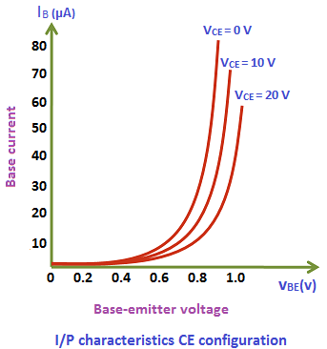

A curve is then drawn between input current IB and input voltage VBE at constant output voltage VCE (0 volts).

Next, the output voltage (VCE) is increased from zero volts to certain voltage level (10 volts) and the output voltage (VCE) is kept constant at 10 volts. While increasing the output voltage (VCE), the input voltage (VBE) is kept constant at zero volts. After we kept the output voltage (VCE) constant at 10 volts, the input voltage VBE is increased from zero volts to different voltage levels. For each voltage level of input voltage (VBE), the corresponding input current (IB) is recorded.

A curve is then drawn between input current IB and input voltage VBE at constant output voltage VCE (10 volts).

This process is repeated for higher fixed values of output voltage (VCE).

When output voltage (VCE) is at zero volts and emitter-base junction is forward biased by input voltage (VBE), the emitter-base junction acts like a normal [p-n junction diode](https://www.physics-and-radio-electronics.com/electronic-devices-and-circuits/semiconductor-diodes/pnjunctionsemiconductordiode.html). So the input characteristics of the CE configuration is same as the characteristics of a normal pn junction diode.

The cut in voltage of a silicon transistor is 0.7 volts and germanium transistor is 0.3 volts. In our case, it is a silicon transistor. So from the above graph, we can see that after 0.7 volts, a small increase in input voltage (VBE) will rapidly increases the input current (IB).

In common emitter (CE) configuration, the input current (IB) is very small as compared to the input current  (IE) in [common base (CB) configuration](https://www.physics-and-radio-electronics.com/electronic-devices-and-circuits/transistors/bipolarjunctiontransistor/commonbaseconfiguration.html). The input current in CE configuration is measured in microamperes (μA) whereas the input current in CB configuration is measured in milliamperes (mA).

In common emitter (CE) configuration, the input current (IB) is produced in the base region which is lightly doped and has small width. So the base region produces only a small input current (IB). On the other hand, in common base (CB) configuration, the input current (IE) is produced in the emitter region which is heavily doped and has large width. So the emitter region produces a large input current (IE). Therefore, the input current (IB) produced in the common emitter (CE) configuration is small as compared to the common base (CB) configuration.

Due to forward bias, the emitter-base junction acts as a forward biased diode and due to reverse bias, the collector-base junction acts as a reverse biased diode.

Therefore, the [width of the depletion region](https://www.physics-and-radio-electronics.com/electronic-devices-and-circuits/semiconductor-diodes/widthofdepletionregion.html) at the emitter-base junction is very small whereas the width of the depletion region at the collector-base junction is very large.

If the output voltage VCE applied to the collector-base junction is further increased, the depletion region width further increases. The base region is lightly doped as compared to the collector region. So the depletion region penetrates more into the base region and less into the collector region. As a result, the width of the base region decreases which in turn reduces the input current (IB) produced in the base region.

From the above characteristics, we can see that for higher fixed values of output voltage VCE, the curve shifts to the right side. This is because for higher fixed values of output voltage, the cut in voltage is increased above 0.7 volts. Therefore, to overcome this cut in voltage, more input voltage VBE is needed than previous case.

Output characteristics

The output characteristics describe the relationship between output current (IC) and output voltage (VCE).

First, draw a vertical line and a horizontal line. The vertical line represents y-axis and horizontal line represents x-axis. The output current or collector current (IC) is taken along y-axis (vertical line) and the output voltage (VCE)is taken along x-axis (horizontal line).

To determine the output characteristics, the input current or base current IB is kept constant at 0 μA and the output voltage VCE is increased from zero volts to different voltage levels. For each level of output voltage, the corresponding output current (IC) is recorded.

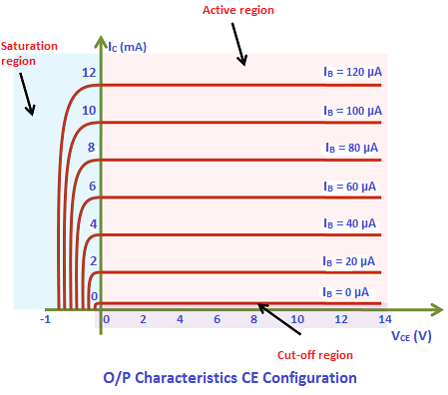

A curve is then drawn between output current IC and output voltage VCE at constant input current IB (0 μA).

When the base current or input current IB = 0 μA, the transistor operates in the cut-off region. In this region, both junctions are reverse biased.

Next, the input current (IB) is increased from 0 μA to 20 μA by adjusting the input voltage (VBE). The input current (IB)is kept constant at 20 μA.

While increasing the input current (IB), the output voltage (VCE) is kept constant at 0 volts.

After we kept the input current (IB) constant at 20 μA, the output voltage (VCE) is increased from zero volts to different voltage levels. For each voltage level of output voltage (VCE), the corresponding output current (IC) is recorded.

A curve is then drawn between output current IC and output voltage VCE at constant input current IB (20 μA). This region is known as the active region of a transistor. In this region, emitter-base junction is forward biased and the collector-base junction is reverse biased.

This steps are repeated for higher fixed values of input current IB (I.e. 40 μA, 60 μA, 80 μA and so on).

When output voltage VCE is reduced to a small value (0.2 V), the collector-base junction becomes forward biased. This is because the output voltage VCE has less effect on collector-base junction than input voltage VBE.

As we know that the emitter-base junction is already forward biased. Therefore, when both the junctions are forward biased, the transistor operates in the saturation region. In this region, a small increase in output voltage VCE will rapidly increases the output current IC.

Transistor parameters

Dynamic input resistance (ri)

Dynamic input resistance is defined as the ratio of change in input voltage or base voltage (VBE) to the corresponding change in input current or base current (IB), with the output voltage or collector voltage (VCE) kept at constant.

Dynamic input resistance is defined as the ratio of change in input voltage or base voltage (VBE) to the corresponding change in input current or base current (IB), with the output voltage

In CE configuration, the input resistance is very low.

Dynamic output resistance (ro)  
Dynamic output resistance is defined as the ratio of change in output voltage or collector voltage (VCE) to the corresponding change in output current or collector current (IC), with the input current or base current (IB) kept at constant.

Dynamic output resistance is defined as the ratio of change in output voltage or collector voltage (VCE) to the corresponding change in output current or collector 

In CE configuration, the output resistance is high.

Current gain β

The current gain of a transistor in CE configuration is defined as the ratio of output current or collector current (IC) to the input current or base current (IB).

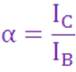

The current gain of a transistor in CE configuration is high. Therefore, the transistor in CE configuration is used for amplifying the [current](https://www.physics-and-radio-electronics.com/electronic-devices-and-circuits/introduction/electriccurrent-howelectriccurrentproduced.html).

Common Collector Configuration

In this configuration, the base terminal of the [transistor](https://www.physics-and-radio-electronics.com/electronic-devices-and-circuits/transistors/bipolarjunctiontransistor/bipolarjunctiontransistorintroduction.html) serves as the input, the emitter terminal is the output and the collector terminal is common for both input and output. Hence, it is named as common collector configuration. The input is applied between the base and collector while the output is taken from the emitter and collector.

In common collector configuration, the collector terminal is grounded so the common collector configuration is also known as grounded collector configuration.

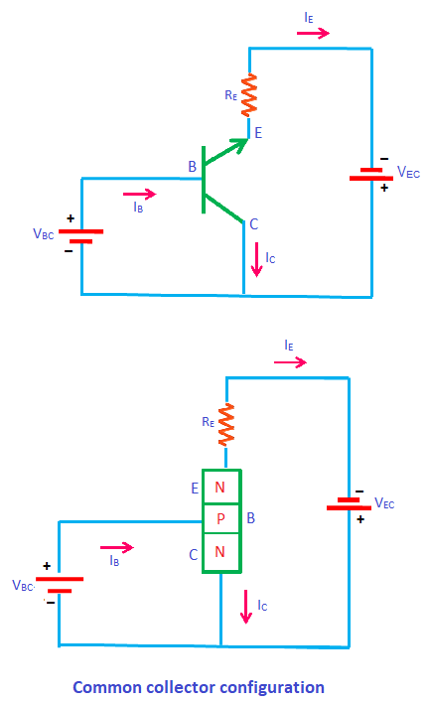

Sometimes common collector configuration is also referred to as emitter follower, voltage follower, common collector amplifier, CC amplifier, or CC configuration. This configuration is mostly used as a voltage buffer.

The input supply voltage between base and collector is denoted by VBC while the output voltage between emitter and collector is denoted by VEC.

In this configuration, input [current](https://www.physics-and-radio-electronics.com/electronic-devices-and-circuits/introduction/electriccurrent-howelectriccurrentproduced.html) or base current is denoted by IB and output current or emitter current is denoted by IE.The common collector amplifier has high input impedance and low output impedance. It has low voltage gain and high current gain.

The power gain of the common collector amplifier is medium. To fully describe the behavior of a transistor with CC configuration, we need two set of characteristics - input characteristics and output characteristics.

Input characteristics

The input characteristics describe the relationship between input current or base current (IB) and input voltage or base-collector voltage (VBC).

First, draw a vertical line and a horizontal line. The vertical line represents y-axis and horizontal line represents x-ax

The input current or base current (IB) is taken along y-axis (vertical line) and the input voltage or base-collector voltage (VBC) is taken along x-axis (horizontal line).

To determine the input characteristics, the output voltage VEC is kept constant at 3V and the input voltage VBC is increased from zero volts to different voltage levels. For each level of input voltage VBC, the corresponding input current IB is noted. A curve is then drawn between input current IB and input voltage VBC at constant output voltage VEC (3V).

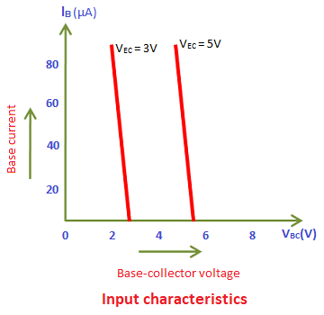

Next, the output voltage VEC is increased from 3V to different voltage level, say for example 5V and then kept constant at 5V. While increasing the output voltage VEC, the input voltage VBC is kept constant at zero volts.

After we kept the output voltage VEC constant at 5V, the input voltage VBC is increased from zero volts to different voltage levels. For each level of input voltage VBC, the corresponding input current IB is noted. A curve is then drawn between input current IB and input voltage VBC at constant output voltage VEC (5V).

This process is repeated for higher fixed values of output voltage (VEC).

Output characteristics

The output characteristics describe the relationship between output current or emitter current (IE) and output voltage or emitter-collector voltage (VEC).

First, draw a vertical line and a horizontal line. The vertical line represents y-axis and horizontal line represents x-axis.

The output current or emitter current (IE) is taken along y-axis (vertical line) and the output voltage or emitter-collector voltage (VEC) is taken along x-axis (horizontal line).

To determine the output characteristics, the input current IB is kept constant at zero micro amperes and the output voltage VEC is increased from zero volts to different voltage levels. For each level of output voltage VEC, the corresponding output current IE is noted. A curve is then drawn between output current IE and output voltage VEC at constant input current IB (0 μA).

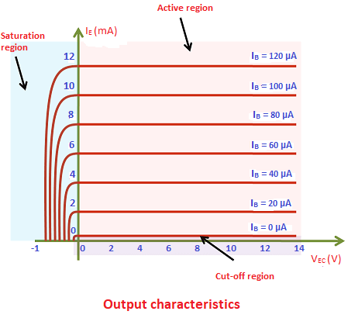

Next, the input current (IB) is increased from 0 μA to 20 μA and then kept constant at 20 μA. While increasing the input current (IB), the output voltage (VEC) is kept constant at 0 volts.

After we kept the input current (IB) constant at 20 μA, the output voltage (VEC) is increased from zero volts to different voltage levels. For each level of output voltage (VEC), the corresponding output current (IE) is recorded. A curve is then drawn between output current IE and output voltage VEC at constant input current IB (20μA). This region is known as the active region of a transistor.

This process is repeated for higher fixed values of input current IB (I.e. 40 μA, 60 μA, 80 μA and so on).

In common collector configuration, if the input current or base current is zero then the output current or emitter current is also zero. As a result, no [current](https://www.physics-and-radio-electronics.com/electronic-devices-and-circuits/introduction/electriccurrent-howelectriccurrentproduced.html) flows through the transistor. So the transistor will be in the cutoff region. If the base current is slightly increased then the output current or emitter current also increases. So the transistor falls into the active region. If the base current is heavily increased then the current flowing through the transistor also heavily increases. As a result, the transistor falls into the saturation region.

Transistor parameters

Dynamic input resistance (ri)

Dynamic input resistance is defined as the ratio of change in input voltage or base voltage (VBC) to the corresponding change in input current or base current (IB), with the output voltage or emitter voltage (VEC) kept at constant.

Dynamic input resistance is defined as the ratio of change in input voltage or base voltage (VBC) to the corresponding change in input current or base current (IB), with the output voltage or emitter voltage (VEC) kept at constant.

The input resistance of common collector amplifier is high.

Dynamic output resistance (ro)

Dynamic output resistance is defined as the ratio of change in output voltage or emitter voltage (VEC) to the corresponding change in output current or emitter current (IE), with the input current or base current (IB) kept at constant. The output resistance of common collector amplifier is low.

Dynamic output resistance is defined as the ratio of change in output voltage or emitter voltage (VEC) to the corresponding change in output current or emitter current (IE), with the input current or base current (IB) kept at constant. The output resistance of common collector amplifier is low.

Current amplification factor (**γ)**

The current amplification factor is defined as the ratio of change in output current or emitter current IE to the change in input current or base current IB. It is expressed by **γ.**

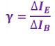

The current gain of a common collector amplifier is high.

**Switch:**

When used as an AC signal amplifier, the transistors Base biasing voltage is applied in such a way that it always operates within its “active” region, that is the linear part of the output characteristics curves are used.

However, both the NPN & PNP type bipolar transistors can be made to operate as “ON/OFF” type solid state switch by biasing the transistors Base terminal differently to that for a signal amplifier.

Solid state switches are one of the main applications for the use of transistor to switch a DC output “ON” or “OFF”. Some output devices, such as LED’s only require a few milliamps at logic level DC voltages and can therefore be driven directly by the output of a logic gate. However, high power devices such as motors, solenoids or lamps, often require more power than that supplied by an ordinary logic gate so transistor switches are used.

If the circuit uses the **Bipolar Transistor as a Switch**, then the biasing of the transistor, either NPN or PNP is arranged to operate the transistor at both sides of the “ I-V ” characteristics curves we have seen previously.

**(The areas** of operation for a transistor switch are known as the **Saturation Region** and the **Cut-off Region**. This means then that we can ignore the operating Q-point biasing and voltage divider circuitry required for amplification, and use the transistor as a switch by driving it back and forth between its “fully-OFF” (cut-off) and “fully-ON” (saturation) regions as shown below.

**Operating Regions**

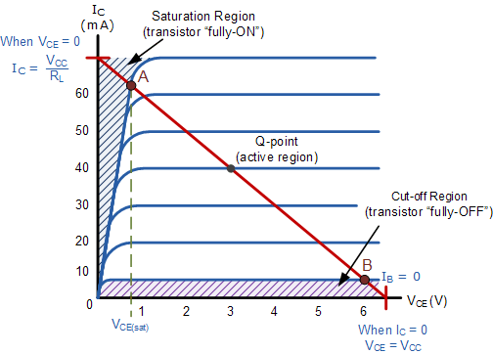

The pink shaded area at the bottom of the curves represents the “Cut-off” region while the blue area to the left represents the “Saturation” region of the transistor. Both these transistor regions are defined as:

**1. Cut-off Region**

Here the operating conditions of the transistor are zero input base current ( IB ), zero output collector current ( IC ) and maximum collector voltage ( VCE ) which results in a large depletion layer and no current flowing through the device. Therefore the transistor is switched “Fully-OFF”.

**Cut-off Characteristics**

|  |  |
| --- | --- |
| transistor switch in cut-off | * • The input and Base are grounded ( 0v ) * • Base-Emitter voltage VBE < 0.7v * • Base-Emitter junction is reverse biased * • Base-Collector junction is reverse biased * • Transistor is “fully-OFF” ( Cut-off region ) * • No Collector current flows ( IC = 0 ) * • VOUT = VCE = VCC = ”1″ * • Transistor operates as an “open switch” |

Then we can define the “cut-off region” or “OFF mode” when using a bipolar transistor as a switch as being, both junctions reverse biased, VB < 0.7v and IC = 0. For a PNP transistor, the Emitter potential must be negative with respect to the Base.

**2. Saturation Region**

Here the transistor will be biased so that the maximum amount of base current is applied, resulting in maximum collector current resulting in the minimum collector emitter voltage drop which results in the depletion layer being as small as possible and maximum current flowing through the transistor. Therefore the transistor is switched “Fully-ON”.

**Saturation Characteristics**

|  |  |
| --- | --- |
| transistor switch in saturation | * • The input and Base are connected to VCC * • Base-Emitter voltage VBE > 0.7v * • Base-Emitter junction is forward biased * • Base-Collector junction is forward biased * • Transistor is “fully-ON” ( saturation region ) * • Max Collector current flows ( IC = Vcc/RL ) * • VCE = 0 ( ideal saturation ) * • VOUT = VCE = ”0″ * • Transistor operates as a “closed switch” |

Then we can define the “saturation region” or “ON mode” when using a bipolar transistor as a switch as being, both junctions forward biased, VB > 0.7v and IC = Maximum. For a PNP transistor, the Emitter potential must be positive with respect to the Base.

Then the transistor operates as a “single-pole single-throw” (SPST) solid state switch. With a zero signal applied to the Base of the transistor it turns “OFF” acting like an open switch and zero collector current flows. With a positive signal applied to the Base of the transistor it turns “ON” acting like a closed switch and maximum circuit current flows through the device.

The simplest way to switch moderate to high amounts of power is to use the transistor with an open-collector output and the transistors Emitter terminal connected directly to ground. When used in this way, the transistors open collector output can thus “sink” an externally supplied voltage to ground thereby controlling any connected load.

**Transistor Load Line Analysis**

**Definition:** The load line analysis of [transistor](https://circuitglobe.com/transistor.html) means for the given value of collector-emitter voltage we find the value of collector current. This can be done by plotting the output characteristic and then determine the collector current IC with respect to collector-emitter voltage VCE. The load line analysis can easily be obtained by determining the output characteristics of the load line analysis methods.

**DC Load Line**

The DC load represents the desirable combinations of the collector current and the collector-emitter voltage. It is drawn when no signal is given to the input, and the transistor becomes bias.

Consider a CE [NPN transistor](https://circuitglobe.com/npn-transistor.html) circuit shown in the figure below where no signal is applied to the input side. For this circuit, DC condition will obtain, and the output characteristic of such a circuit is shown in the figure below.

[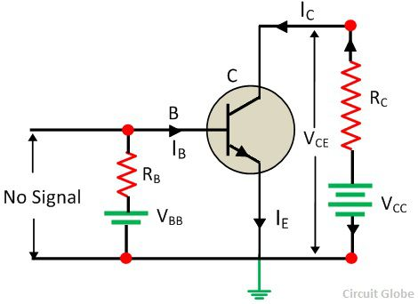](https://circuitglobe.com/wp-content/uploads/2017/05/transistor-as-an-load-amplifier-circuit.jpg)

The DC load line curve of the above circuit is shown in the figure below.

[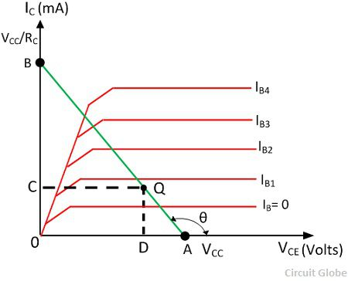](https://circuitglobe.com/wp-content/uploads/2017/05/transistor-load-analysis-graph.jpg)

By applying Kirchhoff’s voltage law to the collector circuit, we get,

[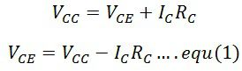](https://circuitglobe.com/wp-content/uploads/2017/05/equation-1-load-analysis.jpg)

The above equation shows that the VCC and RC are the constant value, and it is the first-degree equation which is represented by the straight line on the output characteristic. This load line is known as a DC load line. The input characteristic is used to determine the locus of VCE and IC point for the given value of RC. The end point of the line are located as

**1.** The collector-emitter voltage VCE is maximum when the collector current IC = 0 then from the equation (1) we get,

[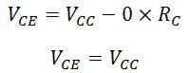](https://circuitglobe.com/wp-content/uploads/2017/05/equation-2-transistor-load-analysis.jpg)

The first point A (OA = VCC) on the collector-emitter voltage axis shown in the figure above.

**2.** The collector current IC becomes maximum when the collector-emitter voltage VCE = 0 then from the equation (1) we get.

[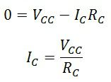](https://circuitglobe.com/wp-content/uploads/2017/05/equation-3-transistor-load-analysis.jpg)

This gives the second point on the collector current axis as shown in the figure above.

By adding the points A and B, the DC load line is drawn. With the help of load line, any value of collector current can be determined.