- A) Launching and Using FTK Imager
- Start FTK Imager
  - Double-click the FTK Imager icon on your desktop (or find it under Start → All Programs → AccessData → FTK Imager).
- Create a Logical Image
- From the menu bar choose File → Create Disk Image.

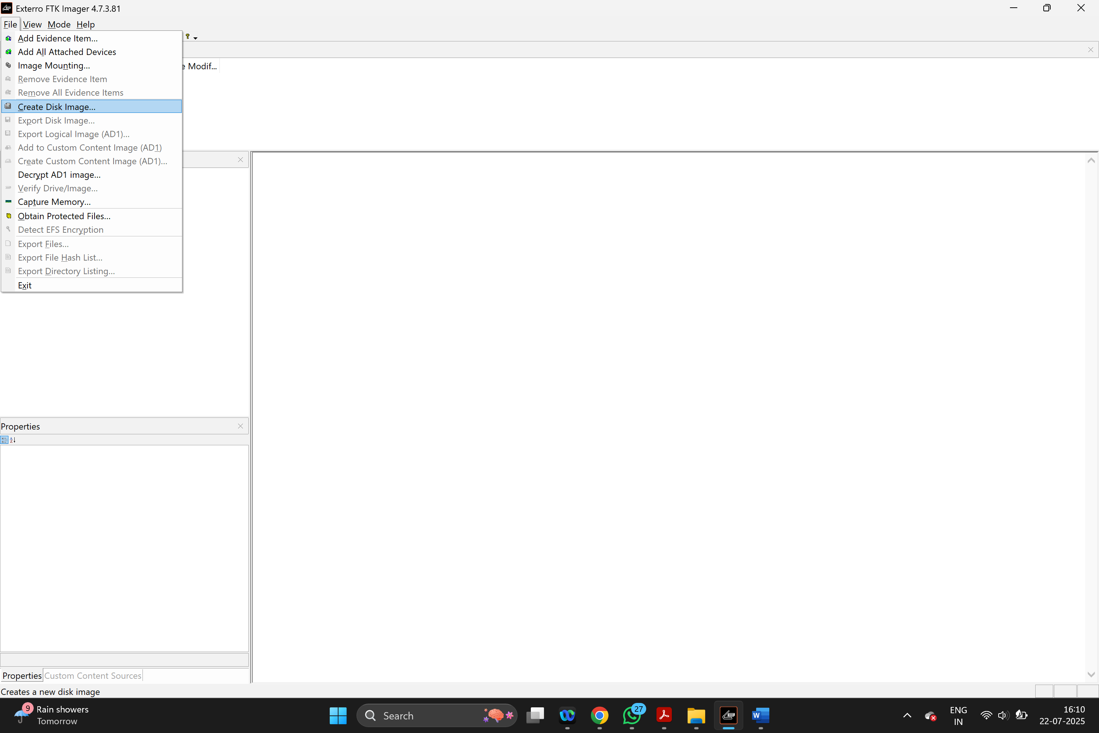

- In the dialog, select your option and click Next.

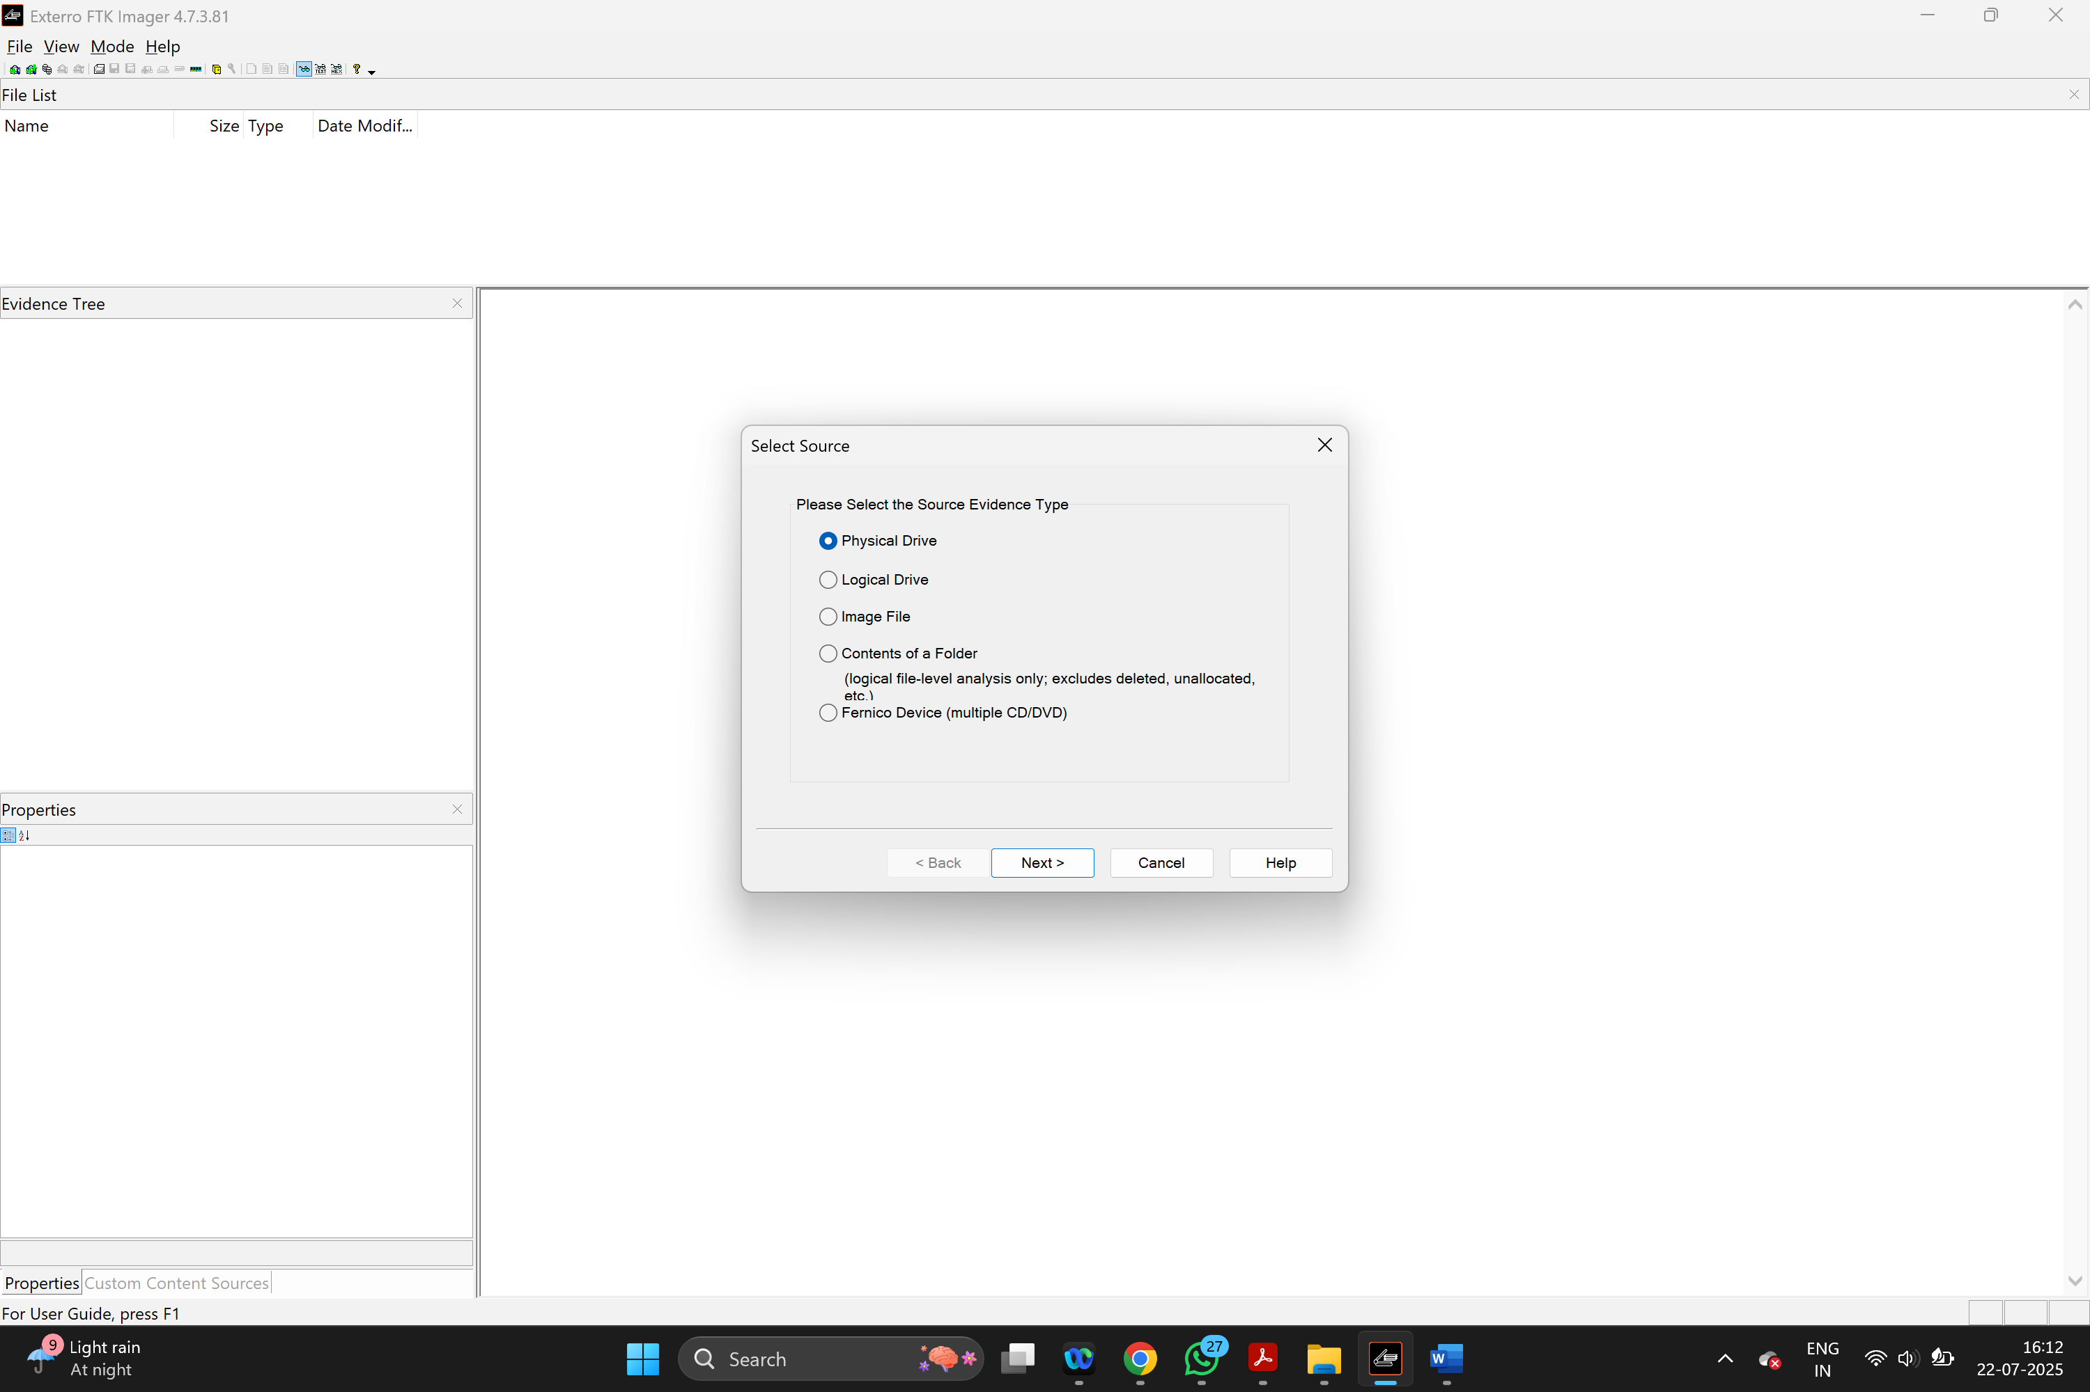
- In the next screen, pick the drive letter of your USB stick (e.g., E:\) and click Finish
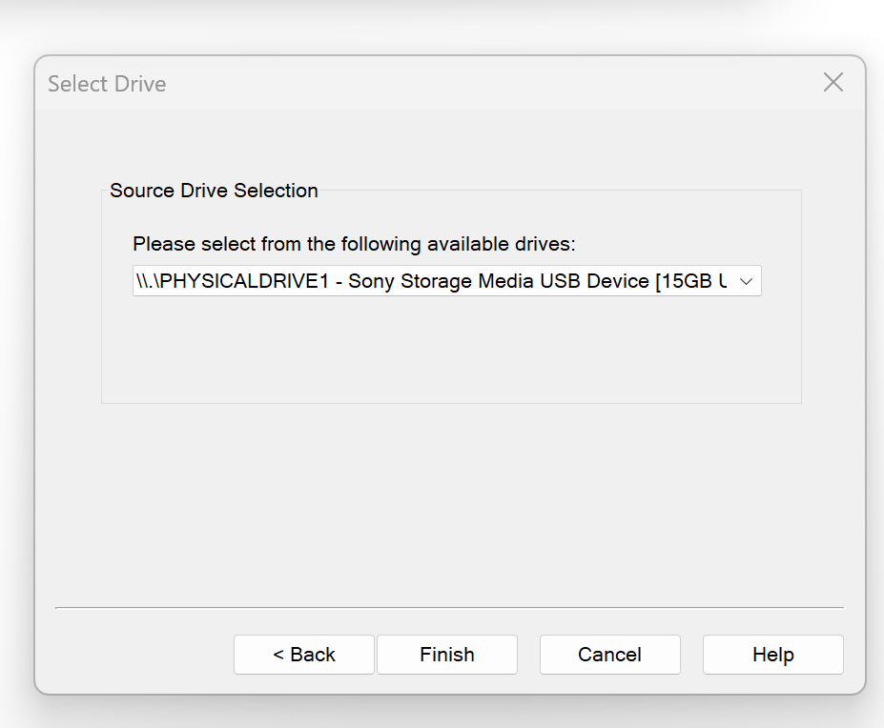
- Configure Destination & Options
- Click Add… to choose a destination folder and filename for your image 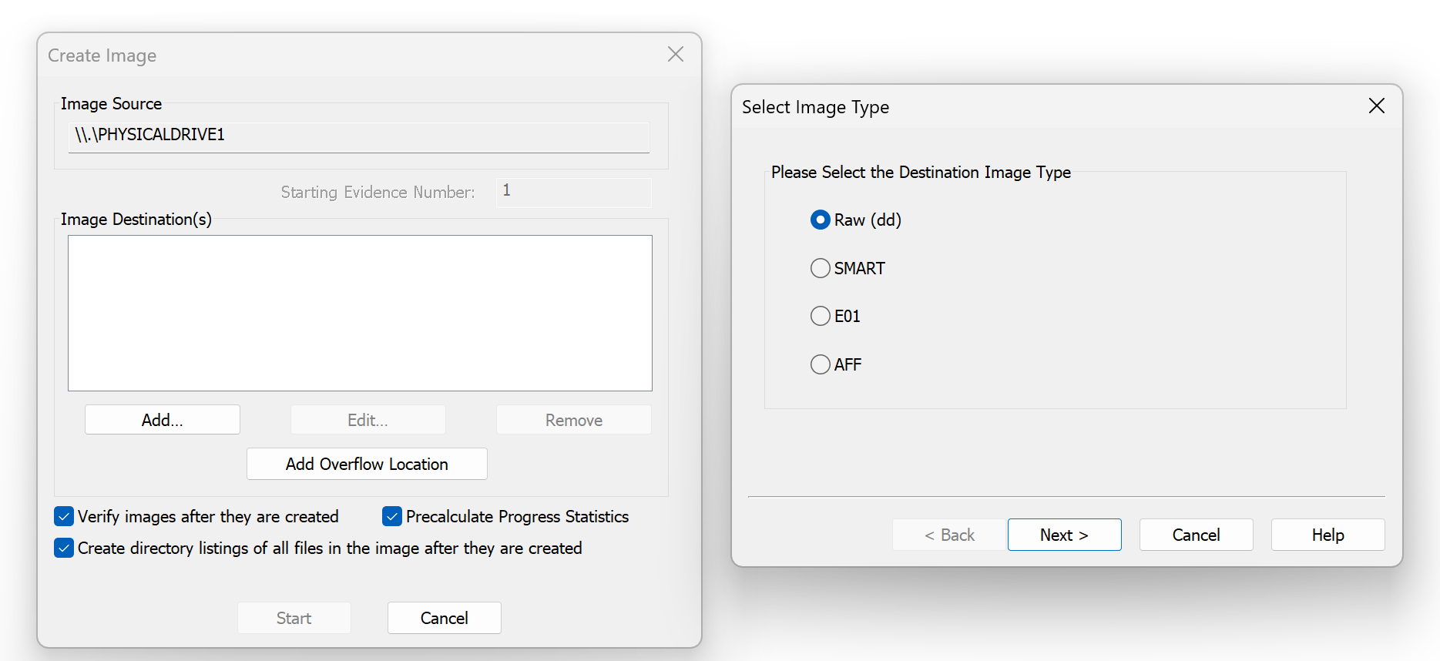
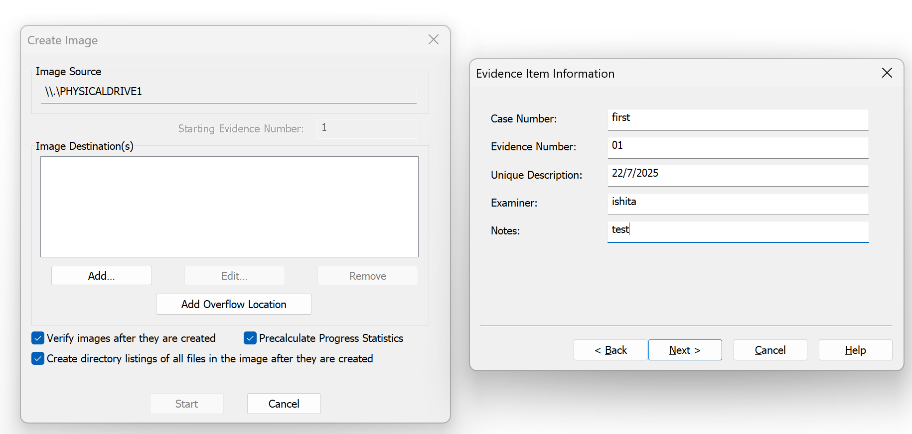

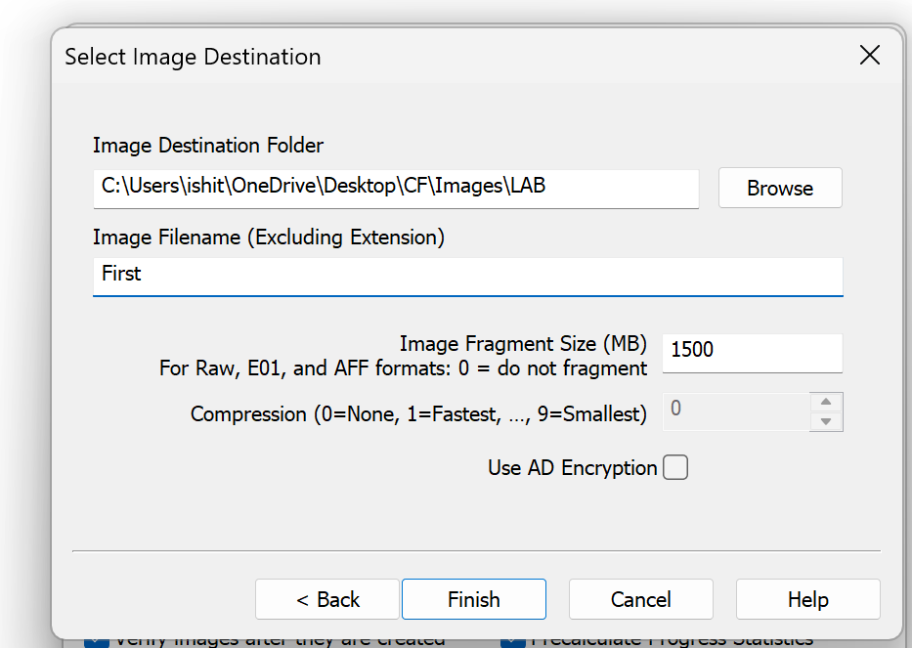

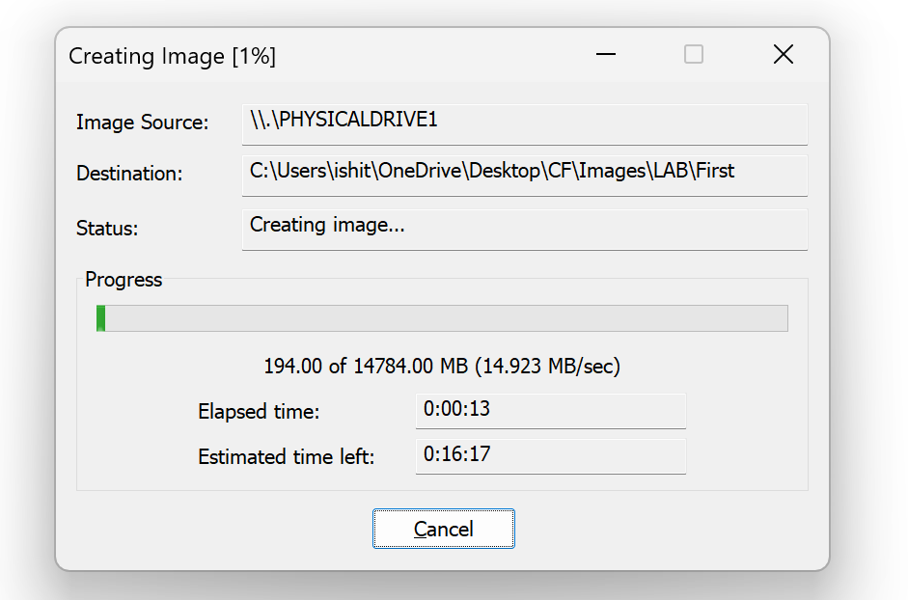
- Check the boxes for Calculate MD5 and Calculate SHA1 so that FTK will compute both hashes as it images.
  - Click Start.
- Observe the Hash Values
- Once complete, a summary window appears showing MD5 and SHA1 checksums.
- Note these values in your observations table.
- (Optional) Re-run the hash on the saved image file via File → Verify Image Hash to see they match exactly.

