Samya – 1RUA24CSE0405

Lab 1: Incident Response Simulation Using TheHive

Aim

To simulate a malware incident and manage the complete incident response lifecycle using TheHive platform.

Inputs
- Suspicious IP address: 192.168.1.10
- Malicious domain: malicious.com
- File hash: d41d8cd98f00b204e9800998ecf8427e
- Alert information indicating phishing-based activity

Tools Used
- TheHive (Open Source IR Platform) Version- 5.2.16-1
- Cortex Version – Not integrated in this setup

Procedure:
- Configuration of TheHive server
- Cortex analyzer integration

Detailed step by step procedure with the considered case-study.
Case Study: Phishing-Based Cyber Attack

Case Study Overview
A phishing-based cyber attack was detected in network traffic logs. Suspicious IP address activity and a malicious domain were identified. The incident was investigated and handled using TheHive incident response platform following standard IR phases: Detection, Containment, Eradication, and Recovery.

Step 0: Detection Phase (Pre-Case Creation)
- Suspicious IP address detected in network traffic logs.
- Malicious domain identified.
- File hash value associated with suspicious activity observed.
- Based on these indicators, the incident was escalated and a case was created in TheHive for further investigation.
Objective: Identify potential malicious activity and initiate formal incident response.

Step 1: Login to TheHive Platform
- Accessed TheHive web interface at http://localhost:9000
- Logged in using administrator credentials.
- Verified successful authentication and dashboard access.
Objective: Gain administrative access to manage and investigate security incidents
Step 2: Create a New Case
- Navigated to Cases → Create Case
- Entered the following details:
Field | Value
Title | Attack
Severity | High
TLP | Amber
PAP | Amber
Tags | phishing, malware
Description | Suspicious IP and malicious domain detected in network traffic logs. Investigation initiated.
- Clicked Confirm
- System displayed “Case created successfully”
Objective: Initiate formal investigation workflow for the detected incident.

Step 3: Add Observables (Indicators of Compromise)
Navigated to the Observables tab and added:
- Suspicious IP address
- Malicious domain
- File hash value
These indicators were marked with appropriate classification.
Objective: Record technical evidence related to the phishing attack.

Step 4: Task Creation and Incident Response Phases
TheHive automatically generated structured tasks under the default template:
- Containment
- Eradication
- Recovery
Each task was reviewed and updated according to investigation progress.

Step 5: Containment Phase
Actions performed:
- Isolated affected system from network
- Blocked malicious IP and domain at firewall
- Restricted suspicious user access
Task status updated to Completed
Objective: Prevent further spread of the attack and limit damage.

Step 6: Eradication Phase
Actions performed:
- Removed malware artifacts
- Cleaned infected files
- Reset compromised user credentials
- Applied security patches
Task marked as Completed
Objective: Eliminate root cause and remove malicious components.

Step 7: Recovery Phase
Actions performed:
- Restored system to stable operational state
- Verified patch installation
- Monitored system for reinfection
- Confirmed no suspicious activity post-recovery
Task marked as Completed
Objective: Safely restore business operations.

Step 8: Lesson learned
Actions performed:
- Users need better awareness and training to identify phishing emails.
- Multi-Factor Authentication (MFA) should be enabled to prevent account compromise.
- Email filtering and spoofing detection must be improved.
- Faster user reporting and monitoring can reduce incident impact.
Task marked as Completed
Objective: Safely restore business operations.

Step 8: Case Classification and Closure
- Incident verified as True Positive
- Impact confirmed
- Case Summary added including full investigation findings
- All tasks completed successfully
- Case closed

Incident Metrics Observed
- Time to detect: 3 minutes
- Time to triage: 16 minutes
- Time to acknowledge: 19 minutes
- Time to resolve: 14 minutes

Conclusion
The phishing-based cyber-attack was successfully detected, investigated, contained, eradicated, and resolved using TheHive incident response workflow. All identified Indicators of Compromise were handled, and system integrity was restored.
The case demonstrates structured incident response handling using professional IR lifecycle methodology.

Results and Screenshots: (with image caption and brief description)
1. 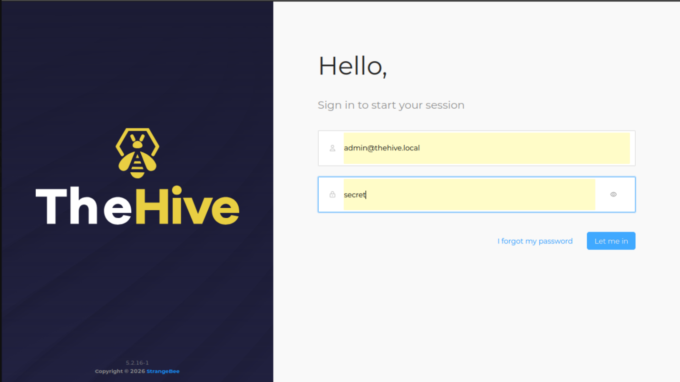
This screenshot shows the login interface of TheHive platform. The default administrator account (admin@thehive.local) is used to access the system for initial configuration and user management. This step allows the administrator to create organization users and manage case investigation workflows.

2.
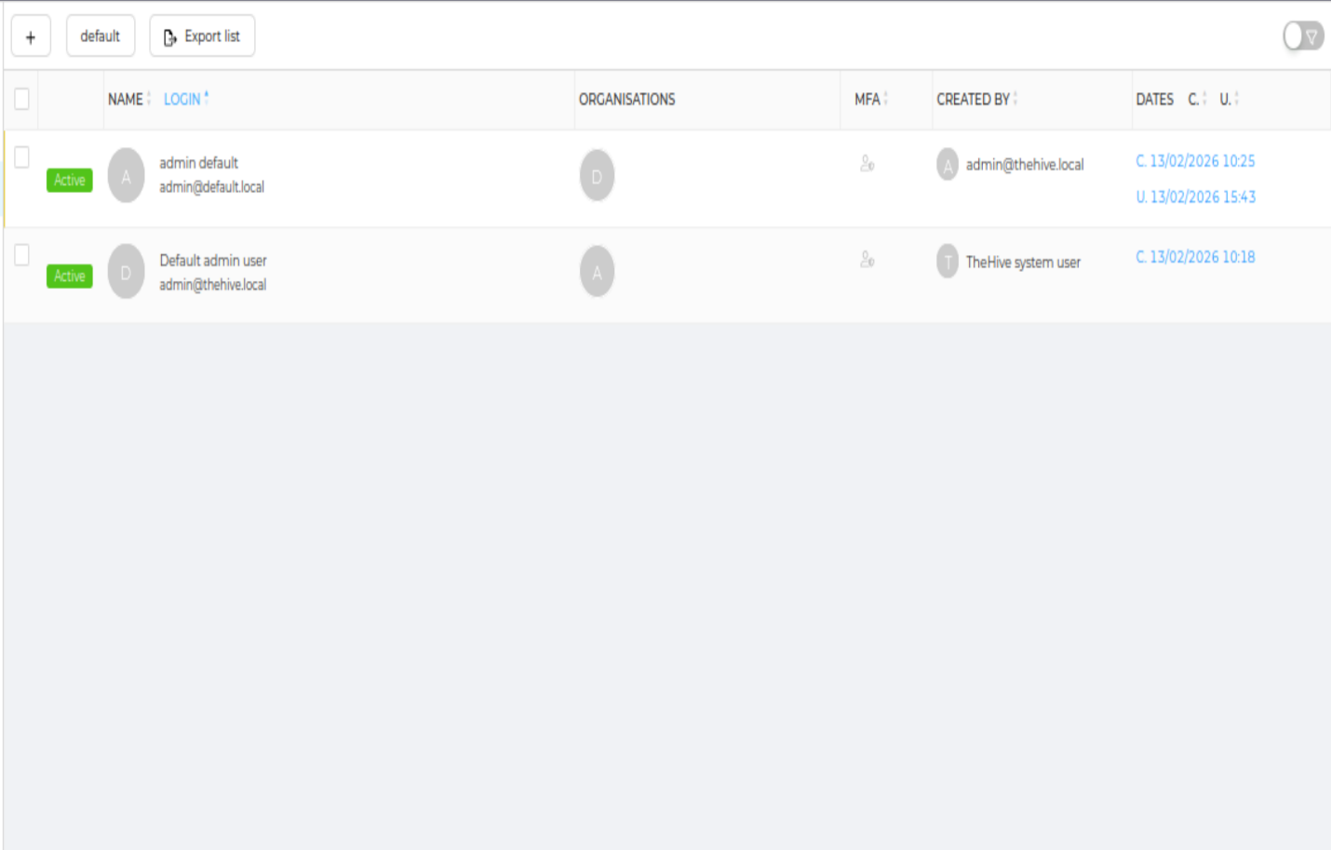

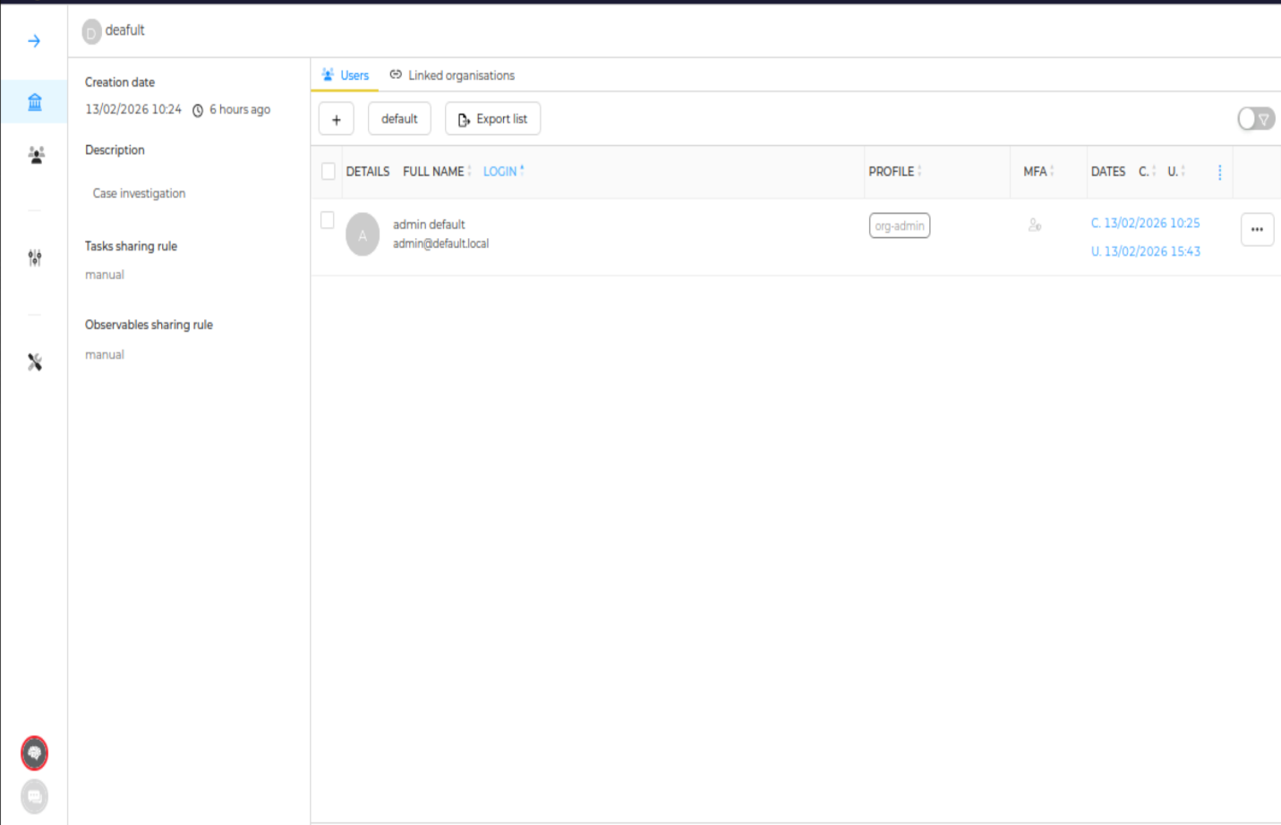

The administrator successfully created and configured users within the default organization in TheHive. The user accounts are active and assigned appropriate roles (org-admin), enabling access to case management functionalities. This ensures controlled access and proper role-based management within the incident response platform.

3.

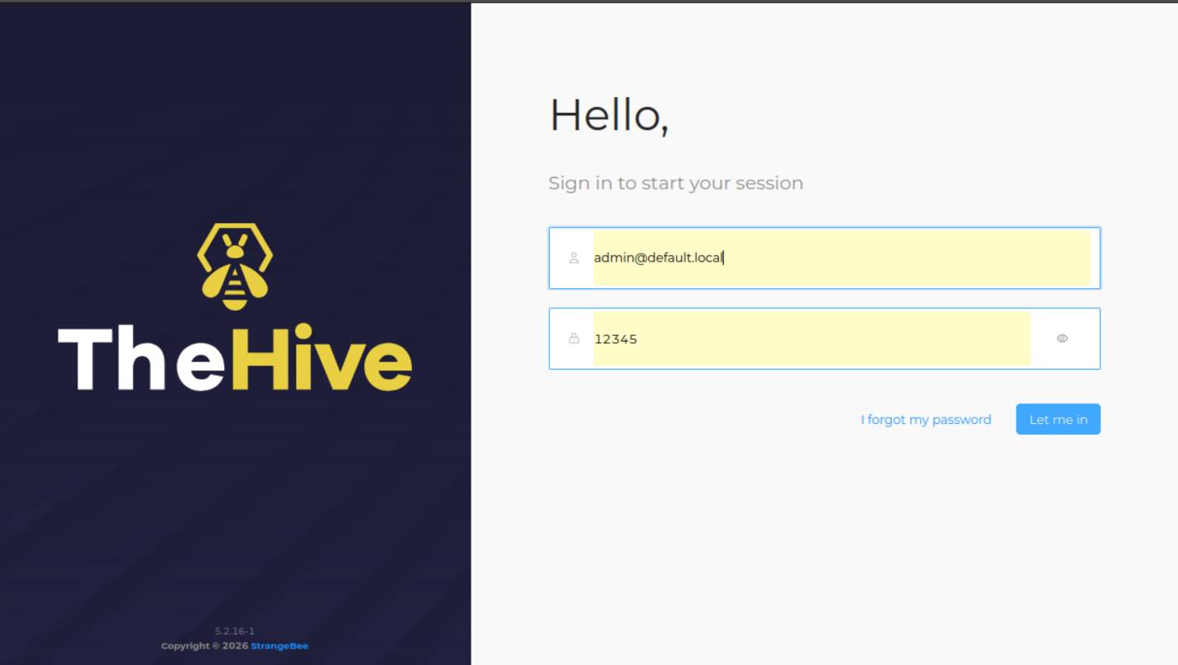
TheHive login interface displaying administrator authentication using the default organization credentials. The admin user (admin@default.local) logs into the platform to access case management and incident response functionalities.

4.
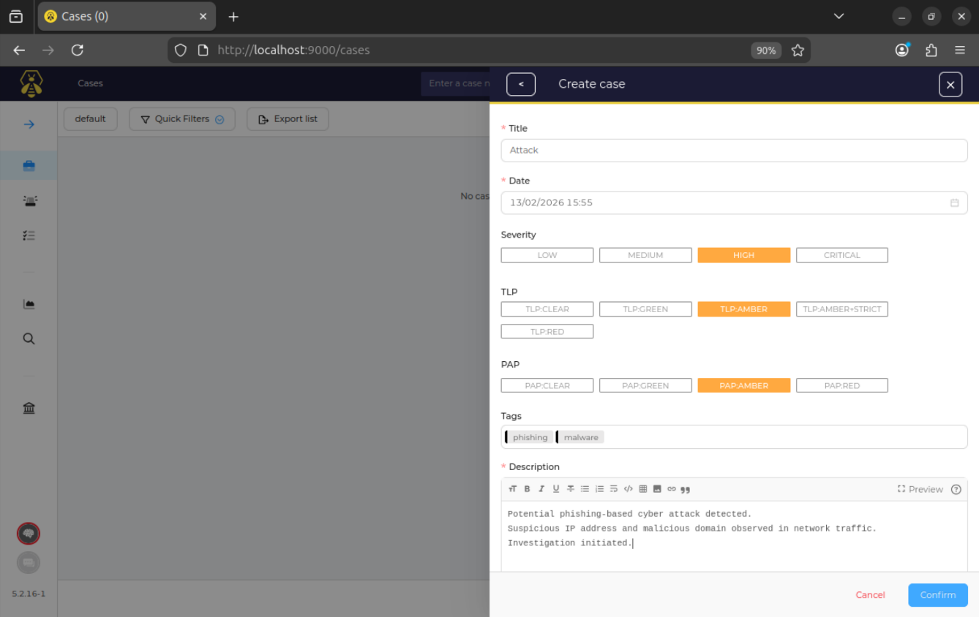

Creation of a new incident case titled “Attack” in TheHive platform. The case is configured with High severity, TLP: Amber, and PAP: Amber. Relevant tags (phishing, malware) are added, and a brief description of the suspected phishing-based cyber attack is provided before confirming case creation.

5.
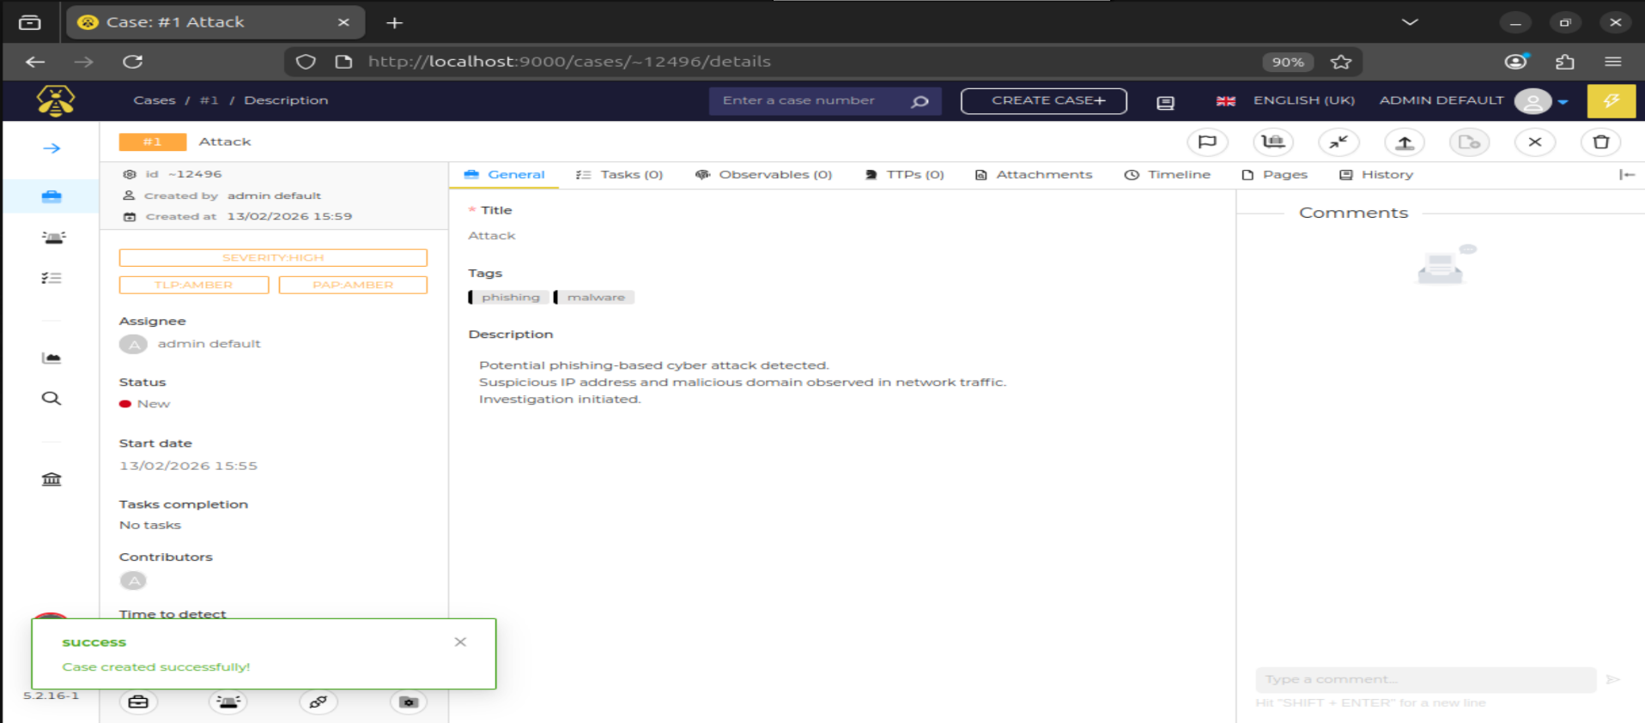
6. 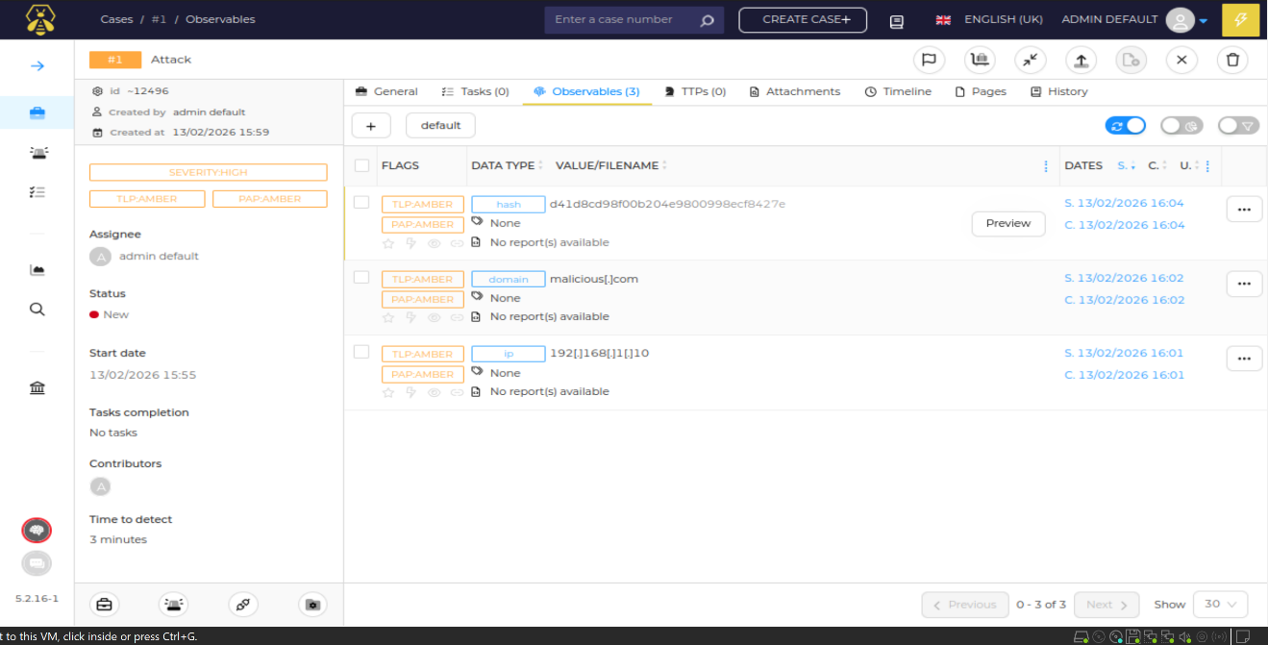

Observables (IP address, malicious domain, and file hash) are added to Case #1 under the Observables section. Each indicator is classified with appropriate data types and marked with TLP: Amber and PAP: Amber. These artifacts support the investigation and help in analyzing the phishing-based attack scenario.

7.
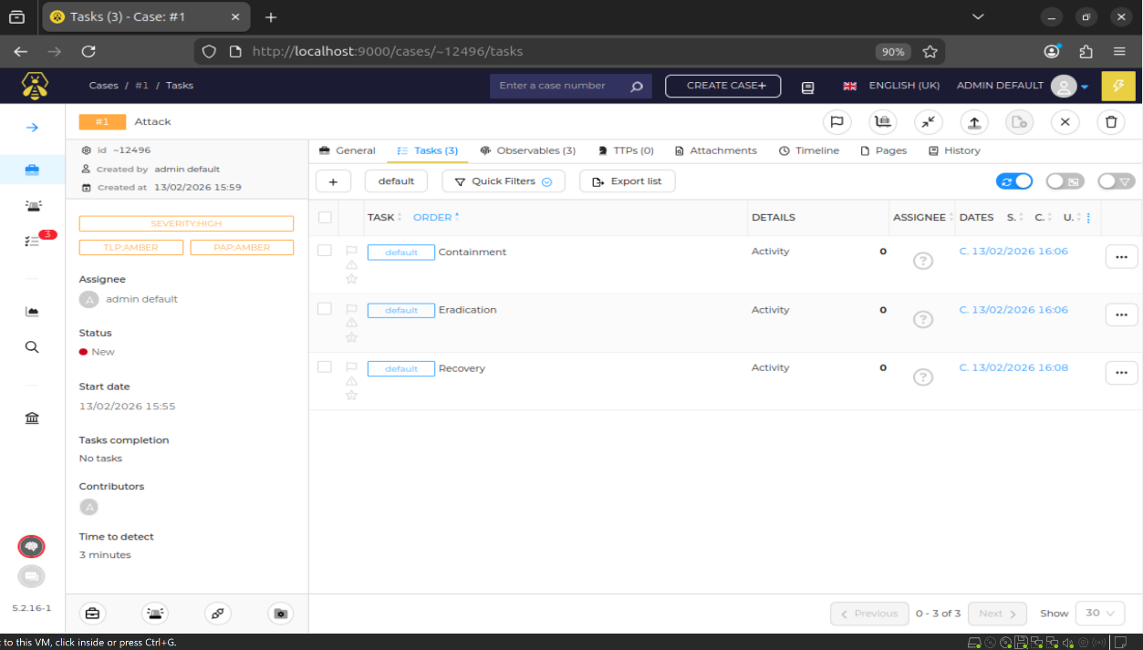

The predefined incident response tasks — Containment, Eradication, and Recovery — are created automatically for Case #1. These tasks structure the investigation workflow and allow systematic handling of the security incident through different response phases.

8.
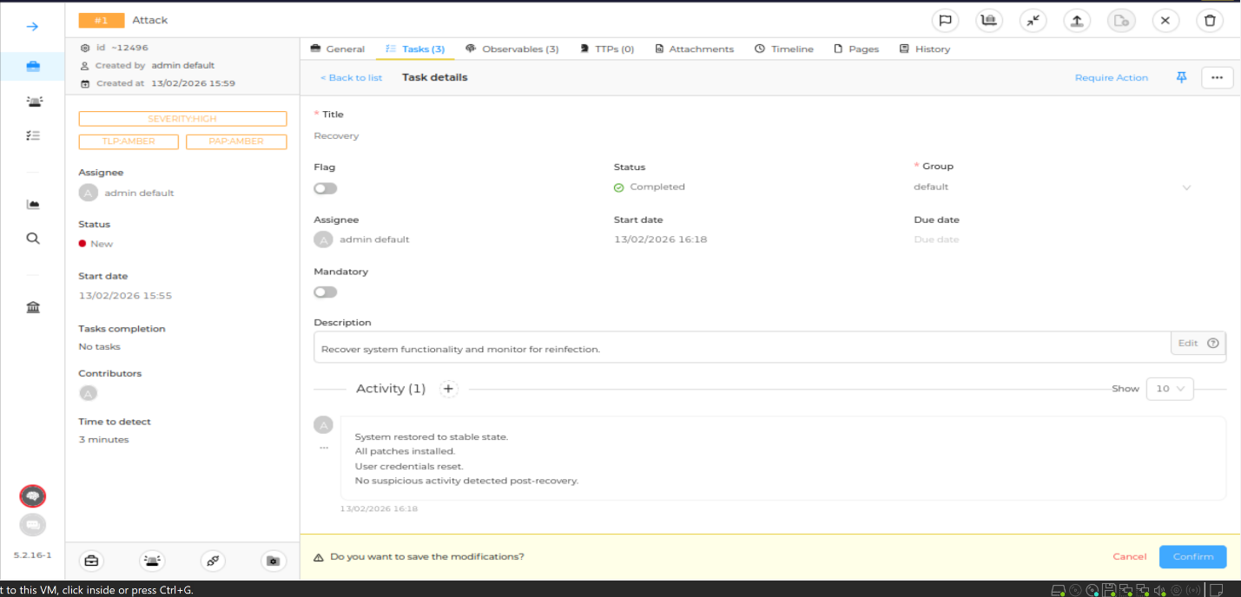
The Recovery phase of the incident response was successfully completed. System functionality was restored, security patches were applied, compromised credentials were reset, and the environment was monitored to ensure no further malicious activity was detected. The task status was marked as Completed, confirming full recovery from the incident.

9.
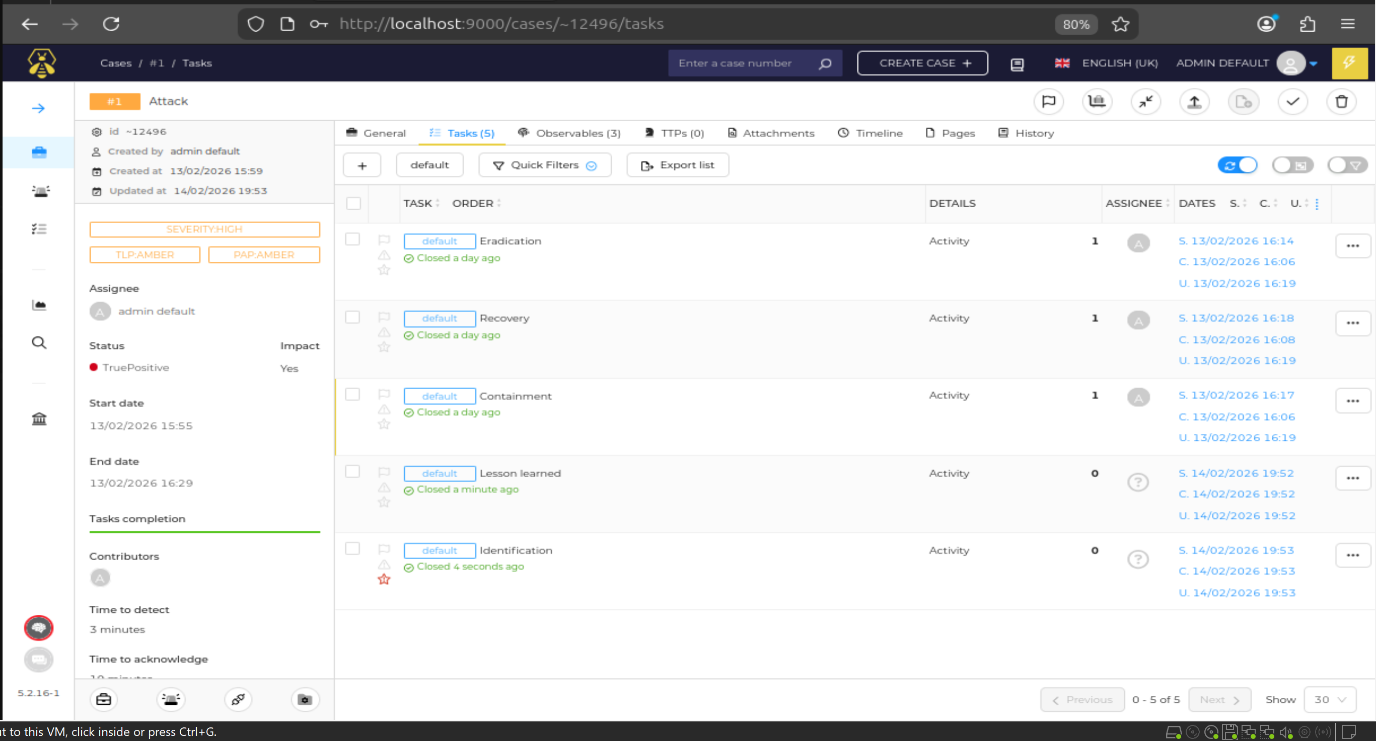
All incident response tasks — Containment, Eradication, and Recovery — were successfully completed for Case #1 (Attack). Each task was updated with activity logs and marked as closed. The Tasks completion bar confirms that the response process was fully executed according to the defined incident handling workflow.

10..
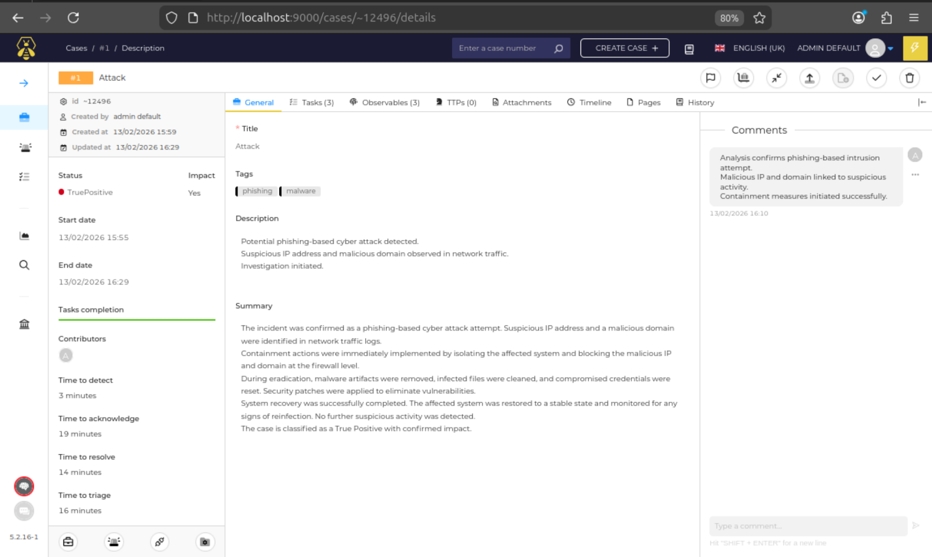
The incident investigation was completed and confirmed as a phishing-based cyber attack (True Positive) with impact. All response phases — Containment, Eradication, and Recovery — were successfully executed. Malicious IP and domain were blocked, infected artifacts were removed, credentials were reset, and the system was restored to a stable state. The case was officially closed after verification and monitoring.

Conclusion
This experiment demonstrates structured incident handling using an industry-grade IR platform.

