BSFM DATABASE PROJECT
Customers and Service Bookings
Database design and SQL queries for a cleaning and facilities management booking system
Name | Abrar Faisal
Student ID | 2104010202286
Course | Internship
Project website | https://bsfm.ae/
GitHub repository | https://github.com/abrarfaisal2286/bsfm-database-project

Table of Contents

1. Introduction 3
2. Tools and Environment 3
3. Database Design 3
3.1 Overview of the Three Tables 3
3.2 Entity Relationship Diagram 4
3.3 Column Definitions 4
4. Table Structures in phpMyAdmin 6
4.1 Customer 6
4.2 Service 6
4.3 Booking 7
5. Setup and Sample Data 7
5.1 Creating the Database 7
5.2 Sample Data 8
6. SQL Queries and Results 9
6.1 Query 1: Register a New Customer (INSERT) 9
6.2 Query 2: Place a New Booking (INSERT) 10
6.3 Query 3: Booking History of One Customer (SELECT with JOIN) 11
6.4 Query 4: Upcoming Confirmed Bookings (SELECT with Two JOINs) 12
6.5 Query 5: Confirm a Pending Booking (UPDATE) 13
6.6 Query 6: Remove a Cancelled Booking (DELETE) 14
6.7 Query 7: Bookings per Service Category (Aggregate) 15
6.8 Summary of Results 15
7. Notes and Observations 16
8. GitHub Repository 16
9. Conclusion 16

1. Introduction
BSFM is a cleaning and facilities management company (https://bsfm.ae/). This project designs and builds the part of a booking database that stores customers, the services on offer, and the bookings that customers make.
This is design and query work only. Nothing was implemented on the live website. The database was built and tested on a local computer.
The task was to:
- Design and create the Customer, Service and Booking tables.
- Store customer details, service types with prices, and booking dates and status.
- Perform the four basic database operations: create, read, update and delete rows.
- Use JOIN queries to produce a customer’s booking history and a list of upcoming bookings.

The complete database has six tables. This report covers Customer, Service and Booking. The other three tables (Staff, Assignment and Invoice) belong to a separate part of the same system. They are created and filled by the shared setup scripts so that the database is complete, but they are not covered in this report.

2. Tools and Environment
The following tools were used to build and test the database.
Tool | Purpose
XAMPP | A package that installs the Apache web server and the MySQL database server on a local computer.
phpMyAdmin | A web page used to create the database and to run SQL commands.
MySQL (MariaDB) | The database engine. The database is named bsfm_db and uses the utf8mb4 character set.
Notepad | Used to save the SQL commands as script files.
GitHub | Stores the SQL scripts and screenshots in an online repository.

Note: The database server that comes with XAMPP is MariaDB, a close relative of MySQL. It runs every command in this report without changes.

3. Database Design

3.1 Overview of the Three Tables
Table | What it stores
Customer | One row per customer: name, phone number, email and address.
Service | One row per service offered, with its category and price.
Booking | One row per booking. It links one customer to one service and stores the date, time, address and status.

3.2 Entity Relationship Diagram
Figure 1 shows how the three tables connect. PK means primary key, the column that identifies each row. FK means foreign key, a column that points to a row in another table. The 1 and N show that one row on the 1 side can be linked to many rows on the N side.
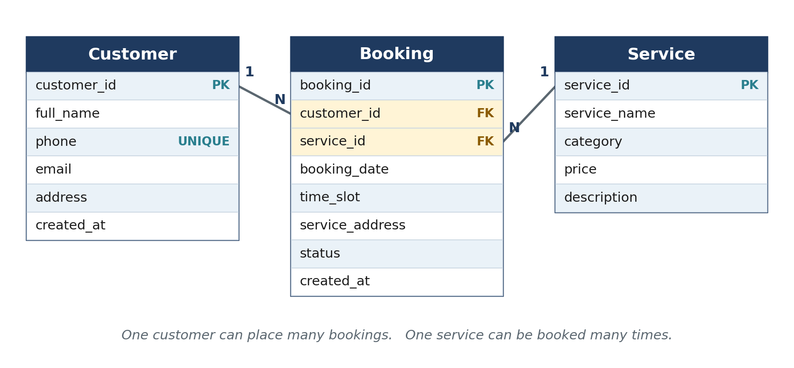
Figure 1: Entity relationship diagram of the Customer, Booking and Service tables

- One customer can place many bookings. Each booking belongs to exactly one customer.
- One service can appear in many bookings. Each booking is for exactly one service.
- The foreign keys protect the data: a booking cannot be created for a customer or a service that does not exist.

3.3 Column Definitions
CUSTOMER TABLE
Column | Data type | Rules | Purpose
customer_id | INT | Primary key, numbers itself | Unique ID of each customer
full_name | VARCHAR(100) | Required | Customer’s full name
phone | VARCHAR(20) | Required, must be unique | Contact number. The unique rule stops the same customer being registered twice.
email | VARCHAR(100) | Optional | Contact email
address | VARCHAR(255) | Optional | Customer’s address
created_at | DATETIME | Filled in automatically | When the customer was registered

SERVICE TABLE
Column | Data type | Rules | Purpose
service_id | INT | Primary key, numbers itself | Unique ID of each service
service_name | VARCHAR(100) | Required | Name of the service
category | VARCHAR(50) | Required | Group the service belongs to (Cleaning or Maintenance)
price | DECIMAL(10,2) | Required | Price of the service, with two decimal places
description | TEXT | Optional | Short description of the service

BOOKING TABLE
Column | Data type | Rules | Purpose
booking_id | INT | Primary key, numbers itself | Unique ID of each booking
customer_id | INT | Required, foreign key to Customer | Who made the booking
service_id | INT | Required, foreign key to Service | Which service was booked
booking_date | DATE | Required | Day of the service
time_slot | VARCHAR(20) | Optional | Time of day, for example 10:00 AM
service_address | VARCHAR(255) | Optional | Where the service takes place
status | ENUM | Pending, Confirmed, Completed or Cancelled. Default: Pending | Current state of the booking. ENUM allows only these four values.
created_at | DATETIME | Filled in automatically | When the booking was created

4. Table Structures in phpMyAdmin
The screenshots below show the three tables as they were created in phpMyAdmin.

4.1 Customer
The gold key marks customer_id as the primary key. The grey key beside phone marks the unique rule. Only email, address and created_at allow empty values.
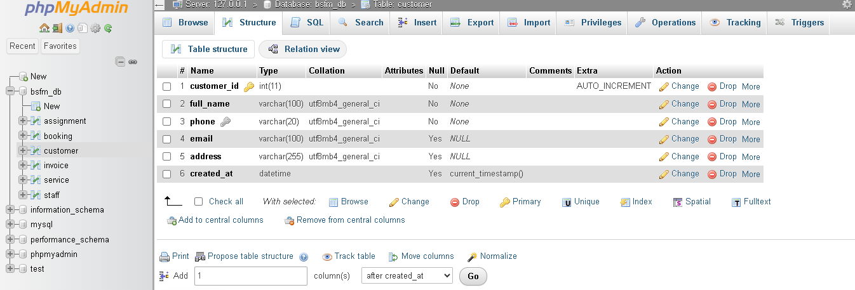
Figure 2: Structure of the Customer table

4.2 Service
Only description allows empty values. The price column stores exact amounts with two decimal places.
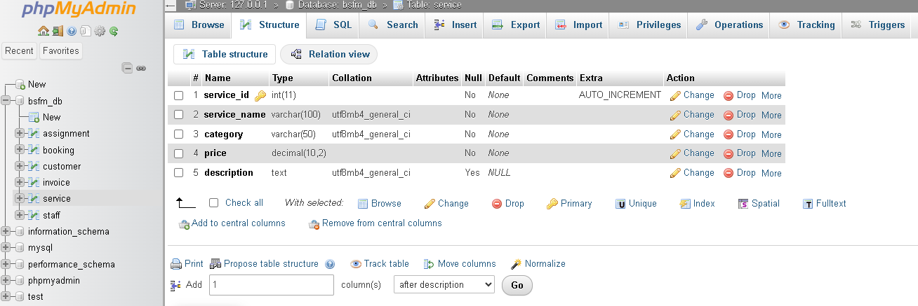
Figure 3: Structure of the Service table

4.3 Booking
customer_id and service_id are the foreign keys, and the grey key icons beside them mark the indexes MySQL creates for them. The status column defaults to Pending.
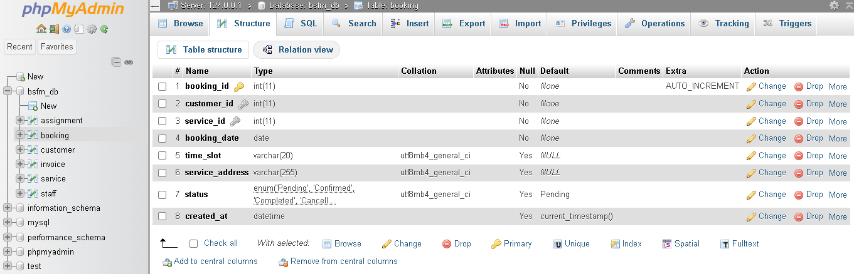
Figure 4: Structure of the Booking table

5. Setup and Sample Data

5.1 Creating the Database
- Installed XAMPP and started Apache and MySQL from the XAMPP Control Panel.
- Opened phpMyAdmin and created a database named bsfm_db with the collation utf8mb4_general_ci.
- Created the tables in this order: Customer, Service, Booking, then Staff, Assignment and Invoice. Booking refers to Customer and Service, so those two must exist first.
- Inserted the sample data in the same order: customers, services, bookings, staff, assignments and invoices.
- Checked the row count of every table (Figure 5).

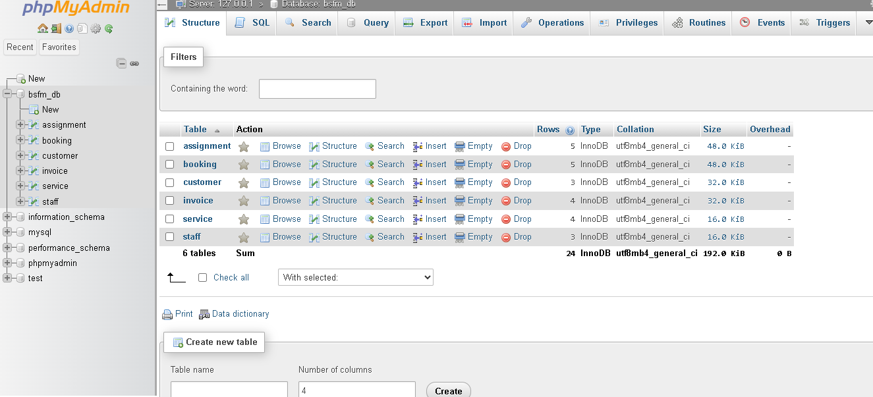
Figure 5: Row counts after loading the sample data: 6 tables and 24 rows

5.2 Sample Data
This is the sample data that was loaded before the queries were run.
CUSTOMER
ID | Full name | Phone | Email | Address
1 | Ahmed Al Mazrouei | 0501112222 | ahmed.m@example.com | Al Reem Island, Abu Dhabi
2 | Fatima Al Suwaidi | 0503334444 | fatima.s@example.com | Khalifa City, Abu Dhabi
3 | Omar Al Nuaimi | 0505556666 | omar.n@example.com | Al Bateen, Abu Dhabi

SERVICE
ID | Service name | Category | Price | Description
1 | Residential Deep Cleaning | Cleaning | 350.00 | Full apartment or villa deep clean
2 | AC Duct Cleaning | Maintenance | 450.00 | Duct cleaning and disinfection
3 | Office Cleaning Contract | Cleaning | 900.00 | Recurring commercial office cleaning
4 | Sofa and Carpet Cleaning | Cleaning | 200.00 | Deep shampoo cleaning for upholstery

BOOKING
ID | Customer ID | Service ID | Date | Time | Status | Address
1 | 1 | 1 | 2026-09-25 | 10:00 AM | Confirmed | Al Reem Island, Abu Dhabi
2 | 2 | 2 | 2026-09-26 | 02:00 PM | Pending | Khalifa City, Abu Dhabi
3 | 3 | 4 | 2026-09-27 | 11:00 AM | Completed | Al Bateen, Abu Dhabi
4 | 1 | 3 | 2026-09-28 | 09:00 AM | Confirmed | Al Reem Island, Abu Dhabi
5 | 2 | 1 | 2026-09-15 | 01:00 PM | Cancelled | Khalifa City, Abu Dhabi

6. SQL Queries and Results
Seven queries were run, in the order shown. Some depend on an earlier one. For example, query 2 uses the customer ID created by query 1. Each query below has its purpose, the SQL code, an explanation and the screenshot of the result.

6.1 Query 1: Register a New Customer (INSERT)
PURPOSE
Register a new customer named Layla Hamdan.
SQL
INSERT INTO Customer (full_name, phone, email, address)
VALUES ('Layla Hamdan', '0507778888',
'layla.h@example.com', 'Yas Island, Abu Dhabi');

HOW IT WORKS
INSERT INTO adds a new row to the Customer table. The customer_id is not given, because the column numbers itself. Customers 1 to 3 already exist, so the new customer becomes number 4. The created_at column also fills itself in with the current date and time.
RESULT
phpMyAdmin reports “1 row inserted” and “Inserted row id: 4”.
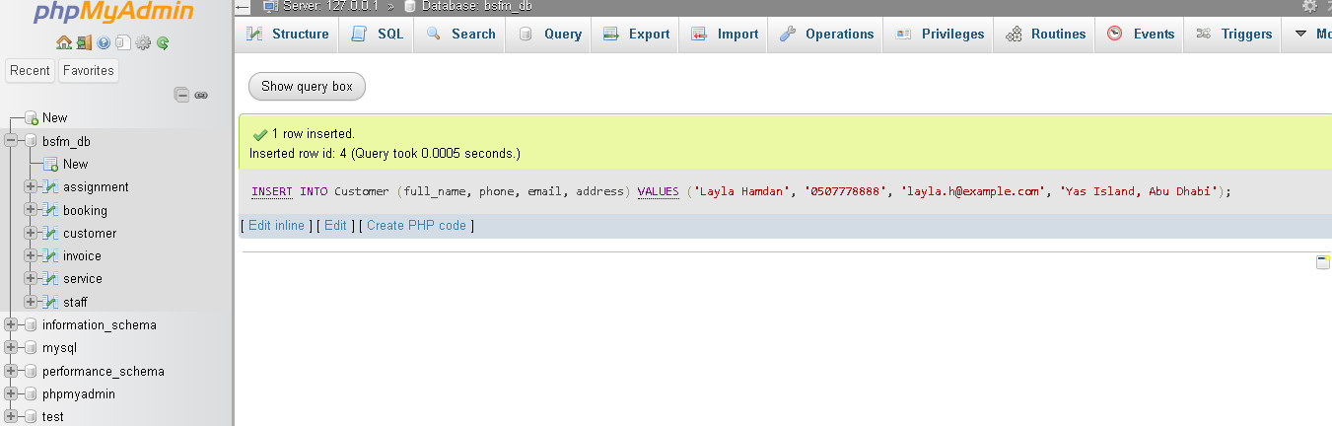
Figure 6: Result of the INSERT into Customer

6.2 Query 2: Place a New Booking (INSERT)
PURPOSE
Place a new booking for the customer who was just registered.
SQL
INSERT INTO Booking
(customer_id, service_id, booking_date, time_slot, service_address, status)
VALUES
(4, 2, '2026-10-01', '03:00 PM', 'Yas Island, Abu Dhabi', 'Pending');

HOW IT WORKS
The new row uses customer_id 4 (Layla Hamdan) and service_id 2 (AC Duct Cleaning) for 1 October 2026 at 03:00 PM, with the status Pending. Because Booking has foreign keys, MySQL first checks that customer 4 and service 2 exist, and rejects the row if either is missing. Bookings 1 to 5 already exist, so this one becomes booking 6.
RESULT
phpMyAdmin reports “1 row inserted” and “Inserted row id: 6”.
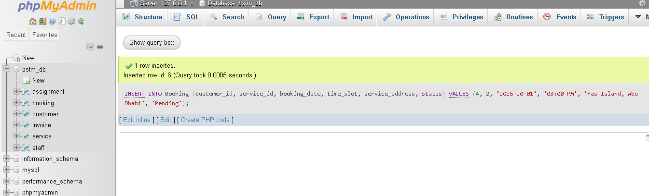
Figure 7: Result of the INSERT into Booking

6.3 Query 3: Booking History of One Customer (SELECT with JOIN)
PURPOSE
Show the full booking history of customer 1 (Ahmed Al Mazrouei), with the newest booking first.
SQL
SELECT b.booking_id, s.service_name, b.booking_date, b.status
FROM Booking b
JOIN Service s ON b.service_id = s.service_id
WHERE b.customer_id = 1
ORDER BY b.booking_date DESC;

HOW IT WORKS
The Booking table stores only the number of the service, not its name. The JOIN connects each booking to its row in the Service table (ON b.service_id = s.service_id), so the service name can be shown. The letters b and s are short names (aliases) for the two tables. WHERE keeps only the bookings of customer 1, and ORDER BY ... DESC puts the latest date first.
RESULT
Two rows are returned: booking 4 (Office Cleaning Contract, 2026-09-28, Confirmed) and booking 1 (Residential Deep Cleaning, 2026-09-25, Confirmed).
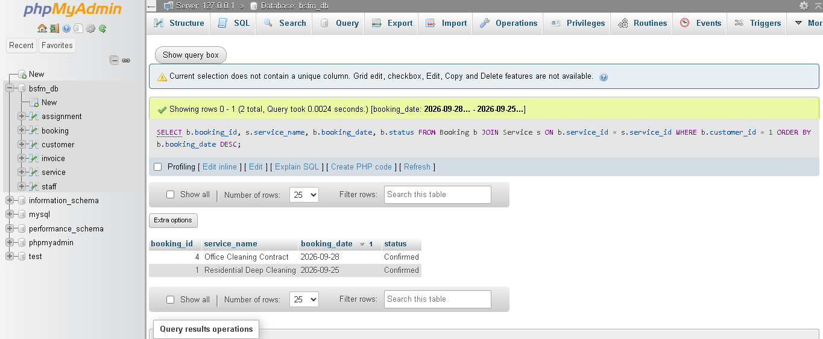
Figure 8: Result of the booking history query

Note: phpMyAdmin shows the message “Current selection does not contain a unique column” above the result. It is not an error. It only means the result cannot be edited in place, because it does not include a key column.

6.4 Query 4: Upcoming Confirmed Bookings (SELECT with Two JOINs)
PURPOSE
List all confirmed bookings that are still to come.
SQL
SELECT c.full_name, s.service_name, b.booking_date, b.time_slot
FROM Booking b
JOIN Customer c ON b.customer_id = c.customer_id
JOIN Service s ON b.service_id = s.service_id
WHERE b.status = 'Confirmed' AND b.booking_date >= CURDATE()
ORDER BY b.booking_date;

HOW IT WORKS
This query joins three tables: Booking (date and status), Customer (the name) and Service (the service name). WHERE keeps only bookings whose status is Confirmed and whose date is today or later. CURDATE() returns today’s date from the computer’s clock. ORDER BY puts the soonest booking first.
RESULT
Two rows are returned, both for Ahmed Al Mazrouei: Residential Deep Cleaning on 2026-09-25 at 10:00 AM, and Office Cleaning Contract on 2026-09-28 at 09:00 AM. The other bookings are not listed because they were not Confirmed when the query ran (bookings 2 and 6 were Pending, booking 3 was Completed and booking 5 was Cancelled).
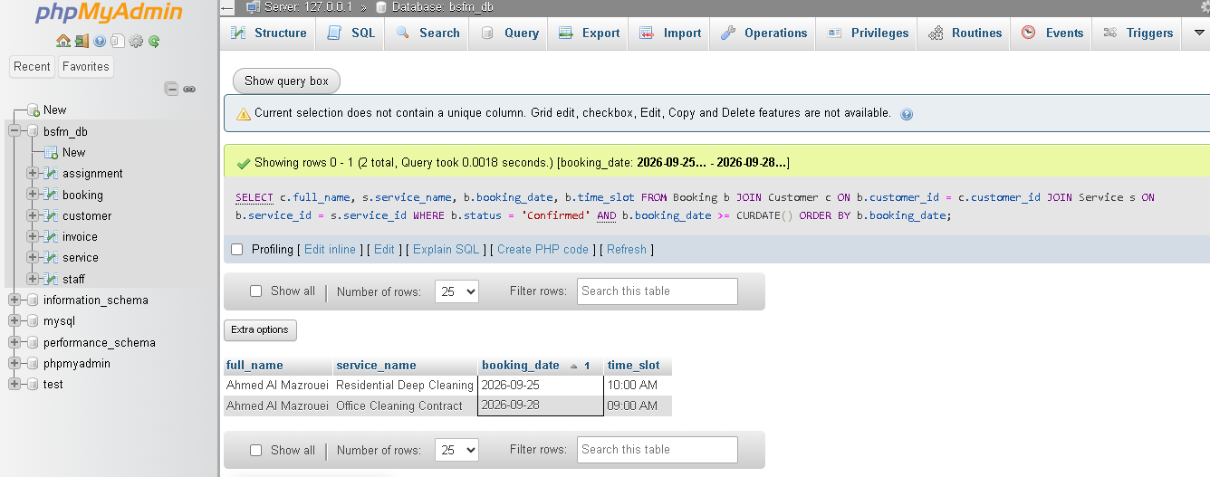
Figure 9: Result of the upcoming confirmed bookings query

Note: Because of CURDATE(), this result depends on the day the query is run. These results were taken on 24 September 2026.

6.5 Query 5: Confirm a Pending Booking (UPDATE)
PURPOSE
Change booking 2 from Pending to Confirmed.
SQL
UPDATE Booking
SET status = 'Confirmed'
WHERE booking_id = 2;

HOW IT WORKS
UPDATE changes existing rows. SET gives the new value of the status column. WHERE booking_id = 2 limits the change to a single booking. Without the WHERE part, every booking in the table would be changed.
RESULT
phpMyAdmin reports “1 row affected”, so exactly one booking was changed.
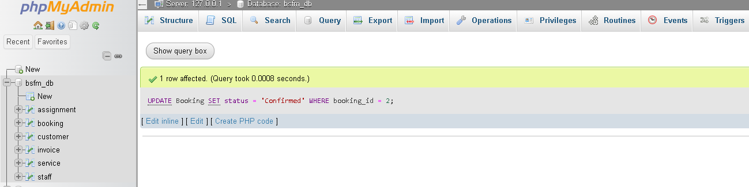
Figure 10: Result of the UPDATE on Booking

Note: After this change, query 4 would also list booking 2 (Fatima Al Suwaidi, AC Duct Cleaning, 2026-09-26).

6.6 Query 6: Remove a Cancelled Booking (DELETE)
PURPOSE
Delete booking 5, which was cancelled.
SQL
DELETE FROM Booking
WHERE booking_id = 5 AND status = 'Cancelled';

HOW IT WORKS
DELETE FROM removes the rows that match the WHERE conditions. There are two conditions: the booking number must be 5 and the status must be Cancelled. The second condition is a safety check, so a booking that is not cancelled is never deleted by mistake.
RESULT
phpMyAdmin reports “1 row deleted”.
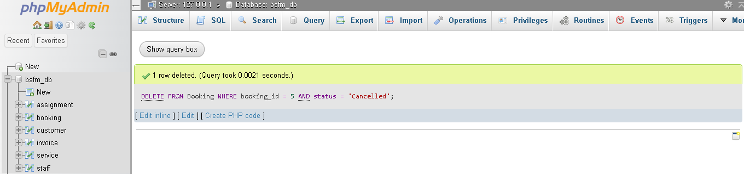
Figure 11: Result of the DELETE on Booking

Note: The foreign keys also protect deletions. A booking that has an invoice or assigned staff cannot be deleted until those rows are removed. Booking 5 had neither, so it could be deleted.

6.7 Query 7: Bookings per Service Category (Aggregate)
PURPOSE
Count how many bookings each service category has.
SQL
SELECT s.category, COUNT(b.booking_id) AS total_bookings
FROM Booking b
JOIN Service s ON b.service_id = s.service_id
GROUP BY s.category;

HOW IT WORKS
The JOIN gives every booking the category of its service. GROUP BY s.category puts the bookings into one group per category. COUNT(b.booking_id) counts the bookings in each group, and AS total_bookings gives that column a readable name.
RESULT
Two rows are returned: Cleaning 3 and Maintenance 2. The Cleaning bookings are 1, 3 and 4 (booking 5 was also a Cleaning booking, but it was deleted in query 6). The Maintenance bookings are 2 and 6, both AC Duct Cleaning.
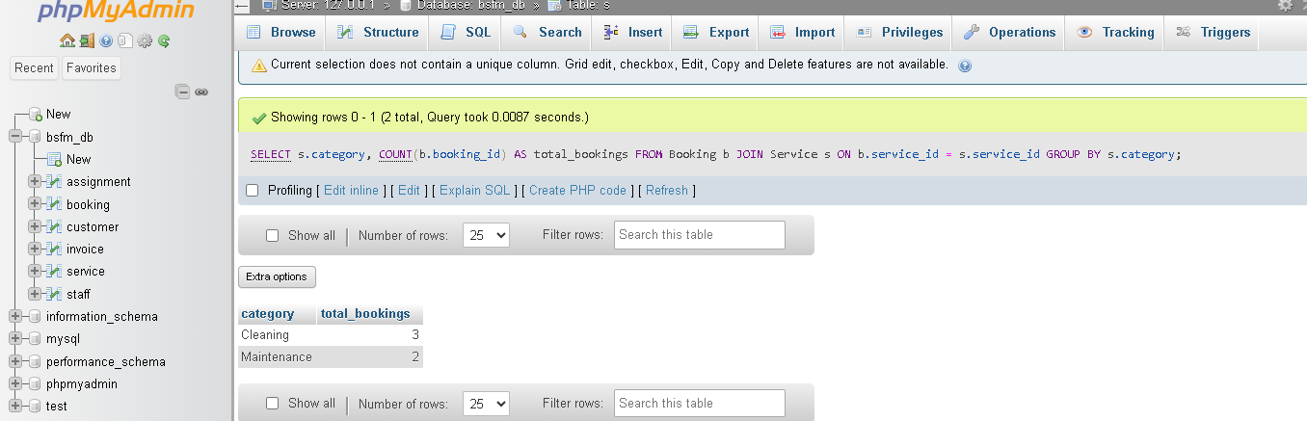
Figure 12: Result of the bookings per category query

Note: The top of the screenshot says “Table: s”. This is only phpMyAdmin showing the short name s that the query gives to the Service table. No table with that name exists.

6.8 Summary of Results
No. | Operation | Tables used | Result
1 | INSERT (create) | Customer | 1 row inserted (customer 4)
2 | INSERT (create) | Booking | 1 row inserted (booking 6)
3 | SELECT with JOIN (read) | Booking, Service | 2 rows
4 | SELECT with two JOINs (read) | Booking, Customer, Service | 2 rows
5 | UPDATE | Booking | 1 row affected
6 | DELETE | Booking | 1 row deleted
7 | SELECT with GROUP BY (aggregate) | Booking, Service | 2 rows (Cleaning 3, Maintenance 2)

7. Notes and Observations
- Order matters. Some statements use fixed ID numbers, such as customer 4 in query 2 and booking 5 in query 6. They work on a fresh database when run in order. Running the sample data a second time would change the numbers and break them.
- Date-dependent result. Query 4 uses CURDATE(), so it returns different rows on different days. For example, booking 1 (25 September 2026) stops appearing once that day has passed.
- Sample data dates. Booking 3 is marked Completed, but its date (27 September 2026) was still in the future when the queries were run. This does not affect any of the queries in this report.
- Rules that protect the data. The unique phone number prevents duplicate customers, the ENUM restricts the status to four valid values, DECIMAL stores prices exactly, and the foreign keys prevent bookings for customers or services that do not exist.
- Supporting tables. Staff, Assignment and Invoice exist in the same database and hold sample data, but they are not queried in this report.

8. GitHub Repository
All scripts and screenshots are stored in this repository: https://github.com/abrarfaisal2286/bsfm-database-project
Path | Contents
sql/01_schema.sql | Creates the database bsfm_db and all six tables
sql/02_sample_data.sql | Inserts the sample data
sql/03_person1_queries.sql | The seven queries described in this report
screenshots/ | The ten screenshots used in this report
README.md | Project overview and results

9. Conclusion
The Customer, Service and Booking tables were designed, created and filled with sample data for BSFM’s booking system. Primary keys, foreign keys, unique values and a restricted status list keep the data consistent.
Seven queries were run and checked against their expected results. They cover all four basic operations (create, read, update and delete), two JOIN reports that give a customer’s booking history and the list of upcoming confirmed bookings, and one aggregate query that counts bookings per category. Every result is documented with a screenshot, and all scripts are available in the GitHub repository.

