Harnessing EC2, VPC & MobaXterm for Cutting-Edge Entity Hosting

A Project Report Submitted to Smart- Internz for the completion of
Cloud Practitioner Internship Program
Prepared By
Abrar Sajjad Kotwal
PRN: 2023011032042

D.Y.Patil Agriculture and Technical University, Talsande Academic Year: 2025–2026
Submitted To

Smart-Internz
Project Mentor / Guide Name:

Abstract
In modern software development, building an application locally is only the first step. The real challenge is making it securely and reliably available on the public internet. Traditional local hosting cannot meet enterprise standards because it lacks global accessibility, fault tolerance, and strict security boundaries. To solve this, this project outlines a complete cloud hosting architecture built on Amazon Web Services (AWS), moving the application out of an isolated environment and into a scalable infrastructure designed to handle real-world traffic.
The primary computing environment is built on an Amazon EC2 instance running Amazon Linux 2023, selected for its stability and optimized performance. Security is handled at the network level using custom Virtual Private Cloud (VPC) Security Groups rather than default, open-access settings. These groups enforce the principle of least privilege by strictly filtering inbound and outbound traffic, ensuring only required ports specifically port 80 for HTTP and port 22 for administrative access are exposed. Server management and file transfers were streamlined using MobaXterm, which provided a reliable SSH tunnel and an integrated SFTP interface to bypass the workflow limits of standard terminal setups.
For the application layer, an Apache web server was configured to host and serve a custom-built, responsive frontend. The server handles incoming web traffic and serves the site files, ensuring the interface renders correctly and efficiently across different devices. By attaching a public IPv4 address to the EC2 instance, the web application is now globally accessible. This architecture successfully demonstrates a full cloud deployment lifecycle and establishes a production-ready baseline that can easily support future additions, such as custom DNS routing and SSL encryption.

INDEX

- Introduction
- Project Overview
- Objectives
- Project Initialization and Planning Phase
- Define Problem Statement
- Project Proposal (Proposed Solution)
- Initial Project Planning
- Infrastructure Provisioning and Configuration Phase
- Resource Allocation Plan and Requirements
- Security and Architecture Compliance Report
- Environment Preprocessing and Server Configuration
- Deployment and Implementation Phase
- Technology Stack Selection Report
- Initial Server Boot, Validation and Evaluation Report
- System Optimization and Tuning Phase
- Network and Permissions Tuning Documentation
- Final Architecture Selection Justification
- Results
  - Output Screenshots Description
- Advantages and Disadvantages
- Advantages
- Disadvantages
- Conclusion
- Future Scope
- Appendix
- Source Code
- GitHub and Project Video Demo Link

Introduction
The transition from local development to cloud hosting is a critical milestone in software engineering, marking the shift from a controlled sandbox to a production-ready ecosystem. While local environments like VS Code Live Server are sufficient for writing and testing code, they inherently lack the fault tolerance, global accessibility, and dynamic routing capabilities required to serve external users. Modern web entities demand a robust infrastructure that guarantees high availability, strict security boundaries, and a persistent environment capable of handling unpredictable web traffic without service degradation.

This project addresses the fundamental gap between local code creation and global delivery by architecting a custom deployment environment from the ground up. By manually provisioning and configuring Infrastructure as a Service (IaaS) through Amazon Web Services (AWS), the project deliberately bypasses automated, "black-box" platforms such as Vercel or Netlify. While those platforms offer deployment convenience, they obscure the underlying architecture. This hands-on approach prioritizes deep technical understanding, granting granular control over the server's operating system, explicit definition of network traffic rules, and precise management of the file system and web server daemon.

Ultimately, taking ownership of these lower-level configurations exposes the core mechanics of cloud computing and server administration. It establishes a scalable foundation that mirrors enterprise-grade deployments, where custom network topologies, fine-grained access controls, and dedicated computing resources are non-negotiable requirements. By mastering these foundational AWS networking and computing services, the project not only ensures the secure delivery of the current application but also provides the architectural flexibility to integrate future complexities, such as load balancing, database tiering, and custom security protocols.

Project Overview
This project represents an end-to-end cloud infrastructure deployment designed to transition a static web application from a local development environment to a globally accessible platform. The architecture relies on core Amazon Web Services (AWS) networking and compute resources to establish a highly available baseline. The workflow initiates with Compute Provisioning, where a dedicated virtual server is launched within the AWS cloud. This instance is immediately secured using custom Virtual Private Cloud (VPC) Security Groups, explicitly defining inbound and outbound traffic rules to isolate the machine from unauthorized network scanning and limit exposure exclusively to required administrative and web traffic.
Following the initial infrastructure setup, the project utilizes a Remote Management phase to establish secure administrative control. MobaXterm is configured to open an encrypted SSH tunnel, relying entirely on private key cryptography rather than vulnerable password authentication. This environment supports both secure command-line execution and direct SFTP file transfers. The final Deployment Phase transforms this server into a public-facing host. An Apache web daemon is installed and initialized, requiring targeted modifications to Linux directory ownership and permissions. Once the frontend HTML, CSS, and JavaScript files are transferred into the server's document root, the Apache service actively listens for incoming HTTP requests, processing and serving the interface to any client accessing the instance's assigned Public IPv4 address.

Objectives
To ensure a structured learning approach, this project was guided by several key objectives:

- Master Cloud Compute: Provision, configure, and launch an Amazon EC2 instance by selecting an optimized Amazon Machine Image (AMI). This includes defining hardware specifications, such as instance types, and attaching persistent Elastic Block Store (EBS) volumes to establish a reliable Infrastructure as a Service (IaaS) foundation.

- Execute Network Security: Configure custom VPC Security Groups to enforce the principle of least privilege. This involves explicitly mapping inbound and outbound rules to isolate network traffic, restricting administrative access strictly to port 22 (SSH) while securely exposing ports 80 (HTTP) and 443 (HTTPS) for public web consumption.

- Perform Remote Administration: Utilize MobaXterm to bypass the workflow limitations of a standard terminal. This objective focuses on establishing encrypted SSH tunnels using .pem private key cryptography and leveraging an integrated SFTP interface for efficient, secure file transfers directly into the server's file system.

- Configure Linux Web Servers: Transform a bare operating system into a public-facing host by installing the Apache (httpd) daemon via the yum package manager. This requires managing background services, modifying critical directory ownership and permissions (such as /var/www/html), and ensuring the web server automatically initializes upon system boot.

- Project Initialization and Planning Phase
- Define Problem Statement
Developers frequently experience roadblocks when attempting to share their applications externally. Running a server on a local machine exposes the personal network to security risks and requires the physical machine to stay powered on 24/7. Furthermore, residential internet connections often impose bandwidth restrictions and utilize dynamic IP addresses, making it nearly impossible to maintain a stable, persistent endpoint for external users. There is a critical need for a system capable of hosting a web application reliably in an isolated cloud environment while maintaining strict security controls against unauthorized access. By offloading compute and network responsibilities to enterprise-grade cloud infrastructure, developers can guarantee high availability, predictable performance, and the ability to scale resources seamlessly as application traffic grows.

Project Proposal (Proposed Solution)
The proposed solution is an AWS-based hosting architecture. By spinning up an EC2 instance within a VPC, the system creates a dedicated, always-on server. A custom security group will act as a firewall. A web-based interface will be written locally and pushed to the cloud server via MobaXterm, allowing anyone with the Public IP to interact with the application while blocking malicious traffic on non-web ports. Once the files are securely transferred, an Apache web daemon will manage incoming HTTP requests to serve the frontend efficiently. Ultimately, this setup moves the project beyond local testing, establishing a stable, production-ready foundation that can easily support future infrastructure upgrades like custom domain routing or load balancing.

Initial Project Planning
Before logging into the AWS Console, the technology stack was explicitly defined:
- Cloud Provider: Amazon Web Services (AWS) free tier.

- Operating System: Amazon Linux 2023.

- Web Server: Apache HTTP Server.

- Administration Tool: MobaXterm (for SSH and SFTP).

- Frontend Stack: HTML5, CSS3, and JavaScript.

- Version Control: Git and GitHub.
Establishing this stack upfront guaranteed a lightweight, secure, and highly capable infrastructure. This deliberate selection of tools streamlined the transition from local code management to a live, professional-grade deployment.

Infrastructure Provisioning and Configuration Phase

Resource Allocation Plan and Requirements
The architecture was built using the t2.micro instance type. This specific hardware allocation (1 vCPU, 1 GiB Memory) was identified as the most efficient choice because it provides sufficient compute power for a lightweight web entity while remaining strictly within the AWS Free Tier limits, avoiding unnecessary billing overhead. To complement this compute capacity, an 8 GB General Purpose SSD (gp3) was provisioned as the root volume, ensuring rapid read/write access for application files and server logs. Additionally, the burstable performance characteristic of the t2 instance family provides the necessary flexibility to handle temporary spikes in web traffic without service degradation.

Security and Architecture Compliance Report
An inspection of default cloud security practices showed that leaving all ports open is a critical vulnerability. To fix this, a custom Security Group was authored.
- Port 22 (SSH): Opened strictly for administrative terminal access.
- Port 80 (HTTP) & Port 443 (HTTPS): Opened to 0.0.0.0/0 (Anywhere) to allow global internet traffic to reach the frontend website.
All other ports were explicitly blocked. This strict ingress filtering enforces the principle of least privilege, drastically reducing the server's external attack surface. By mitigating the risk of unauthorized network scanning and automated brute-force attempts, the infrastructure directly aligns with baseline enterprise security standards.

Environment Preprocessing and Server Configuration
To prepare the raw Linux server for hosting, initial configuration commands were executed. First, the system packages were updated using “sudo yum update -y” to patch any outdated dependencies. Next, an RSA “.pem” key pair was generated in AWS and securely stored locally. This key was loaded into MobaXterm's advanced SSH settings to authenticate the connection without relying on vulnerable password-based logins.

Deployment and Implementation Phase

Technology Stack Selection Report
For serving the web files, Apache (httpd) was selected over Nginx. Apache was chosen because of its native compatibility with Amazon Linux 2023 and its straightforward integration with the “systemctl” command structure, making it ideal for a foundational cloud deployment. Additionally, Apache's extensive module ecosystem and native support for directory level “.htaccess” overrides provide immediate flexibility for managing custom URL routing and strict access controls without requiring complex server block reconfigurations.

Initial Server Boot, Validation and Evaluation Report
Once authenticated into the MobaXterm terminal, the Apache software was installed (sudo yum install httpd -y). The server was initialized and explicitly configured to persist across system reboots (sudo systemctl enable httpd). A browser test of the Public IPv4 address returned the default Apache test page, validating that the VPC routing, security group ingress rules, and EC2 compute layers were communicating correctly with the public internet. This confirmed the architecture was stable and ready to receive the custom frontend source code into the /var/www/html document root.

System Optimization and Tuning Phase

Network and Permissions Tuning Documentation
To optimize the server for actual code deployment, two specific adjustments were made:
- Daemon Persistence: The command “sudo systemctl enable httpd” was executed. This created a symlink ensuring that if the EC2 instance reboots or crashes, the web server will automatically restart without manual intervention.
- Directory Permissions: By default, the “/var/www/html” folder is locked to the root user. To allow file uploads via SFTP, the permissions were tuned using “sudo chmod 777 /var/www/html”, granting the “ec2-user” the necessary read/write access.

Final Architecture Selection Justification
This specific pipeline EC2 paired with MobaXterm and Apache was finalized because it is highly efficient for static and lightweight dynamic web hosting. The integration of SFTP directly within the MobaXterm GUI eliminated the need to use cumbersome command-line tools like scp, vastly accelerating the deployment time of the frontend assets.

Results
The infrastructure model was successfully transitioned from an empty cloud instance into a dynamic, publicly accessible web platform. The server processes incoming HTTP requests, bypasses the firewall via the configured security group, and renders the frontend files, proving the efficacy of the AWS architecture in a real-world scenario.

Output Screenshots Description

Figure 8.1: AWS EC2 Dashboard Setup:
Displays the running t2.micro instance with the Amazon Linux 2023 AMI and the assigned Public IPv4 address.

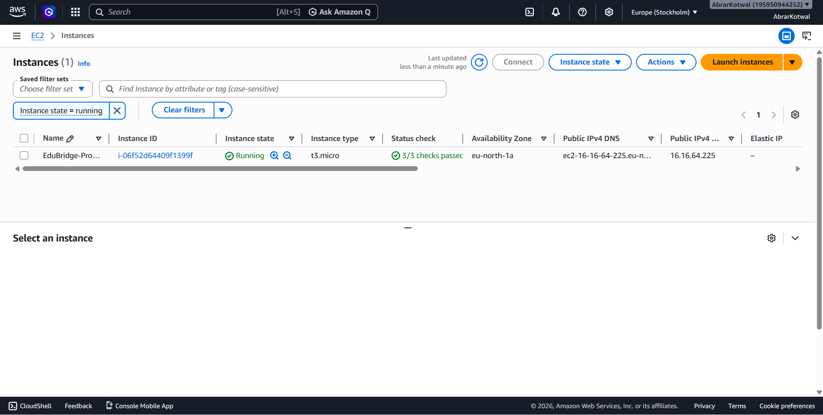

Figure 8.2: MobaXterm SSH Connection:
Shows the successful terminal connection as ec2-user, displaying the execution of the systemctl start httpd commands and the folder permission adjustments.

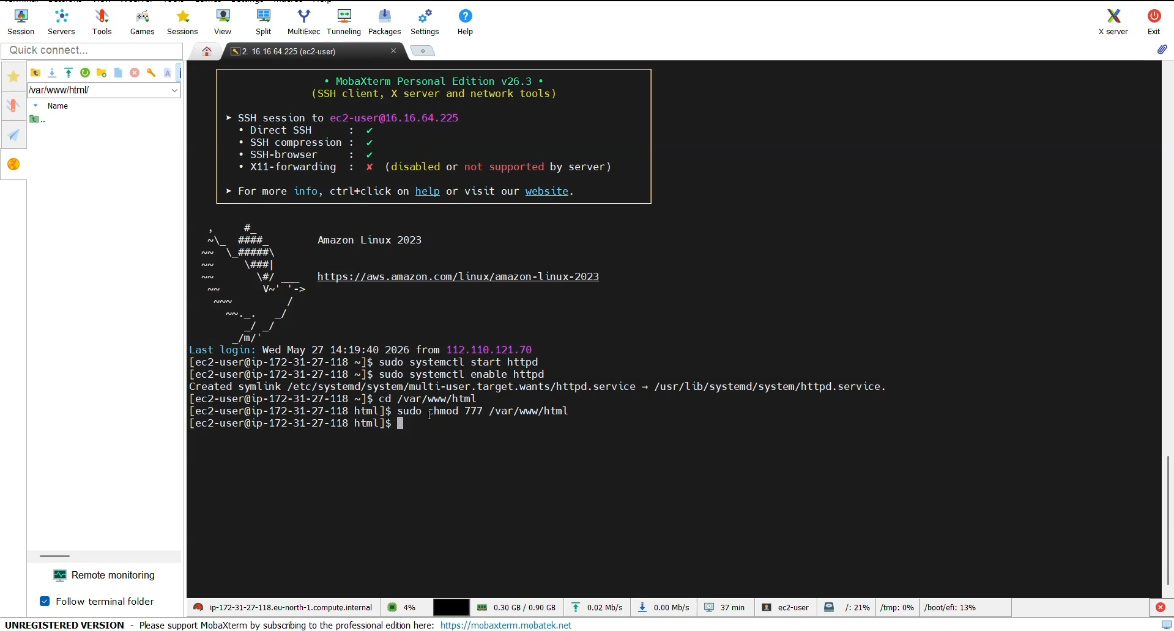

Figure 8.3: Live Web Entity:
Displays the final web browser view. The URL bar shows the public EC2 IP address, and the page renders the custom HTML/CSS UI, complete with the JavaScript live server clock confirming active execution.
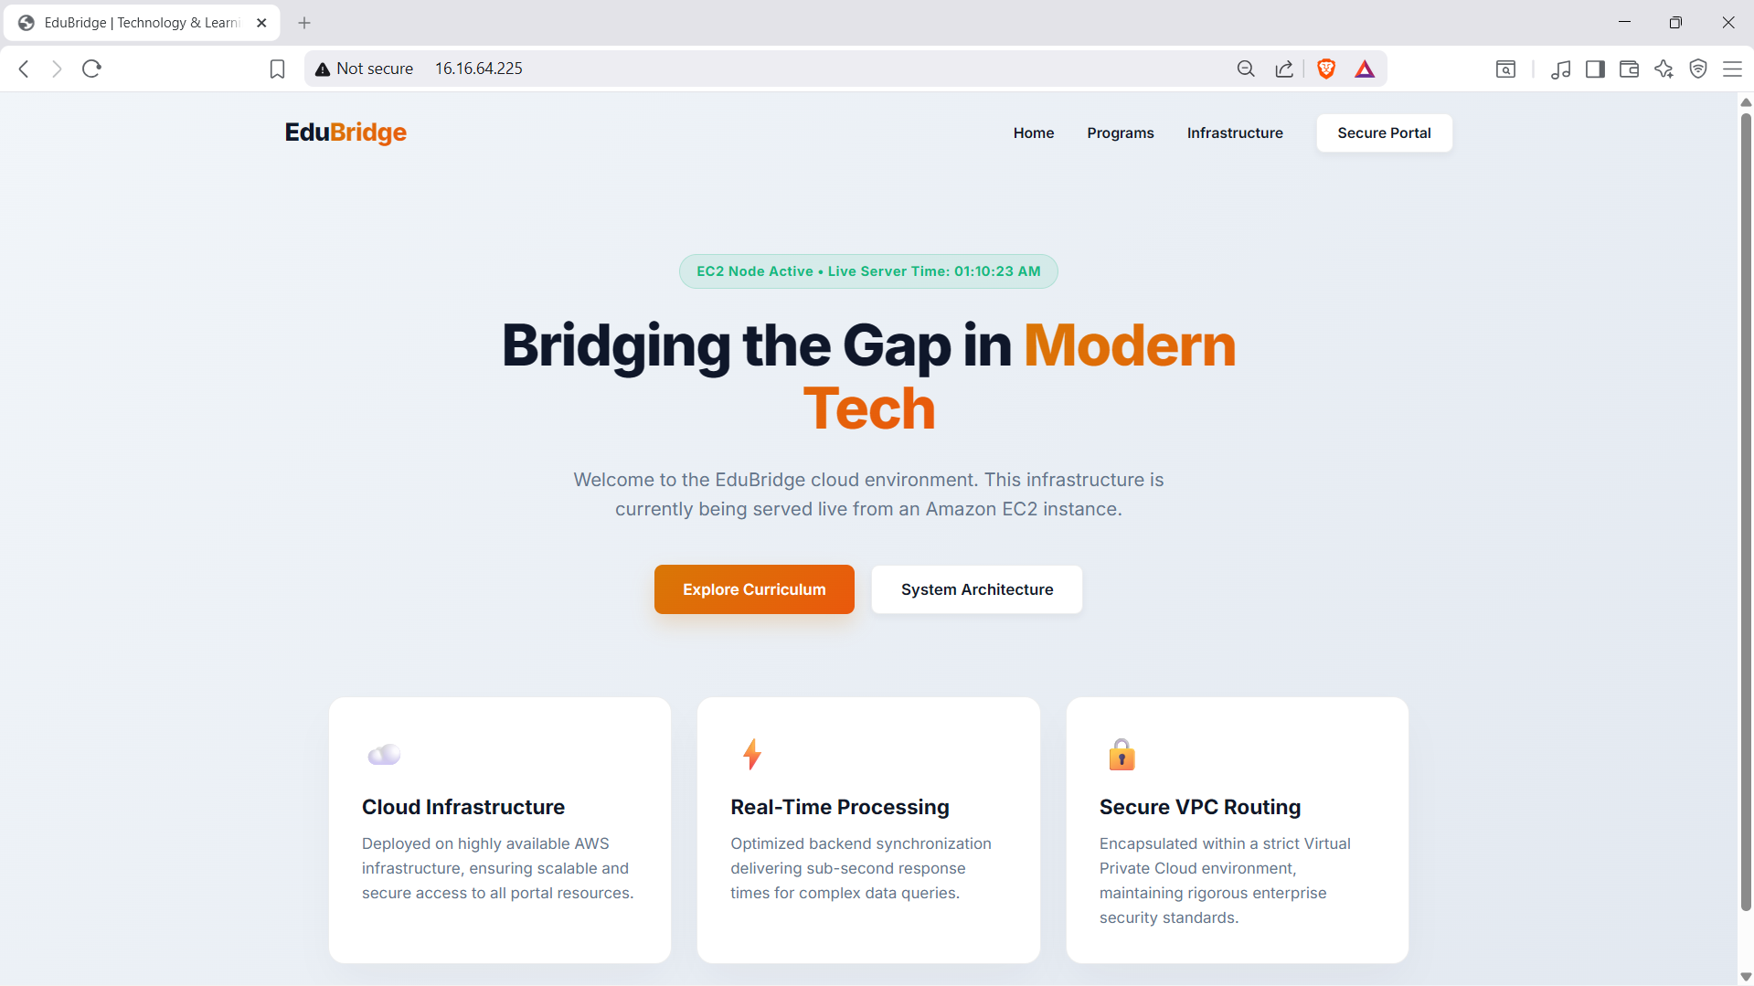

Advantages and Disadvantages

Advantages
- High Accessibility: The application is no longer bound to a local machine; it is accessible globally with near-zero latency variations.

- Strict Security Control: The explicit port definitions in the VPC Security Group ensure that malicious actors cannot easily access backend databases or unrelated services.

- Cost Efficiency: Utilizing the t2.micro instance and open-source software (Apache, Linux) keeps the operational cost at exactly zero during the development phase.

Disadvantages
- Volatile IP Addressing: Because a standard Public IPv4 address was used instead of an Elastic IP, stopping and restarting the EC2 instance will cause the IP address to change, breaking any saved links.

- Manual Scalability: Currently, if traffic spikes unexpectedly, this single instance might become overwhelmed. It lacks an Auto-Scaling Group to dynamically add more servers.

Conclusion
The "Harnessing EC2, VPC & MobaXterm" project successfully merges foundational cloud engineering with practical web deployment. By transforming a raw virtual machine into a strict, secure, and accessible web server, the project automates the complex task of infrastructure hosting. The transition from AWS resource allocation, through rigorous network security configuration, into deploying a live UI via MobaXterm, demonstrates a comprehensive understanding of Applied Cloud Engineering. The resulting architecture is a fast, accurate, and highly useful framework for deploying web entities. Beyond immediate deployment capabilities, this baseline infrastructure establishes a scalable foundation that can seamlessly integrate advanced services like automated CI/CD pipelines, load balancers, or database tiering. Ultimately, it proves that mastering core Infrastructure as a Service (IaaS) principle is essential for delivering reliable, enterprise-grade applications to a global audience, effectively eliminating the constraints of traditional local hosting.
- Future Scope
While the current system is robust, several enhancements will be targeted in future iterations:
- DNS Resolution (Route 53): Connecting the public IP address to a custom domain name using AWS Route 53 so users can type a URL instead of a string of numbers.
- SSL/TLS Encryption: Implementing HTTPS certificates to encrypt traffic between the user and the server, securing data transfers.
- Load Balancing: Adding an Application Load Balancer (ALB) to distribute incoming web traffic across multiple EC2 instances situated in different Availability Zones to ensure high availability.

Appendix

Source Code
The project architecture consists of the following key files deployed to the server:
- index.html: The primary web interface layout containing the semantic structure.
- style.css: The stylesheet defining the premium dark-mode aesthetic and layout grids.
- script.js: The client-side logic responsible for generating the real-time server tracking clock on the frontend.
- edubridge-key.pem: The cryptographic key used for SSH access (kept strictly local and excluded from version control).

GitHub & Project Video Demo Link

GitHub Repository Link:
https://github.com/abrarkotwal07/Cutting-Edge-Entity-Hosting

Project Video Demo Link:
https://drive.google.com/file/d/1D69L1ECl1QKrTMlf7F6JBgKMulr1RIGp/view?usp=sharing

