Restaurant Recommendation System

A Project Report Submitted to Smart- Internz for the completion of
Applied Data Science Internship Program Prepared By
Abrar Sajjad Kotwal
PRN: 2023011032042

D.Y.Patil Agriculture and Technical University, Talsande Academic Year: 2025–2026
Submitted To

Smart-Internz
Project Mentor / Guide Name: Indra Prakash

Abstract
In the modern digital age, finding the perfect dining experience has paradoxically become more difficult due to an overwhelming abundance of choices. Traditional food discovery platforms heavily rely on aggregate 5-star rating systems, which fail to capture the nuanced, highly specific preferences of individual diners. The project titled “Restaurant Recommendation System” focuses on solving this challenge by developing an intelligent, machine-learning-driven engine that assists users in finding dining options based on semantic similarities, textual reviews, and culinary features.
In this study, a massive and highly detailed dataset comprising 51,717 restaurant records from Bangalore (sourced via Zomato) is collected and rigorously pre-processed. Exploratory Data Analysis (EDA) is applied to uncover market trends, such as the highest-rated establishments, the most popular cuisines, and the distribution of restaurant ratings across the city. A Content-Based Filtering model is then implemented, utilizing a TF-IDF (Term Frequency-Inverse Document Frequency) vectorizer to extract deep meaning from customer reviews, alongside Cosine Similarity to calculate the exact mathematical closeness of different dining profiles.
To ensure the model is practical and usable for everyday consumers, the final mathematical matrix is optimized and deployed within a fully functional, interactive web application using the Flask framework. The resulting application allows users to seamlessly input their favorite restaurant and instantly receive a curated, highly accurate list of similar dining establishments, thereby enhancing the dining experience and showcasing the true potential of Applied Data Science.

INDEX

- Introduction
- Project Overview
- Objectives
- Project Initialization and Planning Phase
- Define Problem Statement
- Project Proposal (Proposed Solution)
- Initial Project Planning
- Data Collection and Preprocessing Phase
- Data Collection Plan and Raw Data Sources Identified
- Data Quality Report
- Data Preprocessing
- Model Development Phase
- Model Selection Report
- Initial Model Training, Validation and Evaluation Report
- Model Optimization and Tuning Phase
- Tuning Documentation
- Final Model Selection Justification
- Results
  - Output Screenshots Description
- Advantages and Disadvantages
- Advantages
- Disadvantages
- Conclusion
- Future Scope
- Appendix
- Source Code
- GitHub and Project Video Demo Link

Introduction
The hospitality and gastronomy sectors have witnessed exponential growth. With platforms like Zomato offering thousands of local options, patrons are suffering from "choice paralysis." A simple 4.5-star rating does not differentiate between a loud, fast-paced burger joint and a quiet, romantic Italian bistro. Modern dining requires a personalized approach that aligns with specific taste profiles, ambiances, and culinary expectations.

The Restaurant Recommendation System addresses this gap by replacing manual, trial and error dining selection with a data driven algorithmic approach. By parsing thousands of restaurant reviews and metadata, the application leverages artificial intelligence to understand the underlying context of a restaurant.

This system holds significant value across three distinct real-world scenarios:
- For Restaurant Visitors: It helps users discover new dining experiences tailored to their individual tastes, enhancing satisfaction and reducing the time spent searching.

- For Restaurant Owners: Owners can utilize such systems to ensure their establishments are recommended to the right target audience, thereby increasing relevant foot traffic and customer retention.

- For Food Delivery Platforms: By incorporating this engine, platforms can push highly relevant suggestions to users, subsequently increasing order volumes and overall user engagement.

Project Overview
This project is an end-to-end intelligent web application designed to act as a culinary inference engine. The architecture relies on a robust data science workflow that bridges the gap between raw data and a user-friendly interface.
The workflow begins with Document Collection, where a vast dataset of restaurant information (including names, costs, cuisines, and text reviews) is gathered. This data is fed into a Recommender Engine where textual data is mathematically transformed into spatial vectors. This allows the system to calculate the "distance" (or similarity) between different dining profiles.
Once the data is processed, the system relies on user interaction. A User Profile inputs a target restaurant they already enjoy via a Webpage. The backend engine processes this feedback, cross-references it with the mathematical matrix, and outputs a highly accurate list of similar dining establishments directly to the user's screen.

Objectives

To ensure a structured approach, the project was guided by several key learning and development objectives. By the end of this project, the developer aimed to:
- Master Content-Based Filtering: Understand and implement techniques to build a recommendation system that relies on item attributes rather than user histories.

- Execute Advanced Data Preprocessing: Learn how to handle, clean, and format messy, real-world data, specifically focusing on complex string manipulation and Natural Language Processing (NLP) text cleaning.

- Perform Exploratory Data Analysis (EDA): Utilize visualization libraries to uncover hidden insights, trends, and correlations within the culinary data that might go undetected in raw text.

- Apply Machine Learning Algorithms: Select and deploy the correct mathematical algorithms (TF-IDF and Cosine Similarity) based on the textual nature of the dataset.

- Build a Full-Stack Web Application: Transition the project from a local Jupyter Notebook script into a fully interactive web application using the Flask framework, complete with HTML, CSS, and JavaScript routing.

- Project Initialization and Planning Phase
- Define Problem Statement
Consumers frequently experience frustration when selecting dining venues due to an overwhelming volume of generic reviews. Existing platforms rely heavily on aggregate ratings, which do not account for a user's specific culinary tastes. There is a critical need for an automated system capable of analyzing the deep morphological traits of a restaurant its menu, its vibe, and its customer feedback to recommend truly similar experiences.

Project Proposal (Proposed Solution)
The proposed solution is an NLP-based recommender system. By feeding restaurant reviews into a TF-IDF algorithm, the system learns the unique "vocabulary" of each establishment. A web-based interface allows users to query a known restaurant they enjoy, and the backend engine computes and returns the top matching establishments based on both textual similarity and categorical proximity (such as cost and overall rating).

Initial Project Planning
Before writing any code, the necessary environment and technology stack were established:
- Environment: Anaconda IDE / Anaconda Navigator was utilized to write, test, and manage the code safely.
- Data Handling & Math: pandas and numpy were selected for high-performance matrix and data frame manipulation.
- Visualization: matplotlib, seaborn, and plotly were chosen to generate insightful bar charts and distribution plots.
- Machine Learning: scikit-learn was utilized for its robust feature extraction tools and similarity metric algorithms.
- Web Deployment: Flask was chosen as the lightweight Python web framework for server-side routing and HTML rendering.

Data Collection and Preprocessing Phase

Data Collection Plan and Raw Data Sources Identified
The model was built upon the comprehensive "Zomato Bangalore Restaurants" dataset sourced from Kaggle. The dataset contains 51,717 records and 17 distinct features. Critical features identified for the model included:
- name: The name of the restaurant.
- rate: The overall rating of the restaurant out of 5.
- cuisines: The food styles offered, separated by commas.
- approx_cost(for two people): The estimated cost for a meal.
- reviews_list: A massive list containing textual reviews left by previous customers.

Data Quality Report
Using the pandas.info() and isnull().sum() functions, a detailed inspection of the raw data was conducted. The inspection revealed that the dataset contained significant real-world inconsistencies. Several columns had missing (NaN) values. Furthermore, critical numerical columns like rate and cost were formatted as text strings (e.g., "4.1/5" and "1,200") which prevent mathematical calculations. The text reviews were also filled with punctuation and special characters.

Data Preprocessing
To prepare the data for the NLP engine, rigorous cleaning operations were executed:
- Dropping Unnecessary Columns: Features that added no semantic value to the recommendation (such as url, phone, and dish_liked) were removed to save memory.
- Handling Nulls and Duplicates: All missing NaN values were dropped, and duplicate restaurant entries were removed to prevent skewed matrices.
- Feature Formatting: The approx_cost(for two people) column was renamed to cost. The /5 was stripped from the rate column, commas were removed from the cost column, and both were converted into usable float numerical data types.
- Mean Rating Scaling: A custom script was written to compute the exact mean rating for each unique restaurant. This was then scaled using MinMaxScaler with a feature range of 1 to 5 to standardize the scoring.
- Text Standardization & Cleaning: For the reviews_list and cuisines features, the data was converted to lowercase. A custom function using string.punctuation was applied to strip all punctuation. Finally, nltk was utilized to remove common English "stop words" (e.g., "the", "is", "at") that provide no analytical value.

Exploratory Data Analysis (EDA) & Visualization
Visualizing the data is crucial to understanding the underlying relationships.
- Most Famous Restaurants: A bar plot revealed that Cafe Coffee Day, Onesta, and Empire Restaurant have the highest number of outlets in Bangalore.

- Rating Distribution: A distplot showed that the majority of restaurants possess a rating above 3.5, indicating a generally high standard of dining in the dataset.

- Top Restaurants & Cuisines: Further visualizations showcased the top 10 highest-rated standalone restaurants (like Byg Brewski), and an analysis of two-word frequencies proved that 'North Indian', 'Indian Chinese', and 'Fast food' are the most favored cuisines in the city.

Model Development Phase

Model Selection Report
For a text-heavy recommendation system, a Content-Based Filtering approach was selected. Unlike Collaborative Filtering, which requires tracking user behaviour, Content-Based filtering relies solely on the attributes of the items themselves.

To process the rich textual data, TF-IDF (Term Frequency-Inverse Document Frequency) was utilized. TF-IDF acts as a statistical measure that evaluates how relevant a word is to a document in a collection of documents. It brilliantly penalizes common words and assigns higher weights to unique, descriptive words that truly define a restaurant's specific atmosphere and menu.

Initial Model Training, Validation and Evaluation Report

The cleaned reviews_list data was passed through the TfidfVectorizer. Following this vectorization, Cosine Similarity was employed. Cosine similarity is a metric used to determine how similar two documents are irrespective of their size.
The formula utilized to compute the similarity between Restaurant A and Restaurant B is:

$$similarity\left(A,B\right)=\frac{A.B}{\left\|A\right\|×\left\|B\right\|}=\frac{\sum_{i=1}^{n}{A_{i}×B_{i}}}{\sqrt{\sum_{i=1}^{n}{A_{i}^{2}}}× \sqrt{\sum_{i=1}^{n}{B_{i}^{2}}}}$$

By calculating the linear kernel of the TF-IDF matrix, the system generated a massive array containing the similarity score of each restaurant compared to every other restaurant in the database

Model Optimization and Tuning Phase

Tuning Documentation
To optimize the inference engine for final deployment, specific logic was written into the recommendation function:
- N-Gram Range Optimization: The TF-IDF vectorizer was tuned using ngram_range=(1, 2). This allowed the model to capture both single words and highly relevant two-word phrases (e.g., "fine dining").
- Result Filtering: When a query is made, the algorithm extracts the top 30 most similar restaurant indexes. It then drops any identically named branches (to prevent the system from simply recommending 10 different locations of the same franchise) and finally sorts the remaining list strictly by their Mean Rating. The top 10 highest-rated, highly similar restaurants are then returned.

Final Model Selection Justification
This specific pipeline TF-IDF paired with Cosine Similarity was finalized because it is mathematically highly efficient for sparse text data. Furthermore, integrating the sorting logic by Mean Rating and Cost ensures the user doesn't just get a similar restaurant, but the absolute best quality similar restaurant available.

Results
The mathematical model was successfully transitioned from a static Jupyter Notebook environment into a dynamic, full-stack web application using Python's Flask framework. The resulting application seamlessly processes HTTP requests, executes the Cosine Similarity matrix, and renders interactive HTML pages, proving the efficacy of the NLP algorithms in a real-world scenario.

8.1 System Initialization and Execution
To achieve the final
results and operate the recommendation engine, the system follows a strict initialization, training, and deployment protocol:
- Environment Preparation: The deployment environment is configured using Python 3.x. All essential machine learning, data processing, and server dependencies (such as pandas, scikit-learn, and flask) are installed collectively via the requirements.txt execution.
- Matrix Training (Offline Pre-computation): Before the web server can be booted, the raw analytical dataset (zomato.csv.zip) is extracted into the core directory. The Restaurant_Recommendation_System.ipynb notebook is then executed sequentially. This crucial step performs the Exploratory Data Analysis (EDA), cleans the text, and trains the NLP model. It generates two mandatory files for the server: restaurant1.csv (the cleaned dataset) and restaurant.pkl (the heavy, pre-computed TF-IDF mathematical matrix).
- Server Deployment: With the model trained and serialized, the local Flask server is initialized by executing the main application script via the command line (python app1.py).
- Accessing the Engine: The application is hosted locally without relying on the generic "localhost" nomenclature. The user accesses the fully deployed engine by navigating their preferred web browser directly to the address: http://127.0.0.1:5000/.

8.2 Interface Experience and Output
Instead of operating as a simple backend terminal script, the system is designed as an interactive, luxury "dark-mode" web platform named Lumière Dining. The user journey and visual outputs are structured as follows:
- Landing Interface (index.html): The application opens to a premium landing page detailing the core NLP logic and architectural approach of the project. It features an asymmetrical split-screen layout with deep background tones, gold accents, and elegant Playfair Display typography, providing a highly engaging and professional entry point for the user.
- Query Terminal (web.html / extractor): Users navigate to an initialization page featuring a minimalist, command-palette style search bar. As the user begins typing a target restaurant, an AJAX-powered asynchronous script fetches dynamic typeahead suggestions directly from the Pandas index. This autocompletes feature features full keyboard navigation (Up/Down/Enter), ensuring highly accurate input parameterization and preventing typographical errors from breaking the search vector.
- Inference Dashboard (result.html / keywords): Upon executing the query, the backend engine rapidly maps the index of the target parameter, computes the Cosine Similarity matrix, and transitions the user to the results dashboard. The user is presented with the top 10 most similar dining establishments. To enhance the user experience, the interface includes dynamic JavaScript toggles, empowering the user to view the data either in a structured List View (an elegant, minimalist HTML Table) or a highly visual Grid View (glass morphism CSS Cards). Both views cleanly display the matched Restaurant Name, overlapping Culinary Profiles, Mean Rating (out of 5), and Approximate Cost.

Output Screenshots
Instead of operating as a simple backend terminal script, the system is designed as an interactive, luxury "dark-mode" web platform named Lumière Dining. The user journey and visual outputs are structured across three distinct web pages:

Figure 8.1: Lumière Dining Landing Page (index.html)
The application opens to a premium landing interface detailing the core NLP logic and architectural approach of the project. It features an asymmetrical split-screen layout with deep background tones, gold accents, and elegant Playfair Display typography, providing a highly engaging entry point for the user.

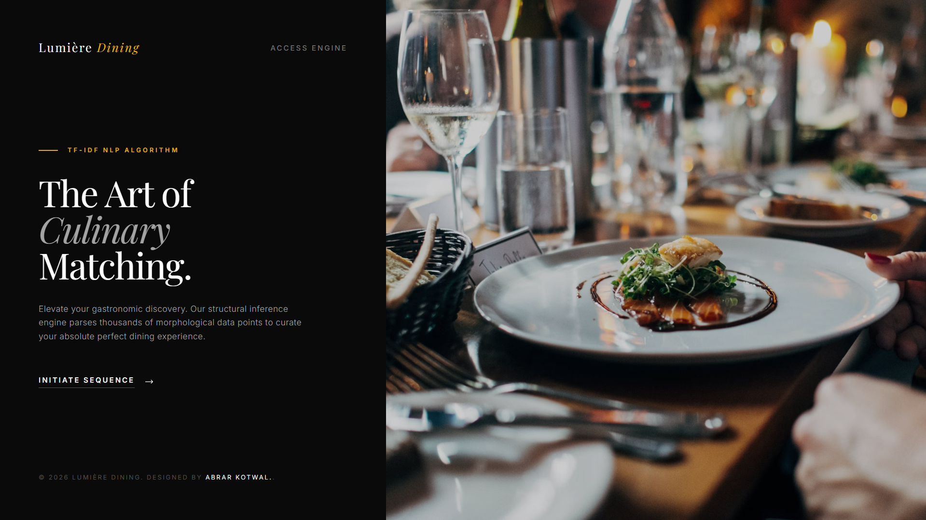

Figure 8.2: Lumière Dining Query Terminal Interface (web.html)
The main dashboard provides a clean, premium, and structured form where users enter their target restaurant name. The input field features a dynamic, AJAX-powered auto-complete function (with full keyboard navigation) to ensure accurate selection. The “Compute Vector” button allows easy submission for the recommendation engine to process the request.

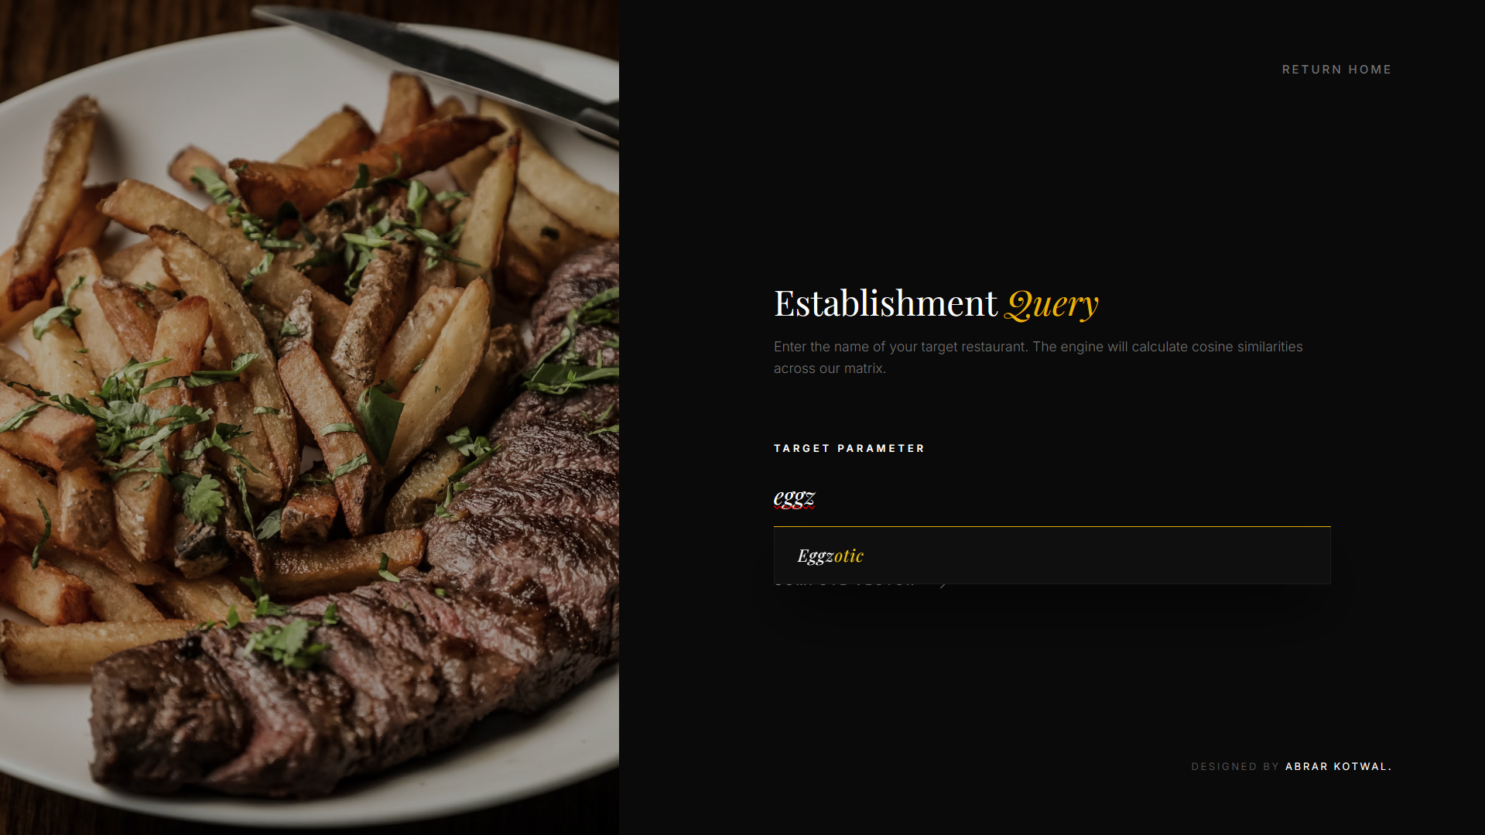

Figure 8.3: Recommendation Inference Dashboard (result.html)
The final screen clearly shows the top 10 recommended dining establishments based on the user's input, confirming the NLP model’s fast and accurate classification performance. To enhance the user experience, the interface includes dynamic JavaScript toggles, empowering the user to view the data either in a structured List View or a highly visual Grid View. Both views cleanly display the matched Restaurant Name, overlapping Culinary Profiles, Mean Rating and Approximate Cost.
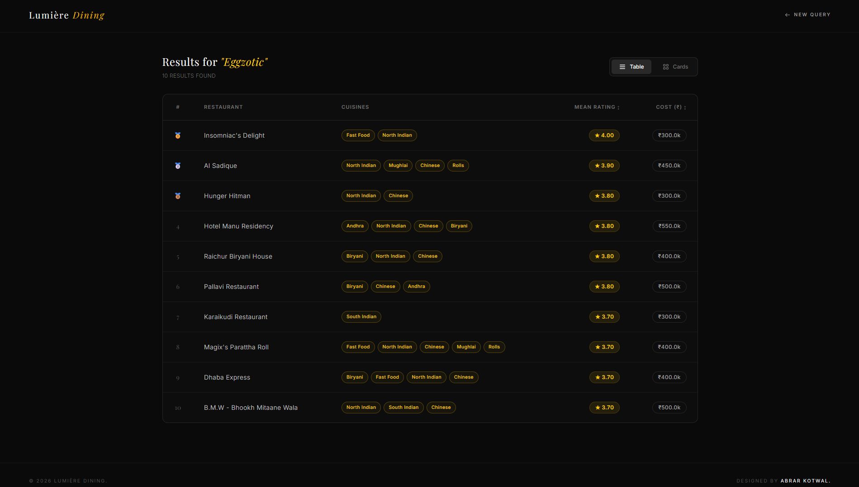
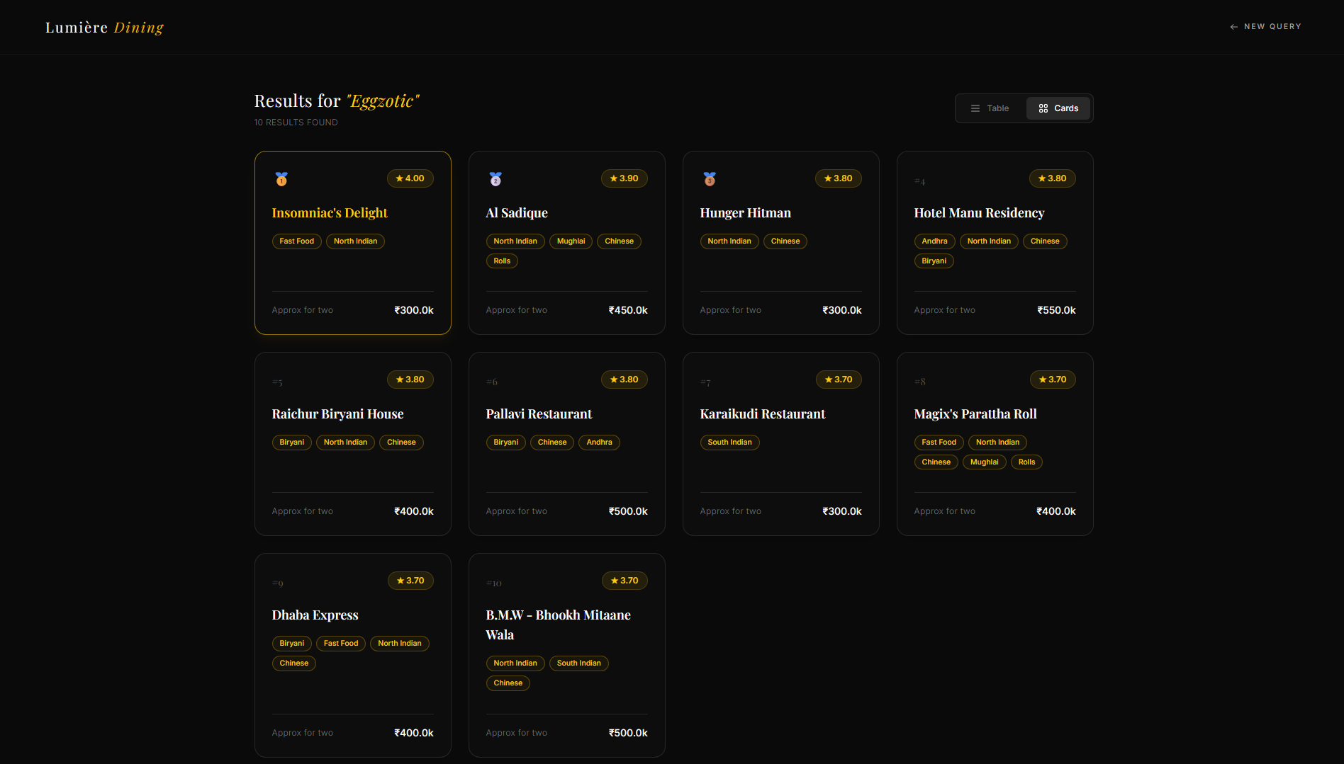

Advantages and Disadvantages

Advantages
- High Personalization: Captures the actual "vibe" and specific culinary focus of a restaurant through text reviews, rather than just suggesting a highly-rated but potentially irrelevant place.
- User-Independent (No Cold Start): Because the system is Content-Based, it does not require a user to have a long history or profile on the app to get excellent recommendations.
- Fast & Accessible: The deployment via Flask provides a seamless UI, abstracting the complex mathematics away from the user into a simple search bar.

Disadvantages
- Item Cold-Start: New restaurants with no reviews or data cannot be accurately vectorized and will not be recommended until sufficient text data is accumulated.
- Data Dependency: The accuracy of the similarity vectors is strictly bound to the quality and volume of the underlying text reviews provided in the Kaggle dataset.

Conclusion
The Restaurant Recommendation System project successfully merges advanced Natural Language Processing with practical, full-stack web development. By transforming subjective, unstructured customer reviews into a strict, mathematically comparable format, the engine automates the complex task of culinary curation. The transition from raw data collection, through rigorous preprocessing and EDA, into deploying a Cosine Similarity matrix via Flask, demonstrates a comprehensive understanding of Applied Data Science. The resulting application is a fast, accurate, and highly useful tool that redefines how users discover dining experiences.
- Future Scope
While the current system is robust, several enhancements could be made in future iterations:
- Live API Integration: Connecting the backend to live APIs (such as Google Places or live Zomato APIs) to dynamically update the TF-IDF matrix with fresh reviews daily, rather than relying on a static CSV file.
- Hybrid Implementation: Combining the current Content-Based engine with Collaborative Filtering to account for overall trending establishments and user behaviour over time.
- Geospatial & Filter Upgrades: Adding an interactive map interface and slider filters to allow users to narrow down the mathematical recommendations by their immediate GPS radius and specific budget constraints.

Appendix

Source Code
The project architecture consists of the following key files:
- Restaurant_Recommendation_System.ipynb: The primary Jupyter Notebook handling all EDA, text cleaning, vectorization, and data generation.
- restaurant1.csv: The cleaned and formatted dataset used by the web app.
- restaurant.pkl: The serialized TF-IDF/Cosine Similarity model used for rapid real-time prediction.
- app1.py: The main Flask application file serving as the backend controller. It handles routing (/, /extractor, /keywords), processes the POST requests, and returns the HTML table dynamically.
- templates/: This directory contains the HTML files (home.html, extractor.html, keywords.html) defining the structure of the web interface.
- static/: Contains the necessary CSS and JavaScript assets for styling and responsiveness.

GitHub & Project Video Demo Link

GitHub Repository Link:
https://github.com/abrarkotwal07/Restaurant_Recommendation_System

Project Video Demo Link:
https://drive.google.com/file/d/1n3Kxl9PEW9thAgaLhSDsG2rGOwYtul4Y/view?usp=sharing

