

**North South University**

**Department of Electrical and Computer Engineering**

**Development of Web Based**

**Multi-Vendor E-Commerce System**

**Faculty – SAA3**

# 

**Group - 03**

**Section - 14**

**CSE299**

# 

**Team Members:**

**Sadman Chowdhury Siam -** 1711172042

**Abrar Faisal -** 1712677642

**Abdullah Ibne Ali -** 1711200042

**1. Project Name**

Development Of Web Based Multi-Vendor E-Commerce System.

## 2. Problem

E-commerce is a system that refers to buying and selling of goods from different places using the internet, and the transfer of money and data to execute these transactions.

When people go shopping like places in New Market, Bashundhara City, Jamuna Future Park and many others renowned shopping mall they face many problems. New market is very crowded and congested with the risk of thieves. People have to waste a lot of time on the road because of heavy traffic. Basically, in our country the weather is too hot and humid so it is very difficult to go for shopping for this unbearable heat and public transport discomforts. Sometimes people need to go through a very hard time finding the shop for their desired products. For these such problems, E-Commerce is the best solution for both the customers and the sellers that will reduce their sufferings and maximize their efforts for buying and selling the desired products.

In Bangladesh E-Commerce sectors growth has exceeded all expectations and has had a leading impact on changing the economy in terms of investment. In Bangladesh E-Commerce started in the late 90s. During the period of 2000-2008, the E-Commerce sector observed a slow growth. Annual rate of growth in the ecommerce sector for the past three years is trending above 200% year on year [1]. According to Bangladesh bank, payments and transactions by credit cards were nearly Tk 11 billion in June 2008. Massive changes occurred in the mentioned sector when Bangladesh Bank allowed online payment in the country, thus, officially opening up the e-commerce sector. In the year 2013 Bangladesh Association of Software and Information Services (BASIS) and Bangladesh Bank jointly observed “E-Commerce Week” for the first time in the country. It has observed a growth rate above 300% for the last three years. Market share for E-Commerce for B2B and B2C are 10% and 90% respectively. There are 50,000 people actively engaged in E-Commerce with projections of 1,000,000 people being employed in the sector over the next 10 years. Transaction sizes for ecommerce purchases are still relatively small. Average spending per online shopper is BDT 9000-10000. About 70.5% of e-commerce users spend less than BDT 5,000 a month. About 29.3% buyers using a website directly as compared to 43.5% using Facebook Page for purchasing products online.7 Contribution of e-commerce as a percentage of GDP is less than 1%, if we take industries connected with e-commerce under consideration it nears 2.5% [2].

At present per day, approximately 20 thousand & per month 5-6 lakh parcel was delivered all over the country. All commerce will become an e-commerce within the next few years and this process will help the sector mature. Currently, there are 1,000 e-commerce entrepreneurs in the country, who are running their business through websites. There are approximately 8,200 Facebook pages also running this business [3].

**3. Literature Review**

The very first E-Commerce site established in Bangladesh was Rokomari.com which sold only books.

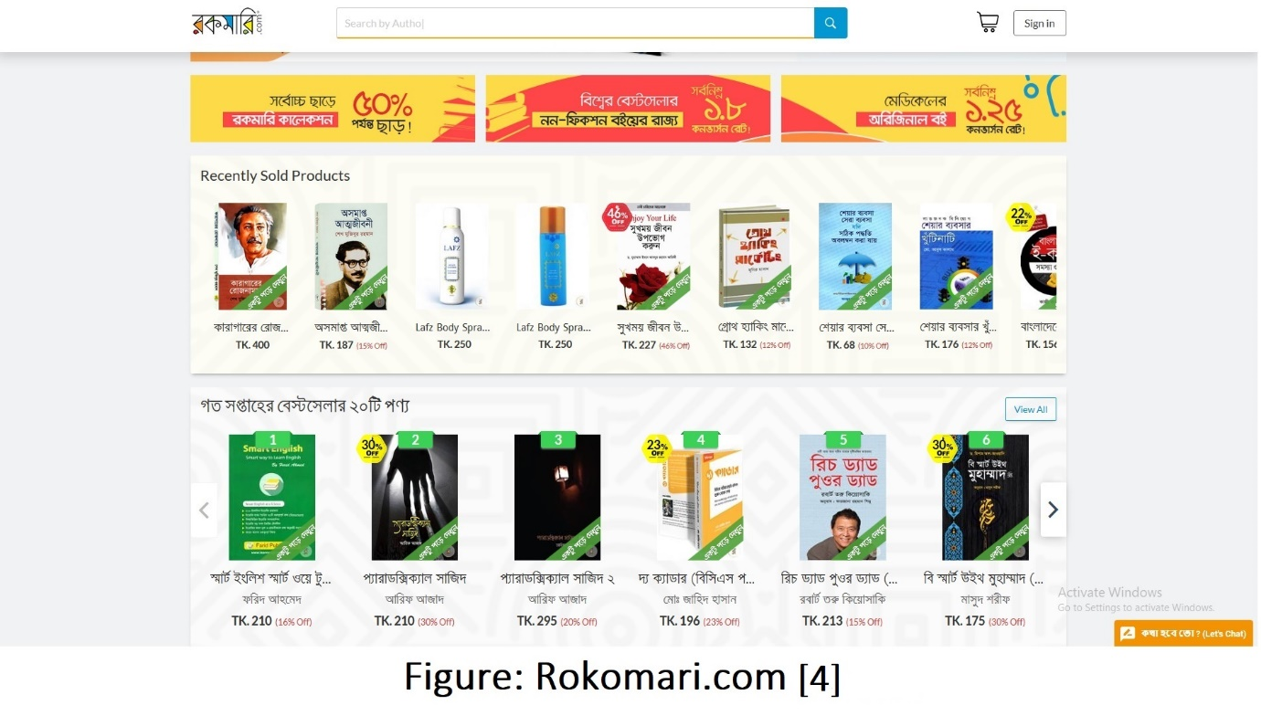

The leading Ecommerce services in Bangladesh are Daraz, Ajker deal, Pickaboo etc. Daraz have all types of products. It is a multi-vendor Ecommerce site. They collect products from suppliers across the country and deliver it to customers. Pickaboo is known for selling mobile and electronics.

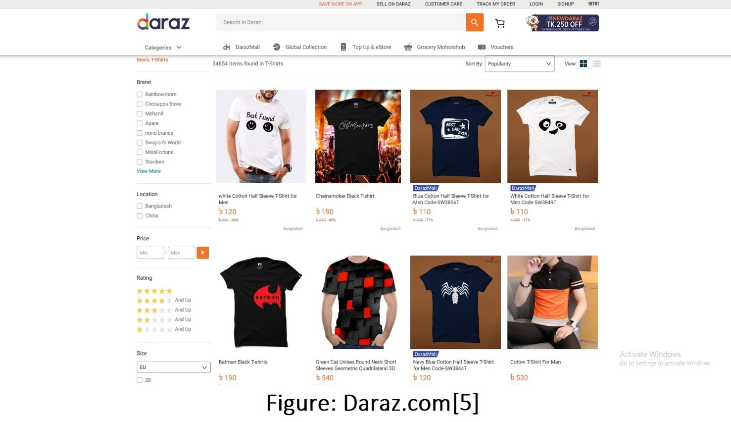

Also, some super shops are providing their E-Commerce sites where users can order from home. For example: Chaldal provides grocery items to the customers. Agora also have their online system. People have the choice of compare pricing and quality. They have a lot of options to choose from.

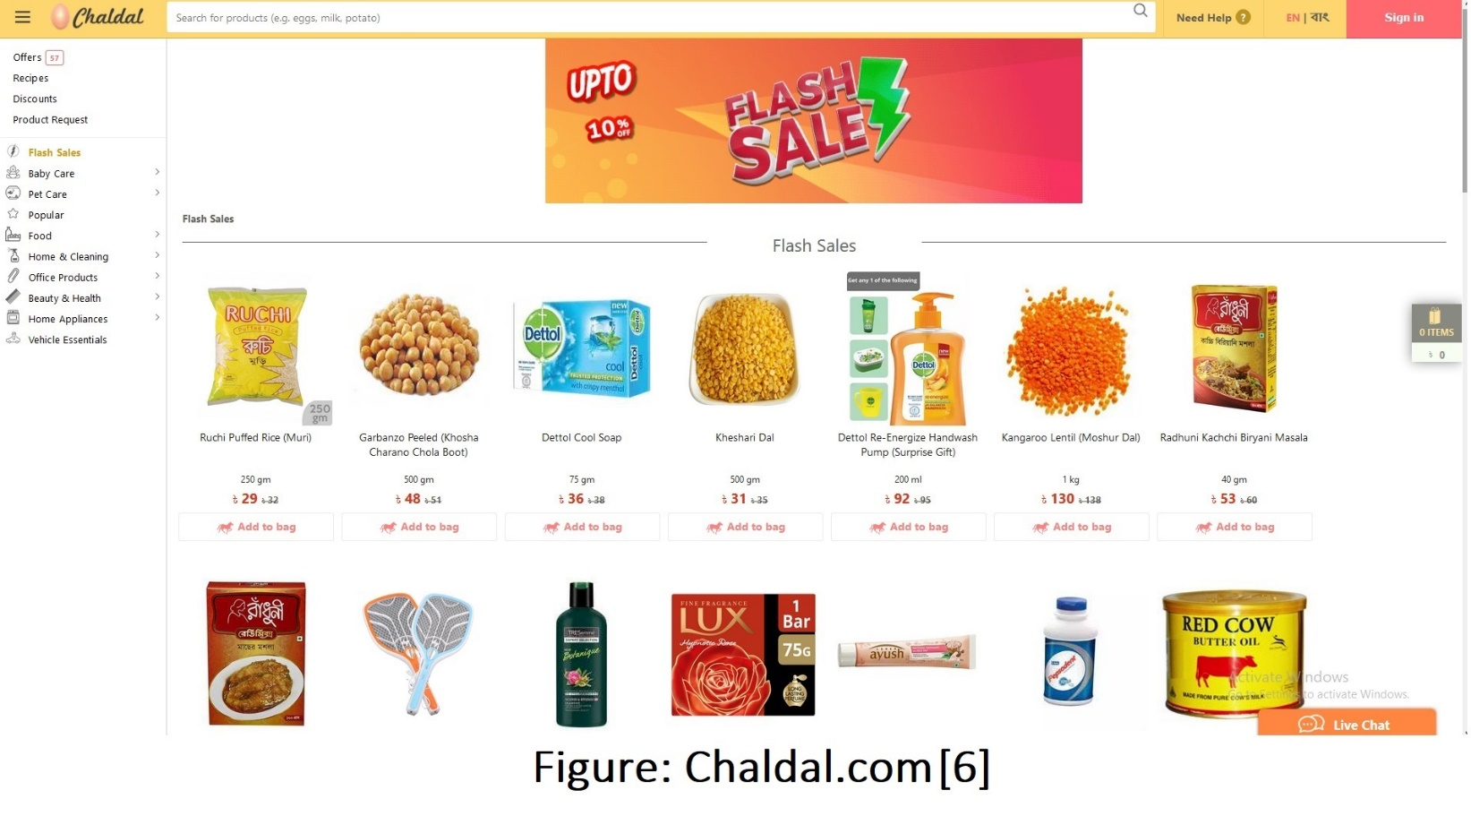

But as they say with great power comes great responsibility which the E-Commerce sites are not abiding by at all. Many people get broken, expired products. Products get exchanged among the customers. There was also an incident like this: when a guy ordered an I-phone and got a trimmer instead as they tagged the trimmer as an I-phone for being of about the same size. Also, products don’t get delivered timely. The delivery guys often run away with these products and the E-Commerce sites can’t do anything about it as they didn’t verify the delivery workers background at the beginning. As a result, people don’t get the facilities of these E-Commerce sites in our country in full extent.

**4. Solution**

According to the problems specified in our previous article, our main goal is to introduce a better E-Commerce system in our country to counter these problems. Modern problems require modern solutions. So we will be fixing these problems following the present day socio-economic structure of Dhaka city and Bangladesh.

Bootstrap is going to be used for the front end. It is a free and open-source CSS framework directed at responsive, mobile-first front-end web development. It contains CSS- and JavaScript-based design templates for typography, forms, buttons, navigation and other interface components.

For the back end, Django is going to be used. Django is a Python-based free and open-source web framework, which follows the model-view-template (MVT) architectural pattern.

For database we will be using PostgreSQL with a real time virtual private server.

Major feature of our E-commerce solution is pointed out below to give a clearer view why our E-Commerce is going to be better than any other E-Commerce system ever introduced in our country.

1. **Login and Registration: ​**Both Business and general user will have separate login and registration system. They will have to provide their Email, First Name, Last Name, Phone Number, Password to signup first and then their data will be collected in our database permanently. So, whenever they login again, they will directly be taken to the main homepage of the website.

1. **Homepage:** The homepage will consist of navigation bars that will contain links of other pages linked to homepage. User can get a primary overview from the homepage what the website is about and which facilities it is providing.
2. **Product Uploading:** Business Users will have the option to upload products. While uploading products, they can add product name, category, short description, picture, price tags etc.
3. **Searching Products:** General Users will go through these products and select the ones they prefer according to their choice and budget. The products will be categorized and shown from price variation to most popular which will make it easy for them to take decisions.
4. **Cart:** Products will be added to General users’ cart. Every general user gets a specific ID after signing up in our database. According to that ID and after crossmatching with their cart ID’s, they will proceed to checkout. Before checking out they will see their total amount of money they need to pay adding additional delivery charges.
5. **Checkout and Payment:** They can then give their payment method here. How they want to pay and also address for their home delivery. Payment can be done through payment gateway system which will provide services of payment through visa or master card. Manual payment can also be done on our cash on delivery system.
6. **Comments:** General users will be able to make review of products through comments so that they can share their experience with other customers and encourage them to buy those products.

## 5. Users

There will be two types of user

1. Business user
2. General User

**Business User:** They will open account to our system for business purpose and would need to upload their products in it for selling. They have great responsibility to run this business on our system as they would need to maintain profile by introducing new products and supplying the products according to customers need. A constant competition will be going among the Business users as the one with more elements to attract the general user’s attention will get the lion’s share of the general users. They will need to have regular communication with system providers as they will be monitored if they are putting unnecessary price tags on their products. On the basis of their profit, flash sales and discounts will be given to general users.

**General User:** They are the main engine that will run the website. They will see the products added by Business users and buy those products. But they won’t be able to change the price or tag of the products as it is only in the hands of the business users. As a result, a healthy business environment will be kept within the business users and general users. However, any unprofessional action such as duplicating master card or visa cards, using fake information, any racial or social abuse towards any other customer in comment section will be taken care of strictly.

**6. Work Plan & Milestone**

The total work is separated into three phases,

1. Analysis
2. Development & Testing
3. Deployment

The table below shows us how much time we need to complete the project and also the estimated working hours we need.

# Total estimation of working hours: 200 hrs.

|  |  |  |  |
| --- | --- | --- | --- |
| **Milestone** | **Tasks** | **Hrs.** | **Date** |
| **1 - Analysis** | | |  |
| 1.1 | Analysis and design stage, gather data and create system mockup | 20 | 03/02/20 |
| 1.2 | Architecture design | 10 | 05/02/20 |
| 1.3 | Design work plan | 5 | 7/02/20 |
| 1.4 | Wrapping up plan | 5 | 12/02/20 |
| 1.5 | Distribution of  tasks to development teams | 2 | 14/02/20 |
| **2 - Development & Testing** | | |  |
| 2.1.1 | Create database | 10 | 15/02/20 |
| 2.1.2 | Front End Design website-(UI/UX) | 2 | 24/02/20 |
| 2.1.3 | Backend (Login,Reg) | 5 | 3/03/20 |
| 2.2 | Testing(Login,Reg) | 1 | 9/03/20 |
| 2.3.1 | Homepage website (React) | 30 | 7/03/20 |
| 2.3.2 | Admin Page Layout (Backend) | 50 | 12/03/20 |
| 2.4.1 | Testing | 1 | 16/03/20 |
| 2.4.2 | Finalize login, Reg, Pages | 2 | 18/03/20 |
| 2.5.1 | Searching (Backend) | 4+ | 19/03/20 |
| 2.5.2 | Searching (Front End) | 6+ | 22/03/20 |
| 2.6.1 | Personal Profile (Backend) | 5 | 28/03/20 |
| 2.6.2 | Personal Profile (Front End) | 3 | 28/03/20 |
| 2.7 | Payment Gateway | 5 | 2/04/20 |
| 2.8 | Combine and Testing | 3 | 8/04/20 |
| 2.9 | Session Checking for Different Level user | 2 | 12/04/20 |
| **3- Deployment** | |  |  |
| 3.1 | Server Test | 2 | 16/04/20 |
| 3.2 | Setup Server Environment | 2 | 17/04/20 |
| 3.3 | Setup Database | 2 | 18/04/20 |
| 3.4 | Upload project to server | 1 | 19/04/20 |
| 3.5 | Test Project from Server | 2 | 19/04/20 |
| 3.6 | Perform Penetration Test & Analyze report | 3 | 20/04/20 |
| 3.7 | Solving Issues | 17 | 20/04/20 |
| 3.8 | Finalizing Project | 3 | 21/04/20 |

## 7. Gantt Chart

|  |  |  |  |  |  |  |  |  |  |  |  |
| --- | --- | --- | --- | --- | --- | --- | --- | --- | --- | --- | --- |
|  | 5/02 | 12/02 | 15/02 | 20/02 | 3/03 | 8/03 | 20/03 | 27/03 | 4/04 | 14/04 | 20/04 |
| Analyze & Design |  |  |  |  |  |  |  |  |  |  |  |
| Architecture Design |  |  |  |  |  |  |  |  |  |  |  |
| Project Final Plan |  |  |  |  |  |  |  |  |  |  |  |
| Creating Database |  |  |  |  |  |  |  |  |  |  |  |
| Login & Reg (Frontend) |  |  |  |  |  |  |  |  |  |  |  |
| Login Reg (Backend) |  |  |  |  |  |  |  |  |  |  |  |
| Testing |  |  |  |  |  |  |  |  |  |  |  |
| Homepage (Frontend) |  |  |  |  |  |  |  |  |  |  |  |
| Homepage (Backend) |  |  |  |  |  |  |  |  |  |  |  |
| Overall Development |  |  |  |  |  |  |  |  |  |  |  |
| Testing |  |  |  |  |  |  |  |  |  |  |  |
| Solving Issues |  |  |  |  |  |  |  |  |  |  |  |
| Server Test |  |  |  |  |  |  |  |  |  |  |  |
| Upload to Server |  |  |  |  |  |  |  |  |  |  |  |
| Finalizing Project |  |  |  |  |  |  |  |  |  |  |  |
| Final Deployment |  |  |  |  |  |  |  |  |  |  |  |

## 8. Work Distribution

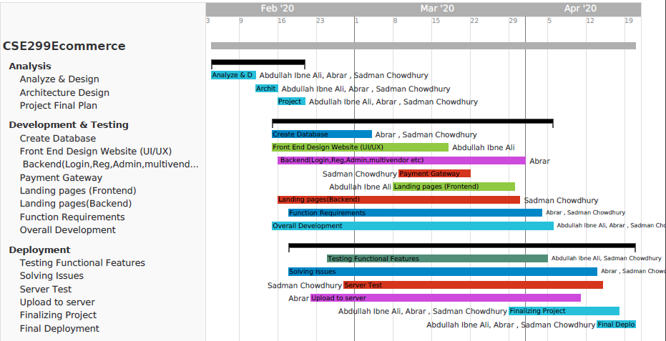

**9. Business Plan**

An Ecommerce system is a great opportunity for business now a days. There are possibilities of income from many sources,

1. We will take 15% from each product sold by our business users. This will be a great source of business.

1. We will take a good number of amounts to advertise our business users. This will help our users to grow their business as well as ours.
2. We will sell subscription and coupon to our general users. They will use this for discount. which will also be a great source for income.

# 10. References

[1] https://www.export.gov/article?id=Bangladesh-ECommerce.

[2]

https://brainstation-23.com/e-commerce-business-scenario-in-bangladesh-2006-to-2018/.

[3]

https://brainstation-23.com/top-e-commerce-sites-bangladesh-according-alexa/.

[4] https://www.rokomari.com/book

[5] https://www.daraz.com.bd/

[6] https://chaldal.com/