**Question 1 Internal Controls**

1. Spreadsheet Inc. is a software company that develops and designs complex spreadsheets for finance professionals. The company uses its own customized spreadsheet to record its transactions. The spreadsheet is open for use to all customer-facing employees and is also used to issue invoices to customers.
2. Q-Mort Inc. is a financial institution specializing in loans and mortgages. The marketing catchline "loans or mortgages approved in one hour" is a campaign the institution uses to increase its loan and mortgage portfolio. In order to meet the one-hour approval process, the loan officers are given flexibility to decide on the credit and the loan or mortgage amount within one hour of the customer completing the application. The finance officers are paid a percentage of the loan amount as a bonus.
3. The Local Bank Agency is a non-profit organization providing meals to the less fortunate. Most of the agency's revenues are from donations and government grants. The accounting manager is responsible for all the accounting work, including recording donations, approving invoices for payment, preparing and posting all entries into the accounting system, and preparing bank reconciliations.

**Required:** For each of the companies and situations discussed:

1. Identify the control weakness
2. Make a recommendation to improve or correct the control weakness.

**Question 2 Cash and Cash Equivalents**

 A first-year co-op student is trying to determine the cash and cash equivalents that should be reported on a company’s statement of financial position. At year-end:

1. Cash on hand in the cash registers totals $2,920.
2. The balance in the savings account is $57,800 and in the chequing account, $25,000. The company also has a U.S. bank account, which contains the equivalent of $27,000 Canadian at year-end.
3. Amounts due from employees (travel advances) total $8,700.
4. Trading investments held by the company include $25,000 in a term deposit maturing in 120 days, a Government of Canada bond for $50,000 that falls due in 30 days, and $36,000 in shares of Loblaw Companies Limited.
5. The company has $1,230 of NSF cheques from customers that were returned by the bank. NSF fees charged by the bank totaled $55.

**Required:**

1. Determine what items listed are cash and which cash equivalents.
2. What combined amount would be reported as cash and cash equivalents on financial statements?
3. Identify where items that are not cash and cash equivalents would be recorded.

**Bank Reconciliations**

A bank reconciliation is an internal control document. To ensure that the company records are correct and complete, the company compares its ledger entries to a neutral third party’s records (the banks). The bank reconciliation helps the company to correct its records through journal entries.

Reconciling items per bank (statement balance):

Start with Statement Balance: $XXX

Deposits in transit (+)

Outstanding cheques (−)

Bank errors (+ / −)

= Reconciled Cash Balance per Bank $ YYY

Reconciling items per book (GL balance):

These two balances will be equal

Start with GL Balance: $WWW

Deposits showing in Bank (+)

Payments showing in Bank (-)

Book errors (+ / −)

= Adjusted Cash Balance $ YYY

**Question 3 Bank Reconciliation**

Sharper Manufacturing Limited has provided the following information for May:

* Bank statement
* Cash receipts Journal
* Cash deposits Journal

***Required:***

1. Determine the bank balance in the recorded ledger based on the cheque receipts summary (deposits) and the cheque summary (withdrawals).
2. Complete a bank reconciliation including journal entries for May.

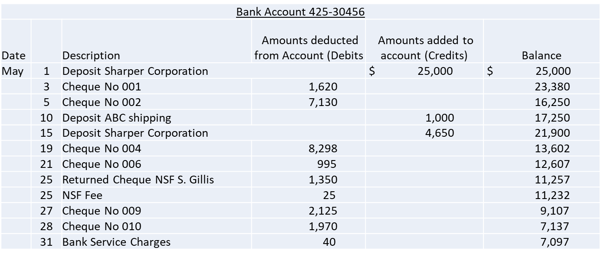

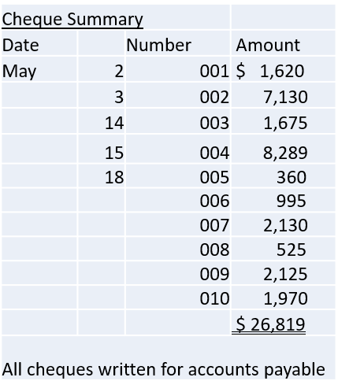

Bank reconciliation:

|  |  |  |
| --- | --- | --- |
|  | | |
|  |  |  |
|  |  |  |
|  |  |  |
|  |  |  |
|  |  |  |
|  |  |  |
|  |  |  |
|  |  |  |
|  |  |  |
|  |  |  |
|  |  |  |
|  |  |  |

|  |  |  |
| --- | --- | --- |
|  |  |  |
|  |  |  |
|  |  |  |
|  |  |  |
|  |  |  |
|  |  |  |
|  |  |  |
|  |  |  |

Journal entries to correct records:

|  |  |  |  |  |
| --- | --- | --- | --- | --- |
| **Date** | **Journal Reference** | **Account** | **Debit** | **Credit** |
|  |  |  |  |  |
|  |  |  |  |  |
|  |  |  |  |  |
|  |  |  |  |  |
|  |  |  |  |  |
|  |  |  |  |  |
|  |  |  |  |  |
|  |  |  |  |  |
|  |  |  |  |  |
|  |  |  |  |  |
|  |  |  |  |  |
|  |  |  |  |  |
|  |  |  |  |  |

**Question 4 Investment Classifications**

Identify whether each of the following is most likely (a) a debt or equity investment, and (b) a non-strategic or strategic investment. (c) Identify the most likely reason (such as earning gains, interest, dividends, obtaining influence or control) for making the investment.

